**Data Science**

**Table of Contents**

1. **Unit I**
2. **Introduction: What Is Data Science?**
3. **Statistical Inference, Exploratory Data Analysis, and the Data Science Process**
4. **Algorithms**
5. **Spam Filters, Naive Bayes, and Wrangling**
6. **Logistic Regression**
7. **Time Stamps and Financial Modeling**
8. **Extracting Meaning from Data**
9. **Recommendation Engines: Building a User-Facing Data Product at Scale**
10. **Unit II**
11. **Data Visualization**
12. **Fraud Detection**
13. **Social Networks and Data Journalism**
14. **Causality**
15. **Epidemiology**
16. **Lesson Learnt from Data Competitions: Data Leakage and Model Evaluation**
17. **Data Engineering : Map Reduce, Pregel and Hadoop**
18. **Motivating Hypothetical : Data Sciencester**
19. **Unit III**
20. **Linear Algebra**
21. **Statistics**
22. **Probability**
23. **Hypothesis and Inference**
24. **Gradient Descent**
25. **Getting Data**
26. **Working with Data**
27. **k-Nearest Neighbors**
28. **Unit IV**

**25. Naïve Bayes**

**26. Simple Linear Regression**

**27. Multiple Regression**

**28. Logistic Regression**

**29. Decision Trees**

**30. Clustering and Natural Language Processing**

**31. Network Analysis and Recommender Systems**

**32. Database and SQL with MAP Reduce**

**Unit – I**

**Chapter 1. Introduction: What Is Data Science?**

Over the past few years, there’s been a lot of hype in the media about “data science” and “Big Data.” A reasonable first reaction to all of this might be some combination of skepticism and confusion; indeed we, Cathy and Rachel, had that exact reaction.

And we let ourselves indulge in our bewilderment for a while, first separately, and then, once we met, together over many Wednesday morning breakfasts. But we couldn’t get rid of a nagging feeling that there was something *real* there, perhaps something deep and profound representing a paradigm shift in our culture around data. Perhaps, we considered, it’s even a paradigm shift that plays to our strengths. Instead of ignoring it, we decided to explore it more.

But before we go into that, let’s first delve into what struck us as confusing and vague—perhaps you’ve had similar inclinations. After that we’ll explain what made us get past our own concerns, to the point where Rachel created a course on data science at Columbia University, Cathy blogged the course, and you’re now reading a book based on it.

**Big Data and Data Science Hype**

Let’s get this out of the way right off the bat, because many of you are likely skeptical of data science already for many of the reasons we were. We want to address this up front to let you know: *we’re right there with you*. If you’re a skeptic too, it probably means you have something useful to contribute to making data science into a more legitimate field that has the power to have a positive impact on society.

So, what is eyebrow-raising about Big Data and data science? Let’s count the ways:

1. There’s a lack of definitions around the most basic terminology. What is “Big Data” anyway? What does “data science” mean? What is the relationship between Big Data and data science? Is data science the science of Big Data? Is data science only the stuff going on in companies like Google and Facebook and tech companies? Why do many people refer to Big Data as crossing disciplines (astronomy, finance, tech, etc.) and to data science as only taking place in tech? Just how *big* is big? Or is it just a relative term? These terms are so ambiguous, they’re well-nigh meaningless.
2. There’s a distinct lack of respect for the researchers in academia and industry labs who have been working on this kind of stuff for years, and whose work is based on decades (in some cases, centuries) of work by statisticians, computer scientists, mathematicians, engineers, and scientists of all types. From the way the media describes it, machine learning algorithms were just invented last week and data was never “big” until Google came along. This is simply not the case. Many of the methods and techniques we’re using—and the challenges we’re facing now—are part of the evolution of everything that’s come before. This doesn’t mean that there’s not new and exciting stuff going on, but we think it’s important to show some basic respect for everything that came before.
3. The hype is crazy—people throw around tired phrases straight out of the height of the pre-financial crisis era like “Masters of the Universe” to describe data scientists, and that doesn’t bode well. In general, hype masks reality and increases the noise-to-signal ratio. The longer the hype goes on, the more many of us will get turned off by it, and the harder it will be to see what’s good underneath it all, if anything.
4. Statisticians already feel that they are studying and working on the “Science of Data.” That’s their bread and butter. Maybe you, dear reader, are not a statistician and don’t care, but imagine that for the statistician, this feels a little bit like how identity theft might feel for you. Although we will make the case that data science is *not* just a rebranding of statistics or machine learning but rather a field unto itself, the media often describes data science in a way that makes it sound like as if it’s simply statistics or machine learning in the context of the tech industry.
5. People have said to us, “Anything that has to call itself a science isn’t.” Although there might be truth in there, that doesn’t mean that the term “data science” *itself* represents nothing, but of course what it represents may not be science but more of a craft.

**Getting Past the Hype**

Rachel’s experience going from getting a PhD in statistics to working at Google is a great example to illustrate why we thought, in spite of the aforementioned reasons to be dubious, there might be some meat in the data science sandwich. In her words:

*It was clear to me pretty quickly that the stuff I was working on at Google was different than anything I had learned at school when I got my PhD in statistics. This is not to say that my degree was useless; far from it—what I’d learned in school provided a framework and way of thinking that I relied on daily, and much of the actual content provided a solid theoretical and practical foundation necessary to do my work.*

*But there were also many skills I had to acquire on the job at Google that I hadn’t learned in school. Of course, my experience is specific to me in the sense that I had a statistics background and picked up more computation, coding, and visualization skills, as well as domain expertise while at Google. Another person coming in as a computer scientist or a social scientist or a physicist would have different gaps and would fill them in accordingly. But what is important here is that, as individuals, we each had different strengths and gaps, yet we were able to solve problems by putting ourselves together into a data team well-suited to solve the data problems that came our way.*

Here’s a reasonable response you might have to this story. It’s a general truism that, whenever you go from school to a real job, you realize there’s a gap between what you learned in school and what you do on the job. In other words, you were simply facing the difference between academic statistics and industry statistics.

We have a couple replies to this:

* Sure, there’s is a difference between industry and academia. But does it really have to be that way? Why do many courses in school have to be so intrinsically out of touch with reality?
* Even so, the gap doesn’t represent simply a difference between industry statistics and academic statistics. The general experience of data scientists is that, at their job, they have access to a *larger body of knowledge and methodology*, as well as a process, which we now define as the *data science process* (details in [Chapter 2](https://learning.oreilly.com/library/view/doing-data-science/9781449363871/ch02.html#chapter-statistical-interference-EDA)), that has foundations in both statistics and computer science.

Around all the hype, in other words, there is a ring of truth: this *is* something new. But at the same time, it’s a fragile, nascent idea at real risk of being rejected prematurely. For one thing, it’s being paraded around as a magic bullet, raising unrealistic expectations that will surely be disappointed.

Rachel gave herself the task of understanding the cultural phenomenon of data science and how others were experiencing it. She started meeting with people at Google, at startups and tech companies, and at universities, mostly from within statistics departments.

From those meetings she started to form a clearer picture of the new thing that’s emerging. She ultimately decided to continue the investigation by giving a course at Columbia called “Introduction to Data Science,” which Cathy covered on her blog. We figured that by the end of the semester, we, and hopefully the students, would know what all this actually meant. And now, with this book, we hope to do the same for many more people.

**Why Now?**

We have massive amounts of data about many aspects of our lives, and, simultaneously, an abundance of inexpensive computing power. Shopping, communicating, reading news, listening to music, searching for information, expressing our opinions—all this is being tracked online, as most people know.

What people might not know is that the “datafication” of our offline behavior has started as well, mirroring the online data collection revolution (more on this later). Put the two together, and there’s a lot to learn about our behavior and, by extension, who we are as a species.

It’s not just Internet data, though—it’s finance, the medical industry, pharmaceuticals, bioinformatics, social welfare, government, education, retail, and the list goes on. There is a growing influence of data in most sectors and most industries. In some cases, the amount of data collected might be enough to be considered “big” (more on this in the next chapter); in other cases, it’s not.

But it’s not only the massiveness that makes all this new data interesting (or poses challenges). It’s that the data itself, often in real time, becomes the building blocks of data *products*. On the Internet, this means Amazonrecommendation systems, friend recommendations on Facebook, film and music recommendations, and so on. In finance, this means credit ratings, trading algorithms, and models. In education, this is starting to mean dynamic personalized learning and assessments coming out of places like Knewton and Khan Academy. In government, this means policies based on data.

We’re witnessing the beginning of a massive, culturally saturated feedback loop where our behavior changes the product and the product changes our behavior. Technology makes this possible: infrastructure for large-scale data processing, increased memory, and bandwidth, as well as a cultural acceptance of technology in the fabric of our lives. This wasn’t true a decade ago.

Considering the impact of this feedback loop, we should start thinking seriously about how it’s being conducted, along with the ethical and technical responsibilities for the people responsible for the process. One goal of this book is a first stab at that conversation.

**Datafication**

In the May/June 2013 issue of *Foreign Affairs*, Kenneth Neil Cukier and Viktor Mayer-Schoenberger wrote an article called [“The Rise of Big Data”](http://fam.ag/1c4x7KY). In it they discuss the concept of datafication, and their example is how we quantify friendships with “likes”: it’s the way everything we do, online or otherwise, ends up recorded for later examination in someone’s data storage units. Or maybe multiple storage units, and maybe also for sale.

They define datafication as a process of “taking all aspects of life and turning them into data.” As examples, they mention that “Google’s augmented-reality glasses datafy the gaze. Twitter datafies stray thoughts. LinkedIn datafies professional networks.”

Datafication is an interesting concept and led us to consider its importance with respect to people’s intentions about sharing their own data. We are being datafied, or rather our actions are, and when we “like” someone or something online, we are intending to be datafied, or at least we should expect to be. But when we merely browse the Web, we are unintentionally, or at least passively, being datafied through cookies that we might or might not be aware of. And when we walk around in a store, or even on the street, we are being datafied in a completely unintentional way, via sensors, cameras, or Google glasses.

This spectrum of intentionality ranges from us gleefully taking part in a social media experiment we are proud of, to all-out surveillance and stalking. But it’s all datafication. Our intentions may run the gamut, but the results don’t.

They follow up their definition in the article with a line that speaks volumes about their perspective:

*Once we datafy things, we can transform their purpose and turn the information into new forms of value.*

Here’s an important question that we will come back to throughout the book: who is “we” in that case? What kinds of *value* do they refer to? Mostly, given their examples, the “we” is the modelers and entrepreneurs making money from getting people to buy stuff, and the “value” translates into something like increased efficiency through automation.

If we want to think bigger, if we want our “we” to refer to people in general, we’ll be swimming against the tide.

**The Current Landscape (with a Little History)**

So, what is data science? Is it new, or is it just statistics or analytics rebranded? Is it real, or is it pure hype? And if it’s new and if it’s real, what does that mean?

This is an ongoing discussion, but one way to understand what’s going on in this industry is to look online and see what current discussions are taking place. This doesn’t necessarily tell us what data science is, but it at least tells us what other people think it is, or how they’re perceiving it. For example, on Quora there’s a discussion from 2010 about “What is Data Science?” and here’s [Metamarket CEO Mike Driscoll’s answer](http://b.qr.ae/18OA3YW):

*Data science, as it’s practiced, is a blend of Red-Bull-fueled hacking and espresso-inspired statistics.*

*But data science is not merely hacking—because when hackers finish debugging their Bash one-liners and Pig scripts, few of them care about non-Euclidean distance metrics.*

*And data science is not merely statistics, because when statisticians finish theorizing the perfect model, few could read a tab-delimited file into R if their job depended on it.*

*Data science is the civil engineering of data. Its acolytes possess a practical knowledge of tools and materials, coupled with a theoretical understanding of what’s possible.*

Driscoll then refers to [Drew Conway’s Venn diagram of data science](http://www.drewconway.com/zia/?p=2378) from 2010, shown in [Figure 1-1](https://learning.oreilly.com/library/view/doing-data-science/9781449363871/ch01.html#drew-conway-venn-diagram).

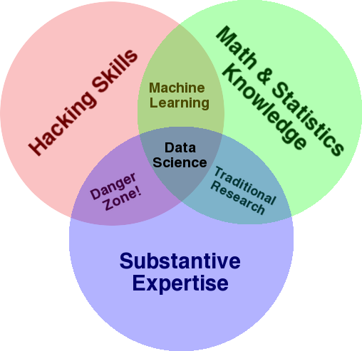

***Figure 1-1. Drew Conway’s Venn diagram of data science***

He also mentions the sexy skills of data geeks from Nathan Yau’s 2009 post, [“Rise of the Data Scientist”](http://flowingdata.com/2009/06/04/rise-of-the-data-scientist/), which include:

* Statistics (traditional analysis you’re used to thinking about)
* Data munging (parsing, scraping, and formatting data)
* Visualization (graphs, tools, etc.)

But wait, is data science just a bag of tricks? Or is it the logical extension of other fields like statistics and machine learning?

For one argument, see Cosma Shalizi’s posts [here](http://goo.gl/SO7ceN) and [here](http://goo.gl/pXg1fU), and Cathy’s posts [here](http://goo.gl/F4K4hE) and [here](http://goo.gl/X9Bmxj), which constitute an ongoing discussion of the difference between a statistician and a data scientist. Cosma basically argues that any statistics department worth its salt does all the stuff in the descriptions of data science that he sees, and therefore data science is just a rebranding and unwelcome takeover of statistics.

For a slightly different perspective, see ASA President Nancy Geller’s 2011 Amstat News article, [“Don’t shun the ‘S’ word”](http://magazine.amstat.org/blog/2011/08/01/prescorneraug11/), in which she defends statistics:

*We need to tell people that Statisticians are the ones who make sense of the data deluge occurring in science, engineering, and medicine; that statistics provides methods for data analysis in all fields, from art history to zoology; that it is exciting to be a Statistician in the 21st century because of the many challenges brought about by the data explosion in all of these fields.*

Though we get her point—the phrase “art history to zoology” is supposed to represent the concept of A to Z—she’s kind of shooting herself in the foot with these examples because they don’t correspond to the high-tech world where much of the data explosion is coming from. Much of the development of the field is happening in industry, not academia. That is, there are people with the job title data scientist in companies, but no professors of data science in academia. (Though this may be changing.)

Not long ago, [DJ Patil](http://linkd.in/16YNRLU) [described](http://oreil.ly/1aKXJwT) how he and [Jeff Hammerbacher](http://linkd.in/17sqKNZ)—then at LinkedIn and Facebook, respectively—coined the term “data scientist” in 2008. So that is when “data scientist” emerged as a job title. (Wikipedia finally gained an entry on data science in 2012.)

It makes sense to us that once the skill set required to thrive at Google—working with a team on problems that required a hybrid skill set of stats and computer science paired with personal characteristics including curiosity and persistence—spread to other Silicon Valley tech companies, it required a new job title. Once it became a pattern, it deserved a name. And once it got a name, everyone and their mother wanted to be one. It got even worse when *Harvard Business Review* declared data scientist to be the [“Sexiest Job of the 21st Century”](http://hbr.org/2012/10/data-scientist-the-sexiest-job-of-the-21st-century).

**THE ROLE OF THE SOCIAL SCIENTIST IN DATA SCIENCE**

Both LinkedIn and Facebook are social network companies. Oftentimes a description or definition of data scientist includes hybrid statistician, software engineer, and social scientist. This made sense in the context of companies where the product was a *social* product and still makes sense when we’re dealing with human or user behavior. But if you think about Drew Conway’s Venn diagram, data science problems cross disciplines—that’s what the substantive expertise is referring to.

In other words, it depends on the context of the problems you’re trying to solve. If they’re social science-y problems like friend recommendations or people you know or user segmentation, then by all means, bring on the social scientist! Social scientists also do tend to be good question askers and have other good investigative qualities, so a social scientist who also has the quantitative and programming chops makes a great data scientist.

But it’s almost a “historical” (historical is in quotes because 2008 isn’t that long ago) artifact to limit your conception of a data scientist to someone who works only with online user behavior data. There’s another emerging field out there called computational social sciences, which could be thought of as a subset of data science.

But we can go back even further. In 2001, William Cleveland wrote a [position paper](http://cm.bell-labs.com/cm/ms/departments/sia/doc/datascience.pdf) about data science called “Data Science: An action plan to expand the field of statistics.”

So data science existed before data scientists? Is this semantics, or does it make sense?

This all begs a few questions: can you define data science by what data scientists *do*? Who gets to define the field, anyway? There’s lots of [buzz](http://ti.me/19Yxv8T) and hype—does the media get to define it, or should we rely on the practitioners, the self-appointed data scientists? Or is there some actual authority? Let’s leave these as open questions for now, though we will return to them throughout the book.

**Data Science Jobs**

Columbia just decided to start an [Institute for Data Sciences and Engineering](http://idse.columbia.edu/) with [Bloomberg’s help](http://mikebloomberg.com/index.cfm?objectid=D867EFB0-C29C-7CA2-F4B1FEBC8B06249D). There are 465 job openings in New York City alone for data scientists last time we checked. That’s a lot. So even if data science isn’t a real field, it has *real* jobs.

And here’s one thing we noticed about most of the job descriptions: they ask data scientists to be experts in computer science, statistics, communication, data visualization, *and* to have extensive domain expertise. Nobody is an expert in everything, which is why it makes more sense to create teams of people who have different profiles and different expertise—together, as a team, they can specialize in all those things. We’ll talk about this more after we look at the composite set of skills in demand for today’s data scientists.

**A Data Science Profile**

In the class, Rachel handed out index cards and asked everyone to profile themselves (on a relative rather than absolute scale) with respect to their skill levels in the following domains:

* Computer science
* Math
* Statistics
* Machine learning
* Domain expertise
* Communication and presentation skills
* Data visualization

As an example, [Figure 1-2](https://learning.oreilly.com/library/view/doing-data-science/9781449363871/ch01.html#rachel-profile) shows Rachel’s data science profile.

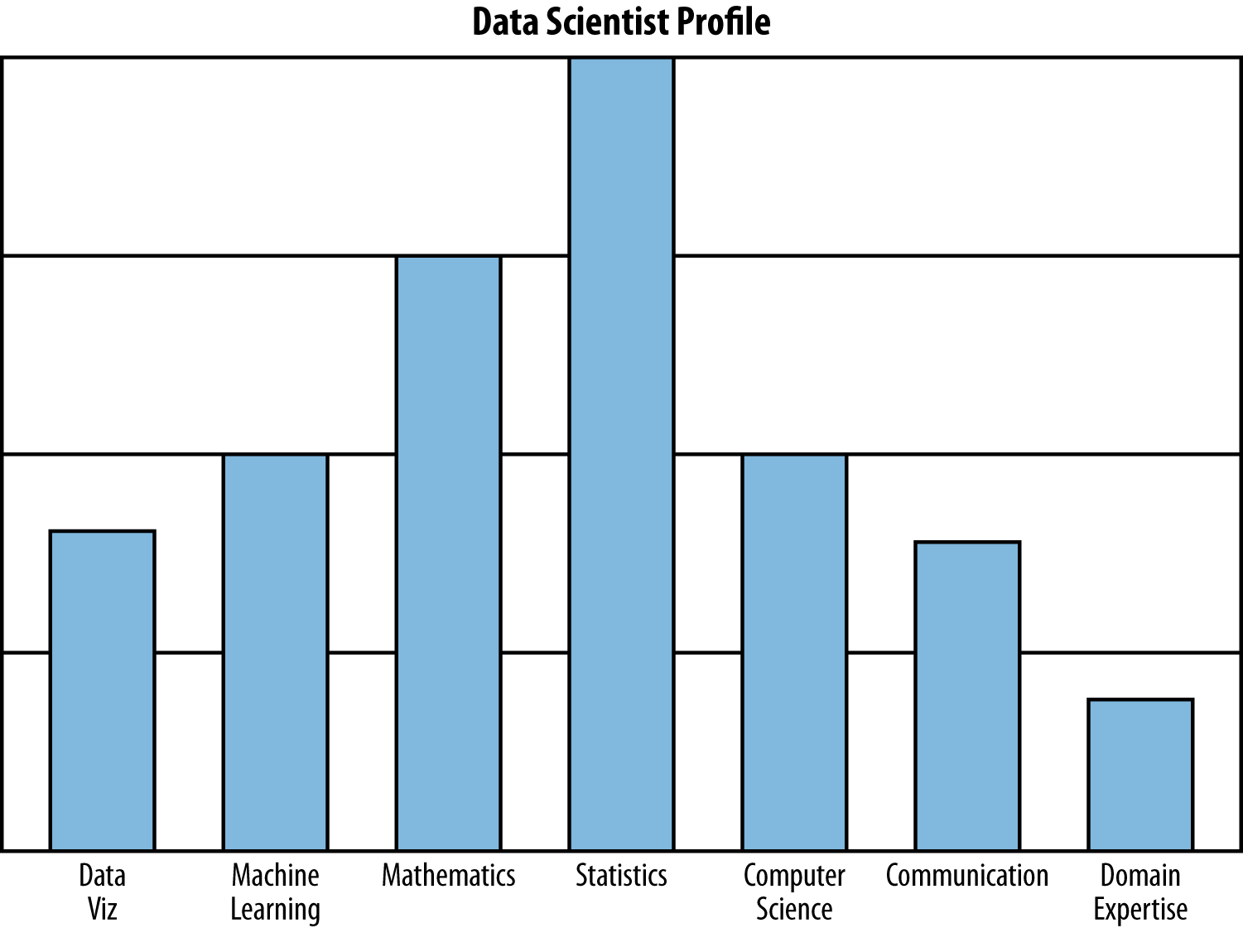

***Figure 1-2. Rachel’s data science profile, which she created to illustrate trying to visualize oneself as a data scientist; she wanted students and guest lecturers to “riff” on this—to add buckets or remove skills, use a different scale or visualization method, and think about the drawbacks of self-reporting***

We taped the index cards to the blackboard and got to see how everyone else thought of themselves. There was quite a bit of variation, which is cool—lots of people in the class were coming from social sciences, for example.

Where is your data science profile at the moment, and where would you like it to be in a few months, or years?

As we mentioned earlier, a data science team works best when different skills (profiles) are represented across different people, because nobody is good at everything. It makes us wonder if it might be more worthwhile to define a “data science team”—as shown in [Figure 1-3](https://learning.oreilly.com/library/view/doing-data-science/9781449363871/ch01.html#data-science-teams)—than to define a data scientist.

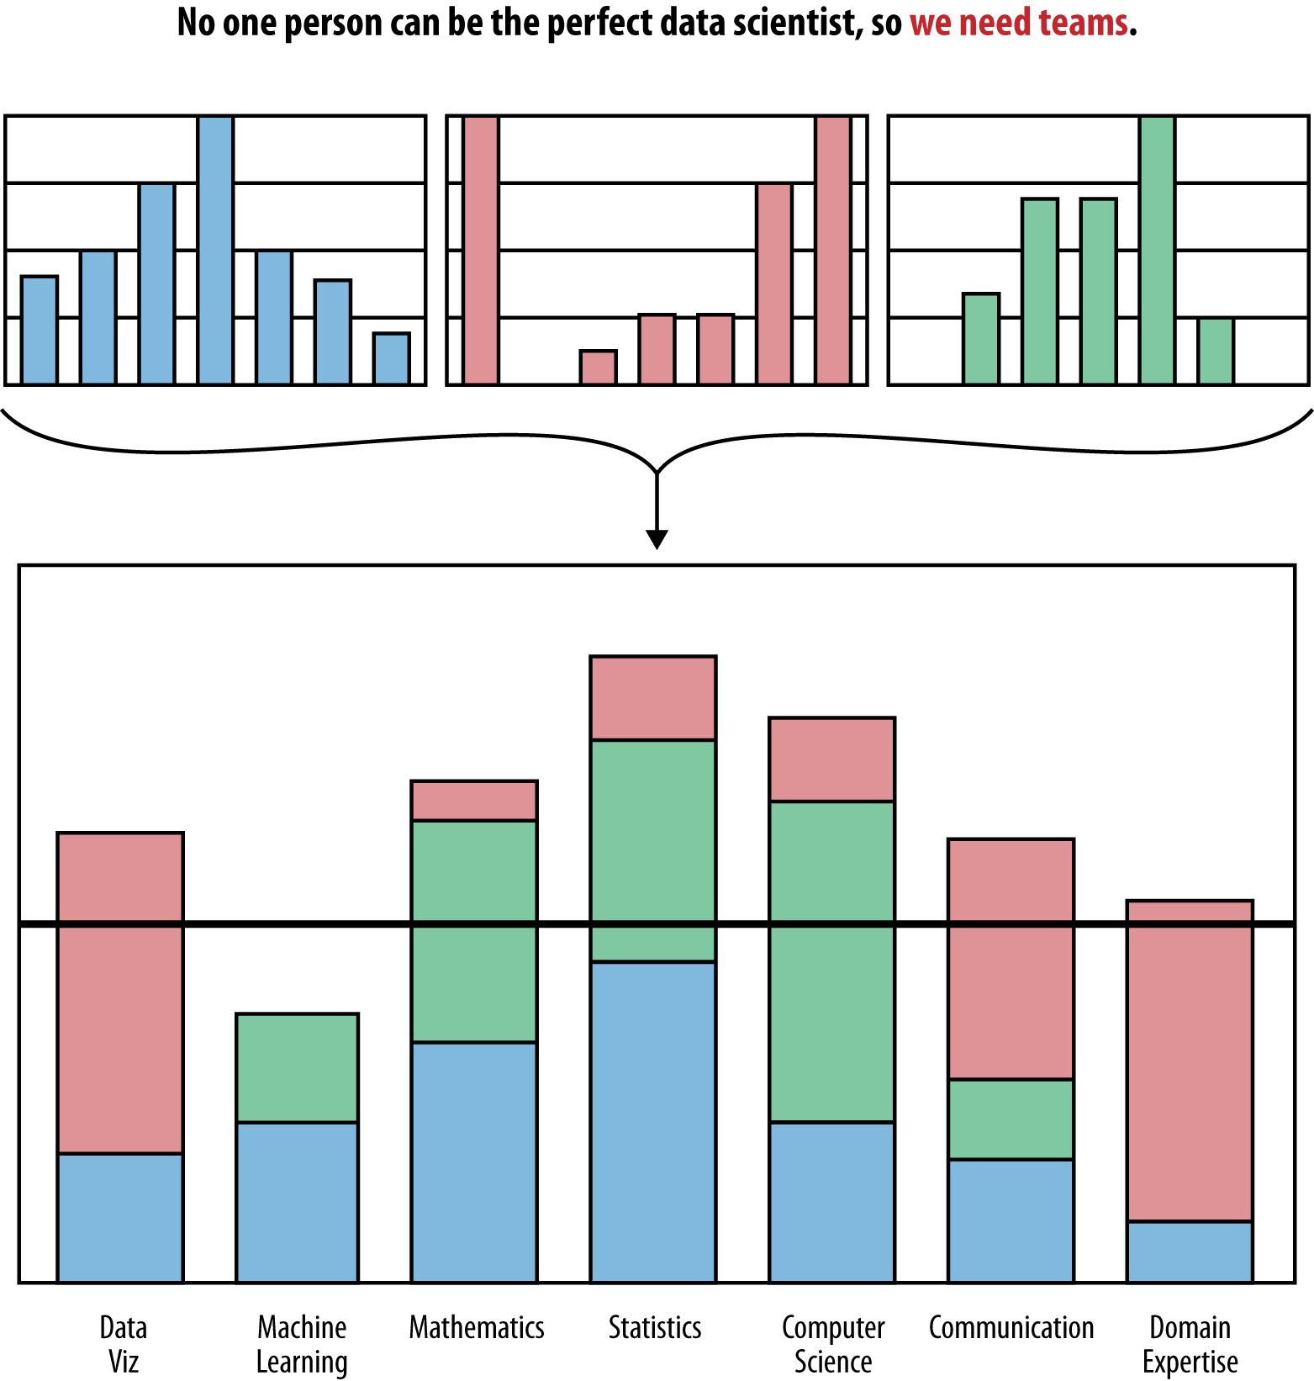

***Figure 1-3. Data science team profiles can be constructed from data scientist profiles; there should be alignment between the data science team profile and the profile of the data problems they try to solve***

**Thought Experiment: Meta-Definition**

Every class had at least one thought experiment that the students discussed in groups. Most of the thought experiments were very open-ended, and the intention was to provoke discussion about a wide variety of topics related to data science. For the first class, the initial thought experiment was: *can we use data science to define data science?*

The class broke into small groups to think about and discuss this question. Here are a few interesting things that emerged from those conversations:

Start with a text-mining model.

We could do a Google search for “data science” and perform a text-mining model. But that would depend on us being a *usagist* rather than a *prescriptionist* with respect to language. A usagist would let the masses define data science (where “the masses” refers to whatever Google’s search engine finds). Would it be better to be a prescriptionist and refer to an authority such as the *Oxford English Dictionary*? Unfortunately, the *OED*probably doesn’t have an entry yet, and we don’t have time to wait for it. Let’s agree that there’s a spectrum, that one authority doesn’t feel right, and that “the masses” doesn’t either.

So what about a clustering algorithm?

How about we look at practitioners of data science and see how *they* describe what they do (maybe in a word cloud for starters)? Then we can look at how people who claim to be other things like statisticians or physicists or economists describe what they do. From there, we can try to use a clustering algorithm (which we’ll use in [Chapter 3](https://learning.oreilly.com/library/view/doing-data-science/9781449363871/ch03.html#chapter-algorithms)) or some other model and see if, when it gets as input “the stuff someone does,” it gives a good prediction on what field that person is in.

Just for comparison, check out what Harlan Harris recently did related to the field of data science: he [took a survey and used clustering to define subfields of data science](http://datacommunitydc.org/blog/2012/08/data-scientists-survey-results-teaser/), which gave rise to [Figure 1-4](https://learning.oreilly.com/library/view/doing-data-science/9781449363871/ch01.html#harlan-harris-clustering).

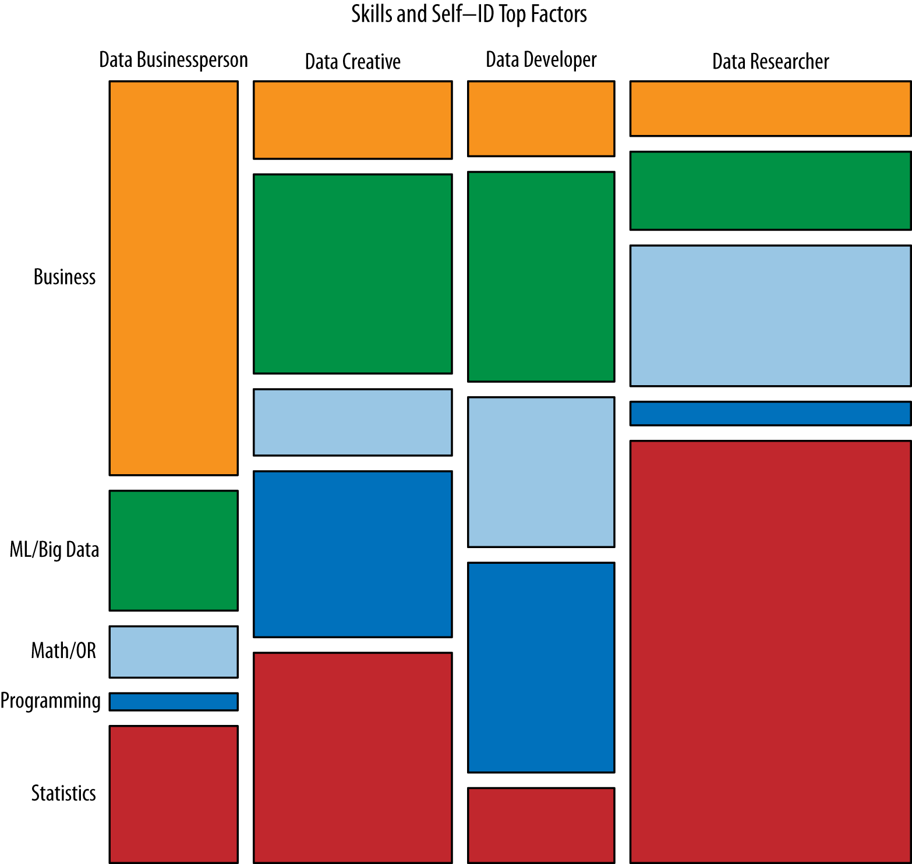

***Figure 1-4. Harlan Harris’s clustering and visualization of subfields of data science from***[***Analyzing the Analyzers***](http://shop.oreilly.com/product/0636920029014.do)***(O’Reilly) by Harlan Harris, Sean Murphy, and Marck Vaisman based on a survey of several hundred data science practitioners in mid-2012***

**OK, So What Is a Data Scientist, Really?**

Perhaps the most concrete approach is to define data science is by its usage—e.g., what data scientists get paid to do. With that as motivation, we’ll describe what data scientists do. And we’ll cheat a bit by talking first about data scientists in academia.

**In Academia**

The reality is that currently, no one calls themselves a data scientist in academia, except to take on a secondary title for the sake of being a part of a “data science institute” at a university, or for applying for a grant that supplies money for data science research.

Instead, let’s ask a related question: who in academia plans to *become* a data scientist? There were 60 students in the Intro to Data Science class at Columbia. When Rachel proposed the course, she assumed the makeup of the students would mainly be statisticians, applied mathematicians, and computer scientists. Actually, though, it ended up being those people plus sociologists, journalists, political scientists, biomedical informatics students, students from NYC government agencies and nonprofits related to social welfare, someone from the architecture school, others from environmental engineering, pure mathematicians, business marketing students, and students who already worked as data scientists. They were all interested in figuring out ways to solve important problems, often of social value, with data.

For the term “data science” to catch on in academia at the level of the faculty, and as a primary title, the research area needs to be more formally defined. Note there is already a rich set of problems that could translate into many PhD theses.

Here’s a stab at what this could look like: an academic data scientist is a scientist, trained in anything from social science to biology, who works with large amounts of data, and must grapple with computational problems posed by the structure, size, messiness, and the complexity and nature of the data, while simultaneously solving a real-world problem.

The case for articulating it like this is as follows: across academic disciplines, the computational and deep data problems have major commonalities. If researchers across departments join forces, they can solve multiple real-world problems from different domains.

**In Industry**

What do data scientists look like in industry? It depends on the level of seniority and whether you’re talking about the Internet/online industry in particular. The role of data scientist need not be exclusive to the tech world, but that’s where the term originated; so for the purposes of the conversation, let us say what it means there.

A chief data scientist should be setting the data strategy of the company, which involves a variety of things: setting everything up from the engineering and infrastructure for collecting data and logging, to privacy concerns, to deciding what data will be user-facing, how data is going to be used to make decisions, and how it’s going to be built back into the product. She should manage a team of engineers, scientists, and analysts and should communicate with leadership across the company, including the CEO, CTO, and product leadership. She’ll also be concerned with patenting innovative solutions and setting research goals.

More generally, a data scientist is someone who knows how to extract meaning from and interpret data, which requires both tools and methods from statistics and machine learning, as well as being human. She spends a lot of time in the process of collecting, cleaning, and munging data, because data is never clean. This process requires persistence, statistics, and software engineering skills—skills that are also necessary for understanding biases in the data, and for debugging logging output from code.

Once she gets the data into shape, a crucial part is exploratory data analysis, which combines visualization and data sense. She’ll find patterns, build models, and algorithms—some with the intention of understanding product usage and the overall health of the product, and others to serve as prototypes that ultimately get baked back into the product. She may design experiments, and she is a critical part of data-driven decision making. She’ll communicate with team members, engineers, and leadership in clear language and with data visualizations so that even if her colleagues are not immersed in the data themselves, they will understand the implications.

That’s the high-level picture, and this book is about helping you understand the vast majority of it. We’re done with *talking* about data science; let’s go ahead and *do* some!

# Chapter 2. Statistical Inference, Exploratory Data Analysis, and the Data Science Process

We begin this chapter with a discussion of statistical inference and statistical thinking. Next we explore what we feel every data scientist should do once they’ve gotten data in hand for any data-related project: exploratory data analysis (EDA).

From there, we move into looking at what we’re defining as the data science process in a little more detail. We’ll end with a thought experiment and a case study.

# Statistical Thinking in the Age of Big Data

*Big Data is a vague term, used loosely, if often, these days. But put simply, the catchall phrase means three things. First, it is a bundle of technologies. Second, it is a potential revolution in measurement. And third, it is a point of view, or philosophy, about how decisions will be—and perhaps should be—made in the future.*

Steve Lohr, The New York Times

When you’re developing your skill set as a data scientist, certain foundational pieces need to be in place first—statistics, linear algebra, some programming. Even once you have those pieces, part of the challenge is that you will be developing several skill sets in parallel simultaneously—data preparation and munging, modeling, coding, visualization, and communication—that are interdependent. As we progress through the book, these threads will be intertwined. That said, we need to start somewhere, and will begin by getting grounded in statistical inference.

We expect the readers of this book to have diverse backgrounds. For example, some of you might already be awesome software engineers who can build data pipelines and code with the best of them but don’t know much about statistics; others might be marketing analysts who don’t really know how to code at all yet; and others might be curious, smart people who want to know what this data science thing is all about.

So while we’re asking that readers already have certain prerequisites down, we can’t come to your house and look at your transcript to make sure you actually have taken a statistics course, or have read a statistics book before. And even if you have taken Introduction to Statistics—a course we know from many awkward cocktail party conversations that 99% of people dreaded and wish they’d never had to take—this likely gave you no flavor for the depth and beauty of statistical inference.

But even if it did, and maybe you’re a PhD-level statistician, it’s always helpful to go back to fundamentals and remind ourselves of what statistical inference and thinking is all about. And further still, in the age of Big Data, classical statistics methods need to be revisited and re-imagined in new contexts.

## Statistical Inference

The world we live in is complex, random, and uncertain. At the same time, it’s one big data-generating machine.

As we commute to work on subways and in cars, as our blood moves through our bodies, as we’re shopping, emailing, procrastinating at work by browsing the Internet and watching the stock market, as we’re building things, eating things, talking to our friends and family about things, while factories are producing products, this all at least potentially produces data.

Imagine spending 24 hours looking out the window, and for every minute, counting and recording the number of people who pass by. Or gathering up everyone who lives within a mile of your house and making them tell you how many email messages they receive every day for the next year. Imagine heading over to your local hospital and rummaging around in the blood samples looking for patterns in the DNA. That all sounded creepy, but it wasn’t supposed to. The point here is that the processes in our lives are actually data-generating processes.

We’d like ways to describe, understand, and make sense of these processes, in part because as scientists we just want to understand the world better, but many times, understanding these processes is part of the solution to problems we’re trying to solve.

Data represents the traces of the real-world processes, and exactly which traces we gather are decided by our data collection or sampling method. You, the data scientist, the observer, are turning the world into data, and this is an utterly subjective, not objective, process.

After separating the process from the data collection, we can see clearly that there are two sources of randomness and uncertainty. Namely, the randomness and uncertainty underlying the process itself, and the uncertainty associated with your underlying data collection methods.

Once you have all this data, you have somehow captured the world, or certain traces of the world. But you can’t go walking around with a huge Excel spreadsheet or database of millions of transactions and look at it and, with a snap of a finger, understand the world and process that generated it.

So you need a new idea, and that’s to simplify those captured traces into something more comprehensible, to something that somehow captures it all in a much more concise way, and that something could be mathematical models or functions of the data, known as statistical estimators.

This overall process of going from the world to the data, and then from the data back to the world, is the field of statistical inference.

More precisely, statistical inference is the discipline that concerns itself with the development of procedures, methods, and theorems that allow us to extract meaning and information from data that has been generated by stochastic (random) processes.

## Populations and Samples

Let’s get some terminology and concepts in place to make sure we’re all talking about the same thing.

In classical statistical literature, a distinction is made between the population and the sample. The word population immediately makes us think of the entire US population of 300 million people, or the entire world’s population of 7 billion people. But put that image out of your head, because in statistical inference population isn’t used to simply describe only people. It could be any set of objects or units, such as tweets or photographs or stars.

If we could measure the characteristics or extract characteristics of all those objects, we’d have a complete set of observations, and the convention is to use NN to represent the total number of observations in the population.

Suppose your population was all emails sent last year by employees at a huge corporation, BigCorp. Then a single observation could be a list of things: the sender’s name, the list of recipients, date sent, text of email, number of characters in the email, number of sentences in the email, number of verbs in the email, and the length of time until first reply.

When we take a sample, we take a subset of the units of size nn in order to examine the observations to draw conclusions and make inferences about the population. There are different ways you might go about getting this subset of data, and you want to be aware of this sampling mechanism because it can introduce biases into the data, and distort it, so that the subset is not a “mini-me” shrunk-down version of the population. Once that happens, any conclusions you draw will simply be wrong and distorted.

In the BigCorp email example, you could make a list of all the employees and select 1/10th of those people at random and take all the email they ever sent, and that would be your sample. Alternatively, you could sample 1/10th of all email sent each day at random, and that would be your sample. Both these methods are reasonable, and both methods yield the same sample size. But if you took them and counted how many email messages each person sent, and used that to estimate the underlying distribution of emails sent by all individuals at BigCorp, you might get entirely different answers.

So if even getting a basic thing down like counting can get distorted when you’re using a reasonable-sounding sampling method, imagine what can happen to more complicated algorithms and models if you haven’t taken into account the process that got the data into your hands.

## Populations and Samples of Big Data

But, wait! In the age of Big Data, where we can record all users’ actions all the time, don’t we observe everything? Is there really still this notion of population and sample? If we had all the email in the first place, why would we need to take a sample?

With these questions, we’ve gotten to the heart of the matter. There are multiple aspects of this that need to be addressed.

Sampling solves some engineering challenges

In the current popular discussion of Big Data, the focus on enterprise solutions such as Hadoop to handle engineering and computational challenges caused by too much data overlooks sampling as a legitimate solution. At Google, for example, software engineers, data scientists, and statisticians sample all the time.

How much data you need at hand really depends on what your goal is: for analysis or inference purposes, you typically don’t need to store all the data all the time. On the other hand, for serving purposes you might: in order to render the correct information in a UI for a user, you need to have all the information for that particular user, for example.

Bias

Even if we have access to all of Facebook’s or Google’s or Twitter’s data corpus, any inferences we make from that data should not be extended to draw conclusions about humans beyond those sets of users, or even those users for any particular day.

Kate Crawford, a principal scientist at Microsoft Research, describes in her Strata talk, “Hidden Biases of Big Data,” how if you analyzed tweets immediately before and after Hurricane Sandy, you would think that most people were supermarket shopping pre-Sandy and partying post-Sandy. However, most of those tweets came from New Yorkers. First of all, they’re heavier Twitter users than, say, the coastal New Jerseyans, and second of all, the coastal New Jerseyans were worrying about other stuff like their house falling down and didn’t have time to tweet.

In other words, you would think that Hurricane Sandy wasn’t all that bad if you used tweet data to understand it. The only conclusion you can actually draw is that this is what Hurricane Sandy was like for the subset of Twitter users (who themselves are not representative of the general US population), whose situation was not so bad that they didn’t have time to tweet.

Note, too, that in this case, if you didn’t have context and know about Hurricane Sandy, you wouldn’t know enough to interpret this data properly.

Sampling

Let’s rethink what the population and the sample are in various contexts.

In statistics we often model the relationship between a population and a sample with an underlying mathematical process. So we make simplifying assumptions about the underlying truth, the mathematical structure, and shape of the underlying generative process that created the data. We observe only one particular realization of that generative process, which is that sample.

So if we think of all the emails at BigCorp as the population, and if we randomly sample from that population by reading some but not all emails, then that sampling process would create one particular sample. However, if we resampled we’d get a different set of observations.

The uncertainty created by such a sampling process has a name: the sampling distribution. But like that 2010 movie [*Inception*](http://en.wikipedia.org/wiki/Inception) with Leonardo DiCaprio, where he’s in a dream within a dream within a dream, it’s possible to instead think of the complete corpus of emails at BigCorp as not the population but as a sample.

This set of emails (and here is where we’re getting philosophical, but that’s what this is all about) could actually be only one single realization from some larger super-population, and if the Great Coin Tosser in the sky had spun again that day, a different set of emails would have been observed.

In this interpretation, we treat this set of emails as a sample that we are using to make inferences about the underlying generative process that is the email writing habits of all the employees at BigCorp.

New kinds of data

Gone are the days when data is just a bunch of numbers and categorical variables. A strong data scientist needs to be versatile and comfortable with dealing a variety of types of data, including:

* Traditional: numerical, categorical, or binary
* Text: emails, tweets, New York Times articles (see [Chapter 4](https://learning.oreilly.com/library/view/doing-data-science/9781449363871/ch04.html#chapter-spam-filters-naive-bayes) or [Chapter 7](https://learning.oreilly.com/library/view/doing-data-science/9781449363871/ch07.html#chapter-kaggle))
* Records: user-level data, timestamped event data, json-formatted log files (see [Chapter 6](https://learning.oreilly.com/library/view/doing-data-science/9781449363871/ch06.html#chapter-financial-modeling) or [Chapter 8](https://learning.oreilly.com/library/view/doing-data-science/9781449363871/ch08.html#chapter-hunch-recommendation-engines))
* Geo-based location data: briefly touched on in this chapter with NYC housing data
* Network (see [Chapter 10](https://learning.oreilly.com/library/view/doing-data-science/9781449363871/ch10.html#chapter-social-networks-data-journalism))
* Sensor data (not covered in this book)
* Images (not covered in this book)

These new kinds of data require us to think more carefully about what sampling means in these contexts.

For example, with the firehose of real-time streaming data, if you analyze a Facebook user-level dataset for a week of activity that you aggregated from timestamped event logs, will any conclusions you draw from this dataset be relevant next week or next year?

How do you sample from a network and preserve the complex network structure?

Many of these questions represent open research questions for the statistical and computer science communities. This is the frontier! Given that some of these are open research problems, in practice, data scientists do the best they can, and often are inventing novel methods as part of their jobs.

##### TERMINOLOGY: BIG DATA

We’ve been throwing around “Big Data” quite a lot already and are guilty of barely defining it beyond raising some big questions in the previous chapter.

A few ways to think about Big Data:

**“Big” is a moving target**. Constructing a threshold for Big Data such as 1 petabyte is meaningless because it makes it sound absolute. Only when the size becomes a challenge is it worth referring to it as “Big.” So it’s a relative term referring to when the size of the data outstrips the state-of-the-art current computational solutions (in terms of memory, storage, complexity, and processing speed) available to handle it. So in the 1970s this meant something different than it does today.

**“Big” is when you can’t fit it on one machine**. Different individuals and companies have different computational resources available to them, so for a single scientist data is big if she can’t fit it on one machine because she has to learn a whole new host of tools and methods once that happens.

**Big Data is a cultural phenomenon**. It describes how much data is part of our lives, precipitated by accelerated advances in technology.

**The 4 Vs:** Volume, variety, velocity, and value. Many people are circulating this as a way to characterize Big Data. Take from it what you will.

## Big Data Can Mean Big Assumptions

In [Chapter 1](https://learning.oreilly.com/library/view/doing-data-science/9781449363871/ch01.html#chapter-what-is-data-science), we mentioned the Cukier and Mayer-Schoenberger article “The Rise of Big Data.” In it, they argue that the Big Data revolution consists of three things:

* Collecting and using a lot of data rather than small samples
* Accepting messiness in your data
* Giving up on knowing the causes

They describe these steps in a rather grand fashion by claiming that Big Data doesn’t need to understand cause given that the data is so enormous. It doesn’t need to worry about sampling error because it is literally keeping track of the truth. The way the article frames this is by claiming that the new approach of Big Data is letting “N=ALL.”

### CAN N=ALL?

Here’s the thing: it’s pretty much never all. And we are very often missing the very things we should care about most.

So, for example, as this [InfoWorld post](http://goo.gl/LeYKDR) explains, Internet surveillance will never really work, because the very clever and tech-savvy criminals that we most want to catch are the very ones we will never be able to catch, because they’re always a step ahead.

An example from that very article—election night polls—is in itself a great counter-example: even if we poll absolutely everyone who leaves the polling stations, we still don’t count people who decided not to vote in the first place. And those might be the very people we’d need to talk to to understand our country’s voting problems.

Indeed, we’d argue that the assumption we make that N=ALL is one of the biggest problems we face in the age of Big Data. It is, above all, a way of excluding the voices of people who don’t have the time, energy, or access to cast their vote in all sorts of informal, possibly unannounced, elections.

Those people, busy working two jobs and spending time waiting for buses, become invisible when we tally up the votes without them. To you this might just mean that the recommendations you receive on Netflix don’t seem very good because most of the people who bother to rate things on Netflix are young and might have different tastes than you, which skews the recommendation engine toward them. But there are plenty of much more insidious consequences stemming from this basic idea.

### DATA IS NOT OBJECTIVE

Another way in which the assumption that N=ALL can matter is that it often gets translated into the idea that data is objective. It is wrong to believe either that data is objective or that “data speaks,” and beware of people who say otherwise.

We were recently reminded of it in a terrifying way by [this New York Times article](http://nyti.ms/18OEq6j) on Big Data and recruiter hiring practices. At one point, a data scientist is quoted as saying, “Let’s put everything in and let the data speak for itself.”

If you read the whole article, you’ll learn that this algorithm tries to find “diamond in the rough” types of people to hire. A worthy effort, but one that you have to think through.

Say you decided to compare women and men with the exact same qualifications that have been hired in the past, but then, looking into what happened next you learn that those women have tended to leave more often, get promoted less often, and give more negative feedback on their environments when compared to the men.

Your model might be likely to hire the man over the woman next time the two similar candidates showed up, rather than looking into the possibility that the company doesn’t treat female employees well.

In other words, ignoring causation can be a flaw, rather than a feature. Models that ignore causation can add to historical problems instead of addressing them (we’ll explore this more in [Chapter 11](https://learning.oreilly.com/library/view/doing-data-science/9781449363871/ch11.html#chapter-causality)). And data doesn’t speak for itself. Data is just a quantitative, pale echo of the events of our society.

##### N = 1

At the other end of the spectrum from N=ALL, we have n=1n=1, by which we mean a sample size of 1. In the old days a sample size of 1 would be ridiculous; you would never want to draw inferences about an entire population by looking at a single individual. And don’t worry, that’s still ridiculous. But the concept of n=1n=1takes on new meaning in the age of Big Data, where for a single person, we actually can record tons of information about them, and in fact we might even sample from all the events or actions they took (for example, phone calls or keystrokes) in order to make inferences about them. This is what user-level modeling is about.

## Modeling

In the next chapter, we’ll look at how we build models from the data we collect, but first we want to discuss what we even mean by this term.

Rachel had a recent phone conversation with someone about a modeling workshop, and several minutes into it she realized the word “model” meant completely different things to them. He was using it to mean data models—the representation one is choosing to store one’s data, which is the realm of database managers—whereas she was talking about statistical models, which is what much of this book is about. One of Andrew Gelman’s blog posts on modeling was recently tweeted by people in the fashion industry, but that’s a different issue.

Even if you’ve used the terms statistical model or mathematical model for years, is it even clear to yourself and to the people you’re talking to what you mean? What makes a model a model? Also, while we’re asking fundamental questions like this, what’s the difference between a statistical model and a machine learning algorithm?

Before we dive deeply into that, let’s add a bit of context with this deliberately provocative Wired magazine piece, [“The End of Theory: The Data Deluge Makes the Scientific Method Obsolete,”](http://www.wired.com/science/discoveries/magazine/16-07/pb_theory) published in 2008 by ChrisAnderson, then editor-in-chief.

Anderson equates massive amounts of data to complete information and argues no models are necessary and “correlation is enough”; e.g., that in the context of massive amounts of data, “they [Google] don’t have to settle for models at all.”

Really? We don’t think so, and we don’t think you’ll think so either by the end of the book. But the sentiment is similar to the Cukier and Mayer-Schoenberger article we just discussed about N=ALL, so you might already be getting a sense of the profound confusion we’re witnessing all around us.

To their credit, it’s the press that’s currently raising awareness of these questions and issues, and someone has to do it. Even so, it’s hard to take when the opinion makers are people who don’t actually work with data. Think critically about whether you buy what Anderson is saying; where you agree, disagree, or where you need more information to form an opinion.

Given that this is how the popular press is currently describing and influencing public perception of data science and modeling, it’s incumbent upon us as data scientists to be aware of it and to chime in with informed comments.

With that context, then, what do we mean when we say models? And how do we use them as data scientists? To get at these questions, let’s dive in.

### WHAT IS A MODEL?

Humans try to understand the world around them by representing it in different ways. Architects capture attributes of buildings through blueprints and three-dimensional, scaled-down versions. Molecular biologists capture protein structure with three-dimensional visualizations of the connections between amino acids. Statisticians and data scientists capture the uncertainty and randomness of data-generating processes with mathematical functions that express the shape and structure of the data itself.

A model is our attempt to understand and represent the nature of reality through a particular lens, be it architectural, biological, or mathematical.

A model is an artificial construction where all extraneous detail has been removed or abstracted. Attention must always be paid to these abstracted details after a model has been analyzed to see what might have been overlooked.

In the case of proteins, a model of the protein backbone with side-chains by itself is removed from the laws of quantum mechanics that govern the behavior of the electrons, which ultimately dictate the structure and actions of proteins. In the case of a statistical model, we may have mistakenly excluded key variables, included irrelevant ones, or assumed a mathematical structure divorced from reality.

### STATISTICAL MODELING

Before you get too involved with the data and start coding, it’s useful to draw a picture of what you think the underlying process might be with your model. What comes first? What influences what? What causes what? What’s a test of that?

But different people think in different ways. Some prefer to express these kinds of relationships in terms of math. The mathematical expressions will be general enough that they have to include parameters, but the values of these parameters are not yet known.

In mathematical expressions, the convention is to use Greek letters for parameters and Latin letters for data. So, for example, if you have two columns of data, x and y, and you think there’s a linear relationship, you’d write down y=β0+β1xy=β0+β1x. You don’t know what β0β0 and β1β1 are in terms of actual numbers yet, so they’re the parameters.

Other people prefer pictures and will first draw a diagram of data flow, possibly with arrows, showing how things affect other things or what happens over time. This gives them an abstract picture of the relationships before choosing equations to express them.

### BUT HOW DO YOU BUILD A MODEL?

How do you have any clue whatsoever what functional form the data should take? Truth is, it’s part art and part science. And sadly, this is where you’ll find the least guidance in textbooks, in spite of the fact that it’s the key to the whole thing. After all, this is the part of the modeling process where you have to make a lot of assumptions about the underlying structure of reality, and we should have standards as to how we make those choices and how we explain them. But we don’t have global standards, so we make them up as we go along, and hopefully in a thoughtful way.

We’re admitting this here: where to start is not obvious. If it were, we’d know the meaning of life. However, we will do our best to demonstrate for you throughout the book how it’s done.

One place to start is exploratory data analysis (EDA), which we will cover in a later section. This entails making plots and building intuition for your particular dataset. EDA helps out a lot, as well as trial and error and iteration.

To be honest, until you’ve done it a lot, it seems very mysterious. The best thing to do is start simply and then build in complexity. Do the dumbest thing you can think of first. It’s probably not that dumb.

For example, you can (and should) plot histograms and look at scatterplots to start getting a feel for the data. Then you just try writing something down, even if it’s wrong first (it will probably be wrong first, but that doesn’t matter).

So try writing down a linear function (more on that in the next chapter). When you write it down, you force yourself to think: does this make any sense? If not, why? What would make more sense? You start simply and keep building it up in complexity, making assumptions, and writing your assumptions down. You can use full-blown sentences if it helps—e.g., “I assume that my users naturally cluster into about five groups because when I hear the sales rep talk about them, she has about five different types of people she talks about”—then taking your words and trying to express them as equations and code.

Remember, it’s always good to start simply. There is a trade-off in modeling between simple and accurate. Simple models may be easier to interpret and understand. Oftentimes the crude, simple model gets you 90% of the way there and only takes a few hours to build and fit, whereas getting a more complex model might take months and only get you to 92%.

You’ll start building up your arsenal of potential models throughout this book. Some of the building blocks of these models are probability distributions.

### PROBABILITY DISTRIBUTIONS

Probability distributions are the foundation of statistical models. When we get to linear regression and Naive Bayes, you will see how this happens in practice. One can take multiple semesters of courses on probability theory, and so it’s a tall challenge to condense it down for you in a small section.

Back in the day, before computers, scientists observed real-world phenomena, took measurements, and noticed that certain mathematical shapes kept reappearing. The classical example is the height of humans, following a normal distribution—a bell-shaped curve, also called a Gaussian distribution, named after Gauss.

Other common shapes have been named after their observers as well (e.g., the Poisson distribution and the Weibull distribution), while other shapes such as Gamma distributions or exponential distributions are named after associated mathematical objects.

Natural processes tend to generate measurements whose empirical shape could be approximated by mathematical functions with a few parameters that could be estimated from the data.

Not all processes generate data that looks like a named distribution, but many do. We can use these functions as building blocks of our models. It’s beyond the scope of the book to go into each of the distributions in detail, but we provide them in [Figure 2-1](https://learning.oreilly.com/library/view/doing-data-science/9781449363871/ch02.html#Figure2.1) as an illustration of the various common shapes, and to remind you that they only have names because someone observed them enough times to think they deserved names. There is actually an infinite number of possible distributions.

They are to be interpreted as assigning a probability to a subset of possible outcomes, and have corresponding functions. For example, the normal distribution is written as:

N(x|μ,σ)∼1σ2π−−√e−(x−μ)22σ2N(x|μ,σ)∼1σ2πe-(x-μ)22σ2

The parameter μμ is the mean and median and controls where the distribution is centered (because this is a symmetric distribution), and the parameter σσ controls how spread out the distribution is. This is the general functional form, but for specific real-world phenomenon, these parameters have actual numbers as values, which we can estimate from the data.

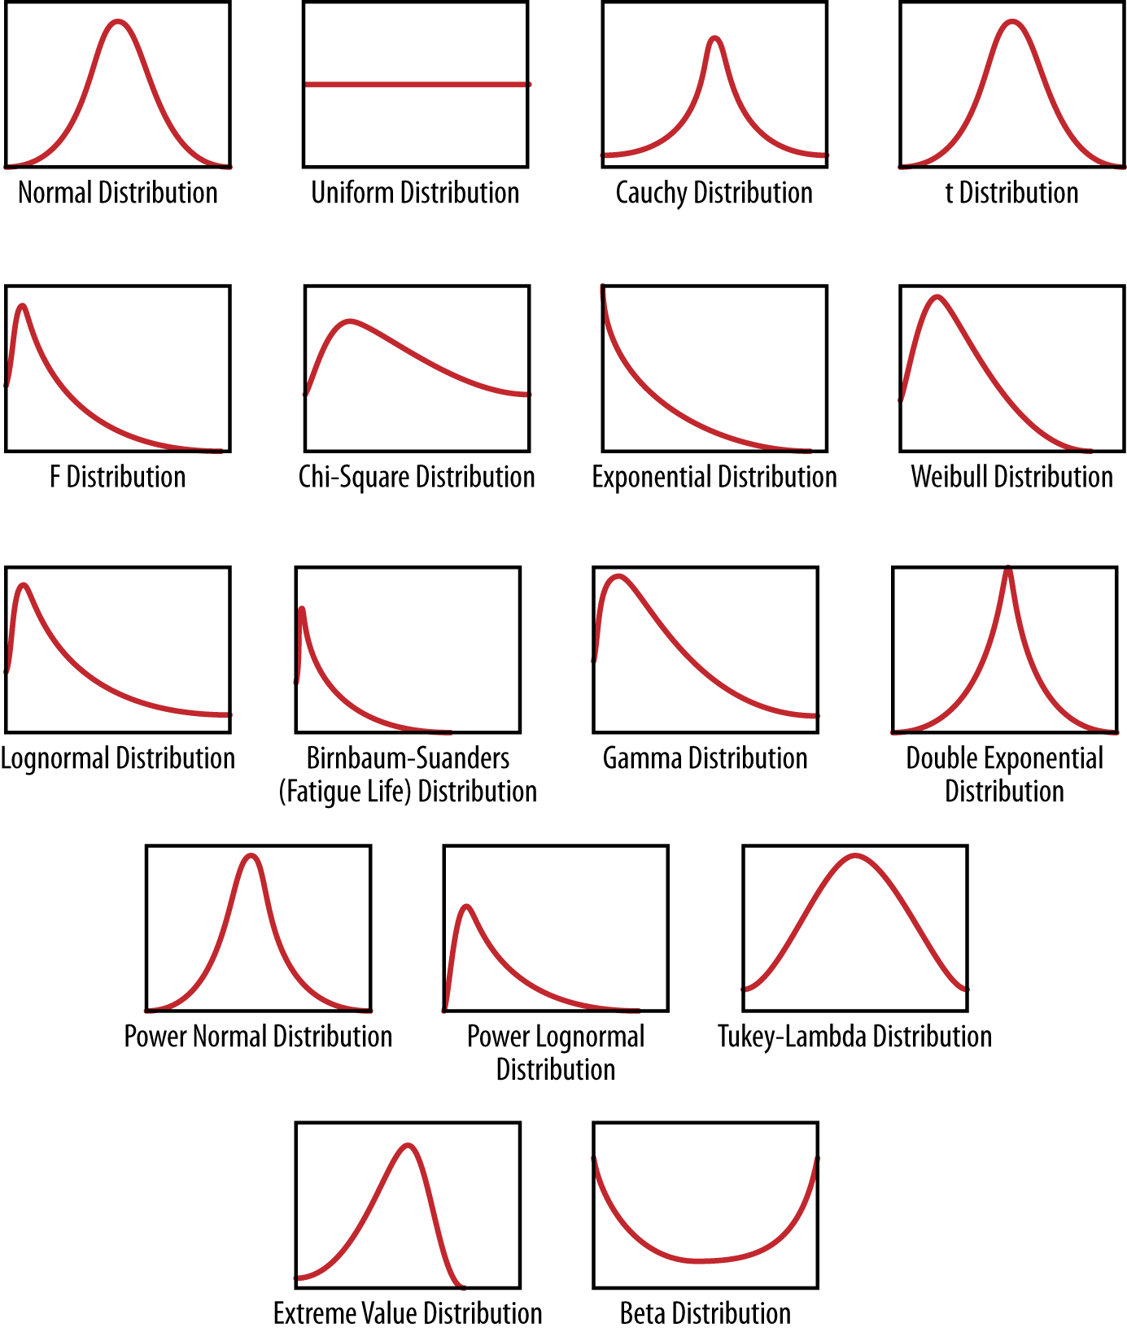

###### *Figure 2-1. A bunch of continuous density functions (aka probability distributions)*

A random variable denoted by xx or yy can be assumed to have a corresponding probability distribution, p(x)p(x), which maps xx to a positive real number. In order to be a probability density function, we’re restricted to the set of functions such that if we integrate p(x)p(x) to get the area under the curve, it is 1, so it can be interpreted as probability.

For example, let xx be the amount of time until the next bus arrives (measured in minutes). xx is a random variable because there is variation and uncertainty in the amount of time until the next bus.

Suppose we know (for the sake of argument) that the time until the next bus has a probability density function of p(x)=2e−2xp(x)=2e-2x. If we want to know the likelihood of the next bus arriving in between 12 and 13 minutes, then we find the area under the curve between 12 and 13 by ∫13122e−2x∫12132e-2x.

How do we know this is the right distribution to use? Well, there are two possible ways: we can conduct an experiment where we show up at the bus stop at a random time, measure how much time until the next bus, and repeat this experiment over and over again. Then we look at the measurements, plot them, and approximate the function as discussed. Or, because we are familiar with the fact that “waiting time” is a common enough real-world phenomenon that a distribution called the exponential distribution has been invented to describe it, we know that it takes the form p(x)=λe−λxp(x)=λe-λx.

In addition to denoting distributions of single random variables with functions of one variable, we use multivariate functions called joint distributions to do the same thing for more than one random variable. So in the case of two random variables, for example, we could denote our distribution by a function p(x,y)p(x,y), and it would take values in the plane and give us nonnegative values. In keeping with its interpretation as a probability, its (double) integral over the whole plane would be 1.

We also have what is called a conditional distribution, p(x|y)p(x|y), which is to be interpreted as the density function of xx given a particular value of yy.

When we’re working with data, conditioning corresponds to subsetting. So for example, suppose we have a set of user-level data for Amazon.com that lists for each user the amount of money spent last month on Amazon, whether the user is male or female, and how many items they looked at before adding the first item to the shopping cart.

If we consider xx to be the random variable that represents the amount of money spent, then we can look at the distribution of money spent across all users, and represent it as p(x)p(x).

We can then take the subset of users who looked at more than five items before buying anything, and look at the distribution of money spent among these users. Let yy be the random variable that represents number of items looked at, then p(x|y>5)p(x|y>5) would be the corresponding conditional distribution. Note a conditional distribution has the same properties as a regular distribution in that when we integrate it, it sums to 1 and has to take nonnegative values.

When we observe data points, i.e., (x1,y1),(x2,y2),...,(xn,yn)(x1,y1),(x2,y2),...,(xn,yn), we are observing realizations of a pair of random variables. When we have an entire dataset with nn rows and kk columns, we are observing nn realizations of the joint distribution of those kk random variables.

For further reading on probability distributions, we recommend Sheldon Ross’ book, A First Course in Probability (Pearson).

### FITTING A MODEL

Fitting a model means that you estimate the parameters of the model using the observed data. You are using your data as evidence to help approximate the real-world mathematical process that generated the data. Fitting the model often involves optimization methods and algorithms, such as maximum likelihood estimation, to help get the parameters.

In fact, when you estimate the parameters, they are actually estimators, meaning they themselves are functions of the data. Once you fit the model, you actually can write it as y=7.2+4.5xy=7.2+4.5x, for example, which means that your best guess is that this equation or functional form expresses the relationship between your two variables, based on your assumption that the data followed a linear pattern.

Fitting the model is when you start actually coding: your code will read in the data, and you’ll specify the functional form that you wrote down on the piece of paper. Then R or Python will use built-in optimization methods to give you the most likely values of the parameters given the data.

As you gain sophistication, or if this is one of your areas of expertise, you’ll dig around in the optimization methods yourself. Initially you should have an understanding that optimization is taking place and how it works, but you don’t have to code this part yourself—it underlies the R or Python functions.

### OVERFITTING

Throughout the book you will be cautioned repeatedly about overfitting, possibly to the point you will have nightmares about it. Overfitting is the term used to mean that you used a dataset to estimate the parameters of your model, but your model isn’t that good at capturing reality beyond your sampled data.

You might know this because you have tried to use it to predict labels for another set of data that you didn’t use to fit the model, and it doesn’t do a good job, as measured by an evaluation metric such as accuracy.

# Exploratory Data Analysis

*“Exploratory data analysis” is an attitude, a state of flexibility, a willingness to look for those things that we believe are not there, as well as those we believe to be there.*

John Tukey

Earlier we mentioned exploratory data analysis (EDA) as the first step toward building a model. EDA is often relegated to chapter 1 (by which we mean the “easiest” and lowest level) of standard introductory statistics textbooks and then forgotten about for the rest of the book.

It’s traditionally presented as a bunch of histograms and stem-and-leaf plots. They teach that stuff to kids in fifth grade so it seems trivial, right? No wonder no one thinks much of it.

But EDA is a critical part of the data science process, and also represents a philosophy or way of doing statistics practiced by a strain of statisticians coming from the Bell Labs tradition.

John Tukey, a mathematician at Bell Labs, developed exploratory data analysis in contrast to confirmatory data analysis, which concerns itself with modeling and hypotheses as described in the previous section. In EDA, there is no hypothesis and there is no model. The “exploratory” aspect means that your understanding of the problem you are solving, or might solve, is changing as you go.

##### HISTORICAL PERSPECTIVE: BELL LABS

Bell Labs is a research lab going back to the 1920s that has made innovations in physics, computer science, statistics, and math, producing languages like C++, and many Nobel Prize winners as well. There was a very successful and productive statistics group there, and among its many notable members was John Tukey, a mathematician who worked on a lot of statistical problems. He is considered the father of EDA and R (which started as the S language at Bell Labs; R is the open source version), and he was interested in trying to visualize high-dimensional data.

We think of Bell Labs as one of the places where data science was “born” because of the collaboration between disciplines, and the massive amounts of complex data available to people working there. It was a virtual playground for statisticians and computer scientists, much like Google is today.

In fact, in 2001, Bill Cleveland wrote “Data Science: An Action Plan for expanding the technical areas of the field of statistics,” which described multidisciplinary investigation, models, and methods for data (traditional applied stats), computing with data (hardware, software, algorithms, coding), pedagogy, tool evaluation (staying on top of current trends in technology), and theory (the math behind the data).

You can read more about Bell Labs in the book The Idea Factory by Jon Gertner (Penguin Books).

The basic tools of EDA are plots, graphs and summary statistics. Generally speaking, it’s a method of systematically going through the data, plotting distributions of all variables (using box plots), plotting time series of data, transforming variables, looking at all pairwise relationships between variables using scatterplot matrices, and generating summary statistics for all of them. At the very least that would mean computing their mean, minimum, maximum, the upper and lower quartiles, and identifying outliers.

But as much as EDA is a set of tools, it’s also a mindset. And that mindset is about your relationship with the data. You want to understand the data—gain intuition, understand the shape of it, and try to connect your understanding of the process that generated the data to the data itself. EDA happens between you and the data and isn’t about proving anything to anyone else yet.

## Philosophy of Exploratory Data Analysis

*Long before worrying about how to convince others, you first have to understand what’s happening yourself.*

Andrew Gelman

While at Google, Rachel was fortunate to work alongside two former Bell Labs/AT&T statisticians—Daryl Pregibon and Diane Lambert, who also work in this vein of applied statistics—and learned from them to make EDA a part of her best practices.

Yes, even with very large Google-scale data, they did EDA. In the context of data in an Internet/engineering company, EDA is done for some of the same reasons it’s done with smaller datasets, but there are additional reasons to do it with data that has been generated from logs.

There are important reasons anyone working with data should do EDA. Namely, to gain intuition about the data; to make comparisons between distributions; for sanity checking (making sure the data is on the scale you expect, in the format you thought it should be); to find out where data is missing or if there are outliers; and to summarize the data.

In the context of data generated from logs, EDA also helps with debugging the logging process. For example, “patterns” you find in the data could actually be something wrong in the logging process that needs to be fixed. If you never go to the trouble of debugging, you’ll continue to think your patterns are real. The engineers we’ve worked with are always grateful for help in this area.

In the end, EDA helps you make sure the product is performing as intended.

Although there’s lots of visualization involved in EDA, we distinguish between EDA and data visualization in that EDA is done toward the beginning of analysis, and data visualization (which we’ll get to in [Chapter 9](https://learning.oreilly.com/library/view/doing-data-science/9781449363871/ch09.html#chapter-data-viz-risk)), as it’s used in our vernacular, is done toward the end to communicate one’s findings. With EDA, the graphics are solely done for you to understand what’s going on.

With EDA, you can also use the understanding you get to inform and improve the development of algorithms. For example, suppose you are trying to develop a ranking algorithm that ranks content that you are showing to users. To do this you might want to develop a notion of “popular.”

Before you decide how to quantify popularity (which could be, for example, highest frequency of clicks, or the post with the most number of comments, or comments above some threshold, or some weighted average of many metrics), you need to understand how the data is behaving, and the best way to do that is looking at it and getting your hands dirty.

Plotting data and making comparisons can get you extremely far, and is far better to do than getting a dataset and immediately running a regression just because you know how. It’s been a disservice to analysts and data scientists that EDA has not been enforced as a critical part of the process of working with data. Take this opportunity to make it part of your process!

Here are some references to help you understand best practices and historical context:

1. Exploratory Data Analysis by John Tukey (Pearson)
2. The Visual Display of Quantitative Information by Edward Tufte (Graphics Press)
3. The Elements of Graphing Data by William S. Cleveland (Hobart Press)
4. Statistical Graphics for Visualizing Multivariate Data by William G. Jacoby (Sage)
5. “Exploratory Data Analysis for Complex Models” by Andrew Gelman (American Statistical Association)
6. [*The Future of Data Analysis*](http://stanford.io/1c4C0DP) by John Tukey. Annals of Mathematical Statistics, Volume 33, Number 1 (1962), 1-67.
7. Data Analysis, Exploratory by David Brillinger [8-page excerpt from International Encyclopedia of Political Science (Sage)]

## Exercise: EDA

There are 31 datasets named nyt1.csv, nyt2.csv,…,nyt31.csv, which you can find here: <https://github.com/oreillymedia/doing_data_science>.

Each one represents one (simulated) day’s worth of ads shown and clicks recorded on the New York Times home page in May 2012. Each row represents a single user. There are five columns: age, gender (0=female, 1=male), number impressions, number clicks, and logged-in.

You’ll be using R to handle these data. It’s a programming language designed specifically for data analysis, and it’s pretty intuitive to start using. You can download it [here](http://www.r-project.org/). Once you have it installed, you can load a single file into R with this command:

data1 <- read.csv(url("http://stat.columbia.edu/~rachel/

datasets/nyt1.csv"))

Once you have the data loaded, it’s time for some EDA:

1. Create a new variable, age_group, that categorizes users as "<18", "18-24", "25-34", "35-44", "45-54", "55-64", and "65+".
2. For a single day:
   * Plot the distributions of number impressions and click-through-rate (CTR=# clicks/# impressions) for these six age categories.
   * Define a new variable to segment or categorize users based on their click behavior.
   * Explore the data and make visual and quantitative comparisons across user segments/demographics (<18-year-old males versus < 18-year-old females or logged-in versus not, for example).
   * Create metrics/measurements/statistics that summarize the data. Examples of potential metrics include CTR, quantiles, mean, median, variance, and max, and these can be calculated across the various user segments. Be selective. Think about what will be important to track over time—what will compress the data, but still capture user behavior.
3. Now extend your analysis across days. Visualize some metrics and distributions over time.
4. Describe and interpret any patterns you find.

### SAMPLE CODE

Here we’ll give you the beginning of a sample solution for this exercise. The reality is that we can’t teach you about data science and teach you how to code all in the same book. Learning to code in a new language requires a lot of trial and error as well as going online and searching on Google or stackoverflow.

Chances are, if you’re trying to figure out how to plot something or build a model in R, other people have tried as well, so rather than banging your head against the wall, look online. [Ed note: There might also be some [books](http://www.oreilly.com/)available to help you out on this front as well.] We suggest not looking at this code until you’ve struggled along a bit:

*# Author: Maura Fitzgerald*

data1 <- read.csv(url("http://stat.columbia.edu/~rachel/

datasets/nyt1.csv"))

*# categorize*

head(data1)

data1$agecat <-cut(data1$Age,c(-**Inf**,0,18,24,34,44,54,64,**Inf**))

*# view*

summary(data1)

*# brackets*

install.packages("doBy")

library("doBy")

siterange <- function(x){c(length(x), min(x), mean(x), max(x))}

summaryBy(Age~agecat, data =data1, FUN=siterange)

*# so only signed in users have ages and genders*

summaryBy(Gender+Signed_In+Impressions+Clicks~agecat,

data =data1)

*# plot*

install.packages("ggplot2")

library(ggplot2)

ggplot(data1, aes(x=Impressions, fill=agecat))

+geom_histogram(binwidth=1)

ggplot(data1, aes(x=agecat, y=Impressions, fill=agecat))

+geom_boxplot()

*# create click thru rate*

*# we don't care about clicks if there are no impressions*

*# if there are clicks with no imps my assumptions about*

*# this data are wrong*

data1$hasimps <-cut(data1$Impressions,c(-**Inf**,0,**Inf**))

summaryBy(Clicks~hasimps, data =data1, FUN=siterange)

ggplot(subset(data1, Impressions>0), aes(x=Clicks/Impressions,

colour=agecat)) + geom_density()

ggplot(subset(data1, Clicks>0), aes(x=Clicks/Impressions,

colour=agecat)) + geom_density()

ggplot(subset(data1, Clicks>0), aes(x=agecat, y=Clicks,

fill=agecat)) + geom_boxplot()

ggplot(subset(data1, Clicks>0), aes(x=Clicks, colour=agecat))

+ geom_density()

*# create categories*

data1$scode[data1$Impressions==0] <- "NoImps"

data1$scode[data1$Impressions >0] <- "Imps"

data1$scode[data1$Clicks >0] <- "Clicks"

*# Convert the column to a factor*

data1$scode <- factor(data1$scode)

head(data1)

*#look at levels*

clen <- function(x){c(length(x))}

etable<-summaryBy(Impressions~scode+Gender+agecat,

data = data1, FUN=clen)

Hint for doing the rest: don’t read all the datasets into memory. Once you’ve perfected your code for one day, read the datasets in one at a time, process them, output any relevant metrics and variables, and store them in a dataframe; then remove the dataset before reading in the next one. This is to get you thinking about how to handle data sharded across multiple machines.

##### ON CODING

In a May 2013 op-ed piece, “How to be a Woman Programmer,” Ellen Ullman describes quite well what it takes to be a programmer (setting aside for now the woman part):

“The first requirement for programming is a passion for the work, a deep need to probe the mysterious space between human thoughts and what a machine can understand; between human desires and how machines might satisfy them.

The second requirement is a high tolerance for failure. Programming is the art of algorithm design and the craft of debugging errant code. In the words of the great John Backus, inventor of the Fortran programming language: You need the willingness to fail all the time. You have to generate many ideas and then you have to work very hard only to discover that they don’t work. And you keep doing that over and over until you find one that does work.”

# The Data Science Process

Let’s put it all together into what we define as the data science process. The more examples you see of people doing data science, the more you’ll find that they fit into the general framework shown in [Figure 2-2](https://learning.oreilly.com/library/view/doing-data-science/9781449363871/ch02.html#data-science-process). As we go through the book, we’ll revisit stages of this process and examples of it in different ways.

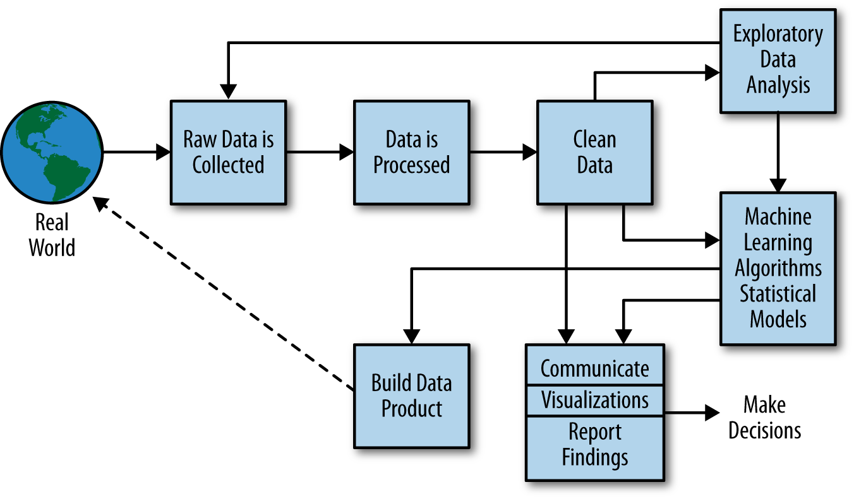

###### *Figure 2-2. The data science process*

First we have the Real World. Inside the Real World are lots of people busy at various activities. Some people are using Google+, others are competing in the Olympics; there are spammers sending spam, and there are people getting their blood drawn. Say we have data on one of these things.

Specifically, we’ll start with raw data—logs, Olympics records, Enron employee emails, or recorded genetic material (note there are lots of aspects to these activities already lost even when we have that raw data). We want to process this to make it clean for analysis. So we build and use pipelines of data munging: joining, scraping, wrangling, or whatever you want to call it. To do this we use tools such as Python, shell scripts, R, or SQL, or all of the above.

Eventually we get the data down to a nice format, like something with columns:

name | event | year | gender | event time

###### NOTE

This is where you typically start in a standard statistics class, with a clean, orderly dataset. But it’s not where you typically start in the real world.

Once we have this clean dataset, we should be doing some kind of EDA. In the course of doing EDA, we may realize that it isn’t actually clean because of duplicates, missing values, absurd outliers, and data that wasn’t actually logged or incorrectly logged. If that’s the case, we may have to go back to collect more data, or spend more time cleaning the dataset.

Next, we design our model to use some algorithm like k-nearest neighbor (k-NN), linear regression, Naive Bayes, or something else. The model we choose depends on the type of problem we’re trying to solve, of course, which could be a classification problem, a prediction problem, or a basic description problem.

We then can interpret, visualize, report, or communicate our results. This could take the form of reporting the results up to our boss or coworkers, or publishing a paper in a journal and going out and giving academic talks about it.

Alternatively, our goal may be to build or prototype a “data product”; e.g., a spam classifier, or a search ranking algorithm, or a recommendation system. Now the key here that makes data science special and distinct from statistics is that this data product then gets incorporated back into the real world, and users interact with that product, and that generates more data, which creates a feedback loop.

This is very different from predicting the weather, say, where your model doesn’t influence the outcome at all. For example, you might predict it will rain next week, and unless you have some powers we don’t know about, you’re not going to cause it to rain. But if you instead build a recommendation system that generates evidence that “lots of people love this book,” say, then you will know that you caused that feedback loop.

Take this loop into account in any analysis you do by adjusting for any biases your model caused. Your models are not just predicting the future, but causing it!

A data product that is productionized and that users interact with is at one extreme and the weather is at the other, but regardless of the type of data you work with and the “data product” that gets built on top of it—be it public policy determined by a statistical model, health insurance, or election polls that get widely reported and perhaps influence viewer opinions—you should consider the extent to which your model is influencing the very phenomenon that you are trying to observe and understand.

## A Data Scientist’s Role in This Process

This model so far seems to suggest this will all magically happen without human intervention. By “human” here, we mean “data scientist.” Someone has to make the decisions about what data to collect, and why. That person needs to be formulating questions and hypotheses and making a plan for how the problem will be attacked. And that someone is the data scientist or our beloved data science team.

Let’s revise or at least add an overlay to make clear that the data scientist needs to be involved in this process throughout, meaning they are involved in the actual coding as well as in the higher-level process, as shown in [Figure 2-3](https://learning.oreilly.com/library/view/doing-data-science/9781449363871/ch02.html#data-scientist-role).

##### CONNECTION TO THE SCIENTIFIC METHOD

We can think of the data science process as an extension or variation of the scientific method:

* Ask a question.
* Do background research.
* Construct a hypothesis.
* Test your hypothesis by doing an experiment.
* Analyze your data and draw a conclusion.
* Communicate your results.

In both the data science process and the scientific method, not every problem requires one to go through all the steps, but almost all problems can be solved with some combination of the stages. For example, if your end goal is a data visualization (which itself could be thought of as a data product), it’s possible you might not do any machine learning or statistical modeling, but you’d want to get all the way to a clean dataset, do some exploratory analysis, and then create the visualization.

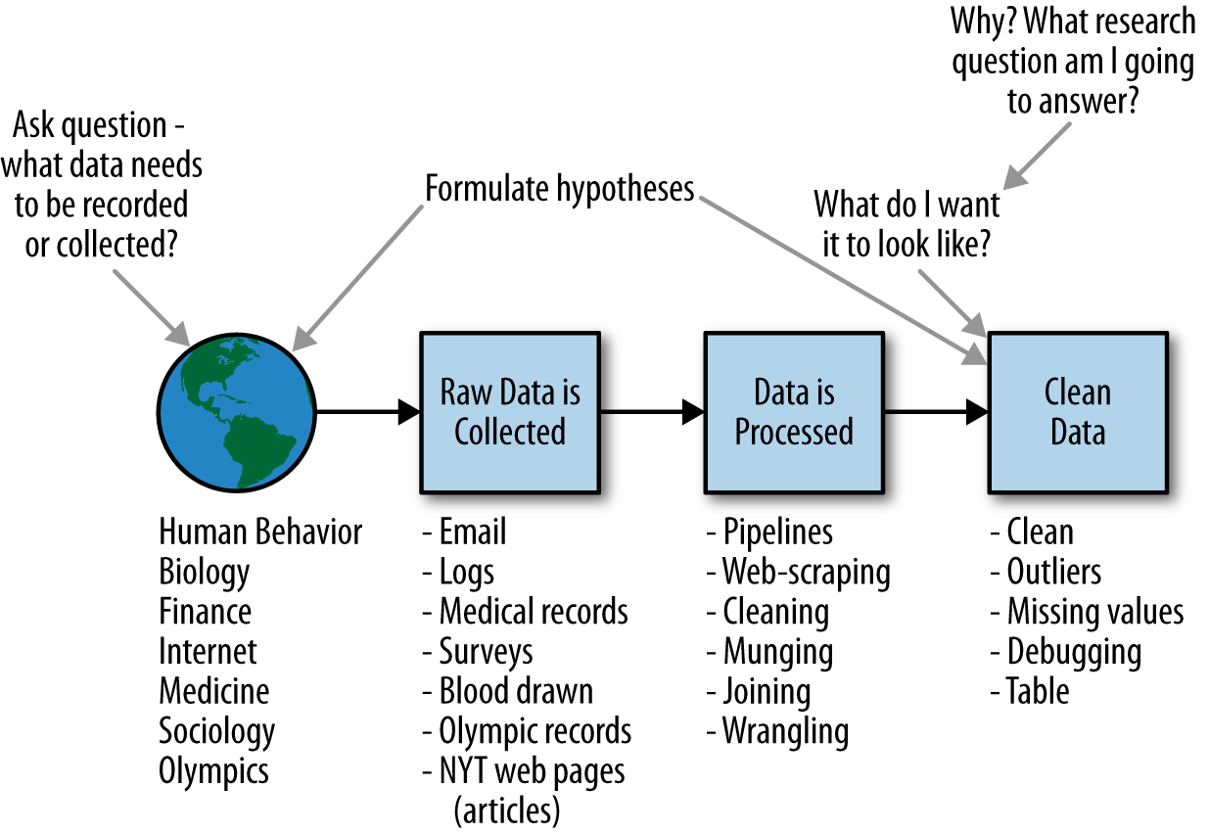

###### *Figure 2-3. The data scientist is involved in every part of this process*

# Thought Experiment: How Would You Simulate Chaos?

Most data problems start out with a certain amount of dirty data, ill-defined questions, and urgency. As data scientists we are, in a sense, attempting to create order from chaos. The class took a break from the lecture to discuss how they’d simulate chaos. Here are some ideas from the discussion:

* A Lorenzian water wheel, which is a Ferris wheel-type contraption with equally spaced buckets of water that rotate around in a circle. Now imagine water being dripped into the system at the very top. Each bucket has a leak, so some water escapes into whatever bucket is directly below the drip. Depending on the rate of the water coming in, this system exhibits a chaotic process that depends on molecular-level interactions of water molecules on the sides of the buckets. Read more about it [in this associated Wikipedia article](http://goo.gl/SjcJ64).
* Many systems can exhibit inherent chaos. Philippe M. Binder and Roderick V. Jensen have written a paper entitled [“Simulating chaotic behavior with finite-state machines”](http://goo.gl/0LoaHw), which is about digital computer simulations of chaos.
* An interdisciplinary program involving M.I.T., Harvard, and Tufts involved teaching a technique that was entitled [“Simulating chaos to teach order”](http://hvrd.me/1g3zzBz). They simulated an emergency on the border between Chad and Sudan’s troubled Darfur region, with students acting as members of Doctors Without Borders, International Medical Corps, and other humanitarian agencies.
* See also Joel Gascoigne’s related essay, [“Creating order from chaos in a startup”](http://goo.gl/v43tZt).

##### INSTRUCTOR NOTES

1. Being a data scientist in an organization is often a chaotic experience, and it’s the data scientist’s job to try to create order from that chaos. So I wanted to simulate that chaotic experience for my students throughout the semester. But I also wanted them to know that things were going to be slightly chaotic for a pedagogical reason, and not due to my ineptitude!
2. I wanted to draw out different interpretations of the word “chaos” as a means to think about the importance of vocabulary, and the difficulties caused in communication when people either don’t know what a word means, or have different ideas of what the word means. Data scientists might be communicating with domain experts who don’t really understand what “logistic regression” means, say, but will pretend to know because they don’t want to appear stupid, or because they think they ought to know, and therefore don’t ask. But then the whole conversation is not really a successful communication if the two people talking don’t really understand what they’re talking about. Similarly, the data scientists ought to be asking questions to make sure they understand the terminology the domain expert is using (be it an astrophysicist, a social networking expert, or a climatologist). There’s nothing wrong with not knowing what a word means, but there is something wrong with not asking! You will likely find that asking clarifying questions about vocabulary gets you even more insight into the underlying data problem.
3. Simulation is a useful technique in data science. It can be useful practice to simulate fake datasets from a model to understand the generative process better, for example, and also to debug code.

# Case Study: RealDirect

Doug Perlson, the CEO of [RealDirect](http://www.realdirect.com/), has a background in real estate law, startups, and online advertising. His goal with RealDirect is to use all the data he can access about real estate to improve the way people sell and buy houses.

Normally, people sell their homes about once every seven years, and they do so with the help of professional brokers and current data. But there’s a problem both with the broker system and the data quality. RealDirect addresses both of them.

First, the brokers. They are typically “free agents” operating on their own—think of them as home sales consultants. This means that they guard their data aggressively, and the really good ones have lots of experience. But in the grand scheme of things, that really means they have only slightly more data than the inexperienced brokers.

RealDirect is addressing this problem by hiring a team of licensed real-estate agents who work together and pool their knowledge. To accomplish this, it built an interface for sellers, giving them useful data-driven tips on how to sell their house. It also uses interaction data to give real-time recommendations on what to do next.

The team of brokers also become data experts, learning to use information-collecting tools to keep tabs on new and relevant data or to access publicly available information. For example, you can now get data on co-op (a certain kind of apartment in NYC) sales, but that’s a relatively recent change.

One problem with publicly available data is that it’s old news—there’s a three-month lag between a sale and when the data about that sale is available. RealDirect is working on real-time feeds on things like when people start searching for a home, what the initial offer is, the time between offer and close, and how people search for a home online.

Ultimately, good information helps both the buyer and the seller. At least if they’re honest.

## How Does RealDirect Make Money?

First, it offers a subscription to sellers—about $395 a month—to access the selling tools. Second, it allows sellers to use RealDirect’s agents at a reduced commission, typically 2% of the sale instead of the usual 2.5% or 3%. This is where the magic of data pooling comes in: it allows RealDirect to take a smaller commission because it’s more optimized, and therefore gets more volume.

The site itself is best thought of as a platform for buyers and sellers to manage their sale or purchase process. There are statuses for each person on site: active, offer made, offer rejected, showing, in contract, etc. Based on your status, different actions are suggested by the software.

There are some challenges they have to deal with as well, of course. First off, there’s a law in New York that says you can’t show all the current housing listings unless those listings reside behind a registration wall, so RealDirect requires registration. On the one hand, this is an obstacle for buyers, but serious buyers are likely willing to do it. Moreover, places that don’t require registration, like [Zillow](http://www.zillow.com/), aren’t true competitors to RealDirect because they are merely showing listings without providing any additional service. Doug pointed out that you also need to register to use [Pinterest](http://pinterest.com/), and it has tons of users in spite of this.

RealDirect comprises licensed brokers in various established realtor associations, but even so it has had its share of hate mail from realtors who don’t appreciate its approach to cutting commission costs. In this sense, RealDirect is breaking directly into a guild. On the other hand, if a realtor refused to show houses because they are being sold on RealDirect, the potential buyers would see those listings elsewhere and complain. So the traditional brokers have little choice but to deal with RealDirect even if they don’t like it. In other words, the listings themselves are sufficiently transparent so that the traditional brokers can’t get away with keeping their buyers away from these houses.

Doug talked about key issues that a buyer might care about—nearby parks, subway, and schools, as well as the comparison of prices per square foot of apartments sold in the same building or block. This is the kind of data they want to increasingly cover as part of the service of RealDirect.

## Exercise: RealDirect Data Strategy

You have been hired as chief data scientist at realdirect.com, and report directly to the CEO. The company (hypothetically) does not yet have its data plan in place. It’s looking to you to come up with a data strategy. Here are a couple ways you could begin to approach this problem:

1. Explore its existing website, thinking about how buyers and sellers would navigate through it, and how the website is structured/organized. Try to understand the existing business model, and think about how analysis of RealDirect user-behavior data could be used to inform decision-making and product development. Come up with a list of research questions you think could be answered by data:
   * What data would you advise the engineers log and what would your ideal datasets look like?
   * How would data be used for reporting and monitoring product usage?
   * How would data be built back into the product/website?
2. Because there is no data yet for you to analyze (typical in a start-up when it’s still building its product), you should get some auxiliary data to help gain intuition about this market. For example, go to <https://github.com/oreillymedia/doing_data_science>. Click on Rolling Sales Update (after the fifth paragraph).

You can use any or all of the datasets here—start with Manhattan August, 2012–August 2013.

* + First challenge: load in and clean up the data. Next, conduct exploratory data analysis in order to find out where there are outliers or missing values, decide how you will treat them, make sure the dates are formatted correctly, make sure values you think are numerical are being treated as such, etc.
  + Once the data is in good shape, conduct exploratory data analysis to visualize and make comparisons (i) across neighborhoods, and (ii) across time. If you have time, start looking for meaningful patterns in this dataset.

1. Summarize your findings in a brief report aimed at the CEO.
2. Being the “data scientist” often involves speaking to people who aren’t also data scientists, so it would be ideal to have a set of communication strategies for getting to the information you need about the data. Can you think of any other people you should talk to?
3. Most of you are not “domain experts” in real estate or online businesses.
   * Does stepping out of your comfort zone and figuring out how you would go about “collecting data” in a different setting give you insight into how you do it in your own field?
   * Sometimes “domain experts” have their own set of vocabulary. Did Doug use vocabulary specific to his domain that you didn’t understand (“comps,” “open houses,” “CPC”)? Sometimes if you don’t understand vocabulary that an expert is using, it can prevent you from understanding the problem. It’s good to get in the habit of asking questions because eventually you will get to something you do understand. This involves persistence and is a habit to cultivate.
4. Doug mentioned the company didn’t necessarily have a data strategy. There is no industry standard for creating one. As you work through this assignment, think about whether there is a set of best practices you would recommend with respect to developing a data strategy for an online business, or in your own domain.

### SAMPLE R CODE

Here’s some sample R code that takes the Brooklyn housing data in the preceding exercise, and cleans and explores it a bit. (The exercise asks you to do this for Manhattan.)

*# Author: Benjamin Reddy*

library(plyr)

require(gdata)

bk <- read.xls("rollingsales_brooklyn.xls",pattern="BOROUGH")

head(bk)

summary(bk)

bk$SALE.PRICE.N <- as.numeric(gsub("[^[:digit:]]","",

bk$SALE.PRICE))

count(is.na(bk$SALE.PRICE.N))

names(bk) <- tolower(names(bk))

*## clean/format the data with regular expressions*

bk$gross.sqft <- as.numeric(gsub("[^[:digit:]]","",

bk$gross.square.feet))

bk$land.sqft <- as.numeric(gsub("[^[:digit:]]","",

bk$land.square.feet))

bk$sale.date <- as.Date(bk$sale.date)

bk$year.built <- as.numeric(as.character(bk$year.built))

*## do a bit of exploration to make sure there's not anything*

*## weird going on with sale prices*

attach(bk)

hist(sale.price.n)

hist(sale.price.n[sale.price.n>0])

hist(gross.sqft[sale.price.n==0])

detach(bk)

*## keep only the actual sales*

bk.sale <- bk[bk$sale.price.n!=0,]

plot(bk.sale$gross.sqft,bk.sale$sale.price.n)

plot(log(bk.sale$gross.sqft),log(bk.sale$sale.price.n))

*## for now, let's look at 1-, 2-, and 3-family homes*

bk.homes <- bk.sale[which(grepl("FAMILY",

bk.sale$building.class.category)),]

plot(log(bk.homes$gross.sqft),log(bk.homes$sale.price.n))

bk.homes[which(bk.homes$sale.price.n<100000),]

[order(bk.homes[which(bk.homes$sale.price.n<100000),]

$sale.price.n),]

*## remove outliers that seem like they weren't actual sales*

bk.homes$outliers <- (log(bk.homes$sale.price.n) <=5) + 0

bk.homes <- bk.homes[which(bk.homes$outliers==0),]

plot(log(bk.homes$gross.sqft),log(bk.homes$sale.price.n))

# Chapter 3. Algorithms

In the previous chapter we discussed in general how models are used in data science. In this chapter, we’re going to be diving into algorithms.

An algorithm is a procedure or set of steps or rules to accomplish a task. Algorithms are one of the fundamental concepts in, or building blocks of, computer science: the basis of the design of elegant and efficient code, data preparation and processing, and software engineering.

Some of the basic types of tasks that algorithms can solve are sorting, searching, and graph-based computational problems. Although a given task such as sorting a list of objects could be handled by multiple possible algorithms, there is some notion of “best” as measured by efficiency and computational time, which matters especially when you’re dealing with massive amounts of data and building consumer-facing products.

Efficient algorithms that work sequentially or in parallel are the basis of pipelines to process and prepare data. With respect to data science, there are at least three classes of algorithms one should be aware of:

1. Data munging, preparation, and processing algorithms, such as sorting, MapReduce, or Pregel.

We would characterize these types of algorithms as data engineering, and while we devote a chapter to this, it’s not the emphasis of this book. This is not to say that you won’t be doing data wrangling and munging—just that we don’t emphasize the algorithmic aspect of it.

1. Optimization algorithms for parameter estimation, including Stochastic Gradient Descent, Newton’s Method, and Least Squares. We mention these types of algorithms throughout the book, and they underlie many R functions.
2. Machine learning algorithms are a large part of this book, and we discuss these more next.

# Machine Learning Algorithms

Machine learning algorithms are largely used to predict, classify, or cluster.

Wait! Back in the previous chapter, didn’t we already say modeling could be used to predict or classify? Yes. Here’s where some lines have been drawn that can make things a bit confusing, and it’s worth understanding who drew those lines.

Statistical modeling came out of statistics departments, and machine learning algorithms came out of computer science departments. Certain methods and techniques are considered to be part of both, and you’ll see that we often use the words somewhat interchangeably.

You’ll find some of the methods in this book, such as linear regression, in machine learning books as well as intro to statistics books. It’s not necessarily useful to argue over who the rightful owner is of these methods, but it’s worth pointing out here that it can get a little vague or ambiguous about what the actual difference is.

In general, machine learning algorithms that are the basis of artificial intelligence (AI) such as image recognition, speech recognition, recommendation systems, ranking and personalization of content—often the basis of data products—are not usually part of a core statistics curriculum or department. They aren’t generally designed to infer the underlying generative process (e.g., to model something), but rather to predict or classify with the most accuracy.

These differences in methods reflect in cultural differences in the approaches of machine learners and statisticians that Rachel observed at Google, and at industry conferences. Of course, data scientists can and should use both approaches.

There are some broad generalizations to consider:

Interpreting parameters

Statisticians think of the parameters in their linear regression models as having real-world interpretations, and typically want to be able to find meaning in behavior or describe the real-world phenomenon corresponding to those parameters. Whereas a software engineer or computer scientist might be wanting to build their linear regression algorithm into production-level code, and the predictive model is what is known as a black box algorithm, they don’t generally focus on the interpretation of the parameters. If they do, it is with the goal of handtuning them in order to optimize predictive power.

Confidence intervals

Statisticians provide confidence intervals and posterior distributions for parameters and estimators, and are interested in capturing the variability or uncertainty of the parameters. Many machine learning algorithms, such as k-means or k-nearest neighbors (which we cover a bit later in this chapter), don’t have a notion of confidence intervals or uncertainty.

The role of explicit assumptions

Statistical models make explicit assumptions about data-generating processes and distributions, and you use the data to estimate parameters. Nonparametric solutions, like we’ll see later in this chapter, don’t make any assumptions about probability distributions, or they are implicit.

We say the following lovingly and with respect: statisticians have chosen to spend their lives investigating uncertainty, and they’re never 100% confident about anything. Software engineers like to build things. They want to build models that predict the best they can, but there are no concerns about uncertainty—just build it! At companies like Facebook or Google, the philosophy is to build and iterate often. If something breaks, it can be fixed. A data scientist who somehow manages to find a balance between the statistical and computer science approaches, and to find value in both these ways of being, can thrive. Data scientists are the multicultural statistician-computer scientist hybrid, so we’re not tied to any one way of thinking over another; they both have value. We’ll sum up our take on this with guest speaker Josh Wills’ ([Chapter 13](https://learning.oreilly.com/library/view/doing-data-science/9781449363871/ch13.html#chapter-data-leakage-model-evaluation)) well-tweeted quote:

*Data scientist (noun): Person who is better at statistics than any software engineer and better at software engineering than any statistician.*

Josh Wills

# Three Basic Algorithms

Many business or real-world problems that can be solved with data can be thought of as classification and prediction problems when we express them mathematically. Happily, a whole host of models and algorithms can be used to classify and predict.

Your real challenge as a data scientist, once you’ve become familiar with how to implement them, is understanding which ones to use depending on the context of the problem and the underlying assumptions. This partially comes with experience—you start seeing enough problems that you start thinking, “Ah, this is a classification problem with a binary outcome” or, “This is a classification problem, but oddly I don’t even have any labels” and you know what to do. (In the first case, you could use logistic regression or Naive Bayes, and in the second you could start with k-means—more on all these shortly!)

Initially, though, when you hear about these methods in isolation, it takes some effort on your part as a student or learner to think, “In the real world, how do I know that this algorithm is the solution to the problem I’m trying to solve?”

It’s a real mistake to be the type of person walking around with a hammer looking for a nail to bang: “I know linear regression, so I’m going to try to solve every problem I encounter with it.” Don’t do that. Instead, try to understand the context of the problem, and the attributes it has as a problem. Think of those in mathematical terms, and then think about the algorithms you know and how they map to this type of problem.

If you’re not sure, it’s good to talk it through with someone who does. So ask a coworker, head to a meetup group, or start one in your area! Also, maintain the attitude that it’s not obvious what to do and that’s what makes it a problem, and so you’re going to approach it circumspectly and methodically. You don’t have to be the know-it-all in the room who says, “Well, obviously we should use linear regression with a penalty function for regularization,” even if that seems to you the right approach.

We’re saying all this because one of the unfortunate aspects of textbooks is they often give you a bunch of techniques and then problems that tell you which method to use that solves the problem (e.g., use linear regression to predict height from weight). Yes, implementing and understanding linear regression the first few times is not obvious, so you need practice with that, but it needs to be addressed that the real challenge once you have mastery over technique is knowing when to use linear regression in the first place.

We’re not going to give a comprehensive overview of all possible machine learning algorithms, because that would make this a machine learning book, and there are already plenty of those.

Having said that, in this chapter we’ll introduce three basic algorithms now and introduce others throughout the book in context. By the end of the book, you should feel more confident about your ability to learn new algorithms so that you can pick them up along the way as problems require them.

We’ll also do our best to demonstrate the thought processes of data scientists who had to figure out which algorithm to use in context and why, but it’s also upon you as a student and learner to force yourself to think about what the attributes of the problem were that made a given algorithm the right algorithm to use.

With that said, we still need to give you some basic tools to use, so we’ll start with linear regression, k-nearest neighbors (k-NN), and k-means. In addition to what was just said about trying to understand the attributes of problems that could use these as solutions, look at these three algorithms from the perspective of: what patterns can we as humans see in the data with our eyes that we’d like to be able to automate with a machine, especially taking into account that as the data gets more complex, we can’t see these patterns?

## Linear Regression

One of the most common statistical methods is linear regression. At its most basic, it’s used when you want to express the mathematical relationship between two variables or attributes. When you use it, you are making the assumption that there is a linear relationship between an outcome variable (sometimes also called the response variable, dependent variable, or label) and a predictor (sometimes also called an independent variable, explanatory variable, or feature); or between one variable and several other variables, in which case you’re modeling the relationship as having a linear structure.

##### WTF. SO IS IT AN ALGORITHM OR A MODEL?

While we tried to make a distinction between the two earlier, we admit the colloquial use of the words “model” and “algorithm” gets confusing because the two words seem to be used interchangeably when their actual definitions are not the same thing at all. In the purest sense, an algorithm is a set of rules or steps to follow to accomplish some task, and a model is an attempt to describe or capture the world. These two seem obviously different, so it seems the distinction should should be obvious. Unfortunately, it isn’t. For example, regression can be described as a statistical model as well as a machine learning algorithm. You’ll waste your time trying to get people to discuss this with any precision.

In some ways this is a historical artifact of statistics and computer science communities developing methods and techniques in parallel and using different words for the same methods. The consequence of this is that the distinction between machine learning and statistical modeling is muddy. Some methods (for example, k-means, discussed in the next section) we might call an algorithm because it’s a series of computational steps used to cluster or classify objects—on the other hand, k-means can be reinterpreted as a special case of a Gaussian mixture model. The net result is that colloquially, people use the terms algorithm and model interchangeably when it comes to a lot of these methods, so try not to let it worry you. (Though it bothers us, too.)

Assuming that there is a linear relationship between an outcome variable and a predictor is a big assumption, but it’s also the simplest one you can make—linear functions are more basic than nonlinear ones in a mathematical sense—so in that sense it’s a good starting point.

In some cases, it makes sense that changes in one variable correlate linearly with changes in another variable. For example, it makes sense that the more umbrellas you sell, the more money you make. In those cases you can feel good about the linearity assumption. Other times, it’s harder to justify the assumption of linearity except locally: in the spirit of calculus, everything can be approximated by line segments as long as functions are continuous.

Let’s back up. Why would you even want to build a linear model in the first place? You might want to use this relationship to predict future outcomes, or you might want to understand or describe the relationship to get a grasp on the situation. Let’s say you’re studying the relationship between a company’s sales and how much that company spends on advertising, or the number of friends someone has on a social networking site and the time that person spends on that site daily. These are all numerical outcomes, which mean linear regression would be a wise choice, at least for a first pass at your problem.

One entry point for thinking about linear regression is to think about deterministic lines first. We learned back in grade school that we could describe a line with a slope and an intercept, y=f(x)=β0+β1*xy=f(x)=β0+β1*x. But the setting there was always deterministic.

Even for the most mathematically sophisticated among us, if you haven’t done it before, it’s a new mindset to start thinking about stochastic functions. We still have the same components: points listed out explicitly in a table (or as tuples), and functions represented in equation form or plotted on a graph. So let’s build up to linear regression starting from a deterministic function.

**Example 1. Overly simplistic example to start**. Suppose you run a social networking site that charges a monthly subscription fee of $25, and that this is your only source of revenue. Each month you collect data and count your number of users and total revenue. You’ve done this daily over the course of two years, recording it all in a spreadsheet. You could express this data as a series of points. Here are the first four:

S={(x,y)=(1,25),(10,250),(100,2500),(200,5000)}S={(x,y)=(1,25),(10,250),(100,2500),(200,5000)}

If you showed this to someone else who didn’t even know how much you charged or anything about your business model (what kind of friend wasn’t paying attention to your business model?!), they might notice that there’s a clear relationship enjoyed by all of these points, namely y=25xy=25x. They likely could do this in their head, in which case they figured out that:

* There’s a linear pattern.
* The coefficient relating xx and yy is 25.
* It seems deterministic.

You can even plot it as in [Figure 3-1](https://learning.oreilly.com/library/view/doing-data-science/9781449363871/ch03.html#Figure3.1) to verify they were right (even though you knew they were because you made the business model in the first place). It’s a line!

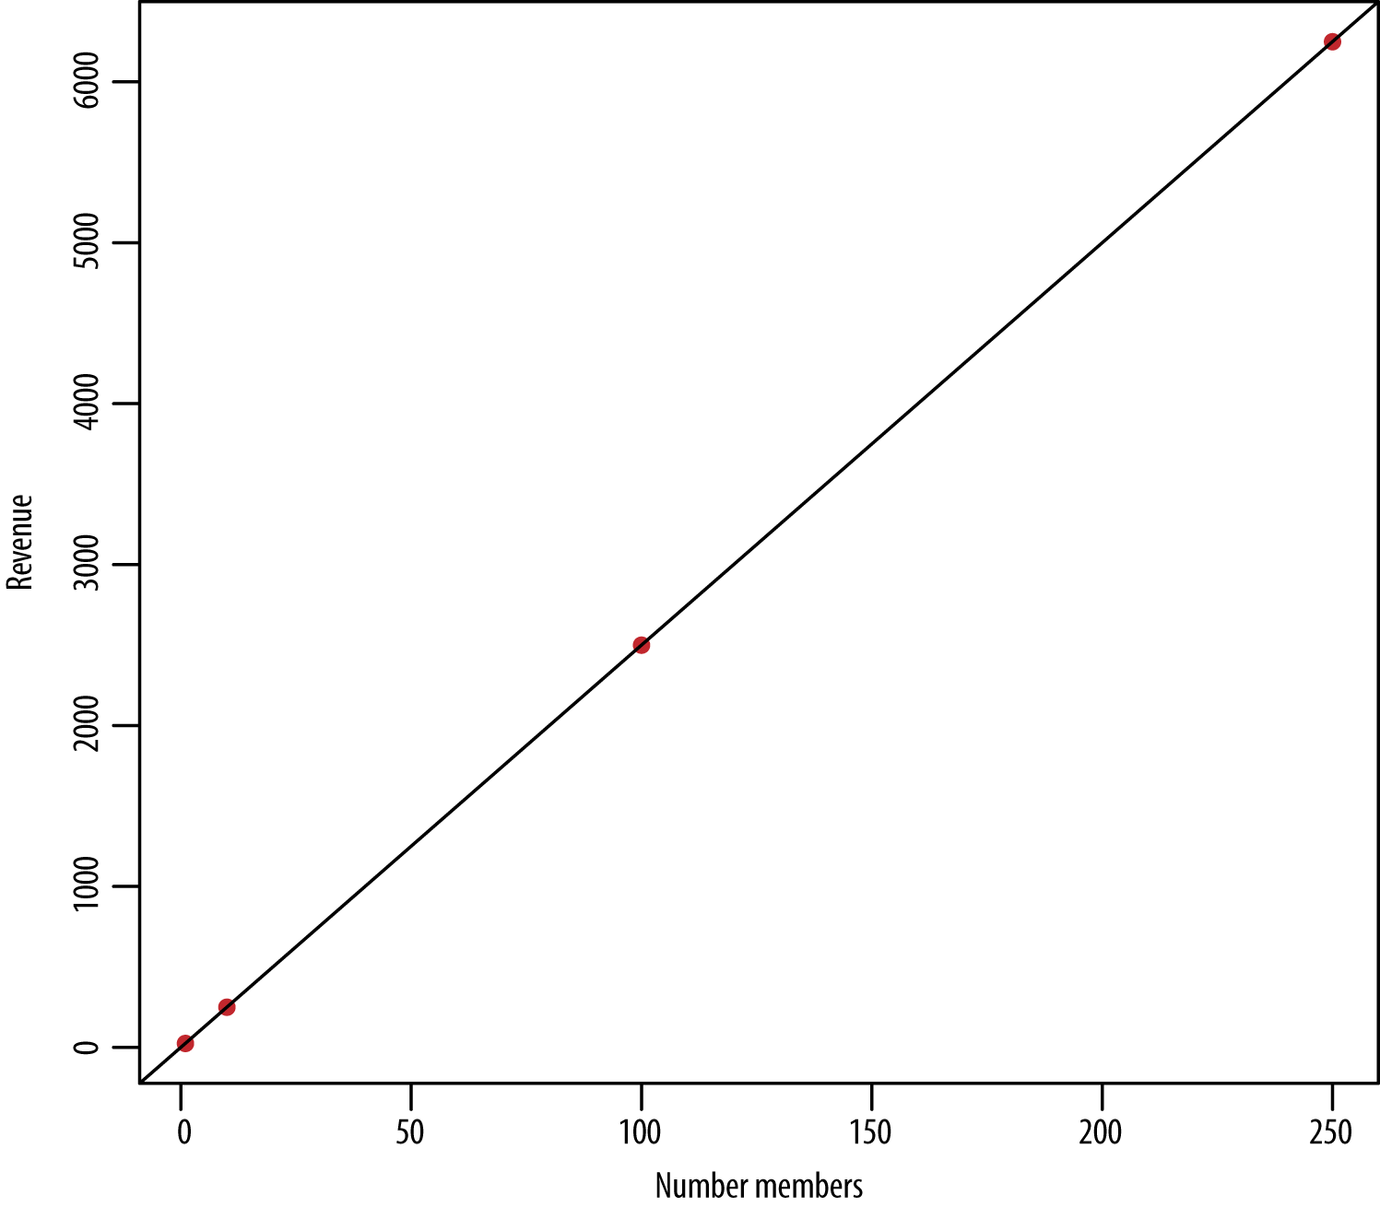

###### *Figure 3-1. An obvious linear pattern*

**Example 2. Looking at data at the user level.** Say you have a dataset keyed by user (meaning each row contains data for a single user), and the columns represent user behavior on a social networking site over a period of a week. Let’s say you feel comfortable that the data is clean at this stage and that you have on the order of hundreds of thousands of users. The names of the columns are total_num_friends, total_new_friends_this_week, num_visits, time_spent, number_apps_downloaded, number_ads_shown, gender, age, and so on. During the course of your exploratory data analysis, you’ve randomly sampled 100 users to keep it simple, and you plot pairs of these variables, for example, xx = total_new_friends and yy = time_spent (in seconds). The business context might be that eventually you want to be able to promise advertisers who bid for space on your website in advance a certain number of users, so you want to be able to forecast number of users several days or weeks in advance. But for now, you are simply trying to build intuition and understand your dataset.

You eyeball the first few rows and see:

|  |  |
| --- | --- |
| 7 | 276 |
| 3 | 43 |
| 4 | 82 |
| 6 | 136 |
| 10 | 417 |
| 9 | 269 |

Now, your brain can’t figure out what’s going on by just looking at them (and your friend’s brain probably can’t, either). They’re in no obvious particular order, and there are a lot of them. So you try to plot it as in [Figure 3-2](https://learning.oreilly.com/library/view/doing-data-science/9781449363871/ch03.html#Figure2.2).

It looks like there’s kind of a linear relationship here, and it makes sense; the more new friends you have, the more time you might spend on the site. But how can you figure out how to describe that relationship? Let’s also point out that there is no perfectly deterministic relationship between number of new friends and time spent on the site, but it makes sense that there is an association between these two variables.

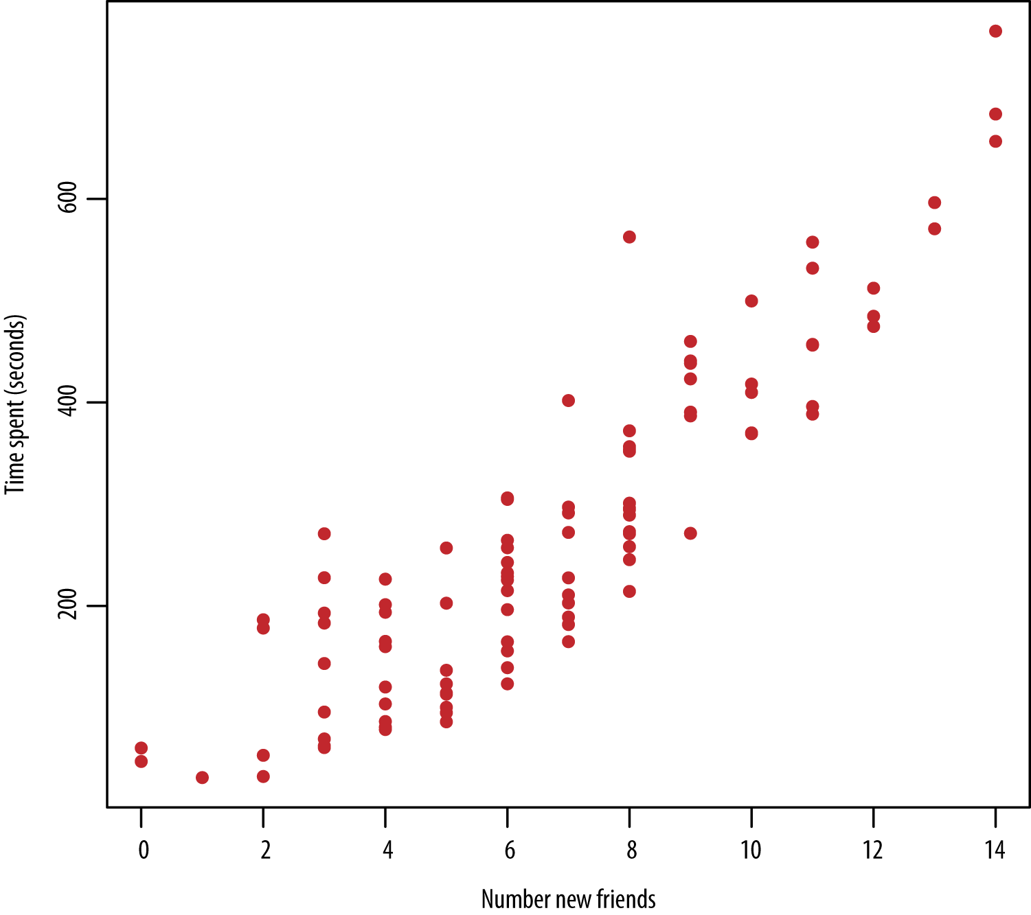

###### *Figure 3-2. Looking kind of linear*

### START BY WRITING SOMETHING DOWN

There are two things you want to capture in the model. The first is the trend and the second is the variation. We’ll start first with the trend.

First, let’s start by assuming there actually is a relationship and that it’s linear. It’s the best you can do at this point.

There are many lines that look more or less like they might work, as shown in [Figure 3-3](https://learning.oreilly.com/library/view/doing-data-science/9781449363871/ch03.html#Figure2.3).

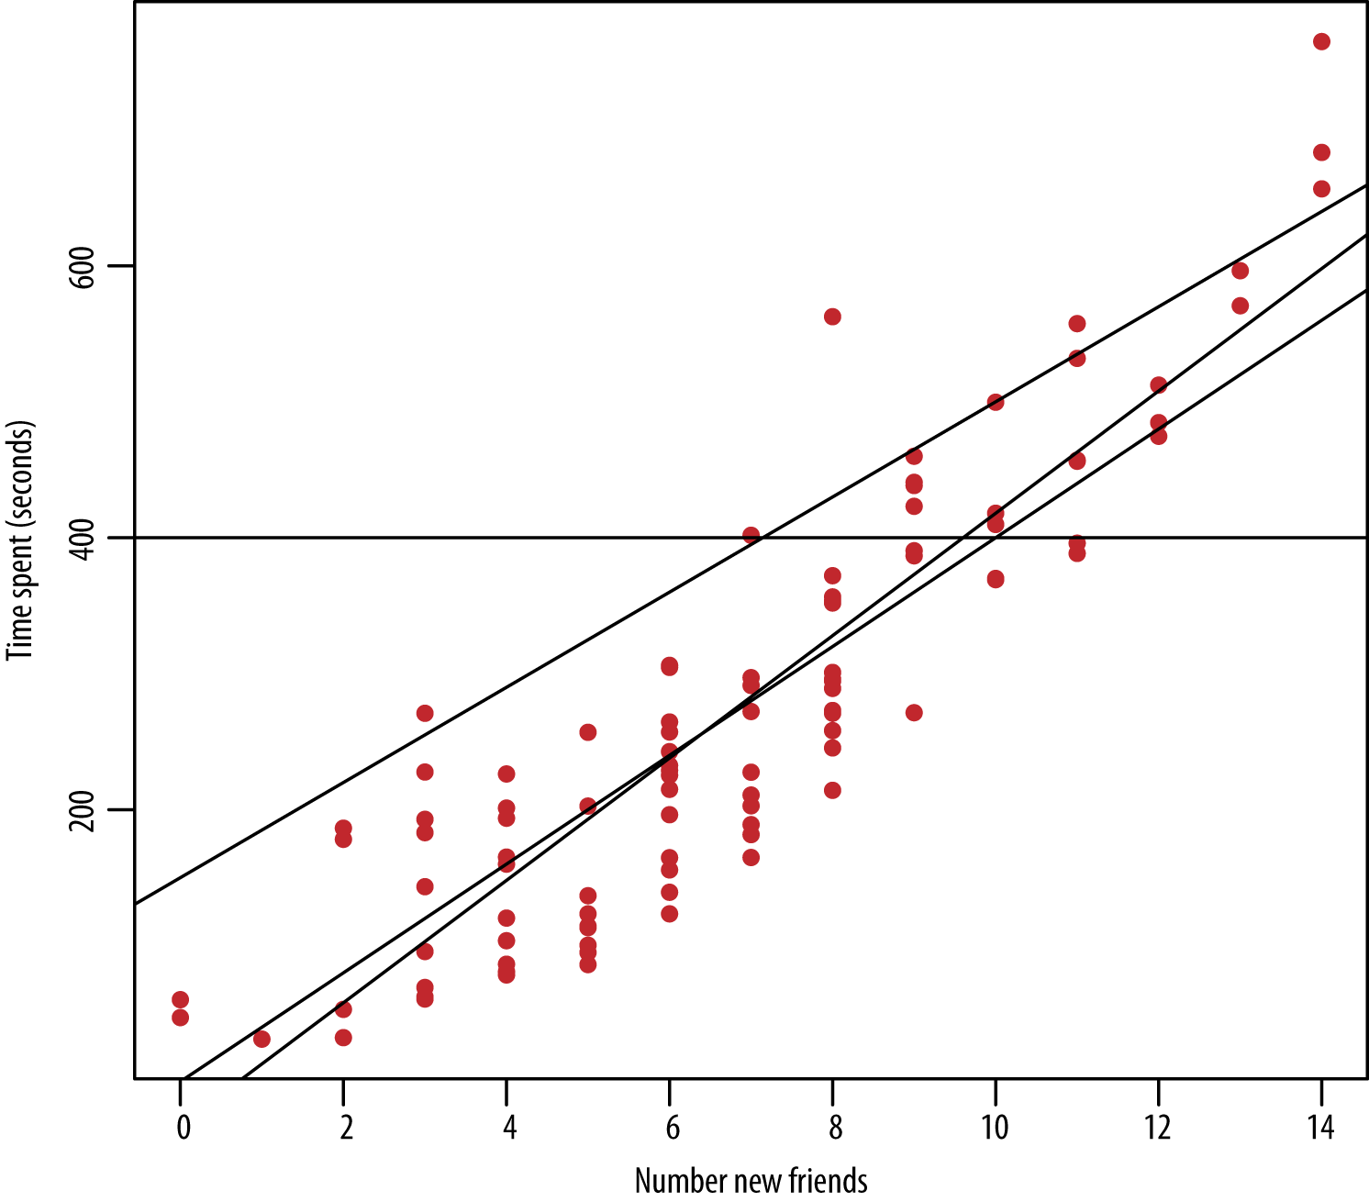

###### *Figure 3-3. Which line is the best fit?*

So how do you pick which one?

Because you’re assuming a linear relationship, start your model by assuming the functional form to be:

y=β0+β1xy=β0+β1x

Now your job is to find the best choices for β0β0 and β1β1 using the observed data to estimate them: (x1,y1),(x2,y2),...(xn,yn)(x1,y1),(x2,y2),...(xn,yn).

Writing this with matrix notation results in this:

y=x⋅βy=x·β

There you go: you’ve written down your model. Now the rest is fitting the model.

### FITTING THE MODEL

So, how do you calculate ββ? The intuition behind linear regression is that you want to find the line that minimizes the distance between all the points and the line.

Many lines look approximately correct, but your goal is to find the optimal one. Optimal could mean different things, but let’s start with optimal to mean the line that, on average, is closest to all the points. But what does closest mean here?

Look at [Figure 3-4](https://learning.oreilly.com/library/view/doing-data-science/9781449363871/ch03.html#Figure2.4). Linear regression seeks to find the line that minimizes the sum of the squares of the vertical distances between the approximated or predicted yiˆyi^s and the observed yiyis. You do this because you want to minimize your prediction errors. This method is called least squares estimation.

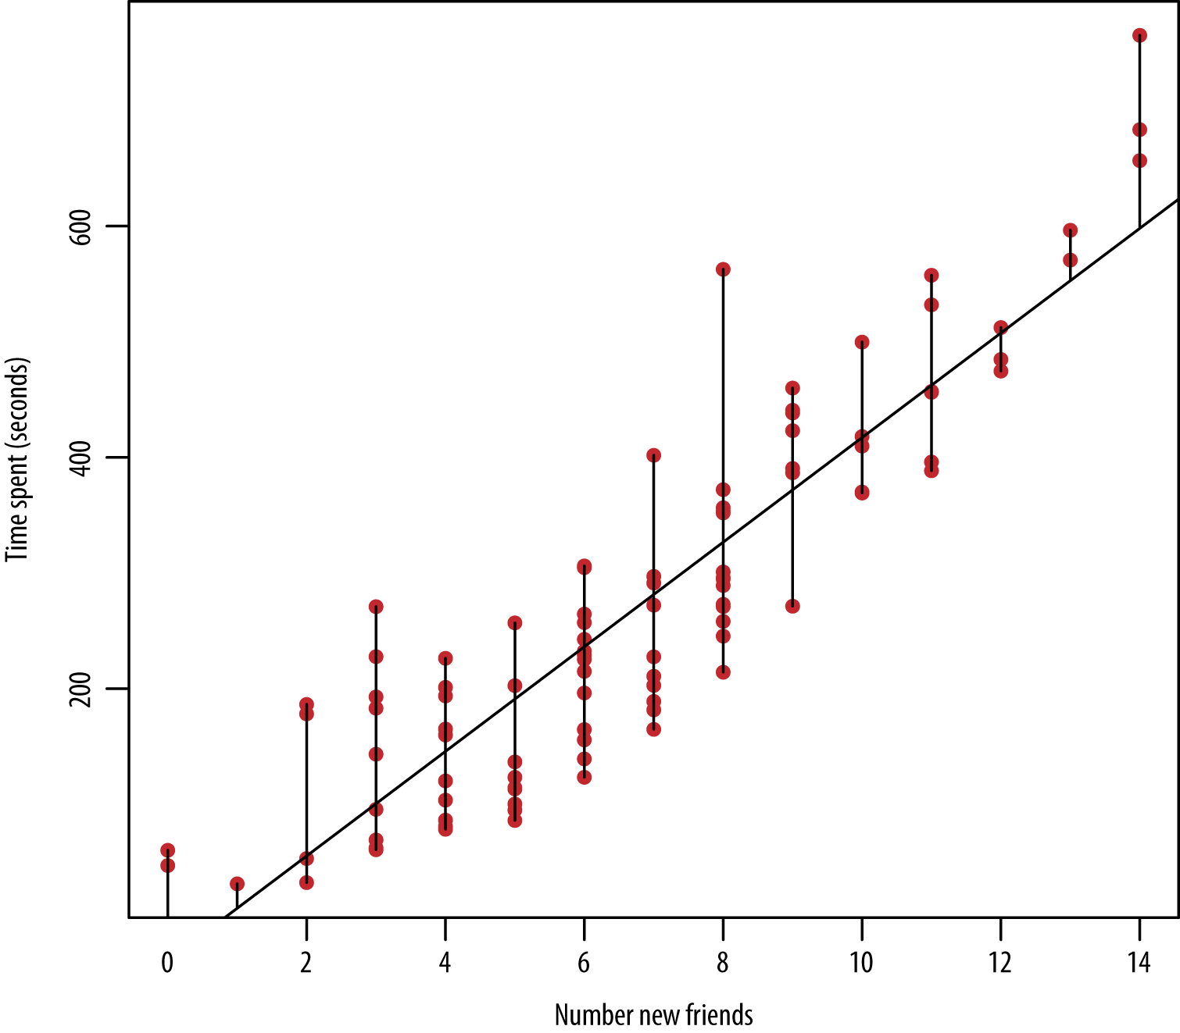

###### *Figure 3-4. The line closest to all the points*

To find this line, you’ll define the “residual sum of squares” (RSS), denoted RSS(β),RSS(β), to be:

RSS(β)=∑i(yi−βxi)2RSS(β)=∑i(yi-βxi)2

where ii ranges over the various data points. It is the sum of all the squared vertical distances between the observed points and any given line. Note this is a function of ββ and you want to optimize with respect to ββ to find the optimal line.

To minimize RSS(β)=(y−βx)t(y−βx),RSS(β)=(y-βx)t(y-βx), differentiate it with respect to ββ and set it equal to zero, then solve for β.β. This results in:

βˆ=(xtx)−1xtyβ^=(xtx)-1xty

Here the little “hat” symbol on top of the ββ is there to indicate that it’s the estimator for ββ. You don’t know the true value of ββ; all you have is the observed data, which you plug into the estimator to get an estimate.

To actually fit this, to get the ββs, all you need is one line of R code where you’ve got a column of y’s and a (single) column of x’s:

model <- lm(y ~ x)

So for the example where the first few rows of the data were:

|  |  |
| --- | --- |
| x | y |
| 7 | 276 |
| 3 | 43 |
| 4 | 82 |
| 6 | 136 |
| 10 | 417 |
| 9 | 269 |

The R code for this would be:

> model <- lm (y~x)

> model

Call:

lm(formula = y ~ x)

Coefficients:

(Intercept) x

-32.08 45.92

> coefs <- coef(model)

> plot(x, y, pch=20,col="red", xlab="Number new friends",

ylab="Time spent (seconds)")

> abline(coefs[1],coefs[2])

And the estimated line is yˆ=−32.08+45.92xy^=-32.08+45.92x, which you’re welcome to round to yˆ=−32+46xy^=-32+46x, and the corresponding plot looks like the lefthand side of [Figure 3-5](https://learning.oreilly.com/library/view/doing-data-science/9781449363871/ch03.html#Figure2.5).

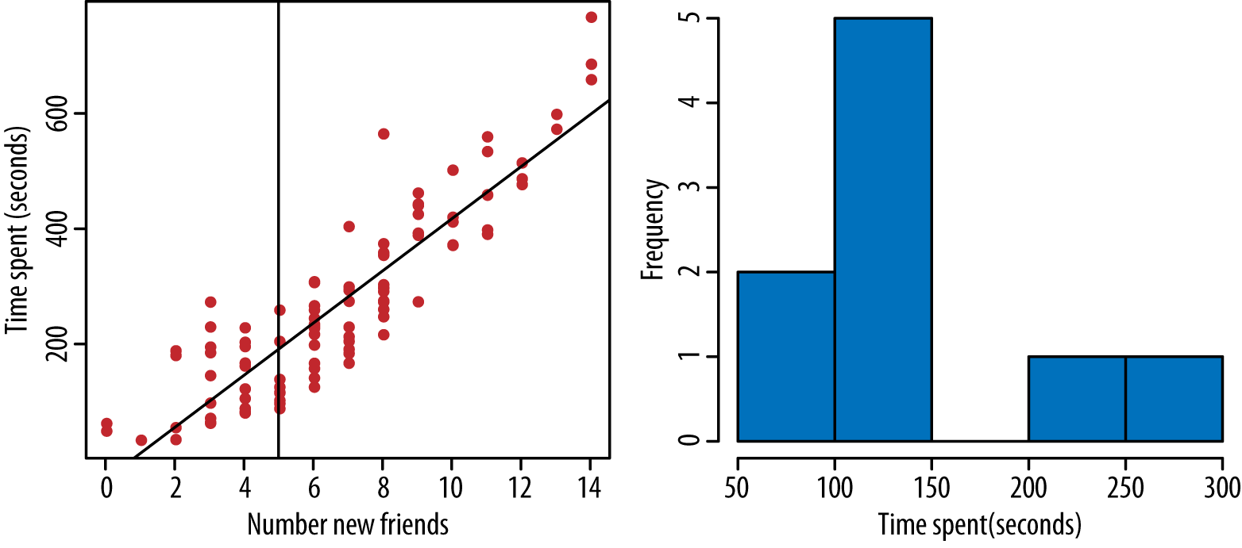

###### *Figure 3-5. On the left is the fitted line. We can see that for any fixed value, say 5, the values for y vary. For people with 5 new friends, we display their time spent in the plot on the right.*

But it’s up to you, the data scientist, whether you think you’d actually want to use this linear model to describe the relationship or predict new outcomes. If a new x-value of 5 came in, meaning the user had five new friends, how confident are you in the output value of –32.08 + 45.92*5 = 195.7 seconds?

In order to get at this question of confidence, you need to extend your model. You know there’s variation among time spent on the site by people with five new friends, meaning you certainly wouldn’t make the claim that everyone with five new friends is guaranteed to spend 195.7 seconds on the site. So while you’ve so far modeled the trend, you haven’t yet modeled the variation.

### EXTENDING BEYOND LEAST SQUARES

Now that you have a simple linear regression model down (one output, one predictor) using least squares estimation to estimate your ββs, you can build upon that model in three primary ways, described in the upcoming sections:

1. Adding in modeling assumptions about the errors
2. Adding in more predictors
3. Transforming the predictors

#### Adding in modeling assumptions about the errors

If you use your model to predict yy for a given value of xx, your prediction is deterministic and doesn’t capture the availability in the observed data. See on the righthand side of [Figure 3-5](https://learning.oreilly.com/library/view/doing-data-science/9781449363871/ch03.html#Figure2.5) that for a fixed value of x=5x=5, there is variability among the time spent on the site. You want to capture this variability in your model, so you extend your model to:

y=β0+β1x+ϵy=β0+β1x+ϵ

where the new term ϵϵ is referred to as noise, which is the stuff that you haven’t accounted for by the relationships you’ve figured out so far. It’s also called the error term—ϵϵ represents the actual error, the difference between the observations and the true regression line, which you’ll never know and can only estimate with your βˆβ^s.

One often makes the modeling assumption that the noise is normally distributed, which is denoted:

ϵ∼N(0,σ2)ϵ∼N(0,σ2)

###### NOTE

Note this is sometimes not a reasonable assumption. If you are dealing with a known fat-tailed distribution, and if your linear model is picking up only a small part of the value of the variable y, then the error terms are likely also fat-tailed. This is the most common situation in financial modeling.

That’s not to say we don’t use linear regression in finance, though. We just don’t attach the “noise is normal” assumption to it.

With the preceding assumption on the distribution of noise, this model is saying that, for any given value of xx, the conditional distribution of yy given xx is p(y|x)∼N(β0+β1x,σ2)p(y|x)∼N(β0+β1x,σ2).

So, for example, among the set of people who had five new friends this week, the amount of the time they spent on the website had a normal distribution with a mean of β0+β1*5β0+β1*5 and a variance of σ2σ2, and you’re going to estimate your parameters β0,β1,σβ0,β1,σ from the data.

How do you fit this model? How do you get the parameters β0,β1,σβ0,β1,σ from the data?

###### NOTE

Turns out that no matter how the ϵϵs are distributed, the least squares estimates that you already derived are the optimal estimators for ββs because they have the property of being unbiased and of being the minimum variance estimators. If you want to know more about these properties and see a proof for this, we refer you to any good book on statistical inference (for example, Statistical Inference by Casella and Berger).

So what can you do with your observed data to estimate the variance of the errors? Now that you have the estimated line, you can see how far away the observed data points are from the line itself, and you can treat these differences, also known as observed errors or residuals ,as observations themselves, or estimates of the actual errors, the ϵϵs. Define ei=yi−yiˆ=yi−(βˆ0+βˆ1xi)ei=yi-yi^=yi-(β^0+β^1xi) for i=1,...,ni=1,...,n.

Then you estimate the variance (σ2σ2) of ϵϵ, as:

∑ie2in−2∑iei2n-2

###### NOTE

Why are we dividing by n–2? A natural question. Dividing by n–2, rather than just n, produces an unbiased estimator. The 2 corresponds to the number of model parameters. Here again, Casella and Berger’s book is an excellent resource for more background information.

This is called the mean squared error and captures how much the predicted value varies from the observed. Mean squared error is a useful quantity for any prediction problem. In regression in particular, it’s also an estimator for your variance, but it can’t always be used or interpreted that way. It appears in the evaluation metrics in the following section.

**Evaluation metrics**

We asked earlier how confident you would be in these estimates and in your model. You have a couple values in the output of the R function that help you get at the issue of how confident you can be in the estimates: p-values and R-squared. Going back to our model in R, if we type in **summary(model)**, which is the name we gave to this model, the output would be:

summary (model)

Call:

lm(formula = y ~ x)

Residuals:

Min 1Q Median 3Q Max

-121.17 -52.63 -9.72 41.54 356.27

Coefficients:

Estimate Std. Error t value Pr(>|t|)

(Intercept) -32.083 16.623 -1.93 0.0565 .

x 45.918 2.141 21.45 <2e-16 ***

Signif. codes: 0 ‘***’ 0.001 ‘**’ 0.01 ‘*’ 0.05 ‘.’ 0.1 ‘ ’ 1

Residual standard error: 77.47 on 98 degrees of freedom

Multiple R-squared: 0.8244, Adjusted R-squared: 0.8226

F-statistic: 460 on 1 and 98 DF, p-value: < 2.2e-16

R-squared

R2=1−∑i(yi−yiˆ)2∑i(yi−y¯)2R2=1-∑i(yi-yi^)2∑i(yi-y¯)2. This can be interpreted as the proportion of variance explained by our model. Note that mean squared error is in there getting divided by total error, which is the proportion of variance unexplainedby our model and we calculate 1 minus that.

p-values

Looking at the output, the estimated ββs are in the column marked Estimate. To see the p-values, look at Pr(>|t|)Pr(>|t|). We can interpret the values in this column as follows: We are making a null hypothesis that the ββs are zero. For any given ββ, the p-value captures the probability of observing the data that we observed, and obtaining the test-statistic that we obtained under the null hypothesis. This means that if we have a low p-value, it is highly unlikely to observe such a test-statistic under the null hypothesis, and the coefficient is highly likely to be nonzero and therefore significant.

Cross-validation

Another approach to evaluating the model is as follows. Divide our data up into a training set and a test set: 80% in the training and 20% in the test. Fit the model on the training set, then look at the mean squared erroron the test set and compare it to that on the training set. Make this comparison across sample size as well. If the mean squared errors are approximately the same, then our model generalizes well and we’re not in danger of overfitting. See [Figure 3-6](https://learning.oreilly.com/library/view/doing-data-science/9781449363871/ch03.html#Figure2.6) to see what this might look like. This approach is highly recommended.

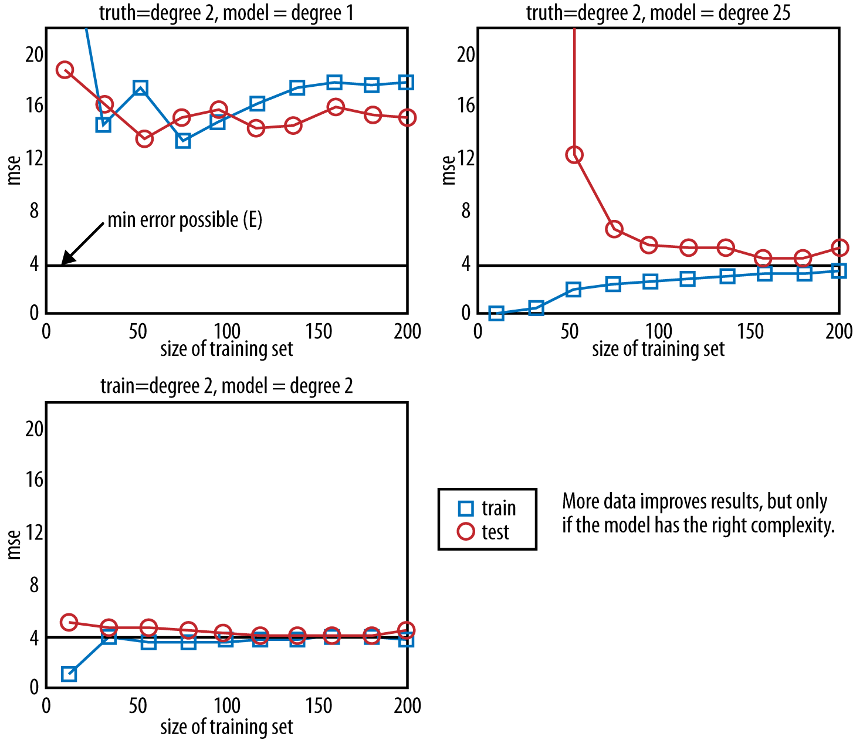

###### *Figure 3-6. Comparing mean squared error in training and test set, taken from a slide of Professor Nando de Freitas; here, the ground truth is known because it came from a dataset with data simulated from a known distribution*

**Other models for error terms**

The mean squared error is an example of what is called a loss function. This is the standard one to use in linear regression because it gives us a pretty nice measure of closeness of fit. It has the additional desirable property that by assuming that εεs are normally distributed, we can rely on the maximum likelihood principle. There are other loss functions such as one that relies on absolute value rather than squaring. It’s also possible to build custom loss functions specific to your particular problem or context, but for now, you’re safe with using mean square error.

#### Adding other predictors

What we just looked at was simple linear regression—one outcome or dependent variable and one predictor. But we can extend this model by building in other predictors, which is called multiple linear regression:

y=β0+β1x1+β2x2+β3x3+ϵ.y=β0+β1x1+β2x2+β3x3+ϵ.

All the math that we did before holds because we had expressed it in matrix notation, so it was already generalized to give the appropriate estimators for the ββ. In the example we gave of predicting time spent on the website, the other predictors could be the user’s age and gender, for example. We’ll explore feature selection more in [Chapter 7](https://learning.oreilly.com/library/view/doing-data-science/9781449363871/ch07.html#chapter-kaggle), which means figuring out which additional predictors you’d want to put in your model. The R code will just be:

model <- lm(y ~ x_1 + x_2 + x_3)

Or to add in interactions between variables:

model <- lm(y ~ x_1 + x_2*x_3)

One key here is to make scatterplots of yy against each of the predictors as well as between the predictors, and histograms of y|xy|x for various values of each of the predictors to help build intuition. As with simple linear regression, you can use the same methods to evaluate your model as described earlier: looking at R2R2, p-values, and using training and testing sets.

#### Transformations

Going back to one xx predicting one yy, why did we assume a linear relationship? Instead, maybe, a better model would be a polynomial relationship like this:

y=β0+β1x+β2x2+β3x3y=β0+β1x+β2x2+β3x3

Wait, but isn’t this linear regression? Last time we checked, polynomials weren’t linear. To think of it as linear, you transform or create new variables—for example, z=x2z=x2—and build a regression model based on zz. Other common transformations are to take the log or to pick a threshold and turn it into a binary predictor instead.

If you look at the plot of time spent versus number friends, the shape looks a little bit curvy. You could potentially explore this further by building up a model and checking to see whether this yields an improvement.

What you’re facing here, though, is one of the biggest challenges for a modeler: you never know the truth. It’s possible that the true model is quadratic, but you’re assuming linearity or vice versa. You do your best to evaluate the model as discussed earlier, but you’ll never really know if you’re right. More and more data can sometimes help in this regard as well.

### REVIEW

Let’s review the assumptions we made when we built and fit our model:

* Linearity
* Error terms normally distributed with mean 0
* Error terms independent of each other
* Error terms have constant variance across values of xx
* The predictors we’re using are the right predictors

When and why do we perform linear regression? Mostly for two reasons:

* If we want to predict one variable knowing others
* If we want to explain or understand the relationship between two or more things

### EXERCISE

To help understand and explore new concepts, you can simulate fake datasets in R. The advantage of this is that you “play God” because you actually know the underlying truth, and you get to see how good your model is at recovering the truth.

Once you’ve better understood what’s going on with your fake dataset, you can then transfer your understanding to a real one. We’ll show you how to simulate a fake dataset here, then we’ll give you some ideas for how to explore it further:

*# Simulating fake data*

x_1 <- rnorm(1000,5,7) *# from a normal distribution simulate*

*# 1000 values with a mean of 5 and*

*# standard deviation of 7*

hist(x_1, col="grey") *# plot p(x)*

true_error <- rnorm(1000,0,2)

true_beta_0 <- 1.1

true_beta_1 <- -8.2

y <- true_beta_0 + true_beta_1*x_1 + true_error

hist(y) *# plot p(y)*

plot(x_1,y, pch=20,col="red") *# plot p(x,y)*

1. Build a regression model and see that it recovers the true values of the ββs.
2. Simulate another fake variable x2x2 that has a Gamma distribution with parameters you pick. Now make the truth be that yy is a linear combination of both x1x1 and x2x2. Fit a model that only depends on x1x1. Fit a model that only depends on x2x2. Fit a model that uses both. Vary the sample size and make a plot of mean square error of the training set and of the test set versus sample size.
3. Create a new variable, zz, that is equal to x12x12. Include this as one of the predictors in your model. See what happens when you fit a model that depends on x1x1 only and then also on zz. Vary the sample size and make a plot of mean square error of the training set and of the test set versus sample size.
4. Play around more by (a) changing parameter values (the true ββs), (b) changing the distribution of the true error, and (c) including more predictors in the model with other kinds of probability distributions. (rnorm() means randomly generate values from a normal distribution. rbinom() does the same for binomial. So look up these functions online and try to find more.)
5. Create scatterplots of all pairs of variables and histograms of single variables.

## k-Nearest Neighbors (k-NN)

K-NN is an algorithm that can be used when you have a bunch of objects that have been classified or labeled in some way, and other similar objects that haven’t gotten classified or labeled yet, and you want a way to automatically label them.

The objects could be data scientists who have been classified as “sexy” or “not sexy”; or people who have been labeled as “high credit” or “low credit”; or restaurants that have been labeled “five star,” “four star,” “three star,” “two star,” “one star,” or if they really suck, “zero stars.” More seriously, it could be patients who have been classified as “high cancer risk” or “low cancer risk.”

Take a second and think whether or not linear regression would work to solve problems of this type.

OK, so the answer is: it depends. When you use linear regression, the output is a continuous variable. Here the output of your algorithm is going to be a categorical label, so linear regression wouldn’t solve the problem as it’s described.

However, it’s not impossible to solve it with linear regression plus the concept of a “threshold.” For example, if you’re trying to predict people’s credit scores from their ages and incomes, and then picked a threshold such as 700 such that if your prediction for a given person whose age and income you observed was above 700, you’d label their predicted credit as “high,” or toss them into a bin labeled “high.” Otherwise, you’d throw them into the bin labeled “low.” With more thresholds, you could also have more fine-grained categories like “very low,” “low,” “medium,” “high,” and “very high.”

In order to do it this way, with linear regression you’d have to establish the bins as ranges of a continuous outcome. But not everything is on a continuous scale like a credit score. For example, what if your labels are “likely Democrat,” “likely Republican,” and “likely independent”? What do you do now?

The intuition behind k-NN is to consider the most similar other items defined in terms of their attributes, look at their labels, and give the unassigned item the majority vote. If there’s a tie, you randomly select among the labels that have tied for first.

So, for example, if you had a bunch of movies that were labeled “thumbs up” or “thumbs down,” and you had a movie called “Data Gone Wild” that hadn’t been rated yet—you could look at its attributes: length of movie, genre, number of sex scenes, number of Oscar-winning actors in it, and budget. You could then find other movies with similar attributes, look at their ratings, and then give “Data Gone Wild” a rating without ever having to watch it.

To automate it, two decisions must be made: first, how do you define similarity or closeness? Once you define it, for a given unrated item, you can say how similar all the labeled items are to it, and you can take the most similaritems and call them neighbors, who each have a “vote.”

This brings you to the second decision: how many neighbors should you look at or “let vote”? This value is k, which ultimately you’ll choose as the data scientist, and we’ll tell you how.

Make sense? Let’s try it out with a more realistic example.

### EXAMPLE WITH CREDIT SCORES

Say you have the age, income, and a credit category of high or low for a bunch of people and you want to use the age and income to predict the credit label of “high” or “low” for a new person.

For example, here are the first few rows of a dataset, with income represented in thousands:

age income credit

69 3 low

66 57 low

49 79 low

49 17 low

58 26 high

44 71 high

You can plot people as points on the plane and label people with an empty circle if they have low credit ratings, as shown in [Figure 3-7](https://learning.oreilly.com/library/view/doing-data-science/9781449363871/ch03.html#Figure2.7).

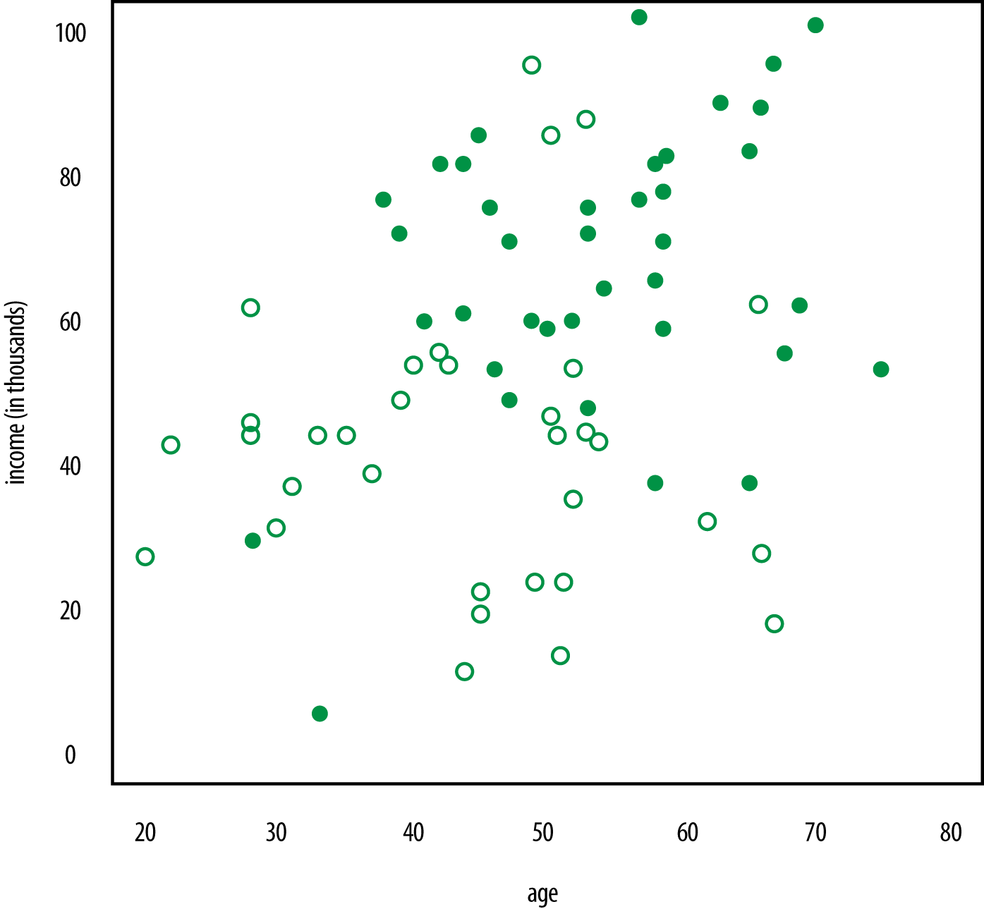

###### *Figure 3-7. Credit rating as a function of age and income*

What if a new guy comes in who is 57 years old and who makes $37,000? What’s his likely credit rating label? Look at [Figure 3-8](https://learning.oreilly.com/library/view/doing-data-science/9781449363871/ch03.html#Fig2.8). Based on the other people near him, what credit score label do you think he should be given? Let’s use k-NN to do it automatically.

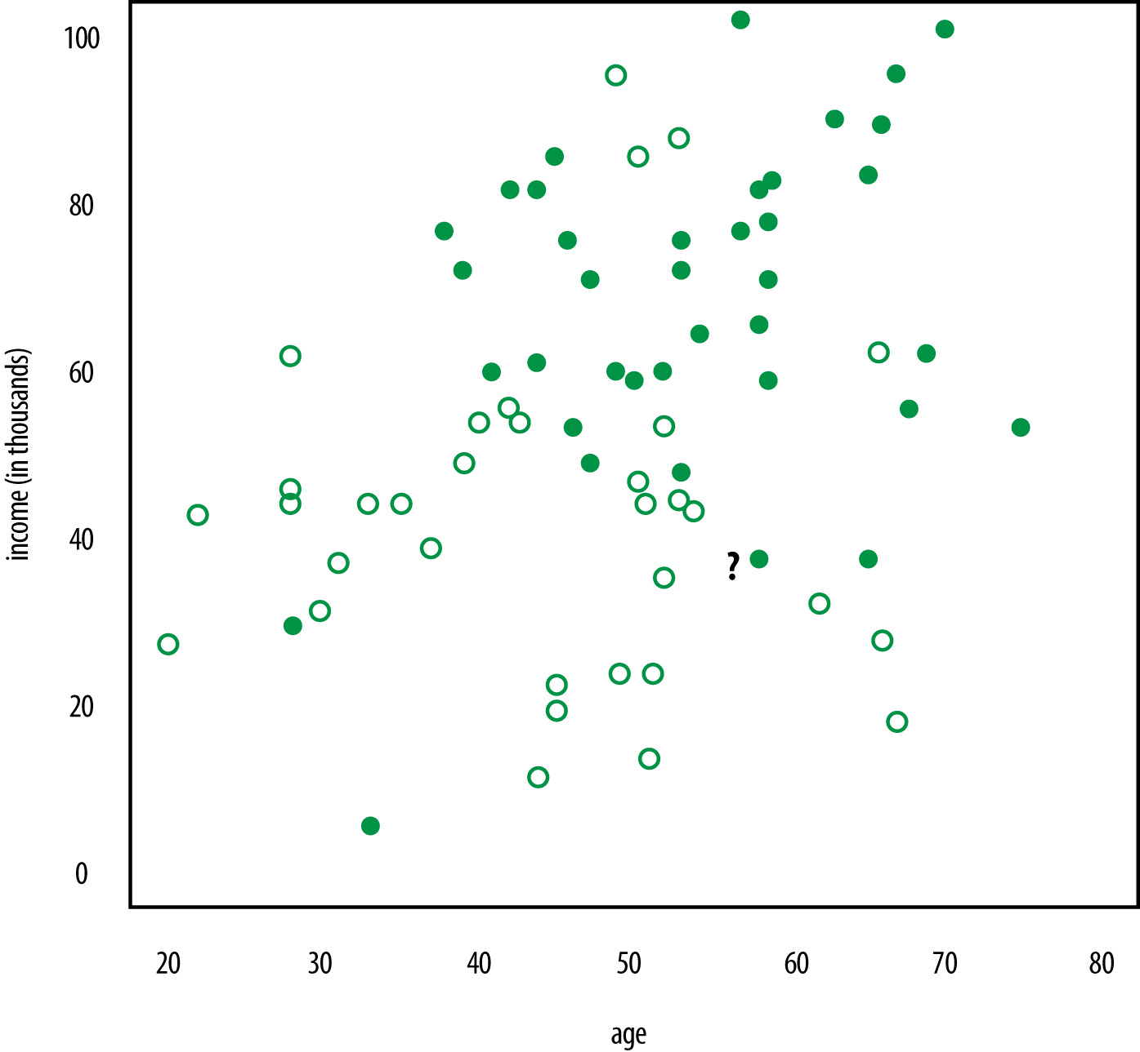

###### *Figure 3-8. What about that guy?*

Here’s an overview of the process:

1. Decide on your similarity or distance metric.
2. Split the original labeled dataset into training and test data.
3. Pick an evaluation metric. (Misclassification rate is a good one. We’ll explain this more in a bit.)
4. Run k-NN a few times, changing k and checking the evaluation measure.
5. Optimize k by picking the one with the best evaluation measure.
6. Once you’ve chosen k, use the same training set and now create a new test set with the people’s ages and incomes that you have no labels for, and want to predict. In this case, your new test set only has one lonely row, for the 57-year-old.

### SIMILARITY OR DISTANCE METRICS

Definitions of “closeness” and similarity vary depending on the context: closeness in social networks could be defined as the number of overlapping friends, for example.

For the sake of our problem of what a neighbor is, we can use Euclidean distance on the plane if the variables are on the same scale. And that can sometimes be a big IF.

##### CAUTION: MODELING DANGER AHEAD!

The scalings question is a really big deal, and if you do it wrong, your model could just suck.

Let’s consider an example: Say you measure age in years, income in dollars, and credit rating as credit scores normally are given—something like SAT scores. Then two people would be represented by triplets such as (25,54000,700)(25,54000,700) and (35,76000,730)(35,76000,730). In particular, their “distance” would be completely dominated by the difference in their salaries.

On the other hand, if you instead measured salary in thousands of dollars, they’d be represented by the triplets (25,54,700)(25,54,700) and (35,76,730)(35,76,730), which would give all three variables similar kinds of influence.

Ultimately the way you scale your variables, or equivalently in this situation the way you define your concept of distance, has a potentially enormous effect on the output. In statistics it is called your “prior.”

Euclidean distance is a good go-to distance metric for attributes that are real-valued and can be plotted on a plane or in multidimensional space. Some others are:

Cosine Similarity

Also can be used between two real-valued vectors, x→x→ and y→y→, and will yield a value between –1 (exact opposite) and 1 (exactly the same) with 0 in between meaning independent. Recall the definition cos(x→,y→)=x→⋅y→∥∥x→∥∥y→∥∥cos(x→,y→)=x→·y→∥x→∥∥y→∥.

Jaccard Distance or Similarity

This gives the distance between a set of objects—for example, a list of Cathy’s friends A={Kahn,Mark,Laura,...}A={Kahn,Mark,Laura,...} and a list of Rachel’s friends B={Mladen,Kahn,Mark,...}B={Mladen,Kahn,Mark,...}—and says how similar those two sets are: J(A,B)=|A⋂B||A⋃B|J(A,B)=|A⋂B||A⋃B|.

Mahalanobis Distance

Also can be used between two real-valued vectors and has the advantage over Euclidean distance that it takes into account correlation and is scale-invariant. d(x→,y→)=(x→−y→)TS−1(x→−y→)−−−−−−−−−−−−−−−−−−−−−√d(x→,y→)=(x→-y→)TS-1(x→-y→), where SS is the covariance matrix.

Hamming Distance

Can be used to find the distance between two strings or pairs of words or DNA sequences of the same length. The distance between olive and ocean is 4 because aside from the “o” the other 4 letters are different. The distance between shoe and hose is 3 because aside from the “e” the other 3 letters are different. You just go through each position and check whether the letters the same in that position, and if not, increment your count by 1.

Manhattan

This is also a distance between two real-valued k-dimensional vectors. The image to have in mind is that of a taxi having to travel the city streets of Manhattan, which is laid out in a grid-like fashion (you can’t cut diagonally across buildings). The distance is therefore defined as d(x→,y→)=∑ki|xi−yi|d(x→,y→)=∑ik|xi-yi|, where ii is the iith element of each of the vectors.

There are many more distance metrics available to you depending on your type of data. We start with a Google search when we’re not sure where to start.

What if your attributes are a mixture of kinds of data? This happens in the case of the movie ratings example: some were numerical attributes, such as budget and number of actors, and one was categorical, genre. But you can always define your own custom distance metric.

For example, you can say if movies are the same genre, that will contribute “0” to their distance. But if they’re of a different genre, that will contribute “10,” where you picked the value 10 based on the fact that this was on the same scale as budget (millions of dollars), which is in the range of 0 and 100. You could do the same with number of actors. You could play around with the 10; maybe 50 is better.

You’ll want to justify why you’re making these choices. The justification could be that you tried different values and when you tested the algorithm, this gave the best evaluation metric. Essentially this 10 is either a second tuning parameter that you’ve introduced into the algorithm on top of the kk, or a prior you’ve put on the model, depending on your point of view and how it’s used.

### TRAINING AND TEST SETS

For any machine learning algorithm, the general approach is to have a training phase, during which you create a model and “train it”; and then you have a testing phase, where you use new data to test how good the model is.

For k-NN, the training phase is straightforward: it’s just reading in your data with the “high” or “low” credit data points marked. In testing, you pretend you don’t know the true label and see how good you are at guessing using the k-NN algorithm.

To do this, you’ll need to save some clean data from the overall data for the testing phase. Usually you want to save randomly selected data, let’s say 20%.

Your R console might look like this:

> head(data)

age income credit

1 69 3 low

2 66 57 low

3 49 79 low

4 49 17 low

5 58 26 high

6 44 71 high

n.points <- 1000 *# number of rows in the dataset*

sampling.rate <- 0.8

*# we need the number of points in the test set to calculate*

*# the misclassification rate*

num.test.set.labels <- n.points * (1 - sampling.rate)

*# randomly sample which rows will go in the training set*

training <- sample(1:n.points, sampling.rate * n.points,

replace=**FALSE**)

*# define the training set to be those rows*

train <- subset(data[training, ], select = c(Age, Income))

*# the other rows are going into the test set*

testing <- setdiff(1:n.points, training)

*# define the test set to be the other rows*

test <- subset(data[testing, ], select = c(Age, Income))

*# this is the subset of labels for the training set*

cl <- data$Credit[training]

*# subset of labels for the test set, we're withholding these*

true.labels <- data$Credit[testing]

### PICK AN EVALUATION METRIC

How do you evaluate whether your model did a good job?

This isn’t easy or universal—you may decide you want to penalize certain kinds of misclassification more than others. False negatives may be way worse than false positives. Coming up with the evaluation metric could be something you work on with a domain expert.

For example, if you were using a classification algorithm to predict whether someone had cancer or not, you would want to minimize false negatives (misdiagnosing someone as not having cancer when they actually do), so you could work with a doctor to tune your evaluation metric.

Note you want to be careful because if you really wanted to have no false negatives, you could just tell everyonethey have cancer. So it’s a trade-off between sensitivity and specificity, where sensitivity is here defined as the probability of correctly diagnosing an ill patient as ill; specificity is here defined as the probability of correctly diagnosing a well patient as well.

# OTHER TERMS FOR SENSITIVITY AND SPECIFICITY

Sensitivity is also called the true positive rate or recall and varies based on what academic field you come from, but they all mean the same thing. And specificity is also called the true negative rate. There is also the false positive rate and the false negative rate, and these don’t get other special names.

Another evaluation metric you could use is precision, defined in [Chapter 5](https://learning.oreilly.com/library/view/doing-data-science/9781449363871/ch05.html#chapter-logistic-regression). The fact that some of the same formulas have different names is due to the fact that different academic disciplines have developed these ideas separately. So precision and recall are the quantities used in the field of information retrieval. Note that precisionis not the same thing as specificity.

Finally, we have accuracy, which is the ratio of the number of correct labels to the total number of labels, and the misclassification rate, which is just 1–accuracy. Minimizing the misclassification rate then just amounts to maximizing accuracy.

### PUTTING IT ALL TOGETHER

Now that you have a distance measure and an evaluation metric, you’re ready to roll.

For each person in your test set, you’ll pretend you don’t know his label. Look at the labels of his three nearest neighbors, say, and use the label of the majority vote to label him. You’ll label all the members of the test set and then use the misclassification rate to see how well you did. All this is done automatically in R, with just this single line of R code:

knn (train, test, cl, k=3)

### CHOOSING K

How do you choose k? This is a parameter you have control over. You might need to understand your data pretty well to get a good guess, and then you can try a few different k’s and see how your evaluation changes. So you’ll run k-nn a few times, changing k, and checking the evaluation metric each time.

# BINARY CLASSES

When you have binary classes like “high credit” or “low credit,” picking kk to be an odd number can be a good idea because there will always be a majority vote, no ties. If there is a tie, the algorithm just randomly picks.

*# we'll loop through and see what the misclassification rate*

*# is for different values of k*

for (k in 1:20) {

print(k)

predicted.labels <- knn(train, test, cl, k)

*# We're using the R function knn()*

num.incorrect.labels <- sum(predicted.labels != true.labels)

misclassification.rate <- num.incorrect.labels /

num.test.set.labels

print(misclassification.rate)

}

Here’s the output in the form (k, misclassification rate):

k misclassification.rate

1, 0.28

2, 0.315

3, 0.26

4, 0.255

5, 0.23

6, 0.26

7, 0.25

8, 0.25

9, 0.235

10, 0.24

So let’s go with k=5k=5 because it has the lowest misclassification rate, and now you can apply it to your guy who is 57 with a $37,000 salary. In the R console, it looks like:

> test <- c(57,37)

> knn(train,test,cl, k = 5)

[1] low

The output by majority vote is a low credit score when k = 5.

# TEST SET IN K-NN

Notice we used the function knn() twice and used it in different ways. In the first way, the test set was some data we were using to evaluate how good the model was. In the second way, the “test” set was actually a new data point that we wanted a prediction for. We could also have given it many rows of people who we wanted predictions for. But notice that R doesn’t know the difference whether what you’re putting in for the test set is truly a “test” set where you know the real labels, or a test set where you don’t know and want predictions.

### WHAT ARE THE MODELING ASSUMPTIONS?

In the previous chapter we discussed modeling and modeling assumptions. So what were the modeling assumptions here?

The k-NN algorithm is an example of a nonparametric approach. You had no modeling assumptions about the underlying data-generating distributions, and you weren’t attempting to estimate any parameters. But you still made some assumptions, which were:

* Data is in some feature space where a notion of “distance” makes sense.
* Training data has been labeled or classified into two or more classes.
* You pick the number of neighbors to use, kk.
* You’re assuming that the observed features and the labels are somehow associated. They may not be, but ultimately your evaluation metric will help you determine how good the algorithm is at labeling. You might want to add more features and check how that alters the evaluation metric. You’d then be tuning both whichfeatures you were using and k. But as always, you’re in danger here of overfitting.

Both linear regression and k-NN are examples of “supervised learning,” where you’ve observed both xx and yy, and you want to know the function that brings xx to yy. Next up, we’ll look at an algorithm you can use when you don’t know what the right answer is.

## k-means

So far we’ve only seen supervised learning, where we know beforehand what label (aka the “right answer”) is and we’re trying to get our model to be as accurate as possible, defined by our chosen evaluation metric.

k-means is the first unsupervised learning technique we’ll look into, where the goal of the algorithm is to determine the definition of the right answer by finding clusters of data for you.

Let’s say you have some kind of data at the user level, e.g., Google+ data, survey data, medical data, or SAT scores.

Start by adding structure to your data. Namely, assume each row of your dataset corresponds to a user as follows:

age gender income state household size

Your goal is to segment the users. This process is known by various names: besides being called segmenting, you could say that you’re going to stratify, group, or cluster the data. They all mean finding similar types of users and bunching them together.

Why would you want to do this? Here are a few examples:

* You might want to give different users different experiences. Marketing often does this; for example, to offer toner to people who are known to own printers.
* You might have a model that works better for specific groups. Or you might have different models for different groups.
* [Hierarchical modeling](http://www.stat.columbia.edu/~gelman/research/published/multi2.pdf) in statistics does something like this; for example, to separately model geographical effects from household effects in survey results.

To see why an algorithm like this might be useful, let’s first try to construct something by hand. That might mean you’d bucket users using handmade thresholds.

So for an attribute like age, you’d create bins: 20–24, 25–30, etc. The same technique could be used for other attributes like income. States or cities are in some sense their own buckets, but you might want fewer buckets, depending on your model and the number of data points. In that case, you could bucket the buckets and think of “East Coast” and “Midwest” or something like that.

Say you’ve done that for each attribute. You may have 10 age buckets, 2 gender buckets, and so on, which would result in 10 × 2 × 50 × 10 × 3 = 30,000 possible bins, which is big.

Imagine this data existing in a five-dimensional space where each axis corresponds to one attribute. So there’s a gender axis, an income axis, and so on. You can also label the various possible buckets along the corresponding axes, and if you did so, the resulting grid would consist of every possible bin—a bin for each possible combination of attributes.

Each user would then live in one of those 30,000 five-dimensional cells. But wait, it’s highly unlikely you’d want to build a different marketing campaign for each bin. So you’d have to bin the bins…

Now you likely see the utility of having an algorithm to do this for you, especially if you could choose beforehand how many bins you want. That’s exactly what k-means is: a clustering algorithm where k is the number of bins.

### 2D VERSION

Let’s back up to a simpler example than the five-dimensional one we just discussed. Let’s say you have users where you know how many ads have been shown to each user (the number of impressions) and how many times each has clicked on an ad (number of clicks).

[Figure 3-9](https://learning.oreilly.com/library/view/doing-data-science/9781449363871/ch03.html#Figure2.10) shows a simplistic picture that illustrates what this might look like.

Visually you can see in the top-left that the data naturally falls into clusters. This may be easy for you to do with your eyes when it’s only in two dimensions and there aren’t that many points, but when you get to higher dimensions and more data, you need an algorithm to help with this pattern-finding process. k-means algorithm looks for clusters in d dimensions, where d is the number of features for each data point.

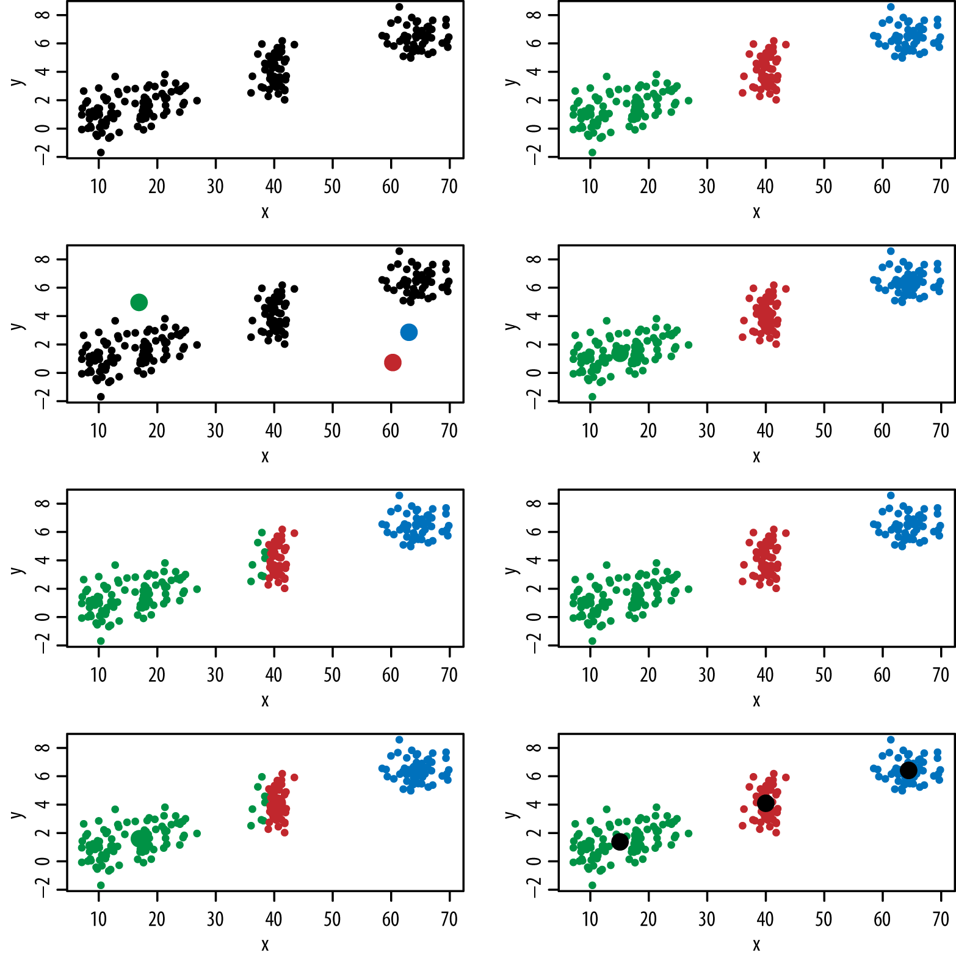

###### *Figure 3-9. Clustering in two dimensions; look at the panels in the left column from top to bottom, and then the right column from top to bottom*

Here’s how the algorithm illustrated in [Figure 3-9](https://learning.oreilly.com/library/view/doing-data-science/9781449363871/ch03.html#Figure2.10) works:

1. Initially, you randomly pick k centroids (or points that will be the center of your clusters) in d-space. Try to make them near the data but different from one another.
2. Then assign each data point to the closest centroid.
3. Move the centroids to the average location of the data points (which correspond to users in this example) assigned to it.
4. Repeat the preceding two steps until the assignments don’t change, or change very little.

It’s up to you to interpret if there’s a natural way to describe these groups once the algorithm’s done. Sometimes you’ll need to jiggle around k a few times before you get natural groupings.

This is an example of unsupervised learning because the labels are not known and are instead discovered by the algorithm.

k-means has some known issues:

* Choosing k is more an art than a science, although there are bounds: 1≤k≤n1≤k≤n, where n is number of data points.
* There are convergence issues—the solution can fail to exist, if the algorithm falls into a loop, for example, and keeps going back and forth between two possible solutions, or in other words, there isn’t a single unique solution.
* Interpretability can be a problem—sometimes the answer isn’t at all useful. Indeed that’s often the biggest problem.

In spite of these issues, it’s pretty fast (compared to other clustering algorithms), and there are broad applications in marketing, computer vision (partitioning an image), or as a starting point for other models.

In practice, this is just one line of code in R:

kmeans(x, centers, iter.max = 10, nstart = 1,

algorithm = c("Hartigan-Wong", "Lloyd", "Forgy",

"MacQueen"))

Your dataset needs to be a matrix, x, each column of which is one of your features. You specify k by selecting centers. It defaults to a certain number of iterations, which is an argument you can change. You can also select the specific algorithm it uses to discover the clusters.

##### HISTORICAL PERSPECTIVE: K-MEANS

Wait, didn’t we just describe the algorithm? It turns out there’s more than one way to go after k-means clustering.

The standard k-means algorithm is attributed to separate work by Hugo Steinhaus and Stuart Lloyd in 1957, but it wasn’t called “k-means” then. The first person to use that term was James MacQueen in 1967. It wasn’t published outside Bell Labs until 1982.

Newer versions of the algorithm are Hartigan-Wong and Lloyd and Forgy, named for their inventors and developed throughout the ’60s and ’70s. The algorithm we described is the default, Hartigan-Wong. It’s fine to use the default.

As history keeps marching on, it’s worth checking out the more recent k-means++ developed in 2007 by David Arthur and Sergei Vassilvitskii (now at Google), which helps avoid convergence issues with k-means by optimizing the initial seeds.

# Exercise: Basic Machine Learning Algorithms

Continue with the NYC (Manhattan) Housing dataset you worked with in the

preceding chapter: <http://abt.cm/1g3A12P>.

* Analyze sales using regression with any predictors you feel are relevant. Justify why regression was appropriate to use.
* Visualize the coefficients and fitted model.
* Predict the neighborhood using a k-NN classifier. Be sure to withhold a subset of the data for testing. Find the variables and the k that give you the lowest prediction error.
* Report and visualize your findings.
* Describe any decisions that could be made or actions that could be taken from this analysis.

## Solutions

In the preceding chapter, we showed how to explore and clean this dataset, so you’ll want to do that first before you build your regression model. Following are two pieces of R code. The first shows how you might go about building your regression models, and the second shows how you might clean and prepare your data and then build a k-NN classifier.

### SAMPLE R CODE: LINEAR REGRESSION ON THE HOUSING DATASET

Author: Ben Reddy

model1 <- lm(log(sale.price.n) ~ log(gross.sqft),data=bk.homes)

*## what's going on here?*

bk.homes[which(bk.homes$gross.sqft==0),]

bk.homes <- bk.homes[which(bk.homes$gross.sqft>0 &

bk.homes$land.sqft>0),]

model1 <- lm(log(sale.price.n) ~ log(gross.sqft),data=bk.homes)

summary(model1)

plot(log(bk.homes$gross.sqft),log(bk.homes$sale.price.n))

abline(model1,col="red",lwd=2)

plot(resid(model1))

model2 <- lm(log(sale.price.n) ~ log(gross.sqft) +

log(land.sqft) + factor(neighborhood),data=bk.homes)

summary(model2)

plot(resid(model2))

*## leave out intercept for ease of interpretability*

model2a <- lm(log(sale.price.n) ~ 0 + log(gross.sqft) +

log(land.sqft) + factor(neighborhood),data=bk.homes)

summary(model2a)

plot(resid(model2a))

*## add building type*

model3 <- lm(log(sale.price.n) ~ log(gross.sqft) +

log(land.sqft) + factor(neighborhood) +

factor(building.class.category),data=bk.homes)

summary(model3)

plot(resid(model3))

*## interact neighborhood and building type*

model4 <- lm(log(sale.price.n) ~ log(gross.sqft) +

log(land.sqft) + factor(neighborhood)*

factor(building.class.category),data=bk.homes)

summary(model4)

plot(resid(model4))

### SAMPLE R CODE: K-NN ON THE HOUSING DATASET

Author: Ben Reddy

require(gdata)

require(geoPlot)

require(class)

mt <- read.xls("rollingsales_manhattan.xls",

pattern="BOROUGH",stringsAsFactors=**FALSE**)

head(mt)

summary(mt)

names(mt) <- tolower(names(mt))

mt$sale.price.n <- as.numeric(gsub("[^[:digit:]]","",

mt$sale.price))

sum(is.na(mt$sale.price.n))

sum(mt$sale.price.n==0)

names(mt) <- tolower(names(mt))

*## clean/format the data with regular expressions*

mt$gross.sqft <- as.numeric(gsub("[^[:digit:]]","",

mt$gross.square.feet))

mt$land.sqft <- as.numeric(gsub("[^[:digit:]]","",

mt$land.square.feet))

mt$sale.date <- as.Date(mt$sale.date)

mt$year.built <- as.numeric(as.character(mt$year.built))

mt$zip.code <- as.character(mt$zip.code)

*## - standardize data (set year built start to 0; land and gross sq ft; sale price (exclude $0 and possibly others); possibly tax block; outside dataset for coords of tax block/lot?)*

min_price <- 10000

mt <- mt[which(mt$sale.price.n>=min_price),]

n_obs <- dim(mt)[1]

mt$address.noapt <- gsub("[,][[:print:]]*","",

gsub("[ ]+"," ",trim(mt$address)))

mt_add <- unique(data.frame(mt$address.noapt,mt$zip.code,

stringsAsFactors=**FALSE**))

names(mt_add) <- c("address.noapt","zip.code")

mt_add <- mt_add[order(mt_add$address.noapt),]

*#find duplicate addresses with different zip codes*

dup <- duplicated(mt_add$address.noapt)

*# remove them*

dup_add <- mt_add[dup,1]

mt_add <- mt_add[(mt_add$address.noapt != dup_add[1] &

mt_add$address.noapt != dup_add[2]),]

n_add <- dim(mt_add)[1]

*# sample 500 addresses so we don't run over our Google Maps API daily limit (and so we're not waiting forever)*

n_sample <- 500

add_sample <- mt_add[sample.int(n_add,size=n_sample),]

*# first, try a query with the addresses we have*

query_list <- addrListLookup(data.frame(1:n_sample,

add_sample$address.noapt,rep("NEW YORK",times=n_sample),

rep("NY",times=n_sample),add_sample$zip.code,

rep("US",times=n_sample)))[,1:4]

query_list$matched <- (query_list$latitude != 0)

unmatched_inds <- which(!query_list$matched)

unmatched <- length(unmatched_inds)

*# try changing EAST/WEST to E/W*

query_list[unmatched_inds,1:4] <- addrListLookup

(data.frame(1:unmatched,gsub(" WEST "," W ",

gsub(" EAST "," E ",add_sample[unmatched_inds,1])),

rep("NEW YORK",times=unmatched), rep("NY",times=unmatched),

add_sample[unmatched_inds,2],rep("US",times=unmatched)))[,1:4]

query_list$matched <- (query_list$latitude != 0)

unmatched_inds <- which(!query_list$matched)

unmatched <- length(unmatched_inds)

*# try changing STREET/AVENUE to ST/AVE*

query_list[unmatched_inds,1:4] <- addrListLookup

(data.frame(1:unmatched,gsub(" WEST "," W ",

gsub(" EAST "," E ",gsub(" STREET"," ST",

gsub(" AVENUE"," AVE",add_sample[unmatched_inds,1])))),

rep("NEW YORK",times=unmatched), rep("NY",times=unmatched),

add_sample[unmatched_inds,2],rep("US",times=unmatched)))[,1:4]

query_list$matched <- (query_list$latitude != 0)

unmatched_inds <- which(!query_list$matched)

unmatched <- length(unmatched_inds)

*## have to be satisfied for now*

add_sample <- cbind(add_sample,query_list$latitude,

query_list$longitude)

names(add_sample)[3:4] <- c("latitude","longitude")

add_sample <- add_sample[add_sample$latitude!=0,]

add_use <- merge(mt,add_sample)

add_use <- add_use[!is.na(add_use$latitude),]

*# map coordinates*

map_coords <- add_use[,c(2,4,26,27)]

table(map_coords$neighborhood)

map_coords$neighborhood <- as.factor(map_coords$neighborhood)

geoPlot(map_coords,zoom=12,color=map_coords$neighborhood)

*## - knn function*

*## - there are more efficient ways of doing this,*

*## but oh well...*

map_coords$class <- as.numeric(map_coords$neighborhood)

n_cases <- dim(map_coords)[1]

split <- 0.8

train_inds <- sample.int(n_cases,floor(split*n_cases))

test_inds <- (1:n_cases)[-train_inds]

k_max <- 10

knn_pred <- matrix(**NA**,ncol=k_max,nrow=length(test_inds))

knn_test_error <- rep(**NA**,times=k_max)

for (i in 1:k_max) {

knn_pred[,i] <- knn(map_coords[train_inds,3:4],

map_coords[test_inds,3:4],cl=map_coords[train_inds,5],k=i)

knn_test_error[i] <- sum(knn_pred[,i]!=

map_coords[test_inds,5])/length(test_inds)

}

plot(1:k_max,knn_test_error)

##### MODELING AND ALGORITHMS AT SCALE

The data you’ve been dealing with so far in this chapter has been pretty small on the Big Data spectrum. What happens to these models and algorithms when you have to scale up to massive datasets?

In some cases, it’s entirely appropriate to sample and work with a smaller dataset, or to run the same model across multiple sharded datasets. (Sharding is where the data is broken up into pieces and divided among diffrent machines, and then you look at the empirical distribution of the estimators across models.) In other words, there are statistical solutions to these engineering challenges.

However, in some cases we want to fit these models at scale, and the challenge of scaling up models generally translates to the challenge of creating parallelized versions or approximations of the optimization methods. Linear regression at scale, for example, relies on matrix inversions or approximations of matrix inversions.

Optimization with Big Data calls for new approaches and theory—this is the frontier! From a 2013 talk by Peter Richtarik from the University of Edinburgh: “In the Big Data domain classical approaches that rely on optimization methods with multiple iterations are not applicable as the computational cost of even a single iteration is often too excessive; these methods were developed in the past when problems of huge sizes were rare to find. We thus need new methods which would be simple, gentle with data handling and memory requirements, and scalable. Our ability to solve truly huge scale problems goes hand in hand with our ability to utilize modern parallel computing architectures such as multicore processors, graphical processing units, and computer clusters.”

Much of this is outside the scope of the book, but a data scientist needs to be aware of these issues, and some of this is discussed in [Chapter 14](https://learning.oreilly.com/library/view/doing-data-science/9781449363871/ch14.html#chapter-mapreduce-hadoop).

# Summing It All Up

We’ve now introduced you to three algorithms that are the basis for the solutions to many real-world problems. If you understand these three, you’re already in good shape. If you don’t, don’t worry, it takes a while to sink in.

Regression is the basis of many forecasting and classification or prediction models in a variety of contexts. We showed you how you can predict a continuous outcome variable with one or more predictors. We’ll revisit it again in [Chapter 5](https://learning.oreilly.com/library/view/doing-data-science/9781449363871/ch05.html#chapter-logistic-regression), where we’ll learn logistic regression, which can be used for classification of binary outcomes; and in [Chapter 6](https://learning.oreilly.com/library/view/doing-data-science/9781449363871/ch06.html#chapter-financial-modeling), where we see it in the context of time series modeling. We’ll also build up your feature selection skills in [Chapter 7](https://learning.oreilly.com/library/view/doing-data-science/9781449363871/ch07.html#chapter-kaggle).

k-NN and k-means are two examples of clustering algorithms, where we want to group together similar objects. Here the notions of distance and evaluation measures became important, and we saw there is some subjectivity involved in picking these. We’ll explore clustering algorithms including Naive Bayes in the next chapter, and in the context of social networks ([Chapter 10](https://learning.oreilly.com/library/view/doing-data-science/9781449363871/ch10.html#chapter-social-networks-data-journalism)). As we’ll see, graph clustering is an interesting area of research. Other examples of clustering algorithms not explored in this book are hierarchical clustering and model-based clustering.

For further reading and a more advanced treatment of this material, we recommend the standard classic Hastie and Tibshirani book, [Elements of Statistical Learning](http://stanford.io/16hcTKn) (Springer). For an in-depth exploration of building regression models in a Bayesian context, we highly recommend Andrew Gelman and Jennifer Hill’s Data Analysis using Regression and Multilevel/Hierarchical *Models*.

# Thought Experiment: Automated Statistician

Rachel attended a workshop in Big Data Mining at Imperial College London in May 2013. One of the speakers, Professor Zoubin Ghahramani from Cambridge University, said that one of his long-term research projects was to build an “automated statistician.” What do you think that means? What do you think would go into building one?

Does the idea scare you? Should it?

# Chapter 4. Spam Filters, Naive Bayes, and Wrangling

The contributor for this chapter is [Jake Hofman](http://www.jakehofman.com/). Jake is at [Microsoft Research](http://research.microsoft.com/) after recently leaving Yahoo! Research. He got a PhD in physics at Columbia and regularly teaches a [fantastic course](http://jakehofman.com/ddm) on data-driven modeling at Columbia, as well as a newer course in computational social science.

As with our other presenters, we first took a look at Jake’s data science profile. It turns out he is an expert on a category that he added to the data science profile called “data wrangling.” He confessed that he doesn’t know if he spends so much time on it because he’s good at it or because he’s bad at it. (He’s good at it.)

# Thought Experiment: Learning by Example

Let’s start by looking at a bunch of text shown in [Figure 4-1](https://learning.oreilly.com/library/view/doing-data-science/9781449363871/ch04.html#SPAMMY), whose rows seem to contain the subject and first line of an email in an inbox.

You may notice that several of the rows of text look like spam.

How did you figure this out? Can you write code to automate the spam filter that your brain represents?



###### *Figure 4-1. Suspiciously spammy*

Rachel’s class had a few ideas about what things might be clear signs of spam:

* Any email is spam if it contains Viagra references. That’s a good rule to start with, but as you’ve likely seen in your own email, people figured out this spam filter rule and got around it by modifying the spelling. (It’s sad that spammers are so smart and aren’t working on more important projects than selling lots of Viagra…)
* Maybe something about the length of the subject gives it away as spam, or perhaps excessive use of exclamation points or other punctuation. But some words like “Yahoo!” are authentic, so you don’t want to make your rule too simplistic.

And here are a few suggestions regarding code you could write to identify spam:

* Try a probabilistic model. In other words, should you not have simple rules, but have many rules of thumb that aggregate together to provide the probability of a given email being spam? This is a great idea.
* What about k-nearest neighbors or linear regression? You learned about these techniques in the previous chapter, but do they apply to this kind of problem? (Hint: the answer is “No.”)

In this chapter, we’ll use Naive Bayes to solve this problem, which is in some sense in between the two. But first…

## Why Won’t Linear Regression Work for Filtering Spam?

Because we’re already familiar with linear regression and that’s a tool in our toolbelt, let’s start by talking through what we’d need to do in order to try to use linear regression. We already know that’s not what we’re going to use, but let’s talk it through to get to why. Imagine a dataset or matrix where each row represents a different email message (it could be keyed by email_id). Now let’s make each word in the email a feature—this means that we create a column called “Viagra,” for example, and then for any message that has the word Viagra in it at least once, we put a 1 in; otherwise we assign a 0. Alternatively, we could put the number of times the word appears. Then each column represents the appearance of a different word.

Thinking back to the previous chapter, in order to use linear regression, we need to have a training set of emails where the messages have already been labeled with some outcome variable. In this case, the outcomes are either spam or not. We could do this by having human evaluators label messages “spam,” which is a reasonable, albeit time-intensive, solution. Another way to do it would be to take an existing spam filter such as Gmail’s spam filter and use those labels. (Now of course if you already had a Gmail spam filter, it’s hard to understand why you might also want to build another spam filter in the first place, but let’s just say you do.) Once you build a model, email messages would come in without a label, and you’d use your model to predict the labels.

The first thing to consider is that your target is binary (0 if not spam, 1 if spam)—you wouldn’t get a 0 or a 1 using linear regression; you’d get a number. Strictly speaking, this option really isn’t ideal; linear regression is aimed at modeling a continuous output and this is binary.

This issue is basically a nonstarter. We should use a model appropriate for the data. But if we wanted to fit it in R, in theory it could still work. R doesn’t check for us whether the model is appropriate or not. We could go for it, fit a linear model, and then use that to predict and then choose a critical value so that above that predicted value we call it “1” and below we call it “0.”

But if we went ahead and tried, it still wouldn’t work because there are too many variables compared to observations! We have on the order of 10,000 emails with on the order of 100,000 words. This won’t work. Technically, this corresponds to the fact that the matrix in the equation for linear regression is not invertible—in fact, it’s not even close. Moreover, maybe we can’t even store it because it’s so huge.

Maybe we could limit it to the top 10,000 words? Then we could at least have an invertible matrix. Even so, that’s too many variables versus observations to feel good about it. With carefully chosen feature selection and domain expertise, we could limit it to 100 words and that could be enough! But again, we’d still have the issue that linear regression is not the appropriate model for a binary outcome.

# ASIDE: STATE OF THE ART FOR SPAM FILTERS

In the last five years, people have started using stochastic gradient methods to avoid the noninvertible (overfitting) matrix problem. Switching to logistic regression with stochastic gradient methods helped a lot, and can account for correlations between words. Even so, Naive Bayes is pretty impressively good considering how simple it is.

## How About k-nearest Neighbors?

We’re going to get to Naive Bayes shortly, we promise, but let’s take a minute to think about trying to use k-nearest neighbors (k-NN) to create a spam filter. We would still need to choose features, probably corresponding to words, and we’d likely define the value of those features to be 0 or 1, depending on whether the word is present or not. Then, we’d need to define when two emails are “near” each other based on which words they both contain.

Again, with 10,000 emails and 100,000 words, we’ll encounter a problem, different from the noninvertible matrix problem. Namely, the space we’d be working in has too many dimensions. Yes, computing distances in a 100,000-dimensional space requires lots of computational work. But that’s not the real problem.

The real problem is even more basic: even our nearest neighbors are really far away. This is called “the curse of dimensionality,” and it makes k-NN a poor algorithm in this case.

##### ASIDE: DIGIT RECOGNITION

Say you want an algorithm to recognize pictures of hand-written digits as shown in [Figure 4-2](https://learning.oreilly.com/library/view/doing-data-science/9781449363871/ch04.html#Figure3.2). In this case, k-NN works well.

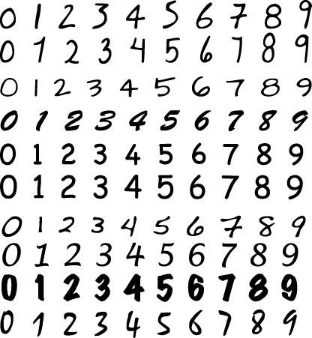

###### *Figure 4-2. Handwritten digits*

To set it up, you take your underlying representation apart pixel by pixel—say in a 16x16 grid of pixels—and measure how bright each pixel is. Unwrap the 16x16 grid and put it into a 256-dimensional space, which has a natural archimedean metric. That is to say, the distance between two different points on this space is the square root of the sum of the squares of the differences between their entries. In other words, it’s the length of the vector going from one point to the other or vice versa. Then you apply the k-NN algorithm.

If you vary the number of neighbors, it changes the shape of the boundary, and you can tune k to prevent overfitting. If you’re careful, you can get 97% accuracy with a sufficiently large dataset.

Moreover, the result can be viewed in a “confusion matrix.” A confusion matrix is used when you are trying to classify objects into kk bins, and is a k×kk×k matrix corresponding to actual label versus predicted label, and the (i,j)(i,j)th element of the matrix is a count of the number of items that were actually labeled ii that were predicted to have label jj. From a confusion matrix, you can get accuracy, the proportion of total predictions that were correct. In the previous chapter, we discussed the misclassification rate. Notice that accuracy = 1 - misclassification rate.

# Naive Bayes

So are we at a loss now that two methods we’re familiar with, linear regression and k-NN, won’t work for the spam filter problem? No! Naive Bayes is another classification method at our disposal that scales well and has nice intuitive appeal.

## Bayes Law

Let’s start with an even simpler example than the spam filter to get a feel for how Naive Bayes works. Let’s say we’re testing for a rare disease, where 1% of the population is infected. We have a highly sensitive and specific test, which is not quite perfect:

* 99% of sick patients test positive.
* 99% of healthy patients test negative.

Given that a patient tests positive, what is the probability that the patient is actually sick?

A naive approach to answering this question is this: Imagine we have 100 × 100 = 10,000 perfectly representative people. That would mean that 100 are sick, and 9,900 are healthy. Moreover, after giving all of them the test we’d get 99 sick people testing sick, but 99 healthy people testing sick as well. If you test positive, in other words, you’re equally likely to be healthy or sick; the answer is 50%. A tree diagram of this approach is shown in [Figure 4-3](https://learning.oreilly.com/library/view/doing-data-science/9781449363871/ch04.html#Figure3.5).

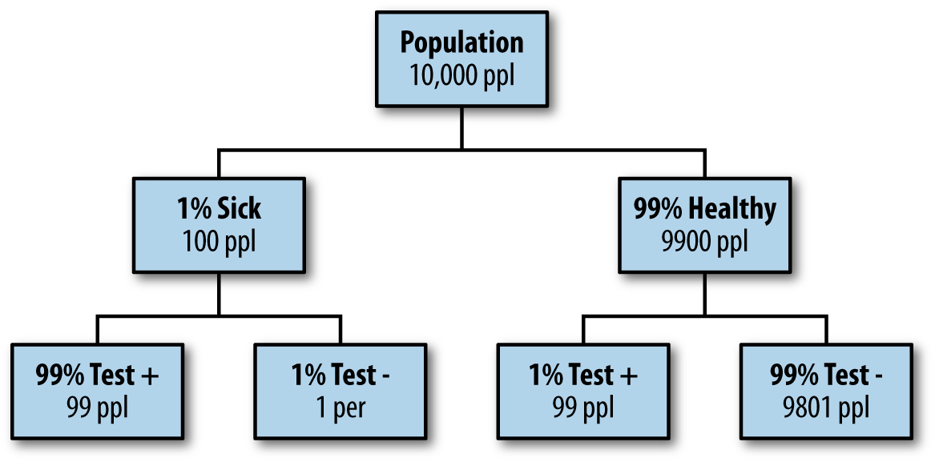

###### *Figure 4-3. Tree diagram to build intuition*

Let’s do it again using fancy notation so we’ll feel smart.

Recall from your basic statistics course that, given events xx and yy, there’s a relationship between the probabilities of either event (denoted p(x)p(x) and p(y)p(y)), the joint probabilities (both happen, which is denoted p(x,y)p(x,y)), and conditional probabilities (event xx happens given yy happens, denoted p(x|y)p(x|y)) as follows:

p(y|x)p(x)=p(x,y)=p(x|y)p(y)p(y|x)p(x)=p(x,y)=p(x|y)p(y)

Using that, we solve for p(y|x)p(y|x) (assuming p(x)≠0p(x)≠0) to get what is called Bayes’ Law:

p(y|x)=p(x|y)p(y)p(x)p(y|x)=p(x|y)p(y)p(x)

The denominator term, p(x),p(x), is often implicitly computed and can thus be treated as a “normalization constant.” In our current situation, set yy to refer to the event “I am sick,” or “sick” for shorthand; and set xx to refer to the event “the test is positive,” or “+” for shorthand. Then we actually know, or at least can compute, every term:

p(sick|+)=p(+|sick)p(sick)p(+)=0.99⋅0.010.99⋅0.01+0.01⋅0.99=0.50=50%p(sick|+)=p(+|sick)p(sick)p(+)=0.99·0.010.99·0.01+0.01·0.99=0.50=50%

## A Spam Filter for Individual Words

So how do we use Bayes’ Law to create a good spam filter? Think about it this way: if the word “Viagra” appears, this adds to the probability that the email is spam. But it’s not conclusive, yet. We need to see what else is in the email.

Let’s first focus on just one word at a time, which we generically call “word.” Then, applying Bayes’ Law, we have:

p(spam|word)=p(word|spam)p(spam)p(word)p(spam|word)=p(word|spam)p(spam)p(word)

The righthand side of this equation is computable using enough pre-labeled data. If we refer to nonspam as “ham” then we only need compute p(word|spam), p(word|ham), p(spam), and p(ham) = 1-p(spam), because we can work out the denominator using the formula we used earlier in our medical test example, namely:

p(word)=p(word|spam)p(spam)+p(word|ham)p(ham)p(word)=p(word|spam)p(spam)+p(word|ham)p(ham)

In other words, we’ve boiled it down to a counting exercise: p(spam)p(spam) counts spam emails versus all emails, p(word|spam)p(word|spam) counts the prevalence of those spam emails that contain “word,” and p(word|ham)p(word|ham) counts the prevalence of the ham emails that contain “word.”

To do this yourself, go online and download [Enron emails](https://www.cs.cmu.edu/~enron/). Let’s build a spam filter on that dataset. This really means we’re building a new spam filter on top of the spam filter that existed for the employees of Enron. We’ll use their definition of spam to train our spam filter. (This does mean that if the spammers have learned anything since 2001, we’re out of luck.)

We could write a quick-and-dirty shell script in bash that runs this, which Jake did. It downloads and unzips the file and creates a folder; each text file is an email; spam and ham go in separate folders.

Let’s look at some basic statistics on a random Enron employee’s email. We can count 1,500 spam versus 3,672 ham, so we already know p(spam)p(spam) and p(ham)p(ham). Using command-line tools, we can also count the number of instances of the word “meeting” in the spam folder:

grep -il meeting enron1/spam/*.txt | wc -l

This gives 16. Do the same for his ham folder, and we get 153. We can now compute the chance that an email is spam only knowing it contains the word “meeting”:

pˆ(spam)=1500/(1500+3672)=.29p^(spam)=1500/(1500+3672)=.29

pˆ(ham)=.71p^(ham)=.71

pˆ(meeting|spam)=16/1500=.0106p^(meeting|spam)=16/1500=.0106

pˆ(meeting|ham)=153/3672=.0416p^(meeting|ham)=153/3672=.0416

pˆ(spam|meeting)=pˆ(meeting|spam)*pˆ(spam)/pˆ(meeting)=(.0106*.29)/(.0106*.29+.0416*.71)=0.09=9%p^(spam|meeting)=p^(meeting|spam)*p^(spam)/p^(meeting)=(.0106*.29)/(.0106*.29+.0416*.71)=0.09=9%

Take note that we didn’t need a fancy programming environment to get this done.

Next, we can try:

* “money”: 80% chance of being spam
* “viagra”: 100% chance
* “enron”: 0% chance

This illustrates that the model, as it stands, is overfitting; we are getting overconfident because of biased data. Is it really a slam-dunk that any email containing the word “Viagra” is spam? It’s of course possible to write a nonspam email with the word “Viagra,” as well as a spam email with the word “Enron.”

## A Spam Filter That Combines Words: Naive Bayes

Next, let’s do it for all the words. Each email can be represented by a binary vector, whose jjth entry is 1 or 0 depending on whether the jjth word appears. Note this is a huge-ass vector, considering how many words we have, and we’d probably want to represent it with the indices of the words that actually show up.

The model’s output is the probability that we’d see a given word vector given that we know it’s spam (or that it’s ham). Denote the email vector to be xx and the various entries xjxj, where the jj indexes the words. For now we can denote “is spam” by cc, and we have the following model for p(x|c),p(x|c), i.e., the probability that the email’s vector looks like this considering it’s spam:

p(x|c)=∏jθjcxj(1−θjc)(1−xj)p(x|c)=∏jθjcxj(1-θjc)(1-xj)

The θθ here is the probability that an individual word is present in a spam email. We saw how to compute that in the previous section via counting, and so we can assume we’ve separately and parallelly computed that for every word.

We are modeling the words independently (also known as “independent trials”), which is why we take the product on the righthand side of the preceding formula and don’t count how many times they are present. That’s why this is called “naive,” because we know that there are actually certain words that tend to appear together, and we’re ignoring this.

So back to the equation, it’s a standard trick when we’re dealing with a product of probabilities to take the log of both sides to get a summation instead:

log(p(x|c))=∑jxjlog(θj/(1−θj))+∑jlog(1−θj)log(p(x|c))=∑jxjlog(θj/(1-θj))+∑jlog(1-θj)

###### NOTE

It’s helpful to take the log because multiplying together tiny numbers can give us numerical problems.

The term log(θj/(1−θj))log(θj/(1-θj)) doesn’t depend on a given email, just the word, so let’s rename it wjwj and assume we’ve computed it once and stored it. Same with the quantity ∑jlog(1−θj)=w0∑jlog(1-θj)=w0. Now we have:

log(p(x|c))=∑jxjwj+w0log(p(x|c))=∑jxjwj+w0

The weights that vary by email are the xjxjs. We need to compute them separately for each email, but that shouldn’t be too hard.

We can put together what we know to compute p(x|c),p(x|c), and then use Bayes’ Law to get an estimate of p(c|x),p(c|x),which is what we actually want—the other terms in Bayes’ Law are easier than this and don’t require separate calculations per email. We can also get away with not computing all the terms if we only care whether it’s more likely to be spam or to be ham. Then only the varying term needs to be computed.

You may notice that this ends up looking like a linear regression, but instead of computing the coefficients wjwj by inverting a huge matrix, the weights come from the Naive Bayes’ algorithm.

This algorithm works pretty well, and it’s “cheap” to train if we have a prelabeled dataset to train on. Given a ton of emails, we’re more or less just counting the words in spam and nonspam emails. If we get more training data, we can easily increment our counts to improve our filter. In practice, there’s a global model, which we personalize to individuals. Moreover, there are lots of hardcoded, cheap rules before an email gets put into a fancy and slow model.

Here are some references for more about Bayes’ Law:

* [“Idiot’s Bayes - not so stupid after all?”](http://goo.gl/sD86Oj) (The whole paper is about why it doesn’t suck, which is related to redundancies in language.)
* [“Naive Bayes at Forty: The Independence Assumption in Information”](http://goo.gl/JqjRg3)
* [“Spam Filtering with Naive Bayes - Which Naive Bayes?”](http://goo.gl/74CxlZ)

# Fancy It Up: Laplace Smoothing

Remember the θjθj from the previous section? That referred to the probability of seeing a given word (indexed by jj) in a spam email. If you think about it, this is just a ratio of counts: θj=njs/njc,θj=njs/njc, where njsnjs denotes the number of times that word appears in a spam email and njcnjc denotes the number of times that word appears in any email.

Laplace Smoothing refers to the idea of replacing our straight-up estimate of θjθj with something a bit fancier:

θjc=(njs+α)/(njc+β)θjc=(njs+α)/(njc+β)

We might fix α=1α=1 and β=10,β=10, for example, to prevent the possibility of getting 0 or 1 for a probability, which we saw earlier happening with “viagra.” Does this seem totally ad hoc? Well, if we want to get fancy, we can see this as equivalent to having a prior and performing a maximal likelihood estimate. Let’s get fancy! If we denote by MLML the maximal likelihood estimate, and by DD the dataset, then we have:

θML=argmaxθp(D|θ)θML=argmaxθp(D|θ)

In other words, the vector of values θjθj is the answer to the question: for what value of θθ were the data D most probable? If we assume independent trials again, as we did in our first attempt at Naive Bayes, then we want to choose the θjθj to separately maximize the following quantity for each jj:

log(θjnjs(1−θj)njc−njs)log(θjnjs(1-θj)njc-njs)

If we take the derivative, and set it to zero, we get:

θjˆ=njs/njcθj^=njs/njc

In other words, just what we had before. So what we’ve found is that the maximal likelihood estimate recovers your result, as long as we assume independence.

Now let’s add a prior. For this discussion we can suppress the jj from the notation for clarity, but keep in mind that we are fixing the jjth word to work on. Denote by MAPMAP the [maximum a posteriori likelihood](http://en.wikipedia.org/wiki/Maximum_a_posteriori_estimation):

θMAP=argmaxp(θ|D)θMAP=argmaxp(θ|D)

This similarly answers the question: given the data I saw, which parameter θθ is the most likely?

Here we will apply the spirit of Bayes’s Law to transform θMAPθMAP to get something that is, up to a constant, equivalent to p(D|θ)⋅p(θ)p(D|θ)·p(θ). The term p(θ)p(θ) is referred to as the “prior,” and we have to make an assumption about its form to make this useful. If we make the assumption that the probability distribution of θθ is of the form θα(1−θ)β,θα(1-θ)β, for some αα and β,β, then we recover the Laplace Smoothed result.

##### IS THAT A REASONABLE ASSUMPTION?

Recall that θθ is the chance that a word is in spam if that word is in some email. On the one hand, as long as both α>0α>0 and β>0,β>0, this distribution vanishes at both 0 and 1. This is reasonable: you want very few words to be expected to never appear in spam or to always appear in spam.

On the other hand, when αα and ββ are large, the shape of the distribution is bunched in the middle, which reflects the prior that most words are equally likely to appear in spam or outside spam. That doesn’t seem true either.

A compromise would have αα and ββ be positive but small, like 1/5. That would keep your spam filter from being too overzealous without having the wrong idea. Of course, you could relax this prior as you have more and better data; in general, strong priors are only needed when you don’t have sufficient data.

# Comparing Naive Bayes to k-NN

Sometimes αα and ββ are called “pseudocounts.” Another common name is “hyperparameters.” They’re fancy but also simple. It’s up to you, the data scientist, to set the values of these two hyperparameters in the numerator and denominator for smoothing, and it gives you two knobs to tune. By contrast, k-NN has one knob, namely k, the number of neighbors. Naive Bayes is a linear classifier, while k-NN is not. The curse of dimensionality and large feature sets are a problem for k-NN, while Naive Bayes performs well. k-NN requires no training (just load in the dataset), whereas Naive Bayes does. Both are examples of supervised learning (the data comes labeled).

# Sample Code in bash

*#!/bin/bash*

*#*

*# file: enron_naive_bayes.sh*

*#*

*# description: trains a simple one-word naive bayes spam*

*# filter using enron email data*

*#*

*# usage: ./enron_naive_bayes.sh <word>*

*#*

*# requirements:*

*# wget*

*#*

*# author: jake hofman (gmail: jhofman)*

*#*

*# how to use the code*

**if** [ $# -eq 1 ]

**then**

word=$1

**else**

echo "usage: enron_naive_bayes.sh <word>"

exit

**fi**

*# if the file doesn't exist, download from the web*

**if** ! [ -e enron1.tar.gz ]

**then**

wget 'http://www.aueb.gr/users/ion/data/

enron-spam/preprocessed/enron1.tar.gz'

**fi**

*# if the directory doesn't exist, uncompress the .tar.gz*

**if** ! [ -d enron1 ]

**then**

tar zxvf enron1.tar.gz

**fi**

*# change into enron1*

cd enron1

*# get counts of total spam, ham, and overall msgs*

Nspam=`ls -l spam/*.txt | wc -l`

Nham=`ls -l ham/*.txt | wc -l`

Ntot=$Nspam+$Nham

echo $Nspam spam examples

echo $Nham ham examples

*# get counts containing word in spam and ham classes*

Nword_spam=`grep -il $word spam/*.txt | wc -l`

Nword_ham=`grep -il $word ham/*.txt | wc -l`

echo $Nword_spam "spam examples containing $word"

echo $Nword_ham "ham examples containing $word"

*# calculate probabilities using bash calculator "bc"*

Pspam=`echo "scale=4; $Nspam / ($Nspam+$Nham)" | bc`

Pham=`echo "scale=4; 1-$Pspam" | bc`

echo

echo "estimated P(spam) =" $Pspam

echo "estimated P(ham) =" $Pham

Pword_spam=`echo "scale=4; $Nword_spam / $Nspam" | bc`

Pword_ham=`echo "scale=4; $Nword_ham / $Nham" | bc`

echo "estimated P($word|spam) =" $Pword_spam

echo "estimated P($word|ham) =" $Pword_ham

Pspam_word=`echo "scale=4; $Pword_spam*$Pspam" | bc`

Pham_word=`echo "scale=4; $Pword_ham*$Pham" | bc`

Pword=`echo "scale=4; $Pspam_word+$Pham_word" | bc`

Pspam_word=`echo "scale=4; $Pspam_word / $Pword" | bc`

echo

echo "P(spam|$word) =" $Pspam_word

*# return original directory*

cd ..

# Scraping the Web: APIs and Other Tools

As a data scientist, you’re not always just handed some data and asked to go figure something out based on it. Often, you have to actually figure out how to go get some data you need to ask a question, solve a problem, do some research, etc. One way you can do this is with an API. For the sake of this discussion, an API (application programming interface) is something websites provide to developers so they can download data from the website easily and in standard format. (APIs are used for much more than this, but for your purpose this is how you’d typically interact with one.) Usually the developer has to register and receive a “key,” which is something like a password. For example, the New York Times has an API [here](http://developer.nytimes.com/docs).

# WARNING ABOUT APIS

Always check the terms and services of a website’s API before scraping. Additionally, some websites limit what data you have access to through their APIs or how often you can ask for data without paying for it.

When you go this route, you often get back weird formats, sometimes in JSON, but there’s no standardization to this standardization; i.e., different websites give you different “standard” formats.

One way to get beyond this is to use [Yahoo’s YQL language](http://developer.yahoo.com/yql/), which allows you to go to the Yahoo! Developer Network and write SQL-like queries that interact with many of the APIs on common sites like this:

select * from flickr.photos.search where text="Cat"

and api_key="lksdjflskjdfsldkfj" limit 10

The output is standard, and you only have to parse this in Python once.

But what if you want data when there’s no API available?

In this case you might want to use something like the Firebug extension for Firefox. You can “inspect the element” on any web page, and Firebug allows you to grab the field inside the HTML. In fact, it gives you access to the full HTML document so you can interact and edit. In this way you can see the HTML as a map of the page and Firebug as a kind of tour guide.

After locating the stuff you want inside the HTML, you can use curl, wget, grep, awk, perl, etc., to write a quick-and-dirty shell script to grab what you want, especially for a one-off grab. If you want to be more systematic, you can also do this using Python or R.

Other parsing tools you might want to look into include:

[lynx and lynx --dump](http://lynx.browser.org/)

Good if you pine for the 1970s. Oh wait, 1992. Whatever.

[Beautiful Soup](http://www.crummy.com/software/BeautifulSoup/)

Robust but kind of slow.

[Mechanize](http://mechanize.rubyforge.org/Mechanize.html) (or [here](http://pypi.python.org/pypi/mechanize/))

Super cool as well, but it doesn’t parse JavaScript.

[PostScript](https://en.wikipedia.org/wiki/PostScript)

Image classification.

##### THOUGHT EXPERIMENT: IMAGE RECOGNITION

How do you determine if an image is a landscape or a headshot?

Start with collecting data. You either need to get someone to label these things, which is a lot of work, or you can grab lots of pictures from [flickr](http://www.flickr.com/) and ask for photos that have already been tagged.

Represent each image with a binned RGB (red, green, blue) intensity histogram. In other words, for each pixel, and for each of red, green, and blue, which are the basic colors in pixels, you measure the intensity, which is a number between 0 and 255.

Then draw three histograms, one for each basic color, showing how many pixels had which intensity. It’s better to do a binned histogram, so have counts of the number of pixels of intensity 0-51, etc. In the end, for each picture, you have 15 numbers, corresponding to 3 colors and 5 bins per color. We are assuming here that every picture has the same number of pixels.

Finally, use k-NN to decide how much “blue” makes a landscape versus a headshot. You can tune the hyperparameters, which in this case are the number of bins as well as k.

# Jake’s Exercise: Naive Bayes for Article Classification

This problem looks at an application of Naive Bayes for multiclass text classification. First, you will use the New York Times Developer API to fetch recent articles from several sections of the Times. Then, using the simple Bernoulli model for word presence, you will implement a classifier which, given the text of an article from the New York Times, predicts the section to which the article belongs.

First, register for a New York Times Developer API key and request access to the Article Search API. After reviewing the API documentation, write code to download the 2,000 most recent articles for each of the Arts, Business, Obituaries, Sports, and World sections. (Hint: Use the nytd_section_facet facet to specify article sections.) The developer console may be useful for quickly exploring the API. Your code should save articles from each section to a separate file in a tab-delimited format, where the first column is the article URL, the second is the article title, and the third is the body returned by the API.

Next, implement code to train a simple Bernoulli Naive Bayes model using these articles. You can consider documents to belong to one of C categories, where the label of the ith document is encoded as yi∈0,1,2,...Cyi∈0,1,2,...C—for example, Arts = 0, Business = 1, etc.—and documents are represented by the sparse binary matrix XX, where Xij=1Xij=1 indicates that the iith document contains the jjth word in our dictionary.

You train by counting words and documents within classes to estimate θjcθjc and θcθc:

θˆjc=njc+α−1nc+α+β−2θ^jc=njc+α-1nc+α+β-2

θˆc=ncnθ^c=ncn

where njcnjc is the number of documents of class c containing the jjth word, ncnc is the number of documents of class cc, nn is the total number of documents, and the user-selected hyperparameters αα and ββ are pseudocounts that “smooth” the parameter estimates. Given these estimates and the words in a document x, you calculate the log-odds for each class (relative to the base class c = 0) by simply adding the class-specific weights of the words that appear to the corresponding bias term:

log(p(y=c|x)p(y=0|x))=∑jwˆjcxj+wˆ0clog(p(y=c|x)p(y=0|x))=∑jw^jcxj+w^0c

where

wˆjc=logθˆjc(1−θˆj0)θˆj0(1−θˆjc)w^jc=logθ^jc(1-θ^j0)θ^j0(1-θ^jc)

wˆ0c=∑jlog1−θˆjc1−θˆj0+logθˆcθˆ0w^0c=∑jlog1-θ^jc1-θ^j0+logθ^cθ^0

Your code should read the title and body text for each article, remove unwanted characters (e.g., punctuation), and tokenize the article contents into words, filtering out stop words (given in the stopwords file). The training phase of your code should use these parsed document features to estimate the weights wˆw^, taking the hyperparameters αα and ββ as input. The prediction phase should then accept these weights as inputs, along with the features for new examples, and output posterior probabilities for each class.

Evaluate performance on a randomized 50/50 train/test split of the data, including accuracy and runtime. Comment on the effects of changing αα and ββ. Present your results in a (5×5) confusion table showing counts for the actual and predicted sections, where each document is assigned to its most probable section. For each section, report the top 10 most informative words. Also present and comment on the top 10 “most difficult to classify” articles in the test set.

Briefly discuss how you expect the learned classifier to generalize to other contexts, e.g., articles from other sources or time periods.

## Sample R Code for Dealing with the NYT API

*# author: Jared Lander*

*#*

*# hard coded call to API*

theCall <- "http://api.nytimes.com/svc/search/v1/

article?format=json&query=nytd_section_facet:

[Sports]&fields=url,title,body&rank=newest&offset=0

&api-key=Your_Key_Here"

*# we need the rjson, plyr, and RTextTools packages*

require(plyr)

require(rjson)

require(RTextTools)

*## first let's look at an individual call*

res1 <- fromJSON(file=theCall)

*# how long is the result*

length(res1$results)

*# look at the first item*

res1$results[[1]]

*# the first item's title*

res1$results[[1]]$title

*# the first item converted to a data.frame, Viewed in the data viewer*

View(as.data.frame(res1$results[[1]]))

*# convert the call results into a data.frame, should be 10 rows by 3 columns*

resList1 <- ldply(res1$results, as.data.frame)

View(resList1)

*## now let's build this for multiple calls*

*# build a string where we will substitute the section for the first %s and offset for the second %s*

theCall <- "http://api.nytimes.com/svc/search/v1/

article?format=json&query=nytd_section_facet:

[%s]&fields=url,title,body&rank=newest&offset=%s

&api-key=Your_Key_Here"

*# create an empty list to hold 3 result sets*

resultsSports <- vector("list", 3)

*## loop through 0, 1 and 2 to call the API for each value*

for(i in 0:2)

{

*# first build the query string replacing the first %s with*

Sport and the second %s with the current value of i

tempCall <- sprintf(theCall, "Sports", i)

*# make the query and get the json response*

tempJson <- fromJSON(file=tempCall)

*# convert the json into a 10x3 data.frame and*

save it to the list

resultsSports[[i + 1]] <- ldply(tempJson$results,

as.data.frame)

}

*# convert the list into a data.frame*

resultsDFSports <- ldply(resultsSports)

*# make a new column indicating this comes from Sports*

resultsDFSports$Section <- "Sports"

*## repeat that whole business for arts*

*## ideally you would do this in a more eloquent manner, but this is just for illustration*

resultsArts <- vector("list", 3)

for(i in 0:2)

{

tempCall <- sprintf(theCall, "Arts", i)

tempJson <- fromJSON(file=tempCall)

resultsArts[[i + 1]] <- ldply(tempJson$results,

as.data.frame)

}

resultsDFArts <- ldply(resultsArts)

resultsDFArts$Section <- "Arts"

*# combine them both into one data.frame*

resultBig <- rbind(resultsDFArts, resultsDFSports)

dim(resultBig)

View(resultBig)

*## now time for tokenizing*

*# create the document-term matrix in english, removing numbers and stop words and stemming words*

doc_matrix <- create_matrix(resultBig$body, language="english",

removeNumbers=**TRUE**, removeStopwords=**TRUE**, stemWords=**TRUE**)

doc_matrix

View(as.matrix(doc_matrix))

*# create a training and testing set*

theOrder <- sample(60)

container <- create_container(matrix=doc_matrix,

labels=resultBig$Section, trainSize=theOrder[1:40],

testSize=theOrder[41:60], virgin=**FALSE**)

# HISTORICAL CONTEXT: NATURAL LANGUAGE PROCESSING

The example in this chapter where the raw data is text is just the tip of the iceberg of a whole field of research in computer science called natural language processing (NLP). The types of problems that can be solved with NLP include machine translation, where given text in one language, the algorithm can translate the text to another language; semantic analysis; part of speech tagging; and document classification (of which spam filtering is an example). Research in these areas dates back to the 1950s

# Chapter 5. Logistic Regression

The contributor for this chapter is [Brian Dalessandro](http://linkd.in/GzPBVI). Brian works at [Media6Degrees](http://m6d.com/) as a VP of data science, and he’s active in the research community. He’s also served as cochair of the [KDD competition](http://kdd2012.sigkdd.org/). M6D (also known as Media 6 Degrees) is a startup in New York City in the online advertising space. [Figure 5-1](https://learning.oreilly.com/library/view/doing-data-science/9781449363871/ch05.html#figure5.1brian) shows Brian’s data science profile—his y-axis is scaled from Clown to Rockstar.

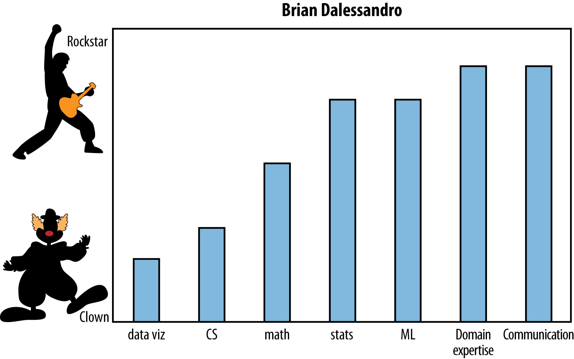

###### *Figure 5-1. Brian’s data science profile*

Brian came to talk to the class about logistic regression and evaluation, but he started out with two thought experiments.

# Thought Experiments

1. How would data science differ if we had a “grand unified theory of everything”? Take this to mean a symbolic explanation of how the world works. This one question raises a bunch of other questions:
   * Would we even need data science if we had such a theory?
   * Is it even theoretically possible to have such a theory? Do such theories lie only in the realm of, say, physics, where we can anticipate the exact return of a comet we see once a century?
   * What’s the critical difference between physics and data science that makes such a theory implausible?
   * Is it just accuracy? Or more generally, how much we imagine can be explained? Is it because we predict human behavior, which can be affected by our predictions, creating a feedback loop?

It might be useful to think of the sciences as a continuum, where physics is all the way on the right, and as you go left, you get more chaotic—you’re adding randomness (and salary). And where is economics on this spectrum? Marketing? Finance?

If we could model this data science stuff like we already know how to model physics, we’d actually know when people will click on what ad, just as we know where the [Mars Rover](http://1.usa.gov/1g3vQUt) will land. That said, there’s general consensus that the real world isn’t as well-understood, nor do we expect it to be in the future.

1. In what sense does data science deserve the word “science” in its name?

Never underestimate the power of creativity—people often have a vision they can describe but no method as to how to get there. As the data scientist, you have to turn that vision into a mathematical model within certain operational constraints. You need to state a well-defined problem, argue for a metric, and optimize for it as well. You also have to make sure you’ve actually answered the original question.

There is art in data science—it’s in translating human problems into the mathematical context of data science and back.

But we always have more than one way of doing this translation—more than one possible model, more than one associated metric, and possibly more than one optimization. So the science in data science is—given raw data, constraints, and a problem statement—how to navigate through that maze and make the best choices. Every design choice you make can be formulated as an hypothesis, against which you will use rigorous testing and experimentation to either validate or refute.

This process, whereby one formulates a well-defined hypothesis and then tests it, might rise to the level of a science in certain cases. Specifically, the scientific method is adopted in data science as follows:

* + You hold on to your existing best performer.
  + Once you have a new idea to prototype, set up an experiment wherein the two best models compete.
  + Rinse and repeat (while not overfitting).

# Classifiers

This section focuses on the process of choosing a classifier. Classification involves mapping your data points into a finite set of labels or the probability of a given label or labels. We’ve already seen some examples of classification algorithms, such as Naive Bayes and k-nearest neighbors (k-NN), in the previous chapters. [Table 5-1](https://learning.oreilly.com/library/view/doing-data-science/9781449363871/ch05.html#table-classifiers) shows a few examples of when you’d want to use classification:

|  |  |
| --- | --- |
| “Will someone click on this ad?” | 0 or 1 (no or yes) |
| “What number is this (image recognition)?” | 0, 1, 2, etc. |
| “What is this news article about?” | “Sports” |
| “Is this spam?” | 0 or 1 |
| “Is this pill good for headaches?” | 0 or 1 |
| *Table 5-1. Classifier example questions and answers* | |

From now on we’ll talk about binary classification only (0 or 1).

In this chapter, we’re talking about logistic regression, but there’s other classification algorithms available, including decision trees (which we’ll cover in [Chapter 7](https://learning.oreilly.com/library/view/doing-data-science/9781449363871/ch07.html#chapter-kaggle)), random forests ([Chapter 7](https://learning.oreilly.com/library/view/doing-data-science/9781449363871/ch07.html#chapter-kaggle)), and support vector machines and neural networks (which we aren’t covering in this book).

The big picture is that given data, a real-world classification problem, and constraints, you need to determine:

1. Which classifier to use
2. Which optimization method to employ
3. Which loss function to minimize
4. Which features to take from the data
5. Which evaluation metric to use

Let’s talk about the first one: how do you know which classifier to choose? One possibility is to try them all, and choose the best performer. This is fine if you have no constraints, or if you ignore constraints. But usually constraints are a big deal—you might have tons of data, or not much time, or both. This is something people don’t talk about enough. Let’s look at some constraints that are common across most algorithms.

## Runtime

Say you need to update 500 models a day. That is the case at M6D, where their models end up being bidding decisions. In that case, they start to care about various speed issues. First, how long it takes to update a model, and second, how long it takes to use a model to actually make a decision if you have it. This second kind of consideration is usually more important and is called runtime.

Some algorithms are slow at runtime. For example, consider k-NN: given a new data point in some large-dimensional space, you actually have to find the k closest data points to it. In particular, you need to have all of your data points in memory.

Linear models, by contrast, are very fast, both to update and to use at runtime. As we’ll see in [Chapter 6](https://learning.oreilly.com/library/view/doing-data-science/9781449363871/ch06.html#chapter-financial-modeling), you can keep running estimates of the constituent parts and just update with new data, which is fast and doesn’t require holding old data in memory. Once you have a linear model, it’s just a matter of storing the coefficient vector in a runtime machine and doing a single dot product against the user’s feature vector to get an answer.

## You

One underappreciated constraint of being a data scientist is your own understanding of the algorithm. Ask yourself carefully, do you understand it for real? Really? It’s OK to admit it if you don’t.

You don’t have to be a master of every algorithm to be a good data scientist. The truth is, getting the best fit of an algorithm often requires intimate knowledge of said algorithm. Sometimes you need to tweak an algorithm to make it fit your data. A common mistake for people not completely familiar with an algorithm is to overfit when they think they’re tweaking.

## Interpretability

You often need to be able to interpret your model for the sake of the business. Decision trees are very easy to interpret. Random forests, on the other hand, are not, even though they are almost the same thing. They can take exponentially longer to explain in full. If you don’t have 15 years to spend understanding a result, you may be willing to give up some accuracy in order to have it be easier to understand.

For example, by law, [credit card companies have to be able to explain their denial-of-credit decisions](http://1.usa.gov/1aKY3vA), so decision trees make more sense than random forests. You might not have a law about it where you work, but it still might make good sense for your business to have a simpler way to explain the model’s decision.

## Scalability

How about scalability? In general, there are three things you have to keep in mind when considering scalability:

1. Learning time: How much time does it take to train the model?
2. Scoring time: How much time does it take to give a new user a score once the model is in production?
3. Model storage: How much memory does the production model use up?

Here’s a useful paper to look at when comparing models: [An Empirical Comparison of Supervised Learning Algorithms](http://goo.gl/bLpoea), from which we’ve learned:

* Simpler models are more interpretable but aren’t as good performers.
* The question of which algorithm works best is problem-dependent.
* It’s also constraint-dependent.

# M6D Logistic Regression Case Study

Brian and his team have three core problems as data scientists at M6D:

1. Feature engineering: Figuring out which features to use and how to use them.
2. User-level conversion prediction: Forecasting when someone will click.
3. Bidding: How much it is worth to show a given ad to a given user?

This case study focuses on the second problem. M6D uses logistic regression for this problem because it’s highly scalable and works great for binary outcomes like clicks.

## Click Models

At M6D, they need to match clients, which represent advertising companies, to individual users. Generally speaking, the advertising companies want to target ads to users based on a user’s likelihood to click. Let’s discuss what kind of data they have available first, and then how you’d build a model using that data.

M6D keeps track of the websites users have visited, but the data scientists don’t look at the contents of the page. Instead they take the associated URL and hash it into some random string. They thus accumulate information about users, which they stash in a vector. As an example, consider the user “u” during some chosen time period:

u = < &ltfxyz, 123, sdqwe, 13ms&gtg >

This means “u” visited four sites and the URLs that “u” visited are hashed to those strings. After collecting information like this for all the users, they build a giant matrix whose columns correspond to sites and whose rows correspond to users, and a given entry is “1” if that user went to that site. Note it’s a sparse matrix, because most people don’t go to all that many sites.

To make this a classification problem, they need to have classes they are trying to predict. Let’s say in this case, they want to predict whether a given user will click on a shoe ad or not. So there’s two classes: “users who clicked on the shoe ad” and “users who did not click on the shoe ad.” In the training dataset, then, in addition to the sparse matrix described, they’ll also have a variable, or column, of labels. They label the behavior “clicked on a shoe ad” as “1,” say, and “didn’t click” as “0.” Once they fit the classifier to the dataset, for any new user, the classifier will predict whether he will click or not (the label) based on the predictors (the user’s browsing history captured in the URL matrix).

Now it’s your turn: your goal is to build and train the model from a training set. Recall that in [Chapter 4](https://learning.oreilly.com/library/view/doing-data-science/9781449363871/ch04.html#chapter-spam-filters-naive-bayes) you learned about spam classifiers, where the features are words. But you didn’t particularly care about the meaning of the words. They might as well be strings. Once you’ve labeled as described earlier, this looks just like spam classification because you have a binary outcome with a large sparse binary matrix capturing the predictors. You can now rely on well-established algorithms developed for spam detection.

You’ve reduced your current problem to a previously solved problem! In the previous chapter, we showed how to solve this with Naive Bayes, but here we’ll focus on using logistic regression as the model.

The output of a logistic regression model is the probability of a given click in this context. Likewise, the spam filters really judge the probability of a given email being spam. You can use these probabilities directly or you could find a threshold so that if the probability is above that threshhold (say, 0.75), you predict a click (i.e., you show an ad), and below it you decide it’s not worth it to show the ad. The point being here that unlike with linear regression—which does its best to predict the actual value—the aim of logistic regression isn’t to predict the actual value (0 or 1). Its job is to output a probability.

Although technically it’s possible to implement a linear model such as linear regression on such a dataset (i.e., R will let you do it and won’t break or tell you that you shouldn’t do it), one of the problems with a linear model like linear regression is that it would give predictions below 0 and above 1, so these aren’t directly interpretable as probabilities.

## The Underlying Math

So far we’ve seen that the beauty of logistic regression is it outputs values bounded by 0 and 1; hence they can be directly interpreted as probabilities. Let’s get into the math behind it a bit. You want a function that takes the data and transforms it into a single value bounded inside the closed interval [0,1][0,1]. For an example of a function bounded between 0 and 1, consider the inverse-logit function shown in [Figure 5-2](https://learning.oreilly.com/library/view/doing-data-science/9781449363871/ch05.html#inverse-logit-function).

P(t)=logit−1(t)≡1(1+e−t)=et1+etP(t)=logit-1(t)≡1(1+e-t)=et1+et

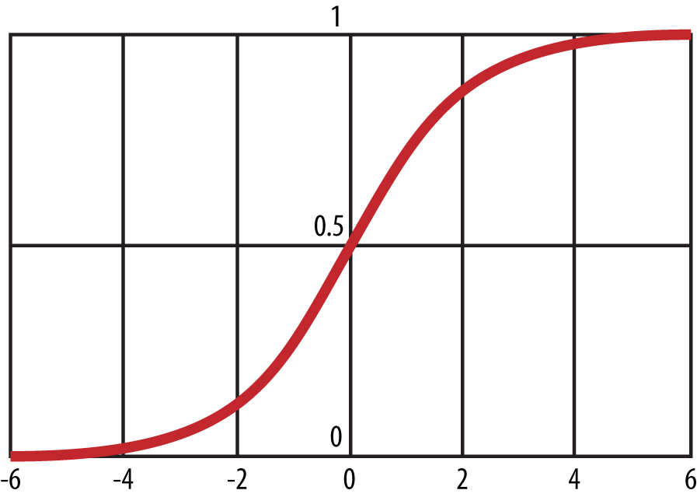

###### *Figure 5-2. The inverse-logit function*

##### LOGIT VERSUS INVERSE-LOGIT

The logit function takes x values in the range [0,1][0,1] and transforms them to y values along the entire real line:

logit(p)=log(p1−p)=log(p)−log(1−p)logit(p)=log(p1-p)=log(p)-log(1-p)

The inverse-logit does the reverse, and takes x values along the real line and tranforms them to y values in the range [0,1].[0,1].

Note when tt is large, e−te-t is tiny so the denominator is close to 1 and the overall value is close to 1. Similarly when tt is small, e−te-t is large so the denominator is large, which makes the function close to zero. So that’s the inverse-logit function, which you’ll use to begin deriving a logistic regression model. In order to model the data, you need to work with a slightly more general function that expresses the relationship between the data and a probability of a click. Start by defining:

P(ci|xi)=[logit−1(α+βτxi)]ci*[1−logit−1(α+βτxi)]1−ciP(ci|xi)=[logit-1(α+βτxi)]ci*[1-logit-1(α+βτxi)]1-ci

Here cici is the labels or classes (clicked or not), and xixi is the vector of features for user ii. Observe that cici can only be 1 or 0, which means that if ci=1ci=1, the second term cancels out and you have:

P(ci=1|xi)=11+e−(α+βτxi)=logit−1(α+βτxi)P(ci=1|xi)=11+e-(α+βτxi)=logit-1(α+βτxi)

And similarly, if ci=0ci=0, the first term cancels out and you have:

P(ci=0|xi)=1−logit−1(α+βτxi)P(ci=0|xi)=1-logit-1(α+βτxi)

To make this a linear model in the outcomes cici, take the log of the [odds ratio](http://en.wikipedia.org/wiki/Odds_ratio):

log(P(ci=1|xi)/(1−P(ci=1|xi)))=α+βτxi.log(P(ci=1|xi)/(1-P(ci=1|xi)))=α+βτxi.

Which can also be written as:

logit(P(ci=1|xi))=α+βτxi.logit(P(ci=1|xi))=α+βτxi.

If it feels to you that we went in a bit of a circle here (this last equation was also implied by earlier equations), it’s because we did. The purpose of this was to show you how to go back and forth between the probabilities and the linearity.

So the logit of the probability that user ii clicks on the shoe ad is being modeled as a linear function of the features, which were the URLs that user ii visited. This model is called the logistic regression model.

The parameter αα is what we call the base rate, or the unconditional probability of “1” or “click” knowing nothing more about a given user’s feature vector xixi. In the case of measuring the likelihood of an average user clicking on an ad, the base rate would correspond to the click-through rate, i.e., the tendency over all users to click on ads. This is typically on the order of 1%.

If you had no information about your specific situation except the base rate, the average prediction would be given by just α:α:

P(ci=1)=11+e−αP(ci=1)=11+e-α

The variable ββ defines the slope of the logit function. Note that in general it’s a vector that is as long as the number of features you are using for each data point. The vector ββ determines the extent to which certain features are markers for increased or decreased likelihood to click on an ad.

## Estimating α and β

Your immediate modeling goal is to use the training data to find the best choices for αα and β.β. In general you want to solve this with maximum likelihood estimation and use a convex optimization algorithm because the likelihood function is convex; you can’t just use derivatives and vector calculus like you did with linear regression because it’s a complicated function of your data, and in particular there is no closed-form solution.

Denote by ΘΘ the pair {α,β}.{α,β}. The likelihood function LL is defined by:

L(Θ|X1,X2,⋯,Xn)=P(X|Θ)=P(X1|Θ)⋅⋯⋅P(Xn|Θ)L(Θ|X1,X2,⋯,Xn)=P(X|Θ)=P(X1|Θ)·⋯·P(Xn|Θ)

where you are assuming the data points XiXi are independent, where i=1,...,ni=1,...,n represent your nn users. This independence assumption corresponds to saying that the click behavior of any given user doesn’t affect the click behavior of all the other users—in this case, “click behavior” means “probability of clicking.” It’s a relatively safe assumption at a given point in time, but not forever. (Remember the independence assumption is what allows you to express the likelihood function as the product of the densities for each of the nn observations.)

You then search for the parameters that maximize the likelihood, having observed your data:

ΘMLE=argmaxΘ∏n1P(Xi|Θ).ΘMLE=argmaxΘ∏1nP(Xi|Θ).

Setting pi=1/(1+e−(α+βtxi))pi=1/(1+e-(α+βtxi)), the probability of a single observation, P(Xi|Θ)P(Xi|Θ) is:

pcii⋅(1−pi)1−cipici·(1-pi)1-ci

So putting it all together, you have:

ΘMLE=argmaxΘ∏n1pcii⋅(1−pi)1−ciΘMLE=argmaxΘ∏1npici·(1-pi)1-ci

Now, how do you maximize the likelihood?

Well, when you faced this situation with linear regression, you took the derivative of the likelihood with respect to αα and ββ, set that equal to zero, and solved. But if you try that in this case, it’s not possible to get a closed-form solution. The key is that the values that maximize the likelihood will also maximize the log likelihood, which is equivalent to minimizing the negative log likelihood. So you transform the problem to find the minimum of the negative log likelihood.

Now you have to decide which optimization method to use. As it turns out, under reasonable conditions, both of the optimization methods we describe below will converge to a global maximum when they converge at all. The “reasonable condition” is that the variables are not linearly dependent, and in particular guarantees that the [Hessian matrix](http://en.wikipedia.org/wiki/Hessian_matrix) will be positive definite.

# MORE ON MAXIMUM LIKELIHOOD ESTIMATION

We realize that we went through that a bit fast, so if you want more details with respect to maximum likelihood estimation, we suggest looking in Statistical Inference by Casella and Berger, or if it’s linear algebra in general you want more details on, check out Gilbert Strang’s Linear Algebra and Its Applications.

## Newton’s Method

You can use numerical techniques to find your global maximum by following the reasoning underlying [Newton’s method from calculus](http://en.wikipedia.org/wiki/Newton's_method); namely, that you can pretty well approximate a function with the first few terms of its [Taylor Series](http://en.wikipedia.org/wiki/Taylor_series).

Specifically, given a step size γγ, you compute a local gradient ▽Θ▽Θ, which corresponds to the first derivative, and a Hessian matrix HH, which corresponds to the second derivative. You put them together and each step of the algorithm looks something like this:

Θn+1=Θn−γH−1⋅▽Θ.Θn+1=Θn-γH-1·▽Θ.

Newton’s method uses the curvature of log-likelihood to choose an appropriate step direction. Note that this calculation involves inverting the k×kk×k Hessian matrix, which is bad when there’s lots of features, as in 10,000 or something. Typically you don’t have that many features, but it’s not impossible.

In practice you’d never actually invert the Hessian—instead you’d solve an equation of the form Ax=yAx=y, which is much more computationally stable than finding A−1A-1.

## Stochastic Gradient Descent

Another possible method to maximize your likelihood (or minimize your negative log likelihood) is called [Stochastic Gradient Descent](http://en.wikipedia.org/wiki/Stochastic_gradient_descent). It approximates a gradient using a single observation at a time. The algorithm updates the current best-fit parameters each time it sees a new data point. The good news is that there’s no big matrix inversion, and it works well with both huge data and sparse features; it’s a big deal in [Mahout](http://mahout.apache.org/) and [Vowpal Wabbit](http://hunch.net/~vw/), two open source projects to enable large-scale machine learning across a variety of algorithms. The bad news is it’s not such a great optimizer and it’s very dependent on step size.

## Implementation

In practice you don’t have to code up the iterative reweighted least squares or stochastic gradient optimization method yourself; this is implemented in R or in any package that implements logistic regression. So suppose you had a dataset that had the following first five rows:

click url_1 url_2 url_3 url_4 url_5

1 0 0 0 1 0

1 0 1 1 0 1

0 1 0 0 1 0

1 0 0 0 0 0

1 1 0 1 0 1

Call this matrix “train,” and then the command line in R would be:

fit <- glm(click ~ url_1 + url_2 + url_3 + url_4 + url_5,

data = train, family = binomial(logit))

## Evaluation

Let’s go back to the big picture from earlier in the chapter where we told you that you have many choices you need to make when confronted with a classification problem. One of the choices is how you’re going to evaluate your model. We discussed this already in [Chapter 3](https://learning.oreilly.com/library/view/doing-data-science/9781449363871/ch03.html#chapter-algorithms) with respect to linear regression and k-NN, as well as in the previous chapter with respect to Naive Bayes. We generally use different evaluation metrics for different kinds of models, and in different contexts. Even logistic regression can be applied in multiple contexts, and depending on the context, you may want to evaluate it in different ways.

First, consider the context of using logistic regression as a ranking model—meaning you are trying to determine the order in which you show ads or items to a user based on the probability they would click. You could use logistic regression to estimate probabilities, and then rank-order the ads or items in decreasing order of likelihood to click based on your model. If you wanted to know how good your model was at discovering relative rank (notice in this case, you could care less about the absolute scores), you’d look to one of:

[Area under the receiver operating curve](http://en.wikipedia.org/wiki/Receiver_operating_characteristic) (AUC)

In signal detection theory, a receiver operating characteristic curve, or ROC curve, is defined as a plot of the true positive rate against the false positive rate for a binary classification problem as you change a threshold. In particular, if you took your training set and ranked the items according to their probabilities and varied the threshold (from ∞∞ to −∞-∞) that determined whether to classify the item as 1 or 0 , and kept plotting the true positive rate versus the false positive rate, you’d get the ROC curve. The area under that curve, referred to as the AUC, is a way to measure the success of a classifier or to compare two classifiers. Here’s a nice paper on it by Tom Fawcett, [“Introduction to ROC Analysis”](http://goo.gl/fE8i7s).

[Area under the cumulative lift curve](http://mrvar.fdv.uni-lj.si/pub/mz/mz3.1/vuk.pdf)

An alternative is the area under the cumulative lift curve, which is frequently used in direct marketing and captures how many times it is better to use a model versus not using the model (i.e., just selecting at random).

We’ll see more of both of these in [Chapter 13](https://learning.oreilly.com/library/view/doing-data-science/9781449363871/ch13.html#chapter-data-leakage-model-evaluation).

##### WARNING: FEEDBACK LOOP!

If you want to productionize logistic regression to rank ads or items based on clicks and impressions, then let’s think about what that means in terms of the data getting generated. So let’s say you put an ad for hair gel above an ad for deodorant, and then more people click on the ad for hair gel—is it because you put it on top or because more people want hair gel? How can you feed that data into future iterations of your algorithm given that you potentially caused the clicks yourself and it has nothing to do with the ad quality? One solution is to always be logging the position or rank that you showed the ads, and then use that as one of the predictors in your algorithm. So you would then model the probability of a click as a function of position, vertical, brand, or whatever other features you want. You could then use the parameter estimated for position and use that going forward as a “position normalizer.” There’s a whole division at Google called Ads Quality devoted to problems such as these, so one little paragraph can’t do justice to all the nuances of it.

Second, now suppose instead that you’re using logistic regression for the purposes of classification. Remember that although the observed output was a binary outcome (1,0), the output of a logistic model is a probability. In order to use this for classification purposes, for any given unlabeled item, you would get its predicted probability of a click. Then to minimize the misclassification rate, if the predicted probability is > 0.5 that the label is 1 (click), you would label the item a 1 (click), and otherwise 0. You have several options for how you’d then evaluate the quality of the model, some of which we already discussed in Chapters [3](https://learning.oreilly.com/library/view/doing-data-science/9781449363871/ch03.html#chapter-algorithms) and [4](https://learning.oreilly.com/library/view/doing-data-science/9781449363871/ch04.html#chapter-spam-filters-naive-bayes), but we’ll tell you about them again here so you see their pervasiveness:

Lift

How much more people are buying or clicking because of a model (once we’ve introduced it into production).

[Accuracy](http://en.wikipedia.org/wiki/Accuracy_and_precision)

How often the correct outcome is being predicted, as discussed in Chapters [3](https://learning.oreilly.com/library/view/doing-data-science/9781449363871/ch03.html#chapter-algorithms) and [4](https://learning.oreilly.com/library/view/doing-data-science/9781449363871/ch04.html#chapter-spam-filters-naive-bayes).

[Precision](http://en.wikipedia.org/wiki/Precision_and_recall)

This is the (number of true positives)/(number of true positives + number of false positives).

[Recall](http://en.wikipedia.org/wiki/Precision_and_recall)

This is the (number of true positives)/(number of true positives + number of false negatives).

[F-score](http://en.wikipedia.org/wiki/F1_score)

We didn’t tell you about this one yet. It essentially combines precision and recall into a single score. It’s the harmonic mean of precision and recall, so (2 × precision × recall)/(precision + recall). There are generalizations of this that are essentially changing how much you weight one or the other.

Finally, for density estimation, where we need to know an actual probability rather than a relative score, we’d look to:

[Mean squared error](http://en.wikipedia.org/wiki/Mean_squared_error)

We discussed with respect to linear regression. As a reminder, this is the average squared distance between the predicted and actual values.

Root squared error

The square root of mean squared error.

[Mean absolute error](http://en.wikipedia.org/wiki/Mean_absolute_error)

This is a variation on mean squared error and is simply the average of the absolute value of the difference between the predicted and actual values.

In general, it’s hard to compare lift curves, but you can compare AUC (area under the receiver operator curve)—they are “base rate invariant.” In other words, if you bring the click-through rate from 1% to 2%, that’s 100% lift; but if you bring it from 4% to 7%, that’s less lift but more effect. AUC does a better job in such a situation when you want to compare.

Density estimation tests tell you how well are you fitting for conditional probability. In advertising, this may arise if you have a situation where each ad impression costs $c$c and for each conversion you receive $q.$q. You will want to target every conversion that has a positive expected value, i.e., whenever:

P(Conversion|X)⋅$q>$cP(Conversion|X)·$q>$c

But to do this you need to make sure the probability estimate on the left is accurate, which in this case means something like the mean squared error of the estimator is small. Note a model can give you good relative rankings—it gets the order right—but bad estimates of the probability.

Think about it this way: it could say to rank items in order 1, 2, and 3 and estimate the probabilities as .7, .5, and .3. It might be that the true probabilities are .03, .02, and .01, so our estimates are totally off, but the ranking was correct.

##### USING A/B TESTING FOR EVALUATION

When we build models and optimize them with respect to some evaluation metric such as accuracy or mean squared error, the estimation method itself is built to optimize parameters with respect to these metrics. In some contexts, the metrics we might want to optimize for are something else altogether, such as revenue. So we might try to build an algorithm that optimizes for accuracy, when our real goal is to make money. The model itself may not directly capture this. So a way to capture it is to run A/B tests (or statistical experiments) where we divert some set of users to one version of the algorithm and another set of users to another version of the algorithm, and check the difference in performance of metrics we care about, such as revenue or revenue per user, or something like that. We’ll discuss A/B testing more in [Chapter 11](https://learning.oreilly.com/library/view/doing-data-science/9781449363871/ch11.html#chapter-causality).

# Media 6 Degrees Exercise

Media 6 Degrees kindly provided a dataset that is perfect for exploring logistic regression models, and evaluating how good the models are. Follow along by implementing the following R code. The dataset can be found at <https://github.com/oreillymedia/doing_data_science>.

## Sample R Code

*# Author: Brian Dalessandro*

*# Read in data, look at the variables and create a training and test set*

file <- "binary_class_dataset.txt"

set <- read.table(file, header = **TRUE**, sep = "\t",

row.names = "client_id")

names(set)

split <- .65

set["rand"] <- runif(nrow(set))

train <- set[(set$rand <= split), ]

test <- set[(set$rand > split), ]

set$Y <- set$Y_BUY

*##########################################################*

*########### R FUNCTIONS ##########*

*##########################################################*

library(mgcv)

*# GAM Smoothed plot*

plotrel <- function(x, y, b, title) {

*# Produce a GAM smoothed representation of the data*

g <- gam(as.formula("y ~ x"), family = "binomial",

data = set)

xs <- seq(min(x), max(x), length = 200)

p <- predict(g, newdata = data.frame(x = xs),

type = "response")

*# Now get empirical estimates (and discretize if*

*# non discrete)*

if (length(unique(x)) > b) {

div <- floor(max(x) / b)

x_b <- floor(x / div) * div

c <- table(x_b, y)

}

else { c <- table(x, y) }

pact <- c[ , 2]/(c[ , 1]+c[ , 2])

cnt <- c[ , 1]+c[ , 2]

xd <- as.integer(rownames(c))

plot(xs, p, type="l", main=title,

ylab = "P(Conversion | Ad, X)", xlab="X")

points(xd, pact, type="p", col="red")

rug(x+runif(length(x)))

}

library(plyr)

*# wMAE plot and calculation*

getmae <- function(p, y, b, title, doplot) {

*# Normalize to interval [0,1]*

max_p <- max(p)

p_norm <- p / max_p

*# break up to b bins and rescale*

bin <- max_p * floor(p_norm * b) / b

d <- data.frame(bin, p, y)

t <- table(bin)

summ <- ddply(d, .(bin), summarise, mean_p = mean(p),

mean_y = mean(y))

fin <- data.frame(bin = summ$bin, mean_p = summ$mean_p,

mean_y = summ$mean_y, t)

*# Get wMAE*

num = 0

den = 0

for (i in c(1:nrow(fin))) {

num <- num + fin$Freq[i] * abs(fin$mean_p[i] -

fin$mean_y[i])

den <- den + fin$Freq[i]

}

wmae <- num / den

if (doplot == 1) {

plot(summ$bin, summ$mean_p, type = "p",

main = paste(title," MAE =", wmae),

col = "blue", ylab = "P(C | AD, X)",

xlab = "P(C | AD, X)")

points(summ$bin, summ$mean_y, type = "p", col = "red")

rug(p)

}

return(wmae)

}

library(ROCR)

get_auc <- function(ind, y) {

pred <- prediction(ind, y)

perf <- performance(pred, 'auc', fpr.stop = 1)

auc <- as.numeric(substr(slot(perf, "y.values"), 1, 8),

double)

return(auc)

}

*# Get X-Validated performance metrics for a given feature set*

getxval <- function(vars, data, folds, mae_bins) {

*# assign each observation to a fold*

data["fold"] <- floor(runif(nrow(data)) * folds) + 1

auc <- c()

wmae <- c()

fold <- c()

*# make a formula object*

f = as.formula(paste("Y", "~", paste(vars,

collapse = "+")))

for (i in c(1:folds)) {

train <- data[(data$fold != i), ]

test <- data[(data$fold == i), ]

mod_x <- glm(f, data=train, family = binomial(logit))

p <- predict(mod_x, newdata = test, type = "response")

*# Get wMAE*

wmae <- c(wmae, getmae(p, test$Y, mae_bins,

"dummy", 0))

fold <- c(fold, i)

auc <- c(auc, get_auc(p, test$Y))

}

return(data.frame(fold, wmae, auc))

}

*###############################################################*

*########## MAIN: MODELS AND PLOTS ##########*

*###############################################################*

*# Now build a model on all variables and look at coefficients and model fit*

vlist <- c("AT_BUY_BOOLEAN", "AT_FREQ_BUY", "AT_FREQ_LAST24_BUY",

"AT_FREQ_LAST24_SV", "AT_FREQ_SV", "EXPECTED_TIME_BUY",

"EXPECTED_TIME_SV", "LAST_BUY", "LAST_SV", "num_checkins")

f = as.formula(paste("Y_BUY", "~" , paste(vlist,

collapse = "+")))

fit <- glm(f, data = train, family = binomial(logit))

summary(fit)

*# Get performance metrics on each variable*

vlist <- c("AT_BUY_BOOLEAN", "AT_FREQ_BUY", "AT_FREQ_LAST24_BUY",

"AT_FREQ_LAST24_SV", "AT_FREQ_SV", "EXPECTED_TIME_BUY",

"EXPECTED_TIME_SV", "LAST_BUY", "LAST_SV", "num_checkins")

*# Create empty vectors to store the performance/evaluation metrics*

auc_mu <- c()

auc_sig <- c()

mae_mu <- c()

mae_sig <- c()

for (i in c(1:length(vlist))) {

a <- getxval(c(vlist[i]), set, 10, 100)

auc_mu <- c(auc_mu, mean(a$auc))

auc_sig <- c(auc_sig, sd(a$auc))

mae_mu <- c(mae_mu, mean(a$wmae))

mae_sig <- c(mae_sig, sd(a$wmae))

}

univar <- data.frame(vlist, auc_mu, auc_sig, mae_mu, mae_sig)

*# Get MAE plot on single variable -*

*# use holdout group for evaluation*

set <- read.table(file, header = **TRUE**, sep = "\t",

row.names="client_id")

names(set)

split<-.65

set["rand"] <- runif(nrow(set))

train <- set[(set$rand <= split), ]

test <- set[(set$rand > split), ]

set$Y <- set$Y_BUY

fit <- glm(Y_BUY ~ num_checkins, data = train,

family = binomial(logit))

y <- test$Y_BUY

p <- predict(fit, newdata = test, type = "response")

getmae(p,y,50,"num_checkins",1)

*# Greedy Forward Selection*

rvars <- c("LAST_SV", "AT_FREQ_SV", "AT_FREQ_BUY",

"AT_BUY_BOOLEAN", "LAST_BUY", "AT_FREQ_LAST24_SV",

"EXPECTED_TIME_SV", "num_checkins",

"EXPECTED_TIME_BUY", "AT_FREQ_LAST24_BUY")

*# Create empty vectors*

auc_mu <- c()

auc_sig <- c()

mae_mu <- c()

mae_sig <- c()

for (i in c(1:length(rvars))) {

vars <- rvars[1:i]

vars

a <- getxval(vars, set, 10, 100)

auc_mu <- c(auc_mu, mean(a$auc))

auc_sig <- c(auc_sig, sd(a$auc))

mae_mu <- c(mae_mu, mean(a$wmae))

mae_sig <- c(mae_sig, sd(a$wmae))

}

kvar<-data.frame(auc_mu, auc_sig, mae_mu, mae_sig)

*# Plot 3 AUC Curves*

y <- test$Y_BUY

fit <- glm(Y_BUY~LAST_SV, data=train,

family = binomial(logit))

p1 <- predict(fit, newdata=test, type="response")

fit <- glm(Y_BUY~LAST_BUY, data=train,

family = binomial(logit))

p2 <- predict(fit, newdata=test, type="response")

fit <- glm(Y_BUY~num_checkins, data=train,

family = binomial(logit))

p3 <- predict(fit, newdata=test,type="response")

pred <- prediction(p1,y)

perf1 <- performance(pred,'tpr','fpr')

pred <- prediction(p2,y)

perf2 <- performance(pred,'tpr','fpr')

pred <- prediction(p3,y)

perf3 <- performance(pred,'tpr','fpr')

plot(perf1, color="blue", main="LAST_SV (blue),

LAST_BUY (red), num_checkins (green)")

plot(perf2, col="red", add=**TRUE**)

plot(perf3, col="green", add=**TRUE**)

# Chapter 6. Time Stamps and Financial Modeling

In this chapter, we have two contributors, Kyle Teague from GetGlue, and someone you are a bit more familiar with by now: Cathy O’Neil. Before Cathy dives into her talk about the main topics for this chapter—times series, financial modeling, and fancypants regression—we’ll hear from Kyle Teague from GetGlue about how they think about building a recommendation system. (We’ll also hear more on this topic in [Chapter 7](https://learning.oreilly.com/library/view/doing-data-science/9781449363871/ch07.html#chapter-kaggle).) We then lay some of the groundwork for thinking about timestamped data, which will segue into Cathy’s talk.

# Kyle Teague and GetGlue

We got to hear from [Kyle Teague](http://linkd.in/GzJtOn), a VP of data science and engineering at [GetGlue](http://getglue.com/feed). Kyle’s background is in electrical engineering. He considers the time he spent doing signal processing in research labs as super valuable, and he’s been programming since he was a kid. He develops in Python.

GetGlue is a New York-based startup whose primary goal is to address the problem of content discovery within the movie and TV space. The usual model for finding out what’s on TV is the 1950’s TV Guide schedule; that’s still how many of us find things to watch. Given that there are thousands of channels, it’s getting increasingly difficult to find out what’s good on TV.

GetGlue wants to change this model, by giving people personalized TV recommendations and personalized guides. Specifically, users “check in” to TV shows, which means they can tell other people they’re watching a show, thereby creating a timestamped data point. They can also perform other actions such as liking or commenting on the show.

We store information in triplets of data of the form {user, action, item}, where the item is a TV show (or a movie). One way to visualize this stored data is by drawing a bipartite graph as shown in [Figure 6-1](https://learning.oreilly.com/library/view/doing-data-science/9781449363871/ch06.html#bipartite-graph).

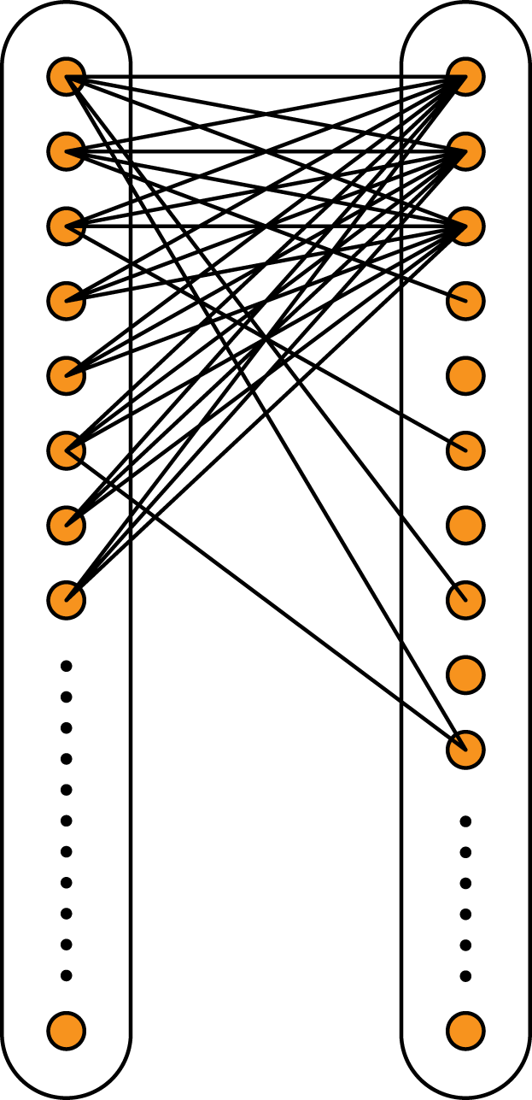

###### *Figure 6-1. Bipartite graph with users and items (shows) as nodes*

We’ll go into graphs in later chapters, but for now you should know that the dots are called “nodes” and the lines are called “edges.” This specific kind of graph, called a bipartite graph, is characterized by there being two kinds of nodes, in this case corresponding to “users” and “items.” All the edges go between a user and an item, specifically if the user in question has acted in some way on the show in question. There are never edges between different users or different shows. The graph in [Figure 6-1](https://learning.oreilly.com/library/view/doing-data-science/9781449363871/ch06.html#bipartite-graph) might display when certain users have “liked” certain TV shows.

GetGlue enhances the graph as follows: it finds ways to create edges between users and between shows, albeit with different kinds of edges. So, for example, users can follow one another or be friends on GetGlue, which produces directed edges; i.e., edges going from one node to another with a direction, usually denoted by an arrow. Similarly, using the set of preferences, GetGlue can learn that two people have similar tastes and they can be connected that way as well, which would probably not be directed.

GetGlue also hires human evaluators to make connections or directional edges between shows. So, for example, True Blood and Buffy the Vampire Slayer might be similar for some reason, and so the humans create a “similarity” edge in the graph between them. There are nuances around the edge being directional; they may draw an arrow pointing from Buffy to True Blood but not vice versa, for example, so their notion of “similar” or “close” captures both content and popularity. [Pandora](http://www.pandora.com/) is purported to do something like this, too.

Another important aspect, especially in the fast-paced TV space, is time. The user checked in or liked a show at a specific time, so the data that logs an action needs to have a timestamp as well: {user, action, item, timestamp}. Timestamps are helpful to see how influence propagates in the graph we’ve constructed, or how the graph evolves over time.

# Timestamps

Timestamped event data is a common data type in the age of Big Data. In fact, it’s one of the causes of Big Data. The fact that computers can record all the actions a user takes means that a single user can generate thousands of data points alone in a day. When people visit a website or use an app, or interact with computers and phones, their actions can be logged, and the exact time and nature of their interaction recorded. When a new product or feature is built, engineers working on it write code to capture the events that occur as people navigate and use the product—that capturing is part of the product.

For example, imagine a user visits the New York Times home page. The website captures which news stories are rendered for that user, and which stories were clicked on. This generates event logs. Each record is an event that took place between a user and the app or website.

Here’s an example of raw data point from GetGlue:

{"userId": "rachelschutt", "numCheckins": "1",

"modelName": "movies", "title": "Collaborator",

"source": "http://getglue.com/stickers/tribeca_film/

collaborator_coming_soon", "numReplies": "0",

"app": "GetGlue", "lastCheckin": "true",

"timestamp": "2012-05-18T14:15:40Z",

"director": "martin donovan", "verb": "watching",

"key": "rachelschutt/2012-05-18T14:15:40Z",

"others": "97", "displayName": "Rachel Schutt",

"lastModified": "2012-05-18T14:15:43Z",

"objectKey": "movies/collaborator/martin_donovan",

"action": "watching"}

If we extract four fields: {"userid":"rachelschutt", "action":"watching", "title":"Collaborator", timestamp:"2012-05-18T14:15:40Z" }, we can think of it as being in the order we just discussed, namely {user, verb, object, timestamp}.

## Exploratory Data Analysis (EDA)

As we described in [Chapter 2](https://learning.oreilly.com/library/view/doing-data-science/9781449363871/ch02.html#chapter-statistical-interference-EDA), it’s best to start your analysis with EDA so you can gain intuition for the data before building models with it. Let’s delve deep into an example of EDA you can do with user data, stream-of-consciousness style. This is an illustration of a larger technique, and things we do here can be modified to other types of data, but you also might need to do something else entirely depending on circumstances.

The very first thing you should look into when dealing with user data is individual user plots over time. Make sure the data makes sense to you by investigating the narrative the data indicates from the perspective of one person.

To do this, take a random sample of users: start with something small like 100 users. Yes, maybe your dataset has millions of users, but to start out, you need to gain intuition. Looking at millions of data points is too much for you as a human. But just by looking at 100, you’ll start to understand the data, and see if it’s clean. Of course, this kind of sample size is not large enough if you were to start making inferences about the entire set of data.

You might do this by finding usernames and grepping or searching for 100 random choices, one at a time. For each user, create a plot like the one in [Figure 6-2](https://learning.oreilly.com/library/view/doing-data-science/9781449363871/ch06.html#EDA-100-users).

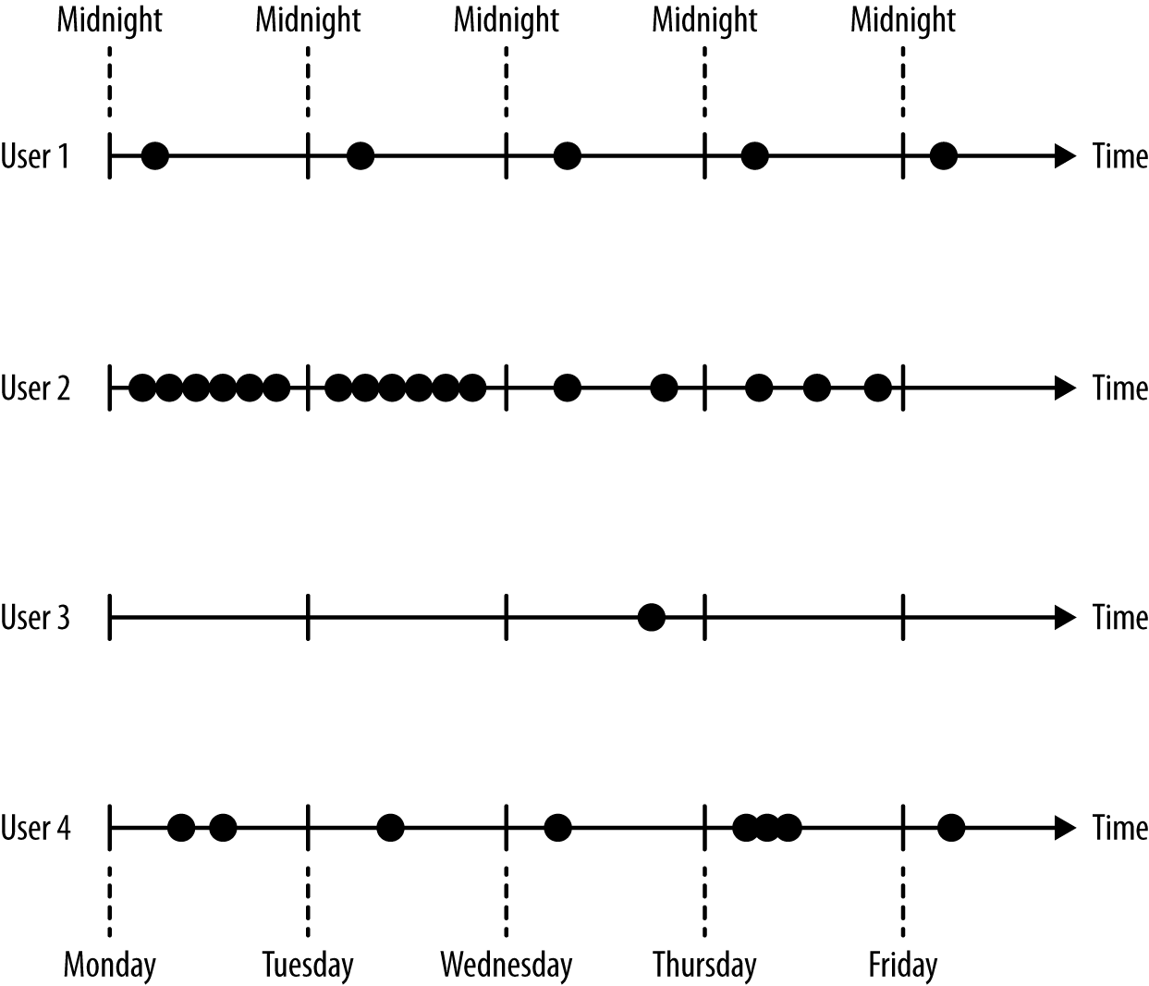

###### *Figure 6-2. An example of a way to visually display user-level data over time*

Now try to construct a narrative from that plot. For example, we could say that user 1 comes the same time each day, whereas user 2 started out active in this time period but then came less and less frequently. User 3 needs a longer time horizon for us to understand his or her behavior, whereas user 4 looks “normal,” whatever that means.

Let’s pose questions from that narrative:

* What is the typical or average user doing?
* What does variation around that look like?
* How would we classify users into different segments based on their behavior with respect to time?
* How would we quantify the differences between these users?

Think abstractly about a certain typical question from data munging discipline. Say we have some raw data where each data point is an event, but we want to have data stored in rows where each row consists of a user followed by a bunch of timestamps corresponding to actions that user performed. How would we get the data to that point? Note that different users will have a different number of timestamps.

Make this reasoning explicit: how would we write the code to create a plot like the one just shown? How would we go about tackling the data munging exercise?

Suppose a user can take multiple actions: “thumbs_up,” or “thumbs_down,” “like,” and “comment.” How can we plot those events? How can we modify our metrics? How can we encode the user data with these different actions? [Figure 6-3](https://learning.oreilly.com/library/view/doing-data-science/9781449363871/ch06.html#thumbs-up-down) provides an example for the first question where we color code actions thumbs up and thumbs down, denoted thumbs_up and thumbs_down.

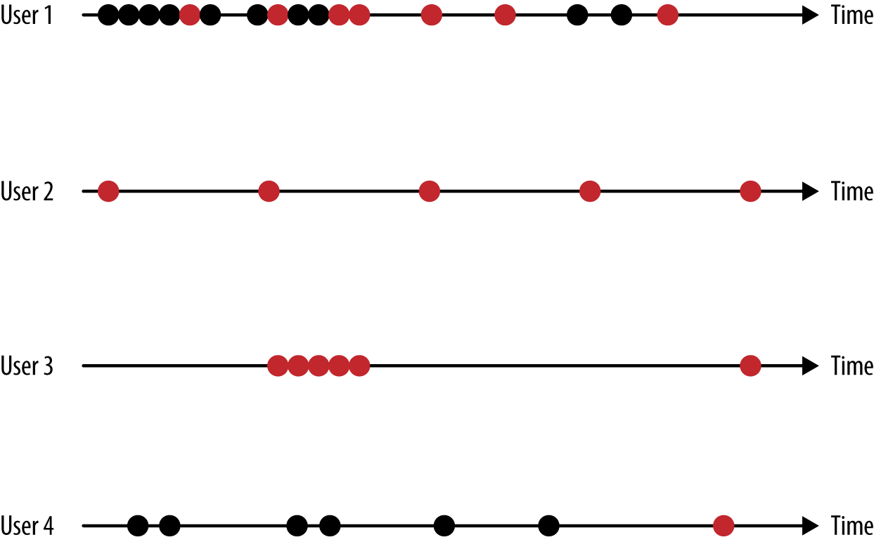

###### *Figure 6-3. Use color to include more information about user actions in a visual display*

In this toy example, we see that all the users did the same thing at the same time toward the right end of the plots. Wait, is this a real event or a bug in the system? How do we check that? Is there a large co-occurence of some action across users? Is “black” more common than “red”? Maybe some users like to always thumb things up, another group always like to thumb things down, and some third group of users are a mix. What’s the definition of a “mix”?

Now that we’ve started to get some sense of variation across users, we can think about how we might want to aggregate users. We might make the x-axis refer to time, and the y-axis refer to counts, as shown in [Figure 6-4](https://learning.oreilly.com/library/view/doing-data-science/9781449363871/ch06.html#aggregate-users).

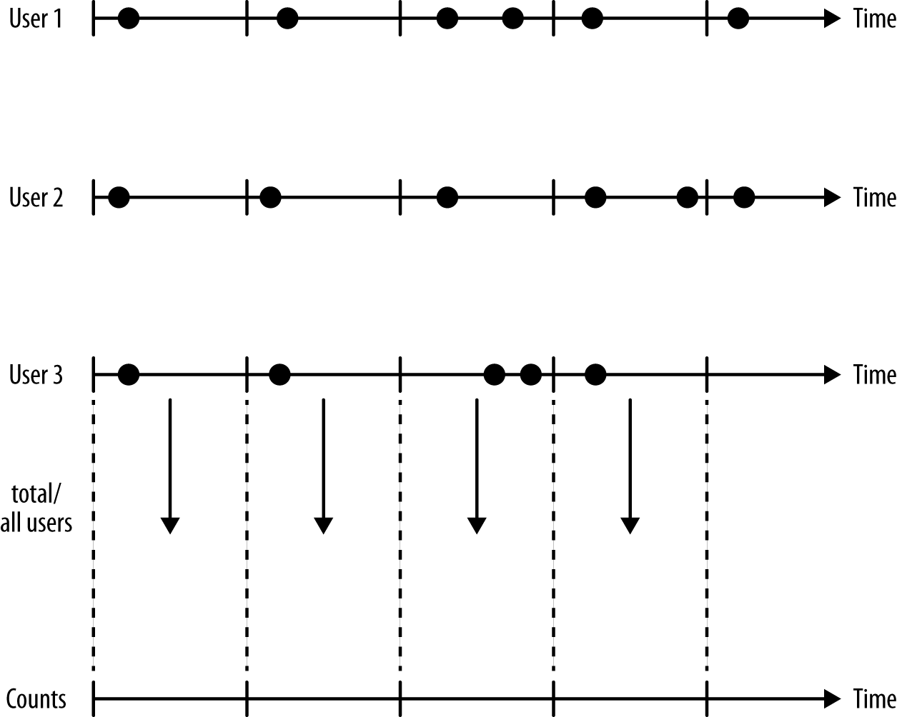

###### *Figure 6-4. Aggregating user actions into counts*

We’re no longer working with 100 individual users, but we’re still making choices, and those choices will impact our perception and understanding of the dataset.

For example, are we counting the number of unique users or the overall number of user logins? Because some users log in multiple times, this can have a huge impact. Are we counting the number of actions or the number of users who did a given action at least once during the given time segment?

What is our time horizon? Are we counting per second, minute, hour, 8-hour segments, day, or week? Why did we choose that? Is the signal overwhelmed by seasonality, or are we searching for seasonality?

Are our users in different time zones? If user 1 and user 2 are in New York and London, respectively, then it’s 7 a.m. in NYC when it’s noon in London. If we count that as 7 a.m. and say “30,000 users did this action in the morning,” then it’s misleading, because it’s not morning in London. How are we going to treat this? We could shift the data into buckets so it’s 7 a.m. for the user, not 7 a.m. in New York, but then we encounter other problems. This is a decision we have to make and justify, and it could go either way depending on circumstances.

# TIMESTAMPS ARE TRICKY

We’re not gonna lie, timestamps are one of the hardest things to get right about modeling, especially around time changes. That’s why it’s sometimes easiest to convert all timestamps into [seconds since the beginning of epoch time](http://www.epochconverter.com/).

Maybe we want to make different plots for different action types, or maybe we will bin actions into broader categories to take a good look at them and gain perspective.

## Metrics and New Variables or Features

The intuition we gained from EDA can now help us construct metrics. For example, we can measure users by keeping tabs on the frequencies or counts of their actions, the time to first event, or simple binary variables such as “did action at least once,” and so on. If we want to compare users, we can construct similarity or difference metrics. We might want to aggregate by user by counting or having a cumulative sum of counts or money spent, or we might aggregate by action by having cumulative or average number of users doing that action once or more than once.

This is by no means a comprehensive list. Metrics can be any function of the data, as long as we have a purpose and reason for creating them and interpreting them.

## What’s Next?

We want to start moving toward modeling, algorithms, and analysis, incorporating the intuition we built from the EDA into our models and algorithms. Our next steps depend on the context, but here are some examples of what we could do.

We might be interested in time series modeling, which includes auto-regression. We’ll talk about this more in the next section on financial modeling, but generally speaking we work with time series when we are trying to predict events that are super time-sensitive, like markets, or somewhat predictable based on what already happened, such as how much money gets invested in pension funds per month.

We might start clustering, as we discussed in [Chapter 3](https://learning.oreilly.com/library/view/doing-data-science/9781449363871/ch03.html#chapter-algorithms). In order to do this, we’d need to define the closeness of users with each other.

Maybe we’ll want to build a monitor that could automatically detect common behavior patterns. Of course we’d first have to define what a common behavior pattern is and what would make things uncommon.

We might try our hands at change-point detection, which is to say the ability to identify when some big event has taken place. What kind of behavior in our system should trigger an alarm? Or, we might try to establish causality. This can be very hard if we haven’t set up an experiment. Finally, we might want to train a recommendation system.

##### HISTORICAL PERSPECTIVE: WHAT’S NEW ABOUT THIS?

Timestamped data itself is not new, and time series analysis is a well-established field (see, for example, [Time Series Analysis by James D. Hamilton](http://amzn.to/16YQg9b)). Historically, the available datasets were fairly small and events were recorded once a day, or even reported at aggregate levels. Some examples of timestamped datasets that have existed for a while even at a granular level are stock prices in finance, credit card transactions, phone call records, or books checked out of the library.

Even so, there are a couple things that make this new, or at least the scale of it new. First, it’s now easy to measure human behavior throughout the day because many of us now carry around devices that can be and are used for measurement purposes and to record actions. Next, timestamps are accurate, so we’re not relying on the user to self-report, which is famously unreliable. Finally, computing power makes it possible to store large amounts of data and process it fairly quickly.

# Cathy O’Neil

Next [Cathy O’Neil](http://www.cathyoneil.org/) spoke. You’re already familiar with her, but let’s check out her data science profile in [Figure 6-5](https://learning.oreilly.com/library/view/doing-data-science/9781449363871/ch06.html#cathy-profile).

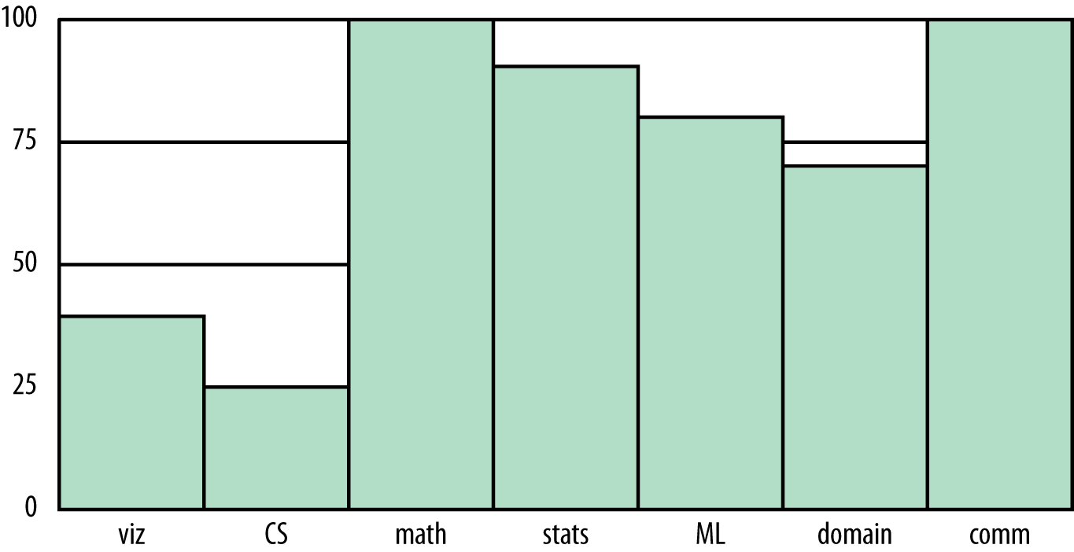

###### *Figure 6-5. Cathy’s data science profile*

Her most obvious weakness is in CS. Although she programs in Python pretty proficiently, and can scrape and parse data, prototype models, and use matplotlib to draw pretty pictures, she is no Java map-reducer and bows down to those people who are. She’s also completely untrained in data visualization, but knows enough to get by and give presentations that people understand.

# Thought Experiment

What do you lose when you think of your training set as a big pile of data and ignore the timestamps?

The big point here is that you can’t tease out cause and effect if you don’t have any sense of time.

What if we amend the question to allow the collection of relative time differentials, so “time since user last logged in” or “time since last click” or “time since last insulin injection,” but not absolute timestamps?

In that case you still have major problems. For example, you’d ignore trends altogether, as well as seasonality, if you don’t order your data over time. So for the insulin example, you might note that 15 minutes after your insulin injection your blood sugar goes down consistently, but you might not notice an overall trend of your rising blood sugar over the past few months if your dataset for the past few months has no absolute timestamp on it. Without putting this data in order, you’d miss the pattern shown in [Figure 6-6](https://learning.oreilly.com/library/view/doing-data-science/9781449363871/ch06.html#figure6.6).

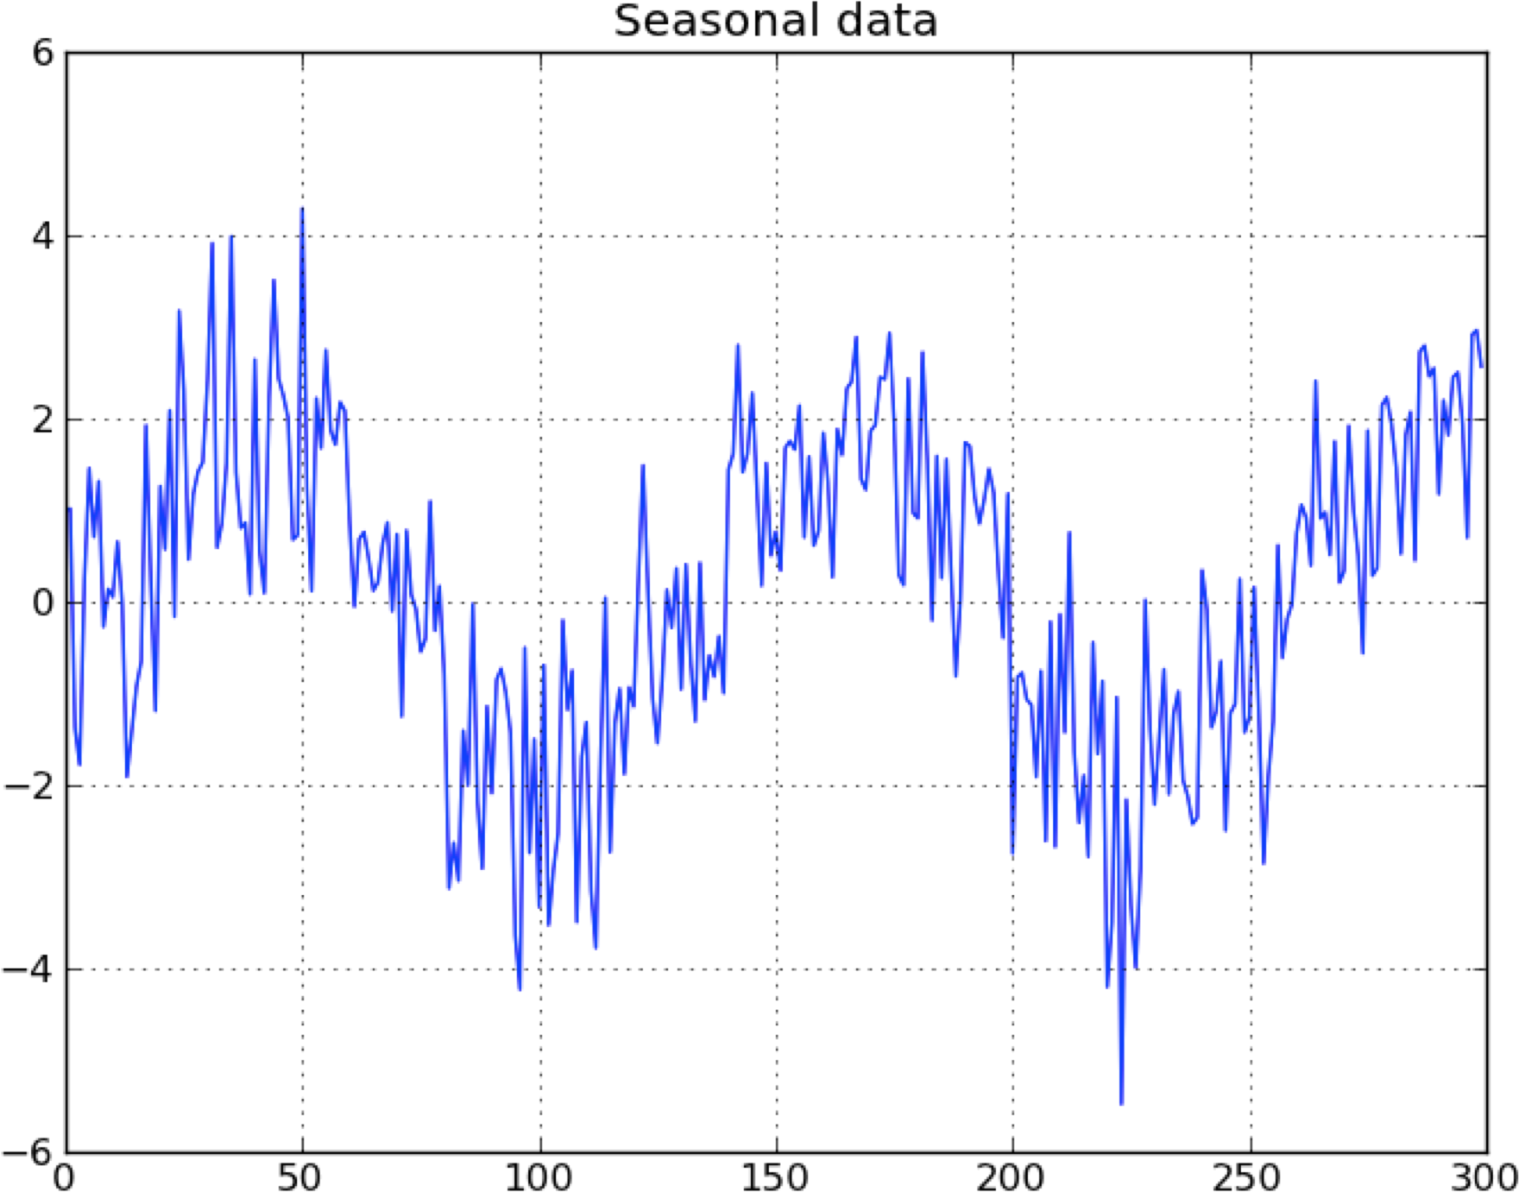

###### *Figure 6-6. Without keeping track of timestamps, we can’t see time-based patterns; here, we see a seasonal pattern in a time series*

This idea, of keeping track of trends and seasonalities, is very important in financial data, and essential to keep track of if you want to make money, considering how small the signals are.

# Financial Modeling

Before the term data scientist existed, there were quants working in finance. There are many overlapping aspects of the job of the quant and the job of the data scientist, and of course some that are very different. For example, as we will see in this chapter, quants are singularly obsessed with timestamps, and don’t care much about whythings work, just if they do.

Of course there’s a limit to what can be covered in just one chapter, but this is meant to give a taste of the kind of approach common in financial modeling.

## In-Sample, Out-of-Sample, and Causality

We need to establish a strict concept of in-sample and out-of-sample data. Note the out-of-sample data is notmeant as testing data—that all happens inside in-sample data. Rather, out-of-sample data is meant to be the data you use after finalizing your model so that you have some idea how the model will perform in production.

We should even restrict the number of times one does out-of-sample analysis on a given dataset because, like it or not, we learn stuff about that data every time, and we will subconsciously overfit to it even in different contexts, with different models.

Next, we need to be careful to always perform causal modeling (note this differs from what statisticians mean by causality). Namely, never use information in the future to predict something now. Or, put differently, we only use information from the past up and to the present moment to predict the future. This is incredibly important in financial modeling. Note it’s not enough to use data about the present if it isn’t actually available and accessible at the present moment. So this means we have to be very careful with timestamps of availability as well as timestamps of reference. This is huge when we’re talking about lagged government data.

Similarly, when we have a set of training data, we don’t know the “best-fit coefficients” for that training data until after the last timestamp on all the data. As we move forward in time from the first timestamp to the last, we expect to get different sets of coefficients as more events happen.

One consequence of this is that, instead of getting one set of “best-fit” coefficients, we actually get an evolutionof each coefficient. This is helpful because it gives us a sense of how stable those coefficients are. In particular, if one coefficient has changed sign 10 times over the training set, then we might well expect a good estimate for it is zero, not the so-called “best fit” at the end of the data. Of course, depending on the variable, we might think of a legitimate reason for it to actually change sign over time.

The in-sample data should, generally speaking, come before the out-of-sample data to avoid causality problems as shown in [Figure 6-7](https://learning.oreilly.com/library/view/doing-data-science/9781449363871/ch06.html#in-sample-data).

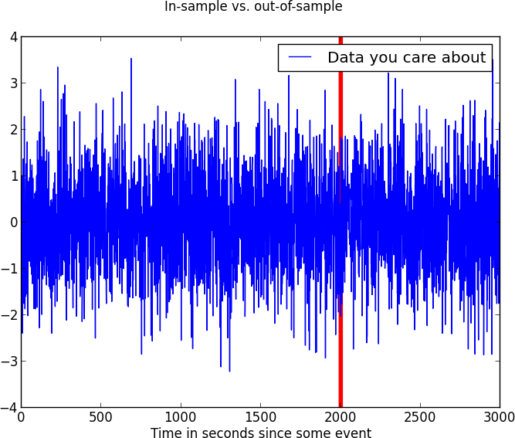

###### *Figure 6-7. In-sample should come before out-of-sample data in a time series dataset*

One final point on causal modeling and in-sample versus out-of-sample. It is consistent with production code, because we are always acting—in the training and in the out-of-sample simulation—as if we’re running our model in production and we’re seeing how it performs. Of course we fit our model in sample, so we expect it to perform better there than in production.

Another way to say this is that, once we have a model in production, we will have to make decisions about the future based only on what we know now (that’s the definition of causal) and we will want to update our model whenever we gather new data. So our coefficients of our model are living organisms that continuously evolve. Just as they should—after all, we’re modeling reality, and things really change over time.

## Preparing Financial Data

We often “prepare” the data before putting it into a model. Typically the way we prepare it has to do with the mean or the variance of the data, or sometimes the data after some transformation like the log (and then the mean or the variance of that transformed data). This ends up being a submodel of our model.

##### TRANSFORMING YOUR DATA

Outside of the context of financial data, preparing and transforming data is also a big part of the process. You have a number of possible techniques to choose from to transform your data to better “behave”:

* Normalize the data by subtracting the mean and dividing by the standard deviation.
* Alternatively normalize or scale by dividing by the maximum value.
* Take the log of the data.
* Bucket into five evenly spaced buckets; or five evenly distributed buckets (or a number other than five), and create a categorical variable from that.
* Choose a meaningful threshold and transform the data into a new binary variable with value 1, if a data point is greater than or equal to the threshold, and 0 if less than the threshold.

Once we have estimates of our mean y¯y¯ and variance σ2yσy2, we can normalize the next data point with these estimates just like we do to get from a Gaussian or normal distribution to the standard normal distribution with mean = 0 and standard deviation = 1:

y↦y−y¯σyy↦y-y¯σy

Of course we may have other things to keep track of as well to prepare our data, and we might run other submodels of our model. For example, we may choose to consider only the “new” part of something, which is equivalent to trying to predict something like yt−yt−1yt-yt-1 instead of yt.yt. Or, we may train a submodel to figure out what part of yt−1yt-1 predicts yt,yt, such as a submodel that is a univariate regression or something.

There are lots of choices here, which will always depend on the situation and the goal you happen to have. Keep in mind, though, that it’s all causal, so you have to be careful when you train your overall model how to introduce your next data point and make sure the steps are all in order of time, and that you’re never ever cheating and looking ahead in time at data that hasn’t happened yet.

In particular, and it happens all the time, one can’t normalize by the mean calculuated over the training set. Instead, have a running estimate of the mean, which you know at a given moment, and normalize with respect to that.

To see why this is so dangerous, imagine a market crash in the middle of your training set. The mean and variance of your returns are heavily affected by such an event, and doing something as innocuous as a mean estimate translates into anticipating the crash before it happens. Such a causal interference tends to help the model, and could likely make a bad model look good (or, what is more likely, make a model that is pure noise look good).

## Log Returns

In finance, we consider returns on a daily basis. In other words, we care about how much the stock (or future, or index) changes from day to day. This might mean we measure movement from opening on Monday to opening on Tuesday, but the standard approach is to care about closing prices on subsequent trading days.

We typically don’t consider percent returns, but rather log returns: if Ft denotes a close on day t,t, then the log return that day is defined as log(Ft/Ft−1),log(Ft/Ft-1), whereas the percent return would be computed as 100((Ft/Ft−1)−1).100((Ft/Ft-1)-1). To simplify the discussion, we’ll compare log returns to scaled percent returns, which is the same as percent returns except without the factor of 100. The reasoning is not changed by this difference in scalar.

There are a few different reasons we use log returns instead of percentage returns. For example, log returns are additive but scaled percent returns aren’t. In other words, the five-day log return is the sum of the five one-day log returns. This is often computationally handy.

By the same token, log returns are symmetric with respect to gains and losses, whereas percent returns are biased in favor of gains. So, for example, if our stock goes down by 50%, or has a –0.5 scaled percent gain, and then goes up by 200%, so has a 2.0 scaled percent gain, we are where we started. But working in the same scenarios with log returns, we’d see first a log return of log(0.5)=−0.301log(0.5)=-0.301 followed by a log return of log(2.0)=0.301.log(2.0)=0.301.

Even so, the two kinds of returns are close to each other for smallish returns, so if we work with short time horizons, like daily or shorter, it doesn’t make a huge difference. This can be proven easily: setting x=Ft/Ft−1,x=Ft/Ft-1,the scaled percent return is x−1x-1 and the log return is log(x),log(x), which has the following Taylor expansion:

log(x)=∑n(x−1)nn=(x−1)+(x−1)2/2+⋯log(x)=∑n(x-1)nn=(x-1)+(x-1)2/2+⋯

In other words, the first term of the Taylor expansion agrees with the percent return. So as long as the second term is small compared to the first, which is usually true for daily returns, we get a pretty good approximation of percent returns using log returns.

Here’s a picture of how closely these two functions behave, keeping in mind that when x=1x=1, there’s no change in price whatsoever, as shown in [Figure 6-8](https://learning.oreilly.com/library/view/doing-data-science/9781449363871/ch06.html#no-price-change).

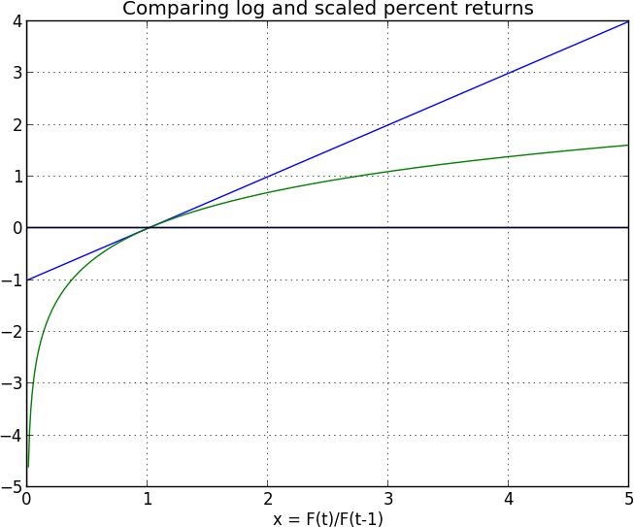

###### *Figure 6-8. Comparing log and scaled percent returns*

## Example: The S&P Index

Let’s work out a toy example. If you start with S&P closing levels as shown in [Figure 6-9](https://learning.oreilly.com/library/view/doing-data-science/9781449363871/ch06.html#SandP-closing), then you get the log returns illustrated in [Figure 6-10](https://learning.oreilly.com/library/view/doing-data-science/9781449363871/ch06.html#SandP-log-returns).

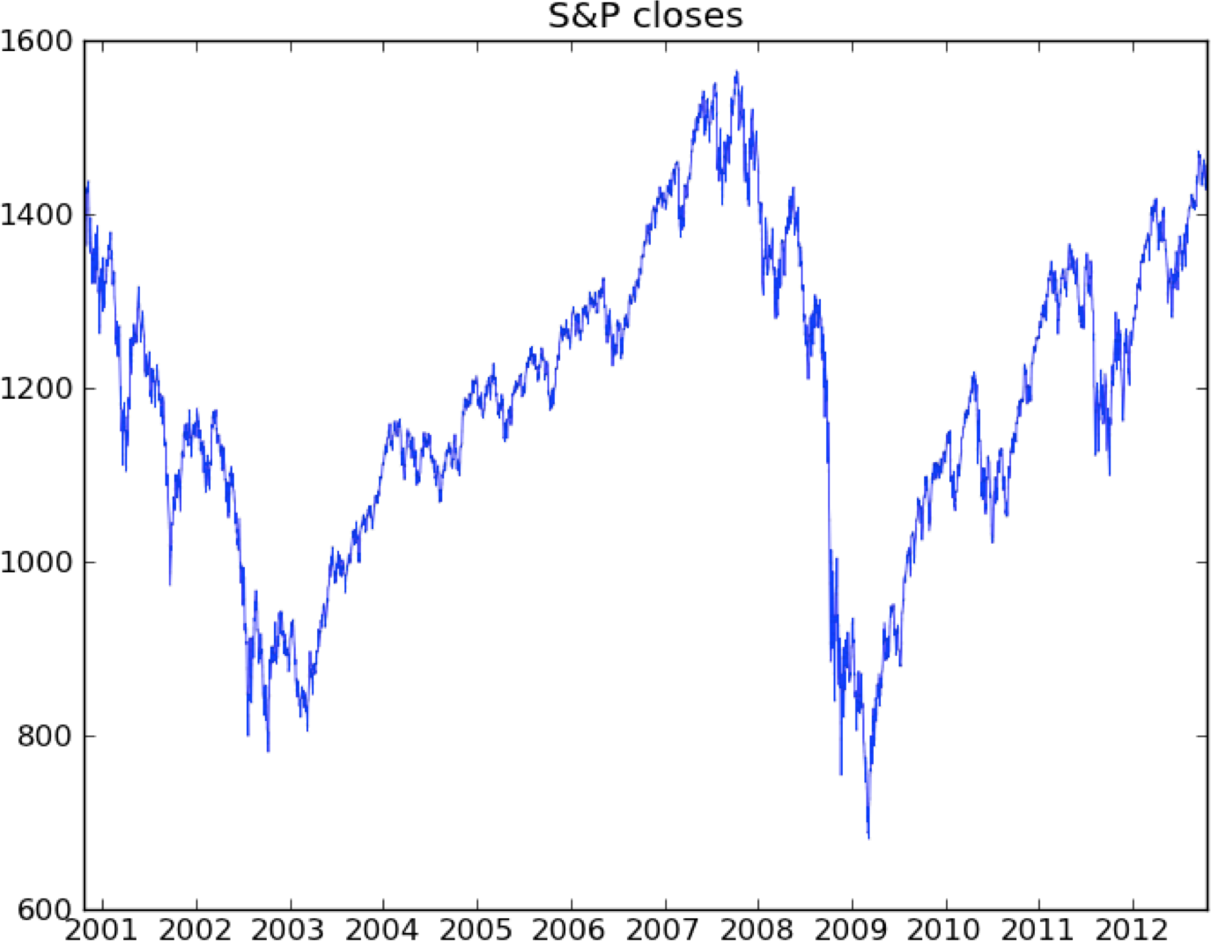

###### *Figure 6-9. S&P closing levels shown over time*

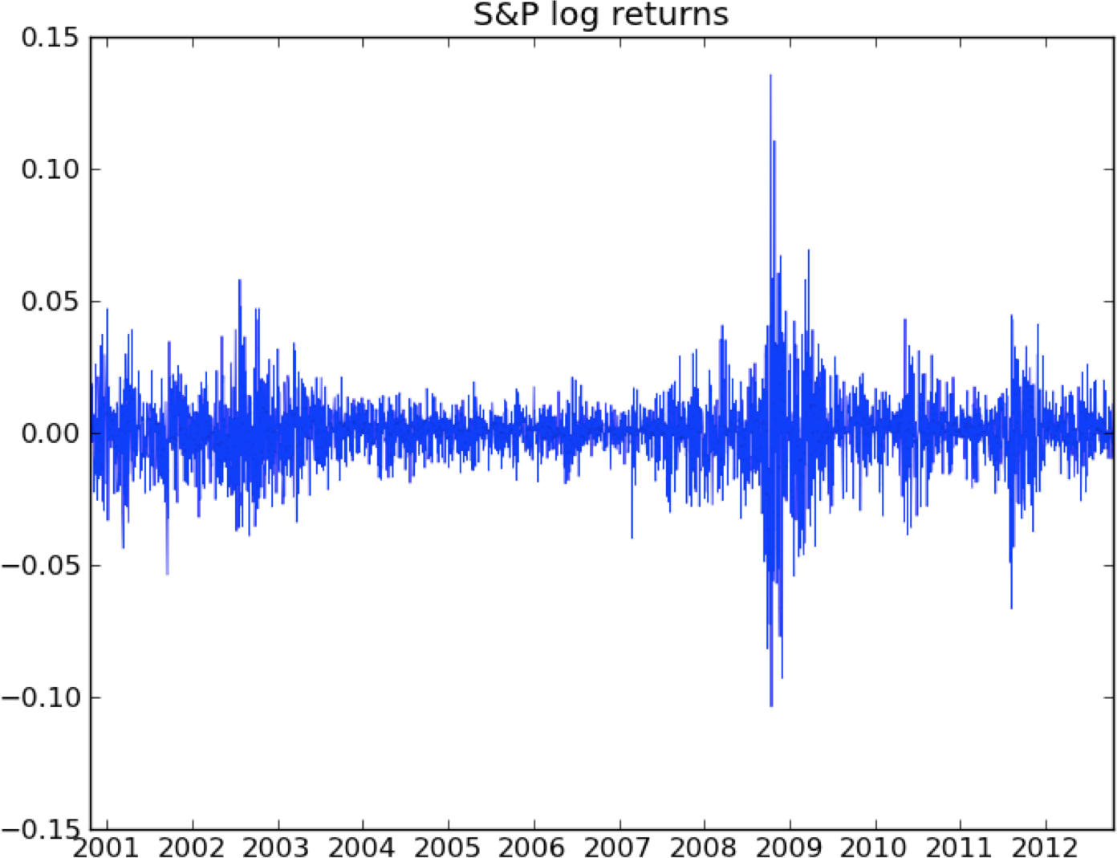

###### *Figure 6-10. The log of the S&P returns shown over time*

What’s that mess? It’s crazy volatility caused by the financial crisis. We sometimes (not always) want to account for that volatility by normalizing with respect to it (described earlier). Once we do that we get something like [Figure 6-11](https://learning.oreilly.com/library/view/doing-data-science/9781449363871/ch06.html#SandP-normed-returns), which is clearly better behaved.

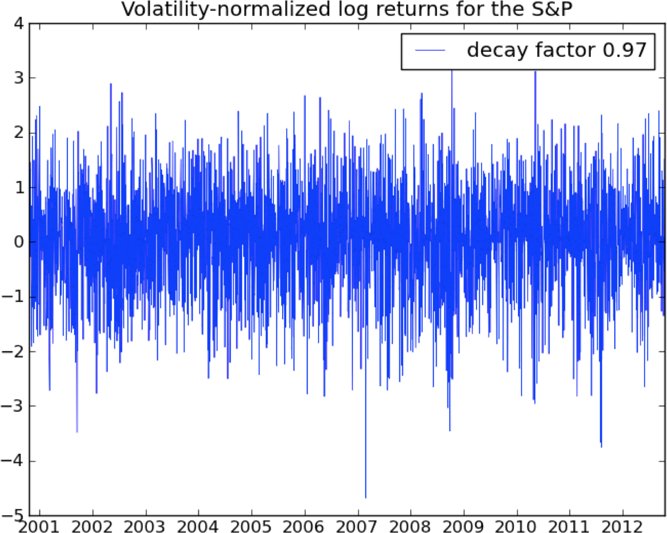

###### *Figure 6-11. The volatility normalized log of the S&P closing returns shown over time*

## Working out a Volatility Measurement

Once we have our returns defined, we can keep a running estimate of how much we have seen it change recently, which is usually measured as a sample standard deviation, and is called a volatility estimate.

A critical decision in measuring the volatility is in choosing a lookback window, which is a length of time in the past we will take our information from. The longer the lookback window is, the more information we have to go by for our estimate. However, the shorter our lookback window, the more quickly our volatility estimate responds to new information. Sometimes you can think about it like this: if a pretty big market event occurs, how long does it take for the market to “forget about it”? That’s pretty vague, but it can give one an intuition on the appropriate length of a lookback window. So, for example, it’s definitely more than a week, sometimes less than four months. It also depends on how big the event is, of course.

Next we need to decide how we are using the past few days’ worth of data. The simplest approach is to take a strictly rolling window, which means we weight each of the previous n days equally and a given day’s return is counted for those n days and then drops off the back of a window. The bad news about this easy approach is that a big return will be counted as big until that last moment, and it will completely disappear. This doesn’t jive with the ways people forget about things—they usually let information gradually fade from their memories.

For this reason we instead have a continuous lookback window, where we exponentially downweight the older data and we have a concept of the “half-life” of the data. This works out to saying that we scale the impact of the past returns depending on how far back in the past they are, and for each day they get multiplied by some number less than 1 (called the decay). For example, if we take the number to be 0.97, then for five days ago we are multiplying the impact of that return by the scalar 0.9750.975. Then we will divide by the sum of the weights, and overall we are taking the weighted average of returns where the weights are just powers of something like 0.97. The “half-life” in this model can be inferred from the number 0.97 using these formulas as –ln(2)/ln(0.97) = 23.

Now that we have figured out how much we want to weight each previous day’s return, we calculate the variance as simply the weighted sum of the squares of the previous returns. Then we take the square root at the end to estimate the volatility.

Note we’ve just given you a formula that involves all of the previous returns. It’s potentially an infinite calculation, albeit with exponentially decaying weights. But there’s a cool trick: to actually compute this we only need to keep one running total of the sum so far, and combine it with the new squared return. So we can update our “vol” (as those in the know call volatility) estimate with one thing in memory and one easy weighted average.

First, we are dividing by the sum of the weights, but the weights are powers of some number s, so it’s a geometric sum and in the limit, the sum is given by 1/(1−s).1/(1-s).

# EXPONENTIAL DOWNWEIGHTING

This technique is called exponential downweighting, a convenient way of compressing the data into a single value that can be updated without having to save the entire dataset.

Next, assume we have the current variance estimate as:

Vold=(1−s)⋅∑ir2isiVold=(1-s)·∑iri2si

and we have a new return r0r0 to add to the series. Then it’s not hard to show we just want:

Vnew=s⋅Vold+(1−s)⋅r20Vnew=s·Vold+(1-s)·r02

Note that we said we would use the sample standard deviation, but the formula for that normally involves removing the mean before taking the sum of squares. Here we ignore the mean, mostly because we are typically taking daily volatility, where the mean (which is hard to anticipate in any case!) is a much smaller factor than the noise, so we can treat it essentially as zero. If we were to measure volatility on a longer time scale such as quarters or years, then we would probably not ignore the mean.

###### NOTE

It really matters which downweighting factor you use, as shown in [Figure 6-12](https://learning.oreilly.com/library/view/doing-data-science/9781449363871/ch06.html#SandP_various_vols).

Indeed, we can game a measurement of risk (and people do) by choosing the downweighting factor that minimizes our risk.

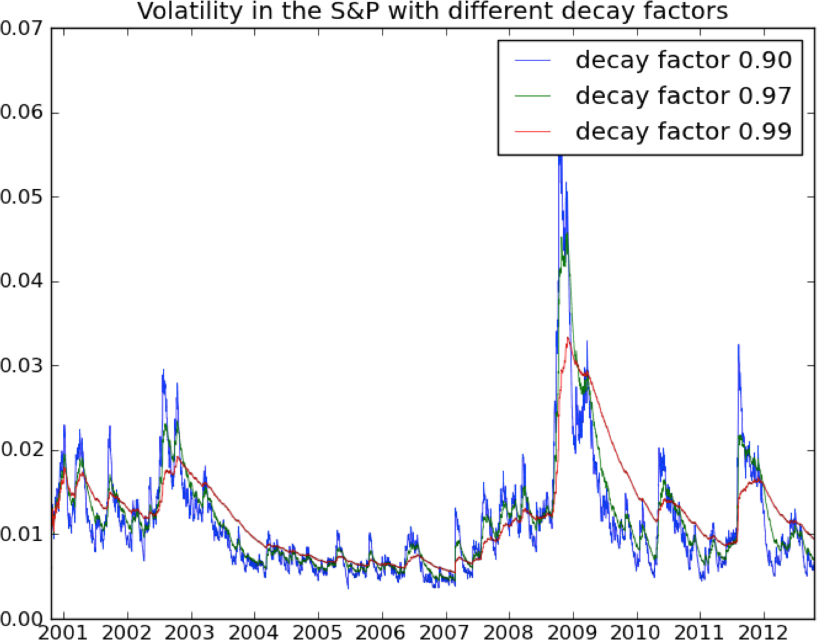

###### *Figure 6-12. Volatility in the S&P with different decay factors*

## Exponential Downweighting

We’ve already seen an example of exponential downweighting in the case of keeping a running estimate of the volatility of the returns of the S&P.

The general formula for downweighting some additive running estimate EE is simple enough. We weight recent data more than older data, and we assign the downweighting of older data a name ss and treat it like a parameter. It is called the decay. In its simplest form we get:

Et=s⋅Et−1+(1−s)⋅etEt=s·Et-1+(1-s)·et

where etet is the new term.

# ADDITIVE ESTIMATES

We need each of our estimates to be additive (which is why we have a running variance estimate rather than a running standard deviation estimate). If what we’re after is a weighted average, say, then we will need to have a running estimate of both numerator and denominator.

If we want to be really careful about smoothness at the beginning (which is more important if we have a few hundred data points or fewer), then we’ll actually vary the parameter ss, via its reciprocal, which we can think of as a kind of half-life. We start with a half-life of 1 and grow it up to the asymptotic “true” half-life N=1/sN=1/s. Thus, when we’re given a vector vv of values etet indexed by days tt, we do something like this:

true_N = N

this_N_est = 1.0

this_E = 0.0

for e_t in v:

this_E = this_E * (1-1/this_N_est) + e_t * (1/this_N_est)

this_N_est = this_N_est*(1-1/true_N) + N * (1/true_N)

## The Financial Modeling Feedback Loop

One thing any quantitative person or data scientist needs to understand about financial modeling is that there’s a feedback loop. If you find a way to make money, it eventually goes away—sometimes people refer to this as the fact that the market “learns over time.”

One way to see this is that, in the end, your model comes down to knowing some price (say) is going to go up in the future, so you buy it before it goes up, you wait, and then you sell it at a profit. But if you think about it, your buying it has actually changed the process, through your market impact, and decreased the signal you were anticipating, at least if the other market players bought it because it looked cheap to them at the previous price; you brought up the price a bit, so you might expect them to buy less in response, which means the overall signal is smaller. Of course, if you only buy one share in anticipation of the increase, your impact is minimal. But if your algorithm works really well, you tend to bet more and more, having a larger and larger impact. Indeed, why would you not bet more? You wouldn’t. After a while you’d learn the optimal amount you can bet and still make good money, and that optimal amount is large enough to have a big impact on the market.

That’s how the market learns—it’s a combination of a bunch of algorithms anticipating things and making them go away.

The consequence of this learning over time is that the existing signals are very weak. Things that were obvious (in hindsight) with the naked eye in the 1970s are no longer available, because they’re all understood and pre-anticipated by the market participants (although new ones might pop into existence).

The bottom line is that, nowadays, we are happy with a 3% correlation for models that have a horizon of 1 day (a “horizon” for your model is how long you expect your prediction to be good). This means not much signal, and lots of noise! Even so, you can still make money if you have such an edge and if your trading costs are sufficiently small.

In particular, lots of the machine learning “metrics of success” for models, such as measurements of precision or accuracy, are not very relevant in this context.

So instead of measuring accuracy, we generally draw a picture to assess models as shown in [Figure 6-13](https://learning.oreilly.com/library/view/doing-data-science/9781449363871/ch06.html#PnL-graphs), namely of the (cumulative) PnL of the model. PnL stands for Profit and Loss and is the day-over-day change (difference, not ratio), or today’s value minus yesterday’s value.

This generalizes to any model as well—you plot the cumulative sum of the product of demeaned forecast and demeaned realized. (A demeaned value is one where the mean’s been subtracted.) In other words, you see if your model consistently does better than the “stupidest” model of assuming everything is average.

If you plot this and you drift up and to the right, you’re good. If it’s too jaggedy, that means your model is taking big bets and isn’t stable.

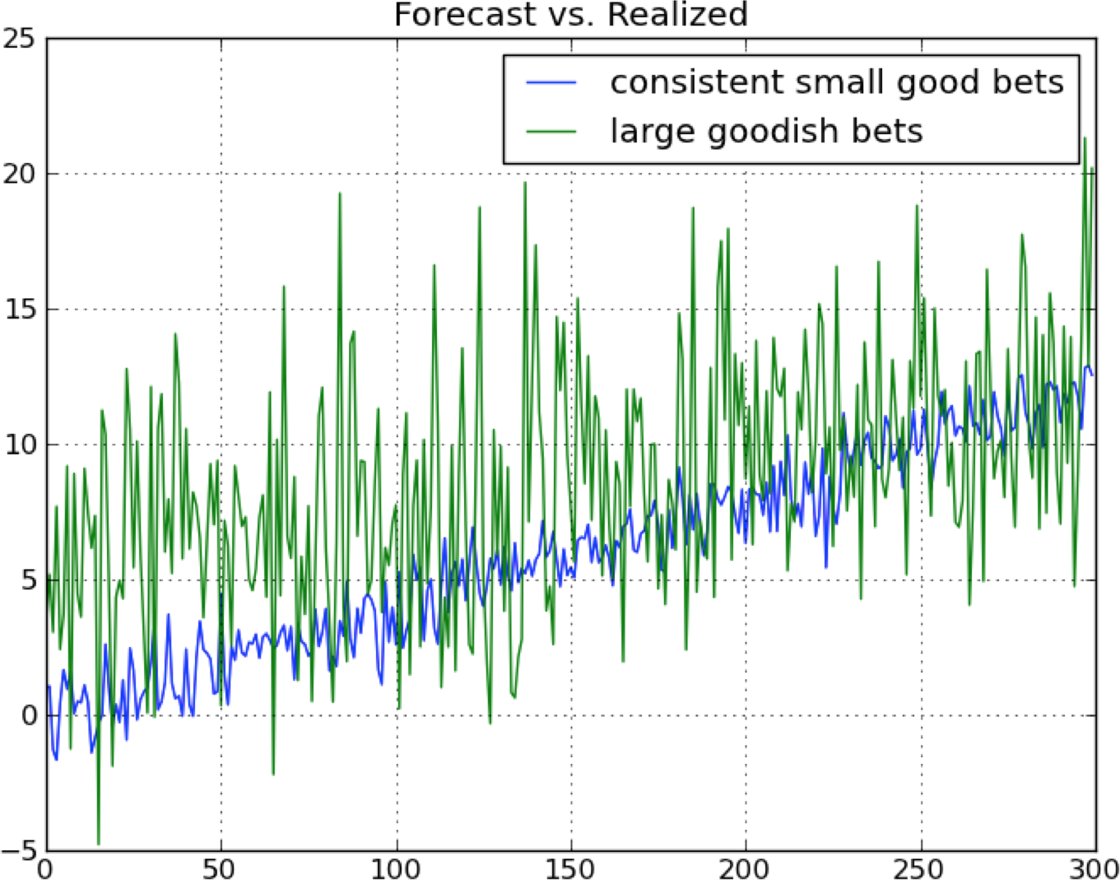

###### *Figure 6-13. A graph of the cumulative PnLs of two theoretical models*

## Why Regression?

So now we know that in financial modeling, the signal is weak. If you imagine there’s some complicated underlying relationship between your information and the thing you’re trying to predict, get over knowing what that is—there’s too much noise to find it. Instead, think of the function as possibly complicated, but continuous, and imagine you’ve written it out as a Taylor Series. Then you can’t possibly expect to get your hands on anything but the linear terms.

Don’t think about using logistic regression, either, because you’d need to be ignoring size, which matters in finance—it matters if a stock went up 2% instead of 0.01%. But logistic regression forces you to have an on/off switch, which would be possible but would lose a lot of information. Considering the fact that we are always in a low-information environment, this is a bad idea.

Note that although we’re claiming you probably want to use linear regression in a noisy environment, the actual terms themselves don’t have to be linear in the information you have. You can always take products of various terms as x’s in your regression. but you’re still fitting a linear model in nonlinear terms.

## Adding Priors

One interpretation of priors is that they can be thought of as opinions that are mathematically formulated and incorporated into our models. In fact, we’ve already encountered a common prior in the form of downweighting old data. The prior can be described as “new data is more important than old data.”

Besides that one, we may also decide to consider something like “coefficients vary smoothly.” This is relevant when we decide, say, to use a bunch of old values of some time series to help predict the next one, giving us a model like:

y=Ft=α0+α1Ft−1+α2Ft−2+ϵy=Ft=α0+α1Ft-1+α2Ft-2+ϵ

which is just the example where we take the last two values of the time series FF to predict the next one. We could use more than two values, of course. If we used lots of lagged values, then we could strengthen our prior in order to make up for the fact that we’ve introduced so many degrees of freedom. In effect, priors reduce degrees of freedom.

The way we’d place the prior about the relationship between coefficients (in this case consecutive lagged data points) is by adding a matrix to our covariance matrix when we perform linear regression. See more about this [here](http://goo.gl/gJURp6).

## A Baby Model

Say we drew a plot in a time series and found that we have strong but fading autocorrelation up to the first 40 lags or so as shown in [Figure 6-14](https://learning.oreilly.com/library/view/doing-data-science/9781449363871/ch06.html#autocorrelation-plot-to-40).

We can calculate autocorrelation when we have time series data. We create a second time series that is the same vector of data shifted by a day (or some fixed time period), and then calculate the correlation between the two vectors.

If we want to predict the next value, we’d want to use the signal that already exists just by knowing the last 40 values. On the other hand, we don’t want to do a linear regression with 40 coefficients because that would be way too many degrees of freedom. It’s a perfect place for a prior.

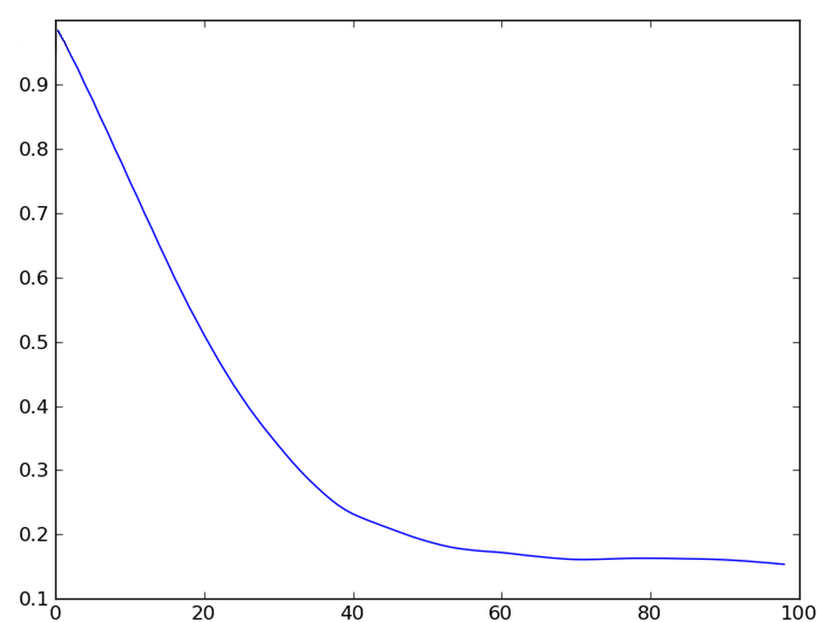

###### *Figure 6-14. Looking at auto-correlation out to 100 lags*

A good way to think about priors is by adding a term to the function we are seeking to minimize, which measures the extent to which we have a good fit. This is called the “penalty function,” and when we have no prior at all, it’s simply the sum of the squares of the error:

F(β)=∑i(yi−xiβ)2=(y−xβ)τ(y−xβ)F(β)=∑i(yi-xiβ)2=(y-xβ)τ(y-xβ)

If we want to minimize FF, which we do, then we take its derivative with respect to the vector of coefficients ββ, set it equal to zero, and solve for ββ—there’s a unique solution, namely:

β=(xτx)−1xτyβ=(xτx)-1xτy

If we now add a standard prior in the form of a penalty term for large coefficients, then we have:

F1(β)=1N∑i(yi−xiβ)2+∑jλ2β2j=1N(y−xβ)τ(y−xβ)+(λIβ)τ(λIβ)F1(β)=1N∑i(yi-xiβ)2+∑jλ2βj2=1N(y-xβ)τ(y-xβ)+(λIβ)τ(λIβ)

This can also be solved using calculus, and we solve for ββ to get:

β1=(xτx+N⋅λ2I)−1xτyβ1=(xτx+N·λ2I)-1xτy

In other words, adding the penalty term for large coefficients translates into adding a scalar multiple of the identity matrix to the covariance matrix in the closed form solution to ββ.

If we now want to add another penalty term that represents a “coefficients vary smoothly” prior, we can think of this as requiring that adjacent coefficients should be not too different from each other, which can be expressed in the following penalty function with a new parameter μμ as follows:

F2(β)=1N∑i(yi−xiβ)2+∑jλ2β2j+∑jμ2(βj−βj+1)2=1N(y−xβ)τ(y−xβ)+λ2βτβ+μ2(Iβ−Mβ)τ(Iβ−Mβ)F2(β)=1N∑i(yi-xiβ)2+∑jλ2βj2+∑jμ2(βj-βj+1)2=1N(y-xβ)τ(y-xβ)+λ2βτβ+μ2(Iβ-Mβ)τ(Iβ-Mβ)

where MM is the matrix that contains zeros everywhere except on the lower off-diagonals, where it contains 1’s. Then MβMβ is the vector that results from shifting the coefficients of ββ by one and replacing the last coefficient by 0. The matrix MM is called a shift operator and the difference I−MI-M can be thought of as a discrete derivative operator (see [here](http://goo.gl/2D4LeH) for more information on discrete calculus).

Because this is the most complicated version, let’s look at this in detail. Remembering our vector calculus, the derivative of the scalar function F2(β)F2(β) with respect to the vector ββ is a vector, and satisfies a bunch of the properties that happen at the scalar level, including the fact that it’s both additive and linear and that:

∂uτ⋅u∂β=2∂uτ∂βu∂uτ·u∂β=2∂uτ∂βu

Putting the preceding rules to use, we have:

∂F2(β)∂β=1N∂(y−xβ)τ(y−xβ)∂β+λ2⋅∂βτβ∂β+μ2⋅∂((I−M)β)τ((I−M)β)∂β∂F2(β)∂β=1N∂(y-xβ)τ(y-xβ)∂β+λ2·∂βτβ∂β+μ2·∂((I-M)β)τ((I-M)β)∂β=−2Nxτ(y−xβ)+2λ2⋅β+2μ2(I−M)τ(I−M)β=-2Nxτ(y-xβ)+2λ2·β+2μ2(I-M)τ(I-M)β

Setting this to 0 and solving for ββ gives us:

β2=(xτx+N⋅λ2I+N⋅μ2⋅(I−M)τ(I−M))−1xτyβ2=(xτx+N·λ2I+N·μ2·(I-M)τ(I-M))-1xτy

In other words, we have yet another matrix added to our covariance matrix, which expresses our prior that coefficients vary smoothly. Note that the symmetric matrix (I−M)τ(I−M)(I-M)τ(I-M) has 1’s along its sub- and super-diagonal, but also has 2’s along its diagonal. In other words, we need to adjust our λλ as we adjust our μμ because there is an interaction between these terms.

# PRIORS AND HIGHER DERIVATIVES

If you want to, you can add a prior about the second derivative (or other higher derivatives) as well, by squaring the derivative operator (I−M)(I-M) (or taking higher powers of it).

So what’s the model? Well, remember we will choose an exponential downweighting term γγ for our data, and we will keep a running estimate of both xτxxτx and xτyxτy as was explained previously. The hyperparameters of our model are then γ,γ, λ,λ, and μμ. We usually have a sense of how large γγ should be based on the market, and the other two parameters depend on each other and on the data itself. This is where it becomes an art—you want to optimize to some extent on these choices, without going overboard and overfitting.

## Exercise: GetGlue and Timestamped Event Data

GetGlue kindly provided a dataset for us to explore their data, which contains timestamped events of users checking in and rating TV shows and movies.

The [raw data](http://bit.ly/1aL8XS0) is on a per-user basis, from 2007 to 2012, and only shows ratings and check-ins for TV shows and movies. It’s less than 3% of their total data, and even so it’s big, namely 11 GB once it’s uncompressed.

Here’s some R code to look at the first 10 rows:

*#*

*# author: Jared Lander*

*#*

require(rjson)

require(plyr)

*# the location of the data*

dataPath <- "http://getglue-data.s3.amazonaws.com/

getglue_sample.tar.gz"

*# build a connection that can decompress the file*

theCon <- gzcon(url(dataPath))

*# read 10 lines of the data*

n.rows <- 10

theLines <- readLines(theCon, n=n.rows)

*# check its structure*

str(theLines)

*# notice the first element is different than the rest*

theLines[1]

*# use fromJSON on each element of the vector, except the first*

theRead <- lapply(theLines[-1], fromJSON)

*# turn it all into a data.frame*

theData <- ldply(theRead, as.data.frame)

*# see how we did*

View(theData)

Start with these steps:

1. Load in 1,000 rows of data and spend time looking at it with your eyes. For this entire assignment, work with these 1,000 rows until your code is in good shape. Then you can extend to 100,000 or 1 million rows.
2. Aggregate and count data. Find answers to the following questions:
   * How many unique actions can a user take? And how many actions of each type are in this dataset?
   * How many unique users are in this dataset?
   * What are the 10 most popular movies?
   * How many events in this dataset occurred in 2011?
3. Propose five new questions that you think are interesting and worth investigating.
4. Investigate/answer your questions.
5. Visualize. Come up with one visualization that you think captures something interesting about this dataset.

## Exercise: Financial Data

Here’s an exercise to help you explore the concepts in this chapter:

1. Get the Data: Go to Yahoo! Finance and download daily data from a stock that has at least eight years of data, making sure it goes from earlier to later. If you don’t know how to do it, Google it.
2. Create the time series of daily log returns of the stock price.
3. Just for comparison, do the same for volume data (i.e., create the time series of daily log changes in volume).
4. Next, try to set up a linear regression model that uses the past two returns to predict the next return. Run it and see if you can make any money with it. Try it for both stock returns and volumes. Bonus points if you: do a causal model, normalize for volatility (standard deviation), or put in an exponential decay for old data.
5. Draw the cumulative P&L (forecast × realized) graphs and see if they drift up.

# Chapter 7. Extracting Meaning from Data

How do companies extract meaning from the data they have?

In this chapter we hear from two people with very different approaches to that question—namely, William Cukierski from [Kaggle](http://www.kaggle.com/) and David Huffaker from Google.

# William Cukierski

Will went to Cornell for a BA in physics and to Rutgers to get his PhD in biomedical engineering. He focused on cancer research, studying pathology images. While working on writing his dissertation, he got more and more involved in Kaggle competitions (more about Kaggle in a bit), finishing very near the top in multiple competitions, and now works for Kaggle.

After giving us some background in data science competitions and crowdsourcing, Will will explain how his company works for the participants in the platform as well as for the larger community.

Will will then focus on feature extraction and feature selection. Quickly, feature extraction refers to taking the raw dump of data you have and curating it more carefully, to avoid the “garbage in, garbage out” scenario you get if you just feed raw data into an algorithm without enough forethought. Feature selection is the process of constructing a subset of the data or functions of the data to be the predictors or variables for your models and algorithms.

## Background: Data Science Competitions

There is a history in the machine learning community of data science competitions—where individuals or teams compete over a period of several weeks or months to design a prediction algorithm. What it predicts depends on the particular dataset, but some examples include whether or not a given person will get in a car crash, or like a particular film. A training set is provided, an evaluation metric determined up front, and some set of rules is provided about, for example, how often competitors can submit their predictions, whether or not teams can merge into larger teams, and so on.

Examples of machine learning competitions include the annual Knowledge Discovery and Data Mining (KDD) competition, the one-time million-dollar Netflix prize (a competition that lasted two years), and, as we’ll learn a little later, Kaggle itself.

Some remarks about data science competitions are warranted. First, data science competitions are part of the data science ecosystem—one of the cultural forces at play in the current data science landscape, and so aspiring data scientists ought to be aware of them.

Second, creating these competitions puts one in a position to codify data science, or define its scope. By thinking about the challenges that they’ve issued, it provides a set of examples for us to explore the central question of this book: what is data science? This is not to say that we will unquestionably accept such a definition, but we can at least use it as a starting point: what attributes of the existing competitions capture data science, and what aspects of data science are missing?

Finally, competitors in the the various competitions get ranked, and so one metric of a “top” data scientist could be their standings in these competitions. But notice that many top data scientists, especially women, and including the authors of this book, don’t compete. In fact, there are few women at the top, and we think this phenomenon needs to be explicitly thought through when we expect top ranking to act as a proxy for data science talent.

# DATA SCIENCE COMPETITIONS CUT OUT ALL THE MESSY STUFF

Competitions might be seen as formulaic, dry, and synthetic compared to what you’ve encountered in normal life. Competitions cut out the messy stuff before you start building models—asking good questions, collecting and cleaning the data, etc.—as well as what happens once you have your model, including visualization and communication. The team of Kaggle data scientists actually spends a lot of time creating the dataset and evaluation metrics, and figuring out what questions to ask, so the question is: while they’re doing data science, are the contestants?

## Background: Crowdsourcing

There are two kinds of crowdsourcing models. First, we have the distributive crowdsourcing model, like Wikipedia, which is for relatively simplistic but large-scale contributions. On Wikipedia, the online encyclopedia, anyone in the world can contribute to the content, and there is a system of regulation and quality control set up by volunteers. The net effect is a fairly high-quality compendium of all of human knowledge (more or less).

Then, there’s the singular, focused, difficult problems that [Kaggle](http://www.kaggle.com/), [DARPA](http://en.wikipedia.org/wiki/DARPA#Active_projects), [InnoCentive](http://www.innocentive.com/), and other companies specialize in. These companies issue a challenge to the public, but generally only a set of people with highly specialized skills compete. There is usually a cash prize, and glory or the respect of your community, associated with winning.

Crowdsourcing projects have historically had a number of issues that can impact their usefulness. A couple aspects impact the likelihood that people will participate. First off, many lack an evaluation metric. How do you decide who wins? In some cases, the evaluation method isn’t always objective. There might be a subjective measure, where the judges decide your design is bad or they just have different taste. This leads to a high barrier to entry, because people don’t trust the evaluation criterion. Additionally, one doesn’t get recognition until after they’ve won or at least ranked highly. This leads to high sunk costs for the participants, which people know about in advance—this can become yet another barrier to entry.

Organizational factors can also hinder success. A competition that is not run well conflates participants with [mechanical turks](https://www.mturk.com/mturk/welcome): in other words, they assume the competitors to be somewhat mindless and give bad questions and poor prizes. This precedent is just bad for everyone in that it demoralizes data scientists and doesn’t help businesses answer more essential questions that get the most from their data. Another common problem is when the competitions don’t chunk the work into bite-sized pieces. Either the question is too big to tackle or too small to be interesting.

Learning from these mistakes, we expect a good competition to have a feasible, interesting question, with an evaluation metric that is transparent and objective. The problem is given, the dataset is given, and the metric of success is given. Moreover, the prizes are established up front.

Let’s get a bit of historical context for crowdsourcing, since it is not a new idea. Here are a few examples:

* In 1714, [the British Royal Navy couldn’t measure longitude](http://www.crowdsourcing.com/cs/2008/05/chapter-7-what.html), and put out a prize worth $6 million in today’s dollars to get help. [John Harrison, an unknown cabinetmaker, figured out how to make a clock to solve the problem](http://www.goodreads.com/book/show/4806.Longitude).
* In 2002, the TV network Fox issued a prize for the next pop solo artist, which resulted in the television show [American Idol](http://en.wikipedia.org/wiki/American_Idol), where contestants compete in an elimination-round style singing competition.
* There’s also the [X-prize company](http://www.xprize.org/), which offers “incentivized prize competitions…to bring about radical breakthroughs for the benefits of humanity, thereby inspiring the formation of new industries and the revitalization of markets.” A total of $10 million was offered for the Ansari X-prize, a space competition, and $100 million was invested by contestants trying to solve it. Note this shows that it’s not always such an efficient process overall—but on the other hand, it could very well be efficient for the people offering the prize if it gets solved.

##### TERMINOLOGY: CROWDSOURCING AND MECHANICAL TURKS

These are a couple of terms that have started creeping into the vernacular over the past few years.

Although crowdsourcing—the concept of using many people to solve a problem independently—is not new, the term was only fairly recently coined in 2006. The basic idea is a that a challenge is issued and contestants compete to find the best solution. The Wisdom of Crowds was a book written by James Suriowiecki (Anchor, 2004) with the central thesis that, on average, crowds of people will make better decisions than experts, a related phenomenon. It is only under certain conditions (independence of the individuals rather than group-think where a group of people talking to each other can influence each other into wildly incorrect solutions), where groups of people can arrive at the correct solution. And only certain problems are well-suited to this approach.

Amazon Mechanical Turk is an online crowdsourcing service where humans are given tasks. For example, there might be a set of images that need to be labeled as “happy” or “sad.” These labels could then be used as the basis of a training set for a supervised learning problem. An algorithm could then be trained on these human-labeled images to automatically label new images. So the central idea of Mechanical Turk is to have humans do fairly routine tasks to help machines, with the goal of the machines then automating tasks to help the humans! Any researcher with a task they need automated can use Amazon Mechanical Turk as long as they provide compensation for the humans. And any human can sign up and be part of the crowdsourcing service, although there are some quality control issues—if the researcher realizes the human is just labeling every other image as “happy” and not actually looking at the images, then the human won’t be used anymore for labeling.

Mechanical Turk is an example of artificial artificial intelligence (yes, double up on the “artificial”), in that the humans are helping the machines helping the humans.

# The Kaggle Model

*Being a data scientist is when you learn more and more about more and more, until you know nothing about everything.*

Will Cukierski

Kaggle is a company whose tagline is, “We’re making data science a sport.” Kaggle forms relationships with companies and with data scientists. For a fee, Kaggle hosts competitions for businesses that essentially want to crowdsource (or leverage the wider data science community) to solve their data problems. Kaggle provides the infrastructure and attracts the data science talent.

They also have in house a bunch of top-notch data scientists, including Will himself. The companies are their paying customers, and they provide datasets and data problems that they want solved. Kaggle crowdsources these problems with data scientists around the world. Anyone can enter. Let’s first describe the Kaggle experience for a data scientist and then discuss the customers.

## A Single Contestant

In Kaggle competitions, you are given a training set, and also a test set where the yys are hidden, but the xxs are given, so you just use your model to get your predicted xxs for the test set and upload them into the Kaggle system to see your evaluation score. This way you don’t share your actual code with Kaggle unless you win the prize (and Kaggle doesn’t have to worry about which version of Python you’re running). Note that even giving out just the xxs is real information—in particular it tells you, for example, what sizes of xxs your algorithm should optimize for. Also for the purposes of the competition, there is a third hold-out set that contestants never have access to. You don’t see the xxs or the yys—that is used to determine the competition winner when the competition closes.

On Kaggle, the participants are encouraged to submit their models up to five times a day during the competitions, which last a few weeks. As contestants submit their predictions, the Kaggle leaderboard updates immediately to display the contestant’s current evaluation metric on the hold-out test set. With a sufficient number of competitors doing this, we see a “leapfrogging” between them as shown in [Figure 7-1](https://learning.oreilly.com/library/view/doing-data-science/9781449363871/ch07.html#leapfrogging-viz), where one ekes out a 5% advantage, giving others incentive to work harder. It also establishes a band of accuracy around a problem that you generally don’t have—in other words, given no other information, with nobody else working on the problem you’re working on, you don’t know if your 75% accurate model is the best possible.

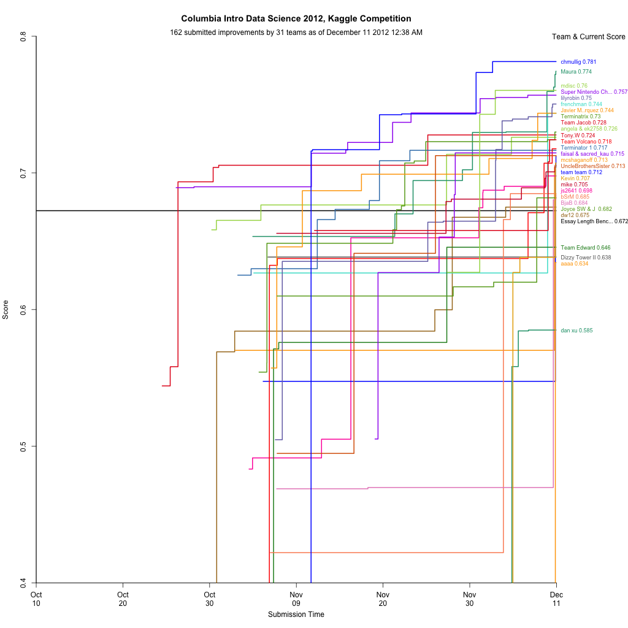

###### *Figure 7-1. Chris Mulligan, a student in Rachel’s class, created this leapfrogging visualization to capture the competition in real time as it progressed throughout the semester*

This leapfrogging effect is good and bad. It encourages people to squeeze out better performing models, possibly at the risk of overfitting, but it also tends to make models much more complicated as they get better. One reason you don’t want competitions lasting too long is that, after a while, the only way to inch up performance is to make things ridiculously complicated. For example, the original Netflix Prize lasted two years and the final winning model was too complicated for them to actually put into production.

## Their Customers

So why would companies pay to work with Kaggle? The hole that Kaggle is filling is the following: there’s a mismatch between those who need analysis and those with skills. Even though companies desperately need analysis, they tend to hoard data; this is the biggest obstacle for success for those companies that even host a Kaggle competition. Many companies don’t host competitions at all, for similar reasons. Kaggle’s innovation is that it convinces businesses to share proprietary data with the benefit that their large data problems will be solved for them by crowdsourcing Kaggle’s tens of thousands of data scientists around the world.

Kaggle’s contests have produced some good results so far. Allstate, the auto insurance company—which has a good actuarial team already—challenged their data science competitors to improve their actuarial model that, given attributes of drivers, approximates the probability of a car crash. The 202 competitors improved Allstate’s model by 271% under normalized Gini coefficient (see <http://www.kaggle.com/solutions/casestudies/allstate> for more). Another example includes a company where the prize for competitors was $1,000, and it benefited the company on the order of $100,000.

##### IS THIS FAIR?

Is it fair to the data scientists already working at the companies that engage with Kaggle? Some of them might lose their job, for example, if the result of the competition is better than the internal model. Is it fair to get people to basically work for free and ultimately benefit a for-profit company? Does it result in data scientists losing their fair market price? Kaggle charges a fee for hosting competitions, and it offers well-defined prizes, so a given data scientist can always choose to not compete. Is that enough?

This seems like it could be a great opportunity for companies, but only while the data scientists of the world haven’t realized their value and have extra time on their hands. As soon as they price their skills better they might think twice about working for (almost) free, unless it’s for a cause they actually believe in.

When Facebook was recently hiring data scientists, they hosted a Kaggle competition, where the prize was an interview. There were 422 competitors. We think it’s convenient for Facebook to have interviewees for data science positions in such a posture of gratitude for the mere interview. Cathy thinks this distracts data scientists from asking hard questions about what the data policies are and the underlying ethics of the company.

##### KAGGLE’S ESSAY SCORING COMPETITION

Part of the final exam for the Columbia class was an essay grading contest. The students had to build it, train it, and test it, just like any other Kaggle competition, and group work was encouraged. The details of the essay contest are discussed below, and you access the data at [https://inclass.kaggle.com](https://inclass.kaggle.com/).

You are provided access to hand-scored essays so that you can build, train, and test an automatic essay scoring engine. Your success depends upon how closely you can deliver scores to those of human expert graders.

For this competition, there are five essay sets. Each of the sets of essays was generated from a single prompt. Selected essays range from an average length of 150 to 550 words per response. Some of the essays are dependent upon source information and others are not. All responses were written by students ranging in grade levels 7 to 10. All essays were hand graded and were double-scored. Each of the datasets has its own unique characteristics. The variability is intended to test the limits of your scoring engine’s capabilities. The data has these columns:

id

A unique identifier for each individual student essay set

1-5

An id for each set of essays

essay

The ASCII text of a student’s response

rater1

Rater 1’s grade

rater2

Rater 2’s grade

grade

Resolved score between the raters

# Thought Experiment: What Are the Ethical Implications of a Robo-Grader?

Will asked students to consider whether they would want their essays automatically graded by an underlying computer algorithm, and what the ethical implications of automated grading would be. Here are some of their thoughts.

Human graders aren’t always fair.

In the case of doctors, there have been studies where a given doctor is shown the same slide two months apart and gives different diagnoses. We aren’t consistent ourselves, even if we think we are. Let’s keep that in mind when we talk about the “fairness” of using machine learning algorithms in tricky situations. Machine learning has been used to research cancer, where the stakes are much higher, although there’s probably less effort in gaming them.

Are machines making things more structured, and is this inhibiting creativity?

Some might argue that people want things to be standardized. (It also depends on how much you really care about your grade.) It gives us a consistency that we like. People don’t want artistic cars, for example; they want safe cars. Even so, is it wise to move from the human to the machine version of same thing for any given thing? Is there a universal answer or is it a case-by-case kind of question?

Is the goal of a test to write a good essay or to do well in a standardized test?

If the latter, you may as well consider a test like a screening: you follow the instructions, and you get a grade depending on how well you follow instructions. Also, the real profit center for standardized testing is, arguably, to sell books to tell you how to take the tests. How does that translate here? One possible way it could translate would be to have algorithms that game the grader algorithms, by building essays that are graded well but are not written by hand. Then we could see education as turning into a war of machines, between the algorithms the students have and the algorithms the teachers have. We’d probably bet on the students in this war.

##### DOMAIN EXPERTISE VERSUS MACHINE LEARNING ALGORITHMS

This is a false dichotomy. It isn’t either/or. You need both to solve data science problems. However, Kaggle’s president Jeremy Howard pissed some domain experts off in a December 2012 New Scientist magazine interview with Peter Aldhous, “Specialist Knowledge is Useless and Unhelpful.” Here’s an excerpt:

PA: What separates the winners from the also-rans?

JH: The difference between the good participants and the bad is the information they feed to the algorithms. You have to decide what to abstract from the data. Winners of Kaggle competitions tend to be curious and creative people. They come up with a dozen totally new ways to think about the problem. The nice thing about algorithms like the random forest is that you can chuck as many crazy ideas at them as you like, and the algorithms figure out which ones work.

PA: That sounds very different from the traditional approach to building predictive models. How have experts reacted?

JH: The messages are uncomfortable for a lot of people. It’s controversial because we’re telling them: “Your decades of specialist knowledge are not only useless, they’re actually unhelpful; your sophisticated techniques are worse than generic methods.” It’s difficult for people who are used to that old type of science. They spend so much time discussing whether an idea makes sense. They check the visualizations and noodle over it. That is all actively unhelpful.

PA: Is there any role for expert knowledge?

JH: Some kinds of experts are required early on, for when you’re trying to work out what problem you’re trying to solve. The expertise you need is strategy expertise in answering these questions.

PA: Can you see any downsides to the data-driven, black-box approach that dominates on Kaggle?

JH: Some people take the view that you don’t end up with a richer understanding of the problem. But that’s just not true: The algorithms tell you what’s important and what’s not. You might ask why those things are important, but I think that’s less interesting. You end up with a predictive model that works. There’s not too much to argue about there.

# Feature Selection

The idea of feature selection is identifying the subset of data or transformed data that you want to put into your model.

Prior to working at Kaggle, Will placed highly in competitions (which is how he got the job), so he knows firsthand what it takes to build effective predictive models. Feature selection is not only useful for winning competitions—it’s an important part of building statistical models and algorithms in general. Just because you have data doesn’t mean it all has to go into the model.

For example, it’s possible you have many redundancies or correlated variables in your raw data, and so you don’t want to include all those variables in your model. Similarly you might want to construct new variables by transforming the variables with a logarithm, say, or turning a continuous variable into a binary variable, before feeding them into the model.

# TERMINOLOGY: FEATURES, EXPLANATORY VARIABLES, PREDICTORS

Different branches of academia use different terms to describe the same thing. Statisticians say “explanatory variables” or “dependent variables” or “predictors” when they’re describing the subset of data that is the input to a model. Computer scientists say “features.”

Feature extraction and selection are the most important but underrated steps of machine learning. Better features are better than better algorithms.

Will Cukierski

*We don’t have better algorithms, we just have more data.*

Peter Norvig Director of Research for Google

Is it possible, Will muses, that Norvig really wanted to say we have better features? You see, more data is sometimes just more data (example: I can record dice rolls until the cows come home, but after a while I’m not getting any value add because my features will converge), but for the more interesting problems that Google faces, the feature landscape is complex/rich/nonlinear enough to benefit from collecting the data that supportsthose features.

Why? We are getting bigger and bigger datasets, but that’s not always helpful. If the number of features is larger than the number of observations, or if we have a sparsity problem, then large isn’t necessarily good. And if the huge data just makes it hard to manipulate because of computational reasons (e.g., it can’t all fit on one computer, so the data needs to be sharded across multiple machines) without improving our signal, then that’s a net negative.

To improve the performance of your predictive models, you want to improve your feature selection process.

## Example: User Retention

Let’s give an example for you to keep in mind before we dig into some possible methods. Suppose you have an app that you designed, let’s call it Chasing Dragons (shown in [Figure 7-2](https://learning.oreilly.com/library/view/doing-data-science/9781449363871/ch07.html#Figure6.2)), and users pay a monthly subscription fee to use it. The more users you have, the more money you make. Suppose you realize that only 10% of new users ever come back after the first month. So you have two options to increase your revenue: find a way to increase the retention rate of existing users, or acquire new users. Generally it costs less to keep an existing customer around than to market and advertise to new users. But setting aside that particular cost-benefit analysis of acquistion or retention, let’s choose to focus on your user retention situation by building a model that predictswhether or not a new user will come back next month based on their behavior this month. You could build such a model in order to understand your retention situation, but let’s focus instead on building an algorithm that is highly accurate at predicting. You might want to use this model to give a free month to users who you predict need the extra incentive to stick around, for example.



###### *Figure 7-2. Chasing Dragons, the app designed by you*

A good, crude, simple model you could start out with would be logistic regression, which you first saw back in [Chapter 4](https://learning.oreilly.com/library/view/doing-data-science/9781449363871/ch04.html#chapter-spam-filters-naive-bayes). This would give you the probability the user returns their second month conditional on their activities in the first month. (There is a rich set of statistical literature called Survival Analysis that could also work well, but that’s not necessary in this case—the modeling part isn’t what we want to focus on here, it’s the data.) You record each user’s behavior for the first 30 days after sign-up. You could log every action the user took with timestamps: user clicked the button that said “level 6” at 5:22 a.m., user slew a dragon at 5:23 a.m., user got 22 points at 5:24 a.m., user was shown an ad for deodorant at 5:25 a.m. This would be the data collection phase. Any action the user could take gets recorded.

Notice that some users might have thousands of such actions, and other users might have only a few. These would all be stored in timestamped event logs. You’d then need to process these logs down to a dataset with rows and columns, where each row was a user and each column was a feature. At this point, you shouldn’t be selective; you’re in the feature generation phase. So your data science team (game designers, software engineers, statisticians, and marketing folks) might sit down and brainstorm features. Here are some examples:

* Number of days the user visited in the first month
* Amount of time until second visit
* Number of points on day jj for j=1,...,30j=1,...,30 (this would be 30 separate features)
* Total number of points in first month (sum of the other features)
* Did user fill out Chasing Dragons profile (binary 1 or 0)
* Age and gender of user
* Screen size of device

Use your imagination and come up with as many features as possible. Notice there are redundancies and correlations between these features; that’s OK.

##### FEATURE GENERATION OR FEATURE EXTRACTION

This process we just went through of brainstorming a list of features for Chasing Dragons is the process of feature generation or feature extraction. This process is as much of an art as a science. It’s good to have a domain expert around for this process, but it’s also good to use your imagination.

In today’s technology environment, we’re in a position where we can generate tons of features through logging. Contrast this with other contexts like surveys, for example—you’re lucky if you can get a survey respondent to answer 20 questions, let alone hundreds.

But how many of these features are just noise? In this environment, when you can capture a lot of data, not all of it might be actually useful information.

Keep in mind that ultimately you’re limited in the features you have access to in two ways: whether or not it’s possible to even capture the information, and whether or not it even occurs to you at all to try to capture it. You can think of information as falling into the following buckets:

Relevant and useful, but it’s impossible to capture it.

You should keep in mind that there’s a lot of information that you’re not capturing about users—how much free time do they actually have? What other apps have they downloaded? Are they unemployed? Do they suffer from insomnia? Do they have an addictive personality? Do they have nightmares about dragons? Some of this information might be more predictive of whether or not they return next month. There’s not much you can do about this, except that it’s possible that some of the data you are able to capture serves as a proxy by being highly correlated with these unobserved pieces of information: e.g., if they play the game every night at 3 a.m., they might suffer from insomnia, or they might work the night shift.

Relevant and useful, possible to log it, and you did.

Thankfully it occurred to you to log it during your brainstorming session. It’s great that you chose to log it, but just because you chose to log it doesn’t mean you know that it’s relevant or useful, so that’s what you’d like your feature selection process to discover.

Relevant and useful, possible to log it, but you didn’t.

It could be that you didn’t think to record whether users uploaded a photo of themselves to their profile, and this action is highly predictive of their likelihood to return. You’re human, so sometimes you’ll end up leaving out really important stuff, but this shows that your own imagination is a constraint in feature selection. One of the key ways to avoid missing useful features is by doing usability studies (which will be discussed by David Huffaker later on this chapter), to help you think through the user experience and what aspects of it you’d like to capture.

Not relevant or useful, but you don’t know that and log it.

This is what feature selection is all about—you’ve logged it, but you don’t actually need it and you’d like to be able to know that.

Not relevant or useful, and you either can’t capture it or it didn’t occur to you.

That’s OK! It’s not taking up space, and you don’t need it.

So let’s get back to the logistic regression for your game retention prediction. Let ci=1ci=1 if user ii returns to use Chasing Dragons any time in the subsequent month. Again this is crude—you could choose the subsequent week or subsequent two months. It doesn’t matter. You just first want to get a working model, and then you can refine it.

Ultimately you want your logistic regression to be of the form:

logit(P(ci=1|xi))=α+βτ⋅xilogit(P(ci=1|xi))=α+βτ·xi

So what should you do? Throw all the hundreds of features you created into one big logistic regression? You could. It’s not a terrible thing to do, but if you want to scale up or put this model into production, and get the highest predictive power you can from the data, then let’s talk about how you might refine this list of features.

Will found this [famous paper by Isabelle Guyon published in 2003](http://goo.gl/3dz8Ar) entitled “An Introduction to Variable and Feature Selection” to be a useful resource. The paper focuses mainly on constructing and selecting subsets of features that are useful to build a good predictor. This contrasts with the problem of ﬁnding or ranking all potentially relevant variables. In it she studies three categories of feature selection methods: filters, wrappers, and embedded methods. Keep the Chasing Dragons prediction example in mind as you read on.

## Filters

Filters order possible features with respect to a ranking based on a metric or statistic, such as correlation with the outcome variable. This is sometimes good on a first pass over the space of features, because they then take account of the predictive power of individual features. However, the problem with filters is that you get correlated features. In other words, the filter doesn’t care about redundancy. And by treating the features as independent, you’re not taking into account possible interactions.

This isn’t always bad and it isn’t always good, as Isabelle Guyon explains. On the one hand, two redundant features can be more powerful when they are both used; and on the other hand, something that appears useless alone could actually help when combined with another possibly useless-looking feature that an interaction would capture.

Here’s an example of a filter: for each feature, run a linear regression with only that feature as a predictor. Each time, note either the p-value or R-squared, and rank order according to the lowest p-value or highest R-squared (more on these two in [“Selection criterion”](https://learning.oreilly.com/library/view/doing-data-science/9781449363871/ch07.html#selection_criterion)).

## Wrappers

Wrapper feature selection tries to find subsets of features, of some fixed size, that will do the trick. However, as anyone who has studied combinations and permutations knows, the number of possible size kk subsets of nnthings, called (nk)nk, [grows exponentially](http://en.wikipedia.org/wiki/Binomial_coefficient#Bounds_and_asymptotic_formulas). So there’s a nasty opportunity for overfitting by doing this.

There are two aspects to wrappers that you need to consider: 1) selecting an algorithm to use to select features and 2) deciding on a selection criterion or filter to decide that your set of features is “good.”

### SELECTING AN ALGORITHM

Let’s first talk about a set of algorithms that fall under the category of stepwise regression, a method for feature selection that involves selecting features according to some selection criterion by either adding or subtracting features to a regression model in a systematic way. There are three primary methods of stepwise regression: forward selection, backward elimination, and a combined approach (forward and backward).

Forward selection

In forward selection you start with a regression model with no features, and gradually add one feature at a time according to which feature improves the model the most based on a selection criterion. This looks like this: build all possible regression models with a single predictor. Pick the best. Now try all possible models that include that best predictor and a second predictor. Pick the best of those. You keep adding one feature at a time, and you stop when your selection criterion no longer improves, but instead gets worse.

Backward elimination

In backward elimination you start with a regression model that includes all the features, and you gradually remove one feature at a time according to the feature whose removal makes the biggest improvement in the selection criterion. You stop removing features when removing the feature makes the selection criterion get worse.

Combined approach

Most subset methods are capturing some flavor of [minimum-redundancy-maximum-relevance](http://en.wikipedia.org/wiki/Minimum_redundancy_feature_selectio). So, for example, you could have a greedy algorithm that starts with the best feature, takes a few more highly ranked, removes the worst, and so on. This a hybrid approach with a filter method.

### SELECTION CRITERION

There are a number of selection criteria you could choose from. As a data scientist you have to select which selection criterion to use. Yes! You need a selection criterion to select the selection criterion.

Part of what we wish to impart to you is that in practice, despite the theoretical properties of these various criteria, the choice you make is somewhat arbitrary. One way to deal with this is to try different selection criteria and see how robust your choice of model is. Different selection criterion might produce wildly different models, and it’s part of your job to decide what to optimize for and why:

R-squared

Given by the formula R2=1−∑i(yi−yiˆ)2∑i(yi−y¯)2R2=1-∑i(yi-yi^)2∑i(yi-y¯)2, it can be interpreted as the proportion of variance explained by your model.

p-values

In the context of regression where you’re trying to estimate coefficients (the ββs), to think in terms of p-values, you make an assumption of there being a null hypothesis that the ββs are zero. For any given ββ, the p-value captures the probability of observing the data that you observed, and obtaining the test-statistic (in this case the estimated βˆβ^) that you got under the null hypothesis. Specifically, if you have a low p-value, it is highly unlikely that you would observe such a test-statistic if the null hypothesis actually held. This translates to meaning that (with some confidence) the coefficient is highly likely to be non-zero.

AIC (Akaike Information Criterion)

Given by the formula 2k−2ln(L)2k-2ln(L), where kk is the number of parameters in the model and ln(L)ln(L) is the “maximized value of the log likelihood.” The goal is to minimize AIC.

BIC (Bayesian Information Criterion)

Given by the formula k*ln(n)−2ln(L)k*ln(n)-2ln(L), where kk is the number of parameters in the model, nn is the number of observations (data points, or users), and ln(L)ln(L) is the maximized value of the log likelihood. The goal is to minimize BIC.

Entropy

This will be discussed more in [“Embedded Methods: Decision Trees”](https://learning.oreilly.com/library/view/doing-data-science/9781449363871/ch07.html#decision_tree_embedded).

### IN PRACTICE

As mentioned, stepwise regression is exploring a large space of all possible models, and so there is the danger of overfitting—it will often fit much better in-sample than it does on new out-of-sample data.

You don’t have to retrain models at each step of these approaches, because there are fancy ways to see how your objective function (aka selection criterion) changes as you change the subset of features you are trying out. These are called “finite differences” and rely essentially on Taylor Series expansions of the objective function.

One last word: if you have a domain expert on hand, don’t go into the machine learning rabbit hole of feature selection unless you’ve tapped into your expert completely!

## Embedded Methods: Decision Trees

Decision trees have an intuitive appeal because outside the context of data science in our every day lives, we can think of breaking big decisions down into a series of questions. See the decision tree in [Figure 7-3](https://learning.oreilly.com/library/view/doing-data-science/9781449363871/ch07.html#Figure6.3) about a college student facing the very important decision of how to spend her time.

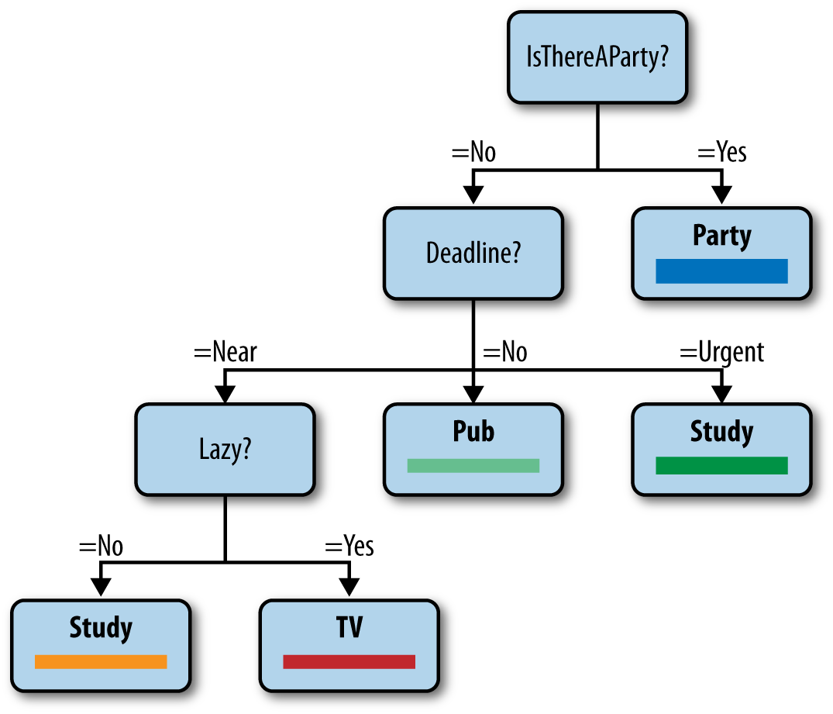

###### *Figure 7-3. Decision tree for college student, aka the party tree (taken with permission from Stephen Marsland’s book,*Machine Learning: An Algorithmic Perspective*[Chapman and Hall/CRC])*

This decision is actually dependent on a bunch of factors: whether or not there are any parties or deadlines, how lazy the student is feeling, and what they care about most (parties). The interpretability of decision trees is one of the best features about them.

In the context of a data problem, a decision tree is a classification algorithm. For the Chasing Dragons example, you want to classify users as “Yes, going to come back next month” or “No, not going to come back next month.” This isn’t really a decision in the colloquial sense, so don’t let that throw you. You know that the class of any given user is dependent on many factors (number of dragons the user slew, their age, how many hours they already played the game). And you want to break it down based on the data you’ve collected. But how do you construct decision trees from data and what mathematical properties can you expect them to have?

Ultimately you want a tree that is something like [Figure 7-4](https://learning.oreilly.com/library/view/doing-data-science/9781449363871/ch07.html#Figure6.4).

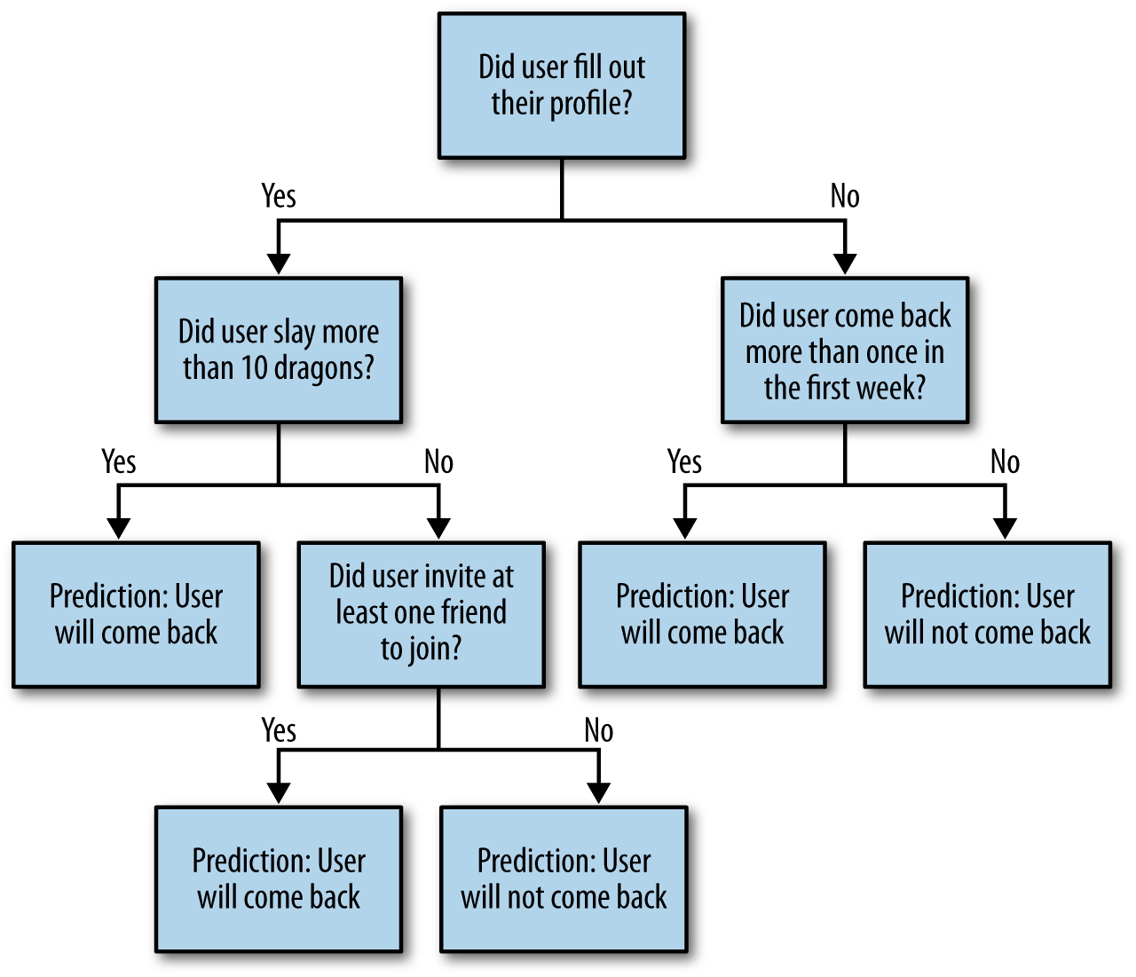

###### *Figure 7-4. Decision tree for Chasing Dragons*

But you want this tree to be based on data and not just what you feel like. Choosing a feature to pick at each step is like playing the game 20 Questions really well. You take whatever the most informative thing is first. Let’s formalize that—we need a notion of “informative.”

For the sake of this discussion, assume we break compound questions into multiple yes-or-no questions, and we denote the answers by “0” or “1.” Given a random variable X,X, we denote by p(X=1)p(X=1) and p(X=0)p(X=0) the probability that XX is true or false, respectively.

## Entropy

To quantify what is the most “informative” feature, we define [entropy](http://en.wikipedia.org/wiki/Entropy_(information_theory))–effectively a measure for how mixed up something is—for XX as follows:

H(X)=−p(X=1)log2(p(X=1))−p(X=0)log2(p(X=0))H(X)=-p(X=1)log2(p(X=1))-p(X=0)log2(p(X=0))

Note when p(X=1)=0p(X=1)=0 or p(X=0)=0p(X=0)=0, the entropy vanishes, consistent with the fact that:

limt→0t⋅log(t)=0limt→0t·log(t)=0

In particular, if either option has probability zero, the entropy is 0. Moreover, because p(X=1)=1−p(X=0)p(X=1)=1-p(X=0), the entropy is symmetric about 0.5 and maximized at 0.5, which we can easily confirm using a bit of calculus. [Figure 7-5](https://learning.oreilly.com/library/view/doing-data-science/9781449363871/ch07.html#Figure6.5) shows a picture of that.

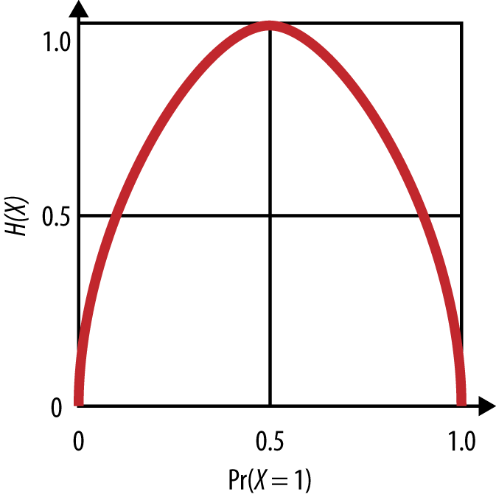

###### *Figure 7-5. Entropy*

Mathematically, we kind of get this. But what does it mean in words, and why are we calling it entropy? Earlier, we said that entropy is a measurement of how mixed up something is.

So, for example, if XX denotes the event of a baby being born a boy, we’d expect it to be true or false with probability close to 1/2, which corresponds to high entropy, i.e., the bag of babies from which we are selecting a baby is highly mixed.

But if XX denotes the event of a rainfall in a desert, then it’s low entropy. In other words, the bag of day-long weather events is not highly mixed in deserts.

Using this concept of entropy, we will be thinking of XX as the target of our model. So, XX could be the event that someone buys something on our site. We’d like to know which attribute of the user will tell us the most information about this event XX. We will define the information gain, denoted IG(X,a)IG(X,a), for a given attribute aa, as the entropy we lose if we know the value of that attribute:

IG(X,a)=H(X)−H(X|a)IG(X,a)=H(X)-H(X|a)

To compute this we need to define H(X|a)H(X|a). We can do this in two steps. For any actual value a0a0 of the attribute aa we can compute the specific conditional entropy H(X|a=a0)H(X|a=a0) as you might expect:

H(X|a=a0)=−p(X=1|a=a0)log2(p(X=1|a=a0))−p(X=0|a=a0)log2(p(X=0|a=a0))H(X|a=a0)=-p(X=1|a=a0)log2(p(X=1|a=a0))-p(X=0|a=a0)log2(p(X=0|a=a0))

and then we can put it all together, for all possible values of aa, to get the conditional entropy H(X|a)H(X|a):

H(X|a)=∑aip(a=ai)⋅H(X|a=ai)H(X|a)=∑aip(a=ai)·H(X|a=ai)

In words, the conditional entropy asks: how mixed is our bag really if we know the value of attribute aa? And then information gain can be described as: how much information do we learn about XX (or how much entropy do we lose) once we know aa?

Going back to how we use the concept of entropy to build decision trees: it helps us decide what feature to split our tree on, or in other words, what’s the most informative question to ask?

## The Decision Tree Algorithm

You build your decision tree iteratively, starting at the root. You need an algorithm to decide which attribute to split on; e.g., which node should be the next one to identify. You choose that attribute in order to maximize information gain, because you’re getting the most bang for your buck that way. You keep going until all the points at the end are in the same class or you end up with no features left. In this case, you take the majority vote.

Often people “prune the tree” afterwards to avoid overfitting. This just means cutting it off below a certain depth. After all, by design, the algorithm gets weaker and weaker as you build the tree, and it’s well known that if you build the entire tree, it’s often less accurate (with new data) than if you prune it.

This is an example of an embedded feature selection algorithm. (Why embedded?) You don’t need to use a filter here because the information gain method is doing your feature selection for you.

Suppose you have your Chasing Dragons dataset. Your outcome variable is Return: a binary variable that captures whether or not the user returns next month, and you have tons of predictors. You can use the R library rpart and the function rpart, and the code would look like this:

*# Classification Tree with rpart*

library(rpart)

*# grow tree*

model1 <- rpart(Return ~ profile + num_dragons +

num_friends_invited + gender + age +

num_days, method="class", data=chasingdragons)

printcp(model1) *# display the results*

plotcp(model1) *# visualize cross-validation results*

summary(model1) *# detailed summary of thresholds picked to transform to binary*

*# plot tree*

plot(model1, uniform=**TRUE**,

main="Classification Tree for Chasing Dragons")

text(model1, use.n=**TRUE**, all=**TRUE**, cex=.8)

## Handling Continuous Variables in Decision Trees

Packages that already implement decision trees can handle continuous variables for you. So you can provide continuous features, and it will determine an optimal threshold for turning the continuous variable into a binary predictor. But if you are building a decision tree algorithm yourself, then in the case of continuous variables, you need to determine the correct threshold of a value so that it can be thought of as a binary variable. So you could partition a user’s number of dragon slays into “less than 10” and “at least 10,” and you’d be getting back to the binary variable case. In this case, it takes some extra work to decide on the information gain because it depends on the threshold as well as the feature.

In fact, you could think of the decision of where the threshold should live as a separate submodel. It’s possible to optimize to this choice by maximizing the entropy on individual attributes, but that’s not clearly the best way to deal with continuous variables. Indeed, this kind of question can be as complicated as feature selection itself—instead of a single threshold, you might want to create bins of the value of your attribute, for example. What to do? It will always depend on the situation.

##### SURVIVING THE TITANIC

For fun, Will pointed us to this decision tree for [surviving on the Titanic](http://goo.gl/YsyWJW) on the BigML website. The original data is from the [Encyclopedia Titanica](http://www.encyclopedia-titanica.org/)–source code and data are available there. [Figure 7-6](https://learning.oreilly.com/library/view/doing-data-science/9781449363871/ch07.html#Figure6.6) provides just a snapshot of it, but if you go to the site, it is interactive.

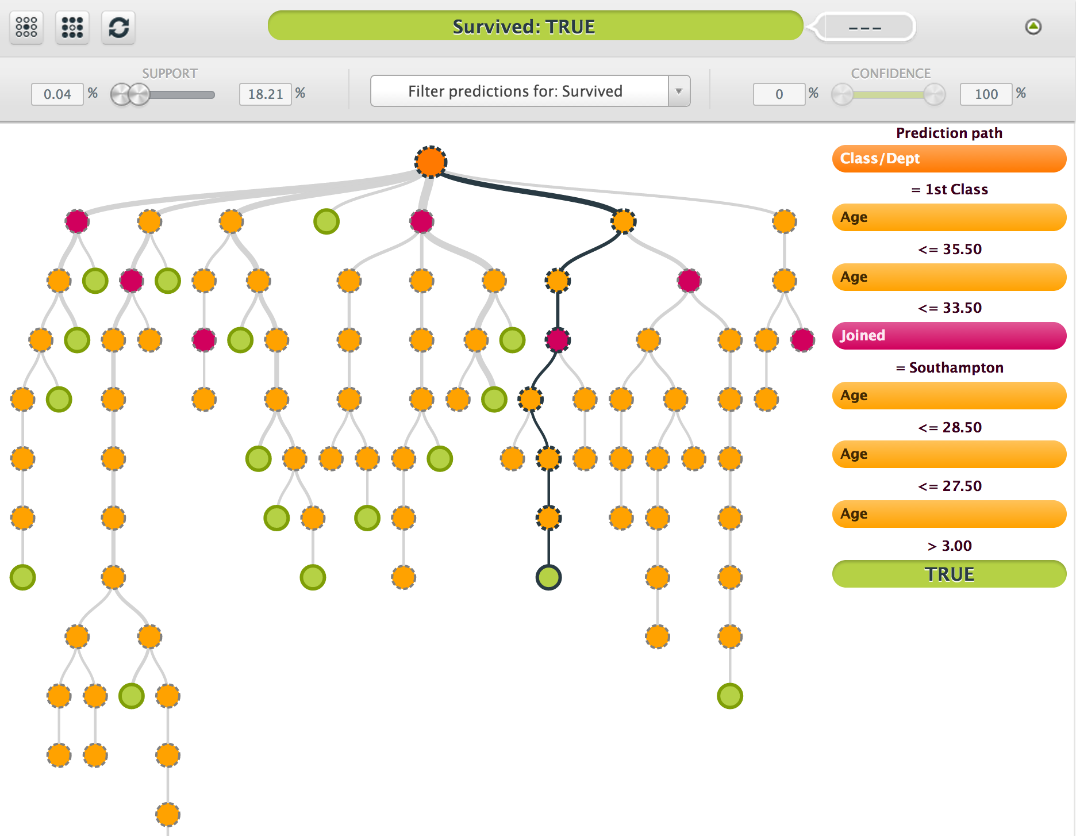

###### *Figure 7-6. Surviving the Titanic*

## Random Forests

Let’s turn to another algorithm for feature selection. Random forests generalize decision trees with [*bagging*](http://en.wikipedia.org/wiki/Bootstrap_aggregating), otherwise known as bootstrap aggregating. We will explain bagging in more detail later, but the effect of using it is to make your models more accurate and more robust, but at the cost of interpretability—random forests are notoriously difficult to understand. They’re conversely easy to specify, with two hyperparameters: you just need to specify the number of trees you want in your forest, say NN, as well as the number of features to randomly select for each tree, say FF.

Before we get into the weeds of the random forest algorithm, let’s review bootstrapping. A bootstrap sample is a sample with replacement, which means we might sample the same data point more than once. We usually take to the sample size to be 80% of the size of the entire (training) dataset, but of course this parameter can be adjusted depending on circumstances. This is technically a third hyperparameter of our random forest algorithm.

Now to the algorithm. To construct a random forest, you construct NN decision trees as follows:

1. For each tree, take a bootstrap sample of your data, and for each node you randomly select FF features, say 5 out of the 100 total features.
2. Then you use your entropy-information-gain engine as described in the previous section to decide which among those features you will split your tree on at each stage.

Note that you could decide beforehand how deep the tree should get, or you could prune your trees after the fact, but you typically don’t prune the trees in random forests, because a great feature of random forests is that they can incorporate idiosyncratic noise.

The code for this would look like:

*# Author: Jared Lander*

*#*

*# we will be using the diamonds data from ggplot*

require(ggplot2)

*# load and view the diamonds data*

data(diamonds)

head(diamonds)

*# plot a histogram with a line marking $12,000*

ggplot(diamonds) + geom_histogram(aes(x=price)) +

geom_vline(xintercept=12000)

*# build a TRUE/FALSE variable indicating if the price is above*

*# our threshold*

diamonds$Expensive <- ifelse(diamonds$price >= 12000, 1, 0)

head(diamonds)

*# get rid of the price column*

diamonds$price <- **NULL**

*## glmnet*

require(glmnet)

*# build the predictor matrix, we are leaving out the last*

*# column which is our response*

x <- model.matrix(~., diamonds[, -ncol(diamonds)])

*# build the response vector*

y <- as.matrix(diamonds$Expensive)

*# run the glmnet*

system.time(modGlmnet <- glmnet(x=x, y=y, family="binomial"))

*# plot the coefficient path*

plot(modGlmnet, label=**TRUE**)

*# this illustrates that setting a seed allows you to recreate*

*# random results, run them both a few times*

set.seed(48872)

sample(1:10)

*## decision tree*

require(rpart)

*# fire a simple decision tree*

modTree <- rpart(Expensive ~ ., data=diamonds)

*# plot the splits*

plot(modTree)

text(modTree)

*## bagging (or bootstrap aggregating)*

require(boot)

mean(diamonds$carat)

sd(diamonds$carat)

*# function for bootstrapping the mean*

boot.mean <- function(x, i)

{

mean(x[i])

}

*# allows us to find the variability of the mean*

boot(data=diamonds$carat, statistic=boot.mean, R=120)

require(adabag)

modBag <- bagging(formula=Species ~ ., iris, mfinal=10)

*## boosting*

require(mboost)

system.time(modglmBoost <- glmboost(as.factor(Expensive) ~ .,

data=diamonds, family=Binomial(link="logit")))

summary(modglmBoost)

?blackboost

*## random forests*

require(randomForest)

system.time(modForest <- randomForest(Species ~ ., data=iris,

importance=**TRUE**, proximity=**TRUE**))

##### CRITICISMS OF FEATURE SELECTION

Let’s address a common criticism of feature selection. Namely, it’s no better than data dredging. If we just take whatever answer we get that correlates with our target, however far afield it is, then we could end up thinking that [Bangladeshi butter production predicts the S&P](http://nerdsonwallstreet.typepad.com/my_weblog/files/dataminejune_2000.pdf). Generally we’d like to first curate the candidate features at least to some extent. Of course, the more observations we have, the less we need to be concerned with spurious signals.

There’s a well-known [bias-variance tradeoff](http://en.wikipedia.org/wiki/Supervised_learning#Bias-variance_tradeoff): a model is “high bias” if it’s is too simple (the features aren’t encoding enough information). In this case, lots more data doesn’t improve our model. On the other hand, if our model is too complicated, then “high variance” leads to overfitting. In this case we want to reduce the number of features we are using.

## User Retention: Interpretability Versus Predictive Power

So let’s say you built the decision tree, and that it predicts quite well. But should you interpret it? Can you try to find meaning in it?

It could be that it basically tells you “the more the user plays in the first month, the more likely the user is to come back next month,” which is kind of useless, and this kind of thing happens when you’re doing analysis. It feels circular–of course the more they like the app now, the more likely they are to come back. But it could also be that it tells you that showing them ads in the first five minutes decreases their chances of coming back, but it’s OK to show ads after the first hour, and this would give you some insight: don’t show ads in the first five minutes! Now to study this more, you really would want to do some A/B testing (see [Chapter 11](https://learning.oreilly.com/library/view/doing-data-science/9781449363871/ch11.html#chapter-causality)), but this initial model and feature selection would help you prioritize the types of tests you might want to run.

It’s also worth noting that features that have to do with the user’s behavior (user played 10 times this month) are qualitatively different than features that have to do with your behavior (you showed 10 ads, and you changed the dragon to be red instead of green). There’s a causation/correlation issue here. If there’s a correlation of getting a high number of points in the first month with returning to play next month, does that mean if you just give users a high number of points this month without them playing at all, they’ll come back? No! It’s not the number of points that caused them to come back, it’s that they’re really into playing the game (a confounding factor), which correlates with both their coming back and their getting a high number of points. You therefore would want to do feature selection with all variables, but then focus on the ones you can do something about (e.g., show fewer ads) conditional on user attributes.

# David Huffaker: Google’s Hybrid Approach to Social Research

David’s focus is on the effective marriages of both qualitative and quantitative research, and of big and little data. Large amounts of big quantitative data can be more effectively extracted if you take the time to think on a small scale carefully first, and then leverage what you learned on the small scale to the larger scale. And vice versa, you might find patterns in the large dataset that you want to investigate by digging in deeper by doing intensive usability studies with a handful of people, to add more color to the phenomenon you are seeing, or verify interpretations by connecting your exploratory data analysis on the large dataset with relevant academic literature.

David was one of Rachel’s colleagues at Google. They had a successful collaboration—starting with complementary skill sets, an explosion of goodness ensued when they were put together to work on Google+(Google’s social layer) with a bunch of other people, especially software engineers and computer scientists. David brings a social scientist perspective to the analysis of social networks. He’s strong in quantitative methods for understanding and analyzing online social behavior. He got a PhD in media, technology, and society from Northwestern University. David spoke about Google’s approach to social research to encourage the class to think in ways that connect the qualitative to the quantitative, and the small-scale to the large-scale.

Google does a good job of putting people together. They blur the lines between research and development. They even wrote about it in this July 2012 position paper: [Google’s Hybrid Approach to Research](http://goo.gl/ejtPw2). Their researchers are embedded on product teams. The work is iterative, and the engineers on the team strive to have near-production code from day 1 of a project. They leverage engineering infrastructure to deploy experiments to their mass user base and to rapidly deploy a prototype at scale. Considering the scale of Google’s user base, redesign as they scale up is not a viable option. They instead do experiments with smaller groups of users.

## Moving from Descriptive to Predictive

David suggested that as data scientists, we consider how to move into an experimental design so as to move to a causal claim between variables rather than a descriptive relationship. In other words, our goal is to move from the descriptive to the predictive.

As an example, he talked about the genesis of the “circle of friends” feature of Google+. Google knows people want to selectively share; users might send pictures to their family, whereas they’d probably be more likely to send inside jokes to their friends. Google came up with the idea of circles, but it wasn’t clear if people would use them. How can Google answer the question of whether people will use circles to organize their social network? It’s important to know what motivates users when they decide to share.

Google took a mixed-method approach, which means they used multiple methods to triangulate on findings and insights. Some of their methods were small and qualitative, some of them larger and quantitative.

Given a random sample of 100,000 users, they set out to determine the popular names and categories of names given to circles. They identified 168 active users who filled out surveys and they had longer interviews with 12. The depth of these interviews was weighed against selection bias inherent in finding people that are willing to be interviewed.

They found that the majority were engaging in selective sharing, that most people used circles, and that the circle names were most often work-related or school-related, and that they had elements of a strong-link (“epic bros”) or a weak-link (“acquaintances from PTA”).

They asked the survey participants why they share content. The answers primarily came in three categories. First, the desire to share about oneself: personal experiences, opinions, etc. Second, discourse: people want to participate in a conversation. Third, evangelism: people like to spread information.

Next they asked participants why they choose their audiences. Again, three categories: first, privacy—many people were public or private by default. Second, relevance: they wanted to share only with those who may be interested, and they don’t want to pollute other people’s data stream. Third, distribution: some people just want to maximize their potential audience.

The takeaway from this study was that people do enjoy selectively sharing content, depending on context and the audience. So Google has to think about designing features for the product around content, context, and audience. They want to not just keep these findings in mind for design, but also when they do data science at scale.

##### THOUGHT EXPERIMENT: LARGE-SCALE NETWORK ANALYSIS

We’ll dig more into network analysis in [Chapter 10](https://learning.oreilly.com/library/view/doing-data-science/9781449363871/ch10.html#chapter-social-networks-data-journalism) with John Kelly. But for now, think about how you might take the findings from the Google+ usability studies and explore selectively sharing content on a massive scale using data. You can use large data and look at connections between actors like a graph. For Google+, the users are the nodes and the edges (directed) are “in the same circle.” Think about what data you would want to log, and then how you might test some of the hypotheses generated from speaking with the small group of engaged users.

As data scientists, it can be helpful to think of different structures and representations of data, and once you start thinking in terms of networks, you can see them everywhere.

Other examples of networks:

* The nodes are users in [Second Life](http://secondlife.com/), and the edges correspond to interactions between users. Note there is more than one possible way for players to interact in this game, leading to potentially different kinds of edges.
* The nodes are websites, the (directed) edges are links.
* [Nodes are theorems, directed edges are dependencies](http://www.math.columbia.edu/~dejong/plaatje.png).

## Social at Google

As you may have noticed, “social” is a layer across all of Google. Search now incorporates this layer: if you search for something you might see that your friend “+1”ed it. This is called a social annotation. It turns out that people care more about annotation when it comes from someone with domain expertise rather than someone you’re very close to. So you might care more about the opinion of a wine expert at work than the opinion of your mom when it comes to purchasing wine.

Note that sounds obvious but if you started the other way around, asking who you’d trust, you might start with your mom. In other words, “close ties”–even if you can determine those—are not the best feature to rank annotations. But that begs the question, what is? Typically in a situation like this, data scientists might use click-through rate, or how long it takes to click.

In general you need to always keep in mind a quantitative metric of success. This defines success for you, so you have to be careful.

## Privacy

Human-facing technology has thorny issues of privacy, which makes stuff hard. Google conducted a survey of how people felt uneasy about content. They asked, how does it affect your engagement? What is the nature of your privacy concerns?

Turns out there’s a strong correlation between privacy concern and low engagement, which isn’t surprising. It’s also related to how well you understand what information is being shared, and the question of when you post something, where it goes, and how much control you have over it. When you are confronted with a huge pile of complicated settings, you tend to start feeling passive.

The survey results found broad categories of concern as follows:

Identity theft

* Financial loss

Digital world

* Access to personal data
* Really private stuff I searched on
* Unwanted spam
* Provocative photo (oh *&!$ my boss saw that)
* Unwanted solicitation
* Unwanted ad targeting

Physical world

* Offline threats/harassment
* Harm to my family
* Stalkers
* Employment risks

## Thought Experiment: What Is the Best Way to Decrease Concern and Increase Understanding and Control?

So given users’ understandable concerns about privacy, students in Rachel’s class brainstormed some potential solutions that Google could implement (or that anyone dealing with user-level data could consider).

Possibilities:

* You could write and post a manifesto of your data policy. Google tried that, but it turns out nobody likes to read manifestos.
* You could educate users on your policies a la the Netflix feature “because you liked this, we think you might like this.” But it’s not always so easy to explain things in complicated models.
* You could simply get rid of all stored data after a year. But you’d still need to explain that you do that.

Maybe we could rephrase the question: how do you design privacy settings to make it easier for people? In particular, how do you make it transparent? Here are some ideas along those lines:

* Make a picture or graph of where data is going.
* Give people a privacy switchboard.
* Provide access to quick settings.
* Make the settings you show people categorized by “things you don’t have a choice about” versus “things you do” for the sake of clarity.
* Best of all, you could make reasonable default setting so people don’t have to worry about it.

David left us with these words of wisdom: as you move forward and have access to Big Data, you really should complement them with qualitative approaches. Use mixed methods to come to a better understanding of what’s going on. Qualitative surveys can really help.

# Chapter 8. Recommendation Engines: Building a User-Facing Data Product at Scale

Recommendation engines, also called recommendation systems, are the quintessential data product and are a good starting point when you’re explaining to non–data scientists what you do or what data science really is. This is because many people have interacted with recommendation systems when they’ve been suggested books on Amazon.com or gotten recommended movies on Netflix. Beyond that, however, they likely have not thought much about the engineering and algorithms underlying those recommendations, nor the fact that their behavior when they buy a book or rate a movie is generating data that then feeds back into the recommendation engine and leads to (hopefully) improved recommendations for themselves and other people.

Aside from being a clear example of a product that literally uses data as its fuel, another reason we call recommendation systems “quintessential” is that building a solid recommendation system end-to-end requires an understanding of linear algebra and an ability to code; it also illustrates the challenges that Big Data poses when dealing with a problem that makes intuitive sense, but that can get complicated when implementing its solution at scale.

In this chapter, [Matt Gattis](http://gatt.is/) walks us through what it took for him to build a recommendation system for Hunch.com—including why he made certain decisions, and how he thought about trade-offs between various algorithms when building a large-scale engineering system and infrastructure that powers a user-facing product.

Matt graduated from MIT in CS, worked at SiteAdvisor, and co-founded [Hunch](http://hunch.com/) as its CTO. Hunch is a website that gives you recommendations of any kind. When they started out, it worked like this: they’d ask people a bunch of questions (people seem to love answering questions), and then someone could ask the engine questions like, “What cell phone should I buy?” or, “Where should I go on a trip?” and it would give them advice. They use machine learning to give better and better advice. Matt’s role there was doing the R&D for the underlying recommendation engine.

At first, they focused on trying to make the questions as fun as possible. Then, of course, they saw things needing to be asked that would be extremely informative as well, so they added those. Then they found that they could ask merely 20 questions and then predict the rest of them with 80% accuracy. There were questions that you might imagine and some that are surprising, like whether people were competitive versus uncompetitive, introverted versus extroverted, thinking versus perceiving, etc.—not unlike [MBTI](http://en.wikipedia.org/wiki/MBTI).

Eventually Hunch expanded into more of an [API](http://en.wikipedia.org/wiki/Application_programming_interface) model where they crawl the Web for data rather than asking people direct questions. The service can also be used by third parties to personalize content for a given site—a nice business proposition that led to [eBay acquiring Hunch.com](http://rww.to/19lETsY).

Matt has been building code since he was a kid, so he considers software engineering to be his strong suit. Hunch requires cross-domain experience so he doesn’t consider himself a domain expert in any focused way, except for recommendation systems themselves.

The best quote Matt gave us was this: “Forming a data team is kind of like planning a heist.” He means that you need people with all sorts of skills, and that one person probably can’t do everything by herself. (Think [Ocean’s Eleven](http://imdb.to/1bqZHH9), but sexier.)

# A Real-World Recommendation Engine

Recommendation engines are used all the time—what movie would you like, knowing other movies you liked? What book would you like, keeping in mind past purchases? What kind of vacation are you likely to embark on, considering past trips?

There are plenty of different ways to go about building such a model, but they have very similar feels if not implementation. We’re going to show you how to do one relatively simple but complete version in this chapter.

To set up a recommendation engine, suppose you have users, which form a set UU; and you have items to recommend, which form a set VV. As Kyle Teague told us in [Chapter 6](https://learning.oreilly.com/library/view/doing-data-science/9781449363871/ch06.html#chapter-financial-modeling), you can denote this as a bipartite graph (shown again in [Figure 8-1](https://learning.oreilly.com/library/view/doing-data-science/9781449363871/ch08.html#bipartite-graph2)) if each user and each item has a node to represent it—there is a line from a user to an item if that user has expressed an opinion about that item. Note they might not always love that item, so the edges could have weights: they could be positive, negative, or on a continuous scale (or discontinuous, but many-valued like a star system). The implications of this choice can be heavy but we won’t delve too deep here—for us they are numeric ratings.

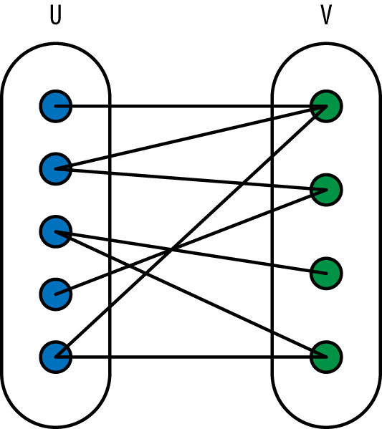

###### *Figure 8-1. Bipartite graph with users and items (television shows) as nodes*

Next up, you have training data in the form of some preferences—you know some of the opinions of some of the users on some of the items. From those training data, you want to predict other preferences for your users. That’s essentially the output for a recommendation engine.

You may also have metadata on users (i.e., they are male or female, etc.) or on items (the color of the product). For example, users come to your website and set up accounts, so you may know each user’s gender, age, and preferences for up to three items.

You represent a given user as a vector of features, sometimes including only metadata—sometimes including only preferences (which would lead to a [sparse vector](http://en.wikipedia.org/wiki/Sparse_vector/) because you don’t know all the user’s opinions)—and sometimes including both, depending on what you’re doing with the vector. Also, you can sometimes bundle all the user vectors together to get a big user matrix, which we call UU, through [abuse of notation](http://en.wikipedia.org/wiki/Abuse_of_notation/).

## Nearest Neighbor Algorithm Review

Let’s review the nearest neighbor algorithm (discussed in [Chapter 3](https://learning.oreilly.com/library/view/doing-data-science/9781449363871/ch03.html#chapter-algorithms)): if you want to predict whether user A likes something, you look at a user B closest to user A who has an opinion, then you assume A’s opinion is the same as B’s. In other words, once you’ve identified a similar user, you’d then find something that user A hadn’t rated (which you’d assume meant he hadn’t ever seen that movie or bought that item), but that user B had rated and liked and use that as your recommendation for user A.

As discussed in [Chapter 3](https://learning.oreilly.com/library/view/doing-data-science/9781449363871/ch03.html#chapter-algorithms), to implement this you need a metric so you can measure distance. One example when the opinions are binary: [Jaccard distance](http://en.wikipedia.org/wiki/Jaccard_index), i.e., 1–(the number of things they both like divided by the number of things either of them likes). Other examples include [cosine similarity](http://en.wikipedia.org/wiki/Cosine_similarity) or [Euclidean distance](http://en.wikipedia.org/wiki/Euclidean_distance).

# WHICH METRIC IS BEST?

You might get a different answer depending on which metric you choose. But that’s a good thing. Try out lots of different distance functions and see how your results change and think about why.

## Some Problems with Nearest Neighbors

So you could use nearest neighbors; it makes some intuitive sense that you’d want to recommend items to people by finding similar people and using those people’s opinions to generate ideas and recommendations. But there are a number of problems nearest neighbors poses. Let’s go through them:

Curse of dimensionality

There are too many dimensions, so the closest neighbors are too far away from each other to realistically be considered “close.”

Overfitting

Overfitting is also a problem. So one guy is closest, but that could be pure noise. How do you adjust for that? One idea is to use k-NN, with, say, k=5 rather than k=1, which increases the noise.

Correlated features

There are tons of features, moreover, that are highly correlated with each other. For example, you might imagine that as you get older you become more conservative. But then counting both age and politics would mean you’re double counting a single feature in some sense. This would lead to bad performance, because you’re using redundant information and essentially placing double the weight on some variables. It’s preferable to build in an understanding of the correlation and project onto smaller dimensional space.

Relative importance of features

Some features are more informative than others. Weighting features may therefore be helpful: maybe your age has nothing to do with your preference for item 1. You’d probably use something like covariances to choose your weights.

Sparseness

If your vector (or matrix, if you put together the vectors) is too sparse, or you have lots of missing data, then most things are unknown, and the Jaccard distance means nothing because there’s no overlap.

Measurement errors

There’s measurement error (also called reporting error): people may lie.

Computational complexity

There’s a calculation cost—computational complexity.

Sensitivity of distance metrics

Euclidean distance also has a scaling problem: distances in age outweigh distances for other features if they’re reported as 0 (for don’t like) or 1 (for like). Essentially this means that raw euclidean distance doesn’t make much sense. Also, old and young people might think one thing but middle-aged people something else. We seem to be assuming a linear relationship, but it may not exist. Should you be binning by age group instead, for example?

Preferences change over time

User preferences may also change over time, which falls outside the model. For example, at eBay, they might be buying a printer, which makes them only want ink for a short time.

Cost to update

It’s also expensive to update the model as you add more data.

The biggest issues are the first two on the list, namely overfitting and the curse of dimensionality problem. How should you deal with them? Let’s think back to a method you’re already familiar with—linear regression—and build up from there.

## Beyond Nearest Neighbor: Machine Learning Classification

We’ll first walk through a simplification of the actual machine learning algorithm for this—namely we’ll build a separate linear regression model for each item. With each model, we could then predict for a given user, knowing their attributes, whether they would like the item corresponding to that model. So one model might be for predicting whether you like Mad Men and another model might be for predicting whether you would like Bob Dylan.

Denote by fi,jfi,j user ii’s stated preference for item jj if you have it (or user ii’s attribute, if item jj is a metadata item like age or is_logged_in). This is a subtle point but can get a bit confusing if you don’t internalize this: you are treating metadata here also as if it’s an “item.” We mentioned this before, but it’s OK if you didn’t get it—hopefully it will click more now. When we said we could predict what you might like, we’re also saying we could use this to predict your attribute; i.e., if we didn’t know if you were a male/female because that was missing data or we had never asked you, we might be able to predict that.

To let this idea settle even more, assume we have three numeric attributes for each user, so we have fi,1,fi,2,fi,1,fi,2, and fi,3.fi,3. Then to guess user ii’s preference on a new item (we temporarily denote this estimate by pipi) we can look for the best choice of βkβk so that:

pi=β1fi,1+β2fi,2+β3fi,3+ϵpi=β1fi,1+β2fi,2+β3fi,3+ϵ

The good news: You know how to estimate the coefficients by linear algebra, optimization, and statistical inference: specifically, linear regression.

The bad news: This model only works for one item, and to be complete, you’d need to build as many models as you have items. Moreover, you’re not using other items’ information at all to create the model for a given item, so you’re not leveraging other pieces of information.

But wait, there’s more good news: This solves the “weighting of the features” problem we discussed earlier, because linear regression coefficients are weights.

Crap, more bad news: overfitting is still a problem, and it comes in the form of having huge coefficients when you don’t have enough data (i.e., not enough opinions on given items).

# IMPORTANT TECHNICAL NOTE

Let’s make more rigorous the preceding argument that huge coefficients imply overfitting, or maybe even just a bad model. For example, if two of your variables are exactly the same, or are nearly the same, then the coefficient on one can be 100,000 and the other can be –100,000 and really they add nothing to the model. In general you should always have some prior on what a reasonable size would be for your coefficients, which you do by normalizing all of your variables and imagining what an “important” effect would translate to in terms of size of coefficients—anything much larger than that (in an absolute value) would be suspect.

To solve the overfitting problem, you impose a Bayesian prior that these weights shouldn’t be too far out of whack—this is done by adding a penalty term for large coefficients. In fact, [this ends up being equivalent to adding a prior matrix to the covariance matrix](http://mathbabe.org/2013/02/24/the-overburdened-prior/). That solution depends on a single parameter, which is traditionally called λ.λ.

But that begs the question: how do you choose λ?λ? You could do it experimentally: use some data as your training set, evaluate how well you did using particular values of λλ, and adjust. That’s kind of what happens in real life, although note that it’s not exactly consistent with the idea of estimating what a reasonable size would be for your coefficient.

# IMPORTANT TECHNICAL NOTE

You can’t use this penalty term for large coefficients and assume the “weighting of the features” problem is still solved, because in fact you’d be penalizing some coefficients way more than others if they start out on different scales. The easiest way to get around this is to normalize your variables before entering them into the model, similar to how we did it in [Chapter 6](https://learning.oreilly.com/library/view/doing-data-science/9781449363871/ch06.html#chapter-financial-modeling). If you have some reason to think certain variables should have larger coefficients, then you can normalize different variables with different means and variances. At the end of the day, the way you normalize is again equivalent to imposing a prior.

A final problem with this prior stuff: although the problem will have a unique solution (as in the penalty will have a unique minimum) if you make λλ large enough, by that time you may not be solving the problem you care about. Think about it: if you make λλ absolutely huge, then the coefficients will all go to zero and you’ll have no model at all.

## The Dimensionality Problem

OK, so we’ve tackled the overfitting problem, so now let’s think about overdimensionality—i.e., the idea that you might have tens of thousands of items. We typically use both [Singular Value Decomposition (SVD)](http://en.wikipedia.org/wiki/Singular_value_decomposition) and [Principal Component Analysis (PCA)](http://en.wikipedia.org/wiki/Principal_component_analysis) to tackle this, and we’ll show you how shortly.

To understand how this works before we dive into the math, let’s think about how we reduce dimensions and create “latent features” internally every day. For example, people invent concepts like “coolness,” but we can’t directly measure how cool someone is. Other people exhibit different patterns of behavior, which we internally map or reduce to our one dimension of “coolness.” So coolness is an example of a latent feature in that it’s unobserved and not measurable directly, and we could think of it as reducing dimensions because perhaps it’s a combination of many “features” we’ve observed about the person and implicitly weighted in our mind.

Two things are happening here: the dimensionality is reduced into a single feature and the latent aspect of that feature.

But in this algorithm, we don’t decide which latent factors to care about. Instead we let the machines do the work of figuring out what the important latent features are. “Important” in this context means they explain the variance in the answers to the various questions—in other words, they model the answers efficiently.

Our goal is to build a model that has a representation in a low dimensional subspace that gathers “taste information” to generate recommendations. So we’re saying here that taste is latent but can be approximated by putting together all the observed information we do have about the user.

Also consider that most of the time, the rating questions are binary (yes/no). To deal with this, Hunch created a separate variable for every question. They also found that comparison questions may be better at revealing preferences.

##### TIME TO BRUSH UP ON YOUR LINEAR ALGEBRA IF YOU HAVEN’T ALREADY

A lot of the rest of this chapter likely won’t make sense (and we want it to make sense to you!) if you don’t know linear algebra and understand the terminology and geometric interpretation of words like rank (hint: the linear algebra definition of that word has nothing to do with ranking algorithms), orthogonal, transpose, base, span, and matrix decomposition. Thinking about data in matrices as points in space, and what it would mean to transform that space or take subspaces can give you insights into your models, why they’re breaking, or how to make your code more efficient. This isn’t just a mathematical exercise for the sake of it—although there is elegance and beauty in it—it can be the difference between a start-up that fails and a start-up that gets acquired by eBay. We recommend [Khan Academy’s](https://www.khanacademy.org/math/linear-algebra) excellent free online introduction to linear algebra if you need to brush up your linear algebra skills.

## Singular Value Decomposition (SVD)

Hopefully we’ve given you some intuition about what we’re going to do. So let’s get into the math now starting with singular value decomposition. Given an m×nm×n matrix XX of rank k,k, it is a [theorem from linear algebra](http://en.wikipedia.org/wiki/Singular_value_decomposition#Statement_of_the_theorem) that we can always compose it into the product of three matrices as follows:

X=USVτX=USVτ

where UU is m×km×k, SS is k×kk×k, and VV is k×nk×n, the columns of UU and VV are pairwise [orthogonal](http://en.wikipedia.org/wiki/Orthogonal_vectors), and SS is [diagonal](http://en.wikipedia.org/wiki/Diagonal_matrix). Note the standard statement of SVD is slightly more involved and has U and V both square unitary matrices, and has the middle “diagonal” matrix a rectangular. We’ll be using this form, because we’re going to be taking approximations to XX of increasingly smaller rank. You can find the proof of the existence of this form as a step in the proof of existence of the general form [here](http://goo.gl/GLS6sG).

Let’s apply the preceding matrix decomposition to our situation. XX is our original dataset, which has users’ ratings of items. We have mm users, nn items, and kk would be the rank of X,X, and consequently would also be an upper bound on the number dd of latent variables we decide to care about—note we choose dd whereas m,n,m,n, and kkare defined through our training dataset. So just like in k-NN, where kk is a tuning parameter (different kk entirely—not trying to confuse you!), in this case, dd is the tuning parameter.

Each row of UU corresponds to a user, whereas VV has a row for each item. The values along the diagonal of the square matrix SS are called the “singular values.” They measure the importance of each latent variable—the most important latent variable has the biggest singular value.

## Important Properties of SVD

Because the columns of UU and VV are orthogonal to each other, you can order the columns by singular values via a base change operation. That way, if you put the columns in decreasing order of their corresponding singular values (which you do), then the dimensions are ordered by importance from highest to lowest. You can take lower rank approximation of XX by throwing away part of S.S. In other words, replace SS by a submatrix taken from the upper-left corner of S.S.

Of course, if you cut off part of SS you’d have to simultaneously cut off part of UU and part of V,V, but this is OK because you’re cutting off the least important vectors. This is essentially how you choose the number of latent variables dd—you no longer have the original matrix XX anymore, only an approximation of it, because dd is typically much smaller than kk, but it’s still pretty close to X.X. This is what people mean when they talk about “compression,” if you’ve ever heard that term thrown around. There is often an important interpretation to the values in the matrices UU and VV. For example, you can see, by using SVD, that the “most important” latentfeature is often something like whether someone is a man or a woman.

How would you actually use this for recommendation? You’d take XX, fill in all of the empty cells with the average rating for that item (you don’t want to fill it in with 0 because that might mean something in the rating system, and SVD can’t handle missing values), and then compute the SVD. Now that you’ve decomposed it this way, it means that you’ve captured latent features that you can use to compare users if you want to. But that’s not what you want—you want a prediction. If you multiply out the UU, SS, and VτVτ together, you get an approximation to XX—or a prediction, XˆX^—so you can predict a rating by simply looking up the entry for the appropriate user/item pair in the matrix XˆX^.

Going back to our original list of issues with nearest neighbors in [“Some Problems with Nearest Neighbors”](https://learning.oreilly.com/library/view/doing-data-science/9781449363871/ch08.html#problems-with-nearest-neighbors), we want to avoid the problem of missing data, but that is not fixed by the preceding SVD approach, nor is the computational complexity problem. In fact, SVD is extremely computationally expensive. So let’s see how we can improve on that.

## Principal Component Analysis (PCA)

Let’s look at another approach for predicting preferences. With this approach, you’re still looking for UU and VV as before, but you don’t need SS anymore, so you’re just searching for UU and VV such that:

X≡U⋅VτX≡U·Vτ

Your optimization problem is that you want to minimize the discrepancy between the actual XX and your approximation to XX via UU and VV measured via the squared error:

argmin∑i,j(xi,j−ui⋅vj)2argmin∑i,j(xi,j-ui·vj)2

Here you denote by uiui the row of UU corresponding to user i,i, and similarly you denote by vjvj the row of VVcorresponding to item j.j. As usual, items can include metadata information (so the vector of ages of all the users will be a row in VV).

Then the dot product ui⋅vjui·vj is the predicted preference of user ii for item j,j, and you want that to be as close as possible to the actual preference xi,jxi,j.

So, you want to find the best choices of UU and VV that minimize the squared differences between prediction and observation on everything you actually know, and the idea is that if it’s really good on stuff you know, it will also be good on stuff you’re guessing. This should sound familiar to you—it’s mean squared error, like we used for linear regression.

Now you get to choose a parameter, namely the number dd defined as how may latent features you want to use. The matrix UU will have a row for each user and a column for each latent feature, and the matrix VV will have a row for each item and a column for each latent feature.

How do you choose d?d? It’s typically about 100, because it’s more than 20 (as we told you, through the course of developing the product, we found that we had a pretty good grasp on someone if we ask them 20 questions) and it’s as much as you care to add before it’s computationally too much work.

###### NOTE

The resulting latent features are the basis of a well-defined subspace of the total nn-dimensional space of potential latent variables. There’s no reason to think this solution is unique if there are a bunch of missing values in your “answer” matrix. But that doesn’t necessarily matter, because you’re just looking for a solution.

### THEOREM: THE RESULTING LATENT FEATURES WILL BE UNCORRELATED

We already discussed that correlation was an issue with k-NN, and who wants to have redundant information going into their model? So a nice aspect of these latent features is that they’re uncorrelated. Here’s a sketch of the proof:

Say we’ve found matrices UU and VV with a fixed product U⋅V=XU·V=X such that the squared error term is minimized. The next step is to find the best UU and VV such that their entries are small—actually we’re minimizing the sum of the squares of the entries of UU and V.V. But we can modify UU with any invertible d×dd×d matrix GG as long as we modify VV by its inverse: U⋅V=(U⋅G)⋅(G−1⋅V)=X.U·V=(U·G)·(G-1·V)=X.

Assume for now we only modify with determinant 1 matrices G;G; i.e., we restrict ourselves to volume-preserving transformations. If we ignore for now the size of the entries of VV and concentrate only on the size of the entries of U,U, we are minimizing the surface area of a dd-dimensional parallelepiped in nn space (specifically, the one generated by the columns of UU) where the volume is fixed. This is achieved by making the sides of the parallelepiped mutually orthogonal, which is the same as saying the latent features will be uncorrelated.

But don’t forget, we’ve ignored VV! However, it turns out that VV’s rows will also be mutually orthogonal when we force UU’s columns to be. This is not hard to see if you keep in mind XX has its SVD as discussed previously. In fact, the SVD and this form U⋅VU·V have a lot in common, and some people just call this an SVD algorithm, even though it’s not quite.

Now we allow modifications with nontrivial determinant—so, for example, let GG be some scaled version of the identity matrix. Then if we do a bit of calculus, it turns out that the best choice of scalar (i.e., to minimize the sum of the squares of the entries of UU and of VV) is in fact the geometric mean of those two quantities, which is cool. In other words, we’re minimizing the arithmetic mean of them with a single parameter (the scalar) and the answer is the geometric mean.

So that’s the proof. Believe us?

## Alternating Least Squares

But how do you do this? How do you actually find UU and VV? In reality, as you will see next, you’re not first minimizing the squared error and then minimizing the size of the entries of the matrices UU and V.V. You’re actually doing both at the same time.

So your goal is to find UU and VV by solving the optimization problem described earlier. This optimization doesn’t have a nice closed formula like ordinary least squares with one set of coefficients. Instead, you need an iterative algorithm like gradient descent. As long as your problem is convex you’ll converge OK (i.e., you won’t find yourself at a local, but not global, maximum), and you can force your problem to be convex using regularization.

Here’s the algorithm:

* Pick a random VV.
* Optimize UU while VV is fixed.
* Optimize VV while UU is fixed.
* Keep doing the preceding two steps until you’re not changing very much at all. To be precise, you choose an ϵϵ and if your coefficients are each changing by less than ϵϵ, then you declare your algorithm “converged.”

### THEOREM WITH NO PROOF: THE PRECEDING ALGORITHM WILL CONVERGE IF YOUR PRIOR IS LARGE ENOUGH

If you enlarge your prior, you make the optimization easier because you’re artificially creating a more convex function—on the other hand, if your prior is huge, then all your coefficients will be zero anyway, so that doesn’t really get you anywhere. So actually you might not want to enlarge your prior. Optimizing your prior is philosophically screwed because how is it a prior if you’re back-fitting it to do what you want it to do? Plus you’re mixing metaphors here to some extent by searching for a close approximation of XX at the same time you are minimizing coefficients. The more you care about coefficients, the less you care about XX. But in actuality, you only want to care about XX.

## Fix V and Update U

The way you do this optimization is user by user. So for user i,i, you want to find:

argminui∑j∈Pi(pi,j−ui*vj)2argminui∑j∈Pi(pi,j-ui*vj)2

where vjvj is fixed. In other words, you just care about this user for now.

But wait a minute, this is the same as linear least squares, and has a closed form solution! In other words, set:

ui=(Vτ*,iV*,i)−1Vτ*,iP*i,ui=(V*,iτV*,i)-1V*,iτP*i,

where V*,iV*,i is the subset of VV for which you have preferences coming from user i.i. Taking the inverse is easy because it’s d×d,d×d, which is small. And there aren’t that many preferences per user, so solving this many times is really not that hard. Overall you’ve got a doable update for UU.

When you fix UU and optimize VV, it’s analogous—you only ever have to consider the users that rated that movie, which may be pretty large for popular movies but on average isn’t; but even so, you’re only ever inverting a d×dd×d matrix.

Another cool thing: because each user is only dependent on their item’s preferences, you can parallelize this update of UU or V.V. You can run it on as many different machines as you want to make it fast.

## Last Thoughts on These Algorithms

There are lots of different versions of this approach, but we hope we gave you a flavor for the trade-offs between these methods and how they can be used to make predictions. Sometimes you need to extend a method to make it work in your particular case.

For example, you can add new users, or new data, and keep optimizing UU and VV. You can choose which users you think need more updating to save computing time. Or if they have enough ratings, you can decide not to update the rest of them.

As with any machine learning model, you should perform [cross-validation](http://en.wikipedia.org/wiki/Cross-validation_(statistics)) for this model—leave out a bit and see how you did, which we’ve discussed throughout the book. This is a way of testing overfitting problems.

# Thought Experiment: Filter Bubbles

What are the implications of using error minimization to predict preferences? How does presentation of recommendations affect the feedback collected?

For example, can you end up in local maxima with rich-get-richer effects? In other words, does showing certain items at the beginning give them an unfair advantage over other things? And so do certain things just get popular or not based on luck?

How do you correct for this?

# Exercise: Build Your Own Recommendation System

In [Chapter 6](https://learning.oreilly.com/library/view/doing-data-science/9781449363871/ch06.html#chapter-financial-modeling), we did some exploratory data analysis on the GetGlue dataset. Now’s your opportunity to build a recommendation system with that dataset. The following code isn’t for GetGlue, but it is Matt’s code to illustrate implementing a recommendation system on a relatively small dataset. Your challenge is to adjust it to work with the GetGlue data.

## Sample Code in Python

**import** **math**,**numpy**

pu = [[(0,0,1),(0,1,22),(0,2,1),(0,3,1),(0,5,0)],[(1,0,1),(1,1,32),(1,2,0),(1,3,0),(1,4,1),(1,5,0)],[(2,0,0),(2,1,18),(2,2,1),(2,3,1),(2,4,0),(2,5,1)],[(3,0,1),(3,1,40),(3,2,1),(3,3,0),(3,4,0),(3,5,1)],[(4,0,0),(4,1,40),(4,2,0),(4,4,1),(4,5,0)],[(5,0,0),(5,1,25),(5,2,1),(5,3,1),(5,4,1)]]

pv = [[(0,0,1),(0,1,1),(0,2,0),(0,3,1),(0,4,0),(0,5,0)],[(1,0,22),(1,1,32),(1,2,18),(1,3,40),(1,4,40),(1,5,25)],[(2,0,1),(2,1,0),(2,2,1),(2,3,1),(2,4,0),(2,5,1)],[(3,0,1),(3,1,0),(3,2,1),(3,3,0),(3,5,1)],[(4,1,1),(4,2,0),(4,3,0),(4,4,1),(4,5,1)],[(5,0,0),(5,1,0),(5,2,1),(5,3,1),(5,4,0)]]

V = numpy.mat([[ 0.15968384, 0.9441198 , 0.83651085],

[ 0.73573009, 0.24906915, 0.85338239],

[ 0.25605814, 0.6990532 , 0.50900407],

[ 0.2405843 , 0.31848888, 0.60233653],

[ 0.24237479, 0.15293281, 0.22240255],

[ 0.03943766, 0.19287528, 0.95094265]])

**print** V

U = numpy.mat(numpy.zeros([6,3]))

L = 0.03

**for** iter **in** xrange(5):

**print** "**\n**----- ITER %s -----"%(iter+1)

**print** "U"

urs = []

**for** uset **in** pu:

vo = []

pvo = []

**for** i,j,p **in** uset:

vor = []

**for** k **in** xrange(3):

vor.append(V[j,k])

vo.append(vor)

pvo.append(p)

vo = numpy.mat(vo)

ur = numpy.linalg.inv(vo.T*vo +

L*numpy.mat(numpy.eye(3))) *

vo.T * numpy.mat(pvo).T

urs.append(ur.T)

U = numpy.vstack(urs)

**print** U

**print** "V"

vrs = []

**for** vset **in** pv:

uo = []

puo = []

**for** j,i,p **in** vset:

uor = []

**for** k **in** xrange(3):

uor.append(U[i,k])

uo.append(uor)

puo.append(p)

uo = numpy.mat(uo)

vr = numpy.linalg.inv(uo.T*uo + L*numpy.mat(numpy.eye(3))) * uo.T * numpy.mat(puo).T

vrs.append(vr.T)

V = numpy.vstack(vrs)

**print** V

err = 0.

n = 0.

**for** uset **in** pu:

**for** i,j,p **in** uset:

err += (p - (U[i]*V[j].T)[0,0])**2

n += 1

**print** math.sqrt(err/n)

**print**

**print** U*V.T

**Unit – II**

# Chapter 9. Data Visualization

Data visualization is the graphical representation of information and data. By using visual elements like charts, graphs, and maps, data visualization tools provide an accessible way to see and understand trends, outliers, and patterns in data.

In the world of Big Data, data visualization tools and technologies are essential to analyze massive amounts of information and make data-driven decisions.

The advantages and benefits of good data visualization

Our eyes are drawn to colors and patterns. We can quickly identify red from blue, square from circle. Our culture is visual, including everything from art and advertisements to TV and movies.

Data visualization is another form of visual art that grabs our interest and keeps our eyes on the message. When we see a chart, we quickly see trends and outliers. If we can see something, we internalize it quickly. It’s storytelling with a purpose. If you’ve ever stared at a massive spreadsheet of data and couldn’t see a trend, you know how much more effective a visualization can be.

Big Data is here and we need to know what it says

As the “age of Big Data” kicks into high-gear, visualization is an increasingly key tool to make sense of the trillions of rows of data generated every day. Data visualization helps to tell stories by curating data into a form easier to understand, highlighting the trends and outliers. A good visualization tells a story, removing the noise from data and highlighting the useful information.

However, it’s not simply as easy as just dressing up a graph to make it look better or slapping on the “info” part of an infographic. Effective data visualization is a delicate balancing act between form and function. The plainest graph could be too boring to catch any notice or it make tell a powerful point; the most stunning visualization could utterly fail at conveying the right message or it could speak volumes. The data and the visuals need to work together, and there’s an art to combining great analysis with great storytelling.

Why data visualization is important for any career

It’s hard to think of a professional industry that doesn’t benefit from making data more understandable. Every STEM field benefits from understanding data—and so do fields in government, finance, marketing, history, consumer goods, service industries, education, sports, and so on.

While we’ll always wax poetically about data visualization (you’re on the Tableau website, after all) there are practical, real-life applications that are undeniable. And, since visualization is so prolific, it’s also one of the most useful professional skills to develop. The better you can convey your points visually, whether in a dashboard or a slide deck, the better you can leverage that information.

The concept of the citizen data scientist is on the rise. Skill sets are changing to accommodate a data-driven world. It is increasingly valuable for professionals to be able to use data to make decisions and use visuals to tell stories of when data informs the who, what, when, where, and how. While traditional education typically draws a distinct line between creative storytelling and technical analysis, the modern professional world also values those who can cross between the two: data visualization sits right in the middle of analysis and visual storytelling.

Examples of data visualization in action

Of course, one of the best ways to understand data visualization is to see it. What a crazy concept!

With public data visualization galleries and data everywhere online, it can be overwhelming to know where to start. We’ve collected 10 of the best examples of data visualization of all time, with examples that map historical conquests, analyze film scripts, reveal hidden causes of mortality, and more.

Tableau’s own public gallery shows off loads of visualizations made with the free Tableau Public tool, we feature some common starter business dashboards as usable templates, and Viz of the Day collects some of the best community creations. Plus, there are tons of great blogs and books about data visualization containing excellent examples, explanations, and information about best practices.

The different types of visualizations

When you think of data visualization, your first thought probably immediately goes to simple bar graphs or pie charts. While these may be an integral part of visualizing data and a common baseline for many data graphics, the right visualization must be paired with the right set of information. Simple graphs are only the tip of the iceberg. There’s a whole selection of visualization methods to present data in effective and interesting ways.

Common general types of data visualization:

Charts

Tables

Graphs

Maps

Infographics

Dashboards

More specific examples of methods to visualize data:

Area Chart

Bar Chart

Box-and-whisker Plots

Bubble Cloud

Bullet Graph

Cartogram

Circle View

Dot Distribution Map

Gantt Chart

Heat Map

Highlight Table

Histogram

Matrix

Network

Polar Area

Radial Tree

Scatter Plot (2D or 3D)

Streamgraph

Text Tables

Timeline

Treemap

Wedge Stack Graph

Word Cloud

And any mix-and-match combination in a dashboard!

Learn more about data visualizations (and how to create your own)

If you’re feeling inspired or want to learn more, there are tons of resources to tap into. Data visualization and data journalism are full of enthusiastic practitioners eager to share their tips, tricks, theory, and more.

Blogs about data visualization are a perfect place to start

See our list of great data visualization blogs full of examples, inspiration, and educational resources.

The experts who write books and teach classes about the theory behind data visualization also tend to keep blogs where they analyze the latest trends in the field and discuss new vizzes. Many will offer critique on modern graphics or write tutorials to create effective visualizations.

Others will collect many different data visualizations from around the web in order to highlight the most intriguing ones. Blogs are a great way to learn more about specific subsets of data visualization or to look for relatable inspiration from well-done projects.

Learn about historical examples and theory from books

Read our list of great books about data visualization theory and practice.

While blogs can keep up with the changing field of data visualization, books focus on where the theory stays constant. Humans have been trying to present data in a visual form throughout our entire existence. One of the earlier books about data visualization, originally published in 1983, set the stage for data visualization to come and still remains relevant to this day.

More current books still deal with theory and techniques, offering up timeless examples and practical tips. Some even take completed projects and present the visual graphics in book-form as an archival display.

There are loads of free courses and paid training programs

There are plenty of great paid and free courses and resources on data visualization out there, including right here on the Tableau website. There are videos, articles, and whitepapers for everyone from beginner to data rockstar. When it comes to third-party courses, however, we won’t provide specific suggestions in this article at this time.

A note on data visualization tools and software

There are dozens of tools for data visualization and data analysis. These range from simple to complex, from intuitive to obtuse. Not every tool is right for every person looking to learn visualization techniques, and not every tool can scale to industry or enterprise purposes. If you’d like to learn more about the options, feel free to read up here or dive into detailed third-party analysis like the Gartner Magic Quadrant.

Also, remember that good data visualization theory and skills will transcend specific tools and products. When you’re learning this skill, focus on best practices and explore your own personal style when it comes to visualizations and dashboards. Data visualization isn’t going away any time soon, so it’s important to build a foundation of analysis and storytelling and exploration that you can carry with you regardless of the tools or software you end up using.

# Chapter 10.  Fraud Detection

Fraud detection is a topic applicable to many industries including banking and financial sectors, insurance, government agencies and law enforcement, and more. Fraud attempts have seen a drastic increase in recent years, making fraud detection more important than ever. Despite efforts on the part of the affected institutions, hundreds of millions of dollars are lost to fraud every year. Since relatively few cases show fraud in a large population, finding these can be tricky.

In banking, fraud can involve using stolen credit cards, forging checks, misleading accounting practices, etc. In insurance, 25% of claims contain some form of fraud, resulting in approximately 10% of insurance payout dollars. Fraud can range from exaggerated losses to deliberately causing an accident for the payout. With all the different methods of fraud, finding it becomes harder still.

Data mining and statistics help to anticipate and quickly detect fraud and take immediate action to minimize costs. Through the use of sophisticated data mining tools, millions of transactions can be searched to spot patterns and detect fraudulent transactions.

An important early step in fraud detection is to identify factors that can lead to fraud. What specific phenomena typically occur before, during, or after a fraudulent incident? What other characteristics are generally seen with fraud? When these phenomena and characteristics are pinpointed, predicting and detecting fraud becomes a much more manageable task.

Association Rules graph for Fraud DetectionUsing sophisticated data mining tools such as decision trees (Boosting trees, Classification trees, CHAID and Random Forests), machine learning, association rules, cluster analysis and neural networks , predictive models can be generated to estimate things such as probability of fraudulent behavior or the dollar amount of fraud. These predictive models help to focus resources in the most efficient manner to prevent or recuperate fraud losses.

"Fraud” vs. “Erroneous” Claims, Information, etc.

The notion of “fraud” implies an intention on the part of some party or individual presumably planning to commit fraud. From the perspective of the target of that attempt, it is usually less important whether or not intentional fraud has occurred, or some erroneous information was introduced into the credit system or process evaluating insurance claims etc. So from the perspective of the credit, retail, insurance, or similar business the issue is rather whether or not a transaction that will be associated with loss has occurred or is about to occur, if a claim can be subrogated, rejected, or funds recovered somehow, etc.

While the techniques briefly outlined here are often discussed under the topic of “fraud detection”, other terms are also frequently used to describe this class of data mining (or predictive modeling; see below) application, as “opportunities for recovery”, “anomaly detection”, or using similar terminology.

From the (predictive) modeling or data mining perspective, the distinction between “intentional fraud” vs. “opportunities for recovery” or “reducing loss” is also mostly irrelevant, other than that the specific perspective of how losses occur may guide the search for relevant predictors (and databases where to find relevant information). For example, intentional fraud may be associated with unusually “normal” data patterns as intentional fraud usually aims to stay undetected – and thus hide as an average/common transaction; other opportunities for recovery of loss (other than intentional fraud), however, may simply involve the detection of duplicate claims or transactions, the identification of typical opportunities for subrogation of insurance claims, correctly predicting when consumers are accumulating too much debt, and so on.

In the following paragraphs, the “fraud” term will be used as a short hand to reference the types of issues briefly outlined above.

Fraud Detection as a Predictive Modeling Problem

One way to approach the issue of fraud detection is to consider it a predictive modeling problem, of correctly anticipating a (hopefully) rare event. If historical data are available where fraud or opportunities for preventing loss have been identified and verified, then the typical useful predictive modeling workflow can be directed at increasing the chances to capture those opportunities.

In practice, for example, many insurance companies support investigative units, to evaluate opportunities for saving money on claims that were submitted. The goal is to identify a screening mechanism so that the expensive detailed investigation into claims (requiring highly experienced personnel) is selectively applied to claims where the overall probability for recovery (detecting fraud, opportunities to save money, etc.; see the introductory paragraphs) is generally high. Thus, with an accurate predictive model for detecting likely fraud, subsequent "manual" resources required to investigate a claim in detail are generally more likely to reduce loss.

Predicting Rare Events

The approach to predicting the likelihood of fraud as described above essentially comes down to a standard predictive modeling problem. The goal is to identify the best predictors and a validated model providing the greatest Lift to maximize the likelihood that the observations predicted to be fraudulent will indeed be associated with fraud (loss). That knowledge can then be used to reject applications for credit, or to initiate a more detailed investigation into an insurance claim, credit application, purchase via credit card, etc.

As most types of fraud are sporadic events (less than 30% of cases are fraud), the stratified sampling technique can be used to oversample from the fraudulent group. This technique aids in model building. With more cases from the group of interest, data mining models are better able to find the patterns and relationships to detect fraud.

Depending on the base rate of fraudulent events in the training data it may be necessary to apply appropriate stratified sampling strategies to create a good data set for model building, i.e., a data file where fraudulent vs. non-fraudulent observations are represented with approximately equal probability (as described in stratified random sampling, model building is usually easiest and most successful when the data presented to the learning algorithms include exemplars of all relevant classes with about equal proportions;).

Fraud Detection as Anomaly Detection, Intrusion Detection

Another use case and problem definition of "fraud detection" presents itself rather as an "intrusion" or anomaly detection problem. Such cases arise when there is no good training (historical) data set that can be unambiguously assembled where known fraudulent and non-fraudulent observations are clearly identified.

For example, consider again the simple case of an insurance use case. A claim is filed against a policy, which given existing procedures (and rule engines, see below) triggered a further investigation that resulted in some recovery for the insurance company in a small proportion of cases. If one were to assemble a training dataset of all claims, some of which were further investigated and some recovery occurred or perhaps fraud was uncovered, then any modeling of such a dataset would likely capture to a large extent the rules and procedures that led to the investigation in the first place. (However, perhaps a more useful training dataset could be constructed only from those data referred to the investigative unit for further evaluation.). In other common cases, there is no "investigative unit" in the first place, and the data available for analysis do not contain a useful indicator of fraud or potentially recoverable loss, or potential savings.

In such cases, the available information simply consist of a large and often complex data set of claims, applications, purchases, etc. with now clear outcome "indicator variable" that would be useful for predictive modeling (and supervised learning). In those cases, another approach is to effectively perform unsupervised learning to identify in the data set (or data stream) "unusual observations" that are likely associated with fraud, unusual conditions, etc.

For example, consider the typical health insurance case. A large number of very (in fact extremely) diverse claims are filed, usually encoded via a complex and rich coding scheme to capture various health issues and common and "approved" or "accepted" therapies. Also, with each claim there can be the expectation of obvious subsequent claims (e.g., a hip replacement requires subsequent rehabilitation), and so on.

Anomaly Detection

The field of anomaly detection has many applications in industrial process monitoring, to identify "outliers" in multivariate space that may indicate a process problem. A good example of such an application for monitoring multivariate batch processes is discussed in the chapter on Multivariate Process Monitoring for batch processes, using Partial Least Squares methods. The same logic and approach can fundamentally be applied for fraud detection in other (non-industrial-process) data streams.

To return to the example of a health care, assume that a large number of claims are filed and entered into a database every day. The goal is to identify all claims where reduced payments (less than the claim) are due, including outright fraudulent claims. How can that be achieved?

A-PRIORI RULES.

First, obviously there are a set of complex rules that should be applied to identify inappropriately filed claims, duplicate claims and so on. Typically, complex rules engines are in place that will filter all claims to verify that they are formally correct, i.e., consistent with the applicable policies and contracts. Duplicate claims will also have to be checked.

What remains are formally legitimate claims which nonetheless could (and probably do) contain fraudulent claims. To find those it is necessary to identify any configurations of data fields associated with the claims that would allow us to separate the legitimate claims from those that are not. Of course, if no such patterns exist in the data, then nothing can be done; however, if such patterns do exist then the task becomes to find those "unusual" claims.

THE USUAL AND UNUSUAL.

There are many ways to define what might constitute an "unusual" claim. But basically there are two ways to look at this problem: Either by identifying outliers in the multivariate space, i.e., unusual combinations of data fields that are unlike typical claims, or by identifying "in-liers", that is, claims that are "too typical", and hence suspect of having been "made up".

HOW TO DETECT THE USUAL AND UNUSUAL.

This task is one of unsupervised learning. The basic data analysis (data mining) approach is to use some form(s) of clustering methods (e.g., k-means clustering, and then use those clusters to score (assign) new claims: If a new claim cannot be assigned with high confidence to a particular cluster of points in the multivariate space made up of numerous parameters (information available with each claim) then the new claim is "unusual" and an outlier of sorts, and should be considered for further evaluation; if a new claim can be assigned to a particular cluster with very-high confidence, and perhaps, if a large number of claims from a particular source all share that characteristic (i.e., are "in-liers"), then again these claims might warrant further evaluation since they are uncharacteristically "normal".

ANOMALY DETECTION, INTRUSION DETECTION.

It should be noted that similar techniques are useful in all applications where the task is to identify atypical patterns in data, or patterns that are suspiciously too typical. Such use cases exist in the area of intrusion (to networks) detection, as well as many industrial multivariate process monitoring applications where complex manufacturing processes involving a large number of critical parameters must be monitored continuously to ensure overall quality and system health.

Rule Engines and Predictive Modeling

The previous paragraphs briefly mentioned rule engines as one component in fraud detection systems. In fact, they typically are the first and most critical component: Usually, the expertise and experience of domain experts can be translated into formal rules (that can be implemented in an automated scoring system) for pre-screening data for fraud or the possibility of reduced loss. Thus, in practice, the fraud detection analyses and systems based on data mining and predictive modeling techniques serve as the method for further improving the fraud detection system in place, and their effectiveness will be judged against the default rules created by experts. This also means that the final deployment method of the fraud detection system, e.g., in an automated scoring solution, needs to accommodate both sophisticated rules and possibly complex data mining models.

Text Mining and Fraud Detection

In recent years, text mining methods are increasingly used in conjunction with all available numeric data to improve fraud detection systems (e.g., predictive models). The motivation simply is to align all information that can be associated with a record of interest (insurance claim, purchase, credit application), and to use that information to improve the predictive accuracy of the fraud detection system. Basically, the approaches described here are applicable in the same way when used in conjunction with text mining methods, except that the respective unstructured text sources would first have to be pre-processed and "numericized" so that they can be included in the data analysis (predictive modeling) activities.

# Chapter 11. Social Networks and Data Journalism

In this chapter we’ll explore two topics that have started to become especially hot over the past 5 to 10 years: social networks and data journalism. Social networks (not necessarily just online ones) have been studied by sociology departments for decades, as has their counterpart in computer science, math, and statistics departments: graph theory. However, with the emergence of online social networks such as Facebook, LinkedIn, Twitter, and Google+, we now have a new rich source of data, which opens many research problems both from a social science and quantitative/technical point of view.

We’ll hear first about how one company, Morningside Analytics, visualizes and finds meaning in social network data, as well as some of the underlying theory of social networks. From there, we look at constructing stories that can be told from social network data, which is a form of data journalism. Thinking of the data scientist profiles—and in this case, gene expression is an appropriate analogy—the mix of math, stats, communication, visualization, and programming required to do either data science or data journalism is slightly different, but the fundamental skills are the same. At the heart of both is the ability to ask good questions, to answer them with data, and to communicate one’s findings. To that end, we’ll hear briefly about data journalism from the perspective of Jon Bruner, an editor at O’Reilly.

# Social Network Analysis at Morning Analytics

The first contributor for this chapter is John Kelly from [Morningside Analytics](https://www.morningside-analytics.com/), who came to talk to us about network analysis.

Kelly has four diplomas from Columbia, starting with a BA in 1990 from Columbia College, followed by a master’s, MPhil, and PhD in Columbia’s School of Journalism, where he focused on network sociology and statistics in political science. He also spent a couple of terms at Stanford learning survey design and game theory and other quanty stuff. He did his master’s thesis work with [Marc Smith from Microsoft](http://videolectures.net/marc_smith/); the topic was how political discussions evolve as networks. After college and before grad school, Kelly was an artist, using computers to do sound design. He spent three years as the director of digital media at [Columbia School of the Arts](http://arts.columbia.edu/). He’s also a programmer: Kelly taught himself Perl and Python when he spent a year in Vietnam with his wife.

Kelly sees math, statistics, and computer science (including machine learning) as tools he needs to use and be good at in order to do what he really wants to do. Like a chef in a kitchen, he needs good pots and pans and sharp knives, but the meal is the real product.

And what is he serving up in his kitchen? Kelly wants to understand how people come together, and when they do, what their impact is on politics and public policy. His company, Morningside Analytics, has clients like think tanks and political organizations. They typically want to know how social media affects and creates politics.

Communication and presentations are how he makes money—visualizations are integral to both domain expertise and communications—so his expertise lies in visualization combined with drawing conclusions from those visualizations. After all, Morningside Analytics doesn’t get paid to just discover interesting stuff, but rather to help people use it.

## Case-Attribute Data versus Social Network Data

Kelly doesn’t model data in the standard way through case-attribute data. Case-attribute refers to how you normally see people feed models with various “cases,” which can refer to people or events—each of which have various “attributes,” which can refer to age, or operating system, or search histories.

Modeling with case-attribute data started in the 1930s with early market research, and it was soon being applied to marketing as well as politics.

Kelly points out that there’s been a huge bias toward modeling with case-attribute data. One explanation for this bias is that it’s easy to store case-attribute data in databases, or because it’s easy to collect this kind of data. In any case, Kelly thinks it’s missing the point of the many of the questions we are trying to answer.

He mentioned [Paul Lazarsfeld](http://en.wikipedia.org/wiki/Paul_Lazarsfeld) and [Elihu Katz](http://en.wikipedia.org/wiki/Elihu_Katz), two trailblazing sociologists who came here from Europe and developed the field of social network analysis, an approach based not only on individual people but also the relationships between them.

To get an idea of why network analysis is sometimes superior to case-attribute data analysis, think about the following example. The federal government spent money to poll people in Afghanistan. The idea was to see what citizens want in order to anticipate what’s going to happen in the future. But, as Kelly points out, what’ll happen isn’t a simple function of what individuals think; instead, it’s a question of who has the power and what theythink.

Similarly, imagine going back in time and conducting a scientific poll of the citizenry of Europe in 1750 to determine the future politics. If you knew what you were doing you’d be looking at who was marrying whom among the royalty.

In some sense, the current focus on case-attribute data is a problem of looking for something “under the streetlamp”—a kind of observational bias wherein people are used to doing things a certain (often easier) way so they keep doing it that way, even when it doesn’t answer the questions they care about.

Kelly claims that the world is a network much more than it’s a bunch of cases with attributes. If you only understand how individuals behave, how do you tie things together?

# Social Network Analysis

Social network analysis comes from two places: [graph theory](http://en.wikipedia.org/wiki/Graph_theory), where [Euler](http://en.wikipedia.org/wiki/Euler) solved the [Seven Bridges of Konigsberg](http://en.wikipedia.org/wiki/Seven_Bridges_of_K%C3%B6nigsberg) problem, and [sociometry](http://en.wikipedia.org/wiki/Sociometry), started by [Jacob Moreno](http://en.wikipedia.org/wiki/Jacob_L._Moreno) in the 1970s, a time when early computers were getting good at making large-scale computations on large datasets.

Social network analysis was germinated by [Harrison White](http://en.wikipedia.org/wiki/Harrison/_White), professor emeritus at Columbia, contemporaneously with Columbia sociologist [Robert Merton](http://en.wikipedia.org/wiki/Robert/_K./_Merton). Their idea was that people’s actions have to be related to their attributes, but to really understand them you also need to look at the networks (aka systems) that enable them to do something.

How do we bring that idea to our models? Kelly wants us to consider what he calls the micro versus macro, or individual versus systemic divide: how do we bridge this divide? Or rather, how does this divide get bridged in various contexts?

In the US, for example, we have formal mechanisms for bridging those micro/macro divides, namely markets in the case of the “buying stuff” divide, and elections in the case of political divides. But much of the world doesn’t have those formal mechanisms, although they often have a fictive shadow of those things. For the most part, we need to know enough about the actual social network to know who has the power and influence to bring about change.

# Terminology from Social Networks

The basic units of a network are called actors or nodes. They can be people, or websites, or whatever “things” you are considering, and are often indicated as a single dot in a visualization. The relationships between the actors are referred to as relational ties or edges. For example, an instance of liking someone or being friends would be indicated by an edge. We refer to pairs of actors as dyads, and triplets of actors as triads. For example, if we have an edge between node A and node B, and an edge between node B and node C, then triadic closurewould be the existence of an edge between node A and node C.

We sometimes consider subgroups, also called subnetworks, which consist of a subset of the whole set of actors, along with their relational ties. Of course this means we also consider the group itself, which means the entirety of a “network.” Note that this is a relatively easy concept in the case of, say, the Twitter network, but it’s very hard in the case of “liberals.”

We refer to a relation generally as a way of having relational ties between actors. For example, liking another person is a relation, but so is living with someone. A social network is the collection of some set of actors and relations.

There are actually a few different types of social networks. For example, the simplest case is that you have a bunch of actors connected by ties. This is a construct you’d use to display a Facebook graph—any two people are either friends or aren’t, and any two people can theoretically be friends.

In bipartite graphs the connections only exist between two formally separate classes of objects. So you might have people on the one hand and companies on the other, and you might connect a person to a company if she is on the board of that company. Or you could have people and the things they’re possibly interested in, and connect them if they really are.

Finally, there are ego networks, which is typically formed as “the part of the network surrounding a single person.” For example, it could be “the subnetwork of my friends on Facebook,” who may also know one another in certain cases. Studies have shown that people with higher socioeconomic status have more complicated ego networks, and you can infer someone’s level of social status by looking at their ego network.

## Centrality Measures

The first question people often ask when given a social network is: who’s important here?

Of course, there are different ways to be important, and the different definitions that attempt to capture something like importance lead to various centrality measures. We introduce here some of the commonly used examples.

First, there’s the notion of degree. This counts how many people are connected to you. So in Facebook parlance, this is the number of friends you have.

Next, we have the concept of closeness: in words, if you are “close” to everyone, you should have a high closeness score.

To be more precise, we need the notion of distance between nodes in a connected graph, which in the case of a friend network means everyone is connected with everyone else through some chain of mutual friends. The distance between nodes xx and yy, denoted by d(x,y)d(x,y), is simply defined as the length of the shortest path between the two nodes. Now that you have this notation, you can define the closeness of node xx as the sum:

C(x)=∑2−d(x,y)C(x)=∑2-d(x,y)

where the sum is over all nodes yy distinct from xx.

Next, there’s the centrality measure called betweenness, which measures the extent to which people in your network know each other through you, or more precisely whether the shortest paths between them go through you. The idea here is that if you have a high betweenness score, then information probably flows through you.

To make this precise, for any two nodes xx and yy in the same connected part of a network, define σx,yσx,y to be the number of shortest paths between node *xx* and node *yy*, and define σx,y(v)σx,y(v) to be the number of shortest paths between node *xx* and node *yy* that go through a third node *vv*. Then the betweenness score of vv is defined as the sum:

B(v)=∑σx,y(v)σx,yB(v)=∑σx,y(v)σx,y

where the sum is over all distinct pairs of nodes xx and yy that are distinct from vv.

The final centrality measure, which we will go into in detail in [“Representations of Networks and Eigenvalue Centrality”](https://learning.oreilly.com/library/view/doing-data-science/9781449363871/ch10.html#section-eigenvector) after we introduce the concept of an incidence matrix, is called eigenvector centrality. In words, a person who is popular with the popular kids has high eigenvector centrality. Google’s PageRank is an example of such a centrality measure.

## The Industry of Centrality Measures

It’s important to issue a caveat on blindly applying the preceding centrality measures. Namely, the “measurement people” form an industry in which everyone tries to sell themselves as the authority. But experience tells us that each has their weaknesses and strengths. The main thing is to know you’re looking at the right network or subnetwork.

For example, if you’re looking for a highly influential blogger in the Muslim Brotherhood, and you write down the top 100 bloggers in some large graph of bloggers, and start on the top of the list, and go down the list looking for a Muslim Brotherhood blogger, it won’t work: you’ll find someone who is both influential in the large network and who blogs for the Muslim Brotherhood, but they won’t be influential with the Muslim Brotherhood, but rather with transnational elites in the larger network. In other words, you have to keep in mind the local neighborhood of the graph.

Another problem with centrality measures: experience dictates that different contexts require different tools. Something might work with blogs, but when you work with Twitter data, you’ll need to get out something entirely different.

One reason is the different data, but another is the different ways people game centrality measures. For example, with Twitter, people create 5,000 Twitter bots that all follow one another and some strategically selected other (real) people to make them look influential by some measure (probably eigenvector centrality). But of course this isn’t accurate; it’s just someone gaming the measures.

Some network packages exist already and can compute the various centrality measures mentioned previously. For example, see [NetworkX](http://networkx.lanl.gov/) or [igraph](http://igraph.sourceforge.net/) if you use Python, or [statnet](http://statnet.org/) for R, or [NodeXL](http://research.microsoft.com/en-us/projects/nodexl/), if you prefer Excel, and finally keep an eye out for a forthcoming C package from [Jure Leskovec at Stanford](http://stanford.io/18Pejdt).

# Thought Experiment

You’re part of an elite, well-funded think tank in DC. You can hire people and you have $10 million to spend. Your job is to empirically predict the future political situation of Egypt. What kinds of political parties will there be? What is the country of Egypt going to look like in 5, 10, or 20 years? You have access to exactly two of the following datasets for all Egyptians: the Facebook or Twitter network, a complete record of who went to school with who, the text or phone records of everyone, everyone’s addresses, or the network data on members of all formal political organizations and private companies.

Before you decide, keep in mind that things change over time—people might migrate off of Facebook, or political discussions might need to go underground if blogging is too public. Also, Facebook alone gives a lot of information, but sometimes people will try to be stealthy—maybe the very people you are most interested in keeping tabs on. Phone records might be a better representation for that reason.

If you think this scenario is ambitious, you should know it’s already being done. For example, [Siemens from Germany sold Iran software to monitor their national mobile networks](http://en.wikipedia.org/wiki/Nokia_Siemens_Networks#Iran_monitoring_controversy). In fact, governments are, generally speaking, putting more energy into loading the field with their allies, and less with shutting down the field: Pakistan hires Americans to do their pro-Pakistan blogging, and Russians help Syrians.

One last point: you should consider changing the standard direction of your thinking. A lot of the time people ask, what can we learn from this or that data source? Instead, think about it the other way around: what would it mean to predict politics in a society? And what kind of data do you need to know to do that?

In other words, figure out the questions first, and then look for the data to help answer them.

# Morningside Analytics

Kelly showed us a network map of 14 of the world’s largest blogospheres. To understand the pictures, you imagine there’s a force, like a wind, which sends the nodes (blogs) out to the edge, but then there’s a counteracting force, namely the links between blogs, which attach them together. [Figure 10-1](https://learning.oreilly.com/library/view/doing-data-science/9781449363871/ch10.html#arabic-blogosphere) shows an example of the Arabic blogosphere.

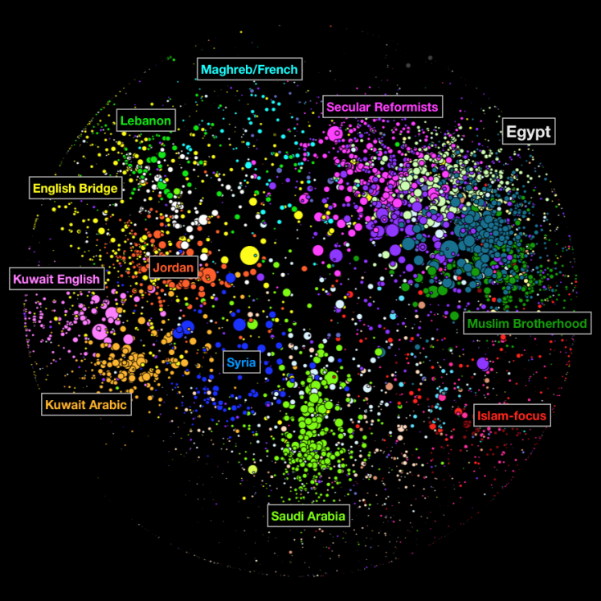

###### *Figure 10-1. Example of the Arabic blogosphere*

The different colors represent countries and clusters of blogs. The size of each dot is centrality through degree, i.e., the number of links to other blogs in the network. The physical structure of the blogosphere can give us insight.

If we analyze text using natural language processing (NLP), thinking of the blog posts as a pile of text or a river of text, then we see the micro or macro picture only—we lose the most important story. What’s missing there is social network analysis (SNA), which helps us map and analyze the patterns of interaction. The 12 different international blogospheres, for example, look different. We can infer that different societies have different interests, which give rise to different patterns.

But why are they different? After all, they’re representations of some higher dimensional thing projected onto two dimensions. Couldn’t it be just that they’re drawn differently? Yes, but we can do lots of text analysis that convinces us these pictures really are showing us something. We put an effort into interpreting the content qualitatively.

So, for example, in the French blogosphere, we see a cluster that discusses gourmet cooking. In Germany we see various clusters discussing politics and lots of crazy hobbies. In English blogs we see two big clusters [Cathy/mathbabe interjects: gay porn and straight porn?]. They turn out to be conservative versus liberal blogs.

In Russia, their blogging networks tend to force people to stay within the networks, which is why we see very well-defined, partitioned clusters.

The proximity clustering is done using the [Fruchterman-Reingold algorithm](http://wiki.gephi.org/index.php/Fruchterman-Reingold), where being in the same neighborhood means your neighbors are connected to other neighbors, so really it reflects a collective phenomenon of influence. Then we interpret the segments. [Figure 10-2](https://learning.oreilly.com/library/view/doing-data-science/9781449363871/ch10.html#english-blogs) shows an example of English language blogs.

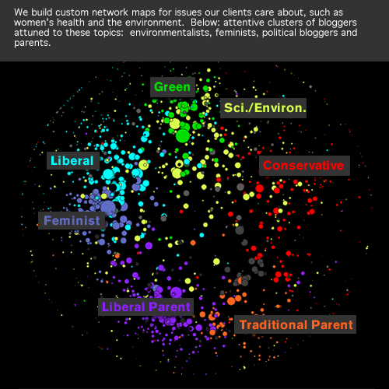

###### *Figure 10-2. English language blogs*

## How Visualizations Help Us Find Schools of Fish

Social media companies are each built around the fact that they either have the data or they have a toolkit—a patented sentiment engine or something, a machine that goes ping. Keep in mind, though, that social media is heavily a product of organizations that pay to move the needle—that is, that game the machine that goes ping. To believe what you see, you need to keep ahead of the game, which means you need to decipher that game to see how it works. That means you need to visualize.

Example: if you are thinking about elections, look at people’s blogs within “moms” or “sports fans.” This is more informative than looking at partisan blogs where you already know the answer.

Here’s another example: Kelly walked us through an analysis, after binning the blogosphere into its segments, of various types of links to partisan videos like MLK’s “I Have a Dream” speech, and a video from the Romney campaign. In the case of the MLK speech, you see that it gets posted in spurts around the election cycle events all over the blogosphere, but in the case of the Romney campaign video, you see a concerted effort by conservative bloggers to post the video in unison.

That is to say, if you were just looking at a histogram of links—a pure count—it might look as if the Romney video had gone viral, but if you look at it through the lens of the understood segmentation of the blogosphere, it’s clearly a planned operation to game the “virality” measures.

Kelly also works with the [Berkman Center for Internet and Society at Harvard](http://cyber.law.harvard.edu/research). He analyzed the Iranian blogosphere in 2008 and again in 2011, and he found much the same in terms of clustering—young anti-government democrats, poetry (an important part of Iranian culture), and conservative pro-regime clusters dominated in both years.

However, only 15% of the blogs are the same from 2008 to 2011.

So, whereas people are often concerned about individuals (the case-attribute model), the individual fish are less important than the schools of fish. By doing social network analysis, we are looking for the schools, because that way we learn about the salient interests of the society and how those interests are stable over time.

The moral of this story is that we need to focus on meso-level patterns, not micro- or macro-level patterns.

# More Background on Social Network Analysis from a Statistical Point of View

One way to start with SNA is to think about a network itself as a random object, much like a random number or random variable. The network can be conceived of as the result of a random process or as coming from an underlying probability distribution. You can in fact imagine a sample of networks, in which case you can ask questions like: What characterizes networks that might conceivably be Twitter-like? Could a given network reflect real-world friendships? What would it even mean to say yes or no to this question?

These are some of the basic questions in the discipline of social network analysis, which has emerged from academic fields such as math, statistics, computer science, physics, and sociology, with far-ranging applications in even more fields including fMRI research, epidemiology, and studies of online social networks such as Facebook or Google+.

## Representations of Networks and Eigenvalue Centrality

In some networks, the edges between nodes are directed: I can follow you on Twitter when you don’t follow me, so there will be an edge from me to you. But other networks have only symmetric edges: we either know each other or don’t. These latter types of networks are called undirected.

An undirected network with NN nodes can be represented by an N×NN×N matrix comprised of 1s and 0s, where the (ii,jj)th element in the matrix is a 1 if and only if nodes ii and jj are connected. This matrix is known as an adjacency matrix, or incidence matrix. Note that we can actually define this for directed networks too, but for undirected networks, the matrix is always symmetric.

Alternatively, a network can be represented by a list of lists: for each node ii, we list the nodes to which node ii is connected. This is known as an incidence list, and note that it doesn’t depend on the network being undirected. Representing the network this way saves storage space—the nodes can have attributes represented as a vector or list. For example, if the nodes are people, the attributes could be demographic information or information about their behavior, habits, or tastes.

The edges themselves can also have values, or weights/vectors, which could capture information about the nature of the relationship between the nodes they connect. These values could be stored in the N×NN×N matrix, in place of the 1s and 0s that simply represent the presence or not of a relationship.

Now with the idea of an adjacency matrix AA in mind, we can finally define eigenvalue centrality, which we first mentioned in [“Centrality Measures”](https://learning.oreilly.com/library/view/doing-data-science/9781449363871/ch10.html#section-centrality-measures). It is compactly defined as the unique vector solution xx to the equation:

Ax=λxAx=λx

such that

xi>0,i=1⋯Nxi>0,i=1⋯N

As it turns out, that last condition is equivalent to choosing the largest eigenvalue λλ. So for an actual algorithm, find the roots of the equation det(A−tI)det(A-tI) and order them by size, grabbing the biggest one and calling it λλ. Then solve for xx by solving the system of equations:

(A−λI)x=0(A-λI)x=0

Now we have xx, the vector of eigenvector centrality scores.

Note this doesn’t give us much of a feel for eigenvalue centrality, even if it gives us a way to compute it. You can get that feel by thinking about it as the limit of a simple iterative scheme—although it requires proof, which you can find, for example, [here](http://goo.gl/UVkLoF).

Namely, start with a vector whose entries are just the degrees of the nodes, perhaps scaled so that the sum of the entries is 1. The degrees themselves aren’t giving us a real understanding of how interconnected a given node is, though, so in the next iteration, add the degrees of all the neighbors of a given node, again scaled. Keep iterating on this, adding degrees of neighbors one further step out each time. In the limit as this iterative process goes on forever, we’ll get the eigenvalue centrality vector.

## A First Example of Random Graphs: The Erdos-Renyi Model

Let’s work out a simple example where a network can be viewed as a single realization of an underlying stochastic process. Namely, where the existence of a given edge follows a probability distribution, and all the edges are considered independently.

Say we start with NN nodes. Then there are D=(N2)D=N2 pairs of nodes, or dyads, which can either be connected by an (undirected) edge or not. Then there are 2D2D possible observed networks. The simplest underlying distribution one can place on the individual edges is called the Erdos-Renyi model, which assumes that for every pair of nodes (i,j)(i,j), an edge exists between the two nodes with probability pp.

##### THE BERNOULLI NETWORK

Not all networks with NN nodes occur with equal probability under this model: observing a network with all nodes attached to all other nodes has probability pDpD, while observing a network with all nodes disconnected has probability (1−p)D(1-p)D. And of course there are many other possible networks between these two extremes. The Erdos-Renyi model is also known as a Bernoulli network. In the mathematics literature, the Erdos-Renyi model is treated as a mathematical object with interesting properties that allow for theorems to be proved.

## A Second Example of Random Graphs: The Exponential Random Graph Model

Here’s the bad news: social networks that can be observed in the real world tend not to resemble Bernoulli networks. For example, friendship networks or academic collaboration networks commonly exhibit characteristics such as transitivity (the tendency, when A knows B and B knows C, that A knows C), clustering (the tendency for more or less well-defined smallish groups to exist with larger networks), reciprocity or mutuality (in a directed network, the tendency for A to follow B if B follows A), and betweenness (the tendency for there to exist special people through whom information flows).

Some of these observed properties of real-world networks are pretty simple to translate into mathematical language. For example, transitivity can be captured by the number of triangles in a network.

Exponential random graph models (ERGMs) are an approach to capture these real-world properties of networks, and they are commonly used within sociology.

The general approach for ERGMs is to choose pertinent graph statistics like the number of triangles, the number of edges, and the number of 2-stars (subgraphs consisting of a node with two spokes—so a node with degree 3 has three 2-stars associated to it) given the number of nodes, and have these act as variables zizi of your model, and then tweak the associated coefficients θiθi to get them tuned to a certain type of behavior you observe or wish to simulate. If z1z1 refers to the number of triangles, then a positive value for θ1θ1 would indicate a tendency toward a larger number of triangles, for example.

Additional graph statistics that have been introduced include kk-stars (subgraphs consisting of a node with kkspokes—so a node with degree k+1k+1 has k+1k+1 kk-stars associated with it), degree, or alternating *kk*-stars, an aggregation statistics on the number of kk-stars for various kk. Let’s give you an idea of what an ERGM might look like formula-wise:

Pr(Y=y)=(1κ)((θ1z1(y)+θ2z2(y)+θ3z3(y))Pr(Y=y)=(1κ)((θ1z1(y)+θ2z2(y)+θ3z3(y))

Here we’re saying that the probability of observing one particular realization of a random graph or network, YY, is a function of the graph statistics or properties, which we just described as denoted by zizi.

In this framework, a Bernoulli network is a special case of an ERGM, where we only have one variable corresponding to number of edges.

### INFERENCE FOR ERGMS

Ideally—though in some cases unrealistic in practice—one could observe a sample of several networks, Y1,...,YnY1,...,Yn, each represented by their adjacency matrices, say for a fixed number NN of nodes.

Given those networks, we could model them as independent and identically distributed observations from the same probability model. We could then make inferences about the parameters of that model.

As a first example, if we fix a Bernoulli network, which is specified by the probability pp of the existence of any given edge, we can calculate the likelihood of any of our sample networks having come from that Bernoulli network as

L=∏nipdi(1−p)D−diL=∏inpdi(1-p)D-di

where didi is the number of observed edges in the iith network and DD is the total number of dyads in the network, as earlier. Then we can back out an estimator for pp as follows:

pˆ=∑ni=1dinDp^=∑i=1ndinD

In practice in the ERGM literature, only one network is observed, which is to say we work with a sample size of one. From this one example we estimate a parameter for the probability model that “generated” this network. For a Bernoulli network, from even just one network, we could estimate pp as the proportion of edges out of the total number of dyads, which seems a reasonable estimate.

But for more complicated ERGMs, estimating the parameters from one observation of the network is tough. If it’s done using something called a pseudo-likelihood estimation procedure, it sometimes produces infinite values (see Mark Handcock’s 2003 paper, [“Assessing Degeneracy of Statistical Models of Social Networks”](http://citeseerx.ist.psu.edu/viewdoc/summary?doi=10.1.1.81.5086)). If it’s instead done using something called MCMC methods, it suffers from something called inferential degeneracy, where the algorithms converge to degenerate graphs—graphs that are complete or empty—or the algorithm does not converge consistently (also covered in Handcock’s paper).

### FURTHER EXAMPLES OF RANDOM GRAPHS: LATENT SPACE MODELS, SMALL-WORLD NETWORKS

Motivated by problems of model degeneracy and instability in exponential random graph models, researchers introduced latent space models (see Peter Hoff’s [“Latent Space Approaches to Social Network Analysis”](http://1.usa.gov/GzAT1Z)).

Latent space models attempt to address the following issue: we observe some reality, but there is some corresponding latent reality that we cannot observe. So, for example, we may observe connections between people on Facebook, but we don’t observe where those people live, or other attributes that make them have a tendency to befriend each other.

Other researchers have proposed small-world networks (see the [Watts and Strogatz model](http://en.wikipedia.org/wiki/Watts_and_Strogatz_model) proposed in their 1998 paper), which lie on a spectrum between completely random and completely regular graphs and attempt to capture the real-world phenomenon of six degrees of separation. A criticism of this model is that it produces networks that are homogeneous in degree, whereas observable real-world networks tend to be scale-free and inhomogeneous in degree.

In addition to the models just described, other classes of models include Markov random fields, stochastic block models, mixed membership models, and stochastic block mixed membership models—each of which model relational data in various ways, and seek to include properties that other models do not. (See, for example, the paper [“Mixed Membership Stochastic Block Models”](http://dl.acm.org/citation.cfm?id=1442798) by Edoardo Airoli, et al.)

Here are some textbooks for further reading:

* [Networks, Crowds, and Markets](http://www.cambridge.org/us/academic/subjects/computer-science/algorithmics-complexity-computer-algebra-and-computational-g/networks-crowds-and-markets-reasoning-about-highly-connected-world) (Cambridge University Press) by David Easley and Jon Kleinberg at Cornell’s computer science department.
* [Chapter on Mining Social-Network graphs](http://stanford.io/1g3IpPN) in the book Mining Massive Datasets (Cambridge University Press) by Anand Rajaraman, Jeff Ullman, and Jure Leskovec in Stanford’s computer science department.
* [Statistical Analysis of Network Data](http://math.bu.edu/people/kolaczyk/softwareSAND.html) (Springer) by Eric D. Kolaczyk at Boston University.

# Data Journalism

Our second speaker of the night was Jon Bruner, an editor at O’Reilly who previously worked as the data editor at [Forbes](http://www.forbes.com/). He is broad in his skills: he does research and writing on anything that involves data.

## A Bit of History on Data Journalism

Data journalism has been around for a while, but until recently, computer-assisted reporting was a domain of Excel power users. (Even now, if you know how to write an Excel program, you’re an elite.)

Things started to change recently: more data became available to us in the form of [APIs](http://en.wikipedia.org/wiki/Application_programming_interface), new tools, and less expensive computing power—so almost anyone can analyze pretty large datasets on a laptop. Programming skills are now widely enough held so that you can find people who are both good writers and good programmers. Many people who are English majors know enough about computers to get by; or on the flip side, you’ll find computer science majors who can write.

In big publications like the New York Times, the practice of data journalism is divided into fields: graphics versus interactive features, research, database engineers, crawlers, software developers, and domain-expert writers. Some people are in charge of raising the right questions but hand off to others to do the analysis. [Charles Duhigg](http://nyti.ms/1c4Oew9)at the New York Times, for example, studied water quality in New York, and got a Freedom of Information Act request to the State of New York—he knew enough to know what would be in that FOIA request and what questions to ask, but someone else did the actual analysis.

At a smaller organization, things are totally different. Whereas the New York Times has 1,000 people on its newsroom “floor,” The Economist has maybe 130, and Forbes has 70 or 80 people in its newsrooms. If you work for anything besides a national daily, you end up doing everything by yourself: you come up with a question, you go get the data, you do the analysis, then you write it up. (Of course, you can also help and collaborate with your colleagues when possible.)

## Writing Technical Journalism: Advice from an Expert

Jon was a math major in college at the University of Chicago, after which he took a job writing at Forbes, where he slowly merged back into quantitative work. For example, he found himself using graph theoretic tools when covering contributions of billionaires to politicians.

He explained the term “data journalism” to the class by way of explaining his own data scientist profile.

First of all, it involved lots of data visualization, because it’s a fast way of describing the bottom line of a dataset. Computer science skills are pretty important in data journalism, too. There are tight deadlines, and the data journalist has to be good with their tools and with messy data—because even federal data is messy. One has to be able to handle arcane formats, and often this means parsing stuff in Python. Jon himself uses JavaScript, Python, SQL, and MongoDB, among other tools.

Statistics, Bruno says, informs the way you think about the world. It inspires you to write things: e.g., the average person on Twitter is a woman with 250 followers, but the median person has 0 followers—the data is clearly skewed. That’s an inspiration right there for a story.

Bruno admits to being a novice in the field of machine learning. However, he claims domain expertise as critical in data journalism: with exceptions for people who can specialize in one subject, say at a governmental office or a huge daily, for a smaller newspaper you need to be broad, and you need to acquire a baseline layer of expertise quickly.

Of course communications and presentations are absolutely huge for data journalists. Their fundamental skill is translation: taking complicated stories and deriving meaning that readers will understand. They also need to anticipate questions, turn them into quantitative experiments, and answer them persuasively.

Here’s advice from Jon for anyone initiating a data journalism project: don’t have a strong thesis before you interview the experts. Go in with a loose idea of what you’re searching for and be willing to change your mind and pivot if the experts lead you in a new and interesting direction. Sounds kind of like exploratory data analysis!

# Chapter 12. Causality

Many of the models and examples in the book so far have been focused on the fundamental problem of prediction. We’ve discussed examples like in [Chapter 8](https://learning.oreilly.com/library/view/doing-data-science/9781449363871/ch08.html#chapter-hunch-recommendation-engines), where your goal was to build a model to predict whether or not a person would be likely to prefer a certain item—a movie or a book, for example. There may be thousands of features that go into the model, and you may use feature selection to narrow those down, but ultimately the model is getting optimized in order to get the highest accuracy. When one is optimizing for accuracy, one doesn’t necessarily worry about the meaning or interpretation of the features, and especially if there are thousands of features, it’s well-near impossible to interpret at all.

Additionally, you wouldn’t even want to make the statement that certain characteristics caused the person to buy the item. So, for example, your model for predicting or recommending a book on Amazon could include a feature “whether or not you’ve read Wes McKinney’s O’Reilly book Python for Data Analysis.” We wouldn’t say that reading his book caused you to read this book. It just might be a good predictor, which would have been discovered and come out as such in the process of optimizing for accuracy. We wish to emphasize here that it’s not simply the familiar correlation-causation trade-off you’ve perhaps had drilled into your head already, but rather that your intent when building such a model or system was not even to understand causality at all, but rather to predict. And that if your intent were to build a model that helps you get at causality, you would go about that in a different way.

A whole different set of real-world problems that actually use the same statistical methods (logistic regression, linear regression) as part of the building blocks of the solution are situations where you do want to understand causality, when you want to be able to say that a certain type of behavior causes a certain outcome. In these cases your mentality or goal is not to optimize for predictive accuracy, but rather to be able to isolate causes.

This chapter will explore the topic of causality, and we have two experts in this area as guest contributors, Ori Stitelman and David Madigan. Madigan’s bio will be in the next chapter and requires this chapter as background. We’ll start instead with Ori, who is currently a data scientist at Wells Fargo. He got his PhD in biostatistics from UC Berkeley after working at a litigation consulting firm. As part of his job, he needed to create stories from data for experts to testify at trial, and he thus developed what he calls “data intuition” from being exposed to tons of different datasets.

# Correlation Doesn’t Imply Causation

One of the biggest statistical challenges, from both a theoretical and practical perspective, is establishing a causal relationship between two variables. When does one thing cause another? It’s even trickier than it sounds.

Let’s say we discover a correlation between ice cream sales and bathing suit sales, which we display by plotting ice cream sales and bathing suit sales over time in [Figure 12-1](https://learning.oreilly.com/library/view/doing-data-science/9781449363871/ch11.html#ice-cream-sales).

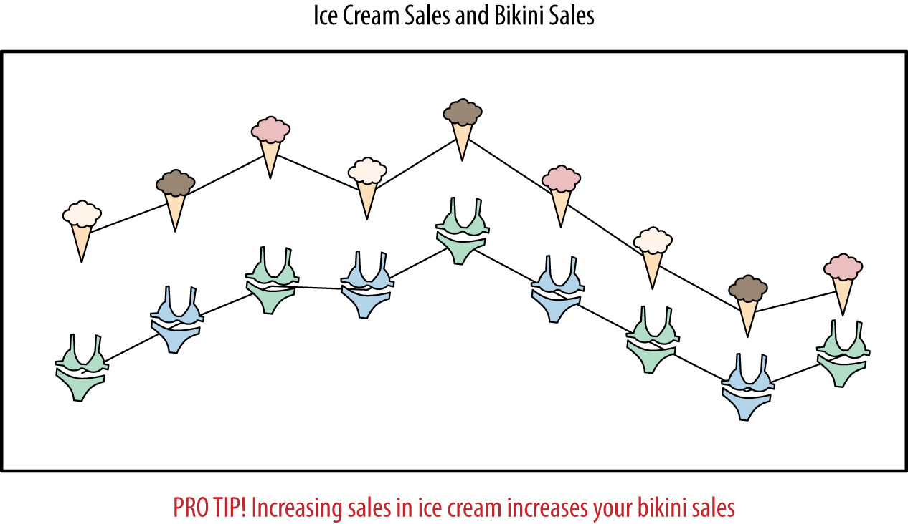

###### *Figure 12-1. Relationship between ice cream sales and bathing suit sales*

This demonstrates a close association between these two variables, but it doesn’t establish causality. Let’s look at this by pretending to know nothing about the situation. All sorts of explanations might work here. Do people find themselves irrestistably drawn toward eating ice cream when they wear bathing suits? Do people change into bathing suits every time they eat ice cream? Or is there some third thing (like hot weather) which we haven’t considered that causes both? Causal inference is the field that deals with better understanding the conditions under which association can be interpreted as causality.

## Asking Causal Questions

The natural form of a causal question is: What is the effect of x on y?

Some examples are: “What is the effect of advertising on customer behavior?” or “What is the effect of drug on time until viral failure?” or in the more general case, “What is the effect of treatment on outcome?”

###### NOTE

The terms “treated” and “untreated” come from the biostatistics, medical, and clinical trials realm, where patients are given a medical treatment, examples of which we will encounter in the next chapter. The terminology has been adopted by the statistical and social science literature.

It turns out estimating causal parameters is hard. In fact, the effectiveness of advertising is almost always considered a moot point because it’s so hard to measure. People will typically choose metrics of success that are easy to estimate but don’t measure what they want, and everyone makes decisions based on them anyway because it’s easier. But they have real negative effects. For example, marketers end up being rewarded for selling stuff to people online who would have bought something anyway.

## Confounders: A Dating Example

Let’s look at an example from the world of online dating involving a lonely guy named Frank. Say Frank is perusing a dating website and comes upon a very desirable woman. He wants to convince her to go out with him on a date, but first he needs to write an email that will get her interested. What should he write in his email to her? Should he tell her she is beautiful? How do we test that with data?

Let’s think about a randomized experiment Frank could run. He could select a bunch of beautiful women, and half the time, randomly, tell them they’re beautiful. He could then see the difference in response rates between the two groups.

For whatever reason, though, Frank doesn’t do this—perhaps he’s too much of a romantic—which leaves us to try to work out whether saying a woman is beautiful is a good move for Frank. It’s on us to get Frank a date.

If we could, we’d understand the future under two alternative realities: the reality where he sends out the email telling a given woman she’s beautiful and the reality where he sends an email but doesn’t use the word beautiful. But only one reality is possible. So how can we proceed?

Let’s write down our causal question explicitly: what is the effect of Frank telling a woman she’s beautiful on him getting a positive response?

In other words, the “treatment” is Frank’s telling a woman she’s beautiful over email, and the “outcome” is a positive response in an email, or possibly no email at all. An email from Frank that doesn’t call the recipient of the email beautiful would be the control for this study.

###### NOTE

There are lots of things we’re not doing here that we might want to try. For example, we’re not thinking about Frank’s attributes. Maybe he’s a really weird unattractive guy that no woman would want to date no matter what he says, which would make this a tough question to solve. Maybe he can’t even spell “beautiful.” Conversely, what if he’s gorgeous and/or famous and it doesn’t matter what he says? Also, most dating sites allow women to contact men just as easily as men contact women, so it’s not clear that our definitions of “treated” and “untreated” are well-defined. Some women might ignore their emails but spontaneously email Frank anyway.

# OK Cupid’s Attempt

As a first pass at understanding the impact of word choice on response rates, the online dating site OK Cupid analyzed over 500,000 first contacts on its site. They looked at keywords and phrases, and how they affected reply rates, shown in [Figure 12-2](https://learning.oreilly.com/library/view/doing-data-science/9781449363871/ch11.html#figure11.2).

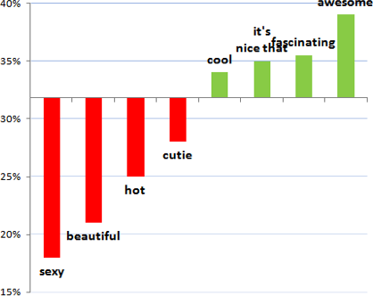

###### *Figure 12-2. OK Cupid’s attempt to demonstrate that using the word “beautiful” in an email hurts your chances of getting a response*

The y-axis shows the response rate. On average the response rate across all emails was ~32%. They then took the subset of emails that included a certain word such as “beautiful” or “awesome,” and looked at the response rate for those emails. Writing this in terms of conditional probabilities, we would say they were estimating these: P(response) = 0.32 vs P(response|"beautiful”) = 0.22.

###### NOTE

One important piece of information missing in this plot is the bucket sizes. How many first contacts contained each of the words? It doesn’t really change things, except it would help in making it clear that the horizontal line at 32% is a weighted average across these various buckets of emails.

They interpreted this graph and created a rule called “Avoid Physical Compliments.” They discussed this in the blog post [“Exactly what to say in a first message”](http://blog.okcupid.com/index.php/online-dating-advice-exactly-what-to-say-in-a-first-message/) with the following explanation: “You might think that words like gorgeous, beautiful, and sexy are nice things to say to someone, but no one wants to hear them. As we all know, people normally like compliments, but when they’re used as pick-up lines, before you’ve even met in person, they inevitably feel… ew. Besides, when you tell a woman she’s beautiful, chances are you’re not.”

This isn’t an experiment, but rather an observational study, which we’ll discuss more later but for now means we collect data as it naturally occurs in the wild. Is it reasonable to conclude from looking at this plot that adding “awesome” to an email increases the response rate, or that “beautiful” decreases the response rate?

Before you answer that, consider the following three things.

First, it could say more about the person who says “beautiful” than the word itself. Maybe they are otherwise ridiculous and overly sappy? Second, people may be describing themselves as beautiful, or some third thing like the world we live in.

These are both important issues when we try to understand population-wide data such as in the figure, because they address the question of whether having the word “beautiful” in the body of the email actually implies what we think it does. But note that both of those issues, if present, are consistently true for a given dude like Frank trying to get a date. So if Frank is sappy, he’s theoretically equally sappy to all the women he writes to, which makes it a consistent experiment, from his perspective, to decide whether or not to use the word “beautiful” in his emails.

The third and most important issue to consider, because it does not stay consistent for a given dude, is that the specific recipients of emails containing the word “beautiful” might be special: for example, they might get tons of email, and only respond to a few of them, which would make it less likely for Frank to get any response at all.

In fact, if the woman in question is beautiful (let’s pretend that’s a well-defined term), that fact affects two separate things at the same time. Both whether Frank uses the word “beautiful” or not in his email, and the outcome, i.e., whether Frank gets a response. For this reason, the fact that the woman is beautiful qualifies as a confounder; in other words, a variable that influences or has a causal effect on both the treatment itself as well as the outcome.

Let’s be honest about what this plot actually shows versus what OK Cupid was implying it showed. It shows the observed response rate for emails that contained the given words. It should not be used and cannot correctly be interpreted as a prescription or suggestion for how to construct an email to get a response because after adjustingfor confounders, which we’ll discuss later in the chapter, using the word “beautiful” could be the best thing we could do. We can’t say for sure because we don’t have the data, but we’ll describe what data we’d need and how we’d analyze it to do this study properly. Their advice might be correct, but the plot they showed does not back up this advice.

# The Gold Standard: Randomized Clinical Trials

So what do we do? How do people ever determine causality?

The gold standard for establishing causality is the randomized experiment. This a setup whereby we randomly assign some group of people to receive a “treatment” and others to be in the “control” group—that is, they don’treceive the treatment. We then have some outcome that we want to measure, and the causal effect is simply the difference between the treatment and control group in that measurable outcome. The notion of using experiments to estimate causal effects rests on the statistical assumption that using randomization to select two groups has created “identical” populations from a statistical point of view.

Randomization works really well: because we’re flipping coins, all other factors that might be confounders (current or former smoker, say) are more or less removed, because we can guarantee that smokers will be fairly evenly distributed between the two groups if there are enough people in the study.

The truly brilliant thing about randomization is that randomization matches well on the possible confounders we thought of, but will also give us balance on the 50 million things we didn’t think of.

So, although we can algorithmically find a better split for the ones we thought of, that quite possibly wouldn’t do as well on the other things. That’s why we really do it randomly, because it does quite well on things we think of and things we don’t.

But there’s bad news for randomized clinical trials as well, as we pointed out earlier. First off, it’s only ethically feasible if there’s something called [clinical equipoise](http://en.wikipedia.org/wiki/Clinical_equipoise), which means the medical community really doesn’t know which treatment is better. If we know treating someone with a drug will be better for them than giving them nothing, we can’t randomly not give people the drug.

For example, if we want to tease out the relationship between smoking and heart disease, we can’t randomly assign someone to smoke, because it’s known to be dangerous. Similarly, the relationship between cocaine and birthweight is fraught with danger, as is the tricky relationship between diet and mortality.

The other problem is that they are expensive and cumbersome. It takes a long time and lots of people to make a randomized clinical trial work. On the other hand, not doing randomized clinical trials can lead to mistaken assumptions that are extremely expensive as well.

Sometimes randomized studies are just plain unfeasible. Let’s go back to our OK Cupid example, where we have a set of observational data and we have a good reason to believe there are confounders that are screwing up our understanding of the effect size. As noted, the gold standard would be to run an experiment, and while the OK Cupid employees could potentially run an experiment, it would be unwise for them to do so—randomly sending email to people telling them they are “beautiful” would violate their agreement with their customers.

In conclusion, when they are possible, randomized clinical trials are the gold standard for elucidating cause-and-effect relationships. It’s just that they aren’t always possible.

##### AVERAGE VERSUS THE INDIVIDUAL

Randomized clinical trials measure the effect of a certain drug averaged across all people. Sometimes they might bucket users to figure out the average effect on men or women or people of a certain age, and so on. But in the end, it still has averaged out stuff so that for a given individual we don’t know what they effect would be on them. There is a push these days toward personalized medicine with the availability of genetic data, which means we stop looking at averages because we want to make inferences about the one. Even when we were talking about Frank and OK Cupid, there’s a difference between conducting this study across all men versus Frank alone.

# A/B Tests

In software companies, what we described as random experiments are sometimes referred to as A/B tests. In fact, we found that if we said the word “experiments” to software engineers, it implied to them “trying something new” and not necessarily the underlying statistical design of having users experience different versions of the product in order to measure the impact of that difference using metrics. The concept is intuitive enough and seems simple. In fact, if we set up the infrastructure properly, running an experiment can come down to writing a short configuration file and changing just one parameter—be it a different color or layout or underlying algorithm—that gives some users a different experience than others. So, there are aspects of running A/B tests in a tech company that make it much easier than in a clinical trial. And there’s much less at stake in terms of the idea that we’re not dealing with people’s lives. Other convenient things are there aren’t compliance issues, so with random clinical trials we can’t control whether someone takes the drug or not, whereas online, we can control what we show the user. But notice we said if we set up the experimental infrastructure properly, and that’s a big IF.

It takes a lot of work to set it up well and then to properly analyze the data. When different teams at a company are all working on new features of a product and all want to try out variations, then if you’re not careful a single user could end up experiencing multiple changes at once. For example, the UX team might change the color or size of the font, or the layout to see if that increases click-through rate. While at the same time the content ranking team might want to change the algorithm that chooses what to recommend to users, and the ads team might be making changes to their bidding system. Suppose the metric you care about is return rate, and a user starts coming back more, and you had them in three different treatments but you didn’t know that because the teams weren’t coordinating with each other. Your team might assume the treatment is the reason the user is coming back more, but it might be the combination of all three.

There are various aspects of an experimental infrastructure that you need to consider, which are described in much more detail in [Overlapping Experiment Infrastructure: More, Better, Faster Experimentation](http://research.google.com/pubs/pub36500.html), a 2010 paper by Google employees Diane Tang, et al. See the following sidebar for an excerpt from this paper.

##### FROM “OVERLAPPING EXPERIMENT INFRASTRUCTURE: MORE, BETTER, FASTER EXPERIMENTATION”

The design goals for our experiment infrastructure are therefore: more, better, faster.

More

We need scalability to run more experiments simultaneously. However, we also need ﬂexibility: different experiments need different conﬁgurations and different sizes to be able to measure statistically signiﬁcant effects. Some experiments only need to change a subset of trafﬁc, say Japanese trafﬁc only, and need to be sized appropriately. Other experiments may change all trafﬁc and produce a large change in metrics, and so can be run on less trafﬁc.

Better

Invalid experiments should not be allowed run on live trafﬁc. Valid but bad experiments (e.g., buggy or unintentionally producing really poor results) should be caught quickly and disabled. Standardized metrics should be easily available for all experiments so that experiment comparisons are fair: two experimenters should use the same ﬁlters to remove robot trafﬁc when calculating a metric such as CTR.

Faster

It should be easy and quick to set up an experiment; easy enough that a non-engineer can do so without writing any code. Metrics should be available quickly so that experiments can be evaluated quickly. Simple iterations should be quick to do. Ideally, the system should not just support experiments, but also controlled ramp-ups, i.e., gradually ramping up a change to all trafﬁc in a systematic and well-understood way.

That experimental infrastructure has a large team working on it and analyzing the results of the experiments on a full-time basis, so this is nontrivial. To make matters more complicated, now that we’re in an age of social networks, we can no longer assume that users are independent (which is part of the randomization assumption underlying experiments). So, for example, Rachel might be in the treatment group of an experiment Facebook is running (which is impossible because Rachel isn’t actually on Facebook, but just pretend), which lets Rachel post some special magic kind of post, and Cathy might be in the control group, but she still sees the special magic post, so she actually received a different version of the treatment, so the experimental design must take into account the underlying network structure. This is a nontrivial problem and still an open research area.

# Second Best: Observational Studies

While the gold standard is generally understood to be randomized experiments or A/B testing, they might not always be possible, so we sometimes go with second best, namely observational studies.

Let’s start with a definition:

An observational study is an empirical study in which the objective is to elucidate cause-and-effect relationships in which it is not feasible to use controlled experimentation.

Most data science activity revolves around observational data, although A/B tests, as you saw earlier, are exceptions to that rule. Most of the time, the data you have is what you get. You don’t get to replay a day on the market where Romney won the presidency, for example.

Designed studies are almost always theoretically better tests, as we know, but there are plenty of examples where it’s unethical to run them. Observational studies are done in contexts in which you can’t do designed experiments, in order to elucidate cause-and-effect.

In reality, sometimes you don’t care about cause-and-effect; you just want to build predictive models. Even so, there are many core issues in common with the two.

## Simpson’s Paradox

There are all kinds of pitfalls with observational studies.

For example, look at the graph in [Figure 12-3](https://learning.oreilly.com/library/view/doing-data-science/9781449363871/ch11.html#figure11.3), where you’re finding a best-fit line to describe whether taking higher doses of the “bad drug” is correlated to higher probability of a heart attack.

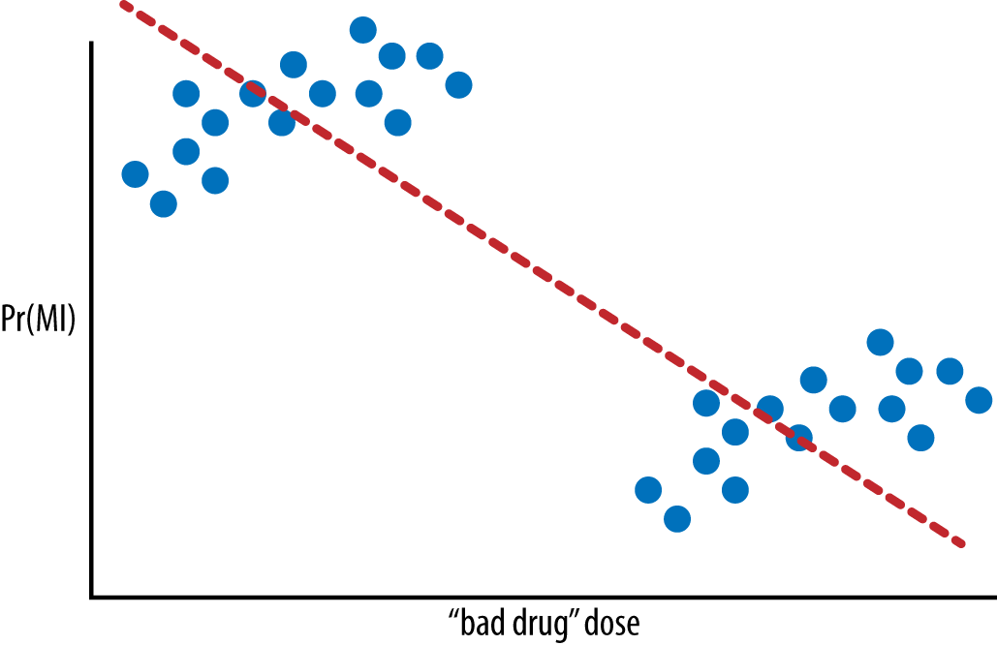

###### *Figure 12-3. Probability of having a heart attack (also known as MI, or myocardial infarction) as a function of the size of the dose of a bad drug*

It looks like, from this vantage point, the higher the dose, the fewer heart attacks the patient has. But there are two clusters, and if you know more about those two clusters, you find the opposite conclusion, as you can see in [Figure 12-4](https://learning.oreilly.com/library/view/doing-data-science/9781449363871/ch11.html#figure11.4).

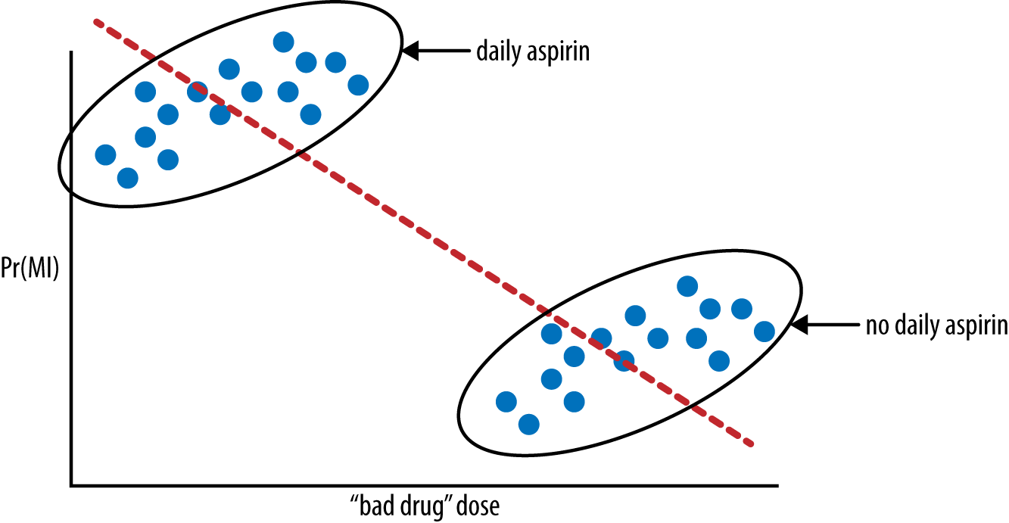

###### *Figure 12-4. Probability of having a heart attack as a function of the size of the dose of a bad drug*and*whether or not the patient also took aspirin*

This picture was rigged, so the issue is obvious. But, of course, when the data is multidimensional, you wouldn’t even always draw such a simple picture.

In this example, we’d say aspirin-taking is a confounder. We’ll talk more about this in a bit, but for now we’re saying that the aspirin-taking or nonaspirin-taking of the people in the study wasn’t randomly distributed among the people, and it made a huge difference in the apparent effect of the drug.

Note that, if you think of the original line as a predictive model, it’s actually still the best model you can obtain knowing nothing more about the aspirin-taking habits or genders of the patients involved. The issue here is really that you’re trying to assign causality.

It’s a general problem with regression models on observational data. You have no idea what’s going on. As Madigan described it, “it’s the Wild West out there.”

It could be the case that within each group there are males and females, and if you partition by those, you see that the more drugs they take, the better again. Because a given person either is male or female, and either takes aspirin or doesn’t, this kind of thing really matters.

This illustrates the fundamental problem in observational studies: a trend that appears in different groups of data disappears when these groups are combined, or vice versa. This is sometimes called [Simpson’s Paradox](http://en.wikipedia.org/wiki/Simpson's_paradox).

## The Rubin Causal Model

The [Rubin causal model](http://en.wikipedia.org/wiki/Rubin_causal_model) is a mathematical framework for understanding what information we know and don’t know in observational studies.

It’s meant to investigate the confusion when someone says something like, “I got lung cancer because I smoked.” Is that true? If so, you’d have to be able to support the statement, “If I hadn’t smoked, I wouldn’t have gotten lung cancer,” but nobody knows that for sure.

Define ZiZi to be the treatment applied to unit ii (0 = control, 1= treatment), Yi(1)Yi(1) to be the response for unit ii if Zi=1Zi=1 and Yi(0)Yi(0) to be the response for unit ii if Zi=0Zi=0.

Then the unit level causal effect, the thing we care about, is Yi(1)−Yi(0)Yi(1)-Yi(0), but we only see one of Yi(0)Yi(0) and Yi(1)Yi(1).

Example: ZiZi is 1 if I smoked, 0 if I didn’t (I am the unit). Yi(1)Yi(1) is 1 if I got cancer and I smoked, and 0 if I smoked and didn’t get cancer. Similarly Yi(0)Yi(0) is 1 or 0, depending on whether I got cancer while not smoking. The overall causal effect on me is the difference Yi(1)−Yi(0)Yi(1)-Yi(0). This is equal to 1 if I really got cancer because I smoked, it’s 0 if I got cancer (or didn’t) independent of smoking, and it’s –1 if I avoided cancer by smoking. But I’ll never know my actual value because I only know one term out of the two.

On a population level, we do know how to infer that there are quite a few “1"s among the population, but we will never be able to assign a given individual that number.

This is sometimes called the [fundamental problem of causal inference](http://en.wikipedia.org/wiki/Rubin_causal_model#The_fundamental_problem_of_causal_inference).

## Visualizing Causality

We can represent the concepts of causal modeling using what is called a causal graph.

Denote by WW the set of all potential confounders. Note it’s a big assumption that we can take account of all of them, and we will soon see how unreasonable this seems to be in epidemiology research in the next chapter.

In our example with Frank, we have singled out one thing as a potential confounder—the woman he’s interested in being beautiful—but if we thought about it more we might come up with other confounders, such as whether Frank is himself attractive, or whether he’s desperate, both of which affect how he writes to women as well as whether they respond positively to him.

Denote by AA the treatment. In our case the treatment is Frank’s using the word “beautiful” in an introductory email. We usually assume this to have a binary (0/1) status, so for a given woman Frank writes to, we’d assign her a “1” if Frank uses the word “beautiful.” Just keep in mind that if he says it’s beautiful weather, we’d be measuring counting that as a “1” even though we’re thinking about him calling the woman beautiful.

Denote by YY the binary (0/1) outcome. We’d have to make this well-defined, so, for example, we can make sure Frank asks the women he writes to for their phone number, and we could define a positive outcome, denoted by “1,” as Frank getting the number. We’d need to make this as precise as possible, so, for example, we’d say it has to happen in the OK Cupid platform within a week of Frank’s original email. Note we’d be giving a “1” to women who ignore his emails but for some separate reason send him an email with their number. It would also be hard to check that the number isn’t fake.

The nodes in a causal graph are labeled by these sets of confounders, treatment, and outcome, and the directed edges, or arrows, indicate causality. In other words, the node the arrow is coming out of in some way directly affects the node the arrow is going into.

In our case we have [Figure 12-5](https://learning.oreilly.com/library/view/doing-data-science/9781449363871/ch11.html#figure11.5).

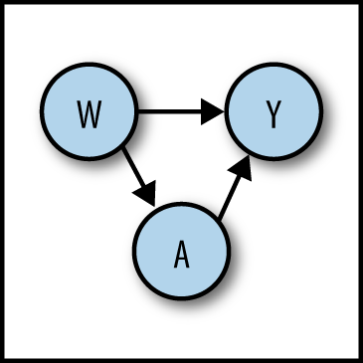

###### *Figure 12-5. Causal graph with one treatment, one confounder, and one outcome*

In the case of the OK Cupid example, the causal graph is the simplest possible causal graph: one treatment, one confounder, and one outcome. But they can get much more complicated.

## Definition: The Causal Effect

Let’s say we have a population of 100 people that take some drug, and we screen them for cancer. Say 30 of them get cancer, which gives them a cancer rate of 0.30. We want to ask the question, did the drug cause the cancer?

To answer that, we’d have to know what would’ve happened if they hadn’t taken the drug. Let’s play God and stipulate that, had they not taken the drug, we would have seen 20 get cancer, so a rate of 0.20. We typically measure the increased risk of cancer as the difference of these two numbers, and we call it the causal effect. So in this case, we’d say the causal effect is 10 percentage points.

###### NOTE

The causal effect is sometimes defined as the ratio of these two numbers instead of the difference.

But we don’t have God’s knowledge, so instead we choose another population to compare this one to, and we see whether they get cancer or not, while not taking the drug. Say they have a natural cancer rate of 0.10. Then we would conclude, using them as a proxy, that the increased cancer rate is the difference between 0.30 and 0.10, so 20%. This is of course wrong, but the problem is that the two populations have some underlying differences that we don’t account for.

If these were the “same people,” down to the chemical makeup of each others’ molecules, this proxy calculation would work perfectly. But of course they’re not.

So how do we actually select these people? One technique is to use what is called propensity score matching or modeling. Essentially what we’re doing here is creating a pseudo-random experiment by creating a synthetic control group by selecting people who were just as likely to have been in the treatment group but weren’t. How do we do this? See the word in that sentence, “likely”? Time to break out the logistic regression. So there are two stages to doing propensity score modeling. The first stage is to use logistic regression to model the probability of each person’s likelihood to have received the treatment; we then might pair people up so that one person received the treatment and the other didn’t, but they had been equally likely (or close to equally likely) to have received it. Then we can proceed as we would if we had a random experiment on our hands.

For example, if we wanted to measure the effect of smoking on the probability of lung cancer, we’d have to find people who shared the same probability of smoking. We’d collect as many covariates of people as we could (age, whether or not their parents smoked, whether or not their spouses smoked, weight, diet, exercise, hours a week they work, blood test results), and we’d use as an outcome whether or not they smoked. We’d build a logistic regression that predicted the probability of smoking. We’d then use that model to assign to each person the probability, which would be called their propensity score, and then we’d use that to match. Of course we’re banking on the fact that we figured out and were able to observe all the covariates associated with likelihood of smoking, which we’re probably not. And that’s the inherent difficulty in these methods: we’ll never know if we actually adjusted for everything we needed to adjust for. However, one of the nice aspects of them is we’ll see that when we do adjust for confounders, it can make a big difference in the estimated causal effect.

The details of setting of matching can be slightly more complicated than just paired matching—there are more complex schemes to try to create balance in the synthetic treatment and control group. And there are packages in R that can do it all automatically for you, except you must specify the model that you want to use for matching in the first place to generate the propensity scores, and which variable you want to be the outcome corresponding to the causal effect you are estimating.

What kind of data would we need to measure the causal effect in our dating example? One possibility is to have some third party, a mechanical turk, for example, go through the dating profiles of the women that Frank emails and label the ones that are beautiful. That way we could see to what extent being beautiful is a confounder. This approach is called stratification and, as we will see in the next chapter, it can introduce problems as well as fix them.

# Three Pieces of Advice

Ori took a moment to give three pieces of parting advice for best practices when modeling.

First, when estimating causal parameters, it is crucial to understand the data-generating methods and distributions, which will in turn involve gaining some subject matter knowledge. Knowing exactly how the data was generated will also help you ascertain whether the assumptions you make are reasonable.

Second, the first step in a data analysis should always be to take a step back and figure out what you want to know. Write it down carefully, and then find and use the tools you’ve learned to answer those directly. Later on be sure and come back to decide how close you came to answering your original question or questions. Sounds obvious, but you’d be surprised how often people forget to do this.

Finally, don’t ignore the necessary data intuition when you make use of algorithms. Just because your method converges, it doesn’t mean the results are meaningful. Make sure you’ve created a reasonable narrative and ways to check its validity.

# Chapter 13. Epidemiology

# Thought Experiment

We now have detailed, longitudinal medical data on tens of millions of patients. What can we do with it?

To be more precise, we have tons of phenomenological data: this is individual, patient-level medical record data. The largest of the databases has records on 80 million people: every prescription drug, every condition ever diagnosed, every hospital or doctor’s visit, every lab result, procedures, all timestamped.

But we still do things like we did in the Middle Ages; the vast majority of diagnosis and treatment is done in a doctor’s brain. Can we do better? Can we harness these data to do a better job delivering medical care?

This is a hugely important clinical problem, especially as a healthcare insurer. Can we intervene to avoid hospitalizations?

So for example, there was a prize offered on Kaggle, called “Improve Healthcare, Win $3,000,000.” It challenged people to accurately predict who is going to go to the hospital next year. However, keep in mind that they’ve coarsened the data for privacy reasons.

There are a lot of sticky ethical issues surrounding this 80 million person medical record dataset. What nefarious things could we do with this data? Instead of helping people stay well, we could use such models to gouge sick people with huge premiums, or we could drop sick people from insurance altogether.

This is not a modeling question. It’s a question of what, as a society, we want to do with our models.

# Modern Academic Statistics

It used to be the case, say 20 years ago, according to Madigan, that academic statisticians would either sit in their offices proving theorems with no data in sight—they wouldn’t even know how to run a t-test—or sit around in their offices and dream up a new test, or a new way of dealing with missing data, or something like that, and then they’d look around for a dataset to whack with their new method. In either case, the work of an academic statistician required no domain expertise.

Nowadays things are different. The top stats journals are more deep in terms of application areas, the papers involve deep collaborations with people in social sciences or other applied sciences. Madigan sets an example by engaging with the medical community.

Madigan went on to make a point about the modern machine learning community, which he is or was part of: it’s a newish academic field, with conferences and journals, etc., but from his perspective, it’s characterized by what statistics was 20 years ago: invent a method, try it on datasets. In terms of domain expertise engagement, it’s a step backward instead of forward.

Not to say that statistics are perfect; very few academic statisticians have serious hacking skills, with Madigan’s colleague Mark Hansen being an unusual counterexample. In Madigan’s opinion, statisticians should not be allowed out of school unless they have such skills.

# Medical Literature and Observational Studies

As you may not be surprised to hear, medical journals are full of observational studies. The results of these studies have a profound effect on medical practice, on what doctors prescribe, and on what regulators do.

For example, after reading the paper entitled [“Oral bisphosphonates and risk of cancer of oesophagus, stomach, and colorectum: case-control analysis within a UK primary care cohort”](http://1.usa.gov/16UfNjZ) (by Jane Green, et al.), Madigan concluded that we see the potential for the very same kind of confounding problem as in the earlier example with aspirin. The conclusion of the paper is that the risk of cancer increased with 10 or more prescriptions of oral bisphosphonates.

It was published on the front page of the New York Times, the study was done by a group with no apparent conflict of interest, and the drugs are taken by millions of people. But the results might well be wrong and, indeed, were contradicted by later studies.

There are thousands of examples of this. It’s a major problem and people don’t even get that it’s a problem.

Billions upon billions of dollars are spent doing medical studies, and people’s lives depend on the results and the interpretations. We should really know if they work.

# Stratification Does Not Solve the Confounder Problem

The field of epidemiology attempts to adjust for potential confounders. The bad news is that it doesn’t work very well. One reason is that the methods most commonly used rely heavily on stratification, which means partitioning the cases into subcases and looking at those. So, for example, if they think gender is a confounder, they’d adjust for gender in the estimator—a weighted average is one way of stratifying.

But there’s a problem here, too. Stratification could make the underlying estimates of the causal effects go from good to bad, especially when the experiment involves small numbers or when the populations are not truly similar.

For example, say we have the situation shown in [Table 13-1](https://learning.oreilly.com/library/view/doing-data-science/9781449363871/ch12.html#aggregate-epidemiology-data). Keep in mind that we cannot actually “see” the two counterfactual middle columns.

|  |  |  |  |  |
| --- | --- | --- | --- | --- |
|  | Treatment: Drugged | Treatment: Counterfactual | Control: Counterfactual | Control: No Drug |
| Y=1 | 30 | 20 | 30 | 20 |
| Y=0 | 70 | 80 | 70 | 80 |
| P(Y=1) | 0.3 | 0.2 | 0.3 | 0.2 |
| *Table 13-1. Aggregated: Both men and women* | | | | |

Here we have 100 people in both the treatment and control groups, and in both the actual and counterfactual cases, we have a causal effect of 0.3 – 0.2 = 0.1, or 10%.

But when we split this up by gender, we might introduce a problem, especially as the numbers get smaller, as seen in Tables [12-2](https://learning.oreilly.com/library/view/doing-data-science/9781449363871/ch12.html#stratified-men) and [12-3](https://learning.oreilly.com/library/view/doing-data-science/9781449363871/ch12.html#stratified-women).

|  |  |  |  |  |
| --- | --- | --- | --- | --- |
|  | Treatment: Drugged | Treatment: Counterfactual | Control: Counterfactual | Control: No Drug |
| Y=1 | 15 | 2 | 5 | 5 |
| Y=0 | 35 | 8 | 65 | 15 |
| P(Y=1) | 0.3 | 0.2 | 0.07 | 0.25 |
| *Table 13-2. Stratified: Men* | | | | |

|  |  |  |  |  |
| --- | --- | --- | --- | --- |
|  | Treatment: Drugged | Treatment: Counterfactual | Control: Counterfactual | Control: No Drug |
| Y=1 | 15 | 18 | 25 | 15 |
| Y=0 | 35 | 72 | 5 | 65 |
| P(Y=1) | 0.3 | 0.2 | 0.83 | 0.1875 |
| *Table 13-3. Stratified: Women* | | | | |

Our causal estimate for men is 0.3 – 0.25 = 0.05, and for women is 0.3 – 0.1875 = 0.1125. A headline might proclaim that the drug has side effects twice as strong for women as for men.

In other words, stratification doesn’t just solve problems. There are no guarantees your estimates will be better if you stratify. In fact, you should have very good evidence that stratification helps before you decide to do it.

## What Do People Do About Confounding Things in Practice?

In spite of the raised objections, experts in this field essentially use stratification as a major method to working through studies. They deal with confounding variables, or rather variables they deem potentially confounding, by stratifying with respect to them or make other sorts of model-based adjustments, such as propensity score matching, for example. So if taking aspirin is believed to be a potentially confounding factor, they adjust or stratify with respect to it.

For example, with [this study](http://goo.gl/3VgRi0), which studied the risk of venous thromboembolism from the use of certain kinds of oral contraceptives, the researchers chose certain confounders to worry about and concluded the following:

*After adjustment for length of use, users of oral contraceptives with desogestrel, gestodene, or drospirenone were at least at twice the risk of venous thromboembolism compared with users of oral contraceptives with levonorgestrel.*

This report was featured on ABC, and was a big deal. But wouldn’t you worry about confounding issues like aspirin here? How do you choose which confounders to worry about? Or, wouldn’t you worry that the physicians who are prescribing them act different in different situations, leading to different prescriptions? For example, might they give the newer one to people at higher risk of clotting?

Another study came out about this same question and came to a different conclusion, using different confounders. The researchers adjusted for a history of clots, which makes sense when you think about it. Altogether we can view this as an illustration of how, depending on how one chooses to adjust for things, the outputs can vary wildly. It’s starting to seem like a hit or miss methodology.

Another example is a study on oral bisphosphonates, where they adjusted for smoking, alcohol, and BMI. How did they choose those variables? In fact, there are hundreds of examples where two teams made radically different choices on parallel studies.

Madigan and some coauthors tested this by giving a bunch of epidemiologists the job to design five studies at a high level. There was a low-level consistency. However, an additional problem is that luminaries of the field hear this and claim that they know the “right” way to choose the confounders.

# Is There a Better Way?

Madigan and his coauthors examined 50 studies, each of which corresponds to a drug and outcome pair (e.g., antibiotics with GI bleeding). They ran about 5,000 analyses for every pair—namely, every epistudy imaginable—and they did this all on nine different databases.

For example, they fixed the drug to be ACE inhibitors and the outcome to be swelling of the heart. They ran the same analysis on the nine different standard databases, the smallest of which has records of 4,000,000 patients, and the largest of which has records of 80,000,000 patients.

In this one case, for one database, the drug triples the risk of heart swelling; but for another database, it seems to have a six-fold increase of risk. That’s one of the best examples, though, because at least it’s always bad news, which means it’s consistent.

On the other hand, for 20 of the 50 pairs, you can go from statistically significant in one direction to the other direction depending on the database you pick. In other words, you can get whatever you want. [Figure 13-1](https://learning.oreilly.com/library/view/doing-data-science/9781449363871/ch12.html#Figure12.1) shows a picture, where the heart swelling example is at the top.

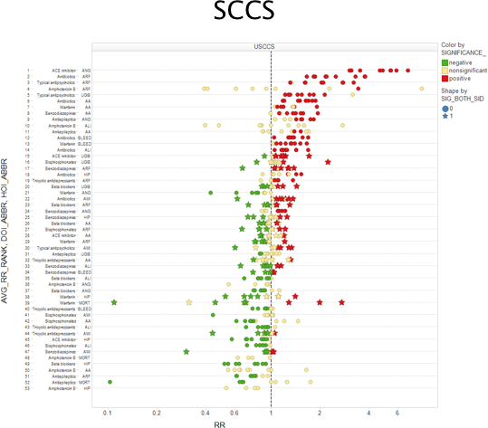

###### *Figure 13-1. Self-controlled case series*

###### NOTE

The choice of database is rarely discussed in published epidemiology papers.

Next they did an even more extensive test, where they essentially tried everything. In other words, every time there was a decision to be made, they did it both ways. The kinds of decisions they tweaked were as follows: which database you tested on, the confounders you accounted for, and the window of time you cared about examining, which refers to the situation where a patient has a heart attack a week or a month after discontinuing a treatment and whether that is counted in the study.

What they saw was that almost all the studies can get either side depending on the choices.

Let’s get back to oral bisphosphonates. A [certain study](http://1.usa.gov/16UfNjZ) concluded that they cause esophageal cancer, but two weeks later, JAMA published a [paper](http://1.usa.gov/1hi2kbj) on the same issue that concluded they are not associated with elevated risk of esophageal cancer. And they were even using the same database. This is not so surprising now for us.

# Research Experiment (Observational Medical Outcomes Partnership)

To address the issues directly, or at least bring to light the limitations of current methods and results, Madigan has worked as a principal investigator on the [OMOP](http://omop.org/) research program, making significant contributions to the project’s methodological work including the development, implementation, and analysis of a variety of statistical methods applied to various observational databases.

##### ABOUT OMOP, FROM ITS WEBSITE

In 2007, recognizing that the increased use of electronic health records (EHR) and availability of other large sets of marketplace health data provided new learning opportunities, Congress directed the FDA to create a new drug surveillance program to more aggressively identify potential safety issues. The FDA launched several initiatives to achieve that goal, including the well-known Sentinel program to create a nationwide data network.

In partnership with PhRMA and the FDA, the Foundation for the National Institutes of Health launched the Observational Medical Outcomes Partnership (OMOP), a public-private partnership. This interdisciplinary research group has tackled a surprisingly difficult task that is critical to the research community’s broader aims: identifying the most reliable methods for analyzing huge volumes of data drawn from heterogeneous sources.

Employing a variety of approaches from the fields of epidemiology, statistics, computer science, and elsewhere, OMOP seeks to answer a critical challenge: what can medical researchers learn from assessing these new health databases, could a single approach be applied to multiple diseases, and could their findings be proven? Success would mean the opportunity for the medical research community to do more studies in less time, using fewer resources and achieving more consistent results. In the end, it would mean a better system for monitoring drugs, devices, and procedures so that the healthcare community can reliably identify risks and opportunities to improve patient care.

Madigan and his colleagues took 10 large medical databases, consisting of a mixture of claims from insurance companies and electronic health records (EHR), covering records of 200 million people in all. This is Big Data unless you talk to an astronomer.

They mapped the data to a common data model and then they implemented every method used in observational studies in healthcare. Altogether they covered 14 commonly used epidemiology designs adapted for longitudinal data. They automated everything in sight. Moreover, there were about 5,000 different “settings” on the 14 methods.

The idea was to see how well the current methods do on predicting things we actually already know.

To locate things they know, they took 10 old drug classes: ACE inhibitors, beta blockers, warfarin, etc., and 10 outcomes of interest: renal failure, hospitalization, bleeding, etc.

For some of these, the results are known. So, for example, warfarin is a blood thinner and definitely causes bleeding. There were nine such known bad effects.

There were also 44 known “negative” cases, where we are super confident there’s just no harm in taking these drugs, at least for these outcomes.

The basic experiment was this: run 5,000 commonly used epidemiological analyses using all 10 databases. How well do they do at discriminating between reds and blues? Kind of like a spam filter test, where one has training emails that are known spam, and one wants to know how well the model does at detecting spam when it comes through.

Each of the models output the same thing: a relative risk (RR) [measured by the causal effect estimate we talked about previously] and an error.

Theirs was an attempt to empirically evaluate how well epidemiology works, kind of the quantitative version of [John Ioannidis’s work](http://stanford.io/15LfJDL).

# WHY HASN’T THIS BEEN DONE BEFORE?

There’s conflict of interest for epidemiology—why would they want to prove their methods don’t work? Also, it’s expensive: it cost 25 million dollars, which of course pales in comparison to the money being put into these studies.

They bought all the data, made the methods work automatically, and did a bunch of calculations in the Amazon cloud. The code is open source. In the second version, they zeroed in on four particular outcomes and built the $25,000,000 so-called ROC curve shown in [Figure 13-2](https://learning.oreilly.com/library/view/doing-data-science/9781449363871/ch12.html#figure12.2).

To understand this graph, we need to define a threshold, which we can start with at 2. This means that if the relative risk is estimated to be above 2, we call it a “bad effect”; otherwise we call it a “good effect.” The choice of threshold will, of course, matter.

If it’s high, say 10, then you’ll never see a 10, so everything will be considered a good effect. Moreover, these are old drugs and wouldn’t be on the market. This means your sensitivity will be low, and you won’t find any real problem. That’s bad! You should find, for example, that warfarin causes bleeding.

There’s of course good news too, with low sensitivity, namely a zero false-positive rate.

What if you set the threshold really low, at –10? Then everything’s bad, and you have a 100% sensitivity but very high false-positive rate.

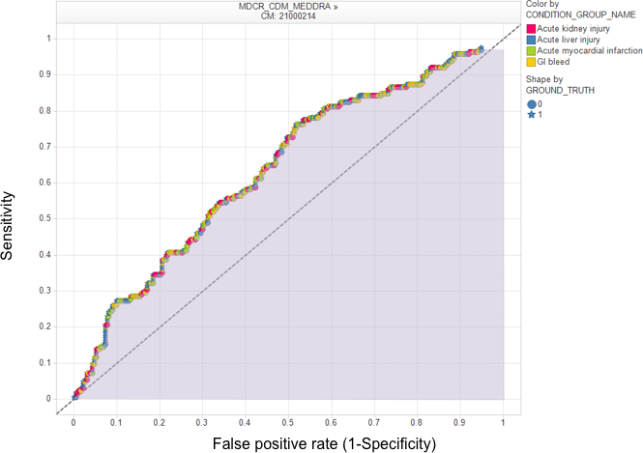

###### *Figure 13-2. The $25,000,000 ROC curve*

As you vary the threshold from very low to very high, you sweep out a curve in terms of sensitivity and false-positive rate, and that’s the curve we see in the figure. There is a threshold (say, 1.8) for which your false positive rate is 30% and your sensitivity is 50%.

###### NOTE

This graph is seriously problematic if you’re the FDA. A 30% false-positive rate is not within the parameters that the FDA considers acceptable.

The overall “goodness” of such a curve is usually measured as the area under the curve (AUC): you want it to be one, and if your curve lies on diagonal, the area is 0.5. This is tantamount to guessing randomly. So if your area under the curve is less than 0.5, it means your model is perverse.

The AUC in the preceding figure is 0.64. Moreover, of the 5,000 analyses run by the research team (which included David Madigan), this is the single best analysis.

But note: this is the best if you can only use the same method for everything. In that case this is as good as it gets, and it’s not that much better than guessing.

One the other hand, no epidemiologist would do that. So what they did next was to specialize the analysis to the database and the outcome. And they got better results: for the Medicare database, and for acute kidney injury, their optimal model gives them an AUC of 0.92 as shown in [Figure 13-3](https://learning.oreilly.com/library/view/doing-data-science/9781449363871/ch12.html#Figure12.3). They can achieve 80% sensitivity with a 10% false-positive rate.

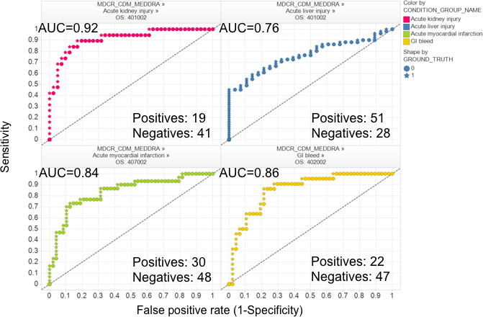

###### *Figure 13-3. Specializing the analysis to the database and the outcome with better results*

They did this using a cross-validation method. Different databases have different methods attached to them. One winning method is called “OS,” which compares within a given patient’s history (so compares times when the patient was on drugs versus when they weren’t). This is not widely used now.

The epidemiologists in general don’t believe the results of this study.

If you go to [http://elmo.omop.org](http://elmo.omop.org/), you can see the AUC for a given database and a given method. The data used in this study was current in mid-2010. To update this, you’d have to get the latest version of the database, and rerun the analysis. Things might have changed.

# Closing Thought Experiment

In the study, 5,000 different analyses were run. Is there a good way of combining them to do better? How about incorporating weighted averages or voting methods across different strategies? The code is publicly available and might make a great PhD thesis.

**Chapter 14. Lessons Learned from Data Competitions: Data Leakage and Model Evaluation**

The contributor for this chapter is [Claudia Perlich](http://people.stern.nyu.edu/cperlich/). Claudia has been the Chief Scientist at [Media 6 Degrees (M6D)](http://m6d.com/) for the past few years. Before that she was in the data analytics group at the IBM center that developed [Watson](http://en.wikipedia.org/wiki/Watson_(computer)), the computer that won [Jeopardy!](http://en.wikipedia.org/wiki/Jeopardy!) (although she didn’t work on that project). Claudia holds a master’s in computer science, and got her PhD in information systems at NYU. She now teaches a class to business students on data science, where she addresses how to assess data science work and how to manage data scientists.

Claudia is also a famously successful data mining competition winner. She won the [KDD Cup](http://www.sigkdd.org/kddcup/) in 2003, 2007, 2008, and 2009, the [ILP Challenge](http://ida.felk.cvut.cz/ilp2012/) in 2005, the [INFORMS Challenge](http://www.kdnuggets.com/news/2008/n07/8i.html) in 2008, and the [Kaggle](http://www.kaggle.com/) HIV competition in 2010.

More recently she’s turned toward being a data mining competition organizer, first for the INFORMS Challenge in 2009, and then for the Heritage Health Prize in 2011. Claudia claims to be retired from competition. Fortunately for the class, she provided some great insights into what can be learned from data competitions. From the many competitions she’s done, she’s learned quite a bit in particular about data leakage, and how to evaluate the models she comes up with for the competitions.

**Claudia’s Data Scientist Profile**

Claudia started by asking what people’s reference point might be to evaluate where they stand with their own data science profile (hers is shown in [Table 14-1](https://learning.oreilly.com/library/view/doing-data-science/9781449363871/ch13.html#claudia-profile). Referring to the data scientist profile from [Chapter 1](https://learning.oreilly.com/library/view/doing-data-science/9781449363871/ch01.html#chapter-what-is-data-science), she said, “There is one skill that you do not have here and that is the most important and the hardest to describe: Data.” She knows some of the world’s best mathematicians, machine language experts, statisticians, etc. Does she calibrate herself toward what is possible (the experts) or just relative to the average person in her field, or just an average person?

|  |  |  |  |  |
| --- | --- | --- | --- | --- |
|  | passable | strong | solid | comment |
| Visualization | x |  |  | I can do it but I do not believe in visualization |
| Computer Science | x |  |  | I have 2 Masters Degrees in CS. I can hack, not production code. |
| Math | x |  |  | That was a long time ago |
| Stats |  | x |  | Little formal training, a lot of stuff picked up on the way and good intuition |
| Machine Learning |  |  | x |  |
| Domain |  |  |  | You are asking the wrong question… |
| Presentation |  |  | x |  |
| Data |  |  | x |  |
| *Table 14-1. Claudia’s data science profile* | | | | |

**The Life of a Chief Data Scientist**

Historically, Claudia has spent her time on predictive modeling, including data mining competitions, writing papers for publications and conferences like KDD and journals, giving talks, writing patents, teaching, and digging around data (her favorite part). She likes to understand something about the world by looking directly at the data.

Claudia’s skill set includes 15 years working with data, where she’s developed data intuition by delving into the *data generating process*, a crucial piece of the puzzle. She’s given a lot of time and thought to the evaluation process and developing model intuition.

Claudia’s primary skills are data manipulation using tools like Unix, sed, awk, Perl, and SQL. She models using various methods, including logistic regression, k-nearest neighbors, and, importantly, she spends a bunch of time setting things up well. She spends about 40% of her time as “contributor,” which means doing stuff directly with data; 40% of her time as “ambassador,” which means writing stuff, and giving talks, mostly external communication to represent M6D; and 20% of her time in “leadership” of her data group.

**On Being a Female Data Scientist**

Being a woman works well in the field of data science, where intuition is useful and is regularly applied. One’s nose gets so well developed by now that one can *smell* it when something is wrong, although this is not the same thing as being able to prove something algorithmically. Also, people typically remember women, even when women don’t remember them. It has worked in her favor, Claudia says, which she’s happy to admit. But then again, she is where she is fundamentally because she’s good.

Being in academia, Claudia has quite a bit of experience with the process of publishing her work in journals and the like. She discussed whether papers submitted for journals and/or conferences are blind to gender. For some time, it was typically double-blind, but now it’s more likely to be one-sided. Moreover, there was [a 2003 paper written by Shawndra Hill and Foster Provost](http://dl.acm.org/citation.cfm?id=981001) that showed you can guess who wrote a paper with 40% accuracy just by knowing the citations, and even more if the author had more publications. Hopefully people don’t actually *use* such models when they referee, but in any case, that means making things “blind” doesn’t necessarily help. More recently the names are included, and hopefully this doesn’t make things too biased. Claudia admits to being slightly biased herself toward institutions—in her experience, certain institutions prepare better work.

**Data Mining Competitions**

Claudia drew a distinction between different types of data mining competitions. The first is the “sterile” kind, where you’re given a clean, prepared data matrix, a standard error measure, and features that are often anonymized. This is a pure machine learning problem.

Examples of this first kind are KDD Cup 2009 and the Netflix Prize, and many of the Kaggle competitions. In such competitions, your approach would emphasize algorithms and computation. The winner would probably have heavy machines and huge modeling ensembles.

**KDD CUPS**

All the KDD Cups, with their tasks and corresponding datasets, can be found at [*http://www.kdd.org/kddcup/index.php*](http://www.kdd.org/kddcup/index.php). Here’s a list:

* KDD Cup 2010: Student performance evaluation
* KDD Cup 2009: Customer relationship prediction
* KDD Cup 2008: Breast cancer
* KDD Cup 2007: Consumer recommendations
* KDD Cup 2006: Pulmonary embolisms detection from image data
* KDD Cup 2005: Internet user search query categorization
* KDD Cup 2004: Particle physics; plus protein homology prediction
* KDD Cup 2003: Network mining and usage log analysis
* KDD Cup 2002: BioMed document; plus gene role classification
* KDD Cup 2001: Molecular bioactivity; plus protein locale prediction
* KDD Cup 2000: Online retailer website clickstream analysis
* KDD Cup 1999: Computer network intrusion detection
* KDD Cup 1998: Direct marketing for profit optimization
* KDD Cup 1997: Direct marketing for lift curve optimization

On the other hand, you have the “real world” kind of data mining competition, where you’re handed raw data (which is often in lots of different tables and not easily joined), you set up the model yourself, and come up with task-specific evaluations. This kind of competition simulates real life more closely, which goes back to Rachel’s thought experiment earlier in this book about how to simulate the chaotic experience of being a data scientist in the classroom. You need practice dealing with messiness.

Examples of this second kind are KDD cup 2007, 2008, and 2010. If you’re in this kind of competition, your approach would involve understanding the domain, analyzing the data, and building the model. The winner might be the person who best understands how to tailor the model to the actual question.

Claudia prefers the second kind, because it’s closer to what you do in real life.

**How to Be a Good Modeler**

Claudia claims that data and domain understanding are the single most important skills you need as a data scientist. At the same time, this can’t really be taught—it can only be *cultivated*.

A few lessons learned about data mining competitions that Claudia thinks are overlooked in academics:

Leakage

The contestants’ best friend and the organizer and practitioners’ worst nightmare. There’s always something wrong with the data, and Claudia has made an artform of figuring out how the people preparing the competition got lazy or sloppy with the data.

Real-life performance measures

Adapting learning beyond standard modeling evaluation measures like mean squared error (MSE), misclassification rate, or area under the curve (AUC). For example, profit would be an example of a real-life performance measure.

Feature construction/transformation

Real data is rarely flat (i.e., given to you in a beautiful matrix) and good, practical solutions for this problem remain a challenge.

**Data Leakage**

In a KDD 2011 paper that Claudia coauthored called [“Leakage in Data Mining: Formulation, Detection, and Avoidance”](http://dl.acm.org/citation.cfm?id=2020496), she, Shachar Kaufman, and Saharon Rosset point to another author, Dorian Pyle, who has written numerous articles and papers on data preparation in data mining, where he refers to a phenomenon that he calls anachronisms (something that is out of place in time), and says that “too good to be true” performance is “a dead giveaway” of its existence. Claudia and her coauthors call this phenomenon “data leakage” in the context of predictive modeling. Pyle suggests turning to exploratory data analysis in order to find and eliminate leakage sources. Claudia and her coauthors sought a rigorous methodology to deal with leakage.

Leakage refers to information or data that helps you predict something, and the fact that you are using this information to predict isn’t fair. It’s a huge problem in modeling, and not just for competitions. Oftentimes it’s an artifact of reversing cause and effect. Let’s walk through a few examples to get a feel for how this might happen.

**Market Predictions**

There was a competition where you needed to predict S&P in terms of whether it would go up or go down. The winning entry had an AUC (area under the [ROC curve](http://en.wikipedia.org/wiki/Receiver_operating_characteristic)) of 0.999 out of 1. Because stock markets are pretty close to random, either someone’s very rich or there’s something wrong. (Hint: there’s something wrong.)

In the good old days you could win competitions this way, by finding the leakage. It’s not clear in this case what the leakage was, and you’d only know if you started digging into the data and finding some piece of information in the dataset that was highly predictive of S & P, but that would *not* be available to you in real time when predicting S & P. We bring this example up because the very fact that they had such a high AUC means that their model must have been relying on leakage, and it would not work if implemented.

**Amazon Case Study: Big Spenders**

The target of this competition was to predict customers who will be likely to spend a lot of money by using historical purchase data. The data consisted of transaction data in different categories. But a winning model identified that “Free Shipping = True” was an excellent predictor of spending a lot. Now notice, you only get offered free shipping *after* you’ve spent a certain amount of money, say above $50.

What happened here? The point is that free shipping is an *effect* of big spending. But it’s not a good way to model big spending, because in particular, it doesn’t work for new customers or for the future. Note: timestamps are weak here. The data that included “Free Shipping = True” was simultaneous with the sale, which is a no-no. You need to only use data from beforehand to predict the future. The difficulty is that this information about free shipping appeared in the collected data, and so it has to be manually removed, which requires consideration and *understanding* the data on the part of the model builder. If you weren’t thinking about leakage, you could just throw the free shipping variable into your model and see it predicted well. But, then when you actually went to implement the model in production, you wouldn’t know that the person was *about* to get free shipping.

**A Jewelry Sampling Problem**

Again for an online retailer, this time the target was predicting customers who buy jewelry. The data consisted of transactions for different categories. A very successful model simply noted that if sum(revenue) = 0, then it predicted jewelry customers very well.

What happened here? The people preparing the data for the competition removed jewelry purchases, but only included people who bought something in the first place. So people who had sum(revenue) = 0 were people who only bought jewelry. The fact that only people who bought something got into the dataset is weird: in particular, you wouldn’t be able to use this on customers before they finished their purchase. So the model wasn’t being trained on the right data to make the model useful. This is a sampling problem, and it’s common.

**WARNING: SAMPLING USERS**

As mentioned, in this case it’s weird to only condition the analysis on the set of people who have already bought something. Do you really want to condition your analysis on *only* people who bought something or *all*people who came to your site? More generally with user-level data, if you’re not careful, you can make fairly simple, but serious sampling mistakes if you don’t think it through. For example, say you’re planning to analyze a dataset from one day of user traffic on your site. If you do this, you are *oversampling* users who come frequently.

Think of it this way with a toy example: suppose you have 80 users. Say that 10 of them come every day, and the others only come once a week. Suppose they’re spread out evenly over 7 days of the week. So on any given day you see 20 users. So you pick a day. You look at those 20 users—10 of them are the ones who come every day, the other 10 come once a week. What’s happening is that you’re oversampling the users who come every day. Their behavior on your site might be totally different than other users, and they’re representing 50% of your dataset even though they only represent 12.5% of your user base.

**IBM Customer Targeting**

At IBM, the target was to predict companies that would be willing to buy “websphere” solutions. The data was transaction data and crawled potential company websites. The winning model showed that if the term “websphere” appeared on the company’s website, then it was a great candidate for the product. What happened? Remember, when considering a potential customer, by definition that company wouldn’t have bought websphere *yet* (otherwise IBM wouldn’t be trying to sell to it); therefore no *potential* customer would have websphere on its site, so it’s not a predictor at all. If IBM could go back in time to see a snapshot of the historical Web as a source of data before the “websphere” solution product existed, then that data would make sense as a predictor. But using today’s data unfortunately contains the leaked information that they ended up buying websphere. You can’t crawl the *historical* Web, just today’s Web.

Seem like a silly, obvious mistake not to make? Maybe. But it’s the sort of thing that happens, and you can’t anticipate this kind of thing until you start digging into the data and really understand what features and predictors *mean*. Just think, if this happened with something “obvious,” it means that more careful thought and digging needs to go on to figure out the less obvious cases. Also, it’s an example of something maybe we haven’t emphasized enough yet in the book. Doing simple sanity checking to make sure things are what you think they are can sometimes get you much further in the end than web scraping and a big fancy machine learning algorithm. It may not seem cool and sexy, but it’s smart and good practice. People might not invite you to a meet-up to talk about it. It may not be publishable research, but at least it’s legitimate and solid work. (Though then again, because of this stuff, Claudia won tons of contests and gets invited to meetups all the time. So we take that back. No, we don’t. The point is, do good work, the rest will follow. Meetups and fame aren’t goals unto themselves. The pursuit of the truth is.)

**Breast Cancer Detection**

You’re trying to study who has breast cancer. Take a look at [Figure 14-1](https://learning.oreilly.com/library/view/doing-data-science/9781449363871/ch13.html#patient-ID). The patient ID, which seems innocent, actually has predictive power. What happened?

In [Figure 14-1](https://learning.oreilly.com/library/view/doing-data-science/9781449363871/ch13.html#patient-ID), red means cancerous, green means not; it’s plotted by patient ID. We see three or four distinct buckets of patient identifiers. It’s very predictive depending on the bucket. This is probably a consequence of using multiple databases corresponding to different cancer centers, some of which take on sicker patients—by definition patients who get assigned to that center are more likely to be sick.

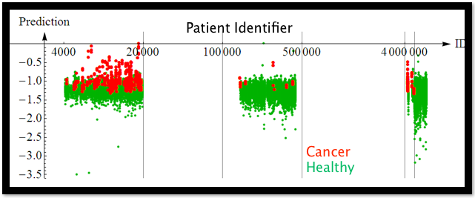

***Figure 14-1. Patients ordered by patient identifier; red means cancerous, green means not***

This situation led to an interesting discussion in the classroom:

*Student: For the purposes of the contest, they should have renumbered the patients and randomized.*

*Claudia: Would that solve the problem? There could be other things in common as well.*

*Another student: The important issue could be to see the extent to which we can figure out which dataset a given patient came from based on things besides their ID.*

*Claudia: Think about this: what do we want these models for in the first place? How well can you really predict cancer?*

Given a new patient, what would *you* do? If the new patient is in a fifth bin in terms of patient ID, then you wouldn’t want to use the identifier model. But if it’s still in this scheme, then maybe that really is the best approach.

This discussion brings us back to the fundamental problem: we need to know what the purpose of the model is and how it is going to be used in order to decide how to build it, and whether it’s working.

**Pneumonia Prediction**

During an INFORMS competition on pneumonia predictions in hospital records—where the goal was to predict whether a patient has pneumonia—a logistic regression that included the number of diagnosis codes as a numeric feature (AUC of 0.80) didn’t do as well as the one that included it as a [categorical feature](http://en.wikipedia.org/wiki/Categorical_variable) (0.90). What happened?

This had to do with how the person prepared the data for the competition, as depicted in [Figure 14-2](https://learning.oreilly.com/library/view/doing-data-science/9781449363871/ch13.html#informs-data-prep).

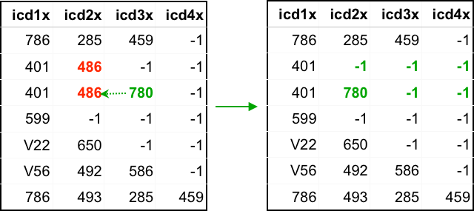

***Figure 14-2. How data preparation was done for the INFORMS competition***

The diagnosis code for pneumonia was 486. So the preparer removed that (and replaced it with a “–1”) if it showed up in the record (rows are different patients; columns are different diagnoses; there is a maximum of four diagnoses; “–1” means there’s nothing for that entry).

Moreover, to avoid telling holes in the data, the preparer moved the other diagnoses to the left if necessary, so that only “–1”s were on the right.

There are two problems with this:

* If the row has only “–1”s, then you know it started out with only pneumonia.
* If the row has no “–1”s, you know there’s no pneumonia (unless there are actually five diagnoses, but that’s less common).

This alone was enough information to win the competition.

**LEAKAGE HAPPENS**

Winning a competition on leakage is easier than building good models. But even if you don’t explicitly understand and game the leakage, your model will do it for you. Either way, leakage is a huge problem with data mining contests in general.

**How to Avoid Leakage**

The message here is not about how to win predictive modeling competitions. The reality is that as a data scientist, you’re at risk of producing a data leakage situation any time you prepare, clean your data, impute missing values, remove outliers, etc. You might be distorting the data in the process of preparing it to the point that you’ll build a model that works well on your “clean” dataset, but will totally suck when applied in the real-world situation where you actually want to apply it. Claudia gave us some very specific advice to avoid leakage. First, you need a strict temporal cutoff: remove all information just prior to the event of interest. For example, stuff you know *before a patient is admitted*. There has to be a timestamp on every entry that corresponds to the time you learned that information, not the time it occurred. Removing columns and rows from your data is asking for trouble, specifically in the form of inconsistencies that can be teased out. The best practice is to start from scratch with unfiltered, raw data after careful consideration. Finally, you need to know how the data was created!

Claudia and her coauthors describe in the paper referenced earlier a suggested methodology for avoiding leakage as a two-stage process of tagging every observation with legitimacy tags during collection and then observing what they call a learn-predict separation.

**Evaluating Models**

How do you know that your model is any good? We’ve gone through this already in some previous chapters, but it’s always good to hear this again from a master.

With powerful algorithms searching for patterns of models, there is a serious danger of overfitting. It’s a difficult concept, but the general idea is that “if you look hard enough, you’ll find something,” even if it does not generalize beyond the particular training data.

To avoid overfitting, we cross-validate and cut down on the complexity of the model to begin with. Here’s a standard picture in [Figure 14-3](https://learning.oreilly.com/library/view/doing-data-science/9781449363871/ch13.html#fitting-neighbors) (although keep in mind we generally work in high dimensional space and don’t have a pretty picture to look at).

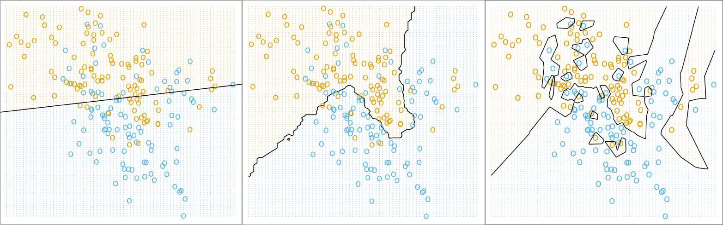

***Figure 14-3. This classic image from Hastie and Tibshirani’s***[***Elements of Statistical Learning***](http://stanford.io/17szrYz)***(Springer-Verlag) shows fitting linear regression to a binary response, fitting 15-nearest neighbors, and fitting 1-nearest neighbors all on the same dataset***

The picture on the left is underfit, in the middle it’s good, and on the right it’s overfit.

The model you use matters when it concerns overfitting, as shown in [Figure 14-4](https://learning.oreilly.com/library/view/doing-data-science/9781449363871/ch13.html#models-matter).

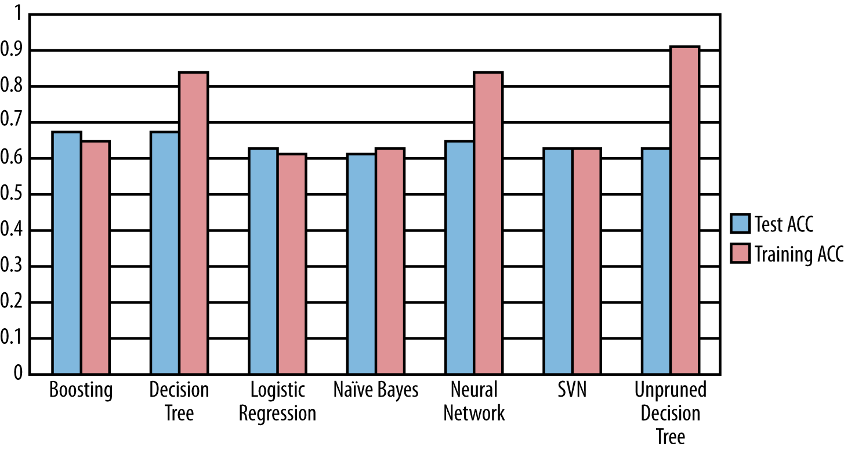

***Figure 14-4. The model you use matters!***

Looking at [Figure 14-4](https://learning.oreilly.com/library/view/doing-data-science/9781449363871/ch13.html#models-matter), unpruned decision trees are the overfitting-est (we just made that word up). This is a well-known problem with unpruned decision trees, which is why people use pruned decision trees.

**Accuracy: Meh**

One of the model evaluation metrics we’ve discussed in this book is accuracy as a means to evaluate classification problems, and in particular binary classification problems. Claudia dismisses accuracy as a bad evaluation method. What’s wrong with accuracy? It’s inappropriate for regression obviously, but even for classification, if the vast majority of binary outcomes are 1, then a stupid model can be accurate but not good (“guess it’s always 1”), and a better model might have lower accuracy.

**Probabilities Matter, Not 0s and 1s**

Nobody makes decisions on the binary outcomes *themselves*. You want to know the *probability* you’ll get breast cancer; you don’t want to be told yes or no. It’s much more information to know a probability. People *care* about probabilities.

So how does Claudia think evaluation should be handled? She’s a proponent of evaluating the ranking and the calibration separately. To evaluate the ranking, we use the ROC curve and calculate the area under it, which typically ranges from 0.5 to 1.0. This is independent of scaling and calibration. [Figure 14-5](https://learning.oreilly.com/library/view/doing-data-science/9781449363871/ch13.html#Figure13.5) shows an example of how to draw an ROC curve.

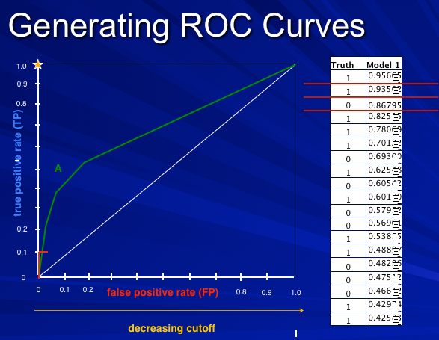

***Figure 14-5. An example of how to draw an ROC curve***

Sometimes to measure rankings, people draw the so-called lift curve shown in [Figure 14-6](https://learning.oreilly.com/library/view/doing-data-science/9781449363871/ch13.html#Figure13.6).

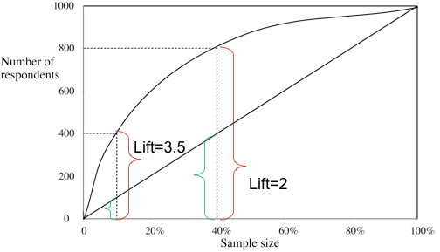

***Figure 14-6. The so-called lift curve***

The key here is that the lift is calculated *with respect to a baseline*. You draw it at a given point, say 10%, by imagining that 10% of people are shown ads, and seeing how many people click versus if you randomly showed 10% of people ads. A lift of 3 means it’s 3 times better.

How do you measure calibration? Are the probabilities accurate? If the model says probability of 0.57 that I have cancer, how do I know if it’s really 0.57? We can’t measure this directly. We can only bucket those predictions and then aggregately compare those in that prediction bucket (say 0.50–0.55) to the actual results for that bucket.

For example, take a look at [Figure 14-7](https://learning.oreilly.com/library/view/doing-data-science/9781449363871/ch13.html#unpruned-decision-tree), which shows what you get when your model is an unpruned decision tree, where the blue diamonds are buckets.

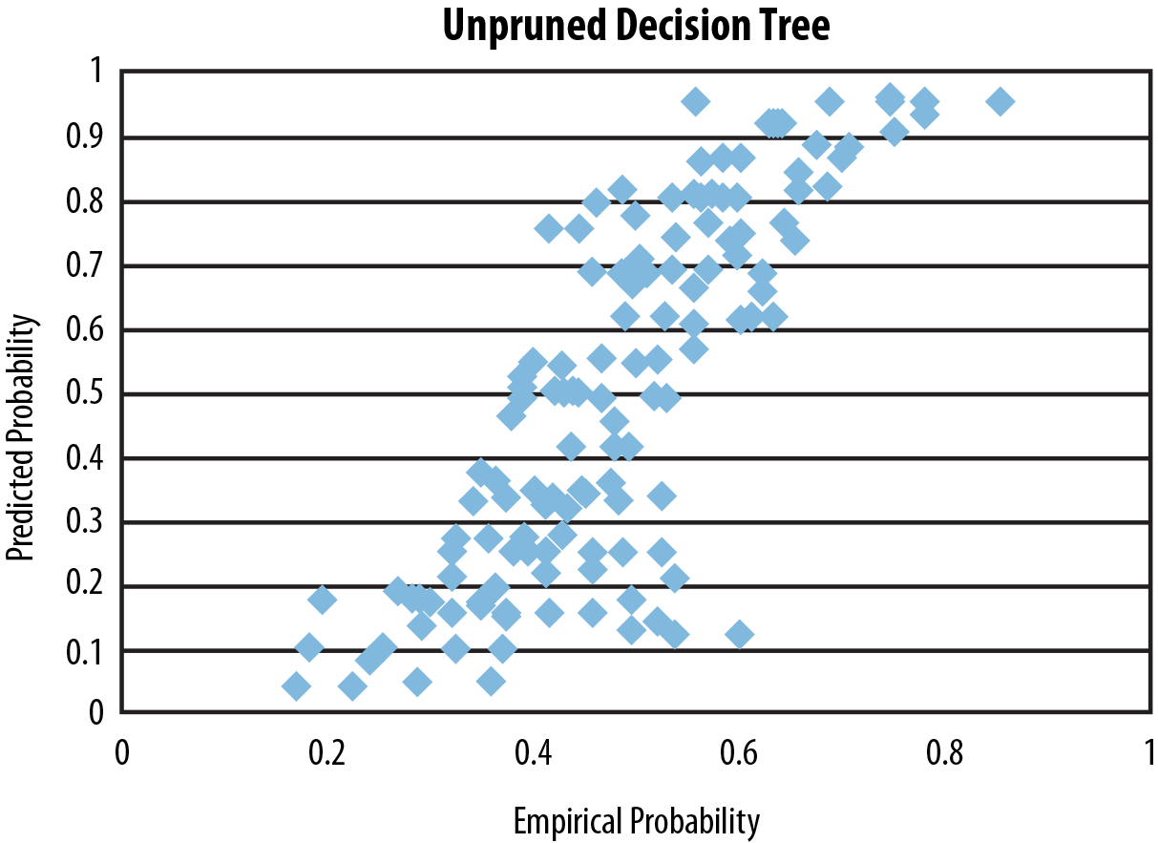

***Figure 14-7. A way to measure calibration is to bucket predictions and plot predicted probability versus empirical probability for each bucket—here, we do this for an unpruned decision tree***

Blue diamonds are buckets of people, say. The x-axis is the empirical, observed fraction of people in that bucket who have cancer, as an example, and the y-axis is the average predicted value for that set of people by the unpruned decision tree. This shows that decision trees don’t generally do well with calibration.

A good model would show buckets right along the x=yx=y curve, but here we’re seeing that the predictions were much more extreme than the actual probabilities. Why does this pattern happen for decision trees?

Claudia says that this is because *trees optimize purity*: it seeks out pockets that have only positives or negatives. Therefore its predictions are more extreme than reality. This is generally true about decision trees: they do not generally perform well with respect to calibration.

Logistic regression looks better when you test calibration, which is typical, as shown in [Figure 14-8](https://learning.oreilly.com/library/view/doing-data-science/9781449363871/ch13.html#logistic-regression-calibration).

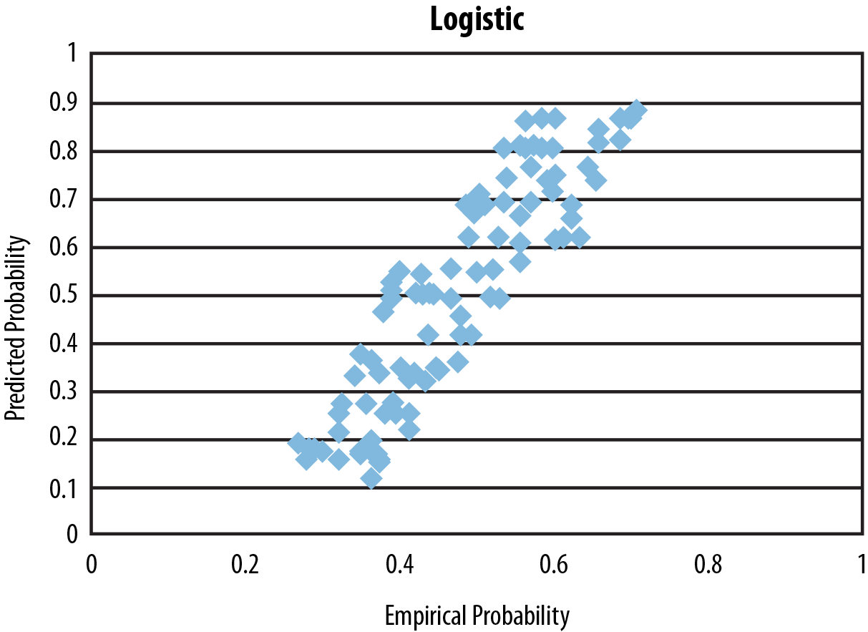

***Figure 14-8. Testing calibration for logistic regression***

Again, blue diamonds are buckets of people. This shows that logistic regression does better with respect to calibration.

**Choosing an Algorithm**

This is not a trivial question and, in particular, tests on smaller datasets may steer you wrong, because as you increase the sample size, the best algorithm might vary. Often decision trees perform very well, but only if there’s enough data.

In general, you need to choose your algorithm depending on the size and nature of your dataset, and you need to choose your evaluation method based partly on your data and partly on what you wish to be good at. Sum of squared error is the maximum likelihood loss function if your data can be assumed to be normal, but if you want to estimate the median, then use absolute errors. If you want to estimate a quantile, then minimize the weighted absolute error.

We worked on a competition about predicting the number of ratings a movie will get in the next year, and we assumed Poisson distributions. In this case, our evaluation method didn’t involve minimizing the sum of squared errors, but rather something else that we found in the literature specific to the Poisson distribution, which depends on the single parameter λλ. So sometimes you need to dig around in the literature to find an evaluation metric that makes sense for your situation.

**A Final Example**

Let’s put some of this together.

Say you want to raise money for a charity. If you send a letter to every person in the mailing list, you raise about $9,000. You’d like to save money and only send a letter to people who are likely to give—only about 5% of people generally give. How can you figure out who those people are?

If you use a (somewhat pruned, as is standard) decision tree, you get $0 profit: it never finds a leaf with majority positives.

If you use a neural network, you still make only $7,500, even if you only send a letter in the case where you expect the return to be higher than the cost.

Let’s break the problem down more. People getting the letter make two decisions: first, they decide whether or not to give, then they decide how much to give. You can model those two decisions separately, using:

E($|person)=P(response=`yes`|person)⋅E($|response=`yes`,person)E($|person)=P(response=`yes`|person)·E($|response=`yes`,person)

Note that you need the first model to be well-calibrated because you really care about the number, not just the ranking. So you can try logistic regression for the first half. For the second part, you train with special examples where there *are* donations.

Altogether, this decomposed model makes a profit of $15,000. The decomposition made it easier for the model to pick up the signals. Note that with infinite data, all would have been good, and you wouldn’t have needed to decompose. But you work with what you got.

Moreover, you are multiplying errors with this approach, which could be a problem if you have a reason to believe that those errors are correlated.

**Parting Thoughts**

According to Claudia, humans are not meant to understand data. Data is outside of our sensory systems, and there are very few people who have a near-sensory connection to numbers. We are instead designed to understand language.

We are also not meant to understand uncertainty: we have all kinds of biases that prevent this from happening that are well documented. Hence, modeling people in the future is intrinsically harder than figuring out how to label things that have already happened.

Even so, we do our best, and this is through careful data generation, meticulous consideration of what our problem is, making sure we model it with data close to how it will be used, making sure we are optimizing to what we actually desire, and doing our homework to learn which algorithms fit which tasks.

# Chapter 15. Data Engineering: MapReduce, Pregel, and Hadoop

# Thought Experiment

How do we think about access to medical records and privacy?

On the one hand, there are very serious privacy issues when it comes to health records—we don’t want just anyone to be able to access someone’s medical history. On the other hand, certain kinds of access can save lives.

By some estimates, one or two patients died per week in a certain smallish town because of the lack of information flow between the hospital’s emergency room and the nearby mental health clinic.[1](https://learning.oreilly.com/library/view/doing-data-science/9781449363871/ch14.html#idm46107852014984) In other words, if the records had been easier to match, they’d have been able to save more lives. On the other hand, if it had been easy to match records, other breaches of confidence might also have occurred. Of course it’s hard to know exactly how many lives are at stake, but it’s nontrivial.

This brings up some natural questions: What is the appropriate amount of privacy in health? Who should have access to your medical records and under what circumstances?

We can assume we think privacy is a generally good thing. For example, to be an atheist is punishable by death in some places, so it’s better to be private about stuff in those conditions. But privacy takes lives too, as we see from this story of emergency room deaths.

We can look to other examples, as well. There are many egregious violations happening in law enforcement, where you have large databases of license plates, say, and people who have access can abuse that information. Arguably, though, in this case it’s a human problem, not a technical problem.

It also can be posed as a philosophical problem: to what extent are we allowed to make decisions on behalf of other people?

There’s also a question of incentives. We might cure cancer faster with more medical data, but we can’t withhold the cure from people who didn’t share their data with us.

And finally, to a given person, it might be considered a security issue. People generally don’t mind if someone has their data; they mind if the data can be used against them and/or linked to them personally.

Going back full circle to the technical issue, it’s super hard to make data truly anonymous. For example, a recent Nature study, [“Unique in the Crowd: the privacy bounds of human mobility”](http://www.nature.com/srep/2013/130325/srep01376/full/srep01376.html) by Yves-Alexandre de Montjoye, et al., on a dataset of 1.5 million cell-phone users in Europe showed that just four points of reference were enough to individually identify 95 percent of the people.

Recently we’ve seen people up in arms about the way the NSA collects data about its citizens (not to mention non-US citizens). In fact, as this book was close to going to print, the Edward Snowden leak occurred. The response has been a very public and loud debate about the right to privacy with respect to our government. Considering how much information is bought and sold online about individuals through information warehousers and brokers like Acxiom—which leads not just to marketing but also insurance, job, and loan information—we might want to consider having that same conversation about our right to privacy with respect to private companies as well.

# MapReduce

Here we get insight into how David, as an engineer, thinks.

He revises the question we’ve asked before in this book: what is Big Data? It’s a buzzword mostly, but it can be useful. He tried this as a working definition:

You’re dealing with Big Data when you’re working with data that doesn’t fit into your computer unit. Note that makes it an evolving definition: Big Data has been around for a long time. The IRS had taxes before computers, so by our definition, the data they had didn’t fit on their (nonexistent) computer unit.

Today, Big Data means working with data that doesn’t fit in one computer. Even so, the size of Big Data changes rapidly. Computers have experienced exponential growth for the past 40 years. We have at least 10 years of exponential growth left (and people said the same thing 10 years ago).

Given this, is Big Data going to go away? Can we ignore it?

David claims we can’t, because although the capacity of a given computer is growing exponentially, those same computers also make the data. The rate of new data is also growing exponentially. So there are actually two exponential curves, and they won’t intersect any time soon.

Let’s work through an example to show how hard this gets.

# Word Frequency Problem

Say you’re told to find the most frequent words in the following list: red, green, bird, blue, green, red, red.

The easiest approach for this problem is inspection, of course. But now consider the problem for lists containing 10,000, or 100,000, or 109109 words.

The simplest approach is to list the words and then count their prevalence. [Figure 15-1](https://learning.oreilly.com/library/view/doing-data-science/9781449363871/ch14.html#Figure14.1) shows an example code snippet from the language [Go](http://golang.org/), which David loves and is helping to build (do you build a language?) and design at Google.

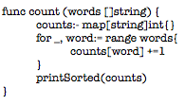

###### *Figure 15-1. Example code snippet from the language Go*

Because counting and sorting are fast, this scales to ~100 million words. The limit now is computer memory—if you think about it, you need to get all the words into memory twice: once when you load in the list of all words, and again when you build a way to associate a count for each word.

You can modify it slightly so it doesn’t have to have all words loaded in memory—keep them on the disk and stream them in by using a [channel](http://en.wikipedia.org/wiki/Channel_(programming)) instead of a list. A channel is something like a stream: you read in the first 100 items, then process them, then you read in the next 100 items.

But there’s still a potential problem, because if every word is unique, and the list is super long, your program will still crash; it will still be too big for memory. On the other hand, this will probably work nearly all the time, because nearly all the time there will be repetition. Real programming is a messy game.

Hold up, computers nowadays are many-core machines; let’s use them all! Then the bandwidth will be the problem, so let’s compress the inputs, too. That helps, and moreover there are better alternatives that get complex. A [heap](http://en.wikipedia.org/wiki/Heap_(data_structure)) of hashed values has a bounded size and can be well-behaved. A heap is something like a partially ordered set, and you can throw away super small elements to avoid holding everything in memory. This won’t always work, but it will in most cases.

# ARE YOU KEEPING UP?

You don’t need to understand all these details, but we want you to get a flavor for the motivation for why MapReduce is even necessary.

Now we can deal with on the order of 10 trillion words, using one computer.

Now say we have 10 computers. This will get us 100 trillion words. Each computer has 1/10th of the input. Let’s get each computer to count up its share of the words. Then have each send its counts to one “controller” machine. The controller adds them up and finds the highest to solve the problem.

We can do this with hashed heaps, too, if we first learn network programming.

Now take a hundred computers. We can process a thousand trillion words. But then the “fan-in,” where the results are sent to the controller, will break everything because of bandwidth problem. We need a tree, where every group of 10 machines sends data to one local controller, and then they all send back to super controller. This will probably work.

But… can we do this with 1,000 machines? No. It won’t work. Because at that scale, one or more computer will fail. If we denote by XX the variable that exhibits whether a given computer is working, so X=0X=0 means it works and X=1X=1 means it’s broken, then we can assume:

P(X=0)=1−ϵP(X=0)=1-ϵ

But this means, when we have 1,000 computers, the chance that no computer is broken is

(1−ϵ)1000(1-ϵ)1000

which is generally pretty small even if ϵϵ is small. So if ϵ=0.001ϵ=0.001 for each individual computer, then the probability that all 1,000 computers work is 0.37, less than even odds. This isn’t sufficiently robust.

What to do?

We address this problem by talking about [fault tolerance](http://en.wikipedia.org/wiki/Fault-tolerant_design) for distributed work. This usually involves replicating the input (the default is to have three copies of everything), and making the different copies available to different machines, so if one blows, another one will still have the good data. We might also embed [checksums](http://en.wikipedia.org/wiki/Checksum) in the data, so the data itself can be audited for errors, and we will automate monitoring by a controller machine (or maybe more than one?).

In general we need to develop a system that detects errors and restarts work automatically when it detects them. To add efficiency, when some machines finish, we should use the excess capacity to rerun work, again checking for errors.

###### NOTE

Q: Wait, I thought we were counting things?! This seems like some other awful rat’s nest we’ve gotten ourselves into.

A: It’s always like this. You cannot reason about the efficiency of fault tolerance easily; everything is complicated. And note, efficiency is just as important as correctness, because a thousand computers are worth more than your salary.

It’s like this:

* The first 10 computers are easy;
* The first 100 computers are hard; and
* The first 1,000 computers are impossible.

There’s really no hope.

Or at least there wasn’t until about eight years ago. At Google now, David uses 10,000 computers regularly.

## Enter MapReduce

In 2004 Jeff and Sanjay published their paper “MapReduce: Simplified Data Processing on Large Clusters” (and [here’s another one on the underlying filesystem](http://research.google.com/archive/gfs.html)).

MapReduce allows us to stop thinking about fault tolerance; it is a platform that does the fault tolerance work for us. Programming 1,000 computers is now easier than programming 100. It’s a library to do fancy things.

To use MapReduce, you write two functions: a mapper function, and then a reducer function. It takes these functions and runs them on many machines that are local to your stored data. All of the fault tolerance is automatically done for you once you’ve placed the algorithm into the map/reduce framework.

The mapper takes each data point and produces an ordered pair of the form (key, value). The framework then sorts the outputs via the “shuffle,” and in particular finds all the keys that match and puts them together in a pile. Then it sends these piles to machines that process them using the reducer function. The reducer function’s outputs are of the form (key, new value), where the new value is some aggregate function of the old values.

So how do we do it for our word counting algorithm? For each word, just send it to the ordered pair with the key as that word and the value being the integer 1. So:

red ---> ("red", 1)

blue ---> ("blue", 1)

red ---> ("red", 1)

Then they go into the “shuffle” (via the “fan-in”) and we get a pile of (“red”, 1)’s, which we can rewrite as (“red”, 1, 1). This gets sent to the reducer function, which just adds up all the 1’s. We end up with (“red”, 2), (“blue”, 1).

The key point is: one reducer handles all the values for a fixed key.

Got more data? Increase the number of map workers and reduce workers. In other words, do it on more computers. MapReduce flattens the complexity of working with many computers. It’s elegant, and people use it even when they shouldn’t (although, at Google it’s not so crazy to assume your data could grow by a factor of 100 overnight). Like all tools, it gets overused.

Counting was one easy function, but now it’s been split up into two functions. In general, converting an algorithm into a series of MapReduce steps is often unintuitive.

For the preceding word count, distribution needs to be uniform. If all your words are the same, they all go to one machine during the shuffle, which causes huge problems. Google has solved this using hash buckets heaps in the mappers in one MapReduce iteration. It’s called [CountSketch](http://stackoverflow.com/questions/6811351/explaining-the-count-sketch-algorithm), and it is built to handle odd datasets.

At Google there’s a real-time monitor for MapReduce jobs, a box with shards that correspond to pieces of work on a machine. It indicates through a bar chart how the various machines are doing. If all the mappers are running well, you’d see a straight line across. Usually, however, everything goes wrong in the reduce step due to nonuniformity of the data; e.g., lots of values on one key.

The data preparation and writing the output, which take place behind the scenes, take a long time, so it’s good to try to do everything in one iteration. Note we’re assuming a distributed filesystem is already there—indeed we have to use MapReduce to get data to the distributed filesystem—once we start using MapReduce, we can’t stop.

Once you get into the optimization process, you find yourself tuning MapReduce jobs to shave off nanoseconds from repetitive processes because you’re dealing with petabytes of data. These are order shifts worthy of physicists. This optimization is almost all done in C++. It’s highly optimized code, and we try to scrape out every ounce of power we can.

# Other Examples of MapReduce

Counting words is the most basic example of MapReduce. Let’s look at another to start getting more of a feel for it. The key attribute of a problem that can be solved with MapReduce is that the data can be distributed among many computers and the algorithm can treat each of those computers separately, i.e., one computer doesn’t need to know what’s going on with any other computer.

Here’s another example where you could use MapReduce. Let’s say you had tons of timestamped event data and logs of users’ actions on a website. For each user, you might have {user_id, IP_address, zipcode, ad_they_saw, did_they_click}. Suppose you wanted to count how many unique users saw ads from each zip code and how many clicked at least once.

How would you use MapReduce to handle this? You could run MapReduce keyed by zip code so that a record with a person living in zip code 90210 would get emitted to (90210,{1,1}) if that person saw an ad and clicked, or (90210,{0,1}) if they saw an ad and didn’t click

What would this give you? At the reducer stage, this would count the total number of clicks and impressions by zip code producing output of the form (90210,{700,15530}), for example. But that’s not what you asked. You wanted the number of unique users. This would actually require two MapReduces.

First use {zip_code,user} as the key and {clicks, impressions} as the value. Then, for example ({90210,user_5321},{0,1}) or ({90210,user_5321}, {1,1}). The reducer would emit a table that per user, per zip code, gave the counts of clicks and impressions. Your new records would now be {user, zipcode, number_clicks, number_impressions}.

Then to get the number of unique users from each zip code and how many clicked at least once, you’d need a second MapReduce job with zipcode as the key, and for each user emits {1, ifelse(clicks>0)} as the value.

So that was a second illustration of using MapReduce to count. But what about something more complicated like using MapReduce to implement a statistical model such as linear regression. Is that possible?

Turns out it is. Here’s a 2006 paper that goes through how the MapReduce framework could be used to implement a variety of [machine learning algorithms](http://goo.gl/dkuSMt). Algorithms that calculate sufﬁcient statistics or gradients that depend upon calculating expected values and summations can use the general approach described in this paper, because these calculations may be batched, and are expressible as a sum over data points.

## What Can’t MapReduce Do?

Sometimes to understand what something is, it can help to understand what it isn’t. So what can’t MapReduce do? Well, we can think of lots of things, like give us a massage. But you’d be forgiven for thinking MapReduce can solve any data problem that comes your way.

But MapReduce isn’t ideal for, say, iterative algorithms where you take a just-computed estimation and use it as input to the next stage in the computation—this is common in various machine learning algorithms that use steepest descent convergence methods. If you wanted to use MapReduce, it is of course possible, but it requires firing up many stages of the engine. Other newer approaches such as [Spark](http://static.usenix.org/event/hotcloud10/tech/full_papers/Zaharia.pdf) might be better suited, which in this context means more efficient.

# Pregel

Just as a point of contrast, another algorithm for processing large-scale data was developed at Google called Pregel. This is a graph-based computational algorithm, where you can imagine the data itself has a graph-based or network-based structure. The computational algorithm allows nodes to communicate with other nodes that they are connected to. There are also aggregators that are nodes that have access to the information that all the nodes have, and can, for example, sum together or average any information that all the nodes send to them.

The basis of the algorithm is a series of supersteps that alternate between nodes sending information to their neighbors and nodes sending information to the aggregators. The original paper is online if you want to [read more](http://dl.acm.org/citation.cfm?id=1807184). There’s also an open source version of Pregel called [Giraph](http://giraph.apache.org/).

# About Josh Wills

Josh Wills is Cloudera’s director of data science, working with customers and engineers to develop Hadoop-based solutions across a wide range of industries. More on Cloudera and Hadoop to come. Prior to joining Cloudera, Josh worked at Google, where he worked on the ad auction system and then led the development of the analytics infrastructure used in Google+. He earned his bachelor’s degree in mathematics from Duke University and his master’s in operations research from The University of Texas at Austin.

Josh is also known for pithy data science quotes, such as: “I turn data into awesome” and the one we saw way back in the start of the book: “data scientist (noun): Person who is better at statistics than any software engineer and better at software engineering than any statistician.” Also this gem: “I am Forrest Gump, I have a toothbrush, I have a lot of data and I scrub.”

Josh primed his topic with a thought experiment first.

# Thought Experiment

How would you build a human-powered airplane? What would you do? How would you form a team?

Maybe you’d run an [X prize](http://www.xprize.org/) competition. This is exactly what some people did, for $50,000, in 1950. It took 10 years for someone to win it. The story of the winner is useful because it illustrates that sometimes you are solving the wrong problem.

Namely, the first few teams spent years planning, and then their planes crashed within seconds. The winning team changed the question to: how do you build an airplane you can put back together in four hours after a crash? After quickly iterating through multiple prototypes, they solved this problem in six months.

# On Being a Data Scientist

Josh had some observations about the job of a data scientist. A data scientist spends all their time doing data cleaning and preparation—a full 90% of the work is this kind of data engineering. When deciding between solving problems and finding insights, a data scientist solves problems. A bit more on that: start with a problem, and make sure you have something to optimize against. Parallelize everything you do.

It’s good to be smart, but being able to learn fast is even better: run experiments quickly to learn quickly.

## Data Abundance Versus Data Scarcity

Most people think in terms of scarcity. They are trying to be conservative, so they throw stuff away. Josh keeps everything. He’s a fan of reproducible research, so he wants to be able to rerun any phase of his analysis. He keeps everything. This is great for two reasons. First, when he makes a mistake, he doesn’t have to restart everything. Second, when he gets new sources of data, it’s easy to integrate them in the point of the flow where it makes sense.

## Designing Models

Models always turn into crazy [Rube Goldberg machines](http://en.wikipedia.org/wiki/Rube_Goldberg_machine), a hodge-podge of different models. That’s not necessarily a bad thing, because if they work, they work. Even if you start with a simple model, you eventually add a hack to compensate for something. This happens over and over again; it’s the nature of designing the model.

### MIND THE GAP

The thing you’re optimizing with your model isn’t the same as the thing you’re optimizing for your business.

Example: friend recommendations on Facebook don’t optimize you accepting friends, but rather maximizing the time you spend on Facebook. Look closely: the suggestions are surprisingly highly populated by attractive people of the opposite sex.

How does this apply in other contexts? In medicine, they study the effectiveness of a drug instead of the health of the patients. They typically focus on success of surgery rather than well-being of the patient.

# Economic Interlude: Hadoop

Let’s go back to MapReduce and [Hadoop](http://en.wikipedia.org/wiki/Hadoop) for a minute. When Josh graduated in 2001, there were two options for file storage—databases and filers—which Josh compared on four dimensions: schema, processing, reliability, and cost (shown in [Table 15-1](https://learning.oreilly.com/library/view/doing-data-science/9781449363871/ch14.html#file-storage-2001)).

|  |  |  |
| --- | --- | --- |
|  | Databases | Filers |
| Schema | Structured | No schemas |
| Processing | Intensive processing done where data is stored | No data processing capability |
| Reliability | Somewhat reliable | Reliable |
| Cost | Expensive at scale | Expensive at scale |
| *Table 15-1. Options for file storage back in 2001* | | |

Since then we’ve started generating lots more data, mostly from the Web. It brings up the natural idea of a data economic indicator: return on byte. How much value can we extract from a byte of data? How much does it cost to store? If we take the ratio, we want it to be bigger than one, or else we discard the data.

Of course, this isn’t the whole story. There’s also a Big Data economic law, which states that no individual record is particularly valuable, but having every record is incredibly valuable. So, for example, for a web index, recommendation system, sensor data, or online advertising, one has an enormous advantage if one has all the existing data, even though each data point on its own isn’t worth much.

## A Brief Introduction to Hadoop

Back before Google had money, it had crappy hardware. So to handle all this data, it came up with idea of copying data to multiple servers. It did this physically at the time, but then automated it. The formal automation of this process was the genesis of [GFS](http://en.wikipedia.org/wiki/GFS2).

There are two core components to [Hadoop](http://en.wikipedia.org/wiki/Hadoop), which is the open source version of Google’s GFS and MapReduce. (You can read more about the origin stories of Hadoop elsewhere. We’ll give you a hint. A small open source project called Nutch and Yahoo! were involved.) The first component is the distributed filesystem ([HDFS](http://en.wikipedia.org/wiki/HDFS#Hadoop_Distributed_File_System)), which is based on the Google filesystem. The data is stored in large files, with block sizes of 64 MB to 256 MB. The blocks are replicated to multiple nodes in the cluster. The master node notices if a node dies. The second component is MapReduce, which David Crawshaw just told us all about.

Also, Hadoop is written in Java, whereas Google stuff is in C++. Writing MapReduce in the Java API is not pleasant. Sometimes you have to write lots and lots of MapReduces. However, if you use [Hadoop streaming](http://hadoop.apache.org/docs/), you can write in Python, R, or other high-level languages. It’s easy and convenient for parallelized jobs.

## Cloudera

Cloudera was cofounded by Doug Cutting, one of the creators of Hadoop, and Jeff Hammerbacher, who we mentioned back in [Chapter 1](https://learning.oreilly.com/library/view/doing-data-science/9781449363871/ch01.html#chapter-what-is-data-science) because he co-coined the job title “data scientist” when he worked at Facebook and built the data science team there.

Cloudera is like [Red Hat](http://www.redhat.com/) for Hadoop, by which we mean they took an open source project and built a company around it. It’s done under the aegis of the [Apache Software Foundation](http://www.apache.org/). The code is available for free, but Cloudera packages it together, gives away various distributions for free, and waits for people to pay for support and to keep it up and running.

[Apache Hive](http://hive.apache.org/) is a data warehousing system on top of Hadoop. It uses a SQL-based query language (includes some MapReduce-specific extensions), and it implements common join and aggregation patterns. This is nice for people who know databases well and are familiar with stuff like this.

# Back to Josh: Workflow

With respect to how Josh would approach building a pipeline using MapReduce, he thinks of his basic unit of analysis as a record. We’ve repeatedly mentioned “timestamped event data,” so you could think of a single one of those as a record, or you could think of transaction records that we discussed in fraud detection or credit card transactions. A typical workflow would then be something like:

1. Use Hive (a SQL-like language that runs on Hadoop) to build records that contain everything you know about an entity (say a person) (intensive MapReduce stuff).
2. Write Python scripts to process the records over and over again (faster and iterative, also MapReduce).
3. Update the records when new data arrives.

Note the scripts in phase 2 are typically map-only jobs, which makes parallelization easy.

Josh prefers standard data formats: text is big and takes up space. [Thrift](http://en.wikipedia.org/wiki/Apache_Thrift), [Avro](http://en.wikipedia.org/wiki/Apache_Avro), and [protocol buffers](http://en.wikipedia.org/wiki/Protobuf) are more compact, binary formats. He also encourages you to use the code and metadata repository [GitHub](https://github.com/). He doesn’t keep large data files in Git.

# So How to Get Started with Hadoop?

If you are working at a company that has a Hadoop cluster, it’s likely that your first experience will be with Apache Hive, which provides a SQL-style abstraction on top of HDFS and MapReduce. Your first MapReduce job will probably involve analyzing logs of user behavior in order to get a better understanding of how customers are using your company’s products.

If you are exploring Hadoop and MapReduce on your own for building analytical applications, there are a couple of good places to start. One option is to build a recommendation engine using Apache Mahout, a collection of machine learning libraries and command-line tools that works with Hadoop. Mahout has a collaborative filtering engine called Taste that can be used to create recommendations given a CSV file of user IDs, item IDs, and an optional weight that indicates the strength of the relationship between the user and the item. Taste uses the same recommendation algorithms that Netflix and Amazon use for building recommendations for their users.

# Chapter 16. Motivating Hypothetical: DataSciencester

Congratulations! You’ve just been hired to lead the data science efforts at DataSciencester, *the* social network for data scientists.

**NOTE**

When I wrote the first edition of this book, I thought that “a social network for data scientists” was a fun, silly hypothetical. Since then people have actually created social networks for data scientists, and have raised much more money from venture capitalists than I made from my book. Most likely there is a valuable lesson here about silly data science hypotheticals and/or book publishing.

Despite being *for* data scientists, DataSciencester has never actually invested in building its own data science practice. (In fairness, DataSciencester has never really invested in building its product either.) That will be your job! Throughout the book, we’ll be learning about data science concepts by solving problems that you encounter at work. Sometimes we’ll look at data explicitly supplied by users, sometimes we’ll look at data generated through their interactions with the site, and sometimes we’ll even look at data from experiments that we’ll design.

And because DataSciencester has a strong “not-invented-here” mentality, we’ll be building our own tools from scratch. At the end, you’ll have a pretty solid understanding of the fundamentals of data science. And you’ll be ready to apply your skills at a company with a less shaky premise, or to any other problems that happen to interest you.

Welcome aboard, and good luck! (You’re allowed to wear jeans on Fridays, and the bathroom is down the hall on the right.)

**Finding Key Connectors**

It’s your first day on the job at DataSciencester, and the VP of Networking is full of questions about your users. Until now he’s had no one to ask, so he’s very excited to have you aboard.

In particular, he wants you to identify who the “key connectors” are among data scientists. To this end, he gives you a dump of the entire DataSciencester network. (In real life, people don’t typically hand you the data you need. [Chapter 9](https://learning.oreilly.com/library/view/data-science-from/9781492041122/ch09.html#getting_data) is devoted to getting data.)

What does this data dump look like? It consists of a list of users, each represented by a dict that contains that user’s id (which is a number) and name (which, in one of the great cosmic coincidences, rhymes with the user’s id):

users = [

{ "id": 0, "name": "Hero" },

{ "id": 1, "name": "Dunn" },

{ "id": 2, "name": "Sue" },

{ "id": 3, "name": "Chi" },

{ "id": 4, "name": "Thor" },

{ "id": 5, "name": "Clive" },

{ "id": 6, "name": "Hicks" },

{ "id": 7, "name": "Devin" },

{ "id": 8, "name": "Kate" },

{ "id": 9, "name": "Klein" }

]

He also gives you the “friendship” data, represented as a list of pairs of IDs:

friendship_pairs = [(0, 1), (0, 2), (1, 2), (1, 3), (2, 3), (3, 4),

(4, 5), (5, 6), (5, 7), (6, 8), (7, 8), (8, 9)]

For example, the tuple (0, 1) indicates that the data scientist with id 0 (Hero) and the data scientist with id 1 (Dunn) are friends. The network is illustrated in [Figure 16-1](https://learning.oreilly.com/library/view/data-science-from/9781492041122/ch01.html#datasciencester_network_ch01).

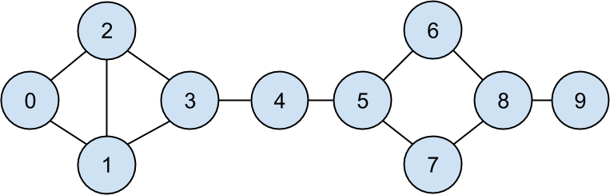

***Figure 16-1. The DataSciencester network***

Having friendships represented as a list of pairs is not the easiest way to work with them. To find all the friendships for user 1, you have to iterate over every pair looking for pairs containing 1. If you had a lot of pairs, this would take a long time.

Instead, let’s create a dict where the keys are user ids and the values are lists of friend ids. (Looking things up in a dict is very fast.)

**NOTE**

Don’t get too hung up on the details of the code right now. In [Chapter 2](https://learning.oreilly.com/library/view/data-science-from/9781492041122/ch02.html#python), I’ll take you through a crash course in Python. For now just try to get the general flavor of what we’re doing.

We’ll still have to look at every pair to create the dict, but we only have to do that once, and we’ll get cheap lookups after that:

*# Initialize the dict with an empty list for each user id:*

friendships = {user["id"]: [] **for** user **in** users}

*# And loop over the friendship pairs to populate it:*

**for** i, j **in** friendship_pairs:

friendships[i].append(j) *# Add j as a friend of user i*

friendships[j].append(i) *# Add i as a friend of user j*

Now that we have the friendships in a dict, we can easily ask questions of our graph, like “What’s the average number of connections?”

First we find the *total* number of connections, by summing up the lengths of all the friends lists:

**def** number_of_friends(user):

*"""How many friends does _user_ have?"""*

user_id = user["id"]

friend_ids = friendships[user_id]

**return** len(friend_ids)

total_connections = sum(number_of_friends(user)

**for** user **in** users) *# 24*

And then we just divide by the number of users:

num_users = len(users) *# length of the users list*

avg_connections = total_connections / num_users *# 24 / 10 == 2.4*

It’s also easy to find the most connected people—they’re the people who have the largest numbers of friends.

Since there aren’t very many users, we can simply sort them from “most friends” to “least friends”:

*# Create a list (user_id, number_of_friends).*

num_friends_by_id = [(user["id"], number_of_friends(user))

**for** user **in** users]

num_friends_by_id.sort( *# Sort the list*

key=**lambda** id_and_friends: id_and_friends[1], *# by num_friends*

reverse=True) *# largest to smallest*

*# Each pair is (user_id, num_friends):*

*# [(1, 3), (2, 3), (3, 3), (5, 3), (8, 3),*

*# (0, 2), (4, 2), (6, 2), (7, 2), (9, 1)]*

One way to think of what we’ve done is as a way of identifying people who are somehow central to the network. In fact, what we’ve just computed is the network metric *degree centrality* ([Figure 16-2](https://learning.oreilly.com/library/view/data-science-from/9781492041122/ch01.html#network_sized_by_degree)).

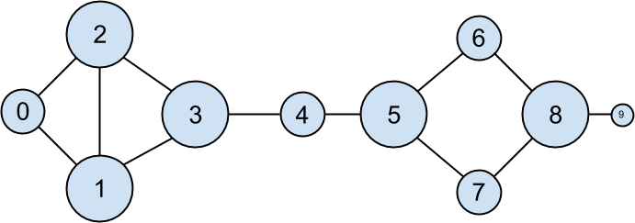

***Figure 16-2. The DataSciencester network sized by degree***

This has the virtue of being pretty easy to calculate, but it doesn’t always give the results you’d want or expect. For example, in the DataSciencester network Thor (id 4) only has two connections, while Dunn (id 1) has three. Yet when we look at the network, it intuitively seems like Thor should be more central. In [Chapter 22](https://learning.oreilly.com/library/view/data-science-from/9781492041122/ch22.html#network_analysis), we’ll investigate networks in more detail, and we’ll look at more complex notions of centrality that may or may not accord better with our intuition.

**Data Scientists You May Know**

While you’re still filling out new-hire paperwork, the VP of Fraternization comes by your desk. She wants to encourage more connections among your members, and she asks you to design a “Data Scientists You May Know” suggester.

Your first instinct is to suggest that users might know the friends of their friends. So you write some code to iterate over their friends and collect the friends’ friends:

**def** foaf_ids_bad(user):

*"""foaf is short for "friend of a friend" """*

**return** [foaf_id

**for** friend_id **in** friendships[user["id"]]

**for** foaf_id **in** friendships[friend_id]]

When we call this on users[0] (Hero), it produces:

[0, 2, 3, 0, 1, 3]

It includes user 0 twice, since Hero is indeed friends with both of his friends. It includes users 1 and 2, although they are both friends with Hero already. And it includes user 3 twice, as Chi is reachable through two different friends:

**print**(friendships[0]) *# [1, 2]*

**print**(friendships[1]) *# [0, 2, 3]*

**print**(friendships[2]) *# [0, 1, 3]*

Knowing that people are friends of friends in multiple ways seems like interesting information, so maybe instead we should produce a *count* of mutual friends. And we should probably exclude people already known to the user:

**from** **collections** **import** Counter *# not loaded by default*

**def** friends_of_friends(user):

user_id = user["id"]

**return** Counter(

foaf_id

**for** friend_id **in** friendships[user_id] *# For each of my friends,*

**for** foaf_id **in** friendships[friend_id] *# find their friends*

**if** foaf_id != user_id *# who aren't me*

**and** foaf_id **not** **in** friendships[user_id] *# and aren't my friends.*

)

**print**(friends_of_friends(users[3])) *# Counter({0: 2, 5: 1})*

This correctly tells Chi (id 3) that she has two mutual friends with Hero (id 0) but only one mutual friend with Clive (id 5).

As a data scientist, you know that you also might enjoy meeting users with similar interests. (This is a good example of the “substantive expertise” aspect of data science.) After asking around, you manage to get your hands on this data, as a list of pairs (user_id, interest):

interests = [

(0, "Hadoop"), (0, "Big Data"), (0, "HBase"), (0, "Java"),

(0, "Spark"), (0, "Storm"), (0, "Cassandra"),

(1, "NoSQL"), (1, "MongoDB"), (1, "Cassandra"), (1, "HBase"),

(1, "Postgres"), (2, "Python"), (2, "scikit-learn"), (2, "scipy"),

(2, "numpy"), (2, "statsmodels"), (2, "pandas"), (3, "R"), (3, "Python"),

(3, "statistics"), (3, "regression"), (3, "probability"),

(4, "machine learning"), (4, "regression"), (4, "decision trees"),

(4, "libsvm"), (5, "Python"), (5, "R"), (5, "Java"), (5, "C++"),

(5, "Haskell"), (5, "programming languages"), (6, "statistics"),

(6, "probability"), (6, "mathematics"), (6, "theory"),

(7, "machine learning"), (7, "scikit-learn"), (7, "Mahout"),

(7, "neural networks"), (8, "neural networks"), (8, "deep learning"),

(8, "Big Data"), (8, "artificial intelligence"), (9, "Hadoop"),

(9, "Java"), (9, "MapReduce"), (9, "Big Data")

]

For example, Hero (id 0) has no friends in common with Klein (id 9), but they share interests in Java and big data.

It’s easy to build a function that finds users with a certain interest:

**def** data_scientists_who_like(target_interest):

*"""Find the ids of all users who like the target interest."""*

**return** [user_id

**for** user_id, user_interest **in** interests

**if** user_interest == target_interest]

This works, but it has to examine the whole list of interests for every search. If we have a lot of users and interests (or if we just want to do a lot of searches), we’re probably better off building an index from interests to users:

**from** **collections** **import** defaultdict

*# Keys are interests, values are lists of user_ids with that interest*

user_ids_by_interest = defaultdict(list)

**for** user_id, interest **in** interests:

user_ids_by_interest[interest].append(user_id)

And another from users to interests:

*# Keys are user_ids, values are lists of interests for that user_id.*

interests_by_user_id = defaultdict(list)

**for** user_id, interest **in** interests:

interests_by_user_id[user_id].append(interest)

Now it’s easy to find who has the most interests in common with a given user:

* Iterate over the user’s interests.
* For each interest, iterate over the other users with that interest.
* Keep count of how many times we see each other user.

In code:

**def** most_common_interests_with(user):

**return** Counter(

interested_user_id

**for** interest **in** interests_by_user_id[user["id"]]

**for** interested_user_id **in** user_ids_by_interest[interest]

**if** interested_user_id != user["id"]

)

We could then use this to build a richer “Data Scientists You May Know” feature based on a combination of mutual friends and mutual interests. We’ll explore these kinds of applications in [Chapter 23](https://learning.oreilly.com/library/view/data-science-from/9781492041122/ch23.html#recommender_systems).

**Salaries and Experience**

Right as you’re about to head to lunch, the VP of Public Relations asks if you can provide some fun facts about how much data scientists earn. Salary data is of course sensitive, but he manages to provide you an anonymous dataset containing each user’s salary (in dollars) and tenure as a data scientist (in years):

salaries_and_tenures = [(83000, 8.7), (88000, 8.1),

(48000, 0.7), (76000, 6),

(69000, 6.5), (76000, 7.5),

(60000, 2.5), (83000, 10),

(48000, 1.9), (63000, 4.2)]

The natural first step is to plot the data (which we’ll see how to do in [Chapter 3](https://learning.oreilly.com/library/view/data-science-from/9781492041122/ch03.html#visualizing_data)). You can see the results in [Figure 16-3](https://learning.oreilly.com/library/view/data-science-from/9781492041122/ch01.html#salaries).

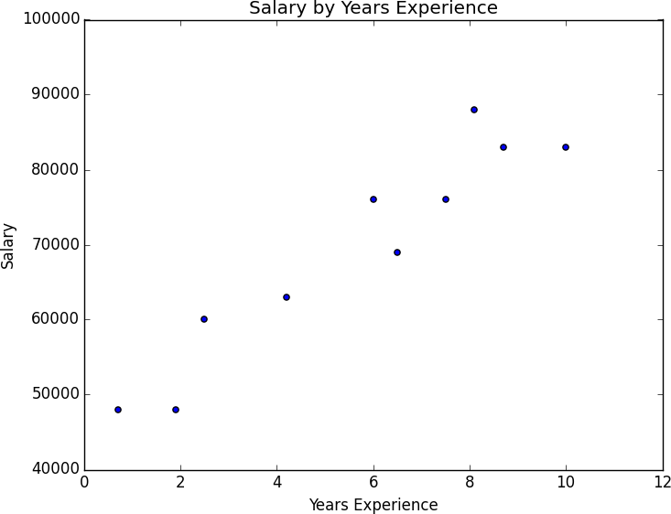

***Figure 16-3. Salary by years of experience***

It seems clear that people with more experience tend to earn more. How can you turn this into a fun fact? Your first idea is to look at the average salary for each tenure:

*# Keys are years, values are lists of the salaries for each tenure.*

salary_by_tenure = defaultdict(list)

**for** salary, tenure **in** salaries_and_tenures:

salary_by_tenure[tenure].append(salary)

*# Keys are years, each value is average salary for that tenure.*

average_salary_by_tenure = {

tenure: sum(salaries) / len(salaries)

**for** tenure, salaries **in** salary_by_tenure.items()

}

This turns out to be not particularly useful, as none of the users have the same tenure, which means we’re just reporting the individual users’ salaries:

{0.7: 48000.0,

1.9: 48000.0,

2.5: 60000.0,

4.2: 63000.0,

6: 76000.0,

6.5: 69000.0,

7.5: 76000.0,

8.1: 88000.0,

8.7: 83000.0,

10: 83000.0}

It might be more helpful to bucket the tenures:

**def** tenure_bucket(tenure):

**if** tenure < 2:

**return** "less than two"

**elif** tenure < 5:

**return** "between two and five"

**else**:

**return** "more than five"

Then we can group together the salaries corresponding to each bucket:

*# Keys are tenure buckets, values are lists of salaries for that bucket.*

salary_by_tenure_bucket = defaultdict(list)

**for** salary, tenure **in** salaries_and_tenures:

bucket = tenure_bucket(tenure)

salary_by_tenure_bucket[bucket].append(salary)

And finally compute the average salary for each group:

*# Keys are tenure buckets, values are average salary for that bucket.*

average_salary_by_bucket = {

tenure_bucket: sum(salaries) / len(salaries)

**for** tenure_bucket, salaries **in** salary_by_tenure_bucket.items()

}

Which is more interesting:

{'between two and five': 61500.0,

'less than two': 48000.0,

'more than five': 79166.66666666667}

And you have your soundbite: “Data scientists with more than five years’ experience earn 65% more than data scientists with little or no experience!”

But we chose the buckets in a pretty arbitrary way. What we’d really like is to make some statement about the salary effect—on average—of having an additional year of experience. In addition to making for a snappier fun fact, this allows us to *make predictions* about salaries that we don’t know. We’ll explore this idea in [Chapter 14](https://learning.oreilly.com/library/view/data-science-from/9781492041122/ch14.html#simple_linear_regression).

**Paid Accounts**

When you get back to your desk, the VP of Revenue is waiting for you. She wants to better understand which users pay for accounts and which don’t. (She knows their names, but that’s not particularly actionable information.)

You notice that there seems to be a correspondence between years of experience and paid accounts:

0.7 paid

1.9 unpaid

2.5 paid

4.2 unpaid

6.0 unpaid

6.5 unpaid

7.5 unpaid

8.1 unpaid

8.7 paid

10.0 paid

Users with very few and very many years of experience tend to pay; users with average amounts of experience don’t. Accordingly, if you wanted to create a model—though this is definitely not enough data to base a model on—you might try to predict “paid” for users with very few and very many years of experience, and “unpaid” for users with middling amounts of experience:

**def** predict_paid_or_unpaid(years_experience):

**if** years_experience < 3.0:

**return** "paid"

**elif** years_experience < 8.5:

**return** "unpaid"

**else**:

**return** "paid"

Of course, we totally eyeballed the cutoffs.

With more data (and more mathematics), we could build a model predicting the likelihood that a user would pay based on his years of experience. We’ll investigate this sort of problem in [Chapter 16](https://learning.oreilly.com/library/view/data-science-from/9781492041122/ch16.html#logistic_regression).

**Topics of Interest**

As you’re wrapping up your first day, the VP of Content Strategy asks you for data about what topics users are most interested in, so that she can plan out her blog calendar accordingly. You already have the raw data from the friend-suggester project:

interests = [

(0, "Hadoop"), (0, "Big Data"), (0, "HBase"), (0, "Java"),

(0, "Spark"), (0, "Storm"), (0, "Cassandra"),

(1, "NoSQL"), (1, "MongoDB"), (1, "Cassandra"), (1, "HBase"),

(1, "Postgres"), (2, "Python"), (2, "scikit-learn"), (2, "scipy"),

(2, "numpy"), (2, "statsmodels"), (2, "pandas"), (3, "R"), (3, "Python"),

(3, "statistics"), (3, "regression"), (3, "probability"),

(4, "machine learning"), (4, "regression"), (4, "decision trees"),

(4, "libsvm"), (5, "Python"), (5, "R"), (5, "Java"), (5, "C++"),

(5, "Haskell"), (5, "programming languages"), (6, "statistics"),

(6, "probability"), (6, "mathematics"), (6, "theory"),

(7, "machine learning"), (7, "scikit-learn"), (7, "Mahout"),

(7, "neural networks"), (8, "neural networks"), (8, "deep learning"),

(8, "Big Data"), (8, "artificial intelligence"), (9, "Hadoop"),

(9, "Java"), (9, "MapReduce"), (9, "Big Data")

]

One simple (if not particularly exciting) way to find the most popular interests is to count the words:

1. Lowercase each interest (since different users may or may not capitalize their interests).
2. Split it into words.
3. Count the results.

In code:

words_and_counts = Counter(word

**for** user, interest **in** interests

**for** word **in** interest.lower().split())

This makes it easy to list out the words that occur more than once:

**for** word, count **in** words_and_counts.most_common():

**if** count > 1:

**print**(word, count)

which gives the results you’d expect (unless you expect “scikit-learn” to get split into two words, in which case it doesn’t give the results you expect):

learning 3

java 3

python 3

big 3

data 3

hbase 2

regression 2

cassandra 2

statistics 2

probability 2

hadoop 2

networks 2

machine 2

neural 2

scikit-learn 2

r 2

**Unit – III**

**Chapter 17. Linear Algebra**

*Is there anything more useless or less useful than algebra?*

Billy Connolly

Linear algebra is the branch of mathematics that deals with *vector spaces*. Although I can’t hope to teach you linear algebra in a brief chapter, it underpins a large number of data science concepts and techniques, which means I owe it to you to at least try. What we learn in this chapter we’ll use heavily throughout the rest of the book.

**Vectors**

Abstractly, *vectors* are objects that can be added together to form new vectors and that can be multiplied by *scalars* (i.e., numbers), also to form new vectors.

Concretely (for us), vectors are points in some finite-dimensional space. Although you might not think of your data as vectors, they are often a useful way to represent numeric data.

For example, if you have the heights, weights, and ages of a large number of people, you can treat your data as three-dimensional vectors [height, weight, age]. If you’re teaching a class with four exams, you can treat student grades as four-dimensional vectors [exam1, exam2, exam3, exam4].

The simplest from-scratch approach is to represent vectors as lists of numbers. A list of three numbers corresponds to a vector in three-dimensional space, and vice versa.

We’ll accomplish this with a type alias that says a Vector is just a list of floats:

**from** **typing** **import** List

Vector = List[float]

height_weight_age = [70, *# inches,*

170, *# pounds,*

40 ] *# years*

grades = [95, *# exam1*

80, *# exam2*

75, *# exam3*

62 ] *# exam4*

We’ll also want to perform *arithmetic* on vectors. Because Python lists aren’t vectors (and hence provide no facilities for vector arithmetic), we’ll need to build these arithmetic tools ourselves. So let’s start with that.

To begin with, we’ll frequently need to add two vectors. Vectors add *componentwise*. This means that if two vectors v and w are the same length, their sum is just the vector whose first element is v[0] + w[0], whose second element is v[1] + w[1], and so on. (If they’re not the same length, then we’re not allowed to add them.)

For example, adding the vectors [1, 2] and [2, 1] results in [1 + 2, 2 + 1] or [3, 3], as shown in [Figure 17-1](https://learning.oreilly.com/library/view/data-science-from/9781492041122/ch04.html#adding_two_vectors).

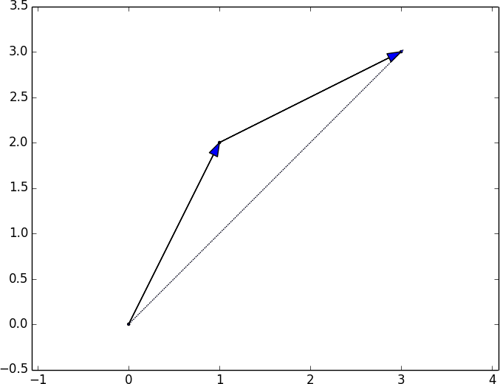

***Figure 17-1. Adding two vectors***

We can easily implement this by zip-ing the vectors together and using a list comprehension to add the corresponding elements:

**def** add(v: Vector, w: Vector) -> Vector:

*"""Adds corresponding elements"""*

**assert** len(v) == len(w), "vectors must be the same length"

**return** [v_i + w_i **for** v_i, w_i **in** zip(v, w)]

**assert** add([1, 2, 3], [4, 5, 6]) == [5, 7, 9]

Similarly, to subtract two vectors we just subtract the corresponding elements:

**def** subtract(v: Vector, w: Vector) -> Vector:

*"""Subtracts corresponding elements"""*

**assert** len(v) == len(w), "vectors must be the same length"

**return** [v_i - w_i **for** v_i, w_i **in** zip(v, w)]

**assert** subtract([5, 7, 9], [4, 5, 6]) == [1, 2, 3]

We’ll also sometimes want to componentwise sum a list of vectors—that is, create a new vector whose first element is the sum of all the first elements, whose second element is the sum of all the second elements, and so on:

**def** vector_sum(vectors: List[Vector]) -> Vector:

*"""Sums all corresponding elements"""*

*# Check that vectors is not empty*

**assert** vectors, "no vectors provided!"

*# Check the vectors are all the same size*

num_elements = len(vectors[0])

**assert** all(len(v) == num_elements **for** v **in** vectors), "different sizes!"

*# the i-th element of the result is the sum of every vector[i]*

**return** [sum(vector[i] **for** vector **in** vectors)

**for** i **in** range(num_elements)]

**assert** vector_sum([[1, 2], [3, 4], [5, 6], [7, 8]]) == [16, 20]

We’ll also need to be able to multiply a vector by a scalar, which we do simply by multiplying each element of the vector by that number:

**def** scalar_multiply(c: float, v: Vector) -> Vector:

*"""Multiplies every element by c"""*

**return** [c * v_i **for** v_i **in** v]

**assert** scalar_multiply(2, [1, 2, 3]) == [2, 4, 6]

This allows us to compute the componentwise means of a list of (same-sized) vectors:

**def** vector_mean(vectors: List[Vector]) -> Vector:

*"""Computes the element-wise average"""*

n = len(vectors)

**return** scalar_multiply(1/n, vector_sum(vectors))

**assert** vector_mean([[1, 2], [3, 4], [5, 6]]) == [3, 4]

A less obvious tool is the *dot product*. The dot product of two vectors is the sum of their componentwise products:

**def** dot(v: Vector, w: Vector) -> float:

*"""Computes v_1 * w_1 + ... + v_n * w_n"""*

**assert** len(v) == len(w), "vectors must be same length"

**return** sum(v_i * w_i **for** v_i, w_i **in** zip(v, w))

**assert** dot([1, 2, 3], [4, 5, 6]) == 32 *# 1 * 4 + 2 * 5 + 3 * 6*

If w has magnitude 1, the dot product measures how far the vector v extends in the w direction. For example, if w = [1, 0], then dot(v, w) is just the first component of v. Another way of saying this is that it’s the length of the vector you’d get if you *projected* v onto w ([Figure 17-2](https://learning.oreilly.com/library/view/data-science-from/9781492041122/ch04.html#dot_product_as_vector_projection)).

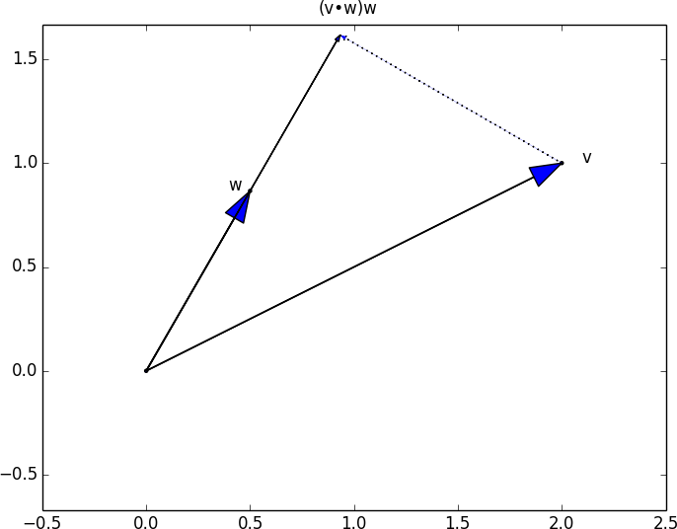

***Figure 17-2. The dot product as vector projection***

Using this, it’s easy to compute a vector’s *sum of squares*:

**def** sum_of_squares(v: Vector) -> float:

*"""Returns v_1 * v_1 + ... + v_n * v_n"""*

**return** dot(v, v)

**assert** sum_of_squares([1, 2, 3]) == 14 *# 1 * 1 + 2 * 2 + 3 * 3*

which we can use to compute its *magnitude* (or length):

**import** **math**

**def** magnitude(v: Vector) -> float:

*"""Returns the magnitude (or length) of v"""*

**return** math.sqrt(sum_of_squares(v)) *# math.sqrt is square root function*

**assert** magnitude([3, 4]) == 5

We now have all the pieces we need to compute the distance between two vectors, defined as:

(v1−w1)2+...+(vn−wn)2−−−−−−−−−−−−−−−−−−−−−−√(v1-w1)2+...+(vn-wn)2

In code:

**def** squared_distance(v: Vector, w: Vector) -> float:

*"""Computes (v_1 - w_1) ** 2 + ... + (v_n - w_n) ** 2"""*

**return** sum_of_squares(subtract(v, w))

**def** distance(v: Vector, w: Vector) -> float:

*"""Computes the distance between v and w"""*

**return** math.sqrt(squared_distance(v, w))

This is possibly clearer if we write it as (the equivalent):

**def** distance(v: Vector, w: Vector) -> float:

**return** magnitude(subtract(v, w))

That should be plenty to get us started. We’ll be using these functions heavily throughout the book.

**NOTE**

Using lists as vectors is great for exposition but terrible for performance.

In production code, you would want to use the NumPy library, which includes a high-performance array class with all sorts of arithmetic operations included.

**Matrices**

A *matrix* is a two-dimensional collection of numbers. We will represent matrices as lists of lists, with each inner list having the same size and representing a *row* of the matrix. If A is a matrix, then A[i][j] is the element in the *i*th row and the *j*th column. Per mathematical convention, we will frequently use capital letters to represent matrices. For example:

*# Another type alias*

Matrix = List[List[float]]

A = [[1, 2, 3], *# A has 2 rows and 3 columns*

[4, 5, 6]]

B = [[1, 2], *# B has 3 rows and 2 columns*

[3, 4],

[5, 6]]

**NOTE**

In mathematics, you would usually name the first row of the matrix “row 1” and the first column “column 1.” Because we’re representing matrices with Python lists, which are zero-indexed, we’ll call the first row of a matrix “row 0” and the first column “column 0.”

Given this list-of-lists representation, the matrix A has len(A) rows and len(A[0]) columns, which we consider its shape:

**from** **typing** **import** Tuple

**def** shape(A: Matrix) -> Tuple[int, int]:

*"""Returns (# of rows of A, # of columns of A)"""*

num_rows = len(A)

num_cols = len(A[0]) **if** A **else** 0 *# number of elements in first row*

**return** num_rows, num_cols

**assert** shape([[1, 2, 3], [4, 5, 6]]) == (2, 3) *# 2 rows, 3 columns*

If a matrix has *n* rows and *k* columns, we will refer to it as an *n × k matrix*. We can (and sometimes will) think of each row of an *n × k* matrix as a vector of length *k*, and each column as a vector of length *n*:

**def** get_row(A: Matrix, i: int) -> Vector:

*"""Returns the i-th row of A (as a Vector)"""*

**return** A[i] *# A[i] is already the ith row*

**def** get_column(A: Matrix, j: int) -> Vector:

*"""Returns the j-th column of A (as a Vector)"""*

**return** [A_i[j] *# jth element of row A_i*

**for** A_i **in** A] *# for each row A_i*

We’ll also want to be able to create a matrix given its shape and a function for generating its elements. We can do this using a nested list comprehension:

**from** **typing** **import** Callable

**def** make_matrix(num_rows: int,

num_cols: int,

entry_fn: Callable[[int, int], float]) -> Matrix:

*"""*

*Returns a num_rows x num_cols matrix*

*whose (i,j)-th entry is entry_fn(i, j)*

*"""*

**return** [[entry_fn(i, j) *# given i, create a list*

**for** j **in** range(num_cols)] *# [entry_fn(i, 0), ... ]*

**for** i **in** range(num_rows)] *# create one list for each i*

Given this function, you could make a 5 × 5 *identity matrix* (with 1s on the diagonal and 0s elsewhere) like so:

**def** identity_matrix(n: int) -> Matrix:

*"""Returns the n x n identity matrix"""*

**return** make_matrix(n, n, **lambda** i, j: 1 **if** i == j **else** 0)

**assert** identity_matrix(5) == [[1, 0, 0, 0, 0],

[0, 1, 0, 0, 0],

[0, 0, 1, 0, 0],

[0, 0, 0, 1, 0],

[0, 0, 0, 0, 1]]

Matrices will be important to us for several reasons.

First, we can use a matrix to represent a dataset consisting of multiple vectors, simply by considering each vector as a row of the matrix. For example, if you had the heights, weights, and ages of 1,000 people, you could put them in a 1,000 × 3 matrix:

data = [[70, 170, 40],

[65, 120, 26],

[77, 250, 19],

*# ....*

]

Second, as we’ll see later, we can use an *n × k* matrix to represent a linear function that maps *k*-dimensional vectors to *n*-dimensional vectors. Several of our techniques and concepts will involve such functions.

Third, matrices can be used to represent binary relationships. In [Chapter 1](https://learning.oreilly.com/library/view/data-science-from/9781492041122/ch01.html#introduction), we represented the edges of a network as a collection of pairs (i, j). An alternative representation would be to create a matrix A such that A[i][j] is 1 if nodes i and j are connected and 0 otherwise.

Recall that before we had:

friendships = [(0, 1), (0, 2), (1, 2), (1, 3), (2, 3), (3, 4),

(4, 5), (5, 6), (5, 7), (6, 8), (7, 8), (8, 9)]

We could also represent this as:

*# user 0 1 2 3 4 5 6 7 8 9*

*#*

friend_matrix = [[0, 1, 1, 0, 0, 0, 0, 0, 0, 0], *# user 0*

[1, 0, 1, 1, 0, 0, 0, 0, 0, 0], *# user 1*

[1, 1, 0, 1, 0, 0, 0, 0, 0, 0], *# user 2*

[0, 1, 1, 0, 1, 0, 0, 0, 0, 0], *# user 3*

[0, 0, 0, 1, 0, 1, 0, 0, 0, 0], *# user 4*

[0, 0, 0, 0, 1, 0, 1, 1, 0, 0], *# user 5*

[0, 0, 0, 0, 0, 1, 0, 0, 1, 0], *# user 6*

[0, 0, 0, 0, 0, 1, 0, 0, 1, 0], *# user 7*

[0, 0, 0, 0, 0, 0, 1, 1, 0, 1], *# user 8*

[0, 0, 0, 0, 0, 0, 0, 0, 1, 0]] *# user 9*

If there are very few connections, this is a much more inefficient representation, since you end up having to store a lot of zeros. However, with the matrix representation it is much quicker to check whether two nodes are connected—you just have to do a matrix lookup instead of (potentially) inspecting every edge:

**assert** friend_matrix[0][2] == 1, "0 and 2 are friends"

**assert** friend_matrix[0][8] == 0, "0 and 8 are not friends"

Similarly, to find a node’s connections, you only need to inspect the column (or the row) corresponding to that node:

*# only need to look at one row*

friends_of_five = [i

**for** i, is_friend **in** enumerate(friend_matrix[5])

**if** is_friend]

With a small graph you could just add a list of connections to each node object to speed up this process; but for a large, evolving graph that would probably be too expensive and difficult to maintain.

We’ll revisit matrices throughout the book.

**For Further Exploration**

* Linear algebra is widely used by data scientists (frequently implicitly, and not infrequently by people who don’t understand it). It wouldn’t be a bad idea to read a textbook. You can find several freely available online:
  + [*Linear Algebra*](http://joshua.smcvt.edu/linearalgebra/), by Jim Hefferon (Saint Michael’s College)
  + [*Linear Algebra*](https://www.math.ucdavis.edu/~linear/linear-guest.pdf), by David Cherney, Tom Denton, Rohit Thomas, and Andrew Waldron (UC Davis)
  + If you are feeling adventurous, [*Linear Algebra Done Wrong*](https://www.math.brown.edu/~treil/papers/LADW/LADW_2017-09-04.pdf), by Sergei Treil (Brown University), is a more advanced introduction.
* All of the machinery we built in this chapter you get for free if you use [NumPy](http://www.numpy.org/). (You get a lot more too, including much better performance.)

**Chapter 18. Statistics**

*Facts are stubborn, but statistics are more pliable.*

Mark Twain

*Statistics* refers to the mathematics and techniques with which we understand data. It is a rich, enormous field, more suited to a shelf (or room) in a library than a chapter in a book, and so our discussion will necessarily not be a deep one. Instead, I’ll try to teach you just enough to be dangerous, and pique your interest just enough that you’ll go off and learn more.

**Describing a Single Set of Data**

Through a combination of word of mouth and luck, DataSciencester has grown to dozens of members, and the VP of Fundraising asks you for some sort of description of how many friends your members have that he can include in his elevator pitches.

Using techniques from [Chapter 1](https://learning.oreilly.com/library/view/data-science-from/9781492041122/ch01.html#introduction), you are easily able to produce this data. But now you are faced with the problem of how to *describe* it.

One obvious description of any dataset is simply the data itself:

num_friends = [100, 49, 41, 40, 25,

*# ... and lots more*

]

For a small enough dataset, this might even be the best description. But for a larger dataset, this is unwieldy and probably opaque. (Imagine staring at a list of 1 million numbers.) For that reason, we use statistics to distill and communicate relevant features of our data.

As a first approach, you put the friend counts into a histogram using Counter and plt.bar ([Figure 18-1](https://learning.oreilly.com/library/view/data-science-from/9781492041122/ch05.html#histogram_friend_counts)):

**from** **collections** **import** Counter

**import** **matplotlib.pyplot** **as** **plt**

friend_counts = Counter(num_friends)

xs = range(101) *# largest value is 100*

ys = [friend_counts[x] **for** x **in** xs] *# height is just # of friends*

plt.bar(xs, ys)

plt.axis([0, 101, 0, 25])

plt.title("Histogram of Friend Counts")

plt.xlabel("# of friends")

plt.ylabel("# of people")

plt.show()

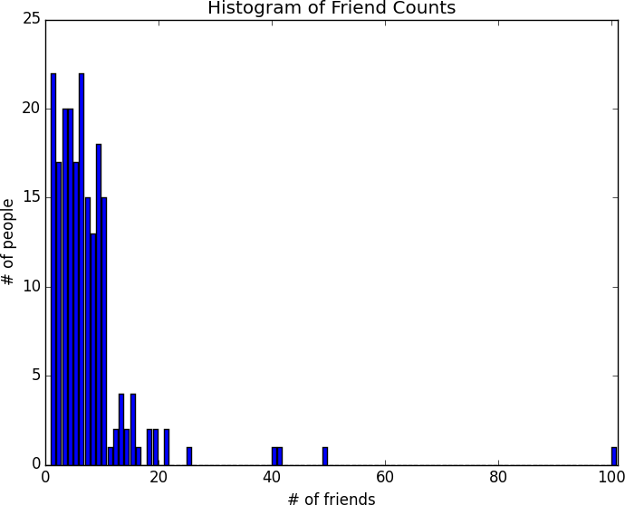

***Figure 18-1. A histogram of friend counts***

Unfortunately, this chart is still too difficult to slip into conversations. So you start generating some statistics. Probably the simplest statistic is the number of data points:

num_points = len(num_friends) *# 204*

You’re probably also interested in the largest and smallest values:

largest_value = max(num_friends) *# 100*

smallest_value = min(num_friends) *# 1*

which are just special cases of wanting to know the values in specific positions:

sorted_values = sorted(num_friends)

smallest_value = sorted_values[0] *# 1*

second_smallest_value = sorted_values[1] *# 1*

second_largest_value = sorted_values[-2] *# 49*

But we’re only getting started.

**Central Tendencies**

Usually, we’ll want some notion of where our data is centered. Most commonly we’ll use the *mean* (or average), which is just the sum of the data divided by its count:

**def** mean(xs: List[float]) -> float:

**return** sum(xs) / len(xs)

mean(num_friends) *# 7.333333*

If you have two data points, the mean is simply the point halfway between them. As you add more points, the mean shifts around, but it always depends on the value of every point. For example, if you have 10 data points, and you increase the value of any of them by 1, you increase the mean by 0.1.

We’ll also sometimes be interested in the *median*, which is the middle-most value (if the number of data points is odd) or the average of the two middle-most values (if the number of data points is even).

For instance, if we have five data points in a sorted vector x, the median is x[5 // 2] or x[2]. If we have six data points, we want the average of x[2] (the third point) and x[3] (the fourth point).

Notice that—unlike the mean—the median doesn’t fully depend on every value in your data. For example, if you make the largest point larger (or the smallest point smaller), the middle points remain unchanged, which means so does the median.

We’ll write different functions for the even and odd cases and combine them:

*# The underscores indicate that these are "private" functions, as they're*

*# intended to be called by our median function but not by other people*

*# using our statistics library.*

**def** _median_odd(xs: List[float]) -> float:

*"""If len(xs) is odd, the median is the middle element"""*

**return** sorted(xs)[len(xs) // 2]

**def** _median_even(xs: List[float]) -> float:

*"""If len(xs) is even, it's the average of the middle two elements"""*

sorted_xs = sorted(xs)

hi_midpoint = len(xs) // 2 *# e.g. length 4 => hi_midpoint 2*

**return** (sorted_xs[hi_midpoint - 1] + sorted_xs[hi_midpoint]) / 2

**def** median(v: List[float]) -> float:

*"""Finds the 'middle-most' value of v"""*

**return** _median_even(v) **if** len(v) % 2 == 0 **else** _median_odd(v)

**assert** median([1, 10, 2, 9, 5]) == 5

**assert** median([1, 9, 2, 10]) == (2 + 9) / 2

And now we can compute the median number of friends:

**print**(median(num_friends)) *# 6*

Clearly, the mean is simpler to compute, and it varies smoothly as our data changes. If we have *n* data points and one of them increases by some small amount *e*, then necessarily the mean will increase by *e* / *n*. (This makes the mean amenable to all sorts of calculus tricks.) In order to find the median, however, we have to sort our data. And changing one of our data points by a small amount *e* might increase the median by *e*, by some number less than *e*, or not at all (depending on the rest of the data).

**NOTE**

There are, in fact, nonobvious tricks to efficiently [compute medians](http://en.wikipedia.org/wiki/Quickselect) without sorting the data. However, they are beyond the scope of this book, so *we* have to sort the data.

At the same time, the mean is very sensitive to outliers in our data. If our friendliest user had 200 friends (instead of 100), then the mean would rise to 7.82, while the median would stay the same. If outliers are likely to be bad data (or otherwise unrepresentative of whatever phenomenon we’re trying to understand), then the mean can sometimes give us a misleading picture. For example, the story is often told that in the mid-1980s, the major at the University of North Carolina with the highest average starting salary was geography, mostly because of NBA star (and outlier) Michael Jordan.

A generalization of the median is the *quantile*, which represents the value under which a certain percentile of the data lies (the median represents the value under which 50% of the data lies):

**def** quantile(xs: List[float], p: float) -> float:

*"""Returns the pth-percentile value in x"""*

p_index = int(p * len(xs))

**return** sorted(xs)[p_index]

**assert** quantile(num_friends, 0.10) == 1

**assert** quantile(num_friends, 0.25) == 3

**assert** quantile(num_friends, 0.75) == 9

**assert** quantile(num_friends, 0.90) == 13

Less commonly you might want to look at the *mode*, or most common value(s):

**def** mode(x: List[float]) -> List[float]:

*"""Returns a list, since there might be more than one mode"""*

counts = Counter(x)

max_count = max(counts.values())

**return** [x_i **for** x_i, count **in** counts.items()

**if** count == max_count]

**assert** set(mode(num_friends)) == {1, 6}

But most frequently we’ll just use the mean.

**Dispersion**

*Dispersion* refers to measures of how spread out our data is. Typically they’re statistics for which values near zero signify *not spread out at all* and for which large values (whatever that means) signify *very spread out*. For instance, a very simple measure is the *range*, which is just the difference between the largest and smallest elements:

*# "range" already means something in Python, so we'll use a different name*

**def** data_range(xs: List[float]) -> float:

**return** max(xs) - min(xs)

**assert** data_range(num_friends) == 99

The range is zero precisely when the max and min are equal, which can only happen if the elements of x are all the same, which means the data is as undispersed as possible. Conversely, if the range is large, then the max is much larger than the min and the data is more spread out.

Like the median, the range doesn’t really depend on the whole dataset. A dataset whose points are all either 0 or 100 has the same range as a dataset whose values are 0, 100, and lots of 50s. But it seems like the first dataset “should” be more spread out.

A more complex measure of dispersion is the *variance*, which is computed as:

**from** **scratch.linear_algebra** **import** sum_of_squares

**def** de_mean(xs: List[float]) -> List[float]:

*"""Translate xs by subtracting its mean (so the result has mean 0)"""*

x_bar = mean(xs)

**return** [x - x_bar **for** x **in** xs]

**def** variance(xs: List[float]) -> float:

*"""Almost the average squared deviation from the mean"""*

**assert** len(xs) >= 2, "variance requires at least two elements"

n = len(xs)

deviations = de_mean(xs)

**return** sum_of_squares(deviations) / (n - 1)

**assert** 81.54 < variance(num_friends) < 81.55

**NOTE**

This looks like it is almost the average squared deviation from the mean, except that we’re dividing by n - 1 instead of n. In fact, when we’re dealing with a sample from a larger population, x_bar is only an *estimate* of the actual mean, which means that on average (x_i - x_bar) ** 2 is an underestimate of x_i’s squared deviation from the mean, which is why we divide by n - 1 instead of n. See [Wikipedia](https://en.wikipedia.org/wiki/Unbiased_estimation_of_standard_deviation).

Now, whatever units our data is in (e.g., “friends”), all of our measures of central tendency are in that same unit. The range will similarly be in that same unit. The variance, on the other hand, has units that are the *square* of the original units (e.g., “friends squared”). As it can be hard to make sense of these, we often look instead at the *standard deviation*:

**import** **math**

**def** standard_deviation(xs: List[float]) -> float:

*"""The standard deviation is the square root of the variance"""*

**return** math.sqrt(variance(xs))

**assert** 9.02 < standard_deviation(num_friends) < 9.04

Both the range and the standard deviation have the same outlier problem that we saw earlier for the mean. Using the same example, if our friendliest user had instead 200 friends, the standard deviation would be 14.89—more than 60% higher!

A more robust alternative computes the difference between the 75th percentile value and the 25th percentile value:

**def** interquartile_range(xs: List[float]) -> float:

*"""Returns the difference between the 75%-ile and the 25%-ile"""*

**return** quantile(xs, 0.75) - quantile(xs, 0.25)

**assert** interquartile_range(num_friends) == 6

which is quite plainly unaffected by a small number of outliers.

**Correlation**

DataSciencester’s VP of Growth has a theory that the amount of time people spend on the site is related to the number of friends they have on the site (she’s not a VP for nothing), and she’s asked you to verify this.

After digging through traffic logs, you’ve come up with a list called daily_minutes that shows how many minutes per day each user spends on DataSciencester, and you’ve ordered it so that its elements correspond to the elements of our previous num_friends list. We’d like to investigate the relationship between these two metrics.

We’ll first look at *covariance*, the paired analogue of variance. Whereas variance measures how a single variable deviates from its mean, covariance measures how two variables vary in tandem from their means:

**from** **scratch.linear_algebra** **import** dot

**def** covariance(xs: List[float], ys: List[float]) -> float:

**assert** len(xs) == len(ys), "xs and ys must have same number of elements"

**return** dot(de_mean(xs), de_mean(ys)) / (len(xs) - 1)

**assert** 22.42 < covariance(num_friends, daily_minutes) < 22.43

**assert** 22.42 / 60 < covariance(num_friends, daily_hours) < 22.43 / 60

Recall that dot sums up the products of corresponding pairs of elements. When corresponding elements of x and y are either both above their means or both below their means, a positive number enters the sum. When one is above its mean and the other below, a negative number enters the sum. Accordingly, a “large” positive covariance means that x tends to be large when y is large and small when y is small. A “large” negative covariance means the opposite—that x tends to be small when y is large and vice versa. A covariance close to zero means that no such relationship exists.

Nonetheless, this number can be hard to interpret, for a couple of reasons:

* Its units are the product of the inputs’ units (e.g., friend-minutes-per-day), which can be hard to make sense of. (What’s a “friend-minute-per-day”?)
* If each user had twice as many friends (but the same number of minutes), the covariance would be twice as large. But in a sense, the variables would be just as interrelated. Said differently, it’s hard to say what counts as a “large” covariance.

For this reason, it’s more common to look at the *correlation*, which divides out the standard deviations of both variables:

**def** correlation(xs: List[float], ys: List[float]) -> float:

*"""Measures how much xs and ys vary in tandem about their means"""*

stdev_x = standard_deviation(xs)

stdev_y = standard_deviation(ys)

**if** stdev_x > 0 **and** stdev_y > 0:

**return** covariance(xs, ys) / stdev_x / stdev_y

**else**:

**return** 0 *# if no variation, correlation is zero*

**assert** 0.24 < correlation(num_friends, daily_minutes) < 0.25

**assert** 0.24 < correlation(num_friends, daily_hours) < 0.25

The correlation is unitless and always lies between –1 (perfect anticorrelation) and 1 (perfect correlation). A number like 0.25 represents a relatively weak positive correlation.

However, one thing we neglected to do was examine our data. Check out [Figure 18-2](https://learning.oreilly.com/library/view/data-science-from/9781492041122/ch05.html#correlation_outlier).

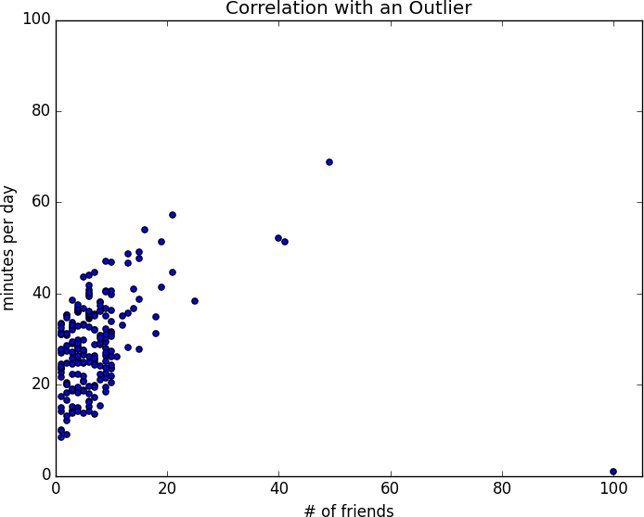

***Figure 18-2. Correlation with an outlier***

The person with 100 friends (who spends only 1 minute per day on the site) is a huge outlier, and correlation can be very sensitive to outliers. What happens if we ignore him?

outlier = num_friends.index(100) *# index of outlier*

num_friends_good = [x

**for** i, x **in** enumerate(num_friends)

**if** i != outlier]

daily_minutes_good = [x

**for** i, x **in** enumerate(daily_minutes)

**if** i != outlier]

daily_hours_good = [dm / 60 **for** dm **in** daily_minutes_good]

**assert** 0.57 < correlation(num_friends_good, daily_minutes_good) < 0.58

**assert** 0.57 < correlation(num_friends_good, daily_hours_good) < 0.58

Without the outlier, there is a much stronger correlation ([Figure 18-3](https://learning.oreilly.com/library/view/data-science-from/9781492041122/ch05.html#correlation_no_outliers)).

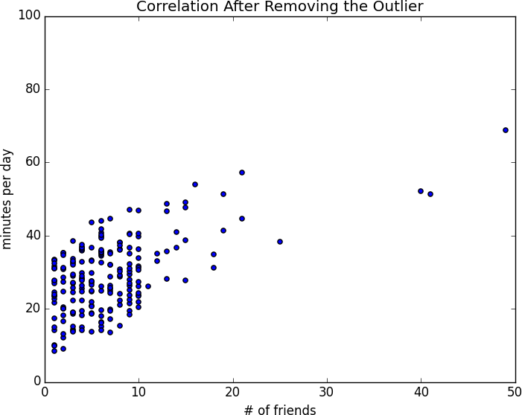

***Figure 18-3. Correlation after removing the outlier***

You investigate further and discover that the outlier was actually an internal *test* account that no one ever bothered to remove. So you feel justified in excluding it.

**Simpson’s Paradox**

One not uncommon surprise when analyzing data is *Simpson’s paradox*, in which correlations can be misleading when *confounding* variables are ignored.

For example, imagine that you can identify all of your members as either East Coast data scientists or West Coast data scientists. You decide to examine which coast’s data scientists are friendlier:

| **Coast** | **# of members** | **Avg. # of friends** |
| --- | --- | --- |
| West Coast | 101 | 8.2 |
| East Coast | 103 | 6.5 |

It certainly looks like the West Coast data scientists are friendlier than the East Coast data scientists. Your coworkers advance all sorts of theories as to why this might be: maybe it’s the sun, or the coffee, or the organic produce, or the laid-back Pacific vibe?

But when playing with the data, you discover something very strange. If you look only at people with PhDs, the East Coast data scientists have more friends on average. And if you look only at people without PhDs, the East Coast data scientists also have more friends on average!

| **Coast** | **Degree** | **# of members** | **Avg. # of friends** |
| --- | --- | --- | --- |
| West Coast | PhD | 35 | 3.1 |
| East Coast | PhD | 70 | 3.2 |
| West Coast | No PhD | 66 | 10.9 |
| East Coast | No PhD | 33 | 13.4 |

Once you account for the users’ degrees, the correlation goes in the opposite direction! Bucketing the data as East Coast/West Coast disguised the fact that the East Coast data scientists skew much more heavily toward PhD types.

This phenomenon crops up in the real world with some regularity. The key issue is that correlation is measuring the relationship between your two variables *all else being equal*. If your dataclasses are assigned at random, as they might be in a well-designed experiment, “all else being equal” might not be a terrible assumption. But when there is a deeper pattern to class assignments, “all else being equal” can be an awful assumption.

The only real way to avoid this is by *knowing your data* and by doing what you can to make sure you’ve checked for possible confounding factors. Obviously, this is not always possible. If you didn’t have data on the educational attainment of these 200 data scientists, you might simply conclude that there was something inherently more sociable about the West Coast.

**Some Other Correlational Caveats**

A correlation of zero indicates that there is no linear relationship between the two variables. However, there may be other sorts of relationships. For example, if:

x = [-2, -1, 0, 1, 2]

y = [ 2, 1, 0, 1, 2]

then x and y have zero correlation. But they certainly have a relationship—each element of y equals the absolute value of the corresponding element of x. What they don’t have is a relationship in which knowing how x_icompares to mean(x) gives us information about how y_i compares to mean(y). That is the sort of relationship that correlation looks for.

In addition, correlation tells you nothing about how large the relationship is. The variables:

x = [-2, -1, 0, 1, 2]

y = [99.98, 99.99, 100, 100.01, 100.02]

are perfectly correlated, but (depending on what you’re measuring) it’s quite possible that this relationship isn’t all that interesting.

**Correlation and Causation**

You have probably heard at some point that “correlation is not causation,” most likely from someone looking at data that posed a challenge to parts of his worldview that he was reluctant to question. Nonetheless, this is an important point—if x and y are strongly correlated, that might mean that x causes y, that y causes x, that each causes the other, that some third factor causes both, or nothing at all.

Consider the relationship between num_friends and daily_minutes. It’s possible that having more friends on the site *causes* DataSciencester users to spend more time on the site. This might be the case if each friend posts a certain amount of content each day, which means that the more friends you have, the more time it takes to stay current with their updates.

However, it’s also possible that the more time users spend arguing in the DataSciencester forums, the more they encounter and befriend like-minded people. That is, spending more time on the site *causes* users to have more friends.

A third possibility is that the users who are most passionate about data science spend more time on the site (because they find it more interesting) and more actively collect data science friends (because they don’t want to associate with anyone else).

One way to feel more confident about causality is by conducting randomized trials. If you can randomly split your users into two groups with similar demographics and give one of the groups a slightly different experience, then you can often feel pretty good that the different experiences are causing the different outcomes.

For instance, if you don’t mind being angrily accused of [*https://www.nytimes.com/2014/06/30/technology/facebook-tinkers-with-users-emotions-in-news-feed-experiment-stirring-outcry.html?*](https://www.nytimes.com/2014/06/30/technology/facebook-tinkers-with-users-emotions-in-news-feed-experiment-stirring-outcry.html?)*r=0[experimenting on your users], you could randomly choose a subset of your users and show them content from only a fraction of their friends. If this subset subsequently spent less time on the site, this would give you some confidence that having more friends _causes* more time to be spent on the site.

**For Further Exploration**

* [SciPy](https://www.scipy.org/), [pandas](http://pandas.pydata.org/), and [StatsModels](http://www.statsmodels.org/) all come with a wide variety of statistical functions.
* Statistics is *important*. (Or maybe statistics *are* important?) If you want to be a better data scientist, it would be a good idea to read a statistics textbook. Many are freely available online, including:
  + [*Introductory Statistics*](https://open.umn.edu/opentextbooks/textbooks/introductory-statistics), by Douglas Shafer and Zhiyi Zhang (Saylor Foundation)
  + [*OnlineStatBook*](http://onlinestatbook.com/), by David Lane (Rice University)
  + [*Introductory Statistics*](https://openstax.org/details/introductory-statistics), by OpenStax (OpenStax College)

**Chapter 19. Probability**

*The laws of probability, so true in general, so fallacious in particular.*

Edward Gibbon

It is hard to do data science without some sort of understanding of *probability* and its mathematics. As with our treatment of statistics in [Chapter](https://learning.oreilly.com/library/view/data-science-from/9781492041122/ch05.html#statistics)18, we’ll wave our hands a lot and elide many of the technicalities.

For our purposes you should think of probability as a way of quantifying the uncertainty associated with *events*chosen from some *universe* of events. Rather than getting technical about what these terms mean, think of rolling a die. The universe consists of all possible outcomes. And any subset of these outcomes is an event; for example, “the die rolls a 1” or “the die rolls an even number.”

Notationally, we write *P*(*E*) to mean “the probability of the event *E*.”

We’ll use probability theory to build models. We’ll use probability theory to evaluate models. We’ll use probability theory all over the place.

One could, were one so inclined, get really deep into the philosophy of what probability theory *means*. (This is best done over beers.) We won’t be doing that.

**Dependence and Independence**

Roughly speaking, we say that two events *E* and *F* are *dependent* if knowing something about whether *E* happens gives us information about whether *F* happens (and vice versa). Otherwise, they are *independent*.

For instance, if we flip a fair coin twice, knowing whether the first flip is heads gives us no information about whether the second flip is heads. These events are independent. On the other hand, knowing whether the first flip is heads certainly gives us information about whether both flips are tails. (If the first flip is heads, then definitely it’s not the case that both flips are tails.) These two events are dependent.

Mathematically, we say that two events *E* and *F* are independent if the probability that they both happen is the product of the probabilities that each one happens:

P(E,F)=P(E)P(F)P(E,F)=P(E)P(F)

In the example, the probability of “first flip heads” is 1/2, and the probability of “both flips tails” is 1/4, but the probability of “first flip heads *and* both flips tails” is 0.

**Conditional Probability**

When two events *E* and *F* are independent, then by definition we have:

P(E,F)=P(E)P(F)P(E,F)=P(E)P(F)

If they are not necessarily independent (and if the probability of *F* is not zero), then we define the probability of *E* “conditional on *F*” as:

P(E|F)=P(E,F)/P(F)P(E|F)=P(E,F)/P(F)

You should think of this as the probability that *E* happens, given that we know that *F* happens.

We often rewrite this as:

P(E,F)=P(E|F)P(F)P(E,F)=P(E|F)P(F)

When *E* and *F* are independent, you can check that this gives:

P(E|F)=P(E)P(E|F)=P(E)

which is the mathematical way of expressing that knowing *F* occurred gives us no additional information about whether *E* occurred.

One common tricky example involves a family with two (unknown) children. If we assume that:

* Each child is equally likely to be a boy or a girl.
* The gender of the second child is independent of the gender of the first child.

Then the event “no girls” has probability 1/4, the event “one girl, one boy” has probability 1/2, and the event “two girls” has probability 1/4.

Now we can ask what is the probability of the event “both children are girls” (*B*) conditional on the event “the older child is a girl” (*G*)? Using the definition of conditional probability:

P(B|G)=P(B,G)/P(G)=P(B)/P(G)=1/2P(B|G)=P(B,G)/P(G)=P(B)/P(G)=1/2

since the event *B* and *G* (“both children are girls *and* the older child is a girl”) is just the event *B*. (Once you know that both children are girls, it’s necessarily true that the older child is a girl.)

Most likely this result accords with your intuition.

We could also ask about the probability of the event “both children are girls” conditional on the event “at least one of the children is a girl” (*L*). Surprisingly, the answer is different from before!

As before, the event *B* and *L* (“both children are girls *and* at least one of the children is a girl”) is just the event *B*. This means we have:

P(B|L)=P(B,L)/P(L)=P(B)/P(L)=1/3P(B|L)=P(B,L)/P(L)=P(B)/P(L)=1/3

How can this be the case? Well, if all you know is that at least one of the children is a girl, then it is twice as likely that the family has one boy and one girl than that it has both girls.

We can check this by “generating” a lot of families:

**import** **enum**, **random**

*# An Enum is a typed set of enumerated values. We can use them*

*# to make our code more descriptive and readable.*

**class** **Kid**(enum.Enum):

BOY = 0

GIRL = 1

**def** random_kid() -> Kid:

**return** random.choice([Kid.BOY, Kid.GIRL])

both_girls = 0

older_girl = 0

either_girl = 0

random.seed(0)

**for** _ **in** range(10000):

younger = random_kid()

older = random_kid()

**if** older == Kid.GIRL:

older_girl += 1

**if** older == Kid.GIRL **and** younger == Kid.GIRL:

both_girls += 1

**if** older == Kid.GIRL **or** younger == Kid.GIRL:

either_girl += 1

**print**("P(both | older):", both_girls / older_girl) *# 0.514 ~ 1/2*

**print**("P(both | either): ", both_girls / either_girl) *# 0.342 ~ 1/3*

**Bayes’s Theorem**

One of the data scientist’s best friends is Bayes’s theorem, which is a way of “reversing” conditional probabilities. Let’s say we need to know the probability of some event *E* conditional on some other event *F*occurring. But we only have information about the probability of *F* conditional on *E* occurring. Using the definition of conditional probability twice tells us that:

P(E|F)=P(E,F)/P(F)=P(F|E)P(E)/P(F)P(E|F)=P(E,F)/P(F)=P(F|E)P(E)/P(F)

The event *F* can be split into the two mutually exclusive events “*F* and *E*” and “*F* and not *E*.” If we write ¬E¬E for “not *E*” (i.e., “*E* doesn’t happen”), then:

P(F)=P(F,E)+P(F,¬E)P(F)=P(F,E)+P(F,¬E)

so that:

P(E|F)=P(F|E)P(E)/[P(F|E)P(E)+P(F|¬E)P(¬E)]P(E|F)=P(F|E)P(E)/[P(F|E)P(E)+P(F|¬E)P(¬E)]

which is how Bayes’s theorem is often stated.

This theorem often gets used to demonstrate why data scientists are smarter than doctors. Imagine a certain disease that affects 1 in every 10,000 people. And imagine that there is a test for this disease that gives the correct result (“diseased” if you have the disease, “nondiseased” if you don’t) 99% of the time.

What does a positive test mean? Let’s use *T* for the event “your test is positive” and *D* for the event “you have the disease.” Then Bayes’s theorem says that the probability that you have the disease, conditional on testing positive, is:

P(D|T)=P(T|D)P(D)/[P(T|D)P(D)+P(T|¬D)P(¬D)]P(D|T)=P(T|D)P(D)/[P(T|D)P(D)+P(T|¬D)P(¬D)]

Here we know that P(T|D)P(T|D), the probability that someone with the disease tests positive, is 0.99. *P*(*D*), the probability that any given person has the disease, is 1/10,000 = 0.0001. P(T|¬D)P(T|¬D), the probability that someone without the disease tests positive, is 0.01. And P(¬D)P(¬D), the probability that any given person doesn’t have the disease, is 0.9999. If you substitute these numbers into Bayes’s theorem, you find:

P(D|T)=0.98%P(D|T)=0.98%

That is, less than 1% of the people who test positive actually have the disease.

**NOTE**

This assumes that people take the test more or less at random. If only people with certain symptoms take the test, we would instead have to condition on the event “positive test *and* symptoms” and the number would likely be a lot higher.

A more intuitive way to see this is to imagine a population of 1 million people. You’d expect 100 of them to have the disease, and 99 of those 100 to test positive. On the other hand, you’d expect 999,900 of them not to have the disease, and 9,999 of those to test positive. That means you’d expect only 99 out of (99 + 9999) positive testers to actually have the disease.

**Random Variables**

A *random variable* is a variable whose possible values have an associated probability distribution. A very simple random variable equals 1 if a coin flip turns up heads and 0 if the flip turns up tails. A more complicated one might measure the number of heads you observe when flipping a coin 10 times or a value picked from range(10) where each number is equally likely.

The associated distribution gives the probabilities that the variable realizes each of its possible values. The coin flip variable equals 0 with probability 0.5 and 1 with probability 0.5. The range(10) variable has a distribution that assigns probability 0.1 to each of the numbers from 0 to 9.

We will sometimes talk about the *expected value* of a random variable, which is the average of its values weighted by their probabilities. The coin flip variable has an expected value of 1/2 (= 0 * 1/2 + 1 * 1/2), and the range(10) variable has an expected value of 4.5.

Random variables can be *conditioned* on events just as other events can. Going back to the two-child example from [“Conditional Probability”](https://learning.oreilly.com/library/view/data-science-from/9781492041122/ch06.html#conditional_probability), if *X* is the random variable representing the number of girls, *X* equals 0 with probability 1/4, 1 with probability 1/2, and 2 with probability 1/4.

We can define a new random variable *Y* that gives the number of girls conditional on at least one of the children being a girl. Then *Y* equals 1 with probability 2/3 and 2 with probability 1/3. And a variable *Z* that’s the number of girls conditional on the older child being a girl equals 1 with probability 1/2 and 2 with probability 1/2.

For the most part, we will be using random variables *implicitly* in what we do without calling special attention to them. But if you look deeply you’ll see them.

**Continuous Distributions**

A coin flip corresponds to a *discrete distribution*—one that associates positive probability with discrete outcomes. Often we’ll want to model distributions across a continuum of outcomes. (For our purposes, these outcomes will always be real numbers, although that’s not always the case in real life.) For example, the *uniform distribution* puts *equal weight* on all the numbers between 0 and 1.

Because there are infinitely many numbers between 0 and 1, this means that the weight it assigns to individual points must necessarily be zero. For this reason, we represent a continuous distribution with a *probability density function* (PDF) such that the probability of seeing a value in a certain interval equals the integral of the density function over the interval.

**NOTE**

If your integral calculus is rusty, a simpler way of understanding this is that if a distribution has density function *f*, then the probability of seeing a value between *x* and *x + h* is approximately *h * f(x)* if *h* is small.

The density function for the uniform distribution is just:

**def** uniform_pdf(x: float) -> float:

**return** 1 **if** 0 <= x < 1 **else** 0

The probability that a random variable following that distribution is between 0.2 and 0.3 is 1/10, as you’d expect. Python’s random.random is a (pseudo)random variable with a uniform density.

We will often be more interested in the *cumulative distribution function* (CDF), which gives the probability that a random variable is less than or equal to a certain value. It’s not hard to create the CDF for the uniform distribution ([Figure 19-1](https://learning.oreilly.com/library/view/data-science-from/9781492041122/ch06.html#uniform_cdf)):

**def** uniform_cdf(x: float) -> float:

*"""Returns the probability that a uniform random variable is <= x"""*

**if** x < 0: **return** 0 *# uniform random is never less than 0*

**elif** x < 1: **return** x *# e.g. P(X <= 0.4) = 0.4*

**else**: **return** 1 *# uniform random is always less than 1*

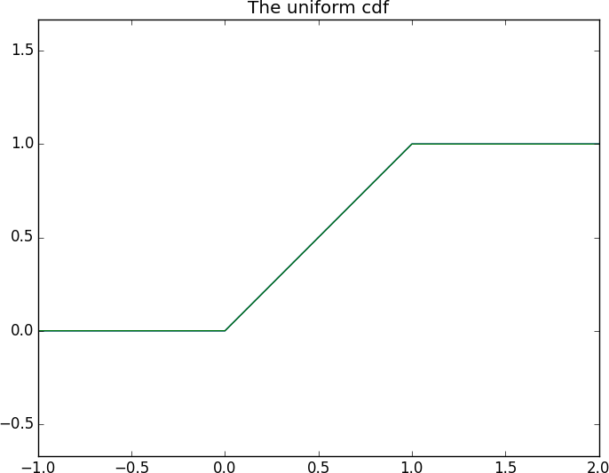

***Figure 19-1. The uniform CDF***

**The Normal Distribution**

The normal distribution is the classic bell curve–shaped distribution and is completely determined by two parameters: its mean *μ* (mu) and its standard deviation *σ* (sigma). The mean indicates where the bell is centered, and the standard deviation how “wide” it is.

It has the PDF:

f(x|μ,σ)=12π−−√σexp(−(x−μ)22σ2)f(x|μ,σ)=12πσexp(-(x-μ)22σ2)

which we can implement as:

**import** **math**

SQRT_TWO_PI = math.sqrt(2 * math.pi)

**def** normal_pdf(x: float, mu: float = 0, sigma: float = 1) -> float:

**return** (math.exp(-(x-mu) ** 2 / 2 / sigma ** 2) / (SQRT_TWO_PI * sigma))

In [Figure 19-2](https://learning.oreilly.com/library/view/data-science-from/9781492041122/ch06.html#various_normal_pdfs), we plot some of these PDFs to see what they look like:

**import** **matplotlib.pyplot** **as** **plt**

xs = [x / 10.0 **for** x **in** range(-50, 50)]

plt.plot(xs,[normal_pdf(x,sigma=1) **for** x **in** xs],'-',label='mu=0,sigma=1')

plt.plot(xs,[normal_pdf(x,sigma=2) **for** x **in** xs],'--',label='mu=0,sigma=2')

plt.plot(xs,[normal_pdf(x,sigma=0.5) **for** x **in** xs],':',label='mu=0,sigma=0.5')

plt.plot(xs,[normal_pdf(x,mu=-1) **for** x **in** xs],'-.',label='mu=-1,sigma=1')

plt.legend()

plt.title("Various Normal pdfs")

plt.show()

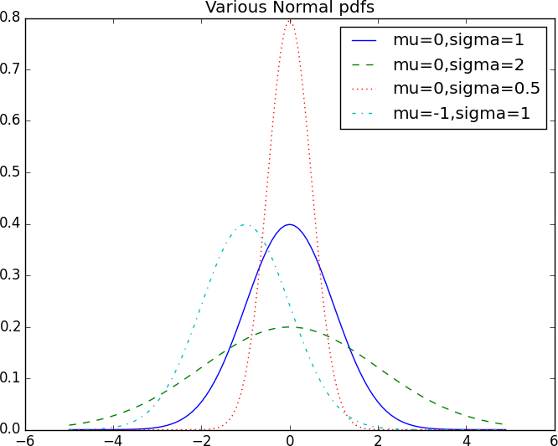

***Figure 19-2. Various normal PDFs***

When *μ* = 0 and *σ* = 1, it’s called the *standard normal distribution*. If *Z* is a standard normal random variable, then it turns out that:

X=σZ+μX=σZ+μ

is also normal but with mean μμ and standard deviation σσ. Conversely, if *X* is a normal random variable with mean μμ and standard deviation σσ,

Z=(X−μ)/σZ=(X-μ)/σ

is a standard normal variable.

The CDF for the normal distribution cannot be written in an “elementary” manner, but we can write it using Python’s math.erf [error function](http://en.wikipedia.org/wiki/Error_function):

**def** normal_cdf(x: float, mu: float = 0, sigma: float = 1) -> float:

**return** (1 + math.erf((x - mu) / math.sqrt(2) / sigma)) / 2

Again, in [Figure 19-3](https://learning.oreilly.com/library/view/data-science-from/9781492041122/ch06.html#various_normal_cdfs), we plot a few CDFs:

xs = [x / 10.0 **for** x **in** range(-50, 50)]

plt.plot(xs,[normal_cdf(x,sigma=1) **for** x **in** xs],'-',label='mu=0,sigma=1')

plt.plot(xs,[normal_cdf(x,sigma=2) **for** x **in** xs],'--',label='mu=0,sigma=2')

plt.plot(xs,[normal_cdf(x,sigma=0.5) **for** x **in** xs],':',label='mu=0,sigma=0.5')

plt.plot(xs,[normal_cdf(x,mu=-1) **for** x **in** xs],'-.',label='mu=-1,sigma=1')

plt.legend(loc=4) *# bottom right*

plt.title("Various Normal cdfs")

plt.show()

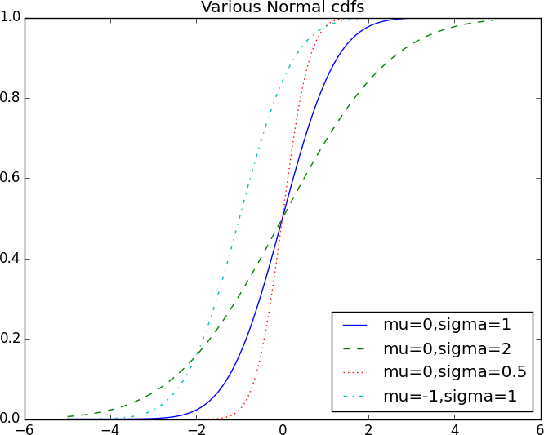

***Figure 19-3. Various normal CDFs***

Sometimes we’ll need to invert normal_cdf to find the value corresponding to a specified probability. There’s no simple way to compute its inverse, but normal_cdf is continuous and strictly increasing, so we can use a [*binary search*](http://en.wikipedia.org/wiki/Binary_search_algorithm):

**def** inverse_normal_cdf(p: float,

mu: float = 0,

sigma: float = 1,

tolerance: float = 0.00001) -> float:

*"""Find approximate inverse using binary search"""*

*# if not standard, compute standard and rescale*

**if** mu != 0 **or** sigma != 1:

**return** mu + sigma * inverse_normal_cdf(p, tolerance=tolerance)

low_z = -10.0 *# normal_cdf(-10) is (very close to) 0*

hi_z = 10.0 *# normal_cdf(10) is (very close to) 1*

**while** hi_z - low_z > tolerance:

mid_z = (low_z + hi_z) / 2 *# Consider the midpoint*

mid_p = normal_cdf(mid_z) *# and the CDF's value there*

**if** mid_p < p:

low_z = mid_z *# Midpoint too low, search above it*

**else**:

hi_z = mid_z *# Midpoint too high, search below it*

**return** mid_z

The function repeatedly bisects intervals until it narrows in on a *Z* that’s close enough to the desired probability.

**The Central Limit Theorem**

One reason the normal distribution is so useful is the *central limit theorem*, which says (in essence) that a random variable defined as the average of a large number of independent and identically distributed random variables is itself approximately normally distributed.

In particular, if x1,...,xnx1,...,xn are random variables with mean *μ* and standard deviation *σ*, and if *n* is large, then:

1n(x1+...+xn)1n(x1+...+xn)

is approximately normally distributed with mean *μ* and standard deviation σ/n−−√σ/n. Equivalently (but often more usefully),

(x1+...+xn)−μnσn−−√(x1+...+xn)-μnσn

is approximately normally distributed with mean 0 and standard deviation 1.

An easy way to illustrate this is by looking at *binomial* random variables, which have two parameters *n* and *p*. A Binomial(*n*,*p*) random variable is simply the sum of *n* independent Bernoulli(*p*) random variables, each of which equals 1 with probability *p* and 0 with probability 1 – *p*:

**def** bernoulli_trial(p: float) -> int:

*"""Returns 1 with probability p and 0 with probability 1-p"""*

**return** 1 **if** random.random() < p **else** 0

**def** binomial(n: int, p: float) -> int:

*"""Returns the sum of n bernoulli(p) trials"""*

**return** sum(bernoulli_trial(p) **for** _ **in** range(n))

The mean of a Bernoulli(*p*) variable is *p*, and its standard deviation is p(1−p)−−−−−−−√p(1-p). The central limit theorem says that as *n* gets large, a Binomial(*n*,*p*) variable is approximately a normal random variable with mean μ=npμ=np and standard deviation σ=np(1−p)−−−−−−−−√σ=np(1-p). If we plot both, you can easily see the resemblance:

**from** **collections** **import** Counter

**def** binomial_histogram(p: float, n: int, num_points: int) -> None:

*"""Picks points from a Binomial(n, p) and plots their histogram"""*

data = [binomial(n, p) **for** _ **in** range(num_points)]

*# use a bar chart to show the actual binomial samples*

histogram = Counter(data)

plt.bar([x - 0.4 **for** x **in** histogram.keys()],

[v / num_points **for** v **in** histogram.values()],

0.8,

color='0.75')

mu = p * n

sigma = math.sqrt(n * p * (1 - p))

*# use a line chart to show the normal approximation*

xs = range(min(data), max(data) + 1)

ys = [normal_cdf(i + 0.5, mu, sigma) - normal_cdf(i - 0.5, mu, sigma)

**for** i **in** xs]

plt.plot(xs,ys)

plt.title("Binomial Distribution vs. Normal Approximation")

plt.show()

For example, when you call make_hist(0.75, 100, 10000), you get the graph in [Figure 19-4](https://learning.oreilly.com/library/view/data-science-from/9781492041122/ch06.html#make_hist_result).

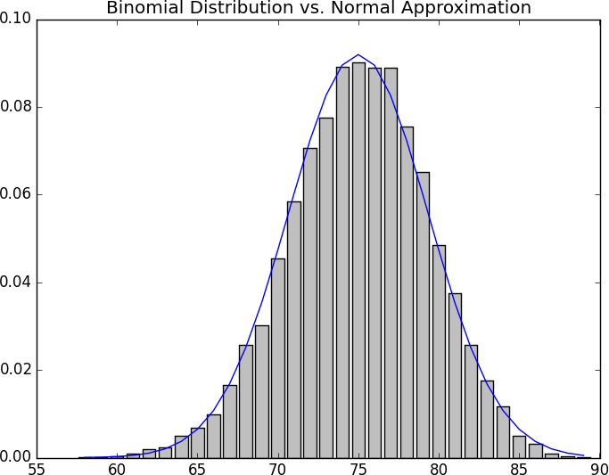

***Figure 19-4. The output from binomial_histogram***

The moral of this approximation is that if you want to know the probability that (say) a fair coin turns up more than 60 heads in 100 flips, you can estimate it as the probability that a Normal(50,5) is greater than 60, which is easier than computing the Binomial(100,0.5) CDF. (Although in most applications you’d probably be using statistical software that would gladly compute whatever probabilities you want.)

# Chapter 20. Hypothesis and Inference

*It is the mark of a truly intelligent person to be moved by statistics.*

George Bernard Shaw

What will we do with all this statistics and probability theory? The science part of data science frequently involves forming and testing hypotheses about our data and the processes that generate it.

# Statistical Hypothesis Testing

Often, as data scientists, we’ll want to test whether a certain hypothesis is likely to be true. For our purposes, hypotheses are assertions like “this coin is fair” or “data scientists prefer Python to R” or “people are more likely to navigate away from the page without ever reading the content if we pop up an irritating interstitial advertisement with a tiny, hard-to-find close button” that can be translated into statistics about data. Under various assumptions, those statistics can be thought of as observations of random variables from known distributions, which allows us to make statements about how likely those assumptions are to hold.

In the classical setup, we have a null hypothesis, H0H0, that represents some default position, and some alternative hypothesis, H1H1, that we’d like to compare it with. We use statistics to decide whether we can reject H0H0 as false or not. This will probably make more sense with an example.

# Example: Flipping a Coin

Imagine we have a coin and we want to test whether it’s fair. We’ll make the assumption that the coin has some probability p of landing heads, and so our null hypothesis is that the coin is fair—that is, that p = 0.5. We’ll test this against the alternative hypothesis p ≠ 0.5.

In particular, our test will involve flipping the coin some number, n, times and counting the number of heads, X. Each coin flip is a Bernoulli trial, which means that X is a Binomial(n,p) random variable, which (as we saw in [Chapter 6](https://learning.oreilly.com/library/view/data-science-from/9781492041122/ch06.html#probability)) we can approximate using the normal distribution:

**from** **typing** **import** Tuple

**import** **math**

**def** normal_approximation_to_binomial(n: int, p: float) -> Tuple[float, float]:

*"""Returns mu and sigma corresponding to a Binomial(n, p)"""*

mu = p * n

sigma = math.sqrt(p * (1 - p) * n)

**return** mu, sigma

Whenever a random variable follows a normal distribution, we can use normal_cdf to figure out the probability that its realized value lies within or outside a particular interval:

**from** **scratch.probability** **import** normal_cdf

*# The normal cdf _is_ the probability the variable is below a threshold*

normal_probability_below = normal_cdf

*# It's above the threshold if it's not below the threshold*

**def** normal_probability_above(lo: float,

mu: float = 0,

sigma: float = 1) -> float:

*"""The probability that an N(mu, sigma) is greater than lo."""*

**return** 1 - normal_cdf(lo, mu, sigma)

*# It's between if it's less than hi, but not less than lo*

**def** normal_probability_between(lo: float,

hi: float,

mu: float = 0,

sigma: float = 1) -> float:

*"""The probability that an N(mu, sigma) is between lo and hi."""*

**return** normal_cdf(hi, mu, sigma) - normal_cdf(lo, mu, sigma)

*# It's outside if it's not between*

**def** normal_probability_outside(lo: float,

hi: float,

mu: float = 0,

sigma: float = 1) -> float:

*"""The probability that an N(mu, sigma) is not between lo and hi."""*

**return** 1 - normal_probability_between(lo, hi, mu, sigma)

We can also do the reverse—find either the nontail region or the (symmetric) interval around the mean that accounts for a certain level of likelihood. For example, if we want to find an interval centered at the mean and containing 60% probability, then we find the cutoffs where the upper and lower tails each contain 20% of the probability (leaving 60%):

**from** **scratch.probability** **import** inverse_normal_cdf

**def** normal_upper_bound(probability: float,

mu: float = 0,

sigma: float = 1) -> float:

*"""Returns the z for which P(Z <= z) = probability"""*

**return** inverse_normal_cdf(probability, mu, sigma)

**def** normal_lower_bound(probability: float,

mu: float = 0,

sigma: float = 1) -> float:

*"""Returns the z for which P(Z >= z) = probability"""*

**return** inverse_normal_cdf(1 - probability, mu, sigma)

**def** normal_two_sided_bounds(probability: float,

mu: float = 0,

sigma: float = 1) -> Tuple[float, float]:

*"""*

*Returns the symmetric (about the mean) bounds*

*that contain the specified probability*

*"""*

tail_probability = (1 - probability) / 2

*# upper bound should have tail_probability above it*

upper_bound = normal_lower_bound(tail_probability, mu, sigma)

*# lower bound should have tail_probability below it*

lower_bound = normal_upper_bound(tail_probability, mu, sigma)

**return** lower_bound, upper_bound

In particular, let’s say that we choose to flip the coin n = 1,000 times. If our hypothesis of fairness is true, Xshould be distributed approximately normally with mean 500 and standard deviation 15.8:

mu_0, sigma_0 = normal_approximation_to_binomial(1000, 0.5)

We need to make a decision about significance—how willing we are to make a type 1 error (“false positive”), in which we reject H0H0 even though it’s true. For reasons lost to the annals of history, this willingness is often set at 5% or 1%. Let’s choose 5%.

Consider the test that rejects H0H0 if X falls outside the bounds given by:

*# (469, 531)*

lower_bound, upper_bound = normal_two_sided_bounds(0.95, mu_0, sigma_0)

Assuming p really equals 0.5 (i.e., H0H0 is true), there is just a 5% chance we observe an X that lies outside this interval, which is the exact significance we wanted. Said differently, if H0H0 is true, then, approximately 19 times out of 20, this test will give the correct result.

We are also often interested in the power of a test, which is the probability of not making a type 2 error (“false negative”), in which we fail to reject H0H0 even though it’s false. In order to measure this, we have to specify what exactly H0H0 being false means. (Knowing merely that p is not 0.5 doesn’t give us a ton of information about the distribution of X.) In particular, let’s check what happens if p is really 0.55, so that the coin is slightly biased toward heads.

In that case, we can calculate the power of the test with:

*# 95% bounds based on assumption p is 0.5*

lo, hi = normal_two_sided_bounds(0.95, mu_0, sigma_0)

*# actual mu and sigma based on p = 0.55*

mu_1, sigma_1 = normal_approximation_to_binomial(1000, 0.55)

*# a type 2 error means we fail to reject the null hypothesis,*

*# which will happen when X is still in our original interval*

type_2_probability = normal_probability_between(lo, hi, mu_1, sigma_1)

power = 1 - type_2_probability *# 0.887*

Imagine instead that our null hypothesis was that the coin is not biased toward heads, or that p≤0.5p≤0.5. In that case we want a one-sided test that rejects the null hypothesis when X is much larger than 500 but not when X is smaller than 500. So, a 5% significance test involves using normal_probability_below to find the cutoff below which 95% of the probability lies:

hi = normal_upper_bound(0.95, mu_0, sigma_0)

*# is 526 (< 531, since we need more probability in the upper tail)*

type_2_probability = normal_probability_below(hi, mu_1, sigma_1)

power = 1 - type_2_probability *# 0.936*

This is a more powerful test, since it no longer rejects H0H0 when X is below 469 (which is very unlikely to happen if H1H1 is true) and instead rejects H0H0 when X is between 526 and 531 (which is somewhat likely to happen if H1H1is true).

# p-Values

An alternative way of thinking about the preceding test involves p-values. Instead of choosing bounds based on some probability cutoff, we compute the probability—assuming H0H0 is true—that we would see a value at least as extreme as the one we actually observed.

For our two-sided test of whether the coin is fair, we compute:

**def** two_sided_p_value(x: float, mu: float = 0, sigma: float = 1) -> float:

*"""*

*How likely are we to see a value at least as extreme as x (in either*

*direction) if our values are from an N(mu, sigma)?*

*"""*

**if** x >= mu:

*# x is greater than the mean, so the tail is everything greater than x*

**return** 2 * normal_probability_above(x, mu, sigma)

**else**:

*# x is less than the mean, so the tail is everything less than x*

**return** 2 * normal_probability_below(x, mu, sigma)

If we were to see 530 heads, we would compute:

two_sided_p_value(529.5, mu_0, sigma_0) *# 0.062*

###### NOTE

Why did we use a value of 529.5 rather than using 530? This is what’s called a [continuity correction](http://en.wikipedia.org/wiki/Continuity_correction). It reflects the fact that normal_probability_between(529.5, 530.5, mu_0, sigma_0) is a better estimate of the probability of seeing 530 heads than normal_probability_between(530, 531, mu_0, sigma_0) is.

Correspondingly, normal_probability_above(529.5, mu_0, sigma_0) is a better estimate of the probability of seeing at least 530 heads. You may have noticed that we also used this in the code that produced [Figure 6-4](https://learning.oreilly.com/library/view/data-science-from/9781492041122/ch06.html#make_hist_result).

One way to convince yourself that this is a sensible estimate is with a simulation:

**import** **random**

extreme_value_count = 0

**for** _ **in** range(1000):

num_heads = sum(1 **if** random.random() < 0.5 **else** 0 *# Count # of heads*

**for** _ **in** range(1000)) *# in 1000 flips,*

**if** num_heads >= 530 **or** num_heads <= 470: *# and count how often*

extreme_value_count += 1 *# the # is 'extreme'*

*# p-value was 0.062 => ~62 extreme values out of 1000*

**assert** 59 < extreme_value_count < 65, f"{extreme_value_count}"

Since the p-value is greater than our 5% significance, we don’t reject the null. If we instead saw 532 heads, the p-value would be:

two_sided_p_value(531.5, mu_0, sigma_0) *# 0.0463*

which is smaller than the 5% significance, which means we would reject the null. It’s the exact same test as before. It’s just a different way of approaching the statistics.

Similarly, we would have:

upper_p_value = normal_probability_above

lower_p_value = normal_probability_below

For our one-sided test, if we saw 525 heads we would compute:

upper_p_value(524.5, mu_0, sigma_0) *# 0.061*

which means we wouldn’t reject the null. If we saw 527 heads, the computation would be:

upper_p_value(526.5, mu_0, sigma_0) *# 0.047*

and we would reject the null.

###### WARNING

Make sure your data is roughly normally distributed before using normal_probability_above to compute p-values. The annals of bad data science are filled with examples of people opining that the chance of some observed event occurring at random is one in a million, when what they really mean is “the chance, assuming the data is distributed normally,” which is fairly meaningless if the data isn’t.

There are various statistical tests for normality, but even plotting the data is a good start.

# Confidence Intervals

We’ve been testing hypotheses about the value of the heads probability p, which is a parameter of the unknown “heads” distribution. When this is the case, a third approach is to construct a confidence interval around the observed value of the parameter.

For example, we can estimate the probability of the unfair coin by looking at the average value of the Bernoulli variables corresponding to each flip—1 if heads, 0 if tails. If we observe 525 heads out of 1,000 flips, then we estimate p equals 0.525.

How confident can we be about this estimate? Well, if we knew the exact value of p, the central limit theorem (recall [“The Central Limit Theorem”](https://learning.oreilly.com/library/view/data-science-from/9781492041122/ch06.html#central_limit_theorem)) tells us that the average of those Bernoulli variables should be approximately normal, with mean p and standard deviation:

math.sqrt(p * (1 - p) / 1000)

Here we don’t know p, so instead we use our estimate:

p_hat = 525 / 1000

mu = p_hat

sigma = math.sqrt(p_hat * (1 - p_hat) / 1000) *# 0.0158*

This is not entirely justified, but people seem to do it anyway. Using the normal approximation, we conclude that we are “95% confident” that the following interval contains the true parameter p:

normal_two_sided_bounds(0.95, mu, sigma) *# [0.4940, 0.5560]*

###### NOTE

This is a statement about the interval, not about p. You should understand it as the assertion that if you were to repeat the experiment many times, 95% of the time the “true” parameter (which is the same every time) would lie within the observed confidence interval (which might be different every time).

In particular, we do not conclude that the coin is unfair, since 0.5 falls within our confidence interval.

If instead we’d seen 540 heads, then we’d have:

p_hat = 540 / 1000

mu = p_hat

sigma = math.sqrt(p_hat * (1 - p_hat) / 1000) *# 0.0158*

normal_two_sided_bounds(0.95, mu, sigma) *# [0.5091, 0.5709]*

Here, “fair coin” doesn’t lie in the confidence interval. (The “fair coin” hypothesis doesn’t pass a test that you’d expect it to pass 95% of the time if it were true.)

# p-Hacking

A procedure that erroneously rejects the null hypothesis only 5% of the time will—by definition—5% of the time erroneously reject the null hypothesis:

**from** **typing** **import** List

**def** run_experiment() -> List[bool]:

*"""Flips a fair coin 1000 times, True = heads, False = tails"""*

**return** [random.random() < 0.5 **for** _ **in** range(1000)]

**def** reject_fairness(experiment: List[bool]) -> bool:

*"""Using the 5% significance levels"""*

num_heads = len([flip **for** flip **in** experiment **if** flip])

**return** num_heads < 469 **or** num_heads > 531

random.seed(0)

experiments = [run_experiment() **for** _ **in** range(1000)]

num_rejections = len([experiment

**for** experiment **in** experiments

**if** reject_fairness(experiment)])

**assert** num_rejections == 46

What this means is that if you’re setting out to find “significant” results, you usually can. Test enough hypotheses against your dataset, and one of them will almost certainly appear significant. Remove the right outliers, and you can probably get your p-value below 0.05. (We did something vaguely similar in [“Correlation”](https://learning.oreilly.com/library/view/data-science-from/9781492041122/ch05.html#correlation); did you notice?)

This is sometimes called [p-hacking](https://www.nature.com/news/scientific-method-statistical-errors-1.14700) and is in some ways a consequence of the “inference from p-values framework.” A good article criticizing this approach is [“The Earth Is Round”](http://www.iro.umontreal.ca/~dift3913/cours/papers/cohen1994_The_earth_is_round.pdf), by Jacob Cohen.

If you want to do good science, you should determine your hypotheses before looking at the data, you should clean your data without the hypotheses in mind, and you should keep in mind that p-values are not substitutes for common sense. (An alternative approach is discussed in [“Bayesian Inference”](https://learning.oreilly.com/library/view/data-science-from/9781492041122/ch07.html#bayesian_inference).)

# Example: Running an A/B Test

One of your primary responsibilities at DataSciencester is experience optimization, which is a euphemism for trying to get people to click on advertisements. One of your advertisers has developed a new energy drink targeted at data scientists, and the VP of Advertisements wants your help choosing between advertisement A (“tastes great!”) and advertisement B (“less bias!”).

Being a scientist, you decide to run an experiment by randomly showing site visitors one of the two advertisements and tracking how many people click on each one.

If 990 out of 1,000 A-viewers click their ad, while only 10 out of 1,000 B-viewers click their ad, you can be pretty confident that A is the better ad. But what if the differences are not so stark? Here’s where you’d use statistical inference.

Let’s say that NANA people see ad A, and that nAnA of them click it. We can think of each ad view as a Bernoulli trial where pApA is the probability that someone clicks ad A. Then (if NANA is large, which it is here) we know that nA/NAnA/NA is approximately a normal random variable with mean pApA and standard deviationσA=pA(1−pA)/NA−−−−−−−−−−−−−√σA=pA(1-pA)/NA.

Similarly, nB/NBnB/NB is approximately a normal random variable with mean pBpB and standard deviation σB=pB(1−pB)/NB−−−−−−−−−−−−−√σB=pB(1-pB)/NB. We can express this in code as:

**def** estimated_parameters(N: int, n: int) -> Tuple[float, float]:

p = n / N

sigma = math.sqrt(p * (1 - p) / N)

**return** p, sigma

If we assume those two normals are independent (which seems reasonable, since the individual Bernoulli trials ought to be), then their difference should also be normal with mean pB−pApB-pA and standard deviation σ2A+σ2B−−−−−−−√σA2+σB2.

###### NOTE

This is sort of cheating. The math only works out exactly like this if you know the standard deviations. Here we’re estimating them from the data, which means that we really should be using a t-distribution. But for large enough datasets, it’s close enough that it doesn’t make much of a difference.

This means we can test the null hypothesis that pApA and pBpB are the same (that is, that pA−pBpA-pB is 0) by using the statistic:

**def** a_b_test_statistic(N_A: int, n_A: int, N_B: int, n_B: int) -> float:

p_A, sigma_A = estimated_parameters(N_A, n_A)

p_B, sigma_B = estimated_parameters(N_B, n_B)

**return** (p_B - p_A) / math.sqrt(sigma_A ** 2 + sigma_B ** 2)

which should approximately be a standard normal.

For example, if “tastes great” gets 200 clicks out of 1,000 views and “less bias” gets 180 clicks out of 1,000 views, the statistic equals:

z = a_b_test_statistic(1000, 200, 1000, 180) *# -1.14*

The probability of seeing such a large difference if the means were actually equal would be:

two_sided_p_value(z) *# 0.254*

which is large enough that we can’t conclude there’s much of a difference. On the other hand, if “less bias” only got 150 clicks, we’d have:

z = a_b_test_statistic(1000, 200, 1000, 150) *# -2.94*

two_sided_p_value(z) *# 0.003*

which means there’s only a 0.003 probability we’d see such a large difference if the ads were equally effective.

# Bayesian Inference

The procedures we’ve looked at have involved making probability statements about our tests: e.g., “There’s only a 3% chance you’d observe such an extreme statistic if our null hypothesis were true.”

An alternative approach to inference involves treating the unknown parameters themselves as random variables. The analyst (that’s you) starts with a prior distribution for the parameters and then uses the observed data and Bayes’s theorem to get an updated posterior distribution for the parameters. Rather than making probability judgments about the tests, you make probability judgments about the parameters.

For example, when the unknown parameter is a probability (as in our coin-flipping example), we often use a prior from the Beta distribution, which puts all its probability between 0 and 1:

**def** B(alpha: float, beta: float) -> float:

*"""A normalizing constant so that the total probability is 1"""*

**return** math.gamma(alpha) * math.gamma(beta) / math.gamma(alpha + beta)

**def** beta_pdf(x: float, alpha: float, beta: float) -> float:

**if** x <= 0 **or** x >= 1: *# no weight outside of [0, 1]*

**return** 0

**return** x ** (alpha - 1) * (1 - x) ** (beta - 1) / B(alpha, beta)

Generally speaking, this distribution centers its weight at:

alpha / (alpha + beta)

and the larger alpha and beta are, the “tighter” the distribution is.

For example, if alpha and beta are both 1, it’s just the uniform distribution (centered at 0.5, very dispersed). If alpha is much larger than beta, most of the weight is near 1. And if alpha is much smaller than beta, most of the weight is near 0. [Figure 20-1](https://learning.oreilly.com/library/view/data-science-from/9781492041122/ch07.html#beta_priors) shows several different Beta distributions.

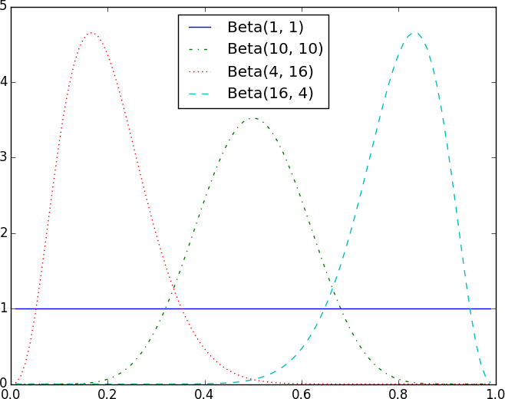

###### *Figure 20-1. Example Beta distributions*

Say we assume a prior distribution on p. Maybe we don’t want to take a stand on whether the coin is fair, and we choose alpha and beta to both equal 1. Or maybe we have a strong belief that the coin lands heads 55% of the time, and we choose alpha equals 55, beta equals 45.

Then we flip our coin a bunch of times and see h heads and t tails. Bayes’s theorem (and some mathematics too tedious for us to go through here) tells us that the posterior distribution for p is again a Beta distribution, but with parameters alpha + h and beta + t.

###### NOTE

It is no coincidence that the posterior distribution was again a Beta distribution. The number of heads is given by a Binomial distribution, and the Beta is the [conjugate prior](http://www.johndcook.com/blog/conjugate_prior_diagram/) to the Binomial distribution. This means that whenever you update a Beta prior using observations from the corresponding binomial, you will get back a Beta posterior.

Let’s say you flip the coin 10 times and see only 3 heads. If you started with the uniform prior (in some sense refusing to take a stand about the coin’s fairness), your posterior distribution would be a Beta(4, 8), centered around 0.33. Since you considered all probabilities equally likely, your best guess is close to the observed probability.

If you started with a Beta(20, 20) (expressing a belief that the coin was roughly fair), your posterior distribution would be a Beta(23, 27), centered around 0.46, indicating a revised belief that maybe the coin is slightly biased toward tails.

And if you started with a Beta(30, 10) (expressing a belief that the coin was biased to flip 75% heads), your posterior distribution would be a Beta(33, 17), centered around 0.66. In that case you’d still believe in a heads bias, but less strongly than you did initially. These three different posteriors are plotted in [Figure 20-2](https://learning.oreilly.com/library/view/data-science-from/9781492041122/ch07.html#beta_posteriors).

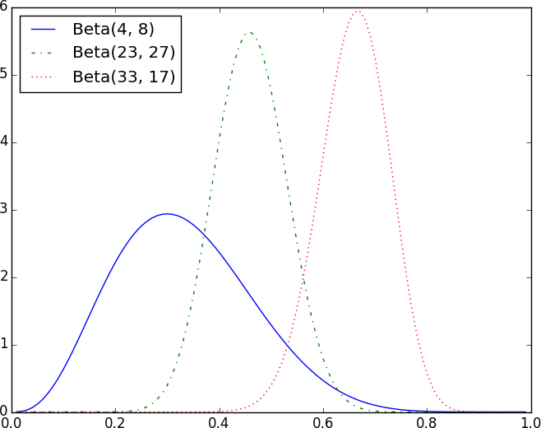

###### *Figure 20-2. Posteriors arising from different priors*

If you flipped the coin more and more times, the prior would matter less and less until eventually you’d have (nearly) the same posterior distribution no matter which prior you started with.

For example, no matter how biased you initially thought the coin was, it would be hard to maintain that belief after seeing 1,000 heads out of 2,000 flips (unless you are a lunatic who picks something like a Beta(1000000,1) prior).

What’s interesting is that this allows us to make probability statements about hypotheses: “Based on the prior and the observed data, there is only a 5% likelihood the coin’s heads probability is between 49% and 51%.” This is philosophically very different from a statement like “If the coin were fair, we would expect to observe data so extreme only 5% of the time.”

Using Bayesian inference to test hypotheses is considered somewhat controversial—in part because the mathematics can get somewhat complicated, and in part because of the subjective nature of choosing a prior. We won’t use it any further in this book, but it’s good to know about.

**Chapter 21. Gradient Descent**

*Those who boast of their descent, brag on what they owe to others.*

Seneca

Frequently when doing data science, we’ll be trying to the find the best model for a certain situation. And usually “best” will mean something like “minimizes the error of its predictions” or “maximizes the likelihood of the data.” In other words, it will represent the solution to some sort of optimization problem.

This means we’ll need to solve a number of optimization problems. And in particular, we’ll need to solve them from scratch. Our approach will be a technique called *gradient descent*, which lends itself pretty well to a from-scratch treatment. You might not find it super-exciting in and of itself, but it will enable us to do exciting things throughout the book, so bear with me.

**The Idea Behind Gradient Descent**

Suppose we have some function f that takes as input a vector of real numbers and outputs a single real number. One simple such function is:

**from** **scratch.linear_algebra** **import** Vector, dot

**def** sum_of_squares(v: Vector) -> float:

*"""Computes the sum of squared elements in v"""*

**return** dot(v, v)

We’ll frequently need to maximize or minimize such functions. That is, we need to find the input v that produces the largest (or smallest) possible value.

For functions like ours, the *gradient* (if you remember your calculus, this is the vector of partial derivatives) gives the input direction in which the function most quickly increases. (If you don’t remember your calculus, take my word for it or look it up on the internet.)

Accordingly, one approach to maximizing a function is to pick a random starting point, compute the gradient, take a small step in the direction of the gradient (i.e., the direction that causes the function to increase the most), and repeat with the new starting point. Similarly, you can try to minimize a function by taking small steps in the *opposite* direction, as shown in [Figure 21-1](https://learning.oreilly.com/library/view/data-science-from/9781492041122/ch08.html#gradient_descent_image).

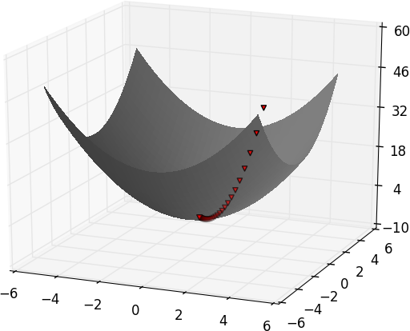

***Figure 21-1. Finding a minimum using gradient descent***

**NOTE**

If a function has a unique global minimum, this procedure is likely to find it. If a function has multiple (local) minima, this procedure might “find” the wrong one of them, in which case you might rerun the procedure from different starting points. If a function has no minimum, then it’s possible the procedure might go on forever.

**Estimating the Gradient**

If f is a function of one variable, its derivative at a point x measures how f(x) changes when we make a very small change to x. The derivative is defined as the limit of the difference quotients:

**from** **typing** **import** Callable

**def** difference_quotient(f: Callable[[float], float],

x: float,

h: float) -> float:

**return** (f(x + h) - f(x)) / h

as h approaches zero.

(Many a would-be calculus student has been stymied by the mathematical definition of limit, which is beautiful but can seem somewhat forbidding. Here we’ll cheat and simply say that “limit” means what you think it means.)

The derivative is the slope of the tangent line at (x,f(x))(x,f(x)), while the difference quotient is the slope of the not-quite-tangent line that runs through (x+h,f(x+h))(x+h,f(x+h)). As *h* gets smaller and smaller, the not-quite-tangent line gets closer and closer to the tangent line ([Figure 21-2](https://learning.oreilly.com/library/view/data-science-from/9781492041122/ch08.html#difference_quotient)).

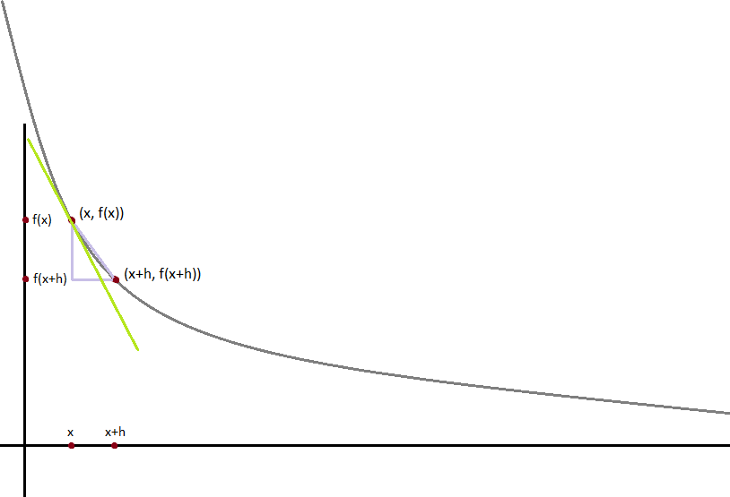

***Figure 21-2. Approximating a derivative with a difference quotient***

For many functions it’s easy to exactly calculate derivatives. For example, the square function:

**def** square(x: float) -> float:

**return** x * x

has the derivative:

**def** derivative(x: float) -> float:

**return** 2 * x

which is easy for us to check by explicitly computing the difference quotient and taking the limit. (Doing so requires nothing more than high school algebra.)

What if you couldn’t (or didn’t want to) find the gradient? Although we can’t take limits in Python, we can estimate derivatives by evaluating the difference quotient for a very small e. [Figure 21-3](https://learning.oreilly.com/library/view/data-science-from/9781492041122/ch08.html#difference_quotient_goodness) shows the results of one such estimation:

xs = range(-10, 11)

actuals = [derivative(x) **for** x **in** xs]

estimates = [difference_quotient(square, x, h=0.001) **for** x **in** xs]

*# plot to show they're basically the same*

**import** **matplotlib.pyplot** **as** **plt**

plt.title("Actual Derivatives vs. Estimates")

plt.plot(xs, actuals, 'rx', label='Actual') *# red x*

plt.plot(xs, estimates, 'b+', label='Estimate') *# blue +*

plt.legend(loc=9)

plt.show()

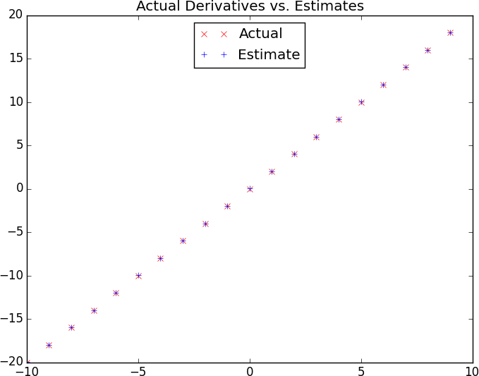

***Figure 21-3. Goodness of difference quotient approximation***

When f is a function of many variables, it has multiple *partial derivatives*, each indicating how f changes when we make small changes in just one of the input variables.

We calculate its *i*th partial derivative by treating it as a function of just its *i*th variable, holding the other variables fixed:

**def** partial_difference_quotient(f: Callable[[Vector], float],

v: Vector,

i: int,

h: float) -> float:

*"""Returns the i-th partial difference quotient of f at v"""*

w = [v_j + (h **if** j == i **else** 0) *# add h to just the ith element of v*

**for** j, v_j **in** enumerate(v)]

**return** (f(w) - f(v)) / h

after which we can estimate the gradient the same way:

**def** estimate_gradient(f: Callable[[Vector], float],

v: Vector,

h: float = 0.0001):

**return** [partial_difference_quotient(f, v, i, h)

**for** i **in** range(len(v))]

**NOTE**

A major drawback to this “estimate using difference quotients” approach is that it’s computationally expensive. If v has length *n*, estimate_gradient has to evaluate f on 2*n* different inputs. If you’re repeatedly estimating gradients, you’re doing a whole lot of extra work. In everything we do, we’ll use math to calculate our gradient functions explicitly.

**Using the Gradient**

It’s easy to see that the sum_of_squares function is smallest when its input v is a vector of zeros. But imagine we didn’t know that. Let’s use gradients to find the minimum among all three-dimensional vectors. We’ll just pick a random starting point and then take tiny steps in the opposite direction of the gradient until we reach a point where the gradient is very small:

**import** **random**

**from** **scratch.linear_algebra** **import** distance, add, scalar_multiply

**def** gradient_step(v: Vector, gradient: Vector, step_size: float) -> Vector:

*"""Moves `step_size` in the `gradient` direction from `v`"""*

**assert** len(v) == len(gradient)

step = scalar_multiply(step_size, gradient)

**return** add(v, step)

**def** sum_of_squares_gradient(v: Vector) -> Vector:

**return** [2 * v_i **for** v_i **in** v]

*# pick a random starting point*

v = [random.uniform(-10, 10) **for** i **in** range(3)]

**for** epoch **in** range(1000):

grad = sum_of_squares_gradient(v) *# compute the gradient at v*

v = gradient_step(v, grad, -0.01) *# take a negative gradient step*

**print**(epoch, v)

**assert** distance(v, [0, 0, 0]) < 0.001 *# v should be close to 0*

If you run this, you’ll find that it always ends up with a v that’s very close to [0,0,0]. The more epochs you run it for, the closer it will get.

**Choosing the Right Step Size**

Although the rationale for moving against the gradient is clear, how far to move is not. Indeed, choosing the right step size is more of an art than a science. Popular options include:

* Using a fixed step size
* Gradually shrinking the step size over time
* At each step, choosing the step size that minimizes the value of the objective function

The last approach sounds great but is, in practice, a costly computation. To keep things simple, we’ll mostly just use a fixed step size. The step size that “works” depends on the problem—too small, and your gradient descent will take forever; too big, and you’ll take giant steps that might make the function you care about get larger or even be undefined. So we’ll need to experiment.

**Using Gradient Descent to Fit Models**

In this book, we’ll be using gradient descent to fit parameterized models to data. In the usual case, we’ll have some dataset and some (hypothesized) model for the data that depends (in a differentiable way) on one or more parameters. We’ll also have a *loss* function that measures how well the model fits our data. (Smaller is better.)

If we think of our data as being fixed, then our loss function tells us how good or bad any particular model parameters are. This means we can use gradient descent to find the model parameters that make the loss as small as possible. Let’s look at a simple example:

*# x ranges from -50 to 49, y is always 20 * x + 5*

inputs = [(x, 20 * x + 5) **for** x **in** range(-50, 50)]

In this case we *know* the parameters of the linear relationship between x and y, but imagine we’d like to learn them from the data. We’ll use gradient descent to find the slope and intercept that minimize the average squared error.

We’ll start off with a function that determines the gradient based on the error from a single data point:

**def** linear_gradient(x: float, y: float, theta: Vector) -> Vector:

slope, intercept = theta

predicted = slope * x + intercept *# The prediction of the model.*

error = (predicted - y) *# error is (predicted - actual).*

squared_error = error ** 2 *# We'll minimize squared error*

grad = [2 * error * x, 2 * error] *# using its gradient.*

**return** grad

Let’s think about what that gradient means. Imagine for some x our prediction is too large. In that case the erroris positive. The second gradient term, 2 * error, is positive, which reflects the fact that small increases in the intercept will make the (already too large) prediction even larger, which will cause the squared error (for this x) to get even bigger.

The first gradient term, 2 * error * x, has the same sign as x. Sure enough, if x is positive, small increases in the slope will again make the prediction (and hence the error) larger. If x is negative, though, small increases in the slope will make the prediction (and hence the error) smaller.

Now, that computation was for a single data point. For the whole dataset we’ll look at the *mean squared error*. And the gradient of the mean squared error is just the mean of the individual gradients.

So, here’s what we’re going to do:

1. Start with a random value for theta.
2. Compute the mean of the gradients.
3. Adjust theta in that direction.
4. Repeat.

After a lot of *epochs* (what we call each pass through the dataset), we should learn something like the correct parameters:

**from** **scratch.linear_algebra** **import** vector_mean

*# Start with random values for slope and intercept*

theta = [random.uniform(-1, 1), random.uniform(-1, 1)]

learning_rate = 0.001

**for** epoch **in** range(5000):

*# Compute the mean of the gradients*

grad = vector_mean([linear_gradient(x, y, theta) **for** x, y **in** inputs])

*# Take a step in that direction*

theta = gradient_step(theta, grad, -learning_rate)

**print**(epoch, theta)

slope, intercept = theta

**assert** 19.9 < slope < 20.1, "slope should be about 20"

**assert** 4.9 < intercept < 5.1, "intercept should be about 5"

**Minibatch and Stochastic Gradient Descent**

One drawback of the preceding approach is that we had to evaluate the gradients on the entire dataset before we could take a gradient step and update our parameters. In this case it was fine, because our dataset was only 100 pairs and the gradient computation was cheap.

Your models, however, will frequently have large datasets and expensive gradient computations. In that case you’ll want to take gradient steps more often.

We can do this using a technique called *minibatch gradient descent*, in which we compute the gradient (and take a gradient step) based on a “minibatch” sampled from the larger dataset:

**from** **typing** **import** TypeVar, List, Iterator

T = TypeVar('T') *# this allows us to type "generic" functions*

**def** minibatches(dataset: List[T],

batch_size: int,

shuffle: bool = True) -> Iterator[List[T]]:

*"""Generates `batch_size`-sized minibatches from the dataset"""*

*# start indexes 0, batch_size, 2 * batch_size, ...*

batch_starts = [start **for** start **in** range(0, len(dataset), batch_size)]

**if** shuffle: random.shuffle(batch_starts) *# shuffle the batches*

**for** start **in** batch_starts:

end = start + batch_size

**yield** dataset[start:end]

**NOTE**

The TypeVar(T) allows us to create a “generic” function. It says that our dataset can be a list of any single type—strs, ints, lists, whatever—but whatever that type is, the outputs will be batches of it.

Now we can solve our problem again using minibatches:

theta = [random.uniform(-1, 1), random.uniform(-1, 1)]

**for** epoch **in** range(1000):

**for** batch **in** minibatches(inputs, batch_size=20):

grad = vector_mean([linear_gradient(x, y, theta) **for** x, y **in** batch])

theta = gradient_step(theta, grad, -learning_rate)

**print**(epoch, theta)

slope, intercept = theta

**assert** 19.9 < slope < 20.1, "slope should be about 20"

**assert** 4.9 < intercept < 5.1, "intercept should be about 5"

Another variation is *stochastic gradient descent*, in which you take gradient steps based on one training example at a time:

theta = [random.uniform(-1, 1), random.uniform(-1, 1)]

**for** epoch **in** range(100):

**for** x, y **in** inputs:

grad = linear_gradient(x, y, theta)

theta = gradient_step(theta, grad, -learning_rate)

**print**(epoch, theta)

slope, intercept = theta

**assert** 19.9 < slope < 20.1, "slope should be about 20"

**assert** 4.9 < intercept < 5.1, "intercept should be about 5"

On this problem, stochastic gradient descent finds the optimal parameters in a much smaller number of epochs. But there are always tradeoffs. Basing gradient steps on small minibatches (or on single data points) allows you to take more of them, but the gradient for a single point might lie in a very different direction from the gradient for the dataset as a whole.

In addition, if we weren’t doing our linear algebra from scratch, there would be performance gains from “vectorizing” our computations across batches rather than computing the gradient one point at a time.

Throughout the book, we’ll play around to find optimal batch sizes and step sizes.

**NOTE**

The terminology for the various flavors of gradient descent is not uniform. The “compute the gradient for the whole dataset” approach is often called *batch gradient descent*, and some people say *stochastic gradient descent* when referring to the minibatch version (of which the one-point-at-a-time version is a special case).

**Chapter 22. Getting Data**

*To write it, it took three months; to conceive it, three minutes; to collect the data in it, all my life.*

F. Scott Fitzgerald

In order to be a data scientist you need data. In fact, as a data scientist you will spend an embarrassingly large fraction of your time acquiring, cleaning, and transforming data. In a pinch, you can always type the data in yourself (or if you have minions, make them do it), but usually this is not a good use of your time. In this chapter, we’ll look at different ways of getting data into Python and into the right formats.

**stdin and stdout**

If you run your Python scripts at the command line, you can *pipe* data through them using sys.stdin and sys.stdout. For example, here is a script that reads in lines of text and spits back out the ones that match a regular expression:

*# egrep.py*

**import** **sys**, **re**

*# sys.argv is the list of command-line arguments*

*# sys.argv[0] is the name of the program itself*

*# sys.argv[1] will be the regex specified at the command line*

regex = sys.argv[1]

*# for every line passed into the script*

**for** line **in** sys.stdin:

*# if it matches the regex, write it to stdout*

**if** re.search(regex, line):

sys.stdout.write(line)

And here’s one that counts the lines it receives and then writes out the count:

*# line_count.py*

**import** **sys**

count = 0

**for** line **in** sys.stdin:

count += 1

*# print goes to sys.stdout*

**print**(count)

You could then use these to count how many lines of a file contain numbers. In Windows, you’d use:

type SomeFile.txt | python egrep.py "[0-9]" | python line_count.py

whereas in a Unix system you’d use:

cat SomeFile.txt | python egrep.py "[0-9]" | python line_count.py

The | is the pipe character, which means “use the output of the left command as the input of the right command.” You can build pretty elaborate data-processing pipelines this way.

**NOTE**

If you are using Windows, you can probably leave out the python part of this command:

type SomeFile.txt | egrep.py "[0-9]" | line_count.py

If you are on a Unix system, doing so requires [a couple more steps](https://stackoverflow.com/questions/15587877/run-a-python-script-in-terminal-without-the-python-command). First add a “shebang” as the first line of your script #!/usr/bin/env python. Then, at the command line, use chmod x egrep.py++ to make the file executable.

Similarly, here’s a script that counts the words in its input and writes out the most common ones:

*# most_common_words.py*

**import** **sys**

**from** **collections** **import** Counter

*# pass in number of words as first argument*

**try**:

num_words = int(sys.argv[1])

**except**:

**print**("usage: most_common_words.py num_words")

sys.exit(1) *# nonzero exit code indicates error*

counter = Counter(word.lower() *# lowercase words*

**for** line **in** sys.stdin

**for** word **in** line.strip().split() *# split on spaces*

**if** word) *# skip empty 'words'*

**for** word, count **in** counter.most_common(num_words):

sys.stdout.write(str(count))

sys.stdout.write("**\t**")

sys.stdout.write(word)

sys.stdout.write("**\n**")

after which you could do something like:

$ cat the_bible.txt | python most_common_words.py 10

36397 the

30031 and

20163 of

7154 to

6484 in

5856 that

5421 he

5226 his

5060 unto

4297 shall

(If you are using Windows, then use type instead of cat.)

**NOTE**

If you are a seasoned Unix programmer, you are probably familiar with a wide variety of command-line tools (for example, egrep) that are built into your operating system and are preferable to building your own from scratch. Still, it’s good to know you can if you need to.

**Reading Files**

You can also explicitly read from and write to files directly in your code. Python makes working with files pretty simple.

**The Basics of Text Files**

The first step to working with a text file is to obtain a *file object* using open:

*# 'r' means read-only, it's assumed if you leave it out*

file_for_reading = open('reading_file.txt', 'r')

file_for_reading2 = open('reading_file.txt')

*# 'w' is write -- will destroy the file if it already exists!*

file_for_writing = open('writing_file.txt', 'w')

*# 'a' is append -- for adding to the end of the file*

file_for_appending = open('appending_file.txt', 'a')

*# don't forget to close your files when you're done*

file_for_writing.close()

Because it is easy to forget to close your files, you should always use them in a with block, at the end of which they will be closed automatically:

**with** open(filename) **as** f:

data = function_that_gets_data_from(f)

*# at this point f has already been closed, so don't try to use it*

process(data)

If you need to read a whole text file, you can just iterate over the lines of the file using for:

starts_with_hash = 0

**with** open('input.txt') **as** f:

**for** line **in** f: *# look at each line in the file*

**if** re.match("^#",line): *# use a regex to see if it starts with '#'*

starts_with_hash += 1 *# if it does, add 1 to the count*

Every line you get this way ends in a newline character, so you’ll often want to strip it before doing anything with it.

For example, imagine you have a file full of email addresses, one per line, and you need to generate a histogram of the domains. The rules for correctly extracting domains are somewhat subtle—see, e.g., the [Public Suffix List](https://publicsuffix.org/)—but a good first approximation is to just take the parts of the email addresses that come after the *@* (this gives the wrong answer for email addresses like *joel@mail.datasciencester.com*, but for the purposes of this example we’re willing to live with that):

**def** get_domain(email_address: str) -> str:

*"""Split on '@' and return the last piece"""*

**return** email_address.lower().split("@")[-1]

*# a couple of tests*

**assert** get_domain('joelgrus@gmail.com') == 'gmail.com'

**assert** get_domain('joel@m.datasciencester.com') == 'm.datasciencester.com'

**from** **collections** **import** Counter

**with** open('email_addresses.txt', 'r') **as** f:

domain_counts = Counter(get_domain(line.strip())

**for** line **in** f

**if** "@" **in** line)

**Delimited Files**

The hypothetical email addresses file we just processed had one address per line. More frequently you’ll work with files with lots of data on each line. These files are very often either *comma-separated* or *tab-separated*: each line has several fields, with a comma or a tab indicating where one field ends and the next field starts.

This starts to get complicated when you have fields with commas and tabs and newlines in them (which you inevitably will). For this reason, you should never try to parse them yourself. Instead, you should use Python’s csv module (or the pandas library, or some other library that’s designed to read comma-separated or tab-delimited files).

**WARNING**

Never parse a comma-separated file yourself. You will screw up the edge cases!

If your file has no headers (which means you probably want each row as a list, and which places the burden on you to know what’s in each column), you can use csv.reader to iterate over the rows, each of which will be an appropriately split list.

For example, if we had a tab-delimited file of stock prices:

6/20/2014 AAPL 90.91

6/20/2014 MSFT 41.68

6/20/2014 FB 64.5

6/19/2014 AAPL 91.86

6/19/2014 MSFT 41.51

6/19/2014 FB 64.34

we could process them with:

**import** **csv**

**with** open('tab_delimited_stock_prices.txt') **as** f:

tab_reader = csv.reader(f, delimiter='**\t**')

**for** row **in** tab_reader:

date = row[0]

symbol = row[1]

closing_price = float(row[2])

process(date, symbol, closing_price)

If your file has headers:

date:symbol:closing_price

6/20/2014:AAPL:90.91

6/20/2014:MSFT:41.68

6/20/2014:FB:64.5

you can either skip the header row with an initial call to reader.next, or get each row as a dict (with the headers as keys) by using csv.DictReader:

**with** open('colon_delimited_stock_prices.txt') **as** f:

colon_reader = csv.DictReader(f, delimiter=':')

**for** dict_row **in** colon_reader:

date = dict_row["date"]

symbol = dict_row["symbol"]

closing_price = float(dict_row["closing_price"])

process(date, symbol, closing_price)

Even if your file doesn’t have headers, you can still use DictReader by passing it the keys as a fieldnamesparameter.

You can similarly write out delimited data using csv.writer:

todays_prices = {'AAPL': 90.91, 'MSFT': 41.68, 'FB': 64.5 }

**with** open('comma_delimited_stock_prices.txt', 'w') **as** f:

csv_writer = csv.writer(f, delimiter=',')

**for** stock, price **in** todays_prices.items():

csv_writer.writerow([stock, price])

csv.writer will do the right thing if your fields themselves have commas in them. Your own hand-rolled writer probably won’t. For example, if you attempt:

results = [["test1", "success", "Monday"],

["test2", "success, kind of", "Tuesday"],

["test3", "failure, kind of", "Wednesday"],

["test4", "failure, utter", "Thursday"]]

*# don't do this!*

**with** open('bad_csv.txt', 'w') **as** f:

**for** row **in** results:

f.write(",".join(map(str, row))) *# might have too many commas in it!*

f.write("**\n**") *# row might have newlines as well!*

You will end up with a *.csv* file that looks like this:

test1,success,Monday

test2,success, kind of,Tuesday

test3,failure, kind of,Wednesday

test4,failure, utter,Thursday

and that no one will ever be able to make sense of.

**Scraping the Web**

Another way to get data is by scraping it from web pages. Fetching web pages, it turns out, is pretty easy; getting meaningful structured information out of them less so.

**HTML and the Parsing Thereof**

Pages on the web are written in HTML, in which text is (ideally) marked up into elements and their attributes:

**<html>**

**<head>**

**<title>**A web page**</title>**

**</head>**

**<body>**

**<p** id="author"**>**Joel Grus**</p>**

**<p** id="subject"**>**Data Science**</p>**

**</body>**

**</html>**

In a perfect world, where all web pages were marked up semantically for our benefit, we would be able to extract data using rules like “find the <p> element whose id is subject and return the text it contains.” In the actual world, HTML is not generally well formed, let alone annotated. This means we’ll need help making sense of it.

To get data out of HTML, we will use the [Beautiful Soup library](http://www.crummy.com/software/BeautifulSoup/), which builds a tree out of the various elements on a web page and provides a simple interface for accessing them. As I write this, the latest version is Beautiful Soup 4.6.0, which is what we’ll be using. We’ll also be using the [Requests library](http://docs.python-requests.org/en/latest/), which is a much nicer way of making HTTP requests than anything that’s built into Python.

Python’s built-in HTML parser is not that lenient, which means that it doesn’t always cope well with HTML that’s not perfectly formed. For that reason, we’ll also install the html5lib parser.

Making sure you’re in the correct virtual environment, install the libraries:

python -m pip install beautifulsoup4 requests html5lib

To use Beautiful Soup, we pass a string containing HTML into the BeautifulSoup function. In our examples, this will be the result of a call to requests.get:

**from** **bs4** **import** BeautifulSoup

**import** **requests**

*# I put the relevant HTML file on GitHub. In order to fit*

*# the URL in the book I had to split it across two lines.*

*# Recall that whitespace-separated strings get concatenated.*

url = ("https://raw.githubusercontent.com/"

"joelgrus/data/master/getting-data.html")

html = requests.get(url).text

soup = BeautifulSoup(html, 'html5lib')

after which we can get pretty far using a few simple methods.

We’ll typically work with Tag objects, which correspond to the tags representing the structure of an HTML page.

For example, to find the first <p> tag (and its contents), you can use:

first_paragraph = soup.find('p') *# or just soup.p*

You can get the text contents of a Tag using its text property:

first_paragraph_text = soup.p.text

first_paragraph_words = soup.p.text.split()

And you can extract a tag’s attributes by treating it like a dict:

first_paragraph_id = soup.p['id'] *# raises KeyError if no 'id'*

first_paragraph_id2 = soup.p.get('id') *# returns None if no 'id'*

You can get multiple tags at once as follows:

all_paragraphs = soup.find_all('p') *# or just soup('p')*

paragraphs_with_ids = [p **for** p **in** soup('p') **if** p.get('id')]

Frequently, you’ll want to find tags with a specific class:

important_paragraphs = soup('p', {'class' : 'important'})

important_paragraphs2 = soup('p', 'important')

important_paragraphs3 = [p **for** p **in** soup('p')

**if** 'important' **in** p.get('class', [])]

And you can combine these methods to implement more elaborate logic. For example, if you want to find every <span> element that is contained inside a <div> element, you could do this:

*# Warning: will return the same <span> multiple times*

*# if it sits inside multiple <div>s.*

*# Be more clever if that's the case.*

spans_inside_divs = [span

**for** div **in** soup('div') *# for each <div> on the page*

**for** span **in** div('span')] *# find each <span> inside it*

Just this handful of features will allow us to do quite a lot. If you end up needing to do more complicated things (or if you’re just curious), check the [documentation](https://www.crummy.com/software/BeautifulSoup/bs4/doc/).

Of course, the important data won’t typically be labeled as class="important". You’ll need to carefully inspect the source HTML, reason through your selection logic, and worry about edge cases to make sure your data is correct. Let’s look at an example.

**Example: Keeping Tabs on Congress**

The VP of Policy at DataSciencester is worried about potential regulation of the data science industry and asks you to quantify what Congress is saying on the topic. In particular, he wants you to find all the representatives who have press releases about “data.”

At the time of publication, there is a page with links to all of the representatives’ websites at [*https://www.house.gov/representatives*](https://www.house.gov/representatives).

And if you “view source,” all of the links to the websites look like:

**<td>**

**<a** href="https://jayapal.house.gov"**>**Jayapal, Pramila**</a>**

**</td>**

Let’s start by collecting all of the URLs linked to from that page:

**from** **bs4** **import** BeautifulSoup

**import** **requests**

url = "https://www.house.gov/representatives"

text = requests.get(url).text

soup = BeautifulSoup(text, "html5lib")

all_urls = [a['href']

**for** a **in** soup('a')

**if** a.has_attr('href')]

**print**(len(all_urls)) *# 965 for me, way too many*

This returns way too many URLs. If you look at them, the ones we want start with either *http://* or *https://*, have some kind of name, and end with either *.house.gov* or *.house.gov/*.

This is a good place to use a regular expression:

**import** **re**

*# Must start with http:// or https://*

*# Must end with .house.gov or .house.gov/*

regex = r"^https?://.*\.house\.gov/?$"

*# Let's write some tests!*

**assert** re.match(regex, "http://joel.house.gov")

**assert** re.match(regex, "https://joel.house.gov")

**assert** re.match(regex, "http://joel.house.gov/")

**assert** re.match(regex, "https://joel.house.gov/")

**assert** **not** re.match(regex, "joel.house.gov")

**assert** **not** re.match(regex, "http://joel.house.com")

**assert** **not** re.match(regex, "https://joel.house.gov/biography")

*# And now apply*

good_urls = [url **for** url **in** all_urls **if** re.match(regex, url)]

**print**(len(good_urls)) *# still 862 for me*

That’s still way too many, as there are only 435 representatives. If you look at the list, there are a lot of duplicates. Let’s use set to get rid of them:

good_urls = list(set(good_urls))

**print**(len(good_urls)) *# only 431 for me*

There are always a couple of House seats empty, or maybe there’s a representative without a website. In any case, this is good enough. When we look at the sites, most of them have a link to press releases. For example:

html = requests.get('https://jayapal.house.gov').text

soup = BeautifulSoup(html, 'html5lib')

*# Use a set because the links might appear multiple times.*

links = {a['href'] **for** a **in** soup('a') **if** 'press releases' **in** a.text.lower()}

**print**(links) *# {'/media/press-releases'}*

Notice that this is a relative link, which means we need to remember the originating site. Let’s do some scraping:

**from** **typing** **import** Dict, Set

press_releases: Dict[str, Set[str]] = {}

**for** house_url **in** good_urls:

html = requests.get(house_url).text

soup = BeautifulSoup(html, 'html5lib')

pr_links = {a['href'] **for** a **in** soup('a') **if** 'press releases'

**in** a.text.lower()}

**print**(f"{house_url}: {pr_links}")

press_releases[house_url] = pr_links

**NOTE**

Normally it is impolite to scrape a site freely like this. Most sites will have a *robots.txt* file that indicates how frequently you may scrape the site (and which paths you’re not supposed to scrape), but since it’s Congress we don’t need to be particularly polite.

If you watch these as they scroll by, you’ll see a lot of */media/press-releases* and *media-center/press-releases*, as well as various other addresses. One of these URLs is [*https://jayapal.house.gov/media/press-releases*](https://jayapal.house.gov/media/press-releases).

Remember that our goal is to find out which congresspeople have press releases mentioning “data.” We’ll write a slightly more general function that checks whether a page of press releases mentions any given term.

If you visit the site and view the source, it seems like there’s a snippet from each press release inside a <p> tag, so we’ll use that as our first attempt:

**def** paragraph_mentions(text: str, keyword: str) -> bool:

*"""*

*Returns True if a <p> inside the text mentions {keyword}*

*"""*

soup = BeautifulSoup(text, 'html5lib')

paragraphs = [p.get_text() **for** p **in** soup('p')]

**return** any(keyword.lower() **in** paragraph.lower()

**for** paragraph **in** paragraphs)

Let’s write a quick test for it:

text = """<body><h1>Facebook</h1><p>Twitter</p>"""

**assert** paragraph_mentions(text, "twitter") *# is inside a <p>*

**assert** **not** paragraph_mentions(text, "facebook") *# not inside a <p>*

At last we’re ready to find the relevant congresspeople and give their names to the VP:

**for** house_url, pr_links **in** press_releases.items():

**for** pr_link **in** pr_links:

url = f"{house_url}/{pr_link}"

text = requests.get(url).text

**if** paragraph_mentions(text, 'data'):

**print**(f"{house_url}")

**break** *# done with this house_url*

When I run this I get a list of about 20 representatives. Your results will probably be different.

**NOTE**

If you look at the various “press releases” pages, most of them are paginated with only 5 or 10 press releases per page. This means that we only retrieved the few most recent press releases for each congressperson. A more thorough solution would have iterated over the pages and retrieved the full text of each press release.

**Using APIs**

Many websites and web services provide *application programming interfaces* (APIs), which allow you to explicitly request data in a structured format. This saves you the trouble of having to scrape them!

**JSON and XML**

Because HTTP is a protocol for transferring *text*, the data you request through a web API needs to be *serialized*into a string format. Often this serialization uses *JavaScript Object Notation* (JSON). JavaScript objects look quite similar to Python dicts, which makes their string representations easy to interpret:

{ "title" : "Data Science Book",

"author" : "Joel Grus",

"publicationYear" : 2019,

"topics" : [ "data", "science", "data science"] }

We can parse JSON using Python’s json module. In particular, we will use its loads function, which deserializes a string representing a JSON object into a Python object:

**import** **json**

serialized = """{ "title" : "Data Science Book",

"author" : "Joel Grus",

"publicationYear" : 2019,

"topics" : [ "data", "science", "data science"] }"""

*# parse the JSON to create a Python dict*

deserialized = json.loads(serialized)

**assert** deserialized["publicationYear"] == 2019

**assert** "data science" **in** deserialized["topics"]

Sometimes an API provider hates you and provides only responses in XML:

**<Book>**

**<Title>**Data Science Book**</Title>**

**<Author>**Joel Grus**</Author>**

**<PublicationYear>**2014**</PublicationYear>**

**<Topics>**

**<Topic>**data**</Topic>**

**<Topic>**science**</Topic>**

**<Topic>**data science**</Topic>**

**</Topics>**

**</Book>**

You can use Beautiful Soup to get data from XML similarly to how we used it to get data from HTML; check its documentation for details.

**Using an Unauthenticated API**

Most APIs these days require that you first authenticate yourself before you can use them. While we don’t begrudge them this policy, it creates a lot of extra boilerplate that muddies up our exposition. Accordingly, we’ll start by taking a look at [GitHub’s API](http://developer.github.com/v3/), with which you can do some simple things unauthenticated:

**import** **requests**, **json**

github_user = "joelgrus"

endpoint = f"https://api.github.com/users/{github_user}/repos"

repos = json.loads(requests.get(endpoint).text)

At this point repos is a list of Python dicts, each representing a public repository in my GitHub account. (Feel free to substitute your username and get your GitHub repository data instead. You do have a GitHub account, right?)

We can use this to figure out which months and days of the week I’m most likely to create a repository. The only issue is that the dates in the response are strings:

"created_at": "2013-07-05T02:02:28Z"

Python doesn’t come with a great date parser, so we’ll need to install one:

python -m pip install python-dateutil

from which you’ll probably only ever need the dateutil.parser.parse function:

**from** **collections** **import** Counter

**from** **dateutil.parser** **import** parse

dates = [parse(repo["created_at"]) **for** repo **in** repos]

month_counts = Counter(date.month **for** date **in** dates)

weekday_counts = Counter(date.weekday() **for** date **in** dates)

Similarly, you can get the languages of my last five repositories:

last_5_repositories = sorted(repos,

key=**lambda** r: r["pushed_at"],

reverse=True)[:5]

last_5_languages = [repo["language"]

**for** repo **in** last_5_repositories]

Typically we won’t be working with APIs at this low “make the requests and parse the responses ourselves” level. One of the benefits of using Python is that someone has already built a library for pretty much any API you’re interested in accessing. When they’re done well, these libraries can save you a lot of the trouble of figuring out the hairier details of API access. (When they’re not done well, or when it turns out they’re based on defunct versions of the corresponding APIs, they can cause you enormous headaches.)

Nonetheless, you’ll occasionally have to roll your own API access library (or, more likely, debug why someone else’s isn’t working), so it’s good to know some of the details.

**Finding APIs**

If you need data from a specific site, look for a “developers” or “API” section of the site for details, and try searching the web for “python <sitename> api” to find a library.

There are libraries for the Yelp API, for the Instagram API, for the Spotify API, and so on.

If you’re looking for a list of APIs that have Python wrappers, there’s a nice one from [Real Python on GitHub](https://github.com/realpython/list-of-python-api-wrappers).

And if you can’t find what you need, there’s always scraping, the last refuge of the data scientist.

**Example: Using the Twitter APIs**

Twitter is a fantastic source of data to work with. You can use it to get real-time news. You can use it to measure reactions to current events. You can use it to find links related to specific topics. You can use it for pretty much anything you can imagine, just as long as you can get access to its data. And you can get access to its data through its APIs.

To interact with the Twitter APIs, we’ll be using the [Twython library](https://github.com/ryanmcgrath/twython) (python -m pip install twython). There are quite a few Python Twitter libraries out there, but this is the one that I’ve had the most success working with. You are encouraged to explore the others as well!

**Getting Credentials**

In order to use Twitter’s APIs, you need to get some credentials (for which you need a Twitter account, which you should have anyway so that you can be part of the lively and friendly Twitter #datascience community).

**WARNING**

Like all instructions that relate to websites that I don’t control, these may become obsolete at some point but will hopefully work for a while. (Although they have already changed multiple times since I originally started writing this book, so good luck!)

Here are the steps:

1. Go to [*https://developer.twitter.com/*](https://developer.twitter.com/).
2. If you are not signed in, click “Sign in” and enter your Twitter username and password.
3. Click Apply to apply for a developer account.
4. Request access for your own personal use.
5. Fill out the application. It requires 300 words (really) on why you need access, so to get over the limit you could tell them about this book and how much you’re enjoying it.
6. Wait some indefinite amount of time.
7. If you know someone who works at Twitter, email them and ask them if they can expedite your application. Otherwise, keep waiting.
8. Once you get approved, go back to [developer.twitter.com](https://developer.twitter.com/), find the “Apps” section, and click “Create an app.”
9. Fill out all the required fields (again, if you need extra characters for the description, you could talk about this book and how edifying you’re finding it).
10. Click CREATE.

Now your app should have a “Keys and tokens” tab with a “Consumer API keys” section that lists an “API key” and an “API secret key.” Take note of those keys; you’ll need them. (Also, keep them secret! They’re like passwords.)

**CAUTION**

Don’t share the keys, don’t publish them in your book, and don’t check them into your public GitHub repository. One simple solution is to store them in a *credentials.json* file that doesn’t get checked in, and to have your code use json.loads to retrieve them. Another solution is to store them in environment variables and use os.environ to retrieve them.

**USING TWYTHON**

The trickiest part of using the Twitter API is authenticating yourself. (Indeed, this is the trickiest part of using a lot of APIs.) API providers want to make sure that you’re authorized to access their data and that you don’t exceed their usage limits. They also want to know who’s accessing their data.

Authentication is kind of a pain. There is a simple way, OAuth 2, that suffices when you just want to do simple searches. And there is a complex way, OAuth 1, that’s required when you want to perform actions (e.g., tweeting) or (in particular for us) connect to the Twitter stream.

So we’re stuck with the more complicated way, which we’ll try to automate as much as we can.

First, you need your API key and API secret key (sometimes known as the consumer key and consumer secret, respectively). I’ll be getting mine from environment variables, but feel free to substitute in yours however you wish:

**import** **os**

*# Feel free to plug your key and secret in directly*

CONSUMER_KEY = os.environ.get("TWITTER_CONSUMER_KEY")

CONSUMER_SECRET = os.environ.get("TWITTER_CONSUMER_SECRET")

Now we can instantiate the client:

**import** **webbrowser**

**from** **twython** **import** Twython

*# Get a temporary client to retrieve an authentication URL*

temp_client = Twython(CONSUMER_KEY, CONSUMER_SECRET)

temp_creds = temp_client.get_authentication_tokens()

url = temp_creds['auth_url']

*# Now visit that URL to authorize the application and get a PIN*

**print**(f"go visit {url} and get the PIN code and paste it below")

webbrowser.open(url)

PIN_CODE = input("please enter the PIN code: ")

*# Now we use that PIN_CODE to get the actual tokens*

auth_client = Twython(CONSUMER_KEY,

CONSUMER_SECRET,

temp_creds['oauth_token'],

temp_creds['oauth_token_secret'])

final_step = auth_client.get_authorized_tokens(PIN_CODE)

ACCESS_TOKEN = final_step['oauth_token']

ACCESS_TOKEN_SECRET = final_step['oauth_token_secret']

*# And get a new Twython instance using them.*

twitter = Twython(CONSUMER_KEY,

CONSUMER_SECRET,

ACCESS_TOKEN,

ACCESS_TOKEN_SECRET)

**TIP**

At this point you may want to consider saving the ACCESS_TOKEN and ACCESS_TOKEN_SECRETsomewhere safe, so that next time you don’t have to go through this rigmarole.

Once we have an authenticated Twython instance, we can start performing searches:

*# Search for tweets containing the phrase "data science"*

**for** status **in** twitter.search(q='"data science"')["statuses"]:

user = status["user"]["screen_name"]

text = status["text"]

**print**(f"{user}: {text}**\n**")

If you run this, you should get some tweets back like:

haithemnyc: Data scientists with the technical savvy &amp; analytical chops to

derive meaning from big data are in demand. http://t.co/HsF9Q0dShP

RPubsRecent: Data Science http://t.co/6hcHUz2PHM

spleonard1: Using #dplyr in #R to work through a procrastinated assignment for

@rdpeng in @coursera data science specialization. So easy and Awesome.

This isn’t that interesting, largely because the Twitter Search API just shows you whatever handful of recent results it feels like. When you’re doing data science, more often you want a lot of tweets. This is where the [Streaming API](https://developer.twitter.com/en/docs/tutorials/consuming-streaming-data) is useful. It allows you to connect to (a sample of) the great Twitter firehose. To use it, you’ll need to authenticate using your access tokens.

In order to access the Streaming API with Twython, we need to define a class that inherits from TwythonStreamer and that overrides its on_success method, and possibly its on_error method:

**from** **twython** **import** TwythonStreamer

*# Appending data to a global variable is pretty poor form*

*# but it makes the example much simpler*

tweets = []

**class** **MyStreamer**(TwythonStreamer):

**def** on_success(self, data):

*"""*

*What do we do when Twitter sends us data?*

*Here data will be a Python dict representing a tweet.*

*"""*

*# We only want to collect English-language tweets*

**if** data.get('lang') == 'en':

tweets.append(data)

**print**(f"received tweet #{len(tweets)}")

*# Stop when we've collected enough*

**if** len(tweets) >= 100:

self.disconnect()

**def** on_error(self, status_code, data):

**print**(status_code, data)

self.disconnect()

MyStreamer will connect to the Twitter stream and wait for Twitter to feed it data. Each time it receives some data (here, a tweet represented as a Python object), it passes it to the on_success method, which appends it to our tweets list if its language is English, and then disconnects the streamer after it’s collected 1,000 tweets.

All that’s left is to initialize it and start it running:

stream = MyStreamer(CONSUMER_KEY, CONSUMER_SECRET,

ACCESS_TOKEN, ACCESS_TOKEN_SECRET)

*# starts consuming public statuses that contain the keyword 'data'*

stream.statuses.filter(track='data')

*# if instead we wanted to start consuming a sample of *all* public statuses*

*# stream.statuses.sample()*

This will run until it collects 100 tweets (or until it encounters an error) and stop, at which point you can start analyzing those tweets. For instance, you could find the most common hashtags with:

top_hashtags = Counter(hashtag['text'].lower()

**for** tweet **in** tweets

**for** hashtag **in** tweet["entities"]["hashtags"])

**print**(top_hashtags.most_common(5))

Each tweet contains a lot of data. You can either poke around yourself or dig through the [Twitter API documentation](https://developer.twitter.com/en/docs/tweets/data-dictionary/overview/tweet-object).

**NOTE**

In a non-toy project, you probably wouldn’t want to rely on an in-memory list for storing the tweets. Instead you’d want to save them to a file or a database, so that you’d have them permanently.

**Chapter 23. Working with Data**

*Experts often possess more data than judgment.*

Colin Powell

Working with data is both an art and a science. We’ve mostly been talking about the science part, but in this chapter we’ll look at some of the art.

**Exploring Your Data**

After you’ve identified the questions you’re trying to answer and have gotten your hands on some data, you might be tempted to dive in and immediately start building models and getting answers. But you should resist this urge. Your first step should be to *explore* your data.

**Exploring One-Dimensional Data**

The simplest case is when you have a one-dimensional dataset, which is just a collection of numbers. For example, these could be the daily average number of minutes each user spends on your site, the number of times each of a collection of data science tutorial videos was watched, or the number of pages of each of the data science books in your data science library.

An obvious first step is to compute a few summary statistics. You’d like to know how many data points you have, the smallest, the largest, the mean, and the standard deviation.

But even these don’t necessarily give you a great understanding. A good next step is to create a histogram, in which you group your data into discrete *buckets* and count how many points fall into each bucket:

**from** **typing** **import** List, Dict

**from** **collections** **import** Counter

**import** **math**

**import** **matplotlib.pyplot** **as** **plt**

**def** bucketize(point: float, bucket_size: float) -> float:

*"""Floor the point to the next lower multiple of bucket_size"""*

**return** bucket_size * math.floor(point / bucket_size)

**def** make_histogram(points: List[float], bucket_size: float) -> Dict[float, int]:

*"""Buckets the points and counts how many in each bucket"""*

**return** Counter(bucketize(point, bucket_size) **for** point **in** points)

**def** plot_histogram(points: List[float], bucket_size: float, title: str = ""):

histogram = make_histogram(points, bucket_size)

plt.bar(histogram.keys(), histogram.values(), width=bucket_size)

plt.title(title)

For example, consider the two following sets of data:

**import** **random**

**from** **scratch.probability** **import** inverse_normal_cdf

random.seed(0)

*# uniform between -100 and 100*

uniform = [200 * random.random() - 100 **for** _ **in** range(10000)]

*# normal distribution with mean 0, standard deviation 57*

normal = [57 * inverse_normal_cdf(random.random())

**for** _ **in** range(10000)]

Both have means close to 0 and standard deviations close to 58. However, they have very different distributions. [Figure 23-1](https://learning.oreilly.com/library/view/data-science-from/9781492041122/ch10.html#histogram_uniform) shows the distribution of uniform:

plot_histogram(uniform, 10, "Uniform Histogram")

while [Figure 23-2](https://learning.oreilly.com/library/view/data-science-from/9781492041122/ch10.html#histogram_normal) shows the distribution of normal:

plot_histogram(normal, 10, "Normal Histogram")

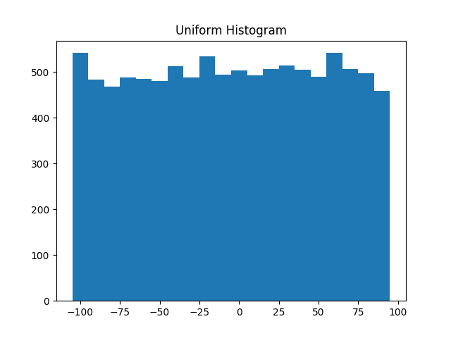

***Figure 23-1. Histogram of uniform***

In this case the two distributions have a pretty different max and min, but even knowing that wouldn’t have been sufficient to understand *how* they differed.

**Two Dimensions**

Now imagine you have a dataset with two dimensions. Maybe in addition to daily minutes you have years of data science experience. Of course you’d want to understand each dimension individually. But you probably also want to scatter the data.

For example, consider another fake dataset:

**def** random_normal() -> float:

*"""Returns a random draw from a standard normal distribution"""*

**return** inverse_normal_cdf(random.random())

xs = [random_normal() **for** _ **in** range(1000)]

ys1 = [ x + random_normal() / 2 **for** x **in** xs]

ys2 = [-x + random_normal() / 2 **for** x **in** xs]

If you were to run plot_histogram on ys1 and ys2, you’d get similar-looking plots (indeed, both are normally distributed with the same mean and standard deviation).

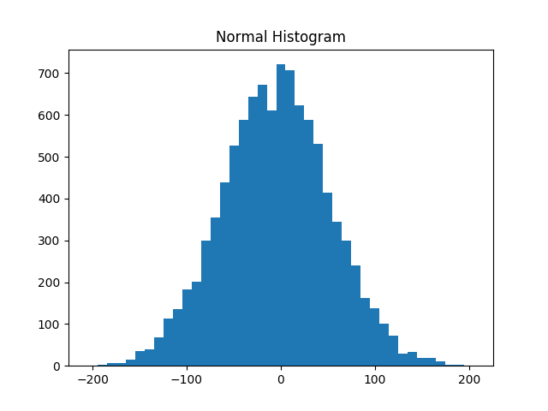

***Figure 23-2. Histogram of normal***

But each has a very different joint distribution with xs, as shown in [Figure 23-3](https://learning.oreilly.com/library/view/data-science-from/9781492041122/ch10.html#scatter_ys1_ys2):

plt.scatter(xs, ys1, marker='.', color='black', label='ys1')

plt.scatter(xs, ys2, marker='.', color='gray', label='ys2')

plt.xlabel('xs')

plt.ylabel('ys')

plt.legend(loc=9)

plt.title("Very Different Joint Distributions")

plt.show()

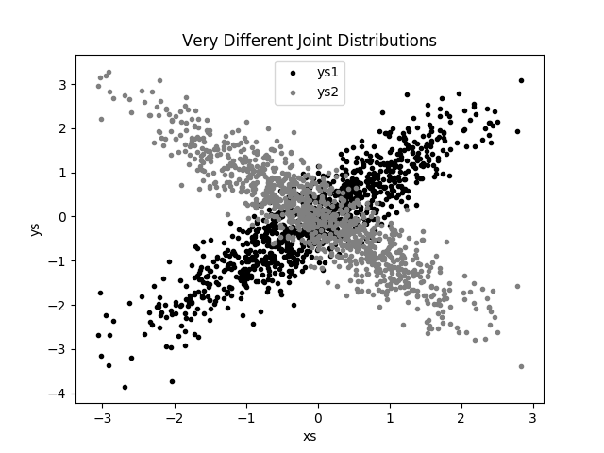

***Figure 23-3. Scattering two different ys***

This difference would also be apparent if you looked at the correlations:

**from** **scratch.statistics** **import** correlation

**print**(correlation(xs, ys1)) *# about 0.9*

**print**(correlation(xs, ys2)) *# about -0.9*

**Many Dimensions**

With many dimensions, you’d like to know how all the dimensions relate to one another. A simple approach is to look at the *correlation matrix*, in which the entry in row *i* and column *j* is the correlation between the *i*th dimension and the *j*th dimension of the data:

**from** **scratch.linear_algebra** **import** Matrix, Vector, make_matrix

**def** correlation_matrix(data: List[Vector]) -> Matrix:

*"""*

*Returns the len(data) x len(data) matrix whose (i, j)-th entry*

*is the correlation between data[i] and data[j]*

*"""*

**def** correlation_ij(i: int, j: int) -> float:

**return** correlation(data[i], data[j])

**return** make_matrix(len(data), len(data), correlation_ij)

A more visual approach (if you don’t have too many dimensions) is to make a *scatterplot matrix* ([Figure 23-4](https://learning.oreilly.com/library/view/data-science-from/9781492041122/ch10.html#scatterplot_matrix)) showing all the pairwise scatterplots. To do that we’ll use plt.subplots, which allows us to create subplots of our chart. We give it the number of rows and the number of columns, and it returns a figure object (which we won’t use) and a two-dimensional array of axes objects (each of which we’ll plot to):

*# corr_data is a list of four 100-d vectors*

num_vectors = len(corr_data)

fig, ax = plt.subplots(num_vectors, num_vectors)

**for** i **in** range(num_vectors):

**for** j **in** range(num_vectors):

*# Scatter column_j on the x-axis vs. column_i on the y-axis*

**if** i != j: ax[i][j].scatter(corr_data[j], corr_data[i])

*# unless i == j, in which case show the series name*

**else**: ax[i][j].annotate("series " + str(i), (0.5, 0.5),

xycoords='axes fraction',

ha="center", va="center")

*# Then hide axis labels except left and bottom charts*

**if** i < num_vectors - 1: ax[i][j].xaxis.set_visible(False)

**if** j > 0: ax[i][j].yaxis.set_visible(False)

*# Fix the bottom-right and top-left axis labels, which are wrong because*

*# their charts only have text in them*

ax[-1][-1].set_xlim(ax[0][-1].get_xlim())

ax[0][0].set_ylim(ax[0][1].get_ylim())

plt.show()

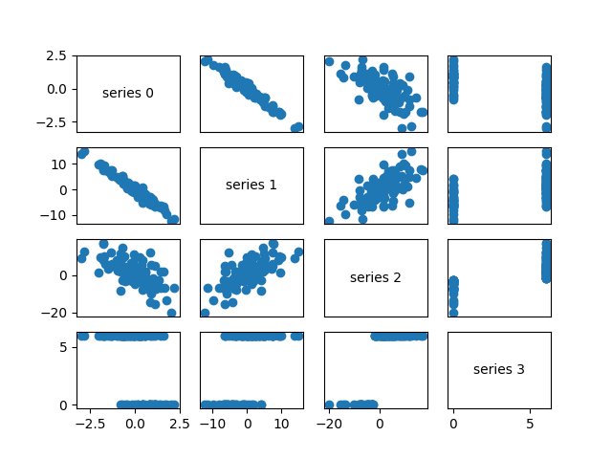

***Figure 23-4. Scatterplot matrix***

Looking at the scatterplots, you can see that series 1 is very negatively correlated with series 0, series 2 is positively correlated with series 1, and series 3 only takes on the values 0 and 6, with 0 corresponding to small values of series 2 and 6 corresponding to large values.

This is a quick way to get a rough sense of which of your variables are correlated (unless you spend hours tweaking matplotlib to display things exactly the way you want them to, in which case it’s not a quick way).

**Using NamedTuples**

One common way of representing data is using dicts:

**import** **datetime**

stock_price = {'closing_price': 102.06,

'date': datetime.date(2014, 8, 29),

'symbol': 'AAPL'}

There are several reasons why this is less than ideal, however. This is a slightly inefficient representation (a dictinvolves some overhead), so that if you have a lot of stock prices they’ll take up more memory than they have to. For the most part, this is a minor consideration.

A larger issue is that accessing things by dict key is error-prone. The following code will run without error and just do the wrong thing:

*# oops, typo*

stock_price['cosing_price'] = 103.06

Finally, while we can type-annotate uniform dictionaries:

prices: Dict[datetime.date, float] = {}

there’s no helpful way to annotate dictionaries-as-data that have lots of different value types. So we also lose the power of type hints.

As an alternative, Python includes a namedtuple class, which is like a tuple but with named slots:

**from** **collections** **import** namedtuple

StockPrice = namedtuple('StockPrice', ['symbol', 'date', 'closing_price'])

price = StockPrice('MSFT', datetime.date(2018, 12, 14), 106.03)

**assert** price.symbol == 'MSFT'

**assert** price.closing_price == 106.03

Like regular tuples, namedtuples are immutable, which means that you can’t modify their values once they’re created. Occasionally this will get in our way, but mostly that’s a good thing.

You’ll notice that we still haven’t solved the type annotation issue. We do that by using the typed variant, NamedTuple:

**from** **typing** **import** NamedTuple

**class** **StockPrice**(NamedTuple):

symbol: str

date: datetime.date

closing_price: float

**def** is_high_tech(self) -> bool:

*"""It's a class, so we can add methods too"""*

**return** self.symbol **in** ['MSFT', 'GOOG', 'FB', 'AMZN', 'AAPL']

price = StockPrice('MSFT', datetime.date(2018, 12, 14), 106.03)

**assert** price.symbol == 'MSFT'

**assert** price.closing_price == 106.03

**assert** price.is_high_tech()

And now your editor can help you out, as shown in [Figure 23-5](https://learning.oreilly.com/library/view/data-science-from/9781492041122/ch10.html#helpful_editor).

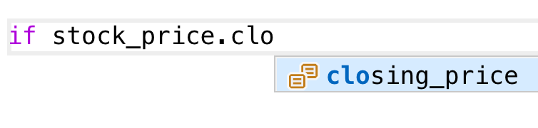

***Figure 23-5. Helpful editor***

**NOTE**

Very few people use NamedTuple in this way. But they should!

**Dataclasses**

Dataclasses are (sort of) a mutable version of NamedTuple. (I say “sort of” because NamedTuples represent their data compactly as tuples, whereas dataclasses are regular Python classes that simply generate some methods for you automatically.)

**NOTE**

Dataclasses are new in Python 3.7. If you’re using an older version, this section won’t work for you.

The syntax is very similar to NamedTuple. But instead of inheriting from a base class, we use a decorator:

**from** **dataclasses** **import** dataclass

@dataclass

**class** **StockPrice2**:

symbol: str

date: datetime.date

closing_price: float

**def** is_high_tech(self) -> bool:

*"""It's a class, so we can add methods too"""*

**return** self.symbol **in** ['MSFT', 'GOOG', 'FB', 'AMZN', 'AAPL']

price2 = StockPrice2('MSFT', datetime.date(2018, 12, 14), 106.03)

**assert** price2.symbol == 'MSFT'

**assert** price2.closing_price == 106.03

**assert** price2.is_high_tech()

As mentioned, the big difference is that we can modify a dataclass instance’s values:

*# stock split*

price2.closing_price /= 2

**assert** price2.closing_price == 51.03

If we tried to modify a field of the NamedTuple version, we’d get an AttributeError.

This also leaves us susceptible to the kind of errors we were hoping to avoid by not using dicts:

*# It's a regular class, so add new fields however you like!*

price2.cosing_price = 75 *# oops*

We won’t be using dataclasses, but you may encounter them out in the wild.

**Cleaning and Munging**

Real-world data is *dirty*. Often you’ll have to do some work on it before you can use it. We saw examples of this in [Chapter 9](https://learning.oreilly.com/library/view/data-science-from/9781492041122/ch09.html#getting_data). We have to convert strings to floats or ints before we can use them. We have to check for missing values and outliers and bad data.

Previously, we did that right before using the data:

closing_price = float(row[2])

But it’s probably less error-prone to do the parsing in a function that we can test:

**from** **dateutil.parser** **import** parse

**def** parse_row(row: List[str]) -> StockPrice:

symbol, date, closing_price = row

**return** StockPrice(symbol=symbol,

date=parse(date).date(),

closing_price=float(closing_price))

*# Now test our function*

stock = parse_row(["MSFT", "2018-12-14", "106.03"])

**assert** stock.symbol == "MSFT"

**assert** stock.date == datetime.date(2018, 12, 14)

**assert** stock.closing_price == 106.03

What if there’s bad data? A “float” value that doesn’t actually represent a number? Maybe you’d rather get a None than crash your program?

**from** **typing** **import** Optional

**import** **re**

**def** try_parse_row(row: List[str]) -> Optional[StockPrice]:

symbol, date_, closing_price_ = row

*# Stock symbol should be all capital letters*

**if** **not** re.match(r"^[A-Z]+$", symbol):

**return** None

**try**:

date = parse(date_).date()

**except** **ValueError**:

**return** None

**try**:

closing_price = float(closing_price_)

**except** **ValueError**:

**return** None

**return** StockPrice(symbol, date, closing_price)

*# Should return None for errors*

**assert** try_parse_row(["MSFT0", "2018-12-14", "106.03"]) **is** None

**assert** try_parse_row(["MSFT", "2018-12--14", "106.03"]) **is** None

**assert** try_parse_row(["MSFT", "2018-12-14", "x"]) **is** None

*# But should return same as before if data is good*

**assert** try_parse_row(["MSFT", "2018-12-14", "106.03"]) == stock

For example, if we have comma-delimited stock prices with bad data:

AAPL,6/20/2014,90.91

MSFT,6/20/2014,41.68

FB,6/20/3014,64.5

AAPL,6/19/2014,91.86

MSFT,6/19/2014,n/a

FB,6/19/2014,64.34

we can now read and return only the valid rows:

**import** **csv**

data: List[StockPrice] = []

**with** open("comma_delimited_stock_prices.csv") **as** f:

reader = csv.reader(f)

**for** row **in** reader:

maybe_stock = try_parse_row(row)

**if** maybe_stock **is** None:

**print**(f"skipping invalid row: {row}")

**else**:

data.append(maybe_stock)

and decide what we want to do about the invalid ones. Generally speaking, the three options are to get rid of them, to go back to the source and try to fix the bad/missing data, or to do nothing and cross our fingers. If there’s one bad row out of millions, it’s probably okay to ignore it. But if half your rows have bad data, that’s something you need to fix.

A good next step is to check for outliers, using techniques from [“Exploring Your Data”](https://learning.oreilly.com/library/view/data-science-from/9781492041122/ch10.html#exploring_your_data) or by ad hoc investigating. For example, did you notice that one of the dates in the stocks file had the year 3014? That won’t (necessarily) give you an error, but it’s quite plainly wrong, and you’ll get screwy results if you don’t catch it. Real-world datasets have missing decimal points, extra zeros, typographical errors, and countless other problems that it’s your job to catch. (Maybe it’s not officially your job, but who else is going to do it?)

**Manipulating Data**

One of the most important skills of a data scientist is *manipulating data*. It’s more of a general approach than a specific technique, so we’ll just work through a handful of examples to give you the flavor of it.

Imagine we have a bunch of stock price data that looks like this:

data = [

StockPrice(symbol='MSFT',

date=datetime.date(2018, 12, 24),

closing_price=106.03),

*# ...*

]

Let’s start asking questions about this data. Along the way we’ll try to notice patterns in what we’re doing and abstract out some tools to make the manipulation easier.

For instance, suppose we want to know the highest-ever closing price for AAPL. Let’s break this down into concrete steps:

1. Restrict ourselves to AAPL rows.
2. Grab the closing_price from each row.
3. Take the max of those prices.

We can do all three at once using a comprehension:

max_aapl_price = max(stock_price.closing_price

**for** stock_price **in** data

**if** stock_price.symbol == "AAPL")

More generally, we might want to know the highest-ever closing price for each stock in our dataset. One way to do this is:

1. Create a dict to keep track of highest prices (we’ll use a defaultdict that returns minus infinity for missing values, since any price will be greater than that).
2. Iterate over our data, updating it.

Here’s the code:

**from** **collections** **import** defaultdict

max_prices: Dict[str, float] = defaultdict(**lambda**: float('-inf'))

**for** sp **in** data:

symbol, closing_price = sp.symbol, sp.closing_price

**if** closing_price > max_prices[symbol]:

max_prices[symbol] = closing_price

We can now start to ask more complicated things, like what are the largest and smallest one-day percent changes in our dataset. The percent change is price_today / price_yesterday - 1, which means we need some way of associating today’s price and yesterday’s price. One approach is to group the prices by symbol, and then, within each group:

1. Order the prices by date.
2. Use zip to get (previous, current) pairs.
3. Turn the pairs into new “percent change” rows.

Let’s start by grouping the prices by symbol:

**from** **typing** **import** List

**from** **collections** **import** defaultdict

*# Collect the prices by symbol*

prices: Dict[str, List[StockPrice]] = defaultdict(list)

**for** sp **in** data:

prices[sp.symbol].append(sp)

Since the prices are tuples, they’ll get sorted by their fields in order: first by symbol, then by date, then by price. This means that if we have some prices all with the same symbol, sort will sort them by date (and then by price, which does nothing, since we only have one per date), which is what we want.

*# Order the prices by date*

prices = {symbol: sorted(symbol_prices)

**for** symbol, symbol_prices **in** prices.items()}

which we can use to compute a sequence of day-over-day changes:

**def** pct_change(yesterday: StockPrice, today: StockPrice) -> float:

**return** today.closing_price / yesterday.closing_price - 1

**class** **DailyChange**(NamedTuple):

symbol: str

date: datetime.date

pct_change: float

**def** day_over_day_changes(prices: List[StockPrice]) -> List[DailyChange]:

*"""*

*Assumes prices are for one stock and are in order*

*"""*

**return** [DailyChange(symbol=today.symbol,

date=today.date,

pct_change=pct_change(yesterday, today))

**for** yesterday, today **in** zip(prices, prices[1:])]

and then collect them all:

all_changes = [change

**for** symbol_prices **in** prices.values()

**for** change **in** day_over_day_changes(symbol_prices)]

At which point it’s easy to find the largest and smallest:

max_change = max(all_changes, key=**lambda** change: change.pct_change)

*# see e.g. http://news.cnet.com/2100-1001-202143.html*

**assert** max_change.symbol == 'AAPL'

**assert** max_change.date == datetime.date(1997, 8, 6)

**assert** 0.33 < max_change.pct_change < 0.34

min_change = min(all_changes, key=**lambda** change: change.pct_change)

*# see e.g. http://money.cnn.com/2000/09/29/markets/techwrap/*

**assert** min_change.symbol == 'AAPL'

**assert** min_change.date == datetime.date(2000, 9, 29)

**assert** -0.52 < min_change.pct_change < -0.51

We can now use this new all_changes dataset to find which month is the best to invest in tech stocks. We’ll just look at the average daily change by month:

changes_by_month: List[DailyChange] = {month: [] **for** month **in** range(1, 13)}

**for** change **in** all_changes:

changes_by_month[change.date.month].append(change)

avg_daily_change = {

month: sum(change.pct_change **for** change **in** changes) / len(changes)

**for** month, changes **in** changes_by_month.items()

}

*# October is the best month*

**assert** avg_daily_change[10] == max(avg_daily_change.values())

We’ll be doing these sorts of manipulations throughout the book, usually without calling too much explicit attention to them.

**Rescaling**

Many techniques are sensitive to the *scale* of your data. For example, imagine that you have a dataset consisting of the heights and weights of hundreds of data scientists, and that you are trying to identify *clusters* of body sizes.

Intuitively, we’d like clusters to represent points near each other, which means that we need some notion of distance between points. We already have a Euclidean distance function, so a natural approach might be to treat (height, weight) pairs as points in two-dimensional space. Consider the people listed in [Table 23-1](https://learning.oreilly.com/library/view/data-science-from/9781492041122/ch10.html#heights-and-weights).

| **Person** | **Height (inches)** | **Height (centimeters)** | **Weight (pounds)** |
| --- | --- | --- | --- |
| A | 63 | 160 | 150 |
| B | 67 | 170.2 | 160 |
| C | 70 | 177.8 | 171 |
| *Table 23-1. Heights and weights* | | | |

If we measure height in inches, then B’s nearest neighbor is A:

**from** **scratch.linear_algebra** **import** distance

a_to_b = distance([63, 150], [67, 160]) *# 10.77*

a_to_c = distance([63, 150], [70, 171]) *# 22.14*

b_to_c = distance([67, 160], [70, 171]) *# 11.40*

However, if we measure height in centimeters, then B’s nearest neighbor is instead C:

a_to_b = distance([160, 150], [170.2, 160]) *# 14.28*

a_to_c = distance([160, 150], [177.8, 171]) *# 27.53*

b_to_c = distance([170.2, 160], [177.8, 171]) *# 13.37*

Obviously it’s a problem if changing units can change results like this. For this reason, when dimensions aren’t comparable with one another, we will sometimes *rescale* our data so that each dimension has mean 0 and standard deviation 1. This effectively gets rid of the units, converting each dimension to “standard deviations from the mean.”

To start with, we’ll need to compute the mean and the standard_deviation for each position:

**from** **typing** **import** Tuple

**from** **scratch.linear_algebra** **import** vector_mean

**from** **scratch.statistics** **import** standard_deviation

**def** scale(data: List[Vector]) -> Tuple[Vector, Vector]:

*"""returns the mean and standard deviation for each position"""*

dim = len(data[0])

means = vector_mean(data)

stdevs = [standard_deviation([vector[i] **for** vector **in** data])

**for** i **in** range(dim)]

**return** means, stdevs

vectors = [[-3, -1, 1], [-1, 0, 1], [1, 1, 1]]

means, stdevs = scale(vectors)

**assert** means == [-1, 0, 1]

**assert** stdevs == [2, 1, 0]

We can then use them to create a new dataset:

**def** rescale(data: List[Vector]) -> List[Vector]:

*"""*

*Rescales the input data so that each position has*

*mean 0 and standard deviation 1. (Leaves a position*

*as is if its standard deviation is 0.)*

*"""*

dim = len(data[0])

means, stdevs = scale(data)

*# Make a copy of each vector*

rescaled = [v[:] **for** v **in** data]

**for** v **in** rescaled:

**for** i **in** range(dim):

**if** stdevs[i] > 0:

v[i] = (v[i] - means[i]) / stdevs[i]

**return** rescaled

Of course, let’s write a test to conform that rescale does what we think it should:

means, stdevs = scale(rescale(vectors))

**assert** means == [0, 0, 1]

**assert** stdevs == [1, 1, 0]

As always, you need to use your judgment. If you were to take a huge dataset of heights and weights and filter it down to only the people with heights between 69.5 inches and 70.5 inches, it’s quite likely (depending on the question you’re trying to answer) that the variation remaining is simply *noise*, and you might not want to put its standard deviation on equal footing with other dimensions’ deviations.

**An Aside: tqdm**

Frequently we’ll end up doing computations that take a long time. When you’re doing such work, you’d like to know that you’re making progress and how long you should expect to wait.

One way of doing this is with the tqdm library, which generates custom progress bars. We’ll use it some throughout the rest of the book, so let’s take this chance to learn how it works.

To start with, you’ll need to install it:

python -m pip install tqdm

There are only a few features you need to know about. The first is that an iterable wrapped in tqdm.tqdm will produce a progress bar:

**import** **tqdm**

**for** i **in** tqdm.tqdm(range(100)):

*# do something slow*

_ = [random.random() **for** _ **in** range(1000000)]

which produces an output that looks like this:

56%|████████████████████ | 56/100 [00:08<00:06, 6.49it/s]

In particular, it shows you what fraction of your loop is done (though it can’t do this if you use a generator), how long it’s been running, and how long it expects to run.

In this case (where we are just wrapping a call to range) you can just use tqdm.trange.

You can also set the description of the progress bar while it’s running. To do that, you need to capture the tqdmiterator in a with statement:

**from** **typing** **import** List

**def** primes_up_to(n: int) -> List[int]:

primes = [2]

**with** tqdm.trange(3, n) **as** t:

**for** i **in** t:

*# i is prime if no smaller prime divides it*

i_is_prime = **not** any(i % p == 0 **for** p **in** primes)

**if** i_is_prime:

primes.append(i)

t.set_description(f"{len(primes)} primes")

**return** primes

my_primes = primes_up_to(100_000)

This adds a description like the following, with a counter that updates as new primes are discovered:

5116 primes: 50%|████████ | 49529/99997 [00:03<00:03, 15905.90it/s]

Using tqdm will occasionally make your code flaky—sometimes the screen redraws poorly, and sometimes the loop will simply hang. And if you accidentally wrap a tqdm loop inside another tqdm loop, strange things might happen. Typically its benefits outweigh these downsides, though, so we’ll try to use it whenever we have slow-running computations.

**Dimensionality Reduction**

Sometimes the “actual” (or useful) dimensions of the data might not correspond to the dimensions we have. For example, consider the dataset pictured in [Figure 23-6](https://learning.oreilly.com/library/view/data-science-from/9781492041122/ch10.html#scatter_pca_data).

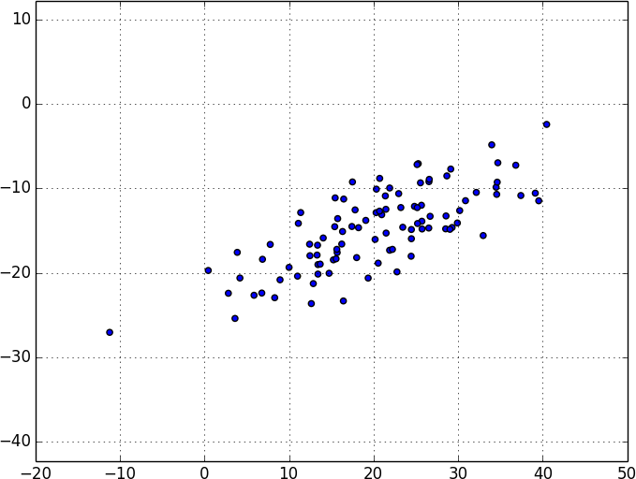

***Figure 23-6. Data with the “wrong” axes***

Most of the variation in the data seems to be along a single dimension that doesn’t correspond to either the x-axis or the y-axis.

When this is the case, we can use a technique called *principal component analysis* (PCA) to extract one or more dimensions that capture as much of the variation in the data as possible.

**NOTE**

In practice, you wouldn’t use this technique on such a low-dimensional dataset. Dimensionality reduction is mostly useful when your dataset has a large number of dimensions and you want to find a small subset that captures most of the variation. Unfortunately, that case is difficult to illustrate in a two-dimensional book format.

As a first step, we’ll need to translate the data so that each dimension has mean 0:

**from** **scratch.linear_algebra** **import** subtract

**def** de_mean(data: List[Vector]) -> List[Vector]:

*"""Recenters the data to have mean 0 in every dimension"""*

mean = vector_mean(data)

**return** [subtract(vector, mean) **for** vector **in** data]

(If we don’t do this, our techniques are likely to identify the mean itself rather than the variation in the data.)

[Figure 23-7](https://learning.oreilly.com/library/view/data-science-from/9781492041122/ch10.html#pca_data_mean_removed) shows the example data after de-meaning.

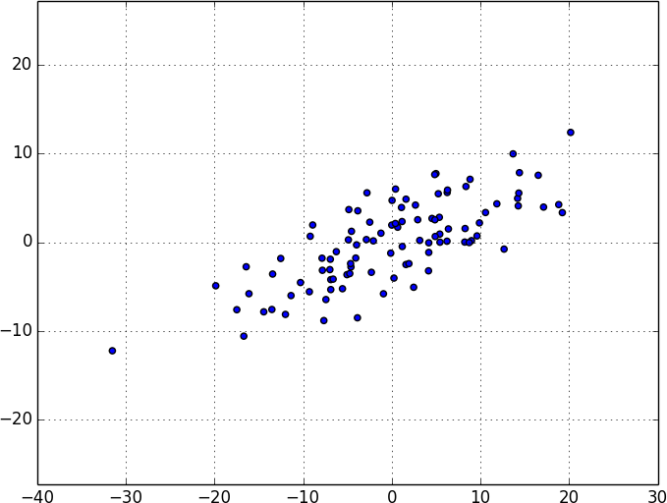

***Figure 23-7. Data after de-meaning***

Now, given a de-meaned matrix *X*, we can ask which is the direction that captures the greatest variance in the data.

Specifically, given a direction d (a vector of magnitude 1), each row x in the matrix extends dot(x, d) in the ddirection. And every nonzero vector w determines a direction if we rescale it to have magnitude 1:

**from** **scratch.linear_algebra** **import** magnitude

**def** direction(w: Vector) -> Vector:

mag = magnitude(w)

**return** [w_i / mag **for** w_i **in** w]

Therefore, given a nonzero vector w, we can compute the variance of our dataset in the direction determined by w:

**from** **scratch.linear_algebra** **import** dot

**def** directional_variance(data: List[Vector], w: Vector) -> float:

*"""*

*Returns the variance of x in the direction of w*

*"""*

w_dir = direction(w)

**return** sum(dot(v, w_dir) ** 2 **for** v **in** data)

We’d like to find the direction that maximizes this variance. We can do this using gradient descent, as soon as we have the gradient function:

**def** directional_variance_gradient(data: List[Vector], w: Vector) -> Vector:

*"""*

*The gradient of directional variance with respect to w*

*"""*

w_dir = direction(w)

**return** [sum(2 * dot(v, w_dir) * v[i] **for** v **in** data)

**for** i **in** range(len(w))]

And now the first principal component that we have is just the direction that maximizes the directional_variance function:

**from** **scratch.gradient_descent** **import** gradient_step

**def** first_principal_component(data: List[Vector],

n: int = 100,

step_size: float = 0.1) -> Vector:

*# Start with a random guess*

guess = [1.0 **for** _ **in** data[0]]

**with** tqdm.trange(n) **as** t:

**for** _ **in** t:

dv = directional_variance(data, guess)

gradient = directional_variance_gradient(data, guess)

guess = gradient_step(guess, gradient, step_size)

t.set_description(f"dv: {dv:.3f}")

**return** direction(guess)

On the de-meaned dataset, this returns the direction [0.924, 0.383], which does appear to capture the primary axis along which our data varies ([Figure 23-8](https://learning.oreilly.com/library/view/data-science-from/9781492041122/ch10.html#pca_data_with_first_principal_component)).

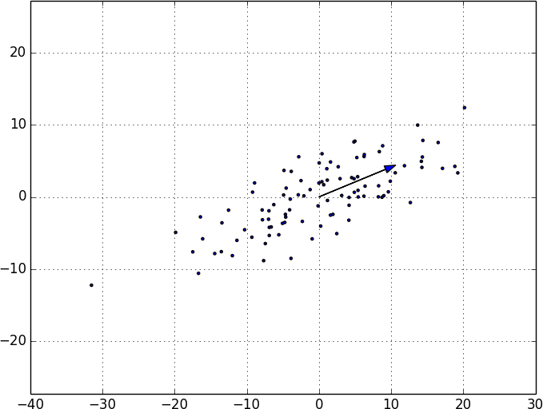

***Figure 23-8. First principal component***

Once we’ve found the direction that’s the first principal component, we can project our data onto it to find the values of that component:

**from** **scratch.linear_algebra** **import** scalar_multiply

**def** project(v: Vector, w: Vector) -> Vector:

*"""return the projection of v onto the direction w"""*

projection_length = dot(v, w)

**return** scalar_multiply(projection_length, w)

If we want to find further components, we first remove the projections from the data:

**from** **scratch.linear_algebra** **import** subtract

**def** remove_projection_from_vector(v: Vector, w: Vector) -> Vector:

*"""projects v onto w and subtracts the result from v"""*

**return** subtract(v, project(v, w))

**def** remove_projection(data: List[Vector], w: Vector) -> List[Vector]:

**return** [remove_projection_from_vector(v, w) **for** v **in** data]

Because this example dataset is only two-dimensional, after we remove the first component, what’s left will be effectively one-dimensional ([Figure 23-9](https://learning.oreilly.com/library/view/data-science-from/9781492041122/ch10.html#pca_data_with_first_component_removed)).

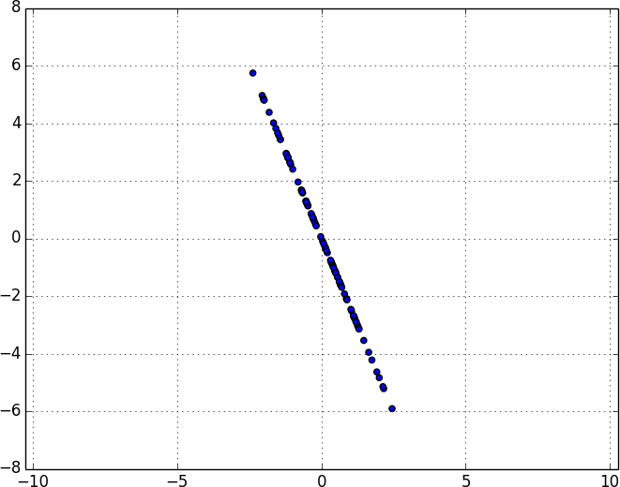

***Figure 23-9. Data after removing the first principal component***

At that point, we can find the next principal component by repeating the process on the result of remove_projection ([Figure 23-10](https://learning.oreilly.com/library/view/data-science-from/9781492041122/ch10.html#second_principal_component)).

On a higher-dimensional dataset, we can iteratively find as many components as we want:

**def** pca(data: List[Vector], num_components: int) -> List[Vector]:

components: List[Vector] = []

**for** _ **in** range(num_components):

component = first_principal_component(data)

components.append(component)

data = remove_projection(data, component)

**return** components

We can then *transform* our data into the lower-dimensional space spanned by the components:

**def** transform_vector(v: Vector, components: List[Vector]) -> Vector:

**return** [dot(v, w) **for** w **in** components]

**def** transform(data: List[Vector], components: List[Vector]) -> List[Vector]:

**return** [transform_vector(v, components) **for** v **in** data]

This technique is valuable for a couple of reasons. First, it can help us clean our data by eliminating noise dimensions and consolidating highly correlated dimensions.

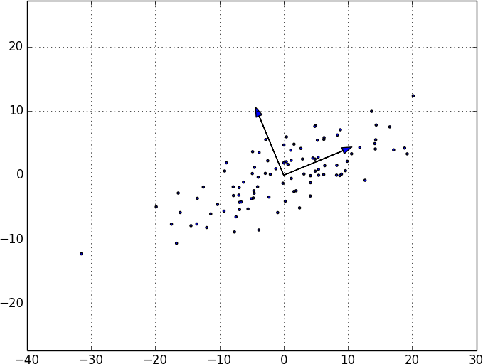

***Figure 23-10. First two principal components***

Second, after extracting a low-dimensional representation of our data, we can use a variety of techniques that don’t work as well on high-dimensional data. We’ll see examples of such techniques throughout the book.

At the same time, while this technique can help you build better models, it can also make those models harder to interpret. It’s easy to understand conclusions like “every extra year of experience adds an average of $10k in salary.” It’s much harder to make sense of “every increase of 0.1 in the third principal component adds an average of $10k in salary.”

**Chapter 24. k-Nearest Neighbors**

*If you want to annoy your neighbors, tell the truth about them.*

Pietro Aretino

Imagine that you’re trying to predict how I’m going to vote in the next presidential election. If you know nothing else about me (and if you have the data), one sensible approach is to look at how my *neighbors* are planning to vote. Living in Seattle, as I do, my neighbors are invariably planning to vote for the Democratic candidate, which suggests that “Democratic candidate” is a good guess for me as well.

Now imagine you know more about me than just geography—perhaps you know my age, my income, how many kids I have, and so on. To the extent my behavior is influenced (or characterized) by those things, looking just at my neighbors who are close to me among all those dimensions seems likely to be an even better predictor than looking at all my neighbors. This is the idea behind *nearest neighbors classification*.

**The Model**

Nearest neighbors is one of the simplest predictive models there is. It makes no mathematical assumptions, and it doesn’t require any sort of heavy machinery. The only things it requires are:

* Some notion of distance
* An assumption that points that are close to one another are similar

Most of the techniques we’ll see in this book look at the dataset as a whole in order to learn patterns in the data. Nearest neighbors, on the other hand, quite consciously neglects a lot of information, since the prediction for each new point depends only on the handful of points closest to it.

What’s more, nearest neighbors is probably not going to help you understand the drivers of whatever phenomenon you’re looking at. Predicting my votes based on my neighbors’ votes doesn’t tell you much about what causes me to vote the way I do, whereas some alternative model that predicted my vote based on (say) my income and marital status very well might.

In the general situation, we have some data points and we have a corresponding set of labels. The labels could be True and False, indicating whether each input satisfies some condition like “is spam?” or “is poisonous?” or “would be enjoyable to watch?” Or they could be categories, like movie ratings (G, PG, PG-13, R, NC-17). Or they could be the names of presidential candidates. Or they could be favorite programming languages.

In our case, the data points will be vectors, which means that we can use the distance function from [Chapter 4](https://learning.oreilly.com/library/view/data-science-from/9781492041122/ch04.html#linear_algebra).

Let’s say we’ve picked a number *k* like 3 or 5. Then, when we want to classify some new data point, we find the *k*nearest labeled points and let them vote on the new output.

To do this, we’ll need a function that counts votes. One possibility is:

**from** **typing** **import** List

**from** **collections** **import** Counter

**def** raw_majority_vote(labels: List[str]) -> str:

votes = Counter(labels)

winner, _ = votes.most_common(1)[0]

**return** winner

**assert** raw_majority_vote(['a', 'b', 'c', 'b']) == 'b'

But this doesn’t do anything intelligent with ties. For example, imagine we’re rating movies and the five nearest movies are rated G, G, PG, PG, and R. Then G has two votes and PG also has two votes. In that case, we have several options:

* Pick one of the winners at random.
* Weight the votes by distance and pick the weighted winner.
* Reduce *k* until we find a unique winner.

We’ll implement the third:

**def** majority_vote(labels: List[str]) -> str:

*"""Assumes that labels are ordered from nearest to farthest."""*

vote_counts = Counter(labels)

winner, winner_count = vote_counts.most_common(1)[0]

num_winners = len([count

**for** count **in** vote_counts.values()

**if** count == winner_count])

**if** num_winners == 1:

**return** winner *# unique winner, so return it*

**else**:

**return** majority_vote(labels[:-1]) *# try again without the farthest*

*# Tie, so look at first 4, then 'b'*

**assert** majority_vote(['a', 'b', 'c', 'b', 'a']) == 'b'

This approach is sure to work eventually, since in the worst case we go all the way down to just one label, at which point that one label wins.

With this function it’s easy to create a classifier:

**from** **typing** **import** NamedTuple

**from** **scratch.linear_algebra** **import** Vector, distance

**class** **LabeledPoint**(NamedTuple):

point: Vector

label: str

**def** knn_classify(k: int,

labeled_points: List[LabeledPoint],

new_point: Vector) -> str:

*# Order the labeled points from nearest to farthest.*

by_distance = sorted(labeled_points,

key=**lambda** lp: distance(lp.point, new_point))

*# Find the labels for the k closest*

k_nearest_labels = [lp.label **for** lp **in** by_distance[:k]]

*# and let them vote.*

**return** majority_vote(k_nearest_labels)

Let’s take a look at how this works.

**Example: The Iris Dataset**

The *Iris* dataset is a staple of machine learning. It contains a bunch of measurements for 150 flowers representing three species of iris. For each flower we have its petal length, petal width, sepal length, and sepal width, as well as its species. You can download it from [*https://archive.ics.uci.edu/ml/datasets/iris*](https://archive.ics.uci.edu/ml/datasets/iris):

**import** **requests**

data = requests.get(

"https://archive.ics.uci.edu/ml/machine-learning-databases/iris/iris.data"

)

**with** open('iris.dat', 'w') **as** f:

f.write(data.text)

The data is comma-separated, with fields:

sepal_length, sepal_width, petal_length, petal_width, class

For example, the first row looks like:

5.1,3.5,1.4,0.2,Iris-setosa

In this section we’ll try to build a model that can predict the class (that is, the species) from the first four measurements.

To start with, let’s load and explore the data. Our nearest neighbors function expects a LabeledPoint, so let’s represent our data that way:

**from** **typing** **import** Dict

**import** **csv**

**from** **collections** **import** defaultdict

**def** parse_iris_row(row: List[str]) -> LabeledPoint:

*"""*

*sepal_length, sepal_width, petal_length, petal_width, class*

*"""*

measurements = [float(value) **for** value **in** row[:-1]]

*# class is e.g. "Iris-virginica"; we just want "virginica"*

label = row[-1].split("-")[-1]

**return** LabeledPoint(measurements, label)

**with** open('iris.data') **as** f:

reader = csv.reader(f)

iris_data = [parse_iris_row(row) **for** row **in** reader]

*# We'll also group just the points by species/label so we can plot them*

points_by_species: Dict[str, List[Vector]] = defaultdict(list)

**for** iris **in** iris_data:

points_by_species[iris.label].append(iris.point)

We’d like to plot the measurements so we can see how they vary by species. Unfortunately, they are four-dimensional, which makes them tricky to plot. One thing we can do is look at the scatterplots for each of the six pairs of measurements ([Figure 24-1](https://learning.oreilly.com/library/view/data-science-from/9781492041122/ch12.html#iris_scatterplots)). I won’t explain all the details, but it’s a nice illustration of more complicated things you can do with matplotlib, so it’s worth studying:

**from** **matplotlib** **import** pyplot **as** plt

metrics = ['sepal length', 'sepal width', 'petal length', 'petal width']

pairs = [(i, j) **for** i **in** range(4) **for** j **in** range(4) **if** i < j]

marks = ['+', '.', 'x'] *# we have 3 classes, so 3 markers*

fig, ax = plt.subplots(2, 3)

**for** row **in** range(2):

**for** col **in** range(3):

i, j = pairs[3 * row + col]

ax[row][col].set_title(f"{metrics[i]} vs {metrics[j]}", fontsize=8)

ax[row][col].set_xticks([])

ax[row][col].set_yticks([])

**for** mark, (species, points) **in** zip(marks, points_by_species.items()):

xs = [point[i] **for** point **in** points]

ys = [point[j] **for** point **in** points]

ax[row][col].scatter(xs, ys, marker=mark, label=species)

ax[-1][-1].legend(loc='lower right', prop={'size': 6})

plt.show()

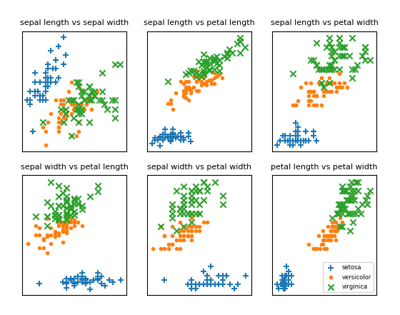

***Figure 24-1. Iris scatterplots***

If you look at those plots, it seems like the measurements really do cluster by species. For example, looking at sepal length and sepal width alone, you probably couldn’t distinguish between *versicolor* and *virginica*. But once you add petal length and width into the mix, it seems like you should be able to predict the species based on the nearest neighbors.

To start with, let’s split the data into a test set and a training set:

**import** **random**

**from** **scratch.machine_learning** **import** split_data

random.seed(12)

iris_train, iris_test = split_data(iris_data, 0.70)

**assert** len(iris_train) == 0.7 * 150

**assert** len(iris_test) == 0.3 * 150

The training set will be the “neighbors” that we’ll use to classify the points in the test set. We just need to choose a value for *k*, the number of neighbors who get to vote. Too small (think *k* = 1), and we let outliers have too much influence; too large (think *k* = 105), and we just predict the most common class in the dataset.

In a real application (and with more data), we might create a separate validation set and use it to choose *k*. Here we’ll just use *k* = 5:

**from** **typing** **import** Tuple

*# track how many times we see (predicted, actual)*

confusion_matrix: Dict[Tuple[str, str], int] = defaultdict(int)

num_correct = 0

**for** iris **in** iris_test:

predicted = knn_classify(5, iris_train, iris.point)

actual = iris.label

**if** predicted == actual:

num_correct += 1

confusion_matrix[(predicted, actual)] += 1

pct_correct = num_correct / len(iris_test)

**print**(pct_correct, confusion_matrix)

On this simple dataset, the model predicts almost perfectly. There’s one *versicolor* for which it predicts *virginica*, but otherwise it gets things exactly right.

**The Curse of Dimensionality**

The *k*-nearest neighbors algorithm runs into trouble in higher dimensions thanks to the “curse of dimensionality,” which boils down to the fact that high-dimensional spaces are *vast*. Points in high-dimensional spaces tend not to be close to one another at all. One way to see this is by randomly generating pairs of points in the *d*-dimensional “unit cube” in a variety of dimensions, and calculating the distances between them.

Generating random points should be second nature by now:

**def** random_point(dim: int) -> Vector:

**return** [random.random() **for** _ **in** range(dim)]

as is writing a function to generate the distances:

**def** random_distances(dim: int, num_pairs: int) -> List[float]:

**return** [distance(random_point(dim), random_point(dim))

**for** _ **in** range(num_pairs)]

For every dimension from 1 to 100, we’ll compute 10,000 distances and use those to compute the average distance between points and the minimum distance between points in each dimension ([Figure 24-2](https://learning.oreilly.com/library/view/data-science-from/9781492041122/ch12.html#curse_of_dimensionality_graph)):

**import** **tqdm**

dimensions = range(1, 101)

avg_distances = []

min_distances = []

random.seed(0)

**for** dim **in** tqdm.tqdm(dimensions, desc="Curse of Dimensionality"):

distances = random_distances(dim, 10000) *# 10,000 random pairs*

avg_distances.append(sum(distances) / 10000) *# track the average*

min_distances.append(min(distances)) *# track the minimum*

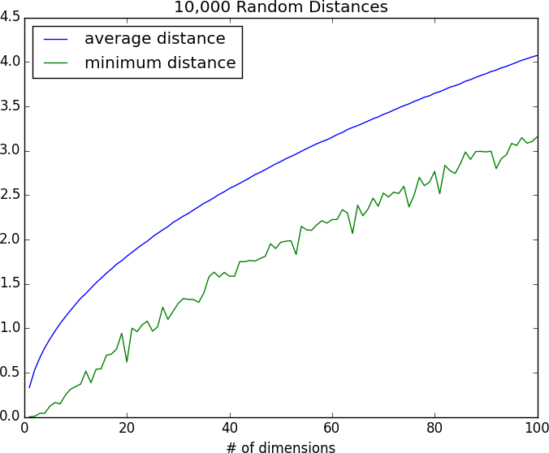

***Figure 24-2. The curse of dimensionality***

As the number of dimensions increases, the average distance between points increases. But what’s more problematic is the ratio between the closest distance and the average distance ([Figure 24-3](https://learning.oreilly.com/library/view/data-science-from/9781492041122/ch12.html#curse_of_dimensionality_graph2)):

min_avg_ratio = [min_dist / avg_dist

**for** min_dist, avg_dist **in** zip(min_distances, avg_distances)]

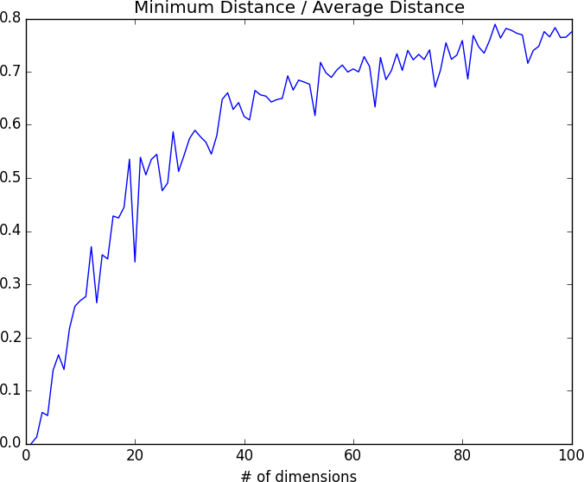

***Figure 24-3. The curse of dimensionality again***

In low-dimensional datasets, the closest points tend to be much closer than average. But two points are close only if they’re close in every dimension, and every extra dimension—even if just noise—is another opportunity for each point to be farther away from every other point. When you have a lot of dimensions, it’s likely that the closest points aren’t much closer than average, so two points being close doesn’t mean very much (unless there’s a lot of structure in your data that makes it behave as if it were much lower-dimensional).

A different way of thinking about the problem involves the sparsity of higher-dimensional spaces.

If you pick 50 random numbers between 0 and 1, you’ll probably get a pretty good sample of the unit interval ([Figure 24-4](https://learning.oreilly.com/library/view/data-science-from/9781492041122/ch12.html#fifty_points_1d)).

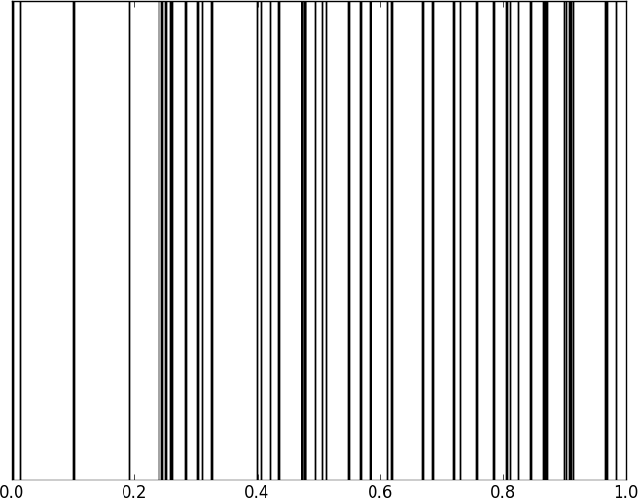

***Figure 24-4. Fifty random points in one dimension***

If you pick 50 random points in the unit square, you’ll get less coverage ([Figure 24-5](https://learning.oreilly.com/library/view/data-science-from/9781492041122/ch12.html#fifty_points_2d)).

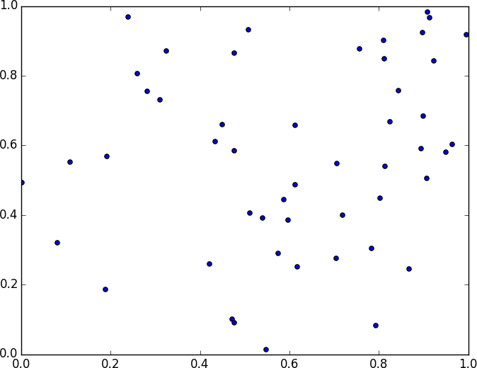

***Figure 24-5. Fifty random points in two dimensions***

And in three dimensions, less still ([Figure 24-6](https://learning.oreilly.com/library/view/data-science-from/9781492041122/ch12.html#fifty_points_3d)).

matplotlib doesn’t graph four dimensions well, so that’s as far as we’ll go, but you can see already that there are starting to be large empty spaces with no points near them. In more dimensions—unless you get exponentially more data—those large empty spaces represent regions far from all the points you want to use in your predictions.

So if you’re trying to use nearest neighbors in higher dimensions, it’s probably a good idea to do some kind of dimensionality reduction first.

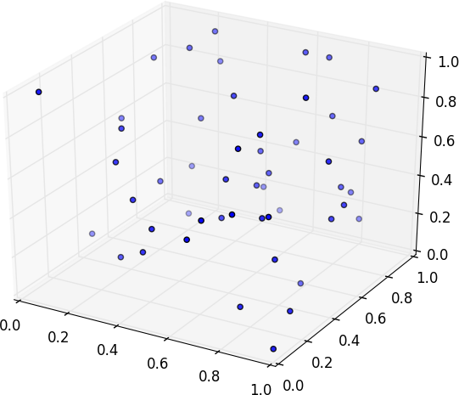

***Figure 24-6. Fifty random points in three dimensions***

**Unit – IV**

**Chapter 25. Naive Bayes**

*It is well for the heart to be naive and for the mind not to be.*

Anatole France

A social network isn’t much good if people can’t network. Accordingly, DataSciencester has a popular feature that allows members to send messages to other members. And while most members are responsible citizens who send only well-received “how’s it going?” messages, a few miscreants persistently spam other members about get-rich schemes, no-prescription-required pharmaceuticals, and for-profit data science credentialing programs. Your users have begun to complain, and so the VP of Messaging has asked you to use data science to figure out a way to filter out these spam messages.

**A Really Dumb Spam Filter**

Imagine a “universe” that consists of receiving a message chosen randomly from all possible messages. Let *S* be the event “the message is spam” and *B* be the event “the message contains the word *bitcoin*.” Bayes’s theorem tells us that the probability that the message is spam conditional on containing the word *bitcoin* is:

P(S|B)=[P(B|S)P(S)]/[P(B|S)P(S)+P(B|¬S)P(¬S)]P(S|B)=[P(B|S)P(S)]/[P(B|S)P(S)+P(B|¬S)P(¬S)]

The numerator is the probability that a message is spam *and* contains *bitcoin*, while the denominator is just the probability that a message contains *bitcoin*. Hence, you can think of this calculation as simply representing the proportion of *bitcoin* messages that are spam.

If we have a large collection of messages we know are spam, and a large collection of messages we know are not spam, then we can easily estimate *P*(*B*|*S*) and *P*(*B*|*¬S*). If we further assume that any message is equally likely to be spam or not spam (so that *P*(*S*) = *P*(*¬S*) = 0.5), then:

P(S|B)=P(B|S)/[P(B|S)+P(B|¬S)]P(S|B)=P(B|S)/[P(B|S)+P(B|¬S)]

For example, if 50% of spam messages have the word *bitcoin*, but only 1% of nonspam messages do, then the probability that any given *bitcoin*-containing email is spam is:

0.5/(0.5+0.01)=98%0.5/(0.5+0.01)=98%

**A More Sophisticated Spam Filter**

Imagine now that we have a vocabulary of many words, *w*1 ..., *w*n. To move this into the realm of probability theory, we’ll write *X*i for the event “a message contains the word *w*i.” Also imagine that (through some unspecified-at-this-point process) we’ve come up with an estimate *P*(*X*i|*S*) for the probability that a spam message contains the *i*th word, and a similar estimate *P*(*X*i|¬*S*) for the probability that a nonspam message contains the *i*th word.

The key to Naive Bayes is making the (big) assumption that the presences (or absences) of each word are independent of one another, conditional on a message being spam or not. Intuitively, this assumption means that knowing whether a certain spam message contains the word *bitcoin* gives you no information about whether that same message contains the word *rolex*. In math terms, this means that:

P(X1=x1,...,Xn=xn|S)=P(X1=x1|S)×⋯×P(Xn=xn|S)P(X1=x1,...,Xn=xn|S)=P(X1=x1|S)×⋯×P(Xn=xn|S)

This is an extreme assumption. (There’s a reason the technique has *naive* in its name.) Imagine that our vocabulary consists *only* of the words *bitcoin* and *rolex*, and that half of all spam messages are for “earn bitcoin” and that the other half are for “authentic rolex.” In this case, the Naive Bayes estimate that a spam message contains both *bitcoin* and *rolex* is:

P(X1=1,X2=1|S)=P(X1=1|S)P(X2=1|S)=.5×.5=.25P(X1=1,X2=1|S)=P(X1=1|S)P(X2=1|S)=.5×.5=.25

since we’ve assumed away the knowledge that *bitcoin* and *rolex* actually never occur together. Despite the unrealisticness of this assumption, this model often performs well and has historically been used in actual spam filters.

The same Bayes’s theorem reasoning we used for our “bitcoin-only” spam filter tells us that we can calculate the probability a message is spam using the equation:

P(S|X=x)=P(X=x|S)/[P(X=x|S)+P(X=x|¬S)]P(S|X=x)=P(X=x|S)/[P(X=x|S)+P(X=x|¬S)]

The Naive Bayes assumption allows us to compute each of the probabilities on the right simply by multiplying together the individual probability estimates for each vocabulary word.

In practice, you usually want to avoid multiplying lots of probabilities together, to prevent a problem called *underflow*, in which computers don’t deal well with floating-point numbers that are too close to 0. Recalling from algebra that log(ab)=loga+logblog(ab)=loga+logb and that exp(logx)=xexp(logx)=x, we usually compute p1*⋯*pnp1*⋯*pn as the equivalent (but floating-point-friendlier):

exp(log(p1)+⋯+log(pn))exp(log(p1)+⋯+log(pn))

The only challenge left is coming up with estimates for P(Xi|S)P(Xi|S) and P(Xi|¬S)P(Xi|¬S), the probabilities that a spam message (or nonspam message) contains the word wiwi. If we have a fair number of “training” messages labeled as spam and not spam, an obvious first try is to estimate P(Xi|S)P(Xi|S) simply as the fraction of spam messages containing the word wiwi.

This causes a big problem, though. Imagine that in our training set the vocabulary word *data* only occurs in nonspam messages. Then we’d estimate P(data|S)=0P(data|S)=0. The result is that our Naive Bayes classifier would always assign spam probability 0 to *any* message containing the word *data*, even a message like “data on free bitcoin and authentic rolex watches.” To avoid this problem, we usually use some kind of smoothing.

In particular, we’ll choose a *pseudocount*—*k*—and estimate the probability of seeing the *i*th word in a spam message as:

P(Xi|S)=(k+numberofspamscontainingwi)/(2k+numberofspams)P(Xi|S)=(k+numberofspamscontainingwi)/(2k+numberofspams)

We do similarly for P(Xi|¬S)P(Xi|¬S). That is, when computing the spam probabilities for the *i*th word, we assume we also saw *k* additional nonspams containing the word and *k* additional nonspams not containing the word.

For example, if *data* occurs in 0/98 spam messages, and if *k* is 1, we estimate *P*(data|*S*) as 1/100 = 0.01, which allows our classifier to still assign some nonzero spam probability to messages that contain the word *data*.

**Implementation**

Now we have all the pieces we need to build our classifier. First, let’s create a simple function to tokenize messages into distinct words. We’ll first convert each message to lowercase, then use re.findall to extract “words” consisting of letters, numbers, and apostrophes. Finally, we’ll use set to get just the distinct words:

**from** **typing** **import** Set

**import** **re**

**def** tokenize(text: str) -> Set[str]:

text = text.lower() *# Convert to lowercase,*

all_words = re.findall("[a-z0-9']+", text) *# extract the words, and*

**return** set(all_words) *# remove duplicates.*

**assert** tokenize("Data Science is science") == {"data", "science", "is"}

We’ll also define a type for our training data:

**from** **typing** **import** NamedTuple

**class** **Message**(NamedTuple):

text: str

is_spam: bool

As our classifier needs to keep track of tokens, counts, and labels from the training data, we’ll make it a class. Following convention, we refer to nonspam emails as *ham* emails.

The constructor will take just one parameter, the pseudocount to use when computing probabilities. It also initializes an empty set of tokens, counters to track how often each token is seen in spam messages and ham messages, and counts of how many spam and ham messages it was trained on:

**from** **typing** **import** List, Tuple, Dict, Iterable

**import** **math**

**from** **collections** **import** defaultdict

**class** **NaiveBayesClassifier**:

**def** __init__(self, k: float = 0.5) -> None:

self.k = k *# smoothing factor*

self.tokens: Set[str] = set()

self.token_spam_counts: Dict[str, int] = defaultdict(int)

self.token_ham_counts: Dict[str, int] = defaultdict(int)

self.spam_messages = self.ham_messages = 0

Next, we’ll give it a method to train it on a bunch of messages. First, we increment the spam_messages and ham_messages counts. Then we tokenize each message text, and for each token we increment the token_spam_counts or token_ham_counts based on the message type:

**def** train(self, messages: Iterable[Message]) -> None:

**for** message **in** messages:

*# Increment message counts*

**if** message.is_spam:

self.spam_messages += 1

**else**:

self.ham_messages += 1

*# Increment word counts*

**for** token **in** tokenize(message.text):

self.tokens.add(token)

**if** message.is_spam:

self.token_spam_counts[token] += 1

**else**:

self.token_ham_counts[token] += 1

Ultimately we’ll want to predict *P*(spam | token). As we saw earlier, to apply Bayes’s theorem we need to know*P*(token | spam) and *P*(token | ham) for each token in the vocabulary. So we’ll create a “private” helper function to compute those:

**def** _probabilities(self, token: str) -> Tuple[float, float]:

*"""returns P(token | spam) and P(token | ham)"""*

spam = self.token_spam_counts[token]

ham = self.token_ham_counts[token]

p_token_spam = (spam + self.k) / (self.spam_messages + 2 * self.k)

p_token_ham = (ham + self.k) / (self.ham_messages + 2 * self.k)

**return** p_token_spam, p_token_ham

Finally, we’re ready to write our predict method. As mentioned earlier, rather than multiplying together lots of small probabilities, we’ll instead sum up the log probabilities:

**def** predict(self, text: str) -> float:

text_tokens = tokenize(text)

log_prob_if_spam = log_prob_if_ham = 0.0

*# Iterate through each word in our vocabulary*

**for** token **in** self.tokens:

prob_if_spam, prob_if_ham = self._probabilities(token)

*# If *token* appears in the message,*

*# add the log probability of seeing it*

**if** token **in** text_tokens:

log_prob_if_spam += math.log(prob_if_spam)

log_prob_if_ham += math.log(prob_if_ham)

*# Otherwise add the log probability of _not_ seeing it,*

*# which is log(1 - probability of seeing it)*

**else**:

log_prob_if_spam += math.log(1.0 - prob_if_spam)

log_prob_if_ham += math.log(1.0 - prob_if_ham)

prob_if_spam = math.exp(log_prob_if_spam)

prob_if_ham = math.exp(log_prob_if_ham)

**return** prob_if_spam / (prob_if_spam + prob_if_ham)

And now we have a classifier.

**Testing Our Model**

Let’s make sure our model works by writing some unit tests for it.

messages = [Message("spam rules", is_spam=True),

Message("ham rules", is_spam=False),

Message("hello ham", is_spam=False)]

model = NaiveBayesClassifier(k=0.5)

model.train(messages)

First, let’s check that it got the counts right:

**assert** model.tokens == {"spam", "ham", "rules", "hello"}

**assert** model.spam_messages == 1

**assert** model.ham_messages == 2

**assert** model.token_spam_counts == {"spam": 1, "rules": 1}

**assert** model.token_ham_counts == {"ham": 2, "rules": 1, "hello": 1}

Now let’s make a prediction. We’ll also (laboriously) go through our Naive Bayes logic by hand, and make sure that we get the same result:

text = "hello spam"

probs_if_spam = [

(1 + 0.5) / (1 + 2 * 0.5), *# "spam" (present)*

1 - (0 + 0.5) / (1 + 2 * 0.5), *# "ham" (not present)*

1 - (1 + 0.5) / (1 + 2 * 0.5), *# "rules" (not present)*

(0 + 0.5) / (1 + 2 * 0.5) *# "hello" (present)*

]

probs_if_ham = [

(0 + 0.5) / (2 + 2 * 0.5), *# "spam" (present)*

1 - (2 + 0.5) / (2 + 2 * 0.5), *# "ham" (not present)*

1 - (1 + 0.5) / (2 + 2 * 0.5), *# "rules" (not present)*

(1 + 0.5) / (2 + 2 * 0.5), *# "hello" (present)*

]

p_if_spam = math.exp(sum(math.log(p) **for** p **in** probs_if_spam))

p_if_ham = math.exp(sum(math.log(p) **for** p **in** probs_if_ham))

*# Should be about 0.83*

**assert** model.predict(text) == p_if_spam / (p_if_spam + p_if_ham)

This test passes, so it seems like our model is doing what we think it is. If you look at the actual probabilities, the two big drivers are that our message contains *spam* (which our lone training spam message did) and that it doesn’t contain *ham* (which both our training ham messages did).

Now let’s try it on some real data.

**Using Our Model**

A popular (if somewhat old) dataset is the [SpamAssassin public corpus](https://spamassassin.apache.org/old/publiccorpus/). We’ll look at the files prefixed with *20021010*.

Here is a script that will download and unpack them to the directory of your choice (or you can do it manually):

**from** **io** **import** BytesIO *# So we can treat bytes as a file.*

**import** **requests** *# To download the files, which*

**import** **tarfile** *# are in .tar.bz format.*

BASE_URL = "https://spamassassin.apache.org/old/publiccorpus"

FILES = ["20021010_easy_ham.tar.bz2",

"20021010_hard_ham.tar.bz2",

"20021010_spam.tar.bz2"]

*# This is where the data will end up,*

*# in /spam, /easy_ham, and /hard_ham subdirectories.*

*# Change this to where you want the data.*

OUTPUT_DIR = 'spam_data'

**for** filename **in** FILES:

*# Use requests to get the file contents at each URL.*

content = requests.get(f"{BASE_URL}/{filename}").content

*# Wrap the in-memory bytes so we can use them as a "file."*

fin = BytesIO(content)

*# And extract all the files to the specified output dir.*

**with** tarfile.open(fileobj=fin, mode='r:bz2') **as** tf:

tf.extractall(OUTPUT_DIR)

It’s possible the location of the files will change (this happened between the first and second editions of this book), in which case adjust the script accordingly.

After downloading the data you should have three folders: *spam*, *easy_ham*, and *hard_ham*. Each folder contains many emails, each contained in a single file. To keep things *really* simple, we’ll just look at the subject lines of each email.

How do we identify the subject line? When we look through the files, they all seem to start with “Subject:”. So we’ll look for that:

**import** **glob**, **re**

*# modify the path to wherever you've put the files*

path = 'spam_data/*/*'

data: List[Message] = []

*# glob.glob returns every filename that matches the wildcarded path*

**for** filename **in** glob.glob(path):

is_spam = "ham" **not** **in** filename

*# There are some garbage characters in the emails; the errors='ignore'*

*# skips them instead of raising an exception.*

**with** open(filename, errors='ignore') **as** email_file:

**for** line **in** email_file:

**if** line.startswith("Subject:"):

subject = line.lstrip("Subject: ")

data.append(Message(subject, is_spam))

**break** *# done with this file*

Now we can split the data into training data and test data, and then we’re ready to build a classifier:

**import** **random**

**from** **scratch.machine_learning** **import** split_data

random.seed(0) *# just so you get the same answers as me*

train_messages, test_messages = split_data(data, 0.75)

model = NaiveBayesClassifier()

model.train(train_messages)

Let’s generate some predictions and check how our model does:

**from** **collections** **import** Counter

predictions = [(message, model.predict(message.text))

**for** message **in** test_messages]

*# Assume that spam_probability > 0.5 corresponds to spam prediction*

*# and count the combinations of (actual is_spam, predicted is_spam)*

confusion_matrix = Counter((message.is_spam, spam_probability > 0.5)

**for** message, spam_probability **in** predictions)

**print**(confusion_matrix)

This gives 84 true positives (spam classified as “spam”), 25 false positives (ham classified as “spam”), 703 true negatives (ham classified as “ham”), and 44 false negatives (spam classified as “ham”). This means our precision is 84 / (84 + 25) = 77%, and our recall is 84 / (84 + 44) = 65%, which are not bad numbers for such a simple model. (Presumably we’d do better if we looked at more than the subject lines.)

We can also inspect the model’s innards to see which words are least and most indicative of spam:

**def** p_spam_given_token(token: str, model: NaiveBayesClassifier) -> float:

*# We probably shouldn't call private methods, but it's for a good cause.*

prob_if_spam, prob_if_ham = model._probabilities(token)

**return** prob_if_spam / (prob_if_spam + prob_if_ham)

words = sorted(model.tokens, key=**lambda** t: p_spam_given_token(t, model))

**print**("spammiest_words", words[-10:])

**print**("hammiest_words", words[:10])

The spammiest words include things like *sale*, *mortgage*, *money*, and *rates*, whereas the hammiest words include things like *spambayes*, *users*, *apt*, and *perl*. So that also gives us some intuitive confidence that our model is basically doing the right thing.

How could we get better performance? One obvious way would be to get more data to train on. There are a number of ways to improve the model as well. Here are some possibilities that you might try:

* Look at the message content, not just the subject line. You’ll have to be careful how you deal with the message headers.
* Our classifier takes into account every word that appears in the training set, even words that appear only once. Modify the classifier to accept an optional min_count threshold and ignore tokens that don’t appear at least that many times.
* The tokenizer has no notion of similar words (e.g., *cheap* and *cheapest*). Modify the classifier to take an optional stemmer function that converts words to *equivalence classes* of words. For example, a really simple stemmer function might be:
* **def** drop_final_s(word):

**return** re.sub("s$", "", word)

Creating a good stemmer function is hard. People frequently use the [Porter stemmer](http://tartarus.org/martin/PorterStemmer/).

* Although our features are all of the form “message contains word wiwi,” there’s no reason why this has to be the case. In our implementation, we could add extra features like “message contains a number” by creating phony tokens like *contains:number* and modifying the tokenizer to emit them when appropriate.

# Chapter 26. Simple Linear Regression

*Art, like morality, consists in drawing the line somewhere.*

G. K. Chesterton

In [Chapter 5](https://learning.oreilly.com/library/view/data-science-from/9781492041122/ch05.html#statistics), we used the correlation function to measure the strength of the linear relationship between two variables. For most applications, knowing that such a linear relationship exists isn’t enough. We’ll want to understand the nature of the relationship. This is where we’ll use simple linear regression.

# The Model

Recall that we were investigating the relationship between a DataSciencester user’s number of friends and the amount of time the user spends on the site each day. Let’s assume that you’ve convinced yourself that having more friends causes people to spend more time on the site, rather than one of the alternative explanations we discussed.

The VP of Engagement asks you to build a model describing this relationship. Since you found a pretty strong linear relationship, a natural place to start is a linear model.

In particular, you hypothesize that there are constants α (alpha) and β (beta) such that:

yi=βxi+α+εiyi=βxi+α+εi

where yiyi is the number of minutes user i spends on the site daily, xixi is the number of friends user i has, and ε is a (hopefully small) error term representing the fact that there are other factors not accounted for by this simple model.

Assuming we’ve determined such an alpha and beta, then we make predictions simply with:

**def** predict(alpha: float, beta: float, x_i: float) -> float:

**return** beta * x_i + alpha

How do we choose alpha and beta? Well, any choice of alpha and beta gives us a predicted output for each input x_i. Since we know the actual output y_i, we can compute the error for each pair:

**def** error(alpha: float, beta: float, x_i: float, y_i: float) -> float:

*"""*

*The error from predicting beta * x_i + alpha*

*when the actual value is y_i*

*"""*

**return** predict(alpha, beta, x_i) - y_i

What we’d really like to know is the total error over the entire dataset. But we don’t want to just add the errors—if the prediction for x_1 is too high and the prediction for x_2 is too low, the errors may just cancel out.

So instead we add up the squared errors:

**from** **scratch.linear_algebra** **import** Vector

**def** sum_of_sqerrors(alpha: float, beta: float, x: Vector, y: Vector) -> float:

**return** sum(error(alpha, beta, x_i, y_i) ** 2

**for** x_i, y_i **in** zip(x, y))

The least squares solution is to choose the alpha and beta that make sum_of_sqerrors as small as possible.

Using calculus (or tedious algebra), the error-minimizing alpha and beta are given by:

**from** **typing** **import** Tuple

**from** **scratch.linear_algebra** **import** Vector

**from** **scratch.statistics** **import** correlation, standard_deviation, mean

**def** least_squares_fit(x: Vector, y: Vector) -> Tuple[float, float]:

*"""*

*Given two vectors x and y,*

*find the least-squares values of alpha and beta*

*"""*

beta = correlation(x, y) * standard_deviation(y) / standard_deviation(x)

alpha = mean(y) - beta * mean(x)

**return** alpha, beta

Without going through the exact mathematics, let’s think about why this might be a reasonable solution. The choice of alpha simply says that when we see the average value of the independent variable x, we predict the average value of the dependent variable y.

The choice of beta means that when the input value increases by standard_deviation(x), the prediction then increases by correlation(x, y) * standard_deviation(y). In the case where x and y are perfectly correlated, a one-standard-deviation increase in x results in a one-standard-deviation-of-y increase in the prediction. When they’re perfectly anticorrelated, the increase in x results in a decrease in the prediction. And when the correlation is 0, beta is 0, which means that changes in x don’t affect the prediction at all.

As usual, let’s write a quick test for this:

x = [i **for** i **in** range(-100, 110, 10)]

y = [3 * i - 5 **for** i **in** x]

*# Should find that y = 3x - 5*

**assert** least_squares_fit(x, y) == (-5, 3)

Now it’s easy to apply this to the outlierless data from [Chapter 5](https://learning.oreilly.com/library/view/data-science-from/9781492041122/ch05.html#statistics):

**from** **scratch.statistics** **import** num_friends_good, daily_minutes_good

alpha, beta = least_squares_fit(num_friends_good, daily_minutes_good)

**assert** 22.9 < alpha < 23.0

**assert** 0.9 < beta < 0.905

This gives values of alpha = 22.95 and beta = 0.903. So our model says that we expect a user with n friends to spend 22.95 + n * 0.903 minutes on the site each day. That is, we predict that a user with no friends on DataSciencester would still spend about 23 minutes a day on the site. And for each additional friend, we expect a user to spend almost a minute more on the site each day.

In [Figure 26-1](https://learning.oreilly.com/library/view/data-science-from/9781492041122/ch14.html#simple_linear_regression_image), we plot the prediction line to get a sense of how well the model fits the observed data.

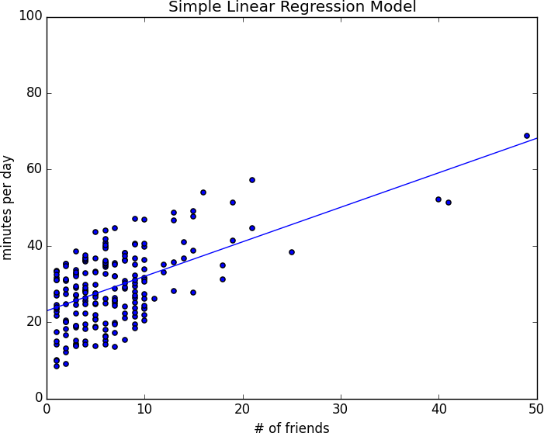

###### *Figure 26-1. Our simple linear model*

Of course, we need a better way to figure out how well we’ve fit the data than staring at the graph. A common measure is the coefficient of determination (or R-squared), which measures the fraction of the total variation in the dependent variable that is captured by the model:

**from** **scratch.statistics** **import** de_mean

**def** total_sum_of_squares(y: Vector) -> float:

*"""the total squared variation of y_i's from their mean"""*

**return** sum(v ** 2 **for** v **in** de_mean(y))

**def** r_squared(alpha: float, beta: float, x: Vector, y: Vector) -> float:

*"""*

*the fraction of variation in y captured by the model, which equals*

*1 - the fraction of variation in y not captured by the model*

*"""*

**return** 1.0 - (sum_of_sqerrors(alpha, beta, x, y) /

total_sum_of_squares(y))

rsq = r_squared(alpha, beta, num_friends_good, daily_minutes_good)

**assert** 0.328 < rsq < 0.330

Recall that we chose the alpha and beta that minimized the sum of the squared prediction errors. A linear model we could have chosen is “always predict mean(y)” (corresponding to alpha = mean(y) and beta = 0), whose sum of squared errors exactly equals its total sum of squares. This means an R-squared of 0, which indicates a model that (obviously, in this case) performs no better than just predicting the mean.

Clearly, the least squares model must be at least as good as that one, which means that the sum of the squared errors is at most the total sum of squares, which means that the R-squared must be at least 0. And the sum of squared errors must be at least 0, which means that the R-squared can be at most 1.

The higher the number, the better our model fits the data. Here we calculate an R-squared of 0.329, which tells us that our model is only sort of okay at fitting the data, and that clearly there are other factors at play.

# Using Gradient Descent

If we write theta = [alpha, beta], we can also solve this using gradient descent:

**import** **random**

**import** **tqdm**

**from** **scratch.gradient_descent** **import** gradient_step

num_epochs = 10000

random.seed(0)

guess = [random.random(), random.random()] *# choose random value to start*

learning_rate = 0.00001

**with** tqdm.trange(num_epochs) **as** t:

**for** _ **in** t:

alpha, beta = guess

*# Partial derivative of loss with respect to alpha*

grad_a = sum(2 * error(alpha, beta, x_i, y_i)

**for** x_i, y_i **in** zip(num_friends_good,

daily_minutes_good))

*# Partial derivative of loss with respect to beta*

grad_b = sum(2 * error(alpha, beta, x_i, y_i) * x_i

**for** x_i, y_i **in** zip(num_friends_good,

daily_minutes_good))

*# Compute loss to stick in the tqdm description*

loss = sum_of_sqerrors(alpha, beta,

num_friends_good, daily_minutes_good)

t.set_description(f"loss: {loss:.3f}")

*# Finally, update the guess*

guess = gradient_step(guess, [grad_a, grad_b], -learning_rate)

*# We should get pretty much the same results:*

alpha, beta = guess

**assert** 22.9 < alpha < 23.0

**assert** 0.9 < beta < 0.905

If you run this you’ll get the same values for alpha and beta as we did using the exact formula.

# Maximum Likelihood Estimation

Why choose least squares? One justification involves maximum likelihood estimation. Imagine that we have a sample of data v1,...,vnv1,...,vn that comes from a distribution that depends on some unknown parameter θ (theta):

p(v1,...,vn|θ)p(v1,...,vn|θ)

If we didn’t know θ, we could turn around and think of this quantity as the likelihood of θ given the sample:

L(θ|v1,...,vn)L(θ|v1,...,vn)

Under this approach, the most likely θ is the value that maximizes this likelihood function—that is, the value that makes the observed data the most probable. In the case of a continuous distribution, in which we have a probability distribution function rather than a probability mass function, we can do the same thing.

Back to regression. One assumption that’s often made about the simple regression model is that the regression errors are normally distributed with mean 0 and some (known) standard deviation σ. If that’s the case, then the likelihood based on seeing a pair (x_i, y_i) is:

L(α,β|xi,yi,σ)=12π−−√σexp(−(yi−α−βxi)2/2σ2)L(α,β|xi,yi,σ)=12πσexp(-(yi-α-βxi)2/2σ2)

The likelihood based on the entire dataset is the product of the individual likelihoods, which is largest precisely when alpha and beta are chosen to minimize the sum of squared errors. That is, in this case (with these assumptions), minimizing the sum of squared errors is equivalent to maximizing the likelihood of the observed data.

**Chapter 27. Multiple Regression**

*I don’t look at a problem and put variables in there that don’t affect it.*

Bill Parcells

Although the VP is pretty impressed with your predictive model, she thinks you can do better. To that end, you’ve collected additional data: you know how many hours each of your users works each day, and whether they have a PhD. You’d like to use this additional data to improve your model.

Accordingly, you hypothesize a linear model with more independent variables:

minutes=α+β1friends+β2workhours+β3phd+εminutes=α+β1friends+β2workhours+β3phd+ε

Obviously, whether a user has a PhD is not a number—but, as we mentioned in [Chapter 11](https://learning.oreilly.com/library/view/data-science-from/9781492041122/ch11.html#machine_learning), we can introduce a *dummy variable* that equals 1 for users with PhDs and 0 for users without, after which it’s just as numeric as the other variables.

**The Model**

Recall that in [Chapter 14](https://learning.oreilly.com/library/view/data-science-from/9781492041122/ch14.html#simple_linear_regression) we fit a model of the form:

yi=α+βxi+εiyi=α+βxi+εi

Now imagine that each input xixi is not a single number but rather a vector of *k* numbers, xi1,...,xikxi1,...,xik. The multiple regression model assumes that:

yi=α+β1xi1+...+βkxik+εiyi=α+β1xi1+...+βkxik+εi

In multiple regression the vector of parameters is usually called *β*. We’ll want this to include the constant term as well, which we can achieve by adding a column of 1s to our data:

beta = [alpha, beta_1, ..., beta_k]

and:

x_i = [1, x_i1, ..., x_ik]

Then our model is just:

**from** **scratch.linear_algebra** **import** dot, Vector

**def** predict(x: Vector, beta: Vector) -> float:

*"""assumes that the first element of x is 1"""*

**return** dot(x, beta)

In this particular case, our independent variable x will be a list of vectors, each of which looks like this:

[1, *# constant term*

49, *# number of friends*

4, *# work hours per day*

0] *# doesn't have PhD*

**Further Assumptions of the Least Squares Model**

There are a couple of further assumptions that are required for this model (and our solution) to make sense.

The first is that the columns of *x* are *linearly independent*—that there’s no way to write any one as a weighted sum of some of the others. If this assumption fails, it’s impossible to estimate beta. To see this in an extreme case, imagine we had an extra field num_acquaintances in our data that for every user was exactly equal to num_friends.

Then, starting with any beta, if we add *any* amount to the num_friends coefficient and subtract that same amount from the num_acquaintances coefficient, the model’s predictions will remain unchanged. This means that there’s no way to find *the* coefficient for num_friends. (Usually violations of this assumption won’t be so obvious.)

The second important assumption is that the columns of *x* are all uncorrelated with the errors εε. If this fails to be the case, our estimates of beta will be systematically wrong.

For instance, in [Chapter 14](https://learning.oreilly.com/library/view/data-science-from/9781492041122/ch14.html#simple_linear_regression), we built a model that predicted that each additional friend was associated with an extra 0.90 daily minutes on the site.

Imagine it’s also the case that:

* People who work more hours spend less time on the site.
* People with more friends tend to work more hours.

That is, imagine that the “actual” model is:

minutes=α+β1friends+β2workhours+εminutes=α+β1friends+β2workhours+ε

where β2β2 is negative, and that work hours and friends are positively correlated. In that case, when we minimize the errors of the single-variable model:

minutes=α+β1friends+εminutes=α+β1friends+ε

we will underestimate β1β1.

Think about what would happen if we made predictions using the single-variable model with the “actual” value of β1β1. (That is, the value that arises from minimizing the errors of what we called the “actual” model.) The predictions would tend to be way too large for users who work many hours and a little too large for users who work few hours, because β2<0β2<0 and we “forgot” to include it. Because work hours is positively correlated with number of friends, this means the predictions tend to be way too large for users with many friends, and only slightly too large for users with few friends.

The result of this is that we can reduce the errors (in the single-variable model) by decreasing our estimate of β1β1, which means that the error-minimizing β1β1 is smaller than the “actual” value. That is, in this case the single-variable least squares solution is biased to underestimate β1β1. And, in general, whenever the independent variables are correlated with the errors like this, our least squares solution will give us a biased estimate of β1β1.

**Fitting the Model**

As we did in the simple linear model, we’ll choose beta to minimize the sum of squared errors. Finding an exact solution is not simple to do by hand, which means we’ll need to use gradient descent. Again we’ll want to minimize the sum of the squared errors. The error function is almost identical to the one we used in [Chapter 14](https://learning.oreilly.com/library/view/data-science-from/9781492041122/ch14.html#simple_linear_regression), except that instead of expecting parameters [alpha, beta] it will take a vector of arbitrary length:

**from** **typing** **import** List

**def** error(x: Vector, y: float, beta: Vector) -> float:

**return** predict(x, beta) - y

**def** squared_error(x: Vector, y: float, beta: Vector) -> float:

**return** error(x, y, beta) ** 2

x = [1, 2, 3]

y = 30

beta = [4, 4, 4] *# so prediction = 4 + 8 + 12 = 24*

**assert** error(x, y, beta) == -6

**assert** squared_error(x, y, beta) == 36

If you know calculus, it’s easy to compute the gradient:

**def** sqerror_gradient(x: Vector, y: float, beta: Vector) -> Vector:

err = error(x, y, beta)

**return** [2 * err * x_i **for** x_i **in** x]

**assert** sqerror_gradient(x, y, beta) == [-12, -24, -36]

Otherwise, you’ll need to take my word for it.

At this point, we’re ready to find the optimal beta using gradient descent. Let’s first write out a least_squares_fit function that can work with any dataset:

**import** **random**

**import** **tqdm**

**from** **scratch.linear_algebra** **import** vector_mean

**from** **scratch.gradient_descent** **import** gradient_step

**def** least_squares_fit(xs: List[Vector],

ys: List[float],

learning_rate: float = 0.001,

num_steps: int = 1000,

batch_size: int = 1) -> Vector:

*"""*

*Find the beta that minimizes the sum of squared errors*

*assuming the model y = dot(x, beta).*

*"""*

*# Start with a random guess*

guess = [random.random() **for** _ **in** xs[0]]

**for** _ **in** tqdm.trange(num_steps, desc="least squares fit"):

**for** start **in** range(0, len(xs), batch_size):

batch_xs = xs[start:start+batch_size]

batch_ys = ys[start:start+batch_size]

gradient = vector_mean([sqerror_gradient(x, y, guess)

**for** x, y **in** zip(batch_xs, batch_ys)])

guess = gradient_step(guess, gradient, -learning_rate)

**return** guess

We can then apply that to our data:

**from** **scratch.statistics** **import** daily_minutes_good

**from** **scratch.gradient_descent** **import** gradient_step

random.seed(0)

*# I used trial and error to choose num_iters and step_size.*

*# This will run for a while.*

learning_rate = 0.001

beta = least_squares_fit(inputs, daily_minutes_good, learning_rate, 5000, 25)

**assert** 30.50 < beta[0] < 30.70 *# constant*

**assert** 0.96 < beta[1] < 1.00 *# num friends*

**assert** -1.89 < beta[2] < -1.85 *# work hours per day*

**assert** 0.91 < beta[3] < 0.94 *# has PhD*

In practice, you wouldn’t estimate a linear regression using gradient descent; you’d get the exact coefficients using linear algebra techniques that are beyond the scope of this book. If you did so, you’d find the equation:

minutes=30.58+0.972friends−1.87workhours+0.923phdminutes=30.58+0.972friends-1.87workhours+0.923phd

which is pretty close to what we found.

**Interpreting the Model**

You should think of the coefficients of the model as representing all-else-being-equal estimates of the impacts of each factor. All else being equal, each additional friend corresponds to an extra minute spent on the site each day. All else being equal, each additional hour in a user’s workday corresponds to about two fewer minutes spent on the site each day. All else being equal, having a PhD is associated with spending an extra minute on the site each day.

What this doesn’t (directly) tell us is anything about the interactions among the variables. It’s possible that the effect of work hours is different for people with many friends than it is for people with few friends. This model doesn’t capture that. One way to handle this case is to introduce a new variable that is the *product* of “friends” and “work hours.” This effectively allows the “work hours” coefficient to increase (or decrease) as the number of friends increases.

Or it’s possible that the more friends you have, the more time you spend on the site *up to a point*, after which further friends cause you to spend less time on the site. (Perhaps with too many friends the experience is just too overwhelming?) We could try to capture this in our model by adding another variable that’s the *square* of the number of friends.

Once we start adding variables, we need to worry about whether their coefficients “matter.” There are no limits to the numbers of products, logs, squares, and higher powers we could add.

**Goodness of Fit**

Again we can look at the R-squared:

**from** **scratch.simple_linear_regression** **import** total_sum_of_squares

**def** multiple_r_squared(xs: List[Vector], ys: Vector, beta: Vector) -> float:

sum_of_squared_errors = sum(error(x, y, beta) ** 2

**for** x, y **in** zip(xs, ys))

**return** 1.0 - sum_of_squared_errors / total_sum_of_squares(ys)

which has now increased to 0.68:

**assert** 0.67 < multiple_r_squared(inputs, daily_minutes_good, beta) < 0.68

Keep in mind, however, that adding new variables to a regression will *necessarily* increase the R-squared. After all, the simple regression model is just the special case of the multiple regression model where the coefficients on “work hours” and “PhD” both equal 0. The optimal multiple regression model will necessarily have an error at least as small as that one.

Because of this, in a multiple regression, we also need to look at the *standard errors* of the coefficients, which measure how certain we are about our estimates of each βiβi. The regression as a whole may fit our data very well, but if some of the independent variables are correlated (or irrelevant), their coefficients might not *mean* much.

The typical approach to measuring these errors starts with another assumption—that the errors εiεi are independent normal random variables with mean 0 and some shared (unknown) standard deviation σσ. In that case, we (or, more likely, our statistical software) can use some linear algebra to find the standard error of each coefficient. The larger it is, the less sure our model is about that coefficient. Unfortunately, we’re not set up to do that kind of linear algebra from scratch.

**Digression: The Bootstrap**

Imagine that we have a sample of *n* data points, generated by some (unknown to us) distribution:

data = get_sample(num_points=n)

In [Chapter 5](https://learning.oreilly.com/library/view/data-science-from/9781492041122/ch05.html#statistics), we wrote a function that could compute the median of the sample, which we can use as an estimate of the median of the distribution itself.

But how confident can we be about our estimate? If all the data points in the sample are very close to 100, then it seems likely that the actual median is close to 100. If approximately half the data points in the sample are close to 0 and the other half are close to 200, then we can’t be nearly as certain about the median.

If we could repeatedly get new samples, we could compute the medians of many samples and look at the distribution of those medians. Often we can’t. In that case we can *bootstrap* new datasets by choosing *n* data points *with replacement* from our data. And then we can compute the medians of those synthetic datasets:

**from** **typing** **import** TypeVar, Callable

X = TypeVar('X') *# Generic type for data*

Stat = TypeVar('Stat') *# Generic type for "statistic"*

**def** bootstrap_sample(data: List[X]) -> List[X]:

*"""randomly samples len(data) elements with replacement"""*

**return** [random.choice(data) **for** _ **in** data]

**def** bootstrap_statistic(data: List[X],

stats_fn: Callable[[List[X]], Stat],

num_samples: int) -> List[Stat]:

*"""evaluates stats_fn on num_samples bootstrap samples from data"""*

**return** [stats_fn(bootstrap_sample(data)) **for** _ **in** range(num_samples)]

For example, consider the two following datasets:

*# 101 points all very close to 100*

close_to_100 = [99.5 + random.random() **for** _ **in** range(101)]

*# 101 points, 50 of them near 0, 50 of them near 200*

far_from_100 = ([99.5 + random.random()] +

[random.random() **for** _ **in** range(50)] +

[200 + random.random() **for** _ **in** range(50)])

If you compute the medians of the two datasets, both will be very close to 100. However, if you look at:

**from** **scratch.statistics** **import** median, standard_deviation

medians_close = bootstrap_statistic(close_to_100, median, 100)

you will mostly see numbers really close to 100. But if you look at:

medians_far = bootstrap_statistic(far_from_100, median, 100)

you will see a lot of numbers close to 0 and a lot of numbers close to 200.

The standard_deviation of the first set of medians is close to 0, while that of the second set of medians is close to 100:

**assert** standard_deviation(medians_close) < 1

**assert** standard_deviation(medians_far) > 90

(This extreme a case would be pretty easy to figure out by manually inspecting the data, but in general that won’t be true.)

**Standard Errors of Regression Coefficients**

We can take the same approach to estimating the standard errors of our regression coefficients. We repeatedly take a bootstrap_sample of our data and estimate beta based on that sample. If the coefficient corresponding to one of the independent variables (say, num_friends) doesn’t vary much across samples, then we can be confident that our estimate is relatively tight. If the coefficient varies greatly across samples, then we can’t be at all confident in our estimate.

The only subtlety is that, before sampling, we’ll need to zip our x data and y data to make sure that corresponding values of the independent and dependent variables are sampled together. This means that bootstrap_sample will return a list of pairs (x_i, y_i), which we’ll need to reassemble into an x_sampleand a y_sample:

**from** **typing** **import** Tuple

**import** **datetime**

**def** estimate_sample_beta(pairs: List[Tuple[Vector, float]]):

x_sample = [x **for** x, _ **in** pairs]

y_sample = [y **for** _, y **in** pairs]

beta = least_squares_fit(x_sample, y_sample, learning_rate, 5000, 25)

**print**("bootstrap sample", beta)

**return** beta

random.seed(0) *# so that you get the same results as me*

*# This will take a couple of minutes!*

bootstrap_betas = bootstrap_statistic(list(zip(inputs, daily_minutes_good)),

estimate_sample_beta,

100)

After which we can estimate the standard deviation of each coefficient:

bootstrap_standard_errors = [

standard_deviation([beta[i] **for** beta **in** bootstrap_betas])

**for** i **in** range(4)]

**print**(bootstrap_standard_errors)

*# [1.272, # constant term, actual error = 1.19*

*# 0.103, # num_friends, actual error = 0.080*

*# 0.155, # work_hours, actual error = 0.127*

*# 1.249] # phd, actual error = 0.998*

(We would likely get better estimates if we collected more than 100 samples and used more than 5,000 iterations to estimate each beta, but we don’t have all day.)

We can use these to test hypotheses such as “does βiβi equal 0?” Under the null hypothesis βi=0βi=0 (and with our other assumptions about the distribution of εiεi), the statistic:

tj=βjˆ/σjˆtj=βj^/σj^

which is our estimate of βjβj divided by our estimate of its standard error, follows a *Student’s t-distribution* with “n−kn-k degrees of freedom.”

If we had a students_t_cdf function, we could compute *p*-values for each least-squares coefficient to indicate how likely we would be to observe such a value if the actual coefficient were 0. Unfortunately, we don’t have such a function. (Although we would if we weren’t working from scratch.)

However, as the degrees of freedom get large, the *t*-distribution gets closer and closer to a standard normal. In a situation like this, where *n* is much larger than *k*, we can use normal_cdf and still feel good about ourselves:

**from** **scratch.probability** **import** normal_cdf

**def** p_value(beta_hat_j: float, sigma_hat_j: float) -> float:

**if** beta_hat_j > 0:

*# if the coefficient is positive, we need to compute twice the*

*# probability of seeing an even *larger* value*

**return** 2 * (1 - normal_cdf(beta_hat_j / sigma_hat_j))

**else**:

*# otherwise twice the probability of seeing a *smaller* value*

**return** 2 * normal_cdf(beta_hat_j / sigma_hat_j)

**assert** p_value(30.58, 1.27) < 0.001 *# constant term*

**assert** p_value(0.972, 0.103) < 0.001 *# num_friends*

**assert** p_value(-1.865, 0.155) < 0.001 *# work_hours*

**assert** p_value(0.923, 1.249) > 0.4 *# phd*

(In a situation *not* like this, we would probably be using statistical software that knows how to compute the *t*-distribution, as well as how to compute the exact standard errors.)

While most of the coefficients have very small *p*-values (suggesting that they are indeed nonzero), the coefficient for “PhD” is not “significantly” different from 0, which makes it likely that the coefficient for “PhD” is random rather than meaningful.

In more elaborate regression scenarios, you sometimes want to test more elaborate hypotheses about the data, such as “at least one of the βjβj is nonzero” or “β1β1 equals β2β2 *and* β3β3 equals β4β4.” You can do this with an *F-test*, but alas, that falls outside the scope of this book.

**Regularization**

In practice, you’d often like to apply linear regression to datasets with large numbers of variables. This creates a couple of extra wrinkles. First, the more variables you use, the more likely you are to overfit your model to the training set. And second, the more nonzero coefficients you have, the harder it is to make sense of them. If the goal is to *explain* some phenomenon, a sparse model with three factors might be more useful than a slightly better model with hundreds.

*Regularization* is an approach in which we add to the error term a penalty that gets larger as beta gets larger. We then minimize the combined error and penalty. The more importance we place on the penalty term, the more we discourage large coefficients.

For example, in *ridge regression*, we add a penalty proportional to the sum of the squares of the beta_i (except that typically we don’t penalize beta_0, the constant term):

*# alpha is a *hyperparameter* controlling how harsh the penalty is.*

*# Sometimes it's called "lambda" but that already means something in Python.*

**def** ridge_penalty(beta: Vector, alpha: float) -> float:

**return** alpha * dot(beta[1:], beta[1:])

**def** squared_error_ridge(x: Vector,

y: float,

beta: Vector,

alpha: float) -> float:

*"""estimate error plus ridge penalty on beta"""*

**return** error(x, y, beta) ** 2 + ridge_penalty(beta, alpha)

We can then plug this into gradient descent in the usual way:

**from** **scratch.linear_algebra** **import** add

**def** ridge_penalty_gradient(beta: Vector, alpha: float) -> Vector:

*"""gradient of just the ridge penalty"""*

**return** [0.] + [2 * alpha * beta_j **for** beta_j **in** beta[1:]]

**def** sqerror_ridge_gradient(x: Vector,

y: float,

beta: Vector,

alpha: float) -> Vector:

*"""*

*the gradient corresponding to the ith squared error term*

*including the ridge penalty*

*"""*

**return** add(sqerror_gradient(x, y, beta),

ridge_penalty_gradient(beta, alpha))

And then we just need to modify the least_squares_fit function to use the sqerror_ridge_gradientinstead of sqerror_gradient. (I’m not going to repeat the code here.)

With alpha set to 0, there’s no penalty at all and we get the same results as before:

random.seed(0)

beta_0 = least_squares_fit_ridge(inputs, daily_minutes_good, 0.0, *# alpha*

learning_rate, 5000, 25)

*# [30.51, 0.97, -1.85, 0.91]*

**assert** 5 < dot(beta_0[1:], beta_0[1:]) < 6

**assert** 0.67 < multiple_r_squared(inputs, daily_minutes_good, beta_0) < 0.69

As we increase alpha, the goodness of fit gets worse, but the size of beta gets smaller:

beta_0_1 = least_squares_fit_ridge(inputs, daily_minutes_good, 0.1, *# alpha*

learning_rate, 5000, 25)

*# [30.8, 0.95, -1.83, 0.54]*

**assert** 4 < dot(beta_0_1[1:], beta_0_1[1:]) < 5

**assert** 0.67 < multiple_r_squared(inputs, daily_minutes_good, beta_0_1) < 0.69

beta_1 = least_squares_fit_ridge(inputs, daily_minutes_good, 1, *# alpha*

learning_rate, 5000, 25)

*# [30.6, 0.90, -1.68, 0.10]*

**assert** 3 < dot(beta_1[1:], beta_1[1:]) < 4

**assert** 0.67 < multiple_r_squared(inputs, daily_minutes_good, beta_1) < 0.69

beta_10 = least_squares_fit_ridge(inputs, daily_minutes_good,10, *# alpha*

learning_rate, 5000, 25)

*# [28.3, 0.67, -0.90, -0.01]*

**assert** 1 < dot(beta_10[1:], beta_10[1:]) < 2

**assert** 0.5 < multiple_r_squared(inputs, daily_minutes_good, beta_10) < 0.6

In particular, the coefficient on “PhD” vanishes as we increase the penalty, which accords with our previous result that it wasn’t significantly different from 0.

**NOTE**

Usually you’d want to rescale your data before using this approach. After all, if you changed years of experience to centuries of experience, its least squares coefficient would increase by a factor of 100 and suddenly get penalized much more, even though it’s the same model.

Another approach is *lasso regression*, which uses the penalty:

**def** lasso_penalty(beta, alpha):

**return** alpha * sum(abs(beta_i) **for** beta_i **in** beta[1:])

Whereas the ridge penalty shrank the coefficients overall, the lasso penalty tends to force coefficients to be 0, which makes it good for learning sparse models. Unfortunately, it’s not amenable to gradient descent, which means that we won’t be able to solve it from scratch.

**Chapter 28. Logistic Regression**

*A lot of people say there’s a fine line between genius and insanity. I don’t think there’s a fine line, I actually think there’s a yawning gulf.*

Bill Bailey

In [Chapter 1](https://learning.oreilly.com/library/view/data-science-from/9781492041122/ch01.html#introduction), we briefly looked at the problem of trying to predict which DataSciencester users paid for premium accounts. Here we’ll revisit that problem.

**The Problem**

We have an anonymized dataset of about 200 users, containing each user’s salary, her years of experience as a data scientist, and whether she paid for a premium account ([Figure 28-1](https://learning.oreilly.com/library/view/data-science-from/9781492041122/ch16.html#logit_image)). As is typical with categorical variables, we represent the dependent variable as either 0 (no premium account) or 1 (premium account).

As usual, our data is a list of rows [experience, salary, paid_account]. Let’s turn it into the format we need:

xs = [[1.0] + row[:2] **for** row **in** data] *# [1, experience, salary]*

ys = [row[2] **for** row **in** data] *# paid_account*

An obvious first attempt is to use linear regression and find the best model:

paidaccount=β0+β1experience+β2salary+εpaidaccount=β0+β1experience+β2salary+ε

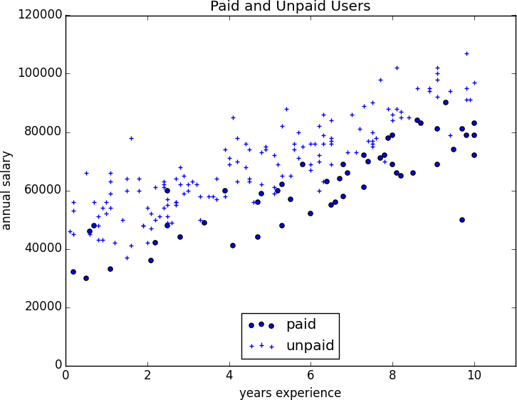

***Figure 28-1. Paid and unpaid users***

And certainly, there’s nothing preventing us from modeling the problem this way. The results are shown in [Figure 28-2](https://learning.oreilly.com/library/view/data-science-from/9781492041122/ch16.html#linear_regression_for_probabilities):

**from** **matplotlib** **import** pyplot **as** plt

**from** **scratch.working_with_data** **import** rescale

**from** **scratch.multiple_regression** **import** least_squares_fit, predict

**from** **scratch.gradient_descent** **import** gradient_step

learning_rate = 0.001

rescaled_xs = rescale(xs)

beta = least_squares_fit(rescaled_xs, ys, learning_rate, 1000, 1)

*# [0.26, 0.43, -0.43]*

predictions = [predict(x_i, beta) **for** x_i **in** rescaled_xs]

plt.scatter(predictions, ys)

plt.xlabel("predicted")

plt.ylabel("actual")

plt.show()

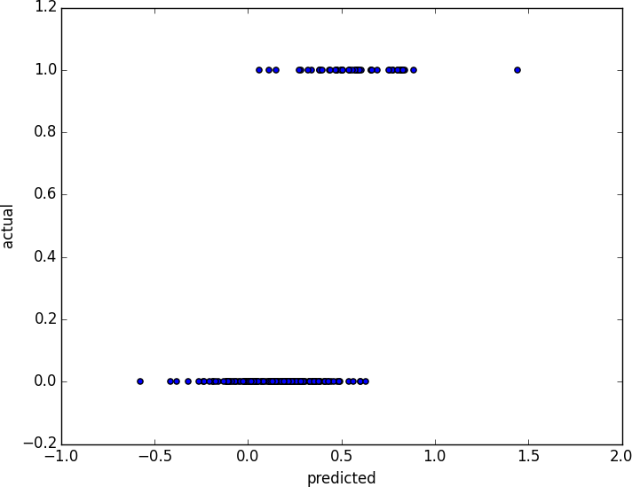

***Figure 28-2. Using linear regression to predict premium accounts***

But this approach leads to a couple of immediate problems:

* We’d like for our predicted outputs to be 0 or 1, to indicate class membership. It’s fine if they’re between 0 and 1, since we can interpret these as probabilities—an output of 0.25 could mean 25% chance of being a paid member. But the outputs of the linear model can be huge positive numbers or even negative numbers, which it’s not clear how to interpret. Indeed, here a lot of our predictions were negative.
* The linear regression model assumed that the errors were uncorrelated with the columns of *x*. But here, the regression coefficient for experience is 0.43, indicating that more experience leads to a greater likelihood of a premium account. This means that our model outputs very large values for people with lots of experience. But we know that the actual values must be at most 1, which means that necessarily very large outputs (and therefore very large values of experience) correspond to very large negative values of the error term. Because this is the case, our estimate of beta is biased.

What we’d like instead is for large positive values of dot(x_i, beta) to correspond to probabilities close to 1, and for large negative values to correspond to probabilities close to 0. We can accomplish this by applying another function to the result.

**The Logistic Function**

In the case of logistic regression, we use the *logistic function*, pictured in [Figure 28-3](https://learning.oreilly.com/library/view/data-science-from/9781492041122/ch16.html#graph_of_logistic_function):

**def** logistic(x: float) -> float:

**return** 1.0 / (1 + math.exp(-x))

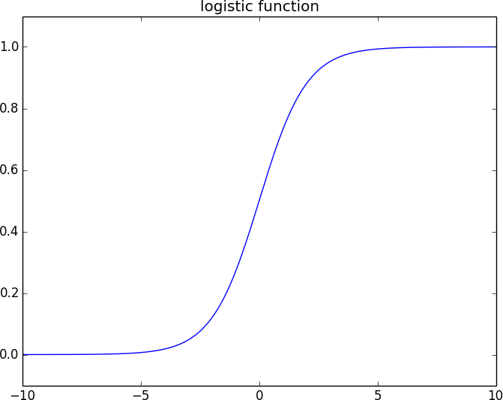

***Figure 28-3. The logistic function***

As its input gets large and positive, it gets closer and closer to 1. As its input gets large and negative, it gets closer and closer to 0. Additionally, it has the convenient property that its derivative is given by:

**def** logistic_prime(x: float) -> float:

y = logistic(x)

**return** y * (1 - y)

which we’ll make use of in a bit. We’ll use this to fit a model:

yi=f(xiβ)+εiyi=f(xiβ)+εi

where *f* is the logistic function.

Recall that for linear regression we fit the model by minimizing the sum of squared errors, which ended up choosing the *β* that maximized the likelihood of the data.

Here the two aren’t equivalent, so we’ll use gradient descent to maximize the likelihood directly. This means we need to calculate the likelihood function and its gradient.

Given some *β*, our model says that each yiyi should equal 1 with probability f(xiβ)f(xiβ) and 0 with probability 1−f(xiβ)1-f(xiβ).

In particular, the PDF for yiyi can be written as:

p(yi|xi,β)=f(xiβ)yi(1−f(xiβ))1−yip(yi|xi,β)=f(xiβ)yi(1-f(xiβ))1-yi

since if yiyi is 0, this equals:

1−f(xiβ)1-f(xiβ)

and if yiyi is 1, it equals:

f(xiβ)f(xiβ)

It turns out that it’s actually simpler to maximize the *log likelihood*:

logL(β|xi,yi)=yilogf(xiβ)+(1−yi)log(1−f(xiβ))logL(β|xi,yi)=yilogf(xiβ)+(1-yi)log(1-f(xiβ))

Because log is a strictly increasing function, any beta that maximizes the log likelihood also maximizes the likelihood, and vice versa. Because gradient descent minimizes things, we’ll actually work with the *negative* log likelihood, since maximizing the likelihood is the same as minimizing its negative:

**import** **math**

**from** **scratch.linear_algebra** **import** Vector, dot

**def** _negative_log_likelihood(x: Vector, y: float, beta: Vector) -> float:

*"""The negative log likelihood for one data point"""*

**if** y == 1:

**return** -math.log(logistic(dot(x, beta)))

**else**:

**return** -math.log(1 - logistic(dot(x, beta)))

If we assume different data points are independent from one another, the overall likelihood is just the product of the individual likelihoods. That means the overall log likelihood is the sum of the individual log likelihoods:

**from** **typing** **import** List

**def** negative_log_likelihood(xs: List[Vector],

ys: List[float],

beta: Vector) -> float:

**return** sum(_negative_log_likelihood(x, y, beta)

**for** x, y **in** zip(xs, ys))

A little bit of calculus gives us the gradient:

**from** **scratch.linear_algebra** **import** vector_sum

**def** _negative_log_partial_j(x: Vector, y: float, beta: Vector, j: int) -> float:

*"""*

*The jth partial derivative for one data point.*

*Here i is the index of the data point.*

*"""*

**return** -(y - logistic(dot(x, beta))) * x[j]

**def** _negative_log_gradient(x: Vector, y: float, beta: Vector) -> Vector:

*"""*

*The gradient for one data point.*

*"""*

**return** [_negative_log_partial_j(x, y, beta, j)

**for** j **in** range(len(beta))]

**def** negative_log_gradient(xs: List[Vector],

ys: List[float],

beta: Vector) -> Vector:

**return** vector_sum([_negative_log_gradient(x, y, beta)

**for** x, y **in** zip(xs, ys)])

at which point we have all the pieces we need.

**Applying the Model**

We’ll want to split our data into a training set and a test set:

**from** **scratch.machine_learning** **import** train_test_split

**import** **random**

**import** **tqdm**

random.seed(0)

x_train, x_test, y_train, y_test = train_test_split(rescaled_xs, ys, 0.33)

learning_rate = 0.01

*# pick a random starting point*

beta = [random.random() **for** _ **in** range(3)]

**with** tqdm.trange(5000) **as** t:

**for** epoch **in** t:

gradient = negative_log_gradient(x_train, y_train, beta)

beta = gradient_step(beta, gradient, -learning_rate)

loss = negative_log_likelihood(x_train, y_train, beta)

t.set_description(f"loss: {loss:.3f} beta: {beta}")

after which we find that beta is approximately:

[-2.0, 4.7, -4.5]

These are coefficients for the rescaled data, but we can transform them back to the original data as well:

**from** **scratch.working_with_data** **import** scale

means, stdevs = scale(xs)

beta_unscaled = [(beta[0]

- beta[1] * means[1] / stdevs[1]

- beta[2] * means[2] / stdevs[2]),

beta[1] / stdevs[1],

beta[2] / stdevs[2]]

*# [8.9, 1.6, -0.000288]*

Unfortunately, these are not as easy to interpret as linear regression coefficients. All else being equal, an extra year of experience adds 1.6 to the input of logistic. All else being equal, an extra $10,000 of salary subtracts 2.88 from the input of logistic.

The impact on the output, however, depends on the other inputs as well. If dot(beta, x_i) is already large (corresponding to a probability close to 1), increasing it even by a lot cannot affect the probability very much. If it’s close to 0, increasing it just a little might increase the probability quite a bit.

What we can say is that—all else being equal—people with more experience are more likely to pay for accounts. And that—all else being equal—people with higher salaries are less likely to pay for accounts. (This was also somewhat apparent when we plotted the data.)

**Goodness of Fit**

We haven’t yet used the test data that we held out. Let’s see what happens if we predict *paid account* whenever the probability exceeds 0.5:

true_positives = false_positives = true_negatives = false_negatives = 0

**for** x_i, y_i **in** zip(x_test, y_test):

prediction = logistic(dot(beta, x_i))

**if** y_i == 1 **and** prediction >= 0.5: *# TP: paid and we predict paid*

true_positives += 1

**elif** y_i == 1: *# FN: paid and we predict unpaid*

false_negatives += 1

**elif** prediction >= 0.5: *# FP: unpaid and we predict paid*

false_positives += 1

**else**: *# TN: unpaid and we predict unpaid*

true_negatives += 1

precision = true_positives / (true_positives + false_positives)

recall = true_positives / (true_positives + false_negatives)

This gives a precision of 75% (“when we predict *paid account* we’re right 75% of the time”) and a recall of 80% (“when a user has a paid account we predict *paid account* 80% of the time”), which is not terrible considering how little data we have.

We can also plot the predictions versus the actuals ([Figure 28-4](https://learning.oreilly.com/library/view/data-science-from/9781492041122/ch16.html#logistic_prediction_vs_actual)), which also shows that the model performs well:

predictions = [logistic(dot(beta, x_i)) **for** x_i **in** x_test]

plt.scatter(predictions, y_test, marker='+')

plt.xlabel("predicted probability")

plt.ylabel("actual outcome")

plt.title("Logistic Regression Predicted vs. Actual")

plt.show()

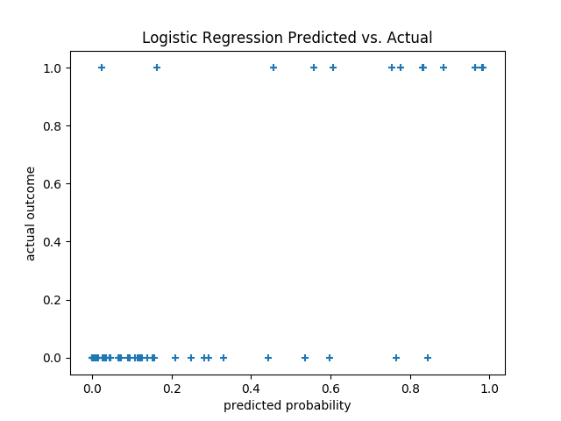

***Figure 28-4. Logistic regression predicted versus actual***

**Support Vector Machines**

The set of points where dot(beta, x_i) equals 0 is the boundary between our classes. We can plot this to see exactly what our model is doing ([Figure 28-5](https://learning.oreilly.com/library/view/data-science-from/9781492041122/ch16.html#logit_image_part_two)).

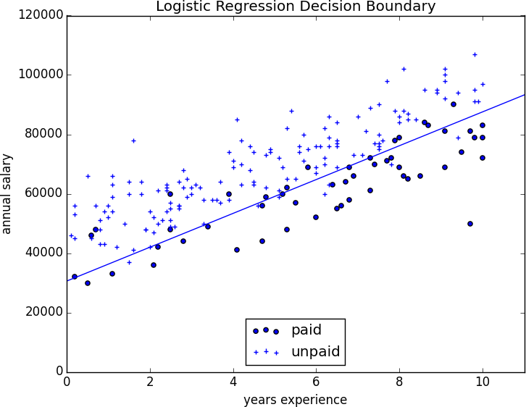

***Figure 28-5. Paid and unpaid users with decision boundary***

This boundary is a *hyperplane* that splits the parameter space into two half-spaces corresponding to *predict paid*and *predict unpaid*. We found it as a side effect of finding the most likely logistic model.

An alternative approach to classification is to just look for the hyperplane that “best” separates the classes in the training data. This is the idea behind the *support vector machine*, which finds the hyperplane that maximizes the distance to the nearest point in each class ([Figure 28-6](https://learning.oreilly.com/library/view/data-science-from/9781492041122/ch16.html#separating_hyperplane)).

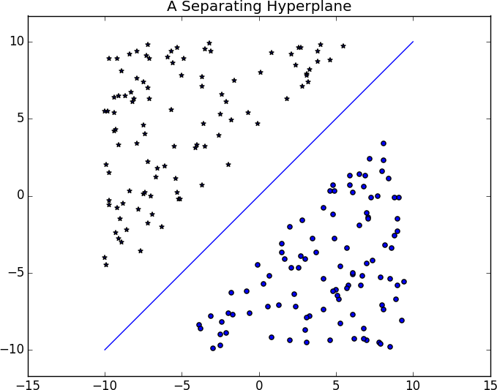

***Figure 28-6. A separating hyperplane***

Finding such a hyperplane is an optimization problem that involves techniques that are too advanced for us. A different problem is that a separating hyperplane might not exist at all. In our “who pays?” dataset there simply is no line that perfectly separates the paid users from the unpaid users.

We can sometimes get around this by transforming the data into a higher-dimensional space. For example, consider the simple one-dimensional dataset shown in [Figure 28-7](https://learning.oreilly.com/library/view/data-science-from/9781492041122/ch16.html#svm_non_separable).

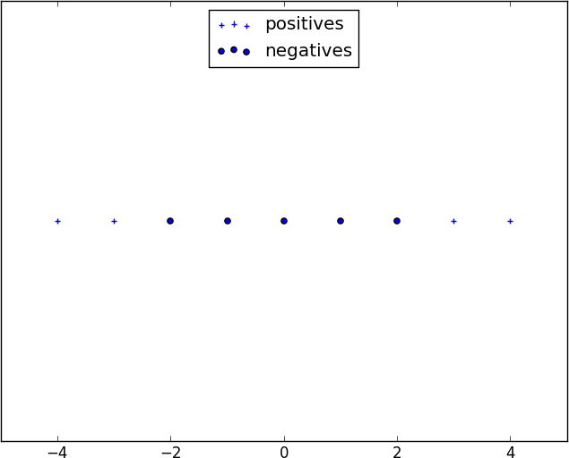

***Figure 28-7. A nonseparable one-dimensional dataset***

It’s clear that there’s no hyperplane that separates the positive examples from the negative ones. However, look at what happens when we map this dataset to two dimensions by sending the point x to (x, x**2). Suddenly it’s possible to find a hyperplane that splits the data ([Figure 28-8](https://learning.oreilly.com/library/view/data-science-from/9781492041122/ch16.html#svm_separable)).

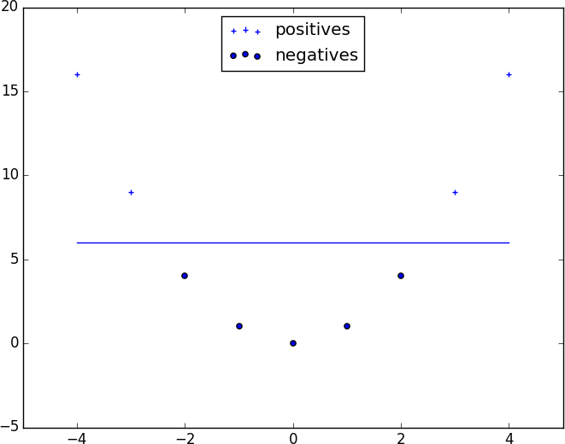

***Figure 28-8. Dataset becomes separable in higher dimensions***

This is usually called the *kernel trick* because rather than actually mapping the points into the higher-dimensional space (which could be expensive if there are a lot of points and the mapping is complicated), we can use a “kernel” function to compute dot products in the higher-dimensional space and use those to find a hyperplane.

It’s hard (and probably not a good idea) to *use* support vector machines without relying on specialized optimization software written by people with the appropriate expertise, so we’ll have to leave our treatment here.

**Chapter 29. Decision Trees**

*A tree is an incomprehensible mystery.*

Jim Woodring

DataSciencester’s VP of Talent has interviewed a number of job candidates from the site, with varying degrees of success. He’s collected a dataset consisting of several (qualitative) attributes of each candidate, as well as whether that candidate interviewed well or poorly. Could you, he asks, use this data to build a model identifying which candidates will interview well, so that he doesn’t have to waste time conducting interviews?

This seems like a good fit for a *decision tree*, another predictive modeling tool in the data scientist’s kit.

**What Is a Decision Tree?**

A decision tree uses a tree structure to represent a number of possible *decision paths* and an outcome for each path.

If you have ever played the game [Twenty Questions](http://en.wikipedia.org/wiki/Twenty_Questions), then you are familiar with decision trees. For example:

* “I am thinking of an animal.”
* “Does it have more than five legs?”
* “No.”
* “Is it delicious?”
* “No.”
* “Does it appear on the back of the Australian five-cent coin?”
* “Yes.”
* “Is it an echidna?”
* “Yes, it is!”

This corresponds to the path:

“Not more than 5 legs” → “Not delicious” → “On the 5-cent coin” → “Echidna!”

in an idiosyncratic (and not very comprehensive) “guess the animal” decision tree ([Table 27-1](https://learning.oreilly.com/library/view/data-science-from/9781492041122/ch17.html#guess_the_animal)).

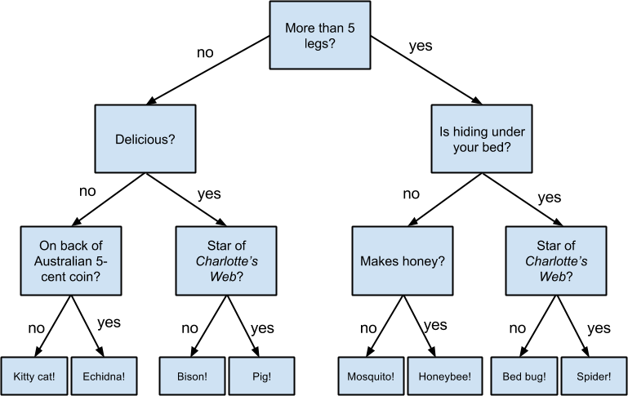

***Table 27-1. A “guess the animal” decision tree***

Decision trees have a lot to recommend them. They’re very easy to understand and interpret, and the process by which they reach a prediction is completely transparent. Unlike the other models we’ve looked at so far, decision trees can easily handle a mix of numeric (e.g., number of legs) and categorical (e.g., delicious/not delicious) attributes and can even classify data for which attributes are missing.

At the same time, finding an “optimal” decision tree for a set of training data is computationally a very hard problem. (We will get around this by trying to build a good-enough tree rather than an optimal one, although for large datasets this can still be a lot of work.) More important, it is very easy (and very bad) to build decision trees that are *overfitted* to the training data, and that don’t generalize well to unseen data. We’ll look at ways to address this.

Most people divide decision trees into *classification trees* (which produce categorical outputs) and *regression trees* (which produce numeric outputs). In this chapter, we’ll focus on classification trees, and we’ll work through the ID3 algorithm for learning a decision tree from a set of labeled data, which should help us understand how decision trees actually work. To make things simple, we’ll restrict ourselves to problems with binary outputs like “Should I hire this candidate?” or “Should I show this website visitor advertisement A or advertisement B?” or “Will eating this food I found in the office fridge make me sick?”

**Entropy**

In order to build a decision tree, we will need to decide what questions to ask and in what order. At each stage of the tree there are some possibilities we’ve eliminated and some that we haven’t. After learning that an animal doesn’t have more than five legs, we’ve eliminated the possibility that it’s a grasshopper. We haven’t eliminated the possibility that it’s a duck. Each possible question partitions the remaining possibilities according to its answer.

Ideally, we’d like to choose questions whose answers give a lot of information about what our tree should predict. If there’s a single yes/no question for which “yes” answers always correspond to True outputs and “no” answers to False outputs (or vice versa), this would be an awesome question to pick. Conversely, a yes/no question for which neither answer gives you much new information about what the prediction should be is probably not a good choice.

We capture this notion of “how much information” with *entropy*. You have probably heard this term used to mean disorder. We use it to represent the uncertainty associated with data.

Imagine that we have a set *S* of data, each member of which is labeled as belonging to one of a finite number of classes C1,...,CnC1,...,Cn. If all the data points belong to a single class, then there is no real uncertainty, which means we’d like there to be low entropy. If the data points are evenly spread across the classes, there is a lot of uncertainty and we’d like there to be high entropy.

In math terms, if pipi is the proportion of data labeled as class cici, we define the entropy as:

H(S)=−p1log2p1−...−pnlog2pnH(S)=-p1log2p1-...-pnlog2pn

with the (standard) convention that 0log0=00log0=0.

Without worrying too much about the grisly details, each term −pilog2pi-pilog2pi is non-negative and is close to 0 precisely when pipi is either close to 0 or close to 1 ([Table 27-2](https://learning.oreilly.com/library/view/data-science-from/9781492041122/ch17.html#p_log_p)).

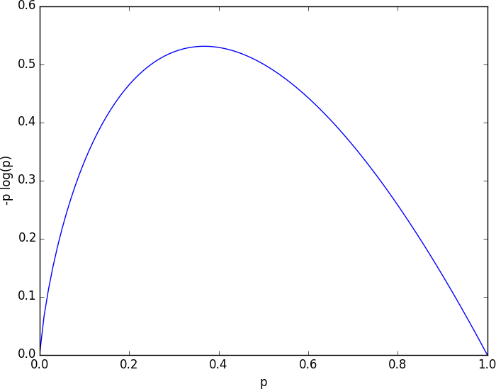

***Table 27-2. A graph of -p log p***

This means the entropy will be small when every pipi is close to 0 or 1 (i.e., when most of the data is in a single class), and it will be larger when many of the pipi’s are not close to 0 (i.e., when the data is spread across multiple classes). This is exactly the behavior we desire.

It is easy enough to roll all of this into a function:

**from** **typing** **import** List

**import** **math**

**def** entropy(class_probabilities: List[float]) -> float:

*"""Given a list of class probabilities, compute the entropy"""*

**return** sum(-p * math.log(p, 2)

**for** p **in** class_probabilities

**if** p > 0) *# ignore zero probabilities*

**assert** entropy([1.0]) == 0

**assert** entropy([0.5, 0.5]) == 1

**assert** 0.81 < entropy([0.25, 0.75]) < 0.82

Our data will consist of pairs (input, label), which means that we’ll need to compute the class probabilities ourselves. Notice that we don’t actually care which label is associated with each probability, only what the probabilities are:

**from** **typing** **import** Any

**from** **collections** **import** Counter

**def** class_probabilities(labels: List[Any]) -> List[float]:

total_count = len(labels)

**return** [count / total_count

**for** count **in** Counter(labels).values()]

**def** data_entropy(labels: List[Any]) -> float:

**return** entropy(class_probabilities(labels))

**assert** data_entropy(['a']) == 0

**assert** data_entropy([True, False]) == 1

**assert** data_entropy([3, 4, 4, 4]) == entropy([0.25, 0.75])

**The Entropy of a Partition**

What we’ve done so far is compute the entropy (think “uncertainty”) of a single set of labeled data. Now, each stage of a decision tree involves asking a question whose answer partitions data into one or (hopefully) more subsets. For instance, our “does it have more than five legs?” question partitions animals into those that have more than five legs (e.g., spiders) and those that don’t (e.g., echidnas).

Correspondingly, we’d like some notion of the entropy that results from partitioning a set of data in a certain way. We want a partition to have low entropy if it splits the data into subsets that themselves have low entropy (i.e., are highly certain), and high entropy if it contains subsets that (are large and) have high entropy (i.e., are highly uncertain).

For example, my “Australian five-cent coin” question was pretty dumb (albeit pretty lucky!), as it partitioned the remaining animals at that point into S1S1 = {echidna} and S2S2 = {everything else}, where S2S2 is both large and high-entropy. (S1S1 has no entropy, but it represents a small fraction of the remaining “classes.”)

Mathematically, if we partition our data *S* into subsets S1,...,SmS1,...,Sm containing proportions q1,...,qmq1,...,qm of the data, then we compute the entropy of the partition as a weighted sum:

H=q1H(S1)+...+qmH(Sm)H=q1H(S1)+...+qmH(Sm)

which we can implement as:

**def** partition_entropy(subsets: List[List[Any]]) -> float:

*"""Returns the entropy from this partition of data into subsets"""*

total_count = sum(len(subset) **for** subset **in** subsets)

**return** sum(data_entropy(subset) * len(subset) / total_count

**for** subset **in** subsets)

**NOTE**

One problem with this approach is that partitioning by an attribute with many different values will result in a very low entropy due to overfitting. For example, imagine you work for a bank and are trying to build a decision tree to predict which of your customers are likely to default on their mortgages, using some historical data as your training set. Imagine further that the dataset contains each customer’s Social Security number. Partitioning on SSN will produce one-person subsets, each of which necessarily has zero entropy. But a model that relies on SSN is *certain* not to generalize beyond the training set. For this reason, you should probably try to avoid (or bucket, if appropriate) attributes with large numbers of possible values when creating decision trees.

**Creating a Decision Tree**

The VP provides you with the interviewee data, consisting of (per your specification) a NamedTuple of the relevant attributes for each candidate—her level, her preferred language, whether she is active on Twitter, whether she has a PhD, and whether she interviewed well:

**from** **typing** **import** NamedTuple, Optional

**class** **Candidate**(NamedTuple):

level: str

lang: str

tweets: bool

phd: bool

did_well: Optional[bool] = None *# allow unlabeled data*

*# level lang tweets phd did_well*

inputs = [Candidate('Senior', 'Java', False, False, False),

Candidate('Senior', 'Java', False, True, False),

Candidate('Mid', 'Python', False, False, True),

Candidate('Junior', 'Python', False, False, True),

Candidate('Junior', 'R', True, False, True),

Candidate('Junior', 'R', True, True, False),

Candidate('Mid', 'R', True, True, True),

Candidate('Senior', 'Python', False, False, False),

Candidate('Senior', 'R', True, False, True),

Candidate('Junior', 'Python', True, False, True),

Candidate('Senior', 'Python', True, True, True),

Candidate('Mid', 'Python', False, True, True),

Candidate('Mid', 'Java', True, False, True),

Candidate('Junior', 'Python', False, True, False)

]

Our tree will consist of *decision nodes* (which ask a question and direct us differently depending on the answer) and *leaf nodes* (which give us a prediction). We will build it using the relatively simple *ID3* algorithm, which operates in the following manner. Let’s say we’re given some labeled data, and a list of attributes to consider branching on:

* If the data all have the same label, create a leaf node that predicts that label and then stop.
* If the list of attributes is empty (i.e., there are no more possible questions to ask), create a leaf node that predicts the most common label and then stop.
* Otherwise, try partitioning the data by each of the attributes.
* Choose the partition with the lowest partition entropy.
* Add a decision node based on the chosen attribute.
* Recur on each partitioned subset using the remaining attributes.

This is what’s known as a “greedy” algorithm because, at each step, it chooses the most immediately best option. Given a dataset, there may be a better tree with a worse-looking first move. If so, this algorithm won’t find it. Nonetheless, it is relatively easy to understand and implement, which makes it a good place to begin exploring decision trees.

Let’s manually go through these steps on the interviewee dataset. The dataset has both True and False labels, and we have four attributes we can split on. So our first step will be to find the partition with the least entropy. We’ll start by writing a function that does the partitioning:

**from** **typing** **import** Dict, TypeVar

**from** **collections** **import** defaultdict

T = TypeVar('T') *# generic type for inputs*

**def** partition_by(inputs: List[T], attribute: str) -> Dict[Any, List[T]]:

*"""Partition the inputs into lists based on the specified attribute."""*

partitions: Dict[Any, List[T]] = defaultdict(list)

**for** input **in** inputs:

key = getattr(input, attribute) *# value of the specified attribute*

partitions[key].append(input) *# add input to the correct partition*

**return** partitions

and one that uses it to compute entropy:

**def** partition_entropy_by(inputs: List[Any],

attribute: str,

label_attribute: str) -> float:

*"""Compute the entropy corresponding to the given partition"""*

*# partitions consist of our inputs*

partitions = partition_by(inputs, attribute)

*# but partition_entropy needs just the class labels*

labels = [[getattr(input, label_attribute) **for** input **in** partition]

**for** partition **in** partitions.values()]

**return** partition_entropy(labels)

Then we just need to find the minimum-entropy partition for the whole dataset:

**for** key **in** ['level','lang','tweets','phd']:

**print**(key, partition_entropy_by(inputs, key, 'did_well'))

**assert** 0.69 < partition_entropy_by(inputs, 'level', 'did_well') < 0.70

**assert** 0.86 < partition_entropy_by(inputs, 'lang', 'did_well') < 0.87

**assert** 0.78 < partition_entropy_by(inputs, 'tweets', 'did_well') < 0.79

**assert** 0.89 < partition_entropy_by(inputs, 'phd', 'did_well') < 0.90

The lowest entropy comes from splitting on level, so we’ll need to make a subtree for each possible levelvalue. Every Mid candidate is labeled True, which means that the Mid subtree is simply a leaf node predicting True. For Senior candidates, we have a mix of Trues and Falses, so we need to split again:

senior_inputs = [input **for** input **in** inputs **if** input.level == 'Senior']

**assert** 0.4 == partition_entropy_by(senior_inputs, 'lang', 'did_well')

**assert** 0.0 == partition_entropy_by(senior_inputs, 'tweets', 'did_well')

**assert** 0.95 < partition_entropy_by(senior_inputs, 'phd', 'did_well') < 0.96

This shows us that our next split should be on tweets, which results in a zero-entropy partition. For these Senior-level candidates, “yes” tweets always result in True while “no” tweets always result in False.

Finally, if we do the same thing for the Junior candidates, we end up splitting on phd, after which we find that no PhD always results in True and PhD always results in False.

[Table 27-3](https://learning.oreilly.com/library/view/data-science-from/9781492041122/ch17.html#hiring_decision_tree) shows the complete decision tree.

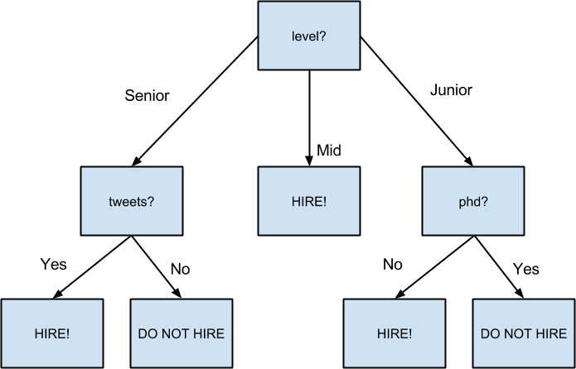

***Table 27-3. The decision tree for hiring***

**Putting It All Together**

Now that we’ve seen how the algorithm works, we would like to implement it more generally. This means we need to decide how we want to represent trees. We’ll use pretty much the most lightweight representation possible. We define a *tree* to be either:

* a Leaf (that predicts a single value), or
* a Split (containing an attribute to split on, subtrees for specific values of that attribute, and possibly a default value to use if we see an unknown value).
* **from** **typing** **import** NamedTuple, Union, Any
* **class** **Leaf**(NamedTuple):
* value: Any
* **class** **Split**(NamedTuple):
* attribute: str
* subtrees: dict
* default_value: Any = None

DecisionTree = Union[Leaf, Split]

With this representation, our hiring tree would look like:

hiring_tree = Split('level', { *# first, consider "level"*

'Junior': Split('phd', { *# if level is "Junior", next look at "phd"*

False: Leaf(True), *# if "phd" is False, predict True*

True: Leaf(False) *# if "phd" is True, predict False*

}),

'Mid': Leaf(True), *# if level is "Mid", just predict True*

'Senior': Split('tweets', { *# if level is "Senior", look at "tweets"*

False: Leaf(False), *# if "tweets" is False, predict False*

True: Leaf(True) *# if "tweets" is True, predict True*

})

})

There’s still the question of what to do if we encounter an unexpected (or missing) attribute value. What should our hiring tree do if it encounters a candidate whose level is Intern? We’ll handle this case by populating the default_value attribute with the most common label.

Given such a representation, we can classify an input with:

**def** classify(tree: DecisionTree, input: Any) -> Any:

*"""classify the input using the given decision tree"""*

*# If this is a leaf node, return its value*

**if** isinstance(tree, Leaf):

**return** tree.value

*# Otherwise this tree consists of an attribute to split on*

*# and a dictionary whose keys are values of that attribute*

*# and whose values are subtrees to consider next*

subtree_key = getattr(input, tree.attribute)

**if** subtree_key **not** **in** tree.subtrees: *# If no subtree for key,*

**return** tree.default_value *# return the default value.*

subtree = tree.subtrees[subtree_key] *# Choose the appropriate subtree*

**return** classify(subtree, input) *# and use it to classify the input.*

All that’s left is to build the tree representation from our training data:

**def** build_tree_id3(inputs: List[Any],

split_attributes: List[str],

target_attribute: str) -> DecisionTree:

*# Count target labels*

label_counts = Counter(getattr(input, target_attribute)

**for** input **in** inputs)

most_common_label = label_counts.most_common(1)[0][0]

*# If there's a unique label, predict it*

**if** len(label_counts) == 1:

**return** Leaf(most_common_label)

*# If no split attributes left, return the majority label*

**if** **not** split_attributes:

**return** Leaf(most_common_label)

*# Otherwise split by the best attribute*

**def** split_entropy(attribute: str) -> float:

*"""Helper function for finding the best attribute"""*

**return** partition_entropy_by(inputs, attribute, target_attribute)

best_attribute = min(split_attributes, key=split_entropy)

partitions = partition_by(inputs, best_attribute)

new_attributes = [a **for** a **in** split_attributes **if** a != best_attribute]

*# Recursively build the subtrees*

subtrees = {attribute_value : build_tree_id3(subset,

new_attributes,

target_attribute)

**for** attribute_value, subset **in** partitions.items()}

**return** Split(best_attribute, subtrees, default_value=most_common_label)

In the tree we built, every leaf consisted entirely of True inputs or entirely of False inputs. This means that the tree predicts perfectly on the training dataset. But we can also apply it to new data that wasn’t in the training set:

tree = build_tree_id3(inputs,

['level', 'lang', 'tweets', 'phd'],

'did_well')

*# Should predict True*

**assert** classify(tree, Candidate("Junior", "Java", True, False))

*# Should predict False*

**assert** **not** classify(tree, Candidate("Junior", "Java", True, True))

And also to data with unexpected values:

*# Should predict True*

**assert** classify(tree, Candidate("Intern", "Java", True, True))

**NOTE**

Since our goal was mainly to demonstrate *how* to build a tree, we built the tree using the entire dataset. As always, if we were really trying to create a good model for something, we would have collected more data and split it into train/validation/test subsets.

**Random Forests**

Given how closely decision trees can fit themselves to their training data, it’s not surprising that they have a tendency to overfit. One way of avoiding this is a technique called *random forests*, in which we build multiple decision trees and combine their outputs. If they’re classification trees, we might let them vote; if they’re regression trees, we might average their predictions.

Our tree-building process was deterministic, so how do we get random trees?

One piece involves bootstrapping data (recall [“Digression: The Bootstrap”](https://learning.oreilly.com/library/view/data-science-from/9781492041122/ch15.html#the_bootstrap)). Rather than training each tree on all the inputs in the training set, we train each tree on the result of bootstrap_sample(inputs). Since each tree is built using different data, each tree will be different from every other tree. (A side benefit is that it’s totally fair to use the nonsampled data to test each tree, which means you can get away with using all of your data as the training set if you are clever in how you measure performance.) This technique is known as *bootstrap aggregating* or *bagging*.

A second source of randomness involves changing the way we choose the best_attribute to split on. Rather than looking at all the remaining attributes, we first choose a random subset of them and then split on whichever of those is best:

*# if there are already few enough split candidates, look at all of them*

**if** len(split_candidates) <= self.num_split_candidates:

sampled_split_candidates = split_candidates

*# otherwise pick a random sample*

**else**:

sampled_split_candidates = random.sample(split_candidates,

self.num_split_candidates)

*# now choose the best attribute only from those candidates*

best_attribute = min(sampled_split_candidates, key=split_entropy)

partitions = partition_by(inputs, best_attribute)

This is an example of a broader technique called *ensemble learning* in which we combine several *weak learners*(typically high-bias, low-variance models) in order to produce an overall strong model.

# Chapter 30. Clustering and Natural Language Processing

*Where we such clusters had*

*As made us nobly wild, not mad*

Robert Herrick

Most of the algorithms in this book are what’s known as *supervised learning* algorithms, in that they start with a set of labeled data and use that as the basis for making predictions about new, unlabeled data. Clustering, however, is an example of *unsupervised learning*, in which we work with completely unlabeled data (or in which our data has labels but we ignore them).

**The Idea**

Whenever you look at some source of data, it’s likely that the data will somehow form *clusters*. A dataset showing where millionaires live probably has clusters in places like Beverly Hills and Manhattan. A dataset showing how many hours people work each week probably has a cluster around 40 (and if it’s taken from a state with laws mandating special benefits for people who work at least 20 hours a week, it probably has another cluster right around 19). A dataset of demographics of registered voters likely forms a variety of clusters (e.g., “soccer moms,” “bored retirees,” “unemployed millennials”) that pollsters and political consultants consider relevant.

Unlike some of the problems we’ve looked at, there is generally no “correct” clustering. An alternative clustering scheme might group some of the “unemployed millennials” with “grad students,” and others with “parents’ basement dwellers.” Neither scheme is necessarily more correct—instead, each is likely more optimal with respect to its own “how good are the clusters?” metric.

Furthermore, the clusters won’t label themselves. You’ll have to do that by looking at the data underlying each one.

**The Model**

For us, each input will be a vector in *d*-dimensional space, which, as usual, we will represent as a list of numbers. Our goal will be to identify clusters of similar inputs and (sometimes) to find a representative value for each cluster.

For example, each input could be a numeric vector that represents the title of a blog post, in which case the goal might be to find clusters of similar posts, perhaps in order to understand what our users are blogging about. Or imagine that we have a picture containing thousands of (red, green, blue) colors and that we need to screen-print a 10-color version of it. Clustering can help us choose 10 colors that will minimize the total “color error.”

One of the simplest clustering methods is *k*-means, in which the number of clusters *k* is chosen in advance, after which the goal is to partition the inputs into sets S1,...,SkS1,...,Sk in a way that minimizes the total sum of squared distances from each point to the mean of its assigned cluster.

There are a lot of ways to assign *n* points to *k* clusters, which means that finding an optimal clustering is a very hard problem. We’ll settle for an iterative algorithm that usually finds a good clustering:

1. Start with a set of *k*-means, which are points in *d*-dimensional space.
2. Assign each point to the mean to which it is closest.
3. If no point’s assignment has changed, stop and keep the clusters.
4. If some point’s assignment has changed, recompute the means and return to step 2.

Using the vector_mean function from [Chapter 4](https://learning.oreilly.com/library/view/data-science-from/9781492041122/ch04.html#linear_algebra), it’s pretty simple to create a class that does this.

To start with, we’ll create a helper function that measures how many coordinates two vectors differ in. We’ll use this to track our training progress:

**from** **scratch.linear_algebra** **import** Vector

**def** num_differences(v1: Vector, v2: Vector) -> int:

**assert** len(v1) == len(v2)

**return** len([x1 **for** x1, x2 **in** zip(v1, v2) **if** x1 != x2])

**assert** num_differences([1, 2, 3], [2, 1, 3]) == 2

**assert** num_differences([1, 2], [1, 2]) == 0

We also need a function that, given some vectors and their assignments to clusters, computes the means of the clusters. It may be the case that some cluster has no points assigned to it. We can’t take the mean of an empty collection, so in that case we’ll just randomly pick one of the points to serve as the “mean” of that cluster:

**from** **typing** **import** List

**from** **scratch.linear_algebra** **import** vector_mean

**def** cluster_means(k: int,

inputs: List[Vector],

assignments: List[int]) -> List[Vector]:

*# clusters[i] contains the inputs whose assignment is i*

clusters = [[] **for** i **in** range(k)]

**for** input, assignment **in** zip(inputs, assignments):

clusters[assignment].append(input)

*# if a cluster is empty, just use a random point*

**return** [vector_mean(cluster) **if** cluster **else** random.choice(inputs)

**for** cluster **in** clusters]

And now we’re ready to code up our clusterer. As usual, we’ll use tqdm to track our progress, but here we don’t know how many iterations it will take, so we then use itertools.count, which creates an infinite iterable, and we’ll return out of it when we’re done:

**import** **itertools**

**import** **random**

**import** **tqdm**

**from** **scratch.linear_algebra** **import** squared_distance

**class** **KMeans**:

**def** __init__(self, k: int) -> None:

self.k = k *# number of clusters*

self.means = None

**def** classify(self, input: Vector) -> int:

*"""return the index of the cluster closest to the input"""*

**return** min(range(self.k),

key=**lambda** i: squared_distance(input, self.means[i]))

**def** train(self, inputs: List[Vector]) -> None:

*# Start with random assignments*

assignments = [random.randrange(self.k) **for** _ **in** inputs]

**with** tqdm.tqdm(itertools.count()) **as** t:

**for** _ **in** t:

*# Compute means and find new assignments*

self.means = cluster_means(self.k, inputs, assignments)

new_assignments = [self.classify(input) **for** input **in** inputs]

*# Check how many assignments changed and if we're done*

num_changed = num_differences(assignments, new_assignments)

**if** num_changed == 0:

**return**

*# Otherwise keep the new assignments, and compute new means*

assignments = new_assignments

self.means = cluster_means(self.k, inputs, assignments)

t.set_description(f"changed: {num_changed} / {len(inputs)}")

Let’s take a look at how this works.

**Example: Meetups**

To celebrate DataSciencester’s growth, your VP of User Rewards wants to organize several in-person meetups for your hometown users, complete with beer, pizza, and DataSciencester t-shirts. You know the locations of all your local users ([Figure 30-1](https://learning.oreilly.com/library/view/data-science-from/9781492041122/ch20.html#user_locations)), and she’d like you to choose meetup locations that make it convenient for everyone to attend.

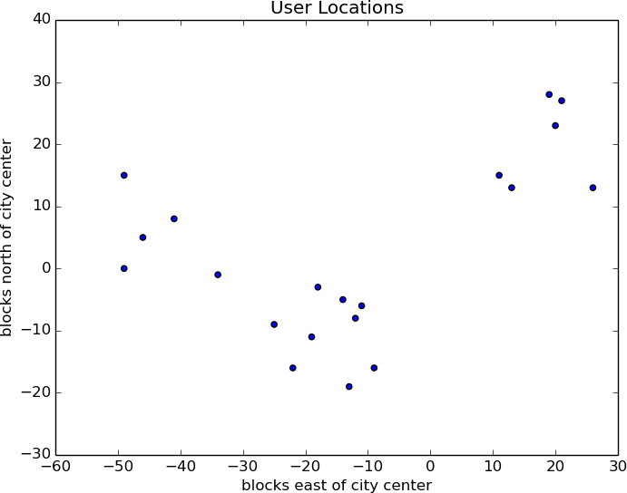

***Figure 30-1. The locations of your hometown users***

Depending on how you look at it, you probably see two or three clusters. (It’s easy to do visually because the data is only two-dimensional. With more dimensions, it would be a lot harder to eyeball.)

Imagine first that she has enough budget for three meetups. You go to your computer and try this:

random.seed(12) *# so you get the same results as me*

clusterer = KMeans(k=3)

clusterer.train(inputs)

means = sorted(clusterer.means) *# sort for the unit test*

**assert** len(means) == 3

*# Check that the means are close to what we expect*

**assert** squared_distance(means[0], [-44, 5]) < 1

**assert** squared_distance(means[1], [-16, -10]) < 1

**assert** squared_distance(means[2], [18, 20]) < 1

You find three clusters centered at [–44, 5], [–16, –10], and [18, 20], and you look for meetup venues near those locations ([Figure 30-2](https://learning.oreilly.com/library/view/data-science-from/9781492041122/ch20.html#user_locations_3_means)).

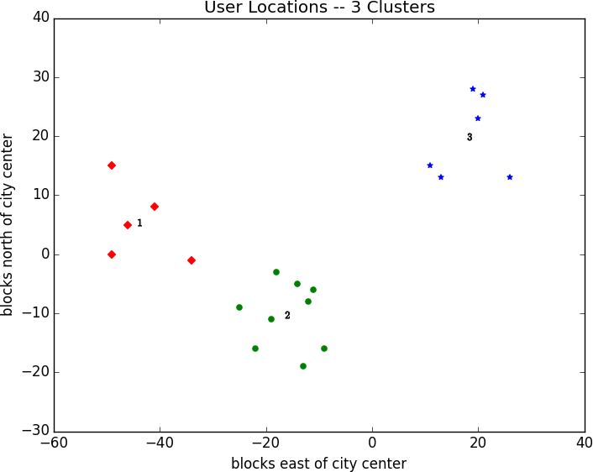

***Figure 30-2. User locations grouped into three clusters***

You show your results to the VP, who informs you that now she only has enough budgeted for *two* meetups.

“No problem,” you say:

random.seed(0)

clusterer = KMeans(k=2)

clusterer.train(inputs)

means = sorted(clusterer.means)

**assert** len(means) == 2

**assert** squared_distance(means[0], [-26, -5]) < 1

**assert** squared_distance(means[1], [18, 20]) < 1

As shown in [Figure 30-3](https://learning.oreilly.com/library/view/data-science-from/9781492041122/ch20.html#user_locations_2_means), one meetup should still be near [18, 20], but now the other should be near [–26, –5].

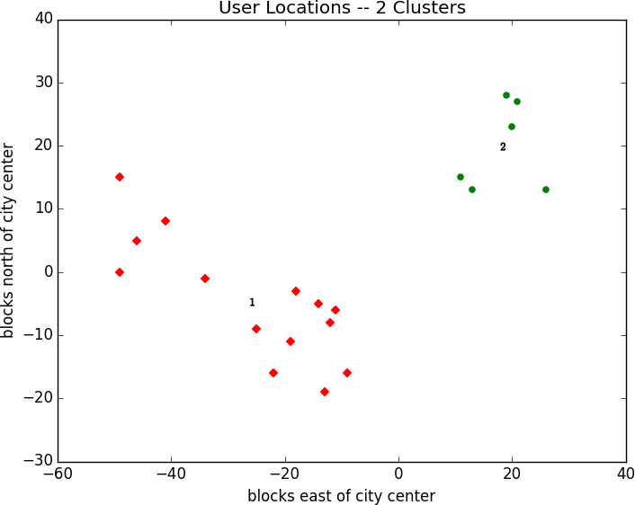

***Figure 30-3. User locations grouped into two clusters***

**Choosing k**

In the previous example, the choice of *k* was driven by factors outside of our control. In general, this won’t be the case. There are various ways to choose a *k*. One that’s reasonably easy to understand involves plotting the sum of squared errors (between each point and the mean of its cluster) as a function of *k* and looking at where the graph “bends”:

**from** **matplotlib** **import** pyplot **as** plt

**def** squared_clustering_errors(inputs: List[Vector], k: int) -> float:

*"""finds the total squared error from k-means clustering the inputs"""*

clusterer = KMeans(k)

clusterer.train(inputs)

means = clusterer.means

assignments = [clusterer.classify(input) **for** input **in** inputs]

**return** sum(squared_distance(input, means[cluster])

**for** input, cluster **in** zip(inputs, assignments))

which we can apply to our previous example:

*# now plot from 1 up to len(inputs) clusters*

ks = range(1, len(inputs) + 1)

errors = [squared_clustering_errors(inputs, k) **for** k **in** ks]

plt.plot(ks, errors)

plt.xticks(ks)

plt.xlabel("k")

plt.ylabel("total squared error")

plt.title("Total Error vs. # of Clusters")

plt.show()

Looking at [Figure 30-4](https://learning.oreilly.com/library/view/data-science-from/9781492041122/ch20.html#choosing_a_k), this method agrees with our original eyeballing that three is the “right” number of clusters.

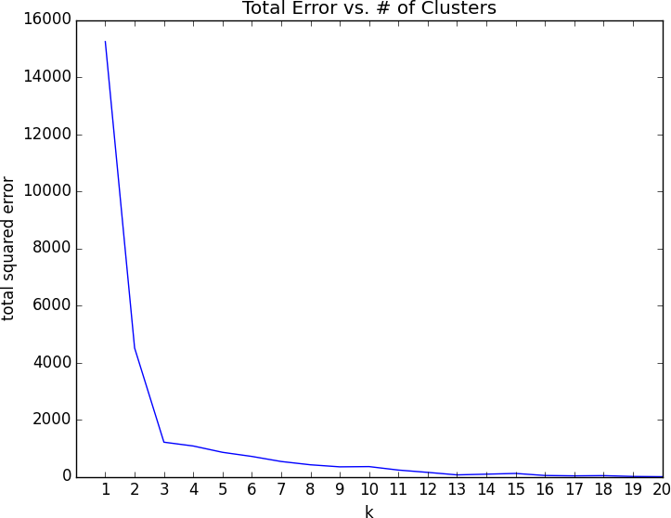

***Figure 30-4. Choosing a k***

**Example: Clustering Colors**

The VP of Swag has designed attractive DataSciencester stickers that he’d like you to hand out at meetups. Unfortunately, your sticker printer can print at most five colors per sticker. And since the VP of Art is on sabbatical, the VP of Swag asks if there’s some way you can take his design and modify it so that it contains only five colors.

Computer images can be represented as two-dimensional arrays of pixels, where each pixel is itself a three-dimensional vector (red, green, blue) indicating its color.

Creating a five-color version of the image, then, entails:

1. Choosing five colors.
2. Assigning one of those colors to each pixel.

It turns out this is a great task for *k*-means clustering, which can partition the pixels into five clusters in red-green-blue space. If we then recolor the pixels in each cluster to the mean color, we’re done.

To start with, we’ll need a way to load an image into Python. We can do this with matplotlib, if we first install the pillow library:

python -m pip install pillow

Then we can just use matplotlib.image.imread:

image_path = r"girl_with_book.jpg" *# wherever your image is*

**import** **matplotlib.image** **as** **mpimg**

img = mpimg.imread(image_path) / 256 *# rescale to between 0 and 1*

Behind the scenes img is a NumPy array, but for our purposes, we can treat it as a list of lists of lists.

img[i][j] is the pixel in the *i*th row and *j*th column, and each pixel is a list [red, green, blue] of numbers between 0 and 1 indicating the [color of that pixel](http://en.wikipedia.org/wiki/RGB_color_model):

top_row = img[0]

top_left_pixel = top_row[0]

red, green, blue = top_left_pixel

In particular, we can get a flattened list of all the pixels as:

*# .tolist() converts a NumPy array to a Python list*

pixels = [pixel.tolist() **for** row **in** img **for** pixel **in** row]

and then feed them to our clusterer:

clusterer = KMeans(5)

clusterer.train(pixels) *# this might take a while*

Once it finishes, we just construct a new image with the same format:

**def** recolor(pixel: Vector) -> Vector:

cluster = clusterer.classify(pixel) *# index of the closest cluster*

**return** clusterer.means[cluster] *# mean of the closest cluster*

new_img = [[recolor(pixel) **for** pixel **in** row] *# recolor this row of pixels*

**for** row **in** img] *# for each row in the image*

and display it, using plt.imshow:

plt.imshow(new_img)

plt.axis('off')

plt.show()

It is difficult to show color results in a black-and-white book, but [Figure 30-5](https://learning.oreilly.com/library/view/data-science-from/9781492041122/ch20.html#mt_both) shows grayscale versions of a full-color picture and the output of using this process to reduce it to five colors.



***Figure 30-5. Original picture and its 5-means decoloring***

**Bottom-Up Hierarchical Clustering**

An alternative approach to clustering is to “grow” clusters from the bottom up. We can do this in the following way:

1. Make each input its own cluster of one.
2. As long as there are multiple clusters remaining, find the two closest clusters and merge them.

At the end, we’ll have one giant cluster containing all the inputs. If we keep track of the merge order, we can re-create any number of clusters by unmerging. For example, if we want three clusters, we can just undo the last two merges.

We’ll use a really simple representation of clusters. Our values will live in *leaf* clusters, which we will represent as NamedTuples:

**from** **typing** **import** NamedTuple, Union

**class** **Leaf**(NamedTuple):

value: Vector

leaf1 = Leaf([10, 20])

leaf2 = Leaf([30, -15])

We’ll use these to grow *merged* clusters, which we will also represent as NamedTuples:

**class** **Merged**(NamedTuple):

children: tuple

order: int

merged = Merged((leaf1, leaf2), order=1)

Cluster = Union[Leaf, Merged]

**NOTE**

This is another case where Python’s type annotations have let us down. You’d like to type hint Merged.children as Tuple[Cluster, Cluster] but mypy doesn’t allow recursive types like that.

We’ll talk about merge order in a bit, but first let’s create a helper function that recursively returns all the values contained in a (possibly merged) cluster:

**def** get_values(cluster: Cluster) -> List[Vector]:

**if** isinstance(cluster, Leaf):

**return** [cluster.value]

**else**:

**return** [value

**for** child **in** cluster.children

**for** value **in** get_values(child)]

**assert** get_values(merged) == [[10, 20], [30, -15]]

In order to merge the closest clusters, we need some notion of the distance between clusters. We’ll use the *minimum* distance between elements of the two clusters, which merges the two clusters that are closest to touching (but will sometimes produce large chain-like clusters that aren’t very tight). If we wanted tight spherical clusters, we might use the *maximum* distance instead, as it merges the two clusters that fit in the smallest ball. Both are common choices, as is the *average* distance:

**from** **typing** **import** Callable

**from** **scratch.linear_algebra** **import** distance

**def** cluster_distance(cluster1: Cluster,

cluster2: Cluster,

distance_agg: Callable = min) -> float:

*"""*

*compute all the pairwise distances between cluster1 and cluster2*

*and apply the aggregation function _distance_agg_ to the resulting list*

*"""*

**return** distance_agg([distance(v1, v2)

**for** v1 **in** get_values(cluster1)

**for** v2 **in** get_values(cluster2)])

We’ll use the merge order slot to track the order in which we did the merging. Smaller numbers will represent *later* merges. This means when we want to unmerge clusters, we do so from lowest merge order to highest. Since Leaf clusters were never merged, we’ll assign them infinity, the highest possible value. And since they don’t have an .order property, we’ll create a helper function:

**def** get_merge_order(cluster: Cluster) -> float:

**if** isinstance(cluster, Leaf):

**return** float('inf') *# was never merged*

**else**:

**return** cluster.order

Similarly, since Leaf clusters don’t have children, we’ll create and add a helper function for that:

**from** **typing** **import** Tuple

**def** get_children(cluster: Cluster):

**if** isinstance(cluster, Leaf):

**raise** **TypeError**("Leaf has no children")

**else**:

**return** cluster.children

Now we’re ready to create the clustering algorithm:

**def** bottom_up_cluster(inputs: List[Vector],

distance_agg: Callable = min) -> Cluster:

*# Start with all leaves*

clusters: List[Cluster] = [Leaf(input) **for** input **in** inputs]

**def** pair_distance(pair: Tuple[Cluster, Cluster]) -> float:

**return** cluster_distance(pair[0], pair[1], distance_agg)

*# as long as we have more than one cluster left...*

**while** len(clusters) > 1:

*# find the two closest clusters*

c1, c2 = min(((cluster1, cluster2)

**for** i, cluster1 **in** enumerate(clusters)

**for** cluster2 **in** clusters[:i]),

key=pair_distance)

*# remove them from the list of clusters*

clusters = [c **for** c **in** clusters **if** c != c1 **and** c != c2]

*# merge them, using merge_order = # of clusters left*

merged_cluster = Merged((c1, c2), order=len(clusters))

*# and add their merge*

clusters.append(merged_cluster)

*# when there's only one cluster left, return it*

**return** clusters[0]

Its use is very simple:

base_cluster = bottom_up_cluster(inputs)

This produces a clustering that looks as follows:

0 1 2 3 4 5 6 7 8 9 10 11 12 13 14 15 16 17 18

──┬──┬─────┬────────────────────────────────┬───────────┬─ [19, 28]

│ │ │ │ └─ [21, 27]

│ │ │ └─ [20, 23]

│ │ └─ [26, 13]

│ └────────────────────────────────────────────┬─ [11, 15]

│ └─ [13, 13]

└─────┬─────┬──┬───────────┬─────┬─ [-49, 0]

│ │ │ │ └─ [-46, 5]

│ │ │ └─ [-41, 8]

│ │ └─ [-49, 15]

│ └─ [-34, 1]

└───────────┬──┬──┬─────┬─ [-22, -16]

│ │ │ └─ [-19, -11]

│ │ └─ [-25, -9]

│ └─────────────────┬─────┬─────┬─ [-11, -6]

│ │ │ └─ [-12, -8]

│ │ └─ [-14, 5]

│ └─ [-18, -3]

└─────────────────┬─ [-13, -19]

└─ [-9, -16]

The numbers at the top indicate “merge order.” Since we had 20 inputs, it took 19 merges to get to this one cluster. The first merge created cluster 18 by combining the leaves [19, 28] and [21, 27]. And the last merge created cluster 0.

If you wanted only two clusters, you’d split at the first fork (“0”), creating one cluster with six points and a second with the rest. For three clusters, you’d continue to the second fork (“1”), which indicates to split that first cluster into the cluster with ([19, 28], [21, 27], [20, 23], [26, 13]) and the cluster with ([11, 15], [13, 13]). And so on.

Generally, though, we don’t want to be squinting at nasty text representations like this. Instead, let’s write a function that generates any number of clusters by performing the appropriate number of unmerges:

**def** generate_clusters(base_cluster: Cluster,

num_clusters: int) -> List[Cluster]:

*# start with a list with just the base cluster*

clusters = [base_cluster]

*# as long as we don't have enough clusters yet...*

**while** len(clusters) < num_clusters:

*# choose the last-merged of our clusters*

next_cluster = min(clusters, key=get_merge_order)

*# remove it from the list*

clusters = [c **for** c **in** clusters **if** c != next_cluster]

*# and add its children to the list (i.e., unmerge it)*

clusters.extend(get_children(next_cluster))

*# once we have enough clusters...*

**return** clusters

So, for example, if we want to generate three clusters, we can just do:

three_clusters = [get_values(cluster)

**for** cluster **in** generate_clusters(base_cluster, 3)]

which we can easily plot:

**for** i, cluster, marker, color **in** zip([1, 2, 3],

three_clusters,

['D','o','*'],

['r','g','b']):

xs, ys = zip(*cluster) *# magic unzipping trick*

plt.scatter(xs, ys, color=color, marker=marker)

*# put a number at the mean of the cluster*

x, y = vector_mean(cluster)

plt.plot(x, y, marker='$' + str(i) + '$', color='black')

plt.title("User Locations -- 3 Bottom-Up Clusters, Min")

plt.xlabel("blocks east of city center")

plt.ylabel("blocks north of city center")

plt.show()

This gives very different results than *k*-means did, as shown in [Figure 30-6](https://learning.oreilly.com/library/view/data-science-from/9781492041122/ch20.html#hierarchical_clustering_image).

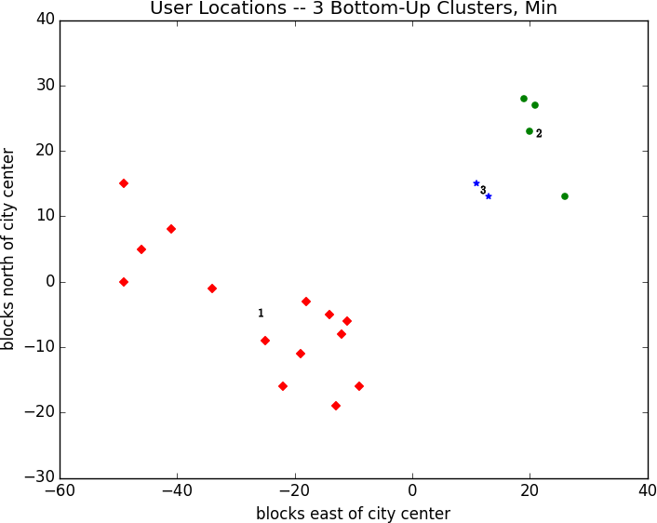

***Figure 30-6. Three bottom-up clusters using min distance***

As mentioned previously, this is because using min in cluster_distance tends to give chain-like clusters. If we instead use max (which gives tight clusters), it looks the same as the 3-means result ([Figure 30-7](https://learning.oreilly.com/library/view/data-science-from/9781492041122/ch20.html#hierarchical_clustering_image_max)).

**NOTE**

The previous bottom_up_clustering implementation is relatively simple, but also shockingly inefficient. In particular, it recomputes the distance between each pair of inputs at every step. A more efficient implementation might instead precompute the distances between each pair of inputs and then perform a lookup inside cluster_distance. A *really* efficient implementation would likely also remember the cluster_distances from the previous step.

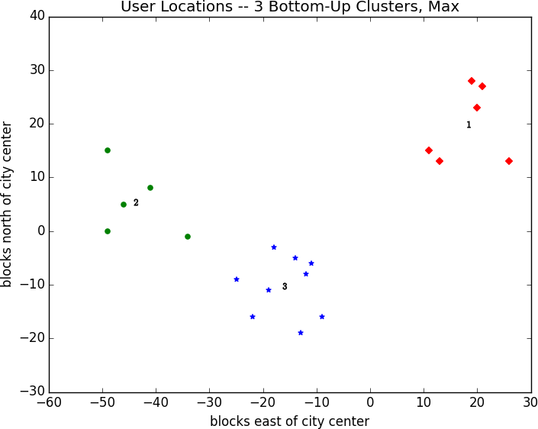

***Figure 30-7. Three bottom-up clusters using max distance***

**Natural Language Processing**

*They have been at a great feast of languages, and stolen the scraps.*

William Shakespeare

*Natural language processing* (NLP) refers to computational techniques involving language. It’s a broad field, but we’ll look at a few techniques, both simple and not simple.

**Word Clouds**

In [Chapter 1](https://learning.oreilly.com/library/view/data-science-from/9781492041122/ch01.html#introduction), we computed word counts of users’ interests. One approach to visualizing words and counts is *word clouds*, which artistically depict the words at sizes proportional to their counts.

Generally, though, data scientists don’t think much of word clouds, in large part because the placement of the words doesn’t mean anything other than “here’s some space where I was able to fit a word.”

If you ever are forced to create a word cloud, think about whether you can make the axes convey something. For example, imagine that, for each of some collection of data science–related buzzwords, you have two numbers between 0 and 100—the first representing how frequently it appears in job postings, and the second how frequently it appears on résumés:

data = [ ("big data", 100, 15), ("Hadoop", 95, 25), ("Python", 75, 50),

("R", 50, 40), ("machine learning", 80, 20), ("statistics", 20, 60),

("data science", 60, 70), ("analytics", 90, 3),

("team player", 85, 85), ("dynamic", 2, 90), ("synergies", 70, 0),

("actionable insights", 40, 30), ("think out of the box", 45, 10),

("self-starter", 30, 50), ("customer focus", 65, 15),

("thought leadership", 35, 35)]

The word cloud approach is just to arrange the words on a page in a cool-looking font ([Figure 30-1](https://learning.oreilly.com/library/view/data-science-from/9781492041122/ch21.html#word_cloud_wordle)).

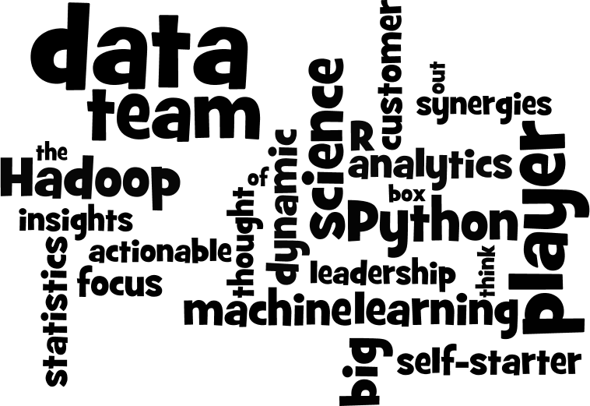

***Figure 30-1. Buzzword cloud***

This looks neat but doesn’t really tell us anything. A more interesting approach might be to scatter them so that horizontal position indicates posting popularity and vertical position indicates résumé popularity, which produces a visualization that conveys a few insights ([Figure 30-2](https://learning.oreilly.com/library/view/data-science-from/9781492041122/ch21.html#word_cloud_scatter)):

**from** **matplotlib** **import** pyplot **as** plt

**def** text_size(total: int) -> float:

*"""equals 8 if total is 0, 28 if total is 200"""*

**return** 8 + total / 200 * 20

**for** word, job_popularity, resume_popularity **in** data:

plt.text(job_popularity, resume_popularity, word,

ha='center', va='center',

size=text_size(job_popularity + resume_popularity))

plt.xlabel("Popularity on Job Postings")

plt.ylabel("Popularity on Resumes")

plt.axis([0, 100, 0, 100])

plt.xticks([])

plt.yticks([])

plt.show()

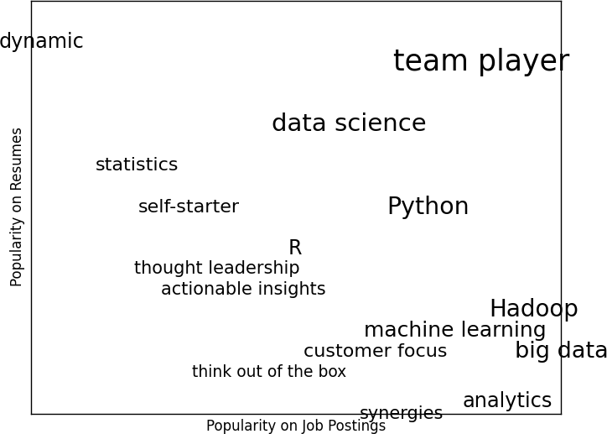

***Figure 30-2. A more meaningful (if less attractive) word cloud***

**n-Gram Language Models**

The DataSciencester VP of Search Engine Marketing wants to create thousands of web pages about data science so that your site will rank higher in search results for data science–related terms. (You attempt to explain to her that search engine algorithms are clever enough that this won’t actually work, but she refuses to listen.)

Of course, she doesn’t want to write thousands of web pages, nor does she want to pay a horde of “content strategists” to do so. Instead, she asks you whether you can somehow programmatically generate these web pages. To do this, we’ll need some way of modeling language.

One approach is to start with a corpus of documents and learn a statistical model of language. In our case, we’ll start with Mike Loukides’s essay [“What Is Data Science?”](http://oreil.ly/1Cd6ykN)

As in [Chapter 9](https://learning.oreilly.com/library/view/data-science-from/9781492041122/ch09.html#getting_data), we’ll use the Requests and Beautiful Soup libraries to retrieve the data. There are a couple of issues worth calling attention to.

The first is that the apostrophes in the text are actually the Unicode character u"\u2019". We’ll create a helper function to replace them with normal apostrophes:

**def** fix_unicode(text: str) -> str:

**return** text.replace(u"**\u2019**", "'")

The second issue is that once we get the text of the web page, we’ll want to split it into a sequence of words and periods (so that we can tell where sentences end). We can do this using re.findall:

**import** **re**

**from** **bs4** **import** BeautifulSoup

**import** **requests**

url = "https://www.oreilly.com/ideas/what-is-data-science"

html = requests.get(url).text

soup = BeautifulSoup(html, 'html5lib')

content = soup.find("div", "article-body") *# find article-body div*

regex = r"[\w']+|[\.]" *# matches a word or a period*

document = []

**for** paragraph **in** content("p"):

words = re.findall(regex, fix_unicode(paragraph.text))

document.extend(words)

We certainly could (and likely should) clean this data further. There is still some amount of extraneous text in the document (for example, the first word is *Section*), and we’ve split on midsentence periods (for example, in *Web 2.0*), and there are a handful of captions and lists sprinkled throughout. Having said that, we’ll work with the document as it is.

Now that we have the text as a sequence of words, we can model language in the following way: given some starting word (say, *book*) we look at all the words that follow it in the source document. We randomly choose one of these to be the next word, and we repeat the process until we get to a period, which signifies the end of the sentence. We call this a *bigram model*, as it is determined completely by the frequencies of the bigrams (word pairs) in the original data.

What about a starting word? We can just pick randomly from words that *follow* a period. To start, let’s precompute the possible word transitions. Recall that zip stops when any of its inputs is done, so that zip(document, document[1:]) gives us precisely the pairs of consecutive elements of document:

**from** **collections** **import** defaultdict

transitions = defaultdict(list)

**for** prev, current **in** zip(document, document[1:]):

transitions[prev].append(current)

Now we’re ready to generate sentences:

**def** generate_using_bigrams() -> str:

current = "." *# this means the next word will start a sentence*

result = []

**while** True:

next_word_candidates = transitions[current] *# bigrams (current, _)*

current = random.choice(next_word_candidates) *# choose one at random*

result.append(current) *# append it to results*

**if** current == ".": **return** " ".join(result) *# if "." we're done*

The sentences it produces are gibberish, but they’re the kind of gibberish you might put on your website if you were trying to sound data-sciencey. For example:

*If you may know which are you want to data sort the data feeds web friend someone on trending topics as the data in Hadoop is the data science requires a book demonstrates why visualizations are but we do massive correlations across many commercial disk drives in Python language and creates more tractable form making connections then use and uses it to solve a data.*

Bigram Model

We can make the sentences less gibberishy by looking at *trigrams*, triplets of consecutive words. (More generally, you might look at *n-grams* consisting of *n* consecutive words, but three will be plenty for us.) Now the transitions will depend on the previous *two* words:

trigram_transitions = defaultdict(list)

starts = []

**for** prev, current, next **in** zip(document, document[1:], document[2:]):

**if** prev == ".": *# if the previous "word" was a period*

starts.append(current) *# then this is a start word*

trigram_transitions[(prev, current)].append(next)

Notice that now we have to track the starting words separately. We can generate sentences in pretty much the same way:

**def** generate_using_trigrams() -> str:

current = random.choice(starts) *# choose a random starting word*

prev = "." *# and precede it with a '.'*

result = [current]

**while** True:

next_word_candidates = trigram_transitions[(prev, current)]

next_word = random.choice(next_word_candidates)

prev, current = current, next_word

result.append(current)

**if** current == ".":

**return** " ".join(result)

This produces better sentences like:

*In hindsight MapReduce seems like an epidemic and if so does that give us new insights into how economies work That’s not a question we could even have asked a few years there has been instrumented.*

Trigram Model

Of course, they sound better because at each step the generation process has fewer choices, and at many steps only a single choice. This means that we frequently generate sentences (or at least long phrases) that were seen verbatim in the original data. Having more data would help; it would also work better if we collected *n*-grams from multiple essays about data science.

**Grammars**

A different approach to modeling language is with *grammars*, rules for generating acceptable sentences. In elementary school, you probably learned about parts of speech and how to combine them. For example, if you had a really bad English teacher, you might say that a sentence necessarily consists of a *noun* followed by a *verb*. If you then have a list of nouns and verbs, you can generate sentences according to the rule.

We’ll define a slightly more complicated grammar:

**from** **typing** **import** List, Dict

*# Type alias to refer to grammars later*

Grammar = Dict[str, List[str]]

grammar = {

"_S" : ["_NP _VP"],

"_NP" : ["_N",

"_A _NP _P _A _N"],

"_VP" : ["_V",

"_V _NP"],

"_N" : ["data science", "Python", "regression"],

"_A" : ["big", "linear", "logistic"],

"_P" : ["about", "near"],

"_V" : ["learns", "trains", "tests", "is"]

}

I made up the convention that names starting with underscores refer to *rules* that need further expanding, and that other names are *terminals* that don’t need further processing.

So, for example, "_S" is the “sentence” rule, which produces an "_NP" (“noun phrase”) rule followed by a "_VP" (“verb phrase”) rule.

The verb phrase rule can produce either the "_V" (“verb”) rule, or the verb rule followed by the noun phrase rule.

Notice that the "_NP" rule contains itself in one of its productions. Grammars can be recursive, which allows even finite grammars like this to generate infinitely many different sentences.

How do we generate sentences from this grammar? We’ll start with a list containing the sentence rule ["_S"]. And then we’ll repeatedly expand each rule by replacing it with a randomly chosen one of its productions. We stop when we have a list consisting solely of terminals.

For example, one such progression might look like:

['_S']

['_NP','_VP']

['_N','_VP']

['Python','_VP']

['Python','_V','_NP']

['Python','trains','_NP']

['Python','trains','_A','_NP','_P','_A','_N']

['Python','trains','logistic','_NP','_P','_A','_N']

['Python','trains','logistic','_N','_P','_A','_N']

['Python','trains','logistic','data science','_P','_A','_N']

['Python','trains','logistic','data science','about','_A', '_N']

['Python','trains','logistic','data science','about','logistic','_N']

['Python','trains','logistic','data science','about','logistic','Python']

How do we implement this? Well, to start, we’ll create a simple helper function to identify terminals:

**def** is_terminal(token: str) -> bool:

**return** token[0] != "_"

Next we need to write a function to turn a list of tokens into a sentence. We’ll look for the first nonterminal token. If we can’t find one, that means we have a completed sentence and we’re done.

If we do find a nonterminal, then we randomly choose one of its productions. If that production is a terminal (i.e., a word), we simply replace the token with it. Otherwise, it’s a sequence of space-separated nonterminal tokens that we need to split and then splice into the current tokens. Either way, we repeat the process on the new set of tokens.

Putting it all together, we get:

**def** expand(grammar: Grammar, tokens: List[str]) -> List[str]:

**for** i, token **in** enumerate(tokens):

*# If this is a terminal token, skip it.*

**if** is_terminal(token): **continue**

*# Otherwise, it's a nonterminal token,*

*# so we need to choose a replacement at random.*

replacement = random.choice(grammar[token])

**if** is_terminal(replacement):

tokens[i] = replacement

**else**:

*# Replacement could be, e.g., "_NP _VP", so we need to*

*# split it on spaces and splice it in.*

tokens = tokens[:i] + replacement.split() + tokens[(i+1):]

*# Now call expand on the new list of tokens.*

**return** expand(grammar, tokens)

*# If we get here, we had all terminals and are done.*

**return** tokens

And now we can start generating sentences:

**def** generate_sentence(grammar: Grammar) -> List[str]:

**return** expand(grammar, ["_S"])

Try changing the grammar—add more words, add more rules, add your own parts of speech—until you’re ready to generate as many web pages as your company needs.

Grammars are actually more interesting when they’re used in the other direction. Given a sentence, we can use a grammar to *parse* the sentence. This then allows us to identify subjects and verbs and helps us make sense of the sentence.

Using data science to generate text is a neat trick; using it to *understand* text is more magical. (See [“For Further Exploration”](https://learning.oreilly.com/library/view/data-science-from/9781492041122/ch21.html#nlp-further-invest) for libraries that you could use for this.)

**An Aside: Gibbs Sampling**

Generating samples from some distributions is easy. We can get uniform random variables with:

random.random()

and normal random variables with:

inverse_normal_cdf(random.random())

But some distributions are harder to sample from. *Gibbs sampling* is a technique for generating samples from multidimensional distributions when we only know some of the conditional distributions.

For example, imagine rolling two dice. Let *x* be the value of the first die and *y* be the sum of the dice, and imagine you wanted to generate lots of (*x*, *y*) pairs. In this case it’s easy to generate the samples directly:

**from** **typing** **import** Tuple

**import** **random**

**def** roll_a_die() -> int:

**return** random.choice([1, 2, 3, 4, 5, 6])

**def** direct_sample() -> Tuple[int, int]:

d1 = roll_a_die()

d2 = roll_a_die()

**return** d1, d1 + d2

But imagine that you only knew the conditional distributions. The distribution of *y* conditional on *x* is easy—if you know the value of *x*, *y* is equally likely to be *x* + 1, *x* + 2, *x* + 3, *x* + 4, *x* + 5, or *x* + 6:

**def** random_y_given_x(x: int) -> int:

*"""equally likely to be x + 1, x + 2, ... , x + 6"""*

**return** x + roll_a_die()

The other direction is more complicated. For example, if you know that *y* is 2, then necessarily *x* is 1 (since the only way two dice can sum to 2 is if both of them are 1). If you know *y* is 3, then *x* is equally likely to be 1 or 2. Similarly, if *y* is 11, then *x* has to be either 5 or 6:

**def** random_x_given_y(y: int) -> int:

**if** y <= 7:

*# if the total is 7 or less, the first die is equally likely to be*

*# 1, 2, ..., (total - 1)*

**return** random.randrange(1, y)

**else**:

*# if the total is 7 or more, the first die is equally likely to be*

*# (total - 6), (total - 5), ..., 6*

**return** random.randrange(y - 6, 7)

The way Gibbs sampling works is that we start with any (valid) values for *x* and *y* and then repeatedly alternate replacing *x* with a random value picked conditional on *y* and replacing *y* with a random value picked conditional on *x*. After a number of iterations, the resulting values of *x* and *y* will represent a sample from the unconditional joint distribution:

**def** gibbs_sample(num_iters: int = 100) -> Tuple[int, int]:

x, y = 1, 2 *# doesn't really matter*

**for** _ **in** range(num_iters):

x = random_x_given_y(y)

y = random_y_given_x(x)

**return** x, y

You can check that this gives similar results to the direct sample:

**def** compare_distributions(num_samples: int = 1000) -> Dict[int, List[int]]:

counts = defaultdict(**lambda**: [0, 0])

**for** _ **in** range(num_samples):

counts[gibbs_sample()][0] += 1

counts[direct_sample()][1] += 1

**return** counts

We’ll use this technique in the next section.

**Topic Modeling**

When we built our “Data Scientists You May Know” recommender in [Chapter 1](https://learning.oreilly.com/library/view/data-science-from/9781492041122/ch01.html#introduction), we simply looked for exact matches in people’s stated interests.

A more sophisticated approach to understanding our users’ interests might try to identify the *topics* that underlie those interests. A technique called *latent Dirichlet allocation* (LDA) is commonly used to identify common topics in a set of documents. We’ll apply it to documents that consist of each user’s interests.

LDA has some similarities to the Naive Bayes classifier we built in [Chapter 13](https://learning.oreilly.com/library/view/data-science-from/9781492041122/ch13.html#naive_bayes), in that it assumes a probabilistic model for documents. We’ll gloss over the hairier mathematical details, but for our purposes the model assumes that:

* There is some fixed number *K* of topics.
* There is a random variable that assigns each topic an associated probability distribution over words. You should think of this distribution as the probability of seeing word *w* given topic *k*.
* There is another random variable that assigns each document a probability distribution over topics. You should think of this distribution as the mixture of topics in document *d*.
* Each word in a document was generated by first randomly picking a topic (from the document’s distribution of topics) and then randomly picking a word (from the topic’s distribution of words).

In particular, we have a collection of documents, each of which is a list of words. And we have a corresponding collection of document_topics that assigns a topic (here a number between 0 and *K* – 1) to each word in each document.

So, the fifth word in the fourth document is:

documents[3][4]

and the topic from which that word was chosen is:

document_topics[3][4]

This very explicitly defines each document’s distribution over topics, and it implicitly defines each topic’s distribution over words.

We can estimate the likelihood that topic 1 produces a certain word by comparing how many times topic 1 produces that word with how many times topic 1 produces *any* word. (Similarly, when we built a spam filter in [Chapter 13](https://learning.oreilly.com/library/view/data-science-from/9781492041122/ch13.html#naive_bayes), we compared how many times each word appeared in spams with the total number of words appearing in spams.)

Although these topics are just numbers, we can give them descriptive names by looking at the words on which they put the heaviest weight. We just have to somehow generate the document_topics. This is where Gibbs sampling comes into play.

We start by assigning every word in every document a topic completely at random. Now we go through each document one word at a time. For that word and document, we construct weights for each topic that depend on the (current) distribution of topics in that document and the (current) distribution of words for that topic. We then use those weights to sample a new topic for that word. If we iterate this process many times, we will end up with a joint sample from the topic–word distribution and the document–topic distribution.

To start with, we’ll need a function to randomly choose an index based on an arbitrary set of weights:

**def** sample_from(weights: List[float]) -> int:

*"""returns i with probability weights[i] / sum(weights)"""*

total = sum(weights)

rnd = total * random.random() *# uniform between 0 and total*

**for** i, w **in** enumerate(weights):

rnd -= w *# return the smallest i such that*

**if** rnd <= 0: **return** i *# weights[0] + ... + weights[i] >= rnd*

For instance, if you give it weights [1, 1, 3], then one-fifth of the time it will return 0, one-fifth of the time it will return 1, and three-fifths of the time it will return 2. Let’s write a test:

**from** **collections** **import** Counter

*# Draw 1000 times and count*

draws = Counter(sample_from([0.1, 0.1, 0.8]) **for** _ **in** range(1000))

**assert** 10 < draws[0] < 190 *# should be ~10%, this is a really loose test*

**assert** 10 < draws[1] < 190 *# should be ~10%, this is a really loose test*

**assert** 650 < draws[2] < 950 *# should be ~80%, this is a really loose test*

**assert** draws[0] + draws[1] + draws[2] == 1000

Our documents are our users’ interests, which look like:

documents = [

["Hadoop", "Big Data", "HBase", "Java", "Spark", "Storm", "Cassandra"],

["NoSQL", "MongoDB", "Cassandra", "HBase", "Postgres"],

["Python", "scikit-learn", "scipy", "numpy", "statsmodels", "pandas"],

["R", "Python", "statistics", "regression", "probability"],

["machine learning", "regression", "decision trees", "libsvm"],

["Python", "R", "Java", "C++", "Haskell", "programming languages"],

["statistics", "probability", "mathematics", "theory"],

["machine learning", "scikit-learn", "Mahout", "neural networks"],

["neural networks", "deep learning", "Big Data", "artificial intelligence"],

["Hadoop", "Java", "MapReduce", "Big Data"],

["statistics", "R", "statsmodels"],

["C++", "deep learning", "artificial intelligence", "probability"],

["pandas", "R", "Python"],

["databases", "HBase", "Postgres", "MySQL", "MongoDB"],

["libsvm", "regression", "support vector machines"]

]

And we’ll try to find:

K = 4

topics. In order to calculate the sampling weights, we’ll need to keep track of several counts. Let’s first create the data structures for them.

* How many times each topic is assigned to each document:
* *# a list of Counters, one for each document*

document_topic_counts = [Counter() **for** _ **in** documents]

* How many times each word is assigned to each topic:
* *# a list of Counters, one for each topic*

topic_word_counts = [Counter() **for** _ **in** range(K)]

* The total number of words assigned to each topic:
* *# a list of numbers, one for each topic*

topic_counts = [0 **for** _ **in** range(K)]

* The total number of words contained in each document:
* *# a list of numbers, one for each document*

document_lengths = [len(document) **for** document **in** documents]

* The number of distinct words:
* distinct_words = set(word **for** document **in** documents **for** word **in** document)

W = len(distinct_words)

* And the number of documents:

D = len(documents)

Once we populate these, we can find, for example, the number of words in documents[3] associated with topic 1 as follows:

document_topic_counts[3][1]

And we can find the number of times *nlp* is associated with topic 2 as follows:

topic_word_counts[2]["nlp"]

Now we’re ready to define our conditional probability functions. As in [Chapter 13](https://learning.oreilly.com/library/view/data-science-from/9781492041122/ch13.html#naive_bayes), each has a smoothing term that ensures every topic has a nonzero chance of being chosen in any document and that every word has a nonzero chance of being chosen for any topic:

**def** p_topic_given_document(topic: int, d: int, alpha: float = 0.1) -> float:

*"""*

*The fraction of words in document 'd'*

*that are assigned to 'topic' (plus some smoothing)*

*"""*

**return** ((document_topic_counts[d][topic] + alpha) /

(document_lengths[d] + K * alpha))

**def** p_word_given_topic(word: str, topic: int, beta: float = 0.1) -> float:

*"""*

*The fraction of words assigned to 'topic'*

*that equal 'word' (plus some smoothing)*

*"""*

**return** ((topic_word_counts[topic][word] + beta) /

(topic_counts[topic] + W * beta))

We’ll use these to create the weights for updating topics:

**def** topic_weight(d: int, word: str, k: int) -> float:

*"""*

*Given a document and a word in that document,*

*return the weight for the kth topic*

*"""*

**return** p_word_given_topic(word, k) * p_topic_given_document(k, d)

**def** choose_new_topic(d: int, word: str) -> int:

**return** sample_from([topic_weight(d, word, k)

**for** k **in** range(K)])

There are solid mathematical reasons why topic_weight is defined the way it is, but their details would lead us too far afield. Hopefully it makes at least intuitive sense that—given a word and its document—the likelihood of any topic choice depends on both how likely that topic is for the document and how likely that word is for the topic.

This is all the machinery we need. We start by assigning every word to a random topic and populating our counters appropriately:

random.seed(0)

document_topics = [[random.randrange(K) **for** word **in** document]

**for** document **in** documents]

**for** d **in** range(D):

**for** word, topic **in** zip(documents[d], document_topics[d]):

document_topic_counts[d][topic] += 1

topic_word_counts[topic][word] += 1

topic_counts[topic] += 1

Our goal is to get a joint sample of the topics–word distribution and the documents–topic distribution. We do this using a form of Gibbs sampling that uses the conditional probabilities defined previously:

**import** **tqdm**

**for** iter **in** tqdm.trange(1000):

**for** d **in** range(D):

**for** i, (word, topic) **in** enumerate(zip(documents[d],

document_topics[d])):

*# remove this word / topic from the counts*

*# so that it doesn't influence the weights*

document_topic_counts[d][topic] -= 1

topic_word_counts[topic][word] -= 1

topic_counts[topic] -= 1

document_lengths[d] -= 1

*# choose a new topic based on the weights*

new_topic = choose_new_topic(d, word)

document_topics[d][i] = new_topic

*# and now add it back to the counts*

document_topic_counts[d][new_topic] += 1

topic_word_counts[new_topic][word] += 1

topic_counts[new_topic] += 1

document_lengths[d] += 1

What are the topics? They’re just numbers 0, 1, 2, and 3. If we want names for them, we have to do that ourselves. Let’s look at the five most heavily weighted words for each ([Table 30-1](https://learning.oreilly.com/library/view/data-science-from/9781492041122/ch21.html#table20-1)):

**for** k, word_counts **in** enumerate(topic_word_counts):

**for** word, count **in** word_counts.most_common():

**if** count > 0:

**print**(k, word, count)

| **Topic 0** | **Topic 1** | **Topic 2** | **Topic 3** |
| --- | --- | --- | --- |
| Java | R | HBase | regression |
| Big Data | statistics | Postgres | libsvm |
| Hadoop | Python | MongoDB | scikit-learn |
| deep learning | probability | Cassandra | machine learning |
| artificial intelligence | pandas | NoSQL | neural networks |
| *Table 30-1. Most common words per topic* | | | |

Based on these I’d probably assign topic names:

topic_names = ["Big Data and programming languages",

"Python and statistics",

"databases",

"machine learning"]

at which point we can see how the model assigns topics to each user’s interests:

**for** document, topic_counts **in** zip(documents, document_topic_counts):

**print**(document)

**for** topic, count **in** topic_counts.most_common():

**if** count > 0:

**print**(topic_names[topic], count)

**print**()

which gives:

['Hadoop', 'Big Data', 'HBase', 'Java', 'Spark', 'Storm', 'Cassandra']

Big Data and programming languages 4 databases 3

['NoSQL', 'MongoDB', 'Cassandra', 'HBase', 'Postgres']

databases 5

['Python', 'scikit-learn', 'scipy', 'numpy', 'statsmodels', 'pandas']

Python and statistics 5 machine learning 1

and so on. Given the “ands” we needed in some of our topic names, it’s possible we should use more topics, although most likely we don’t have enough data to successfully learn them.

**Word Vectors**

A lot of recent advances in NLP involve deep learning. In the rest of this chapter we’ll look at a couple of them using the machinery we developed in [Chapter 19](https://learning.oreilly.com/library/view/data-science-from/9781492041122/ch19.html#deep_learning).

One important innovation involves representing words as low-dimensional vectors. These vectors can be compared, added together, fed into machine learning models, or anything else you want to do with them. They usually have nice properties; for example, similar words tend to have similar vectors. That is, typically the word vector for *big* is pretty close to the word vector for *large*, so that a model operating on word vectors can (to some degree) handle things like synonymy for free.

Frequently the vectors will exhibit delightful arithmetic properties as well. For instance, in some such models if you take the vector for *king*, subtract the vector for *man*, and add the vector for *woman*, you will end up with a vector that’s very close to the vector for *queen*. It can be interesting to ponder what this means about what the word vectors actually “learn,” although we won’t spend time on that here.

Coming up with such vectors for a large vocabulary of words is a difficult undertaking, so typically we’ll *learn*them from a corpus of text. There are a couple of different schemes, but at a high level the task typically looks something like this:

1. Get a bunch of text.
2. Create a dataset where the goal is to predict a word given nearby words (or alternatively, to predict nearby words given a word).
3. Train a neural net to do well on this task.
4. Take the internal states of the trained neural net as the word vectors.

In particular, because the task is to predict a word given nearby words, words that occur in similar contexts (and hence have similar nearby words) should have similar internal states and therefore similar word vectors.

Here we’ll measure “similarity” using *cosine similarity*, which is a number between –1 and 1 that measures the degree to which two vectors point in the same direction:

**from** **scratch.linear_algebra** **import** dot, Vector

**import** **math**

**def** cosine_similarity(v1: Vector, v2: Vector) -> float:

**return** dot(v1, v2) / math.sqrt(dot(v1, v1) * dot(v2, v2))

**assert** cosine_similarity([1., 1, 1], [2., 2, 2]) == 1, "same direction"

**assert** cosine_similarity([-1., -1], [2., 2]) == -1, "opposite direction"

**assert** cosine_similarity([1., 0], [0., 1]) == 0, "orthogonal"

Let’s learn some word vectors to see how this works.

To start with, we’ll need a toy dataset. The commonly used word vectors are typically derived from training on millions or even billions of words. As our toy library can’t cope with that much data, we’ll create an artificial dataset with some structure to it:

colors = ["red", "green", "blue", "yellow", "black", ""]

nouns = ["bed", "car", "boat", "cat"]

verbs = ["is", "was", "seems"]

adverbs = ["very", "quite", "extremely", ""]

adjectives = ["slow", "fast", "soft", "hard"]

**def** make_sentence() -> str:

**return** " ".join([

"The",

random.choice(colors),

random.choice(nouns),

random.choice(verbs),

random.choice(adverbs),

random.choice(adjectives),

"."

])

NUM_SENTENCES = 50

random.seed(0)

sentences = [make_sentence() **for** _ **in** range(NUM_SENTENCES)]

This will generate lots of sentences with similar structure but different words; for example, “The green boat seems quite slow.” Given this setup, the colors will mostly appear in “similar” contexts, as will the nouns, and so on. So if we do a good job of assigning word vectors, the colors should get similar vectors, and so on.

**NOTE**

In practical usage, you’d probably have a corpus of millions of sentences, in which case you’d get “enough” context from the sentences as they are. Here, with only 50 sentences, we have to make them somewhat artificial.

As mentioned earlier, we’ll want to one-hot-encode our words, which means we’ll need to convert them to IDs. We’ll introduce a Vocabulary class to keep track of this mapping:

**from** **scratch.deep_learning** **import** Tensor

**class** **Vocabulary**:

**def** __init__(self, words: List[str] = None) -> None:

self.w2i: Dict[str, int] = {} *# mapping word -> word_id*

self.i2w: Dict[int, str] = {} *# mapping word_id -> word*

**for** word **in** (words **or** []): *# If words were provided,*

self.add(word) *# add them.*

@property

**def** size(self) -> int:

*"""how many words are in the vocabulary"""*

**return** len(self.w2i)

**def** add(self, word: str) -> None:

**if** word **not** **in** self.w2i: *# If the word is new to us:*

word_id = len(self.w2i) *# Find the next id.*

self.w2i[word] = word_id *# Add to the word -> word_id map.*

self.i2w[word_id] = word *# Add to the word_id -> word map.*

**def** get_id(self, word: str) -> int:

*"""return the id of the word (or None)"""*

**return** self.w2i.get(word)

**def** get_word(self, word_id: int) -> str:

*"""return the word with the given id (or None)"""*

**return** self.i2w.get(word_id)

**def** one_hot_encode(self, word: str) -> Tensor:

word_id = self.get_id(word)

**assert** word_id **is** **not** None, f"unknown word {word}"

**return** [1.0 **if** i == word_id **else** 0.0 **for** i **in** range(self.size)]

These are all things we could do manually, but it’s handy to have it in a class. We should probably test it:

vocab = Vocabulary(["a", "b", "c"])

**assert** vocab.size == 3, "there are 3 words in the vocab"

**assert** vocab.get_id("b") == 1, "b should have word_id 1"

**assert** vocab.one_hot_encode("b") == [0, 1, 0]

**assert** vocab.get_id("z") **is** None, "z is not in the vocab"

**assert** vocab.get_word(2) == "c", "word_id 2 should be c"

vocab.add("z")

**assert** vocab.size == 4, "now there are 4 words in the vocab"

**assert** vocab.get_id("z") == 3, "now z should have id 3"

**assert** vocab.one_hot_encode("z") == [0, 0, 0, 1]

We should also write simple helper functions to save and load a vocabulary, just as we have for our deep learning models:

**import** **json**

**def** save_vocab(vocab: Vocabulary, filename: str) -> None:

**with** open(filename, 'w') **as** f:

json.dump(vocab.w2i, f) *# Only need to save w2i*

**def** load_vocab(filename: str) -> Vocabulary:

vocab = Vocabulary()

**with** open(filename) **as** f:

*# Load w2i and generate i2w from it*

vocab.w2i = json.load(f)

vocab.i2w = {id: word **for** word, id **in** vocab.w2i.items()}

**return** vocab

We’ll be using a word vector model called *skip-gram* that takes as input a word and generates probabilities for what words are likely to be seen near it. We will feed it training pairs (word, nearby_word) and try to minimize the SoftmaxCrossEntropy loss.

**NOTE**

Another common model, *continuous bag-of-words* (CBOW), takes the nearby words as the inputs and tries to predict the original word.

Let’s design our neural network. At its heart will be an *embedding* layer that takes as input a word ID and returns a word vector. Under the covers we can just use a lookup table for this.

We’ll then pass the word vector to a Linear layer with the same number of outputs as we have words in our vocabulary. As before, we’ll use softmax to convert these outputs to probabilities over nearby words. As we use gradient descent to train the model, we will be updating the vectors in the lookup table. Once we’ve finished training, that lookup table gives us our word vectors.

Let’s create that embedding layer. In practice we might want to embed things other than words, so we’ll construct a more general Embedding layer. (Later we’ll write a TextEmbedding subclass that’s specifically for word vectors.)

In its constructor we’ll provide the number and dimension of our embedding vectors, so it can create the embeddings (which will be standard random normals, initially):

**from** **typing** **import** Iterable

**from** **scratch.deep_learning** **import** Layer, Tensor, random_tensor, zeros_like

**class** **Embedding**(Layer):

**def** __init__(self, num_embeddings: int, embedding_dim: int) -> None:

self.num_embeddings = num_embeddings

self.embedding_dim = embedding_dim

*# One vector of size embedding_dim for each desired embedding*

self.embeddings = random_tensor(num_embeddings, embedding_dim)

self.grad = zeros_like(self.embeddings)

*# Save last input id*

self.last_input_id = None

In our case we’ll only be embedding one word at a time. However, in other models we might want to embed a sequence of words and get back a sequence of word vectors. (For example, if we wanted to train the CBOW model described earlier.) So an alternative design would take sequences of word IDs. We’ll stick with one at a time, to make things simpler.

**def** forward(self, input_id: int) -> Tensor:

*"""Just select the embedding vector corresponding to the input id"""*

self.input_id = input_id *# remember for use in backpropagation*

**return** self.embeddings[input_id]

For the backward pass we’ll get a gradient corresponding to the chosen embedding vector, and we’ll need to construct the corresponding gradient for self.embeddings, which is zero for every embedding other than the chosen one:

**def** backward(self, gradient: Tensor) -> None:

*# Zero out the gradient corresponding to the last input.*

*# This is way cheaper than creating a new all-zero tensor each time.*

**if** self.last_input_id **is** **not** None:

zero_row = [0 **for** _ **in** range(self.embedding_dim)]

self.grad[self.last_input_id] = zero_row

self.last_input_id = self.input_id

self.grad[self.input_id] = gradient

Because we have parameters and gradients, we need to override those methods:

**def** params(self) -> Iterable[Tensor]:

**return** [self.embeddings]

**def** grads(self) -> Iterable[Tensor]:

**return** [self.grad]

As mentioned earlier, we’ll want a subclass specifically for word vectors. In that case our number of embeddings is determined by our vocabulary, so let’s just pass that in instead:

**class** **TextEmbedding**(Embedding):

**def** __init__(self, vocab: Vocabulary, embedding_dim: int) -> None:

*# Call the superclass constructor*

super().__init__(vocab.size, embedding_dim)

*# And hang onto the vocab*

self.vocab = vocab

The other built-in methods will all work as is, but we’ll add a couple more methods specific to working with text. For example, we’d like to be able to retrieve the vector for a given word. (This is not part of the Layer interface, but we are always free to add extra methods to specific layers as we like.)

**def** __getitem__(self, word: str) -> Tensor:

word_id = self.vocab.get_id(word)

**if** word_id **is** **not** None:

**return** self.embeddings[word_id]

**else**:

**return** None

This dunder method will allow us to retrieve word vectors using indexing:

word_vector = embedding["black"]

And we’d also like the embedding layer to tell us the closest words to a given word:

**def** closest(self, word: str, n: int = 5) -> List[Tuple[float, str]]:

*"""Returns the n closest words based on cosine similarity"""*

vector = self[word]

*# Compute pairs (similarity, other_word), and sort most similar first*

scores = [(cosine_similarity(vector, self.embeddings[i]), other_word)

**for** other_word, i **in** self.vocab.w2i.items()]

scores.sort(reverse=True)

**return** scores[:n]

Our embedding layer just outputs vectors, which we can feed into a Linear layer.

Now we’re ready to assemble our training data. For each input word, we’ll choose as target words the two words to its left and the two words to its right.

Let’s start by lowercasing the sentences and splitting them into words:

**import** **re**

*# This is not a great regex, but it works on our data.*

tokenized_sentences = [re.findall("[a-z]+|[.]", sentence.lower())

**for** sentence **in** sentences]

at which point we can construct a vocabulary:

*# Create a vocabulary (that is, a mapping word -> word_id) based on our text.*

vocab = Vocabulary(word

**for** sentence_words **in** tokenized_sentences

**for** word **in** sentence_words)

And now we can create training data:

**from** **scratch.deep_learning** **import** Tensor, one_hot_encode

inputs: List[int] = []

targets: List[Tensor] = []

**for** sentence **in** tokenized_sentences:

**for** i, word **in** enumerate(sentence): *# For each word*

**for** j **in** [i - 2, i - 1, i + 1, i + 2]: *# take the nearby locations*

**if** 0 <= j < len(sentence): *# that aren't out of bounds*

nearby_word = sentence[j] *# and get those words.*

*# Add an input that's the original word_id*

inputs.append(vocab.get_id(word))

*# Add a target that's the one-hot-encoded nearby word*

targets.append(vocab.one_hot_encode(nearby_word))

With the machinery we’ve built up, it’s now easy to create our model:

**from** **scratch.deep_learning** **import** Sequential, Linear

random.seed(0)

EMBEDDING_DIM = 5 *# seems like a good size*

*# Define the embedding layer separately, so we can reference it.*

embedding = TextEmbedding(vocab=vocab, embedding_dim=EMBEDDING_DIM)

model = Sequential([

*# Given a word (as a vector of word_ids), look up its embedding.*

embedding,

*# And use a linear layer to compute scores for "nearby words."*

Linear(input_dim=EMBEDDING_DIM, output_dim=vocab.size)

])

Using the machinery from [Chapter 19](https://learning.oreilly.com/library/view/data-science-from/9781492041122/ch19.html#deep_learning), it’s easy to train our model:

**from** **scratch.deep_learning** **import** SoftmaxCrossEntropy, Momentum, GradientDescent

loss = SoftmaxCrossEntropy()

optimizer = GradientDescent(learning_rate=0.01)

**for** epoch **in** range(100):

epoch_loss = 0.0

**for** input, target **in** zip(inputs, targets):

predicted = model.forward(input)

epoch_loss += loss.loss(predicted, target)

gradient = loss.gradient(predicted, target)

model.backward(gradient)

optimizer.step(model)

**print**(epoch, epoch_loss) *# Print the loss*

**print**(embedding.closest("black")) *# and also a few nearest words*

**print**(embedding.closest("slow")) *# so we can see what's being*

**print**(embedding.closest("car")) *# learned.*

As you watch this train, you can see the colors getting closer to each other, the adjectives getting closer to each other, and the nouns getting closer to each other.

Once the model is trained, it’s fun to explore the most similar words:

pairs = [(cosine_similarity(embedding[w1], embedding[w2]), w1, w2)

**for** w1 **in** vocab.w2i

**for** w2 **in** vocab.w2i

**if** w1 < w2]

pairs.sort(reverse=True)

**print**(pairs[:5])

which (for me) results in:

[(0.9980283554864815, 'boat', 'car'),

(0.9975147744587706, 'bed', 'cat'),

(0.9953153441218054, 'seems', 'was'),

(0.9927107440377975, 'extremely', 'quite'),

(0.9836183658415987, 'bed', 'car')]

(Obviously *bed* and *cat* are not really similar, but in our training sentences they appear to be, and that’s what the model is capturing.)

We can also extract the first two principal components and plot them:

**from** **scratch.working_with_data** **import** pca, transform

**import** **matplotlib.pyplot** **as** **plt**

*# Extract the first two principal components and transform the word vectors*

components = pca(embedding.embeddings, 2)

transformed = transform(embedding.embeddings, components)

*# Scatter the points (and make them white so they're "invisible")*

fig, ax = plt.subplots()

ax.scatter(*zip(*transformed), marker='.', color='w')

*# Add annotations for each word at its transformed location*

**for** word, idx **in** vocab.w2i.items():

ax.annotate(word, transformed[idx])

*# And hide the axes*

ax.get_xaxis().set_visible(False)

ax.get_yaxis().set_visible(False)

plt.show()

which shows that similar words are indeed clustering together ([Figure 30-3](https://learning.oreilly.com/library/view/data-science-from/9781492041122/ch21.html#word_vectors_plot)):

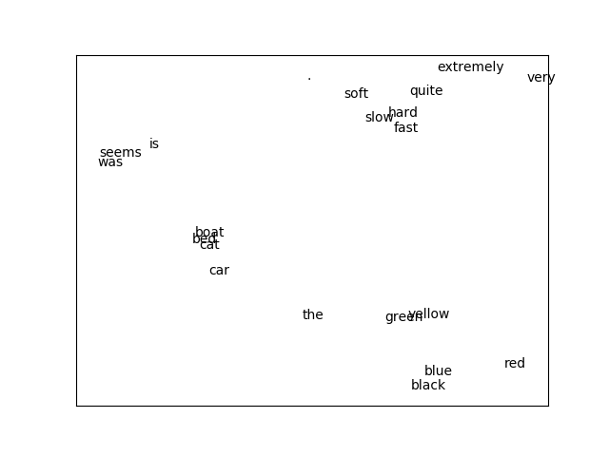

***Figure 30-3. Word vectors***

If you’re interested, it’s not hard to train CBOW word vectors. You’ll have to do a little work. First, you’ll need to modify the Embedding layer so that it takes as input a *list* of IDs and outputs a *list* of embedding vectors. Then you’ll have to create a new layer (Sum?) that takes a list of vectors and returns their sum.

Each word represents a training example where the input is the word IDs for the surrounding words, and the target is the one-hot encoding of the word itself.

The modified Embedding layer turns the surrounding words into a list of vectors, the new Sum layer collapses the list of vectors down to a single vector, and then a Linear layer can produce scores that can be softmaxed to get a distribution representing “most likely words, given this context.”

I found the CBOW model harder to train than the skip-gram one, but I encourage you to try it out.

**Recurrent Neural Networks**

The word vectors we developed in the previous section are often used as the inputs to neural networks. One challenge to doing this is that sentences have varying lengths: you could think of a 3-word sentence as a [3, embedding_dim] tensor and a 10-word sentence as a [10, embedding_dim] tensor. In order to, say, pass them to a Linear layer, we need to do something about that first variable-length dimension.

One option is to use a Sum layer (or a variant that takes the average); however, the *order* of the words in a sentence is usually important to its meaning. To take a common example, “dog bites man” and “man bites dog” are two very different stories!

Another way of handling this is using *recurrent neural networks* (RNNs), which have a *hidden state* they maintain between inputs. In the simplest case, each input is combined with the current hidden state to produce an output, which is then used as the new hidden state. This allows such networks to “remember” (in a sense) the inputs they’ve seen, and to build up to a final output that depends on all the inputs and their order.

We’ll create pretty much the simplest possible RNN layer, which will accept a single input (corresponding to, e.g., a single word in a sentence, or a single character in a word), and which will maintain its hidden state between calls.

Recall that our Linear layer had some weights, w, and a bias, b. It took a vector input and produced a different vector as output using the logic:

output[o] = dot(w[o], input) + b[o]

Here we’ll want to incorporate our hidden state, so we’ll have *two* sets of weights—one to apply to the inputand one to apply to the previous hidden state:

output[o] = dot(w[o], input) + dot(u[o], hidden) + b[o]

Next, we’ll use the output vector as the new value of hidden. This isn’t a huge change, but it will allow our networks to do wonderful things.

**from** **scratch.deep_learning** **import** tensor_apply, tanh

**class** **SimpleRnn**(Layer):

*"""Just about the simplest possible recurrent layer."""*

**def** __init__(self, input_dim: int, hidden_dim: int) -> None:

self.input_dim = input_dim

self.hidden_dim = hidden_dim

self.w = random_tensor(hidden_dim, input_dim, init='xavier')

self.u = random_tensor(hidden_dim, hidden_dim, init='xavier')

self.b = random_tensor(hidden_dim)

self.reset_hidden_state()

**def** reset_hidden_state(self) -> None:

self.hidden = [0 **for** _ **in** range(self.hidden_dim)]

You can see that we start out the hidden state as a vector of 0s, and we provide a function that people using the network can call to reset the hidden state.

Given this setup, the forward function is reasonably straightforward (at least, it is if you remember and understand how our Linear layer worked):

**def** forward(self, input: Tensor) -> Tensor:

self.input = input *# Save both input and previous*

self.prev_hidden = self.hidden *# hidden state to use in backprop.*

a = [(dot(self.w[h], input) + *# weights @ input*

dot(self.u[h], self.hidden) + *# weights @ hidden*

self.b[h]) *# bias*

**for** h **in** range(self.hidden_dim)]

self.hidden = tensor_apply(tanh, a) *# Apply tanh activation*

**return** self.hidden *# and return the result.*

The backward pass is similar to the one in our Linear layer, except that it needs to compute an additional set of gradients for the u weights:

**def** backward(self, gradient: Tensor):

*# Backpropagate through the tanh*

a_grad = [gradient[h] * (1 - self.hidden[h] ** 2)

**for** h **in** range(self.hidden_dim)]

*# b has the same gradient as a*

self.b_grad = a_grad

*# Each w[h][i] is multiplied by input[i] and added to a[h],*

*# so each w_grad[h][i] = a_grad[h] * input[i]*

self.w_grad = [[a_grad[h] * self.input[i]

**for** i **in** range(self.input_dim)]

**for** h **in** range(self.hidden_dim)]

*# Each u[h][h2] is multiplied by hidden[h2] and added to a[h],*

*# so each u_grad[h][h2] = a_grad[h] * prev_hidden[h2]*

self.u_grad = [[a_grad[h] * self.prev_hidden[h2]

**for** h2 **in** range(self.hidden_dim)]

**for** h **in** range(self.hidden_dim)]

*# Each input[i] is multiplied by every w[h][i] and added to a[h],*

*# so each input_grad[i] = sum(a_grad[h] * w[h][i] for h in ...)*

**return** [sum(a_grad[h] * self.w[h][i] **for** h **in** range(self.hidden_dim))

**for** i **in** range(self.input_dim)]

And finally we need to override the params and grads methods:

**def** params(self) -> Iterable[Tensor]:

**return** [self.w, self.u, self.b]

**def** grads(self) -> Iterable[Tensor]:

**return** [self.w_grad, self.u_grad, self.b_grad]

**WARNING**

This “simple” RNN is so simple that you probably shouldn’t use it in practice.

Our SimpleRnn has a couple of undesirable features. One is that its entire hidden state is used to update the input every time you call it. The other is that the entire hidden state is overwritten every time you call it. Both of these make it difficult to train; in particular, they make it difficult for the model to learn long-range dependencies.

For this reason, almost no one uses this kind of simple RNN. Instead, they use more complicated variants like the LSTM (“long short-term memory”) or the GRU (“gated recurrent unit”), which have many more parameters and use parameterized “gates” that allow only some of the state to be updated (and only some of the state to be used) at each timestep.

There is nothing particularly *difficult* about these variants; however, they involve a great deal more code, which would not be (in my opinion) correspondingly more edifying to read. The code for this chapter on [GitHub](https://github.com/joelgrus/data-science-from-scratch)includes an LSTM implementation. I encourage you to check it out, but it’s somewhat tedious and so we won’t discuss it further here.

One other quirk of our implementation is that it takes only one “step” at a time and requires us to manually reset the hidden state. A more practical RNN implementation might accept sequences of inputs, set its hidden state to 0s at the beginning of each sequence, and produce sequences of outputs. Ours could certainly be modified to behave this way; again, this would require more code and complexity for little gain in understanding.

**Example: Using a Character-Level RNN**

The newly hired VP of Branding did not come up with the name *DataSciencester* himself, and (accordingly) he suspects that a better name might lead to more success for the company. He asks you to use data science to suggest candidates for replacement.

One “cute” application of RNNs involves using *characters* (rather than words) as their inputs, training them to learn the subtle language patterns in some dataset, and then using them to generate fictional instances from that dataset.

For example, you could train an RNN on the names of alternative bands, use the trained model to generate new names for fake alternative bands, and then hand-select the funniest ones and share them on Twitter. Hilarity!

Having seen this trick enough times to no longer consider it clever, you decide to give it a shot.

After some digging, you find that the startup accelerator Y Combinator has published [a list of its top 100 (actually 101) most successful startups](https://www.ycombinator.com/topcompanies/), which seems like a good starting point. Checking the page, you find that the company names all live inside <b class="h4"> tags, which means it’s easy to use your web scraping skills to retrieve them:

**from** **bs4** **import** BeautifulSoup

**import** **requests**

url = "https://www.ycombinator.com/topcompanies/"

soup = BeautifulSoup(requests.get(url).text, 'html5lib')

*# We get the companies twice, so use a set comprehension to deduplicate.*

companies = list({b.text

**for** b **in** soup("b")

**if** "h4" **in** b.get("class", ())})

**assert** len(companies) == 101

As always, the page may change (or vanish), in which case this code won’t work. If so, you can use your newly learned data science skills to fix it or just get the list from the book’s GitHub site.

So what is our plan? We’ll train a model to predict the next character of a name, given the current character *and* a hidden state representing all the characters we’ve seen so far.

As usual, we’ll actually predict a probability distribution over characters and train our model to minimize the SoftmaxCrossEntropy loss.

Once our model is trained, we can use it to generate some probabilities, randomly sample a character according to those probabilities, and then feed that character as its next input. This will allow us to *generate* company names using the learned weights.

To start with, we should build a Vocabulary from the characters in the names:

vocab = Vocabulary([c **for** company **in** companies **for** c **in** company])

In addition, we’ll use special tokens to signify the start and end of a company name. This allows the model to learn which characters should *begin* a company name and also to learn when a company name is *finished*.

We’ll just use the regex characters for start and end, which (luckily) don’t appear in our list of companies:

START = "^"

STOP = "$"

*# We need to add them to the vocabulary too.*

vocab.add(START)

vocab.add(STOP)

For our model, we’ll one-hot-encode each character, pass it through two SimpleRnns, and then use a Linearlayer to generate the scores for each possible next character:

HIDDEN_DIM = 32 *# You should experiment with different sizes!*

rnn1 = SimpleRnn(input_dim=vocab.size, hidden_dim=HIDDEN_DIM)

rnn2 = SimpleRnn(input_dim=HIDDEN_DIM, hidden_dim=HIDDEN_DIM)

linear = Linear(input_dim=HIDDEN_DIM, output_dim=vocab.size)

model = Sequential([

rnn1,

rnn2,

linear

])

Imagine for the moment that we’ve trained this model. Let’s write the function that uses it to generate new company names, using the sample_from function from [“Topic Modeling”](https://learning.oreilly.com/library/view/data-science-from/9781492041122/ch21.html#topic_modeling):

**from** **scratch.deep_learning** **import** softmax

**def** generate(seed: str = START, max_len: int = 50) -> str:

rnn1.reset_hidden_state() *# Reset both hidden states*

rnn2.reset_hidden_state()

output = [seed] *# Start the output with the specified seed*

*# Keep going until we produce the STOP character or reach the max length*

**while** output[-1] != STOP **and** len(output) < max_len:

*# Use the last character as the input*

input = vocab.one_hot_encode(output[-1])

*# Generate scores using the model*

predicted = model.forward(input)

*# Convert them to probabilities and draw a random char_id*

probabilities = softmax(predicted)

next_char_id = sample_from(probabilities)

*# Add the corresponding char to our output*

output.append(vocab.get_word(next_char_id))

*# Get rid of START and END characters and return the word*

**return** ''.join(output[1:-1])

At long last, we’re ready to train our character-level RNN. It will take a while!

loss = SoftmaxCrossEntropy()

optimizer = Momentum(learning_rate=0.01, momentum=0.9)

**for** epoch **in** range(300):

random.shuffle(companies) *# Train in a different order each epoch.*

epoch_loss = 0 *# Track the loss.*

**for** company **in** tqdm.tqdm(companies):

rnn1.reset_hidden_state() *# Reset both hidden states.*

rnn2.reset_hidden_state()

company = START + company + STOP *# Add START and STOP characters.*

*# The rest is just our usual training loop, except that the inputs*

*# and target are the one-hot-encoded previous and next characters.*

**for** prev, next **in** zip(company, company[1:]):

input = vocab.one_hot_encode(prev)

target = vocab.one_hot_encode(next)

predicted = model.forward(input)

epoch_loss += loss.loss(predicted, target)

gradient = loss.gradient(predicted, target)

model.backward(gradient)

optimizer.step(model)

*# Each epoch, print the loss and also generate a name.*

**print**(epoch, epoch_loss, generate())

*# Turn down the learning rate for the last 100 epochs.*

*# There's no principled reason for this, but it seems to work.*

**if** epoch == 200:

optimizer.lr *= 0.1

After training, the model generates some actual names from the list (which isn’t surprising, since the model has a fair amount of capacity and not a lot of training data), as well as names that are only slightly different from training names (Scripe, Loinbare, Pozium), names that seem genuinely creative (Benuus, Cletpo, Equite, Vivest), and names that are garbage-y but still sort of word-like (SFitreasy, Sint ocanelp, GliyOx, Doorboronelhav).

Unfortunately, like most character-level-RNN outputs, these are only mildly clever, and the VP of Branding ends up unable to use them.

If I up the hidden dimension to 64, I get a lot more names verbatim from the list; if I drop it to 8, I get mostly garbage. The vocabulary and final weights for all these model sizes are available on [the book’s GitHub site](https://github.com/joelgrus/data-science-from-scratch), and you can use load_weights and load_vocab to use them yourself.

As mentioned previously, the GitHub code for this chapter also contains an implementation for an LSTM, which you should feel free to swap in as a replacement for the SimpleRnns in our company name model.

# Chapter 31. Network Analysis And Recommender Systems

*Your connections to all the things around you literally define who you are.*

Aaron O’Connell

Many interesting data problems can be fruitfully thought of in terms of *networks*, consisting of *nodes* of some type and the *edges* that join them.

For instance, your Facebook friends form the nodes of a network whose edges are friendship relations. A less obvious example is the World Wide Web itself, with each web page a node and each hyperlink from one page to another an edge.

Facebook friendship is mutual—if I am Facebook friends with you, then necessarily you are friends with me. In this case, we say that the edges are *undirected*. Hyperlinks are not—my website links to *whitehouse.gov*, but (for reasons inexplicable to me) *whitehouse.gov* refuses to link to my website. We call these types of edges *directed*. We’ll look at both kinds of networks.

**Betweenness Centrality**

In [Chapter 1](https://learning.oreilly.com/library/view/data-science-from/9781492041122/ch01.html#introduction), we computed the key connectors in the DataSciencester network by counting the number of friends each user had. Now we have enough machinery to take a look at other approaches. We will use the same network, but now we’ll use NamedTuples for the data.

Recall that the network ([Figure 31-1](https://learning.oreilly.com/library/view/data-science-from/9781492041122/ch22.html#datasciencester_network_ch21)) comprised users:

**from** **typing** **import** NamedTuple

**class** **User**(NamedTuple):

id: int

name: str

users = [User(0, "Hero"), User(1, "Dunn"), User(2, "Sue"), User(3, "Chi"),

User(4, "Thor"), User(5, "Clive"), User(6, "Hicks"),

User(7, "Devin"), User(8, "Kate"), User(9, "Klein")]

and friendships:

friend_pairs = [(0, 1), (0, 2), (1, 2), (1, 3), (2, 3), (3, 4),

(4, 5), (5, 6), (5, 7), (6, 8), (7, 8), (8, 9)]



***Figure 31-1. The DataSciencester network***

The friendships will be easier to work with as a dict:

**from** **typing** **import** Dict, List

*# type alias for keeping track of Friendships*

Friendships = Dict[int, List[int]]

friendships: Friendships = {user.id: [] **for** user **in** users}

**for** i, j **in** friend_pairs:

friendships[i].append(j)

friendships[j].append(i)

**assert** friendships[4] == [3, 5]

**assert** friendships[8] == [6, 7, 9]

When we left off we were dissatisfied with our notion of *degree centrality*, which didn’t really agree with our intuition about who the key connectors of the network were.

An alternative metric is *betweenness centrality*, which identifies people who frequently are on the shortest paths between pairs of other people. In particular, the betweenness centrality of node *i* is computed by adding up, for every other pair of nodes *j* and *k*, the proportion of shortest paths between node *j* and node *k* that pass through *i*.

That is, to figure out Thor’s betweenness centrality, we’ll need to compute all the shortest paths between all pairs of people who aren’t Thor. And then we’ll need to count how many of those shortest paths pass through Thor. For instance, the only shortest path between Chi (id 3) and Clive (id 5) passes through Thor, while neither of the two shortest paths between Hero (id 0) and Chi (id 3) does.

So, as a first step, we’ll need to figure out the shortest paths between all pairs of people. There are some pretty sophisticated algorithms for doing so efficiently, but (as is almost always the case) we will use a less efficient, easier-to-understand algorithm.

This algorithm (an implementation of breadth-first search) is one of the more complicated ones in the book, so let’s talk through it carefully:

1. Our goal is a function that takes a from_user and finds *all* shortest paths to every other user.
2. We’ll represent a path as a list of user IDs. Since every path starts at from_user, we won’t include her ID in the list. This means that the length of the list representing the path will be the length of the path itself.
3. We’ll maintain a dictionary called shortest_paths_to where the keys are user IDs and the values are lists of paths that end at the user with the specified ID. If there is a unique shortest path, the list will just contain that one path. If there are multiple shortest paths, the list will contain all of them.
4. We’ll also maintain a queue called frontier that contains the users we want to explore in the order we want to explore them. We’ll store them as pairs (prev_user, user) so that we know how we got to each one. We initialize the queue with all the neighbors of from_user. (We haven’t talked about queues, which are data structures optimized for “add to the end” and “remove from the front” operations. In Python, they are implemented as collections.deque, which is actually a double-ended queue.)
5. As we explore the graph, whenever we find new neighbors that we don’t already know the shortest paths to, we add them to the end of the queue to explore later, with the current user as prev_user.
6. When we take a user off the queue, and we’ve never encountered that user before, we’ve definitely found one or more shortest paths to him—each of the shortest paths to prev_user with one extra step added.
7. When we take a user off the queue and we *have* encountered that user before, then either we’ve found another shortest path (in which case we should add it) or we’ve found a longer path (in which case we shouldn’t).
8. When no more users are left on the queue, we’ve explored the whole graph (or, at least, the parts of it that are reachable from the starting user) and we’re done.

We can put this all together into a (large) function:

**from** **collections** **import** deque

Path = List[int]

**def** shortest_paths_from(from_user_id: int,

friendships: Friendships) -> Dict[int, List[Path]]:

*# A dictionary from user_id to *all* shortest paths to that user.*

shortest_paths_to: Dict[int, List[Path]] = {from_user_id: [[]]}

*# A queue of (previous user, next user) that we need to check.*

*# Starts out with all pairs (from_user, friend_of_from_user).*

frontier = deque((from_user_id, friend_id)

**for** friend_id **in** friendships[from_user_id])

*# Keep going until we empty the queue.*

**while** frontier:

*# Remove the pair that's next in the queue.*

prev_user_id, user_id = frontier.popleft()

*# Because of the way we're adding to the queue,*

*# necessarily we already know some shortest paths to prev_user.*

paths_to_prev_user = shortest_paths_to[prev_user_id]

new_paths_to_user = [path + [user_id] **for** path **in** paths_to_prev_user]

*# It's possible we already know a shortest path to user_id.*

old_paths_to_user = shortest_paths_to.get(user_id, [])

*# What's the shortest path to here that we've seen so far?*

**if** old_paths_to_user:

min_path_length = len(old_paths_to_user[0])

**else**:

min_path_length = float('inf')

*# Only keep paths that aren't too long and are actually new.*

new_paths_to_user = [path

**for** path **in** new_paths_to_user

**if** len(path) <= min_path_length

**and** path **not** **in** old_paths_to_user]

shortest_paths_to[user_id] = old_paths_to_user + new_paths_to_user

*# Add never-seen neighbors to the frontier.*

frontier.extend((user_id, friend_id)

**for** friend_id **in** friendships[user_id]

**if** friend_id **not** **in** shortest_paths_to)

**return** shortest_paths_to

Now let’s compute all the shortest paths:

*# For each from_user, for each to_user, a list of shortest paths.*

shortest_paths = {user.id: shortest_paths_from(user.id, friendships)

**for** user **in** users}

And we’re finally ready to compute betweenness centrality. For every pair of nodes *i* and *j*, we know the *n*shortest paths from *i* to *j*. Then, for each of those paths, we just add 1/n to the centrality of each node on that path:

betweenness_centrality = {user.id: 0.0 **for** user **in** users}

**for** source **in** users:

**for** target_id, paths **in** shortest_paths[source.id].items():

**if** source.id < target_id: *# don't double count*

num_paths = len(paths) *# how many shortest paths?*

contrib = 1 / num_paths *# contribution to centrality*

**for** path **in** paths:

**for** between_id **in** path:

**if** between_id **not** **in** [source.id, target_id]:

betweenness_centrality[between_id] += contrib

As shown in [Figure 31-2](https://learning.oreilly.com/library/view/data-science-from/9781492041122/ch22.html#network_sized_by_betweenness), users 0 and 9 have centrality 0 (as neither is on any shortest path between other users), whereas 3, 4, and 5 all have high centralities (as all three lie on many shortest paths).

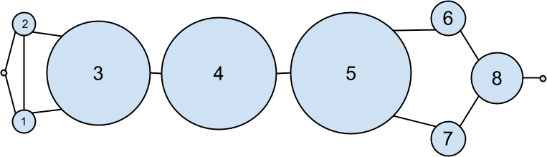

***Figure 31-2. The DataSciencester network sized by betweenness centrality***

**NOTE**

Generally the centrality numbers aren’t that meaningful themselves. What we care about is how the numbers for each node compare to the numbers for other nodes.

Another measure we can look at is *closeness centrality*. First, for each user we compute her *farness*, which is the sum of the lengths of her shortest paths to each other user. Since we’ve already computed the shortest paths between each pair of nodes, it’s easy to add their lengths. (If there are multiple shortest paths, they all have the same length, so we can just look at the first one.)

**def** farness(user_id: int) -> float:

*"""the sum of the lengths of the shortest paths to each other user"""*

**return** sum(len(paths[0])

**for** paths **in** shortest_paths[user_id].values())

after which it’s very little work to compute closeness centrality ([Figure 31-3](https://learning.oreilly.com/library/view/data-science-from/9781492041122/ch22.html#network_sized_by_closeness)):

closeness_centrality = {user.id: 1 / farness(user.id) **for** user **in** users}

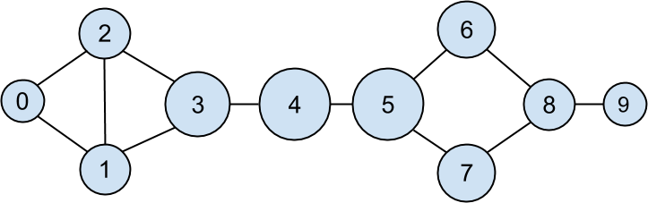

***Figure 31-3. The DataSciencester network sized by closeness centrality***

There is much less variation here—even the very central nodes are still pretty far from the nodes out on the periphery.

As we saw, computing shortest paths is kind of a pain. For this reason, betweenness and closeness centrality aren’t often used on large networks. The less intuitive (but generally easier to compute) *eigenvector centrality* is more frequently used.

**Eigenvector Centrality**

In order to talk about eigenvector centrality, we have to talk about eigenvectors, and in order to talk about eigenvectors, we have to talk about matrix multiplication.

**Matrix Multiplication**

If *A* is an n×mn×m matrix and *B* is an m×km×k matrix (notice that the second dimension of *A* is same as the first dimension of *B*), then their product *AB* is the n×kn×k matrix whose (*i*,*j*)th entry is:

Ai1B1j+Ai2B2j+⋯+AimBmjAi1B1j+Ai2B2j+⋯+AimBmj

which is just the dot product of the *i*th row of *A* (thought of as a vector) with the *j*th column of *B* (also thought of as a vector).

We can implement this using the make_matrix function from [Chapter 4](https://learning.oreilly.com/library/view/data-science-from/9781492041122/ch04.html#linear_algebra):

**from** **scratch.linear_algebra** **import** Matrix, make_matrix, shape

**def** matrix_times_matrix(m1: Matrix, m2: Matrix) -> Matrix:

nr1, nc1 = shape(m1)

nr2, nc2 = shape(m2)

**assert** nc1 == nr2, "must have (# of columns in m1) == (# of rows in m2)"

**def** entry_fn(i: int, j: int) -> float:

*"""dot product of i-th row of m1 with j-th column of m2"""*

**return** sum(m1[i][k] * m2[k][j] **for** k **in** range(nc1))

**return** make_matrix(nr1, nc2, entry_fn)

If we think of an *m*-dimensional vector as an (m, 1) matrix, we can multiply it by an (n, m) matrix to get an (n, 1) matrix, which we can then think of as an *n*-dimensional vector.

This means another way to think about an (n, m) matrix is as a linear mapping that transforms *m*-dimensional vectors into *n*-dimensional vectors:

**from** **scratch.linear_algebra** **import** Vector, dot

**def** matrix_times_vector(m: Matrix, v: Vector) -> Vector:

nr, nc = shape(m)

n = len(v)

**assert** nc == n, "must have (# of cols in m) == (# of elements in v)"

**return** [dot(row, v) **for** row **in** m] *# output has length nr*

When *A* is a *square* matrix, this operation maps *n*-dimensional vectors to other *n*-dimensional vectors. It’s possible that, for some matrix *A* and vector *v*, when *A* operates on *v* we get back a scalar multiple of *v*—that is, that the result is a vector that points in the same direction as *v*. When this happens (and when, in addition, *v* is not a vector of all zeros), we call *v* an *eigenvector* of *A*. And we call the multiplier an *eigenvalue*.

One possible way to find an eigenvector of *A* is by picking a starting vector *v*, applying matrix_times_vector, rescaling the result to have magnitude 1, and repeating until the process converges:

**from** **typing** **import** Tuple

**import** **random**

**from** **scratch.linear_algebra** **import** magnitude, distance

**def** find_eigenvector(m: Matrix,

tolerance: float = 0.00001) -> Tuple[Vector, float]:

guess = [random.random() **for** _ **in** m]

**while** True:

result = matrix_times_vector(m, guess) *# transform guess*

norm = magnitude(result) *# compute norm*

next_guess = [x / norm **for** x **in** result] *# rescale*

**if** distance(guess, next_guess) < tolerance:

*# convergence so return (eigenvector, eigenvalue)*

**return** next_guess, norm

guess = next_guess

By construction, the returned guess is a vector such that, when you apply matrix_times_vector to it and rescale it to have length 1, you get back a vector very close to itself—which means it’s an eigenvector.

Not all matrices of real numbers have eigenvectors and eigenvalues. For example, the matrix:

rotate = [[ 0, 1],

[-1, 0]]

rotates vectors 90 degrees clockwise, which means that the only vector it maps to a scalar multiple of itself is a vector of zeros. If you tried find_eigenvector(rotate) it would run forever. Even matrices that have eigenvectors can sometimes get stuck in cycles. Consider the matrix:

flip = [[0, 1],

[1, 0]]

This matrix maps any vector [x, y] to [y, x]. This means that, for example, [1, 1] is an eigenvector with eigenvalue 1. However, if you start with a random vector with unequal coordinates, find_eigenvector will just repeatedly swap the coordinates forever. (Not-from-scratch libraries like NumPy use different methods that would work in this case.) Nonetheless, when find_eigenvector does return a result, that result is indeed an eigenvector.

**Centrality**

How does this help us understand the DataSciencester network? To start, we’ll need to represent the connections in our network as an adjacency_matrix, whose (*i*,*j*)th entry is either 1 (if user *i* and user *j* are friends) or 0 (if they’re not):

**def** entry_fn(i: int, j: int):

**return** 1 **if** (i, j) **in** friend_pairs **or** (j, i) **in** friend_pairs **else** 0

n = len(users)

adjacency_matrix = make_matrix(n, n, entry_fn)

The eigenvector centrality for each user is then the entry corresponding to that user in the eigenvector returned by find_eigenvector ([Figure 31-4](https://learning.oreilly.com/library/view/data-science-from/9781492041122/ch22.html#network_sized_by_eigenvector)).

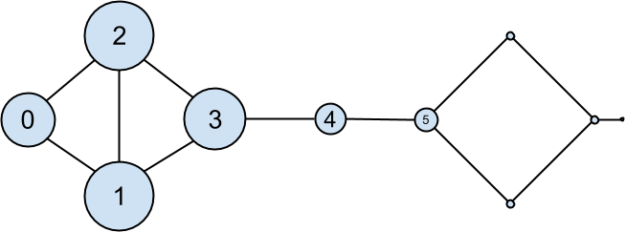

***Figure 31-4. The DataSciencester network sized by eigenvector centrality***

**NOTE**

For technical reasons that are way beyond the scope of this book, any nonzero adjacency matrix necessarily has an eigenvector, all of whose values are nonnegative. And fortunately for us, for this adjacency_matrix our find_eigenvector function finds it.

eigenvector_centralities, _ = find_eigenvector(adjacency_matrix)

Users with high eigenvector centrality should be those who have a lot of connections, and connections to people who themselves have high centrality.

Here users 1 and 2 are the most central, as they both have three connections to people who are themselves highly central. As we move away from them, people’s centralities steadily drop off.

On a network this small, eigenvector centrality behaves somewhat erratically. If you try adding or subtracting links, you’ll find that small changes in the network can dramatically change the centrality numbers. In a much larger network, this would not particularly be the case.

We still haven’t motivated why an eigenvector might lead to a reasonable notion of centrality. Being an eigenvector means that if you compute:

matrix_times_vector(adjacency_matrix, eigenvector_centralities)

the result is a scalar multiple of eigenvector_centralities.

If you look at how matrix multiplication works, matrix_times_vector produces a vector whose *i*th element is:

dot(adjacency_matrix[i], eigenvector_centralities)

which is precisely the sum of the eigenvector centralities of the users connected to user *i*.

In other words, eigenvector centralities are numbers, one per user, such that each user’s value is a constant multiple of the sum of his neighbors’ values. In this case centrality means being connected to people who themselves are central. The more centrality you are directly connected to, the more central you are. This is of course a circular definition—eigenvectors are the way of breaking out of the circularity.

Another way of understanding this is by thinking about what find_eigenvector is doing here. It starts by assigning each node a random centrality. It then repeats the following two steps until the process converges:

1. Give each node a new centrality score that equals the sum of its neighbors’ (old) centrality scores.
2. Rescale the vector of centralities to have magnitude 1.

Although the mathematics behind it may seem somewhat opaque at first, the calculation itself is relatively straightforward (unlike, say, betweenness centrality) and is pretty easy to perform on even very large graphs. (At least, if you use a real linear algebra library it’s easy to perform on large graphs. If you used our matrices-as-lists implementation you’d struggle.)

**Directed Graphs and PageRank**

DataSciencester isn’t getting much traction, so the VP of Revenue considers pivoting from a friendship model to an endorsement model. It turns out that no one particularly cares which data scientists are *friends* with one another, but tech recruiters care very much which data scientists are *respected* by other data scientists.

In this new model, we’ll track endorsements (source, target) that no longer represent a reciprocal relationship, but rather that source endorses target as an awesome data scientist ([Figure 31-5](https://learning.oreilly.com/library/view/data-science-from/9781492041122/ch22.html#datasciencester_network_endorsements)).

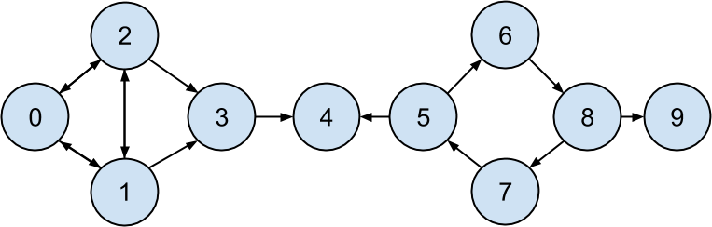

***Figure 31-5. The DataSciencester network of endorsements***

We’ll need to account for this asymmetry:

endorsements = [(0, 1), (1, 0), (0, 2), (2, 0), (1, 2),

(2, 1), (1, 3), (2, 3), (3, 4), (5, 4),

(5, 6), (7, 5), (6, 8), (8, 7), (8, 9)]

after which we can easily find the most_endorsed data scientists and sell that information to recruiters:

**from** **collections** **import** Counter

endorsement_counts = Counter(target **for** source, target **in** endorsements)

However, “number of endorsements” is an easy metric to game. All you need to do is create phony accounts and have them endorse you. Or arrange with your friends to endorse each other. (As users 0, 1, and 2 seem to have done.)

A better metric would take into account *who* endorses you. Endorsements from people who have a lot of endorsements should somehow count more than endorsements from people with few endorsements. This is the essence of the PageRank algorithm, used by Google to rank websites based on which other websites link to them, which other websites link to those, and so on.

(If this sort of reminds you of the idea behind eigenvector centrality, it should.)

A simplified version looks like this:

1. There is a total of 1.0 (or 100%) PageRank in the network.
2. Initially this PageRank is equally distributed among nodes.
3. At each step, a large fraction of each node’s PageRank is distributed evenly among its outgoing links.
4. At each step, the remainder of each node’s PageRank is distributed evenly among all nodes.

**import** **tqdm**

**def** page_rank(users: List[User],

endorsements: List[Tuple[int, int]],

damping: float = 0.85,

num_iters: int = 100) -> Dict[int, float]:

*# Compute how many people each person endorses*

outgoing_counts = Counter(target **for** source, target **in** endorsements)

*# Initially distribute PageRank evenly*

num_users = len(users)

pr = {user.id : 1 / num_users **for** user **in** users}

*# Small fraction of PageRank that each node gets each iteration*

base_pr = (1 - damping) / num_users

**for** iter **in** tqdm.trange(num_iters):

next_pr = {user.id : base_pr **for** user **in** users} *# start with base_pr*

**for** source, target **in** endorsements:

*# Add damped fraction of source pr to target*

next_pr[target] += damping * pr[source] / outgoing_counts[source]

pr = next_pr

**return** pr

If we compute page ranks:

pr = page_rank(users, endorsements)

*# Thor (user_id 4) has higher page rank than anyone else*

**assert** pr[4] > max(page_rank

**for** user_id, page_rank **in** pr.items()

**if** user_id != 4)

PageRank ([Figure 31-6](https://learning.oreilly.com/library/view/data-science-from/9781492041122/ch22.html#network_sized_by_pagerank)) identifies user 4 (Thor) as the highest-ranked data scientist.

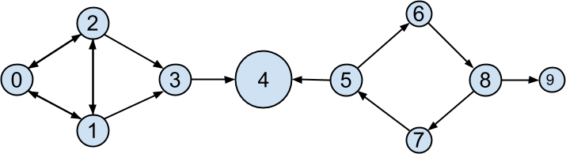

***Figure 31-6. The DataSciencester network sized by PageRank***

Even though Thor has fewer endorsements (two) than users 0, 1, and 2, his endorsements carry with them rank from their endorsements. Additionally, both of his endorsers endorsed only him, which means that he doesn’t have to divide their rank with anyone else.

**Recommender Systems**

*O nature, nature, why art thou so dishonest, as ever to send men with these false recommendations into the world!*

Henry Fielding

Another common data problem is producing recommendations of some sort. Netflix recommends movies you might want to watch. Amazon recommends products you might want to buy. Twitter recommends users you might want to follow. In this chapter, we’ll look at several ways to use data to make recommendations.

In particular, we’ll look at the dataset of users_interests that we’ve used before:

users_interests = [

["Hadoop", "Big Data", "HBase", "Java", "Spark", "Storm", "Cassandra"],

["NoSQL", "MongoDB", "Cassandra", "HBase", "Postgres"],

["Python", "scikit-learn", "scipy", "numpy", "statsmodels", "pandas"],

["R", "Python", "statistics", "regression", "probability"],

["machine learning", "regression", "decision trees", "libsvm"],

["Python", "R", "Java", "C++", "Haskell", "programming languages"],

["statistics", "probability", "mathematics", "theory"],

["machine learning", "scikit-learn", "Mahout", "neural networks"],

["neural networks", "deep learning", "Big Data", "artificial intelligence"],

["Hadoop", "Java", "MapReduce", "Big Data"],

["statistics", "R", "statsmodels"],

["C++", "deep learning", "artificial intelligence", "probability"],

["pandas", "R", "Python"],

["databases", "HBase", "Postgres", "MySQL", "MongoDB"],

["libsvm", "regression", "support vector machines"]

]

And we’ll think about the problem of recommending new interests to a user based on her currently specified interests.

# Manual Curation

Before the internet, when you needed book recommendations you would go to the library, where a librarian was available to suggest books that were relevant to your interests or similar to books you liked.

Given DataSciencester’s limited number of users and interests, it would be easy for you to spend an afternoon manually recommending interests for each user. But this method doesn’t scale particularly well, and it’s limited by your personal knowledge and imagination. (Not that I’m suggesting that your personal knowledge and imagination are limited.) So let’s think about what we can do with data.

# Recommending What’s Popular

One easy approach is to simply recommend what’s popular:

**from** **collections** **import** Counter

popular_interests = Counter(interest

**for** user_interests **in** users_interests

**for** interest **in** user_interests)

which looks like:

[('Python', 4),

('R', 4),

('Java', 3),

('regression', 3),

('statistics', 3),

('probability', 3),

*# ...*

]

Having computed this, we can just suggest to a user the most popular interests that he’s not already interested in:

**from** **typing** **import** List, Tuple

**def** most_popular_new_interests(

user_interests: List[str],

max_results: int = 5) -> List[Tuple[str, int]]:

suggestions = [(interest, frequency)

**for** interest, frequency **in** popular_interests.most_common()

**if** interest **not** **in** user_interests]

**return** suggestions[:max_results]

So, if you are user 1, with interests:

["NoSQL", "MongoDB", "Cassandra", "HBase", "Postgres"]

then we’d recommend you:

[('Python', 4), ('R', 4), ('Java', 3), ('regression', 3), ('statistics', 3)]

If you are user 3, who’s already interested in many of those things, you’d instead get:

[('Java', 3), ('HBase', 3), ('Big Data', 3),

('neural networks', 2), ('Hadoop', 2)]

Of course, “lots of people are interested in Python, so maybe you should be too” is not the most compelling sales pitch. If someone is brand new to our site and we don’t know anything about them, that’s possibly the best we can do. Let’s see how we can do better by basing each user’s recommendations on her existing interests.

# User-Based Collaborative Filtering

One way of taking a user’s interests into account is to look for users who are somehow similar to her, and then suggest the things that those users are interested in.

In order to do that, we’ll need a way to measure how similar two users are. Here we’ll use cosine similarity, which we used in [Chapter 21](https://learning.oreilly.com/library/view/data-science-from/9781492041122/ch21.html#natural_language_processing) to measure how similar two word vectors were.

We’ll apply this to vectors of 0s and 1s, each vector v representing one user’s interests. v[i] will be 1 if the user specified the ith interest, and 0 otherwise. Accordingly, “similar users” will mean “users whose interest vectors most nearly point in the same direction.” Users with identical interests will have similarity 1. Users with no identical interests will have similarity 0. Otherwise, the similarity will fall in between, with numbers closer to 1 indicating “very similar” and numbers closer to 0 indicating “not very similar.”

A good place to start is collecting the known interests and (implicitly) assigning indices to them. We can do this by using a set comprehension to find the unique interests, and then sorting them into a list. The first interest in the resulting list will be interest 0, and so on:

unique_interests = sorted({interest

**for** user_interests **in** users_interests

**for** interest **in** user_interests})

This gives us a list that starts:

**assert** unique_interests[:6] == [

'Big Data',

'C++',

'Cassandra',

'HBase',

'Hadoop',

'Haskell',

*# ...*

]

Next we want to produce an “interest” vector of 0s and 1s for each user. We just need to iterate over the unique_interests list, substituting a 1 if the user has each interest, and a 0 if not:

**def** make_user_interest_vector(user_interests: List[str]) -> List[int]:

*"""*

*Given a list of interests, produce a vector whose ith element is 1*

*if unique_interests[i] is in the list, 0 otherwise*

*"""*

**return** [1 **if** interest **in** user_interests **else** 0

**for** interest **in** unique_interests]

And now we can make a list of user interest vectors:

user_interest_vectors = [make_user_interest_vector(user_interests)

**for** user_interests **in** users_interests]

Now user_interest_vectors[i][j] equals 1 if user i specified interest j, and 0 otherwise.

Because we have a small dataset, it’s no problem to compute the pairwise similarities between all of our users:

**from** **scratch.nlp** **import** cosine_similarity

user_similarities = [[cosine_similarity(interest_vector_i, interest_vector_j)

**for** interest_vector_j **in** user_interest_vectors]

**for** interest_vector_i **in** user_interest_vectors]

after which user_similarities[i][j] gives us the similarity between users i and j:

*# Users 0 and 9 share interests in Hadoop, Java, and Big Data*

**assert** 0.56 < user_similarities[0][9] < 0.58, "several shared interests"

*# Users 0 and 8 share only one interest: Big Data*

**assert** 0.18 < user_similarities[0][8] < 0.20, "only one shared interest"

In particular, user_similarities[i] is the vector of user i’s similarities to every other user. We can use this to write a function that finds the most similar users to a given user. We’ll make sure not to include the user herself, nor any users with zero similarity. And we’ll sort the results from most similar to least similar:

**def** most_similar_users_to(user_id: int) -> List[Tuple[int, float]]:

pairs = [(other_user_id, similarity) *# Find other*

**for** other_user_id, similarity **in** *# users with*

enumerate(user_similarities[user_id]) *# nonzero*

**if** user_id != other_user_id **and** similarity > 0] *# similarity.*

**return** sorted(pairs, *# Sort them*

key=**lambda** pair: pair[-1], *# most similar*

reverse=True) *# first.*

For instance, if we call most_similar_users_to(0) we get:

[(9, 0.5669467095138409),

(1, 0.3380617018914066),

(8, 0.1889822365046136),

(13, 0.1690308509457033),

(5, 0.1543033499620919)]

How do we use this to suggest new interests to a user? For each interest, we can just add up the user similarities of the other users interested in it:

**from** **collections** **import** defaultdict

**def** user_based_suggestions(user_id: int,

include_current_interests: bool = False):

*# Sum up the similarities*

suggestions: Dict[str, float] = defaultdict(float)

**for** other_user_id, similarity **in** most_similar_users_to(user_id):

**for** interest **in** users_interests[other_user_id]:

suggestions[interest] += similarity

*# Convert them to a sorted list*

suggestions = sorted(suggestions.items(),

key=**lambda** pair: pair[-1], *# weight*

reverse=True)

*# And (maybe) exclude already interests*

**if** include_current_interests:

**return** suggestions

**else**:

**return** [(suggestion, weight)

**for** suggestion, weight **in** suggestions

**if** suggestion **not** **in** users_interests[user_id]]

If we call user_based_suggestions(0), the first several suggested interests are:

[('MapReduce', 0.5669467095138409),

('MongoDB', 0.50709255283711),

('Postgres', 0.50709255283711),

('NoSQL', 0.3380617018914066),

('neural networks', 0.1889822365046136),

('deep learning', 0.1889822365046136),

('artificial intelligence', 0.1889822365046136),

*#...*

]

These seem like pretty decent suggestions for someone whose stated interests are “Big Data” and database-related. (The weights aren’t intrinsically meaningful; we just use them for ordering.)

This approach doesn’t work as well when the number of items gets very large. Recall the curse of dimensionality from [Chapter 12](https://learning.oreilly.com/library/view/data-science-from/9781492041122/ch12.html#nearest_neighbors)—in large-dimensional vector spaces most vectors are very far apart (and also point in very different directions). That is, when there are a large number of interests the “most similar users” to a given user might not be similar at all.

Imagine a site like Amazon.com, from which I’ve bought thousands of items over the last couple of decades. You could attempt to identify similar users to me based on buying patterns, but most likely in all the world there’s no one whose purchase history looks even remotely like mine. Whoever my “most similar” shopper is, he’s probably not similar to me at all, and his purchases would almost certainly make for lousy recommendations.

# Item-Based Collaborative Filtering

An alternative approach is to compute similarities between interests directly. We can then generate suggestions for each user by aggregating interests that are similar to her current interests.

To start with, we’ll want to transpose our user-interest matrix so that rows correspond to interests and columns correspond to users:

interest_user_matrix = [[user_interest_vector[j]

**for** user_interest_vector **in** user_interest_vectors]

**for** j, _ **in** enumerate(unique_interests)]

What does this look like? Row j of interest_user_matrix is column j of user_interest_matrix. That is, it has 1 for each user with that interest and 0 for each user without that interest.

For example, unique_interests[0] is Big Data, and so interest_user_matrix[0] is:

[1, 0, 0, 0, 0, 0, 0, 0, 1, 1, 0, 0, 0, 0, 0]

because users 0, 8, and 9 indicated interest in Big Data.

We can now use cosine similarity again. If precisely the same users are interested in two topics, their similarity will be 1. If no two users are interested in both topics, their similarity will be 0:

interest_similarities = [[cosine_similarity(user_vector_i, user_vector_j)

**for** user_vector_j **in** interest_user_matrix]

**for** user_vector_i **in** interest_user_matrix]

For example, we can find the interests most similar to Big Data (interest 0) using:

**def** most_similar_interests_to(interest_id: int):

similarities = interest_similarities[interest_id]

pairs = [(unique_interests[other_interest_id], similarity)

**for** other_interest_id, similarity **in** enumerate(similarities)

**if** interest_id != other_interest_id **and** similarity > 0]

**return** sorted(pairs,

key=**lambda** pair: pair[-1],

reverse=True)

which suggests the following similar interests:

[('Hadoop', 0.8164965809277261),

('Java', 0.6666666666666666),

('MapReduce', 0.5773502691896258),

('Spark', 0.5773502691896258),

('Storm', 0.5773502691896258),

('Cassandra', 0.4082482904638631),

('artificial intelligence', 0.4082482904638631),

('deep learning', 0.4082482904638631),

('neural networks', 0.4082482904638631),

('HBase', 0.3333333333333333)]

Now we can create recommendations for a user by summing up the similarities of the interests similar to his:

**def** item_based_suggestions(user_id: int,

include_current_interests: bool = False):

*# Add up the similar interests*

suggestions = defaultdict(float)

user_interest_vector = user_interest_vectors[user_id]

**for** interest_id, is_interested **in** enumerate(user_interest_vector):

**if** is_interested == 1:

similar_interests = most_similar_interests_to(interest_id)

**for** interest, similarity **in** similar_interests:

suggestions[interest] += similarity

*# Sort them by weight*

suggestions = sorted(suggestions.items(),

key=**lambda** pair: pair[-1],

reverse=True)

**if** include_current_interests:

**return** suggestions

**else**:

**return** [(suggestion, weight)

**for** suggestion, weight **in** suggestions

**if** suggestion **not** **in** users_interests[user_id]]

For user 0, this generates the following (seemingly reasonable) recommendations:

[('MapReduce', 1.861807319565799),

('Postgres', 1.3164965809277263),

('MongoDB', 1.3164965809277263),

('NoSQL', 1.2844570503761732),

('programming languages', 0.5773502691896258),

('MySQL', 0.5773502691896258),

('Haskell', 0.5773502691896258),

('databases', 0.5773502691896258),

('neural networks', 0.4082482904638631),

('deep learning', 0.4082482904638631),

('C++', 0.4082482904638631),

('artificial intelligence', 0.4082482904638631),

('Python', 0.2886751345948129),

('R', 0.2886751345948129)]

# Matrix Factorization

As we’ve seen, we can represent our users’ preferences as a [num_users, num_items] matrix of 0s and 1s, where the 1s represent liked items and the 0s unliked items.

Sometimes you might actually have numeric ratings; for example, when you write an Amazon review you assign the item a score ranging from 1 to 5 stars. You could still represent these by numbers in a [num_users, num_items] matrix (ignoring for now the problem of what to do about unrated items).

In this section we’ll assume we have such ratings data and try to learn a model that can predict the rating for a given user and item.

One way of approaching the problem is to assume that every user has some latent “type,” which can be represented as a vector of numbers, and that each item similarly has some latent “type.”

If the user types are represented as a [num_users, dim] matrix, and the transpose of the item types is represented as a [dim, num_items] matrix, their product is a [num_users, num_items] matrix. Accordingly, one way of building such a model is by “factoring” the preferences matrix into the product of a user matrix and an item matrix.

(Possibly this idea of latent types reminds you of the word embeddings we developed in [Chapter 21](https://learning.oreilly.com/library/view/data-science-from/9781492041122/ch21.html#natural_language_processing). Hold on to that idea.)

Rather than working with our made-up 10-user dataset, we’ll work with the MovieLens 100k dataset, which contains ratings from 0 to 5 for many movies from many users. Each user has only rated a small subset of the movies. We’ll use this to try to build a system that can predict the rating for any given (user, movie) pair. We’ll train it to predict well on the movies each user has rated; hopefully then it will generalize to movies the user hasn’t rated.

To start with, let’s acquire the dataset. You can download it from <http://files.grouplens.org/datasets/movielens/ml-100k.zip>.

Unzip it and extract the files; we’ll only use two of them:

*# This points to the current directory, modify if your files are elsewhere.*

MOVIES = "u.item" *# pipe-delimited: movie_id|title|...*

RATINGS = "u.data" *# tab-delimited: user_id, movie_id, rating, timestamp*

As is often the case, we’ll introduce a NamedTuple to make things easier to work with:

**from** **typing** **import** NamedTuple

**class** **Rating**(NamedTuple):

user_id: str

movie_id: str

rating: float

###### NOTE

The movie ID and user IDs are actually integers, but they’re not consecutive, which means if we worked with them as integers we’d end up with a lot of wasted dimensions (unless we renumbered everything). So to keep it simpler we’ll just treat them as strings.

Now let’s read in the data and explore it. The movies file is pipe-delimited and has many columns. We only care about the first two, which are the ID and the title:

**import** **csv**

*# We specify this encoding to avoid a UnicodeDecodeError.*

*# See: https://stackoverflow.com/a/53136168/1076346.*

**with** open(MOVIES, encoding="iso-8859-1") **as** f:

reader = csv.reader(f, delimiter="|")

movies = {movie_id: title **for** movie_id, title, *_ **in** reader}

The ratings file is tab-delimited and contains four columns for user_id, movie_id, rating (1 to 5), and timestamp. We’ll ignore the timestamp, as we don’t need it:

*# Create a list of [Rating]*

**with** open(RATINGS, encoding="iso-8859-1") **as** f:

reader = csv.reader(f, delimiter="**\t**")

ratings = [Rating(user_id, movie_id, float(rating))

**for** user_id, movie_id, rating, _ **in** reader]

*# 1682 movies rated by 943 users*

**assert** len(movies) == 1682

**assert** len(list({rating.user_id **for** rating **in** ratings})) == 943

There’s a lot of interesting exploratory analysis you can do on this data; for instance, you might be interested in the average ratings for Star Wars movies (the dataset is from 1998, which means it predates The Phantom Menace by a year):

**import** **re**

*# Data structure for accumulating ratings by movie_id*

star_wars_ratings = {movie_id: []

**for** movie_id, title **in** movies.items()

**if** re.search("Star Wars|Empire Strikes|Jedi", title)}

*# Iterate over ratings, accumulating the Star Wars ones*

**for** rating **in** ratings:

**if** rating.movie_id **in** star_wars_ratings:

star_wars_ratings[rating.movie_id].append(rating.rating)

*# Compute the average rating for each movie*

avg_ratings = [(sum(title_ratings) / len(title_ratings), movie_id)

**for** movie_id, title_ratings **in** star_wars_ratings.items()]

*# And then print them in order*

**for** avg_rating, movie_id **in** sorted(avg_ratings, reverse=True):

**print**(f"{avg_rating:.2f} {movies[movie_id]}")

They’re all pretty highly rated:

4.36 Star Wars (1977)

4.20 Empire Strikes Back, The (1980)

4.01 Return of the Jedi (1983)

So let’s try to come up with a model to predict these ratings. As a first step, let’s split the ratings data into train, validation, and test sets:

**import** **random**

random.seed(0)

random.shuffle(ratings)

split1 = int(len(ratings) * 0.7)

split2 = int(len(ratings) * 0.85)

train = ratings[:split1] *# 70% of the data*

validation = ratings[split1:split2] *# 15% of the data*

test = ratings[split2:] *# 15% of the data*

It’s always good to have a simple baseline model and make sure that ours does better than that. Here a simple baseline model might be “predict the average rating.” We’ll be using mean squared error as our metric, so let’s see how the baseline does on our test set:

avg_rating = sum(rating.rating **for** rating **in** train) / len(train)

baseline_error = sum((rating.rating - avg_rating) ** 2

**for** rating **in** test) / len(test)

*# This is what we hope to do better than*

**assert** 1.26 < baseline_error < 1.27

Given our embeddings, the predicted ratings are given by the matrix product of the user embeddings and the movie embeddings. For a given user and movie, that value is just the dot product of the corresponding embeddings.

So let’s start by creating the embeddings. We’ll represent them as dicts where the keys are IDs and the values are vectors, which will allow us to easily retrieve the embedding for a given ID:

**from** **scratch.deep_learning** **import** random_tensor

EMBEDDING_DIM = 2

*# Find unique ids*

user_ids = {rating.user_id **for** rating **in** ratings}

movie_ids = {rating.movie_id **for** rating **in** ratings}

*# Then create a random vector per id*

user_vectors = {user_id: random_tensor(EMBEDDING_DIM)

**for** user_id **in** user_ids}

movie_vectors = {movie_id: random_tensor(EMBEDDING_DIM)

**for** movie_id **in** movie_ids}

By now we should be pretty expert at writing training loops:

**from** **typing** **import** List

**import** **tqdm**

**from** **scratch.linear_algebra** **import** dot

**def** loop(dataset: List[Rating],

learning_rate: float = None) -> None:

**with** tqdm.tqdm(dataset) **as** t:

loss = 0.0

**for** i, rating **in** enumerate(t):

movie_vector = movie_vectors[rating.movie_id]

user_vector = user_vectors[rating.user_id]

predicted = dot(user_vector, movie_vector)

error = predicted - rating.rating

loss += error ** 2

**if** learning_rate **is** **not** None:

*# predicted = m_0 * u_0 + ... + m_k * u_k*

*# So each u_j enters output with coefficent m_j*

*# and each m_j enters output with coefficient u_j*

user_gradient = [error * m_j **for** m_j **in** movie_vector]

movie_gradient = [error * u_j **for** u_j **in** user_vector]

*# Take gradient steps*

**for** j **in** range(EMBEDDING_DIM):

user_vector[j] -= learning_rate * user_gradient[j]

movie_vector[j] -= learning_rate * movie_gradient[j]

t.set_description(f"avg loss: {loss / (i + 1)}")

And now we can train our model (that is, find the optimal embeddings). For me it worked best if I decreased the learning rate a little each epoch:

learning_rate = 0.05

**for** epoch **in** range(20):

learning_rate *= 0.9

**print**(epoch, learning_rate)

loop(train, learning_rate=learning_rate)

loop(validation)

loop(test)

This model is pretty apt to overfit the training set. I got the best results with EMBEDDING_DIM=2, which got me an average loss on the test set of about 0.89.

###### NOTE

If you wanted higher-dimensional embeddings, you could try regularization like we used in [“Regularization”](https://learning.oreilly.com/library/view/data-science-from/9781492041122/ch15.html#regularization). In particular, at each gradient update you could shrink the weights toward 0. I was not able to get any better results that way.

Now, inspect the learned vectors. There’s no reason to expect the two components to be particularly meaningful, so we’ll use principal component analysis:

**from** **scratch.working_with_data** **import** pca, transform

original_vectors = [vector **for** vector **in** movie_vectors.values()]

components = pca(original_vectors, 2)

Let’s transform our vectors to represent the principal components and join in the movie IDs and average ratings:

ratings_by_movie = defaultdict(list)

**for** rating **in** ratings:

ratings_by_movie[rating.movie_id].append(rating.rating)

vectors = [

(movie_id,

sum(ratings_by_movie[movie_id]) / len(ratings_by_movie[movie_id]),

movies[movie_id],

vector)

**for** movie_id, vector **in** zip(movie_vectors.keys(),

transform(original_vectors, components))

]

*# Print top 25 and bottom 25 by first principal component*

**print**(sorted(vectors, key=**lambda** v: v[-1][0])[:25])

**print**(sorted(vectors, key=**lambda** v: v[-1][0])[-25:])

The top 25 are all highly rated, while the bottom 25 are mostly low-rated (or unrated in the training data), which suggests that the first principal component is mostly capturing “how good is this movie?”

It’s hard for me to make much sense of the second component; and, indeed the two-dimensional embeddings performed only slightly better than the one-dimensional embeddings, suggesting that whatever the second component captured is possibly very subtle. (Presumably one of the larger MovieLens datasets would have more interesting things going on.)

**Chapter 32. Databases and SQL**

*Memory is man’s greatest friend and worst enemy.*

Gilbert Parker

The data you need will often live in *databases*, systems designed for efficiently storing and querying data. Thebulk of these are *relational* databases, such as PostgreSQL, MySQL, and SQL Server, which store data in *tables*and are typically queried using Structured Query Language (SQL), a declarative language for manipulating data.

SQL is a pretty essential part of the data scientist’s toolkit. In this chapter, we’ll create NotQuiteABase, a Python implementation of something that’s not quite a database. We’ll also cover the basics of SQL while showing how they work in our not-quite database, which is the most “from scratch” way I could think of to help you understand what they’re doing. My hope is that solving problems in NotQuiteABase will give you a good sense of how you might solve the same problems using SQL.

**CREATE TABLE and INSERT**

A relational database is a collection of tables, and of relationships among them. A table is simply a collection of rows, not unlike some of the matrices we’ve been working with. However, a table also has associated with it a fixed *schema* consisting of column names and column types.

For example, imagine a users dataset containing for each user her user_id, name, and num_friends:

users = [[0, "Hero", 0],

[1, "Dunn", 2],

[2, "Sue", 3],

[3, "Chi", 3]]

In SQL, we might create this table with:

**CREATE** **TABLE** users (

user_id INT **NOT** **NULL**,

name VARCHAR(200),

num_friends INT);

Notice that we specified that the user_id and num_friends must be integers (and that user_id isn’t allowed to be NULL, which indicates a missing value and is sort of like our None) and that the name should be a string of length 200 or less. We’ll use Python types in a similar way.

**NOTE**

SQL is almost completely case and indentation insensitive. The capitalization and indentation style here is my preferred style. If you start learning SQL, you will surely encounter other examples styled differently.

You can insert the rows with INSERT statements:

**INSERT** **INTO** users (user_id, name, num_friends) **VALUES** (0, 'Hero', 0);

Notice also that SQL statements need to end with semicolons, and that SQL requires single quotes for its strings.

In NotQuiteABase, you’ll create a Table by specifying a similar schema. Then to insert a row, you’ll use the table’s insert method, which takes a list of row values that need to be in the same order as the table’s column names.

Behind the scenes, we’ll store each row as a dict from column names to values. A real database would never use such a space-wasting representation, but doing so will make NotQuiteABase much easier to work with.

We’ll implement the NotQuiteABase Table as a giant class, which we’ll implement one method at a time. Let’s start by getting out of the way some imports and type aliases:

**from** **typing** **import** Tuple, Sequence, List, Any, Callable, Dict, Iterator

**from** **collections** **import** defaultdict

*# A few type aliases we'll use later*

Row = Dict[str, Any] *# A database row*

WhereClause = Callable[[Row], bool] *# Predicate for a single row*

HavingClause = Callable[[List[Row]], bool] *# Predicate over multiple rows*

Let’s start with the constructor. To create a NotQuiteABase table, we’ll need to pass in a list of column names, and a list of column types, just as you would if you were creating a table in a SQL database:

**class** **Table**:

**def** __init__(self, columns: List[str], types: List[type]) -> None:

**assert** len(columns) == len(types), "# of columns must == # of types"

self.columns = columns *# Names of columns*

self.types = types *# Data types of columns*

self.rows: List[Row] = [] *# (no data yet)*

We’ll add a helper method to get the type of a column:

**def** col2type(self, col: str) -> type:

idx = self.columns.index(col) *# Find the index of the column,*

**return** self.types[idx] *# and return its type.*

And we’ll add an insert method that checks that the values you’re inserting are valid. In particular, you have to provide the correct number of values, and each has to be the correct type (or None):

**def** insert(self, values: list) -> None:

*# Check for right # of values*

**if** len(values) != len(self.types):

**raise** **ValueError**(f"You need to provide {len(self.types)} values")

*# Check for right types of values*

**for** value, typ3 **in** zip(values, self.types):

**if** **not** isinstance(value, typ3) **and** value **is** **not** None:

**raise** **TypeError**(f"Expected type {typ3} but got {value}")

*# Add the corresponding dict as a "row"*

self.rows.append(dict(zip(self.columns, values)))

In an actual SQL database you’d explicitly specify whether any given column was allowed to contain null (None) values; to make our lives simpler we’ll just say that any column can.

We’ll also introduce a few dunder methods that allow us to treat a table like a List[Row], which we’ll mostly use for testing our code:

**def** __getitem__(self, idx: int) -> Row:

**return** self.rows[idx]

**def** __iter__(self) -> Iterator[Row]:

**return** iter(self.rows)

**def** __len__(self) -> int:

**return** len(self.rows)

And we’ll add a method to pretty-print our table:

**def** __repr__(self):

*"""Pretty representation of the table: columns then rows"""*

rows = "**\n**".join(str(row) **for** row **in** self.rows)

**return** f"{self.columns}**\n**{rows}"

Now we can create our Users table:

*# Constructor requires column names and types*

users = Table(['user_id', 'name', 'num_friends'], [int, str, int])

users.insert([0, "Hero", 0])

users.insert([1, "Dunn", 2])

users.insert([2, "Sue", 3])

users.insert([3, "Chi", 3])

users.insert([4, "Thor", 3])

users.insert([5, "Clive", 2])

users.insert([6, "Hicks", 3])

users.insert([7, "Devin", 2])

users.insert([8, "Kate", 2])

users.insert([9, "Klein", 3])

users.insert([10, "Jen", 1])

If you now print(users), you’ll see:

['user_id', 'name', 'num_friends']

{'user_id': 0, 'name': 'Hero', 'num_friends': 0}

{'user_id': 1, 'name': 'Dunn', 'num_friends': 2}

{'user_id': 2, 'name': 'Sue', 'num_friends': 3}

...

The list-like API makes it easy to write tests:

**assert** len(users) == 11

**assert** users[1]['name'] == 'Dunn'

We’ve got a lot more functionality to add.

**UPDATE**

Sometimes you need to update the data that’s already in the database. For instance, if Dunn acquires another friend, you might need to do this:

**UPDATE** users

**SET** num_friends = 3

**WHERE** user_id = 1;

The key features are:

* What table to update
* Which rows to update
* Which fields to update
* What their new values should be

We’ll add a similar update method to NotQuiteABase. Its first argument will be a dict whose keys are the columns to update and whose values are the new values for those fields. Its second (optional) argument should be a predicate that returns True for rows that should be updated, and False otherwise:

**def** update(self,

updates: Dict[str, Any],

predicate: WhereClause = **lambda** row: True):

*# First make sure the updates have valid names and types*

**for** column, new_value **in** updates.items():

**if** column **not** **in** self.columns:

**raise** **ValueError**(f"invalid column: {column}")

typ3 = self.col2type(column)

**if** **not** isinstance(new_value, typ3) **and** new_value **is** **not** None:

**raise** **TypeError**(f"expected type {typ3}, but got {new_value}")

*# Now update*

**for** row **in** self.rows:

**if** predicate(row):

**for** column, new_value **in** updates.items():

row[column] = new_value

after which we can simply do this:

**assert** users[1]['num_friends'] == 2 *# Original value*

users.update({'num_friends' : 3}, *# Set num_friends = 3*

**lambda** row: row['user_id'] == 1) *# in rows where user_id == 1*

**assert** users[1]['num_friends'] == 3 *# Updated value*

**DELETE**

There are two ways to delete rows from a table in SQL. The dangerous way deletes every row from a table:

**DELETE** **FROM** users;

The less dangerous way adds a WHERE clause and deletes only rows that match a certain condition:

**DELETE** **FROM** users **WHERE** user_id = 1;

It’s easy to add this functionality to our Table:

**def** delete(self, predicate: WhereClause = **lambda** row: True) -> None:

*"""Delete all rows matching predicate"""*

self.rows = [row **for** row **in** self.rows **if** **not** predicate(row)]

If you supply a predicate function (i.e., a WHERE clause), this deletes only the rows that satisfy it. If you don’t supply one, the default predicate always returns True, and you will delete every row.

For example:

*# We're not actually going to run these*

users.delete(**lambda** row: row["user_id"] == 1) *# Deletes rows with user_id == 1*

users.delete() *# Deletes every row*

**SELECT**

Typically you don’t inspect SQL tables directly. Instead you query them with a SELECT statement:

**SELECT** * **FROM** users; *-- get the entire contents*

**SELECT** * **FROM** users **LIMIT** 2; *-- get the first two rows*

**SELECT** user_id **FROM** users; *-- only get specific columns*

**SELECT** user_id **FROM** users **WHERE** name = 'Dunn'; *-- only get specific rows*

You can also use SELECT statements to calculate fields:

**SELECT** **LENGTH**(name) **AS** name_length **FROM** users;

We’ll give our Table class a select method that returns a new Table. The method accepts two optional arguments:

* keep_columns specifies the names of the columns you want to keep in the result. If you don’t supply it, the result contains all the columns.
* additional_columns is a dictionary whose keys are new column names and whose values are functions specifying how to compute the values of the new columns. We’ll peek at the type annotations of those functions to figure out the types of the new columns, so the functions will need to have annotated return types.

If you were to supply neither of them, you’d simply get back a copy of the table:

**def** select(self,

keep_columns: List[str] = None,

additional_columns: Dict[str, Callable] = None) -> 'Table':

**if** keep_columns **is** None: *# If no columns specified,*

keep_columns = self.columns *# return all columns*

**if** additional_columns **is** None:

additional_columns = {}

*# New column names and types*

new_columns = keep_columns + list(additional_columns.keys())

keep_types = [self.col2type(col) **for** col **in** keep_columns]

*# This is how to get the return type from a type annotation.*

*# It will crash if `calculation` doesn't have a return type.*

add_types = [calculation.__annotations__['return']

**for** calculation **in** additional_columns.values()]

*# Create a new table for results*

new_table = Table(new_columns, keep_types + add_types)

**for** row **in** self.rows:

new_row = [row[column] **for** column **in** keep_columns]

**for** column_name, calculation **in** additional_columns.items():

new_row.append(calculation(row))

new_table.insert(new_row)

**return** new_table

**NOTE**

Remember way back in [Chapter 2](https://learning.oreilly.com/library/view/data-science-from/9781492041122/ch02.html#python) when we said that type annotations don’t actually do anything? Well, here’s the counterexample. But look at the convoluted procedure we have to go through to get at them.

Our select returns a new Table, while the typical SQL SELECT just produces some sort of transient result set (unless you explicitly insert the results into a table).

We’ll also need where and limit methods. Both are pretty simple:

**def** where(self, predicate: WhereClause = **lambda** row: True) -> 'Table':

*"""Return only the rows that satisfy the supplied predicate"""*

where_table = Table(self.columns, self.types)

**for** row **in** self.rows:

**if** predicate(row):

values = [row[column] **for** column **in** self.columns]

where_table.insert(values)

**return** where_table

**def** limit(self, num_rows: int) -> 'Table':

*"""Return only the first `num_rows` rows"""*

limit_table = Table(self.columns, self.types)

**for** i, row **in** enumerate(self.rows):

**if** i >= num_rows:

**break**

values = [row[column] **for** column **in** self.columns]

limit_table.insert(values)

**return** limit_table

after which we can easily construct NotQuiteABase equivalents to the preceding SQL statements:

*# SELECT * FROM users;*

all_users = users.select()

**assert** len(all_users) == 11

*# SELECT * FROM users LIMIT 2;*

two_users = users.limit(2)

**assert** len(two_users) == 2

*# SELECT user_id FROM users;*

just_ids = users.select(keep_columns=["user_id"])

**assert** just_ids.columns == ['user_id']

*# SELECT user_id FROM users WHERE name = 'Dunn';*

dunn_ids = (

users

.where(**lambda** row: row["name"] == "Dunn")

.select(keep_columns=["user_id"])

)

**assert** len(dunn_ids) == 1

**assert** dunn_ids[0] == {"user_id": 1}

*# SELECT LENGTH(name) AS name_length FROM users;*

**def** name_length(row) -> int: **return** len(row["name"])

name_lengths = users.select(keep_columns=[],

additional_columns = {"name_length": name_length})

**assert** name_lengths[0]['name_length'] == len("Hero")

Notice that for the multiline “fluent” queries we have to wrap the whole query in parentheses.

**GROUP BY**

Another common SQL operation is GROUP BY, which groups together rows with identical values in specified columns and produces aggregate values like MIN and MAX and COUNT and SUM.

For example, you might want to find the number of users and the smallest user_id for each possible name length:

**SELECT** **LENGTH**(name) **as** name_length,

**MIN**(user_id) **AS** min_user_id,

**COUNT**(*) **AS** num_users

**FROM** users

**GROUP** **BY** **LENGTH**(name);

Every field we SELECT needs to be either in the GROUP BY clause (which name_length is) or an aggregate computation (which min_user_id and num_users are).

SQL also supports a HAVING clause that behaves similarly to a WHERE clause, except that its filter is applied to the aggregates (whereas a WHERE would filter out rows before aggregation even took place).

You might want to know the average number of friends for users whose names start with specific letters but see only the results for letters whose corresponding average is greater than 1. (Yes, some of these examples are contrived.)

**SELECT** SUBSTR(name, 1, 1) **AS** first_letter,

**AVG**(num_friends) **AS** avg_num_friends

**FROM** users

**GROUP** **BY** SUBSTR(name, 1, 1)

**HAVING** **AVG**(num_friends) > 1;

**NOTE**

Functions for working with strings vary across SQL implementations; some databases might instead use SUBSTRING or something else.

You can also compute overall aggregates. In that case, you leave off the GROUP BY:

**SELECT** **SUM**(user_id) **as** user_id_sum

**FROM** users

**WHERE** user_id > 1;

To add this functionality to NotQuiteABase Tables, we’ll add a group_by method. It takes the names of the columns you want to group by, a dictionary of the aggregation functions you want to run over each group, and an optional predicate called having that operates on multiple rows.

Then it does the following steps:

1. Creates a defaultdict to map tuples (of the group-by values) to rows (containing the group-by values). Recall that you can’t use lists as dict keys; you have to use tuples.
2. Iterates over the rows of the table, populating the defaultdict.
3. Creates a new table with the correct output columns.
4. Iterates over the defaultdict and populates the output table, applying the having filter, if any.

**def** group_by(self,

group_by_columns: List[str],

aggregates: Dict[str, Callable],

having: HavingClause = **lambda** group: True) -> 'Table':

grouped_rows = defaultdict(list)

*# Populate groups*

**for** row **in** self.rows:

key = tuple(row[column] **for** column **in** group_by_columns)

grouped_rows[key].append(row)

*# Result table consists of group_by columns and aggregates*

new_columns = group_by_columns + list(aggregates.keys())

group_by_types = [self.col2type(col) **for** col **in** group_by_columns]

aggregate_types = [agg.__annotations__['return']

**for** agg **in** aggregates.values()]

result_table = Table(new_columns, group_by_types + aggregate_types)

**for** key, rows **in** grouped_rows.items():

**if** having(rows):

new_row = list(key)

**for** aggregate_name, aggregate_fn **in** aggregates.items():

new_row.append(aggregate_fn(rows))

result_table.insert(new_row)

**return** result_table

**NOTE**

An actual database would almost certainly do this in a more efficient manner.)

Again, let’s see how we would do the equivalent of the preceding SQL statements. The name_length metrics are:

**def** min_user_id(rows) -> int:

**return** min(row["user_id"] **for** row **in** rows)

**def** length(rows) -> int:

**return** len(rows)

stats_by_length = (

users

.select(additional_columns={"name_length" : name_length})

.group_by(group_by_columns=["name_length"],

aggregates={"min_user_id" : min_user_id,

"num_users" : length})

)

The first_letter metrics:

**def** first_letter_of_name(row: Row) -> str:

**return** row["name"][0] **if** row["name"] **else** ""

**def** average_num_friends(rows: List[Row]) -> float:

**return** sum(row["num_friends"] **for** row **in** rows) / len(rows)

**def** enough_friends(rows: List[Row]) -> bool:

**return** average_num_friends(rows) > 1

avg_friends_by_letter = (

users

.select(additional_columns={'first_letter' : first_letter_of_name})

.group_by(group_by_columns=['first_letter'],

aggregates={"avg_num_friends" : average_num_friends},

having=enough_friends)

)

and the user_id_sum is:

**def** sum_user_ids(rows: List[Row]) -> int:

**return** sum(row["user_id"] **for** row **in** rows)

user_id_sum = (

users

.where(**lambda** row: row["user_id"] > 1)

.group_by(group_by_columns=[],

aggregates={ "user_id_sum" : sum_user_ids })

)

**ORDER BY**

Frequently, you’ll want to sort your results. For example, you might want to know the (alphabetically) first two names of your users:

**SELECT** * **FROM** users

**ORDER** **BY** name

**LIMIT** 2;

This is easy to implement by giving our Table an order_by method that takes an order function:

**def** order_by(self, order: Callable[[Row], Any]) -> 'Table':

new_table = self.select() *# make a copy*

new_table.rows.sort(key=order)

**return** new_table

which we can then use as follows:

friendliest_letters = (

avg_friends_by_letter

.order_by(**lambda** row: -row["avg_num_friends"])

.limit(4)

)

The SQL ORDER BY lets you specify ASC (ascending) or DESC (descending) for each sort field; here we’d have to bake that into our order function.

**JOIN**

Relational database tables are often *normalized*, which means that they’re organized to minimize redundancy. For example, when we work with our users’ interests in Python, we can just give each user a list containing his interests.

SQL tables can’t typically contain lists, so the typical solution is to create a second table called user_interests containing the one-to-many relationship between user_ids and interests. In SQL you might do:

**CREATE** **TABLE** user_interests (

user_id INT **NOT** **NULL**,

interest VARCHAR(100) **NOT** **NULL**

);

whereas in NotQuiteABase you’d create the table:

user_interests = Table(['user_id', 'interest'], [int, str])

user_interests.insert([0, "SQL"])

user_interests.insert([0, "NoSQL"])

user_interests.insert([2, "SQL"])

user_interests.insert([2, "MySQL"])

**NOTE**

There’s still plenty of redundancy—the interest “SQL” is stored in two different places. In a real database you might store user_id and interest_id in the user_interests table and then create a third table, interests, mapping interest_id to interest so you could store the interest names only once each. Here that would just make our examples more complicated than they need to be.

When our data lives across different tables, how do we analyze it? By JOINing the tables together. A JOINcombines rows in the left table with corresponding rows in the right table, where the meaning of “corresponding” is based on how we specify the join.

For example, to find the users interested in SQL you’d query:

**SELECT** users.name

**FROM** users

**JOIN** user_interests

**ON** users.user_id = user_interests.user_id

**WHERE** user_interests.interest = 'SQL'

The JOIN says that, for each row in users, we should look at the user_id and associate that row with every row in user_interests containing the same user_id.

Notice we had to specify which tables to JOIN and also which columns to join ON. This is an INNER JOIN, which returns the combinations of rows (and only the combinations of rows) that match according to the specified join criteria.

There is also a LEFT JOIN, which—in addition to the combinations of matching rows—returns a row for each left-table row with no matching rows (in which case, the fields that would have come from the right table are all NULL).

Using a LEFT JOIN, it’s easy to count the number of interests each user has:

**SELECT** users.id, **COUNT**(user_interests.interest) **AS** num_interests

**FROM** users

**LEFT** **JOIN** user_interests

**ON** users.user_id = user_interests.user_id

The LEFT JOIN ensures that users with no interests will still have rows in the joined dataset (with NULL values for the fields coming from user_interests), and COUNT counts only values that are non-NULL.

The NotQuiteABase join implementation will be more restrictive—it simply joins two tables on whatever columns they have in common. Even so, it’s not trivial to write:

**def** join(self, other_table: 'Table', left_join: bool = False) -> 'Table':

join_on_columns = [c **for** c **in** self.columns *# columns in*

**if** c **in** other_table.columns] *# both tables*

additional_columns = [c **for** c **in** other_table.columns *# columns only*

**if** c **not** **in** join_on_columns] *# in right table*

*# all columns from left table + additional_columns from right table*

new_columns = self.columns + additional_columns

new_types = self.types + [other_table.col2type(col)

**for** col **in** additional_columns]

join_table = Table(new_columns, new_types)

**for** row **in** self.rows:

**def** is_join(other_row):

**return** all(other_row[c] == row[c] **for** c **in** join_on_columns)

other_rows = other_table.where(is_join).rows

*# Each other row that matches this one produces a result row.*

**for** other_row **in** other_rows:

join_table.insert([row[c] **for** c **in** self.columns] +

[other_row[c] **for** c **in** additional_columns])

*# If no rows match and it's a left join, output with Nones.*

**if** left_join **and** **not** other_rows:

join_table.insert([row[c] **for** c **in** self.columns] +

[None **for** c **in** additional_columns])

**return** join_table

So, we could find users interested in SQL with:

sql_users = (

users

.join(user_interests)

.where(**lambda** row: row["interest"] == "SQL")

.select(keep_columns=["name"])

)

And we could get the interest counts with:

**def** count_interests(rows: List[Row]) -> int:

*"""counts how many rows have non-None interests"""*

**return** len([row **for** row **in** rows **if** row["interest"] **is** **not** None])

user_interest_counts = (

users

.join(user_interests, left_join=True)

.group_by(group_by_columns=["user_id"],

aggregates={"num_interests" : count_interests })

)

In SQL, there is also a RIGHT JOIN, which keeps rows from the right table that have no matches, and a FULL OUTER JOIN, which keeps rows from both tables that have no matches. We won’t implement either of those.

**Subqueries**

In SQL, you can SELECT from (and JOIN) the results of queries as if they were tables. So, if you wanted to find the smallest user_id of anyone interested in SQL, you could use a subquery. (Of course, you could do the same calculation using a JOIN, but that wouldn’t illustrate subqueries.)

**SELECT** **MIN**(user_id) **AS** min_user_id **FROM**

(**SELECT** user_id **FROM** user_interests **WHERE** interest = 'SQL') sql_interests;

Given the way we’ve designed NotQuiteABase, we get this for free. (Our query results are actual tables.)

likes_sql_user_ids = (

user_interests

.where(**lambda** row: row["interest"] == "SQL")

.select(keep_columns=['user_id'])

)

likes_sql_user_ids.group_by(group_by_columns=[],

aggregates={ "min_user_id" : min_user_id })

**Indexes**

To find rows containing a specific value (say, where name is “Hero”), NotQuiteABase has to inspect every row in the table. If the table has a lot of rows, this can take a very long time.

Similarly, our join algorithm is extremely inefficient. For each row in the left table, it inspects every row in the right table to see if it’s a match. With two large tables this could take approximately forever.

Also, you’d often like to apply constraints to some of your columns. For example, in your users table you probably don’t want to allow two different users to have the same user_id.

Indexes solve all these problems. If the user_interests table had an index on user_id, a smart joinalgorithm could find matches directly rather than scanning the whole table. If the users table had a “unique” index on user_id, you’d get an error if you tried to insert a duplicate.

Each table in a database can have one or more indexes, which allow you to quickly look up rows by key columns, efficiently join tables together, and enforce unique constraints on columns or combinations of columns.

Designing and using indexes well is something of a black art (which varies somewhat depending on the specific database), but if you end up doing a lot of database work it’s worth learning about.

**Query Optimization**

Recall the query to find all users who are interested in SQL:

**SELECT** users.name

**FROM** users

**JOIN** user_interests

**ON** users.user_id = user_interests.user_id

**WHERE** user_interests.interest = 'SQL'

In NotQuiteABase there are (at least) two different ways to write this query. You could filter the user_interests table before performing the join:

(

user_interests

.where(**lambda** row: row["interest"] == "SQL")

.join(users)

.select(["name"])

)

Or you could filter the results of the join:

(

user_interests

.join(users)

.where(**lambda** row: row["interest"] == "SQL")

.select(["name"])

)

You’ll end up with the same results either way, but filter-before-join is almost certainly more efficient, since in that case join has many fewer rows to operate on.

In SQL, you generally wouldn’t worry about this. You “declare” the results you want and leave it up to the query engine to execute them (and use indexes efficiently).

**NoSQL**

A recent trend in databases is toward nonrelational “NoSQL” databases, which don’t represent data in tables. For instance, MongoDB is a popular schemaless database whose elements are arbitrarily complex JSON documents rather than rows.

There are column databases that store data in columns instead of rows (good when data has many columns but queries need few of them), key/value stores that are optimized for retrieving single (complex) values by their keys, databases for storing and traversing graphs, databases that are optimized to run across multiple datacenters, databases that are designed to run in memory, databases for storing time-series data, and hundreds more.

Tomorrow’s flavor of the day might not even exist now, so I can’t do much more than let you know that NoSQL is a thing. So now you know. It’s a thing.

**MapReduce**

*The future has already arrived. It’s just not evenly distributed yet.*

William Gibson

MapReduce is a programming model for performing parallel processing on large datasets. Although it is a powerful technique, its basics are relatively simple.

Imagine we have a collection of items we’d like to process somehow. For instance, the items might be website logs, the texts of various books, image files, or anything else. A basic version of the MapReduce algorithm consists of the following steps:

1. Use a mapper function to turn each item into zero or more key/value pairs. (Often this is called the mapfunction, but there is already a Python function called map and we don’t need to confuse the two.)
2. Collect together all the pairs with identical keys.
3. Use a reducer function on each collection of grouped values to produce output values for the corresponding key.

**NOTE**

MapReduce is sort of passé, so much so that I considered removing this chapter from the second edition. But I decided it’s still an interesting topic, so I ended up leaving it in (obviously).

This is all sort of abstract, so let’s look at a specific example. There are few absolute rules of data science, but one of them is that your first MapReduce example has to involve counting words.

**Example: Word Count**

DataSciencester has grown to millions of users! This is great for your job security, but it makes routine analyses slightly more difficult.

For example, your VP of Content wants to know what sorts of things people are talking about in their status updates. As a first attempt, you decide to count the words that appear, so that you can prepare a report on the most frequent ones.

When you had a few hundred users, this was simple to do:

**from** **typing** **import** List

**from** **collections** **import** Counter

**def** tokenize(document: str) -> List[str]:

*"""Just split on whitespace"""*

**return** document.split()

**def** word_count_old(documents: List[str]):

*"""Word count not using MapReduce"""*

**return** Counter(word

**for** document **in** documents

**for** word **in** tokenize(document))

With millions of users the set of documents (status updates) is suddenly too big to fit on your computer. If you can just fit this into the MapReduce model, you can use some “big data” infrastructure that your engineers have implemented.

First, we need a function that turns a document into a sequence of key/value pairs. We’ll want our output to be grouped by word, which means that the keys should be words. And for each word, we’ll just emit the value 1 to indicate that this pair corresponds to one occurrence of the word:

**from** **typing** **import** Iterator, Tuple

**def** wc_mapper(document: str) -> Iterator[Tuple[str, int]]:

*"""For each word in the document, emit (word, 1)"""*

**for** word **in** tokenize(document):

**yield** (word, 1)

Skipping the “plumbing” step 2 for the moment, imagine that for some word we’ve collected a list of the corresponding counts we emitted. To produce the overall count for that word, then, we just need:

**from** **typing** **import** Iterable

**def** wc_reducer(word: str,

counts: Iterable[int]) -> Iterator[Tuple[str, int]]:

*"""Sum up the counts for a word"""*

**yield** (word, sum(counts))

Returning to step 2, we now need to collect the results from wc_mapper and feed them to wc_reducer. Let’s think about how we would do this on just one computer:

**from** **collections** **import** defaultdict

**def** word_count(documents: List[str]) -> List[Tuple[str, int]]:

*"""Count the words in the input documents using MapReduce"""*

collector = defaultdict(list) *# To store grouped values*

**for** document **in** documents:

**for** word, count **in** wc_mapper(document):

collector[word].append(count)

**return** [output

**for** word, counts **in** collector.items()

**for** output **in** wc_reducer(word, counts)]

Imagine that we have three documents ["data science", "big data", "science fiction"].

Then wc_mapper applied to the first document yields the two pairs ("data", 1) and ("science", 1). After we’ve gone through all three documents, the collector contains:

{"data" : [1, 1],

"science" : [1, 1],

"big" : [1],

"fiction" : [1]}

Then wc_reducer produces the counts for each word:

[("data", 2), ("science", 2), ("big", 1), ("fiction", 1)]

**Why MapReduce?**

As mentioned earlier, the primary benefit of MapReduce is that it allows us to distribute computations by moving the processing to the data. Imagine we want to word-count across billions of documents.

Our original (non-MapReduce) approach requires the machine doing the processing to have access to every document. This means that the documents all need to either live on that machine or else be transferred to it during processing. More important, it means that the machine can process only one document at a time.

**NOTE**

Possibly it can process up to a few at a time if it has multiple cores and if the code is rewritten to take advantage of them. But even so, all the documents still have to *get to* that machine.

Imagine now that our billions of documents are scattered across 100 machines. With the right infrastructure (and glossing over some of the details), we can do the following:

* Have each machine run the mapper on its documents, producing lots of key/value pairs.
* Distribute those key/value pairs to a number of “reducing” machines, making sure that the pairs corresponding to any given key all end up on the same machine.
* Have each reducing machine group the pairs by key and then run the reducer on each set of values.
* Return each (key, output) pair.

What is amazing about this is that it scales horizontally. If we double the number of machines, then (ignoring certain fixed costs of running a MapReduce system) our computation should run approximately twice as fast. Each mapper machine will only need to do half as much work, and (assuming there are enough distinct keys to further distribute the reducer work) the same is true for the reducer machines.

**MapReduce More Generally**

If you think about it for a minute, all of the word count–specific code in the previous example is contained in the wc_mapper and wc_reducer functions. This means that with a couple of changes we have a much more general framework (that still runs on a single machine).

We could use generic types to fully type-annotate our map_reduce function, but it would end up being kind of a mess pedagogically, so in this chapter we’ll be much more casual about our type annotations:

**from** **typing** **import** Callable, Iterable, Any, Tuple

*# A key/value pair is just a 2-tuple*

KV = Tuple[Any, Any]

*# A Mapper is a function that returns an Iterable of key/value pairs*

Mapper = Callable[..., Iterable[KV]]

*# A Reducer is a function that takes a key and an iterable of values*

*# and returns a key/value pair*

Reducer = Callable[[Any, Iterable], KV]

Now we can write a general map_reduce function:

**def** map_reduce(inputs: Iterable,

mapper: Mapper,

reducer: Reducer) -> List[KV]:

*"""Run MapReduce on the inputs using mapper and reducer"""*

collector = defaultdict(list)

**for** input **in** inputs:

**for** key, value **in** mapper(input):

collector[key].append(value)

**return** [output

**for** key, values **in** collector.items()

**for** output **in** reducer(key, values)]

Then we can count words simply by using:

word_counts = map_reduce(documents, wc_mapper, wc_reducer)

This gives us the flexibility to solve a wide variety of problems.

Before we proceed, notice that wc_reducer is just summing the values corresponding to each key. This kind of aggregation is common enough that it’s worth abstracting it out:

**def** values_reducer(values_fn: Callable) -> Reducer:

*"""Return a reducer that just applies values_fn to its values"""*

**def** reduce(key, values: Iterable) -> KV:

**return** (key, values_fn(values))

**return** reduce

After which we can easily create:

sum_reducer = values_reducer(sum)

max_reducer = values_reducer(max)

min_reducer = values_reducer(min)

count_distinct_reducer = values_reducer(**lambda** values: len(set(values)))

**assert** sum_reducer("key", [1, 2, 3, 3]) == ("key", 9)

**assert** min_reducer("key", [1, 2, 3, 3]) == ("key", 1)

**assert** max_reducer("key", [1, 2, 3, 3]) == ("key", 3)

**assert** count_distinct_reducer("key", [1, 2, 3, 3]) == ("key", 3)

and so on.

**Example: Analyzing Status Updates**

The content VP was impressed with the word counts and asks what else you can learn from people’s status updates. You manage to extract a dataset of status updates that look like:

status_updates = [

{"id": 2,

"username" : "joelgrus",

"text" : "Should I write a second edition of my data science book?",

"created_at" : datetime.datetime(2018, 2, 21, 11, 47, 0),

"liked_by" : ["data_guy", "data_gal", "mike"] },

*# ...*

]

Let’s say we need to figure out which day of the week people talk the most about data science. In order to find this, we’ll just count how many data science updates there are on each day of the week. This means we’ll need to group by the day of week, so that’s our key. And if we emit a value of 1 for each update that contains “data science,” we can simply get the total number using sum:

**def** data_science_day_mapper(status_update: dict) -> Iterable:

*"""Yields (day_of_week, 1) if status_update contains "data science" """*

**if** "data science" **in** status_update["text"].lower():

day_of_week = status_update["created_at"].weekday()

**yield** (day_of_week, 1)

data_science_days = map_reduce(status_updates,

data_science_day_mapper,

sum_reducer)

As a slightly more complicated example, imagine we need to find out for each user the most common word that she puts in her status updates. There are three possible approaches that spring to mind for the mapper:

* Put the username in the key; put the words and counts in the values.
* Put the word in the key; put the usernames and counts in the values.
* Put the username and word in the key; put the counts in the values.

If you think about it a bit more, we definitely want to group by username, because we want to consider each person’s words separately. And we don’t want to group by word, since our reducer will need to see all the words for each person to find out which is the most popular. This means that the first option is the right choice:

**def** words_per_user_mapper(status_update: dict):

user = status_update["username"]

**for** word **in** tokenize(status_update["text"]):

**yield** (user, (word, 1))

**def** most_popular_word_reducer(user: str,

words_and_counts: Iterable[KV]):

*"""*

*Given a sequence of (word, count) pairs,*

*return the word with the highest total count*

*"""*

word_counts = Counter()

**for** word, count **in** words_and_counts:

word_counts[word] += count

word, count = word_counts.most_common(1)[0]

**yield** (user, (word, count))

user_words = map_reduce(status_updates,

words_per_user_mapper,

most_popular_word_reducer)

Or we could find out the number of distinct status-likers for each user:

**def** liker_mapper(status_update: dict):

user = status_update["username"]

**for** liker **in** status_update["liked_by"]:

**yield** (user, liker)

distinct_likers_per_user = map_reduce(status_updates,

liker_mapper,

count_distinct_reducer)

**Example: Matrix Multiplication**

Recall from [“Matrix Multiplication”](https://learning.oreilly.com/library/view/data-science-from/9781492041122/ch22.html#matrix_multiplication) that given an [n, m] matrix A and an [m, k] matrix B, we can multiply them to form an [n, k] matrix C, where the element of C in row i and column j is given by:

C[i][j] = sum(A[i][x] * B[x][j] **for** x **in** range(m))

This works if we represent our matrices as lists of lists, as we’ve been doing.

But large matrices are sometimes *sparse*, which means that most of their elements equal 0. For large sparse matrices, a list of lists can be a very wasteful representation. A more compact representation stores only the locations with nonzero values:

**from** **typing** **import** NamedTuple

**class** **Entry**(NamedTuple):

name: str

i: int

j: int

value: float

For example, a 1 billion × 1 billion matrix has 1 *quintillion* entries, which would not be easy to store on a computer. But if there are only a few nonzero entries in each row, this alternative representation is many orders of magnitude smaller.

Given this sort of representation, it turns out that we can use MapReduce to perform matrix multiplication in a distributed manner.

To motivate our algorithm, notice that each element A[i][j] is only used to compute the elements of C in row i, and each element B[i][j] is only used to compute the elements of C in column j. Our goal will be for each output of our reducer to be a single entry of C, which means we’ll need our mapper to emit keys identifying a single entry of C. This suggests the following:

**def** matrix_multiply_mapper(num_rows_a: int, num_cols_b: int) -> Mapper:

*# C[x][y] = A[x][0] * B[0][y] + ... + A[x][m] * B[m][y]*

*#*

*# so an element A[i][j] goes into every C[i][y] with coef B[j][y]*

*# and an element B[i][j] goes into every C[x][j] with coef A[x][i]*

**def** mapper(entry: Entry):

**if** entry.name == "A":

**for** y **in** range(num_cols_b):

key = (entry.i, y) *# which element of C*

value = (entry.j, entry.value) *# which entry in the sum*

**yield** (key, value)

**else**:

**for** x **in** range(num_rows_a):

key = (x, entry.j) *# which element of C*

value = (entry.i, entry.value) *# which entry in the sum*

**yield** (key, value)

**return** mapper

And then:

**def** matrix_multiply_reducer(key: Tuple[int, int],

indexed_values: Iterable[Tuple[int, int]]):

results_by_index = defaultdict(list)

**for** index, value **in** indexed_values:

results_by_index[index].append(value)

*# Multiply the values for positions with two values*

*# (one from A, and one from B) and sum them up.*

sumproduct = sum(values[0] * values[1]

**for** values **in** results_by_index.values()

**if** len(values) == 2)

**if** sumproduct != 0.0:

**yield** (key, sumproduct)

For example, if you had these two matrices:

A = [[3, 2, 0],

[0, 0, 0]]

B = [[4, -1, 0],

[10, 0, 0],

[0, 0, 0]]

you could rewrite them as tuples:

entries = [Entry("A", 0, 0, 3), Entry("A", 0, 1, 2), Entry("B", 0, 0, 4),

Entry("B", 0, 1, -1), Entry("B", 1, 0, 10)]

mapper = matrix_multiply_mapper(num_rows_a=2, num_cols_b=3)

reducer = matrix_multiply_reducer

*# Product should be [[32, -3, 0], [0, 0, 0]].*

*# So it should have two entries.*

**assert** (set(map_reduce(entries, mapper, reducer)) ==

{((0, 1), -3), ((0, 0), 32)})

This isn’t terribly interesting on such small matrices, but if you had millions of rows and millions of columns, it could help you a lot.

**An Aside: Combiners**

One thing you have probably noticed is that many of our mappers seem to include a bunch of extra information. For example, when counting words, rather than emitting (word, 1) and summing over the values, we could have emitted (word, None) and just taken the length.

One reason we didn’t do this is that, in the distributed setting, we sometimes want to use *combiners* to reduce the amount of data that has to be transferred around from machine to machine. If one of our mapper machines sees the word *data* 500 times, we can tell it to combine the 500 instances of ("data", 1) into a single ("data", 500) before handing off to the reducing machine. This results in a lot less data getting moved around, which can make our algorithm substantially faster still.

Because of the way we wrote our reducer, it would handle this combined data correctly. (If we’d written it using len, it would not have.)